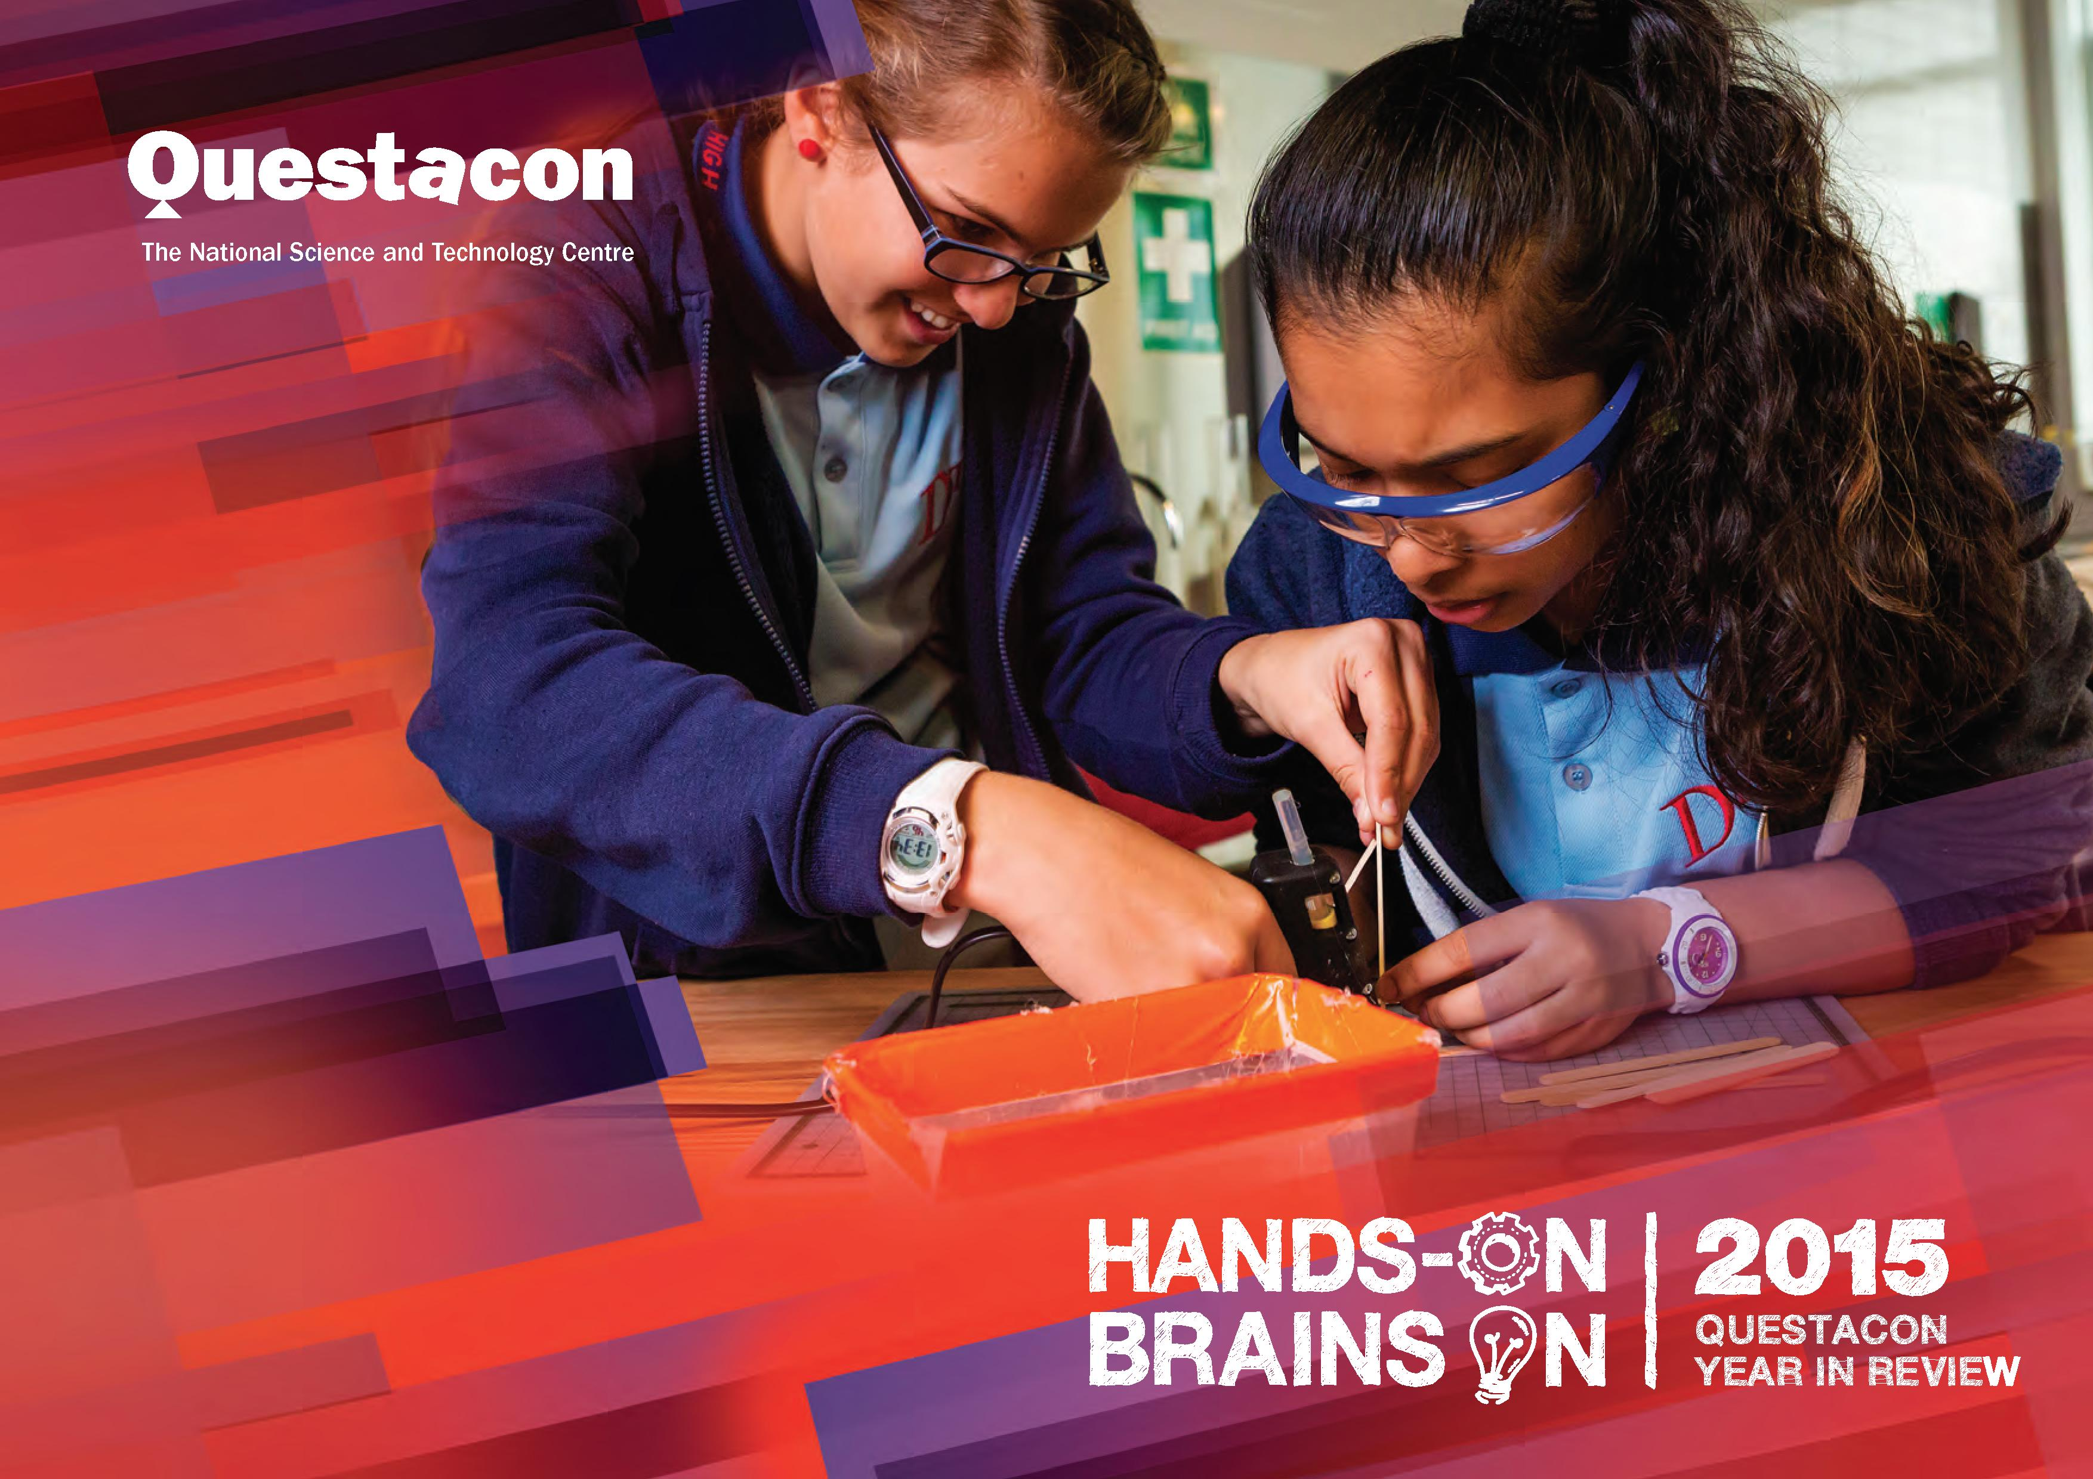
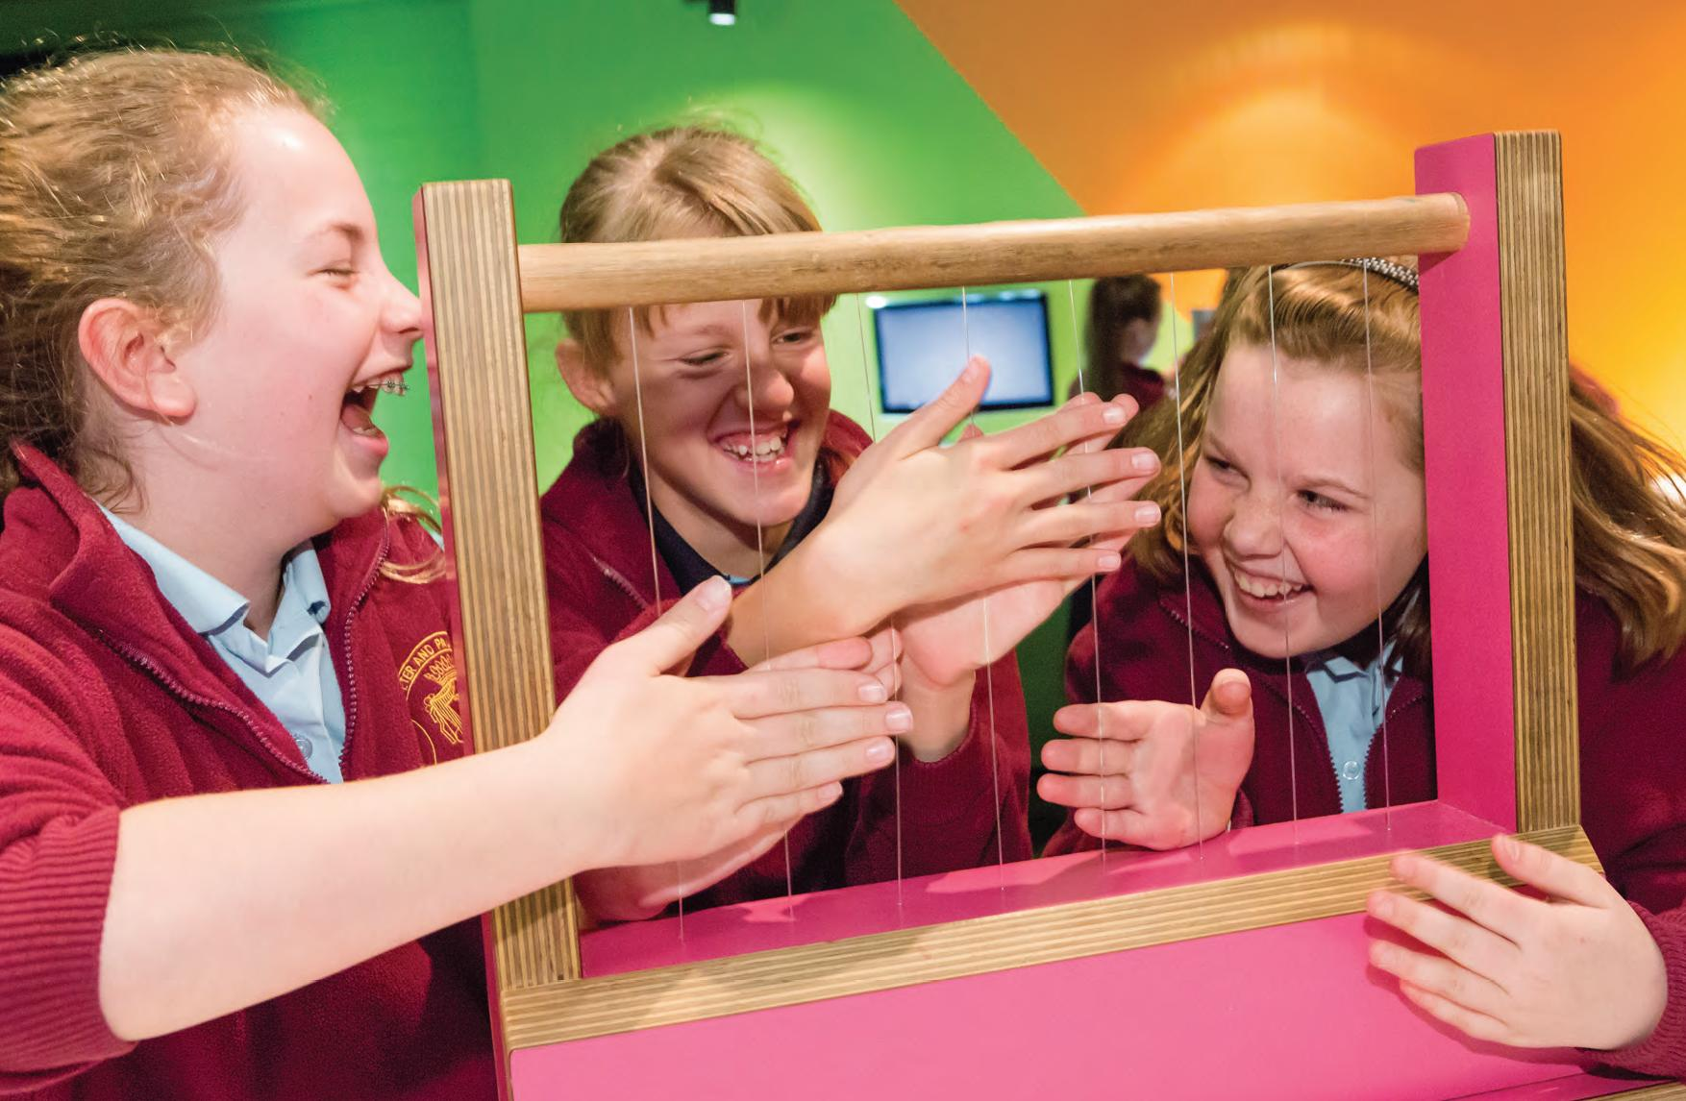

OUR VISION
A better future for all Australians through engagement with science, technology and innovation.
‘We need to teach people to think through problems, to use facts and critical thought and learn about the world in which they live.'
—Professor Brian Schmidt, AC, Nobel Prize Laureate and member of the Questacon Advisory Council
'To say you are not interested in science is to say you are not interested in life.'
—Todd Sampson, 2014 National Science Week Ambassador, science communicator and TV presenter
'Australia cannot be just a quarry and service industries. It needs to be engaged in the excitement of science and innovation and have high skilled technology industries. Questacon encourages young minds to engage in problem solving and to enter the exciting world of science.'
—Mr Charles Goode, AC, Chairman—Flagstaff Partners, Chairman—The Ian Potter Foundation

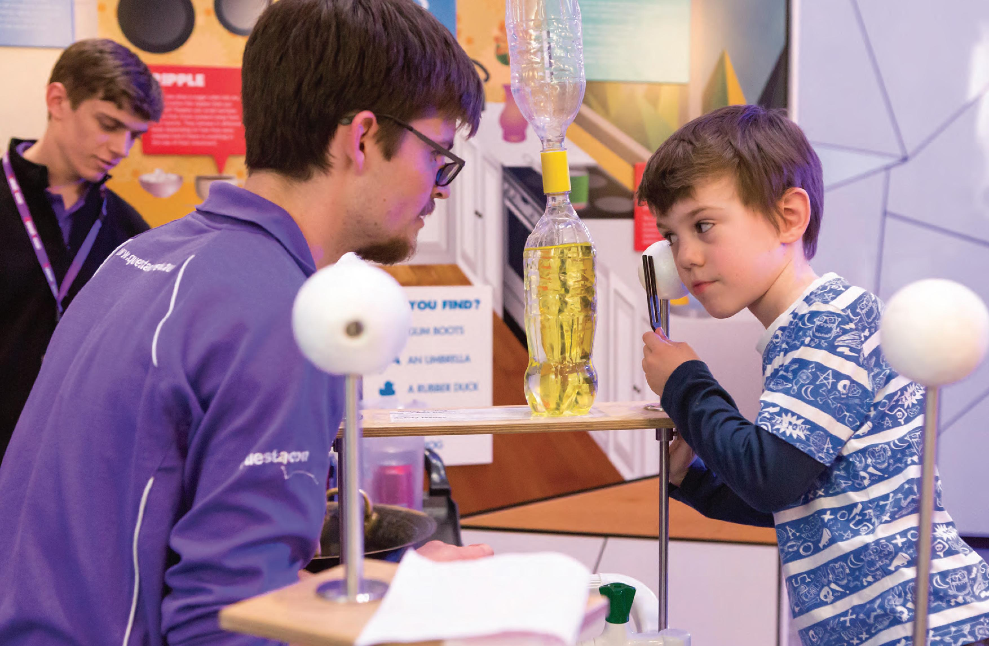

CONTENTS
OUR VISION 3
CONTENTS 5
MINISTER'S INTRODUCTION 9
INTRODUCTION BY THE ASSISTANT MINISTER FOR SCIENCE 11
INTRODUCTION BY THE ASSISSTANT MINISTER FOR INNOVATION 13
CHAIRMAN'S MESSAGE 14
DIRECTOR'S REPORT 17
QUESTACON OVERVIEW 19
Tourism 21
Q Club 21
QUESTACON, POWERED BY PARTNERSHIPS 22
Overview 22
The Ian Potter Foundation 23
Shell Australia 24
Australian National University 24
Samsung Electronics Australia 24
Raytheon 25
IP Australia 25
QUESTACON CANBERRA 27
Questacon Campuses 27
The National Science and Technology Centre 28
The Ian Potter Foundation Technology Learning Centre 31
SCIENCE FOR AUSTRALIA'S FUTURE 32
Inspiring Australia 32
The Prime Minister's Prizes for Science 2014 and 2015 34
NATIONAL PROGRAMMES 36
Shell Questacon Science Circus - Celebrating 30 Years 36
30th Anniversary Celebration and Valedictory Dinner 38
Questacon Smart Skills Initiative 40
Teacher Development Strategy 42
Digital Outreach 45
Exhibitions 46
QUESTACON INTERNATIONAL 47
Science Circus Africa 48
IMPORTANT EVENTS 50
US Ambassadors Innovation Roundtable, 30 July 2014 50
SciNights 50
International Year of Light Launch, 2 March 2015 51
ENLIGHTEN 2015, 27-28 February and 6-7 March 51
3D Design Project Finale with Raytheon, 21 May 2015 52
Members' Night, 12 June 2015 52
Diplomatic Families and Friends Social Event, 26 June 2015 52
ACT Scientist of the Year Award presentation, 20 August 2014 53
Australian Innovation Challenge, 25 November 2015 53
Launch of the Questacon Walks of Wonder 54
QUESTACON PEOPLE 56
Questacon staff awards 58
Questacon Years of Service 59

Note: This year Questacon has changed the way in which it reports its activities. From now on the Annual Review will be for the calendar year, instead of the financial year. To manage the transition to a calendar year report we have captured the later half of 2014 in this year's review.

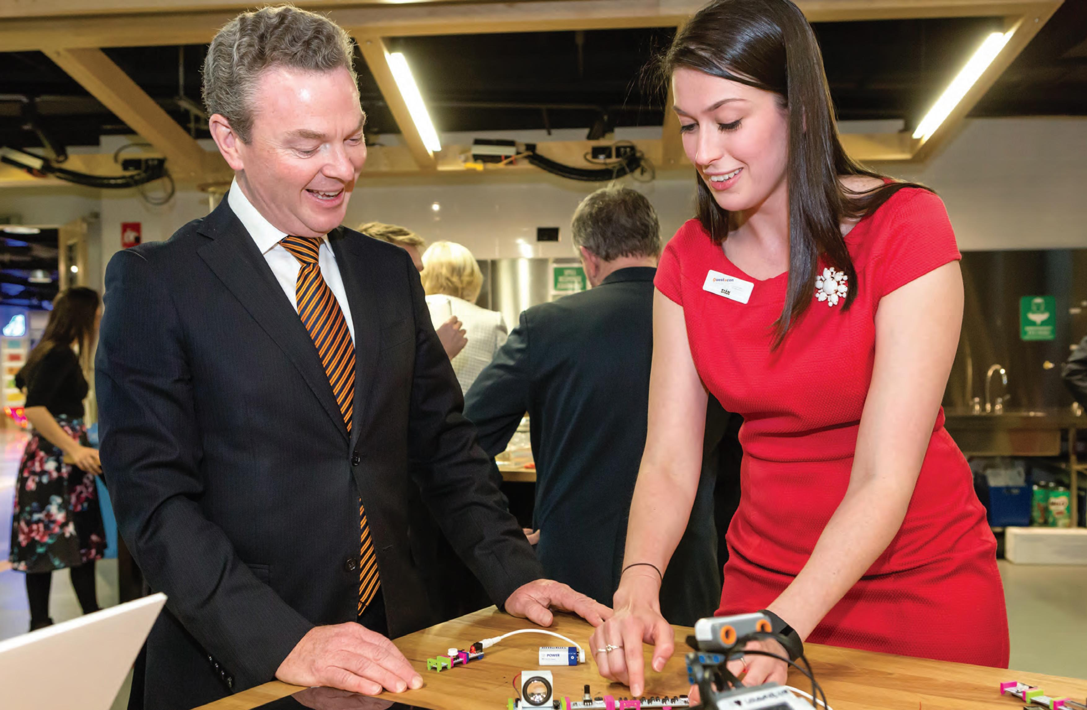

MINISTER'S INTRODUCTION

For more than 25 years, Questacon - The National Science and Technology Centre has made a significant contribution to Australia.
In 2015, the role of this iconic national institution has never been more important.
Science and innovation are at the centre of the Government's agenda.
The Government recognises the importance of science, innovation and technology to our future prosperity and economic security.
This makes Questacon's role in communicating and engaging people in science, technology and innovation more crucial than ever before.
From its support for early and active learning, its fundamental hands-on exhibits, its innovative and creative Smart Skills programme, the Inspiring Australia initiatives, through to the Shell Questacon Science Circus, Questacon continues to successfully inspire and engage Australians of all ages.
Questacon's impacts are diverse and far reaching. Its immense popularity is testament to its national —and international—reputation. In 2015 alone, Questacon has seen 454 251 visitors through its doors; engaged with 136155 school groups and inspired people through its Smart Skills and Shell Questacon Science Circus programmes. These are impressive numbers in anyone's book.
The Shell Questacon Science Circus, which celebrated its 30th birthday this year, has provided five million hours of inspiration, performed over 15 000 science shows in Australian towns and communities, and encouraged and inspired over 5000 teachers with ideas for interactive science activities for the classroom.
This year also saw the launch of major new attractions in Canberra, with prime ministers past and present officiating at the opening of the John Howard Walk of Wonder, and the opening of Spiders, an exhibition jointly developed with the Australian Museum.
The international status of Questacon was further confirmed during the year with the signing of a Memorandum of Understanding with the Singapore Science Centre as one of the pillars of the Australia-Singapore Comprehensive Strategic Partnership - Project 2025. This involves both organisations collaborating on the development and exchange of programs, staff and evaluation data to support initiatives designed to foster innovation and develop high level skills.
It is an exciting time for Australia. Transformation of our economy is underway—and the fuel for the transformation is skilled, creative, and scientifically and technologically literate people. Questacon is at the centre of this transformation and I have seen first-hand the excitement and energy it brings to the community.
This year's review highlights the many achievements Questacon has made on the nation's economic, innovative and educational goals, showcasing the broad reach of Questacon's inspiration over the past 12 months.
I congratulate everyone involved in the success of Questacon and look forward to witnessing the future impacts the institution will no doubt have on Australia and the rest of the world.
The Hon. Christopher Pyne, MP
Minister for Industry, Innovation and Science

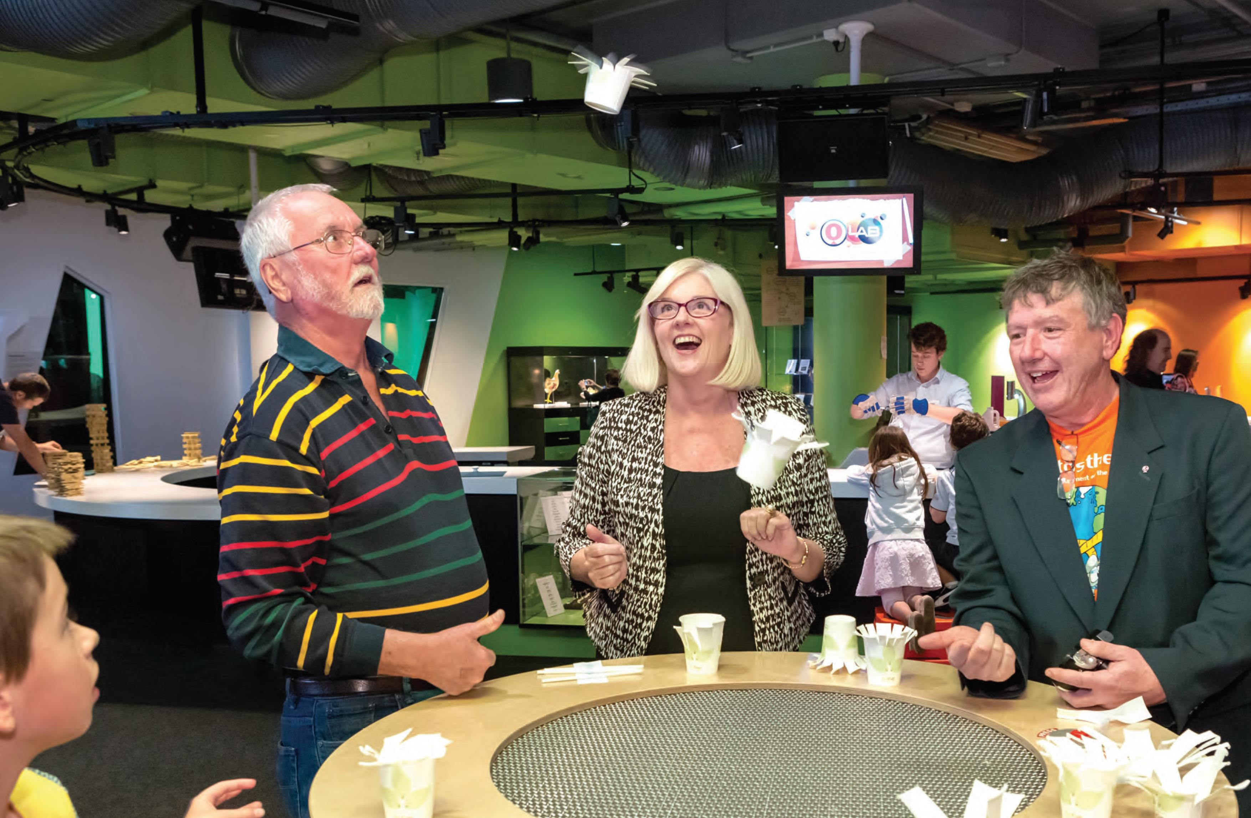

INTRODUCTION BY THE ASSISTANT MINISTER FOR SCIENCE

It's been a big year for Questacon - the National Science and Technology Centre, marked by several major initiatives and announcements that I have had the privilege of being a part of.
The Smart Skills initiative, a great example of a Government-philanthropic partnership, was extended during the year with the announcement that Samsung would become a technology partner. This allowed the programme to expand its reach, and engage teachers and students in harnessing the real potential of technology to help solve problems in a creative and meaningful way.
The Shell Questacon Science Circus celebrated 30 years in 2015, making it one of the longest partnerships of its kind in Australia. Over three decades, it's visited much of Australia, including every capital city, most regional centres, many small communities and even isolated Indigenous settlements.
In 2015, 1.27 million people participated in National Science Week and 4356 media stories were communicated to a potential audience of 36.6 million. These are outstanding figures and an illustration of Questacon's significant impact. But it can't do all this on its own. Questacon owes a lot of its success to its purposeful engagement with key partners, working closely with science education professionals to ensure all programmes complement in-school education. On behalf of the Australian Government I thank these sponsors and partners.
An example of these successful partnerships was the roll out of the AMSPP (Australian Maths and Science Partnerships) teacher mentoring programme. Questacon combined its powerful approaches to learning with leading science and mathematics professional associations, science communication specialists, and local and international experts in face-to-face and teleconferenced teacher mentoring. The programme will lead to trials on how to best support new teachers, and teachers working out of subject, through mentoring and skills development.
Questacon also took part in several major education initiatives over the year, such as the science exchange course held in February. Australian teachers worked with education experts from San Francisco's Exploratorium Teachers Institute to develop new programmes to support Australian science teachers. I was able to see first-hand how staff and facilitators shared knowledge and developed the new programme, making sure our teachers have the necessary support and information will help ensure the next generation of Science, Technology, Engineering, and Mathematics (STEM) graduates.
I was also able to announce two major partnerships with Western Australia and South Australia to deliver science communication programmes over four years under the national Inspiring Australia initiative.
In Western Australia the agreement is with that state's four universities, Engineering Australia and Scitech. In South Australia the agreement is with three universities and the South Australian Museum.
The agreements are worth $1.5 million and $1 million respectively and will deliver programmes that showcase science.
Questacon's many initiatives are an important part of the broader STEM agenda. The institution is at the forefront of innovative activities that are helping to ensure we become a knowledge nation, and it will undoubtedly continue to play this important role in years to come.
The Hon. Karen Andrews, MP Assistant Minister for Science

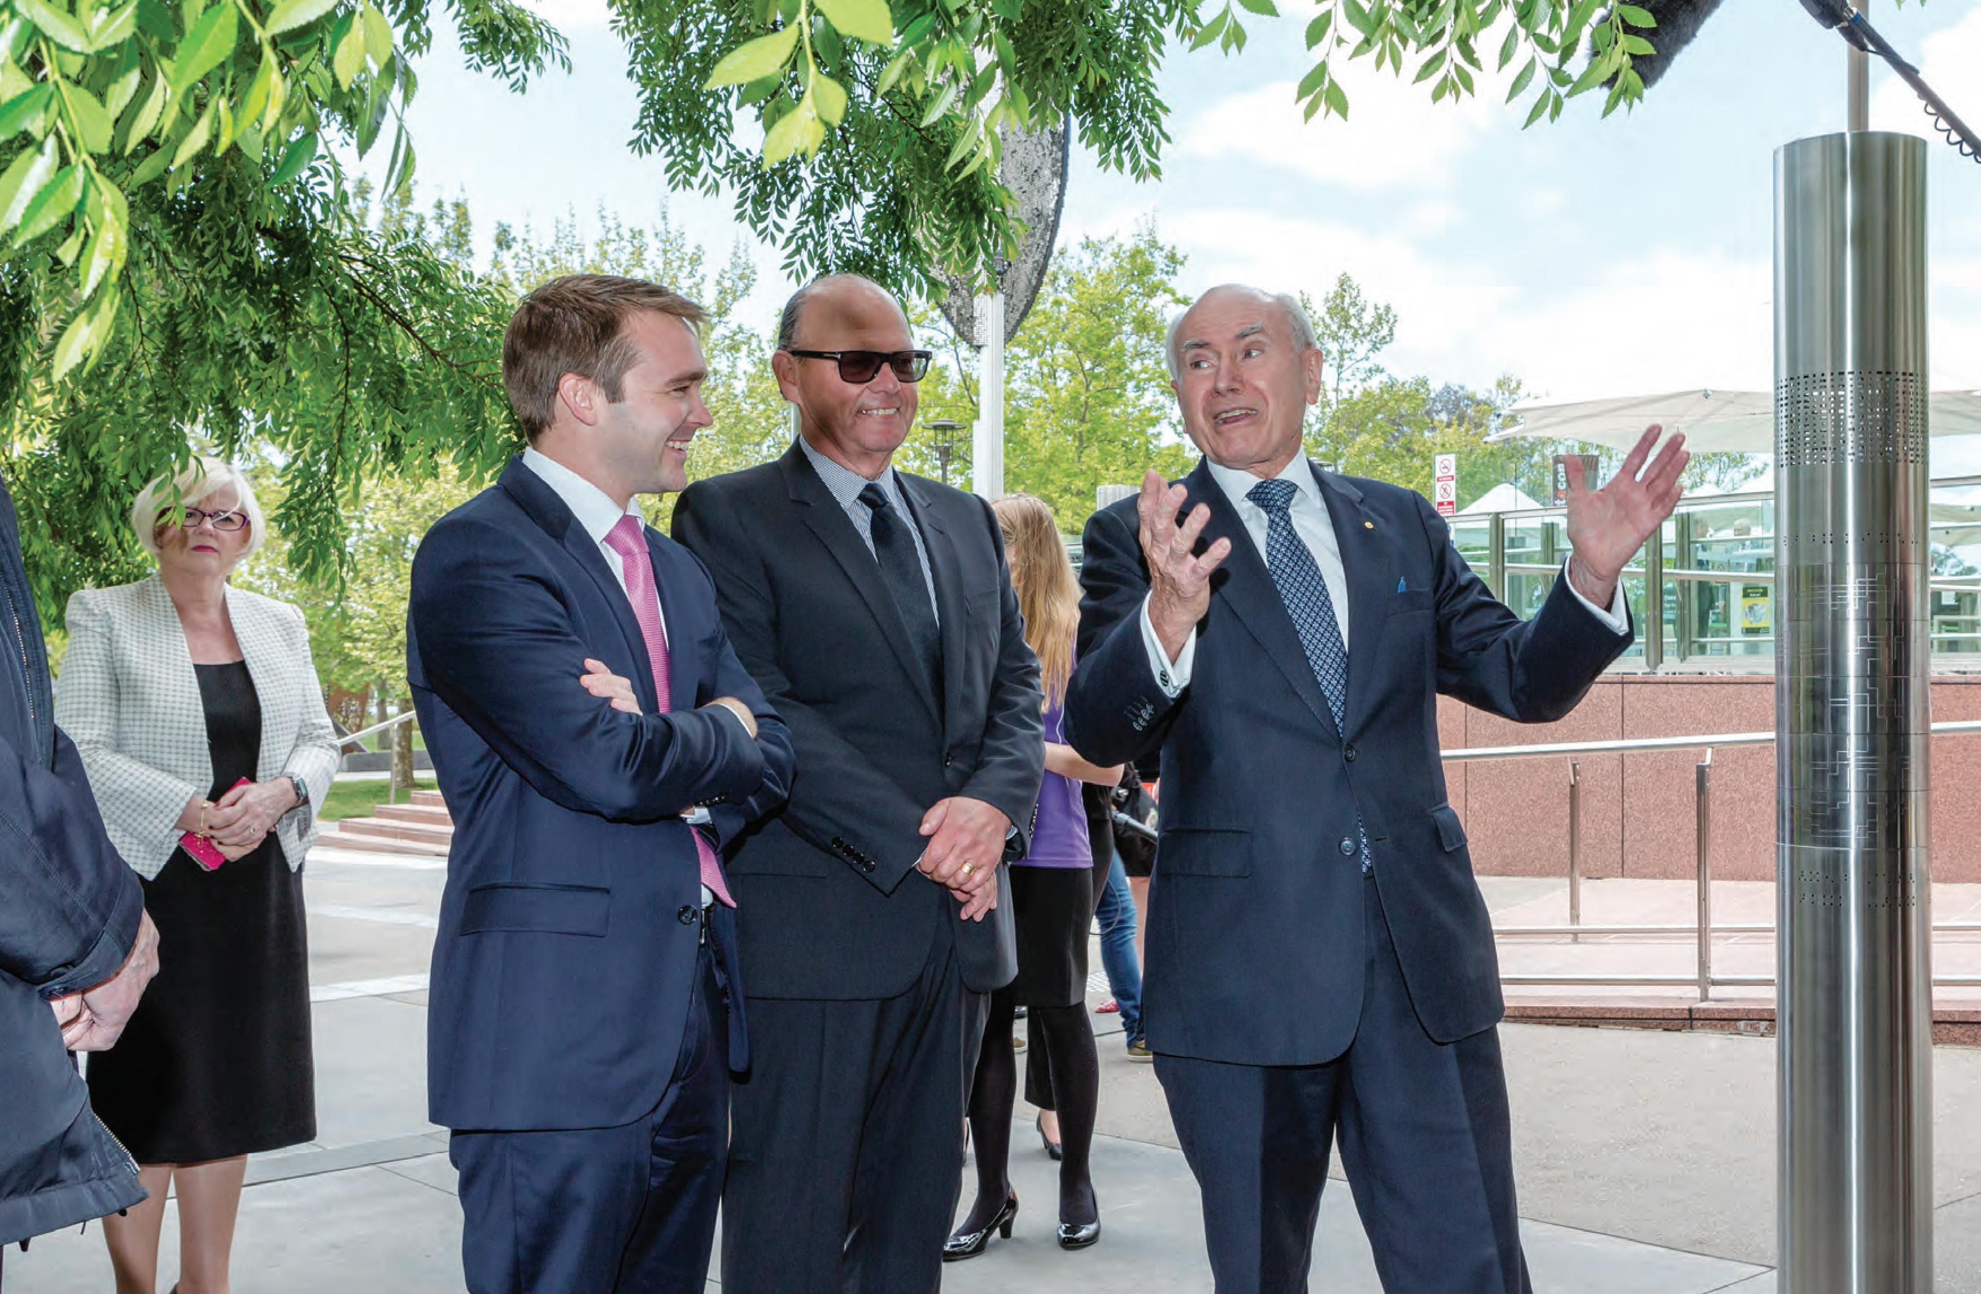

INTRODUCTION BY THE ASSISSTANT MÎNISTER FOR INNOVATION

Science engagement is a key to increasing the intellectual clout of the nation, and if we want more Australians to be scientifically literate and engaged with science and technology, we need to invest in improving the exposure of our school students to STEM skills.
The Government understands the important of having a coordinated STEM approach. Institutions such as Questacon - the National Science and Technology Centre have been the backbone of STEM engagement for many years, providing innovative programmes which are delivered around the nation.
It has been exciting to see Questacon's Smart Skills initiative—supported by the Federal Government, The Ian Potter Foundation, Samsung, IP Australia and others—reaching out across the country.
Of particular note has been the impact of the regional Invention Conventions, run as part of the initiative.
The conventions link students with young entrepreneurial peers and local industry mentors.
It's a great example of how to transform young minds and leave a legacy that Australia will benefit from for many years.
It is exciting to think of the curiosity that has been sparked in young people's minds by Questacon's various exhibitions, outreach programmes or video conferences. Through its leadership in innovating and developing new and effective programmes, and its training and development of science communication professionals who now work across the nation and around the globe, Questacon has truly fulfilled its role as the National Science and Technology Centre.
As Assistant Minister for Innovation, I am acutely aware of the need for strong growth in the skills that will underpin Australia's future economic productivity.
The journey of learning creates the capacity to inspire, innovate, fail and try again, generating the resilience upon which future careers, industry and a productive economy will be built.
Questacon has been playing a key role in this engagement for more than 25 years and I am looking forward to watching them continue to lead in the area of science engagement as we grow the intellectual capacity of Australia.
The Hon. Wyatt Roy, MP Assistant Minister for Innovation

CHAIRMAN'S MESSAGE

Throughout 2014 and 2015, Questacon has continued to deliver as a leader in science engagement, contributing to the transformation of the Australian economic story by helping to build a skilled, creative, scientifically and technologically literate nation.
A series of events and activities were held throughout the year to deliver this mission and to celebrate the achievements of this remarkable institution. As is the Questacon way, each event is inspiring and memorable in its own right. One particular highlight for me was the recent launch of the Questacon Walks of Wonder, with the inaugural walk named in honour of the Hon. John Howard, former prime minister of Australia in recognition of his on-going support for the Questacon Garden of Wonder and investment in plans for Questacon's proposed building expansion.
Standing in Questacon with the building full of flag-waving visitors both young and old, and hearing the roar of excitement ripple across the balconies as the Hon. Malcolm Turnbull, Prime Minister of Australia, and former prime minister the Hon. John Howard entered surrounded by a frenzied press pack, was an experience I will not soon forget. As the Prime Minister called to our youngest visitors high up on the balconies, encouraging them to embrace their Questacon experience to become the future innovators of Australia, this delightful and spontaneous moment brought home to me again, the power of Questacon to inspire and excite all of us.
I was delighted to share the various events of that day with our current and former prime ministers. We were also joined by the Hon. Christopher Pyne (Minister for Industry, Innovation and Science), the Hon. Karen Andrews (Assistant Minister for Science), the Hon. Wyatt Roy, (Assistant Minister for Innovation),
the Hon. Stuart Roberts (Minister for Veteran Affairs and Minister for Human Services), Mr Charles Goode, Chair of The Ian Potter Foundation, and senior leaders in the Australian and International science, business, cultural, government and education sectors. It was a day full of remarkable celebrations—once again cementing Questacon in the hearts and minds of Australians who were there on the day, or who joined the conversation in traditional and social media in the days following.
Questacon's continued success is shared with our valued partners, including Shell, The Ian Potter Foundation, IP Australia, Raytheon, Samsung, the University of Canberra and The Australian National University. I sincerely thank these organisations for their ongoing support for Questacon's activities.
This year marked a significant thirty year milestone for two of those partners in delivering the world renowned Shell Questacon Science Circus. The co-investment in our collective future from The Australian National University, Shell Australia and Questacon has for three decades, supported the Shell Questacon Science Circus in creating the skills to inspire our youth and build our future economy. The programme again went global with science circus tours to Japan in 2014 and countries across Africa in 2015 continuing to model the success of the science circus at home. I congratulate everyone involved in the science circus over thirty years, and thank the partners for their ongoing support of this wonderful programme.
In addition to the Shell Questacon Science Circus, the Smart Skills programme, generously supported by The Ian Potter Foundation, Samsung and IP Australia, has had significant success in its first year, with the delivery of four tours around Australia and three
regional Invention Conventions. The programme continues to develop the next generation of innovative young entrepreneurs. In this digital age, it is critically important Australians are well equipped to fully utilise the tools technology gives us. This is only possible with a combination of inspiring and engaging role models working on the ground with students, teachers and communities to create a lasting impact in innovation, creativity and entrepreneurship in all Australian communities. I look forward to seeing the wonderful fruits of this first year come together in the National Invention Convention in January 2016.
As an enduring national institution and a jewel in Australia's crown, Questacon continues to receive well-deserved bipartisan political support, working to deliver wonderful outcomes to the people of Australia. I am pleased to see the work of Questacon helping to deliver science engagement and inspiration from within the two Canberra facilities and across Australia in a way that is accessible to all.
The public face of Questacon would not be what it is without the efforts of its team behind the scenes. I would like to pay tribute to the Questacon executive team—our much admired and respected Director of Questacon, Professor Graham Durant, to our 'Man of Wonder' Dr Stuart Kohlhagen (Deputy Director and Director of Science and Learning), and to Ms Kate Driver (Deputy Director and General Manager Operations), who makes it all happen. I acknowledge Graham, Stuart and Kate, along with the Questacon leadership team for the contribution they are making to science nationally and through international collaborations. I would also like to thank Ms Glenys Beauchamp and Ms Sue Weston, Secretary and Deputy Secretary of the Department of Industry, Innovation and Science along
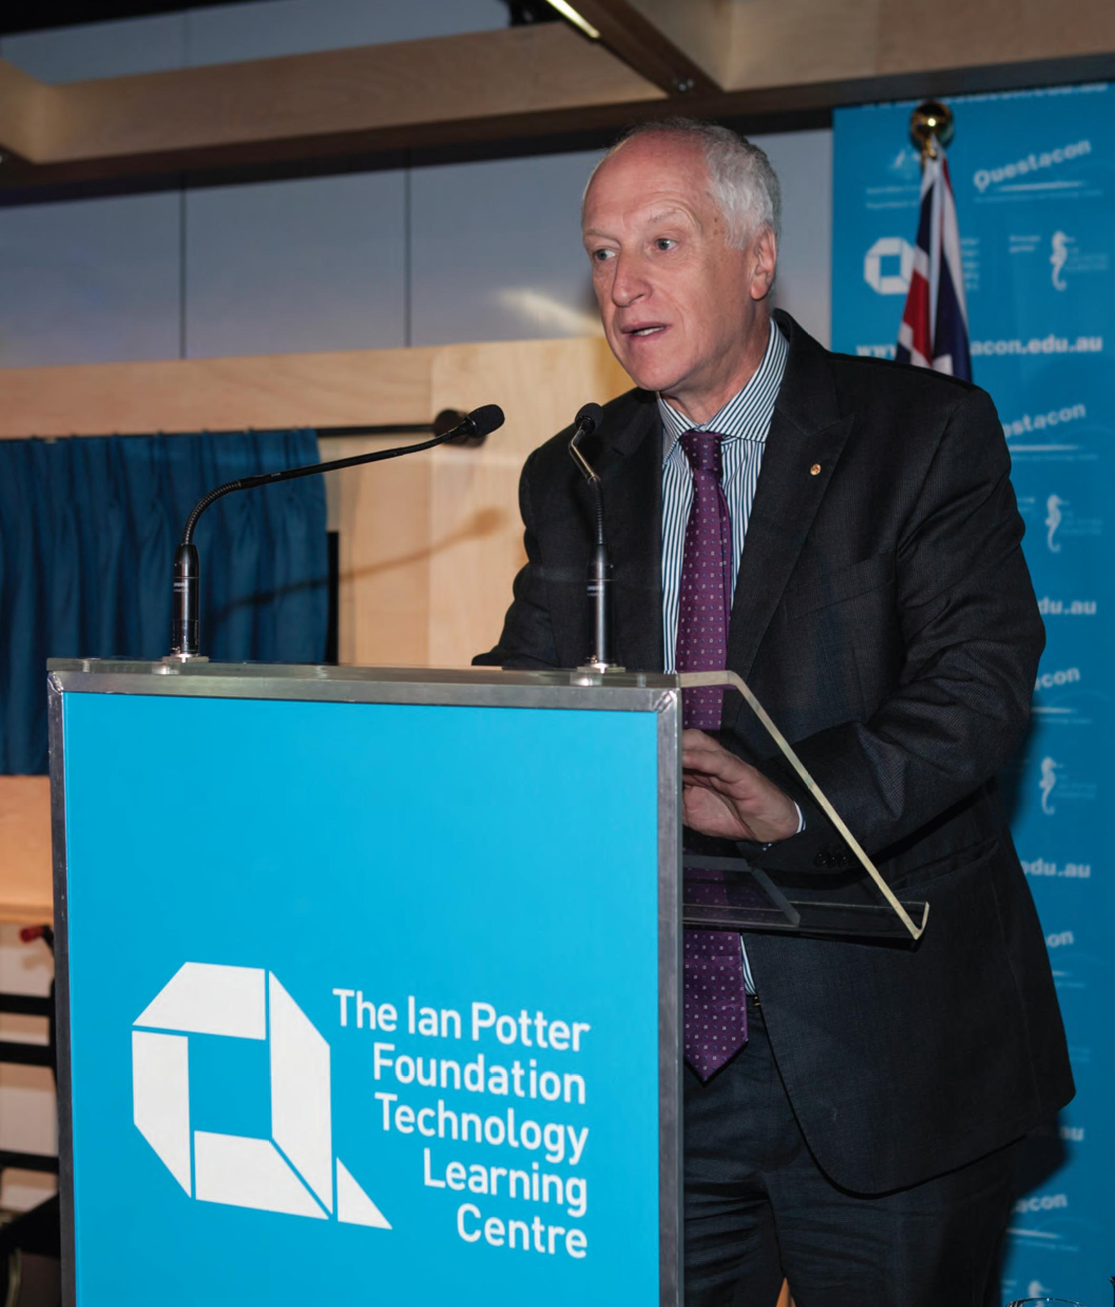
with former Deputy Secretaries Dr Subho Banerjee and Mr Martin Hoffman, for their support throughout 2014 and 2015. I thank 'Team Questacon' for their strong leadership, passion and vision throughout the year.
I thank my colleagues on the Advisory Council: Professor Brian Schmidt, AC, Dr Cathy Foley, Dr Sarah Pearson and Dr Gregory Clark for their commitment, passion and counsel during the year. They contribute their creativity and experience on almost daily basis and are an important ingredient to Questacon's success as advisors and advocates. Having Nobel Prize Laureate Professor Brian Schmidt on the Advisory Council has brought honour to the Council, Team Questacon and the nation. I wish him success in assuming his new role as Vice-Chancellor at The Australian National University in January 2016.
Finally, I thank Questacon's enthusiastic and dedicated team of staff and volunteers. Their daily contribution enables Questacon to remain the dynamic organisation it is today. Their passion and commitment means that Questacon's future is in great hands.
Leon Kempler, OAM
Questacon Advisory Council Chairman

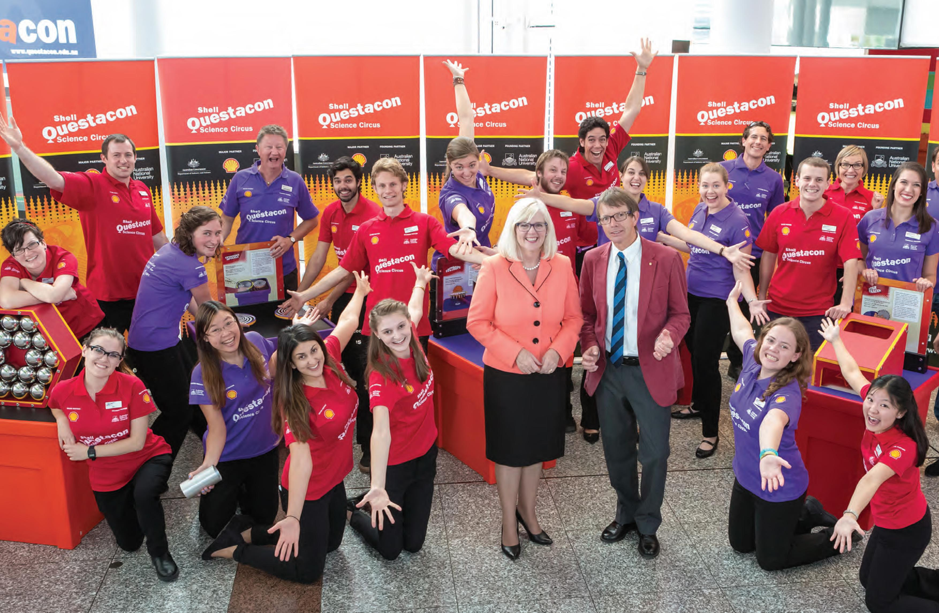

DIRECTOR'S REPORT

Questacon offers motivational hands-on experiences in an inspirational learning environment with exhibits that allow open-ended exploration and offer physical and sometimes emotional experiences. It is a learning environment that is intergenerational with strong socialization, a learning environment in which visitors have a free-choice of what to explore. It is a learning environment that engages both hands and brains.
In common with science centres around the world Questacon embraces a core philosophy Ί hear and I forget, I see and I remember, I do and I understand'.
But what is the difference between forgetting and remembering? Between remembering and understanding? And just what is understanding as opposed to knowing? What is actually happening in our brains, and can neuroscience research now prove the ancient Chinese philosophy? Questacon's partnership with the Science of Learning Research Centre at the University of Queensland offers an interesting opportunity to better understand why hands-on works.
At Questacon we constantly strive to make better, more effective exhibits; to see how we might be able to create more effective immersive learning environments and to do more to engage with research projects that investigate the difference between hearing, seeing and doing. It is known that active engagement is necessary for learning. It is also known that learning has an emotional base. Humour, surprise, curiosity and delight all contribute to the Questacon science show experiences delivered by our Excited Particles. One of Questacon's most memorable exhibits is still 'free fall' which involves visitors hanging from a bar and dropping onto a slide for a gentle landing. There is a surprising strong fear response for many of our young visitors— around one in ten cannot let go of the bar. It is also a social experience. It is remembered and remains a favourite.
It is also known that people learn differently and learning outcomes for individuals can differ significantly for the same learning experience. People bring different knowledge levels, different life experiences, and different attitudes to their visits. A good science centre exhibit acknowledges these differences and offers something meaningful for a child as well as for a professor of physics. Open-ended experiential learning and interactive exploration with hands and brains.
The brains of Homo sapiens evolved through the use of hands, with hands and brains working together to manipulate things. Arguably it led our species on its learning journey and stimulated brain development— the tool, the spoken word, the visualisation; the written word, the printed word, the school, the illustration, the photograph, the film, the personal computer, the internet, the game, the designed intelligent learning environment.
As a species, and as individuals, we never stop learning. Long after we have left school we continue to accumulate knowledge through informal learning experiences, such as Questacon provides.
But we are also committed to excellence within formal education—a vital partnership with informal learning— demonstrated by our latest partnership activity with the University of Canberra. Based on the proven and highly successful Exploratorium Teacher Institute model in San Francisco, the teacher will develop a mix of intensive workshops, face-to-face and virtual teaching resources and unique professional networks, to improve the quality of science and maths teaching in Australia.
As neural networks evolve and form new links, so Questacon's many partnerships work to develop new programmes, and to fine-tune existing ones.
Our partnership with ANU and Shell Australia, as a notable example, has led to the Shell Questacon Science Circus being a pioneering provider of science engagement across the nation. I thank the many staff who have worked with the science circus over the last 30 years, making it such a success.
One of our newest partnerships, with The Ian Potter Foundation, has led to the development of The Ian Potter Foundation Technology Learning Centre. This centre offers deeper experiences, concentrating on the way things are made, showing how components fit together and demonstrating how innovation can solve everyday problems from simple devices to higher-end technology.
I would also like to acknowledge the support of the Ministers, our Advisory Council and our many dedicated staff, who collectively contribute to our engagement with over 2.5 million people each year.
Professor Graham Durant, AM Director, Questacon

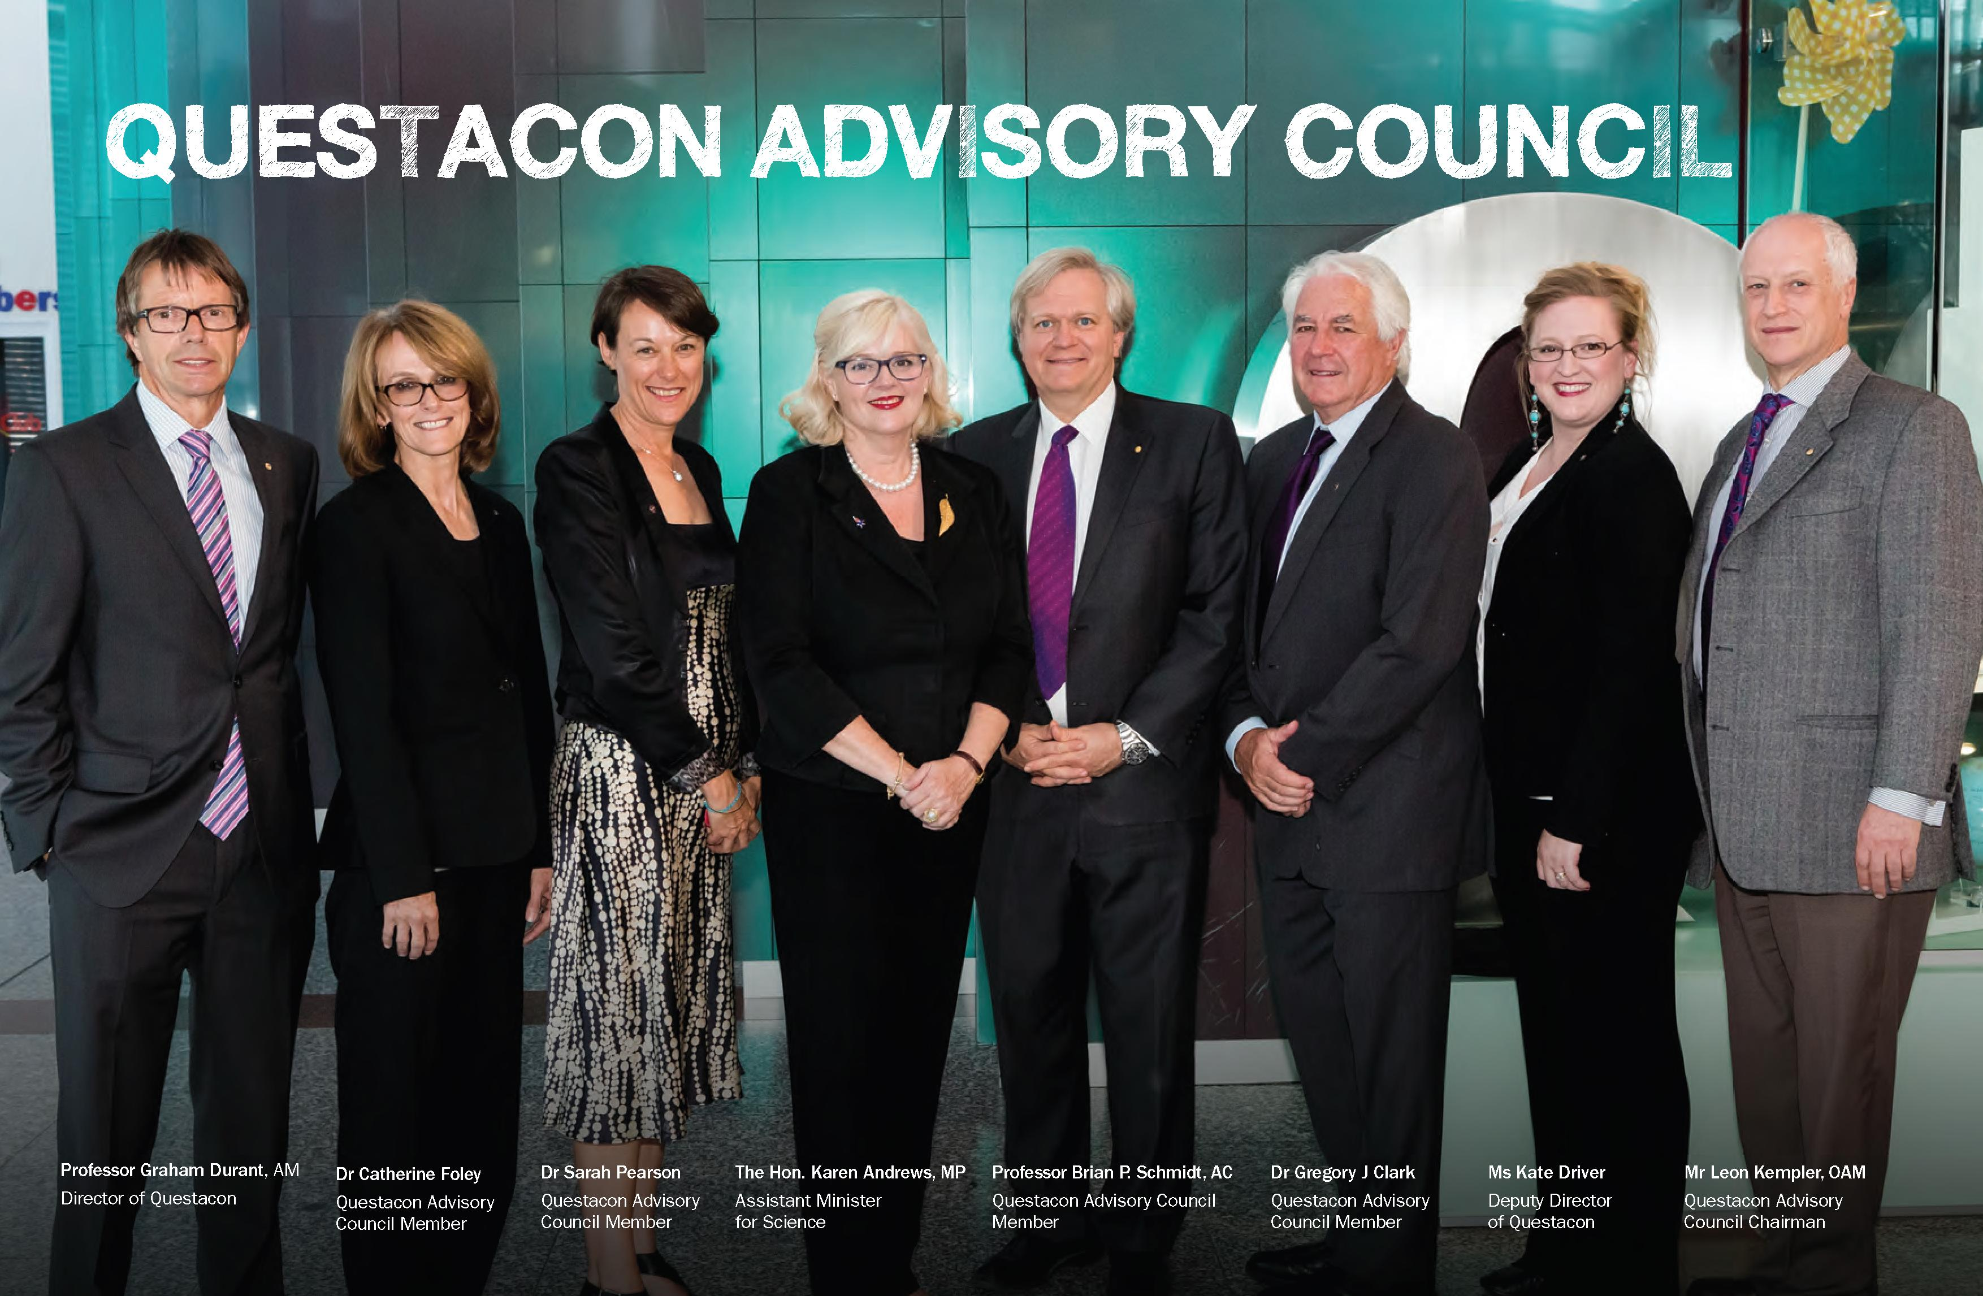q

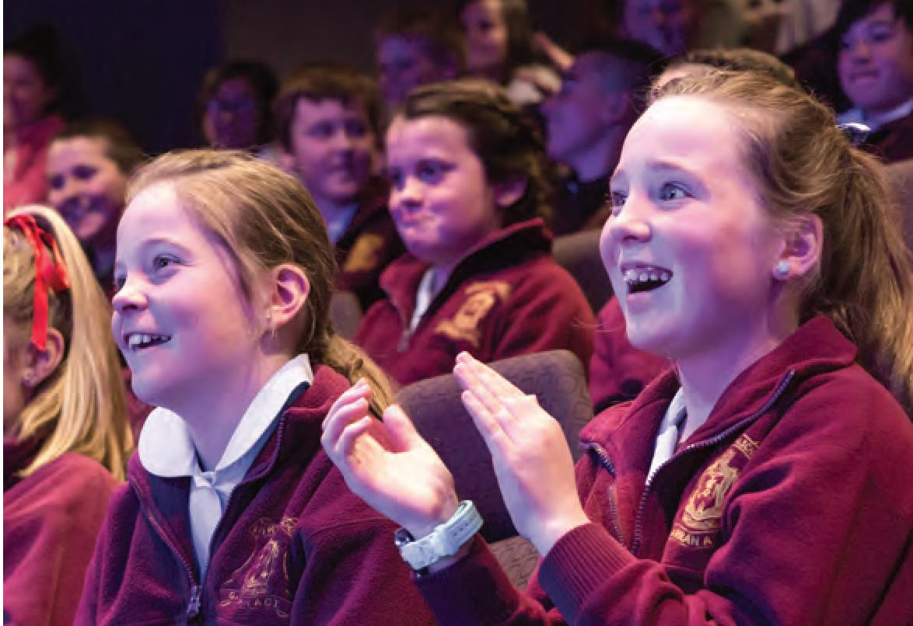
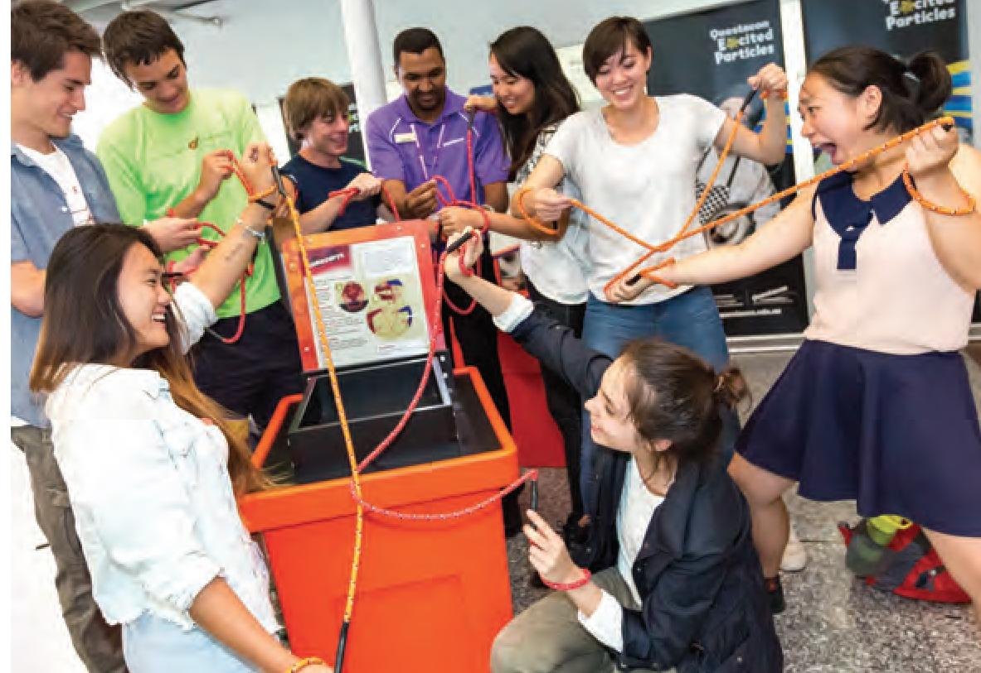
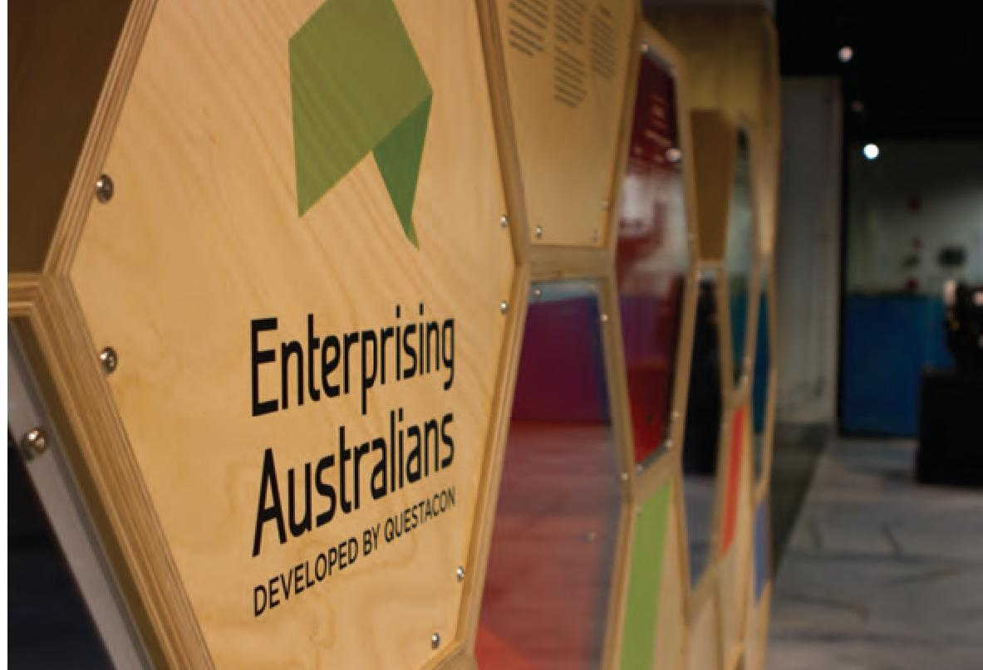

QUESTACON OVERVIEW
Questacon is Australia's National Science and Technology Centre, and is a Division of the Department of Industry, Innovation and Science. Since being founded by Professor Mike Gore, AO, in September 1980 as a project of The Australian National University (ANU). It opened at the Ainslie Public School with 15 exhibits and was staffed entirely by volunteers. Since this time it has become the national leader in developing and presenting world class creative, interactive science exhibits and programmes. Questacon now employs around 230 staff and continues to benefit from a dedicated team of volunteers. Questacon has an annual audience reach of over two million people through centre visitation, outreach programmes, travelling exhibitions, in-school videoconferencing programme and Questacon websites. Questacon was designed to welcome 200 000 visitors annually and has now exceeded capacity with annual visitation averaging 450 000.
As Australia's National Science and Technology Centre, Questacon has an important role to play in Canberra, nationally and internationally. It was deliberately located in the Parliamentary Zone of the National Capital alongside other national institutions to symbolically demonstrate the importance of science and technology in Australia. Questacon plays a role in the science tourism sector, generating revenue and attracting visitors to Canberra. The government is committed to promoting science tourism, particularly in regional Australia.
Questacon's aim is to encourage Australians to recognise that science, technology and innovation are essential to our national prosperity. Hands-on activities experienced at Questacon provide informal
learning opportunities which complements formal science education provided in schools. More directly, Questacon aims to address the skill shortages in science and technology, by striving to influence more students to pursue careers in the fields of STEM.
Questacon actively seeks to make its programmes and exhibitions highly accessible to Australians and international visitors. In addition to the Centre's eight themed exhibition galleries (and over 200 hands-on, interactive exhibits) in Canberra, Questacon travels a variety of exhibitions throughout Australia and overseas, and has outreach programmes in rural, regional and remote Australian and Indigenous communities. Questacon also provides teacher professional development through partnerships with the University of Canberra and The Australian National University.
In 2014 former prime minister the Hon. Tony Abbott, MP, opened The Ian Potter Foundation Technology Learning Centre (IPTLC) in Deakin, ACT. IPTLC responds to the need to foster an innovation culture amongst young people so as to ensure Australia's workforce has the skills and ability required to support innovation and to increase productivity. IPTLC is designed to inspire, encourage and prepare young people for careers in technology, engineering and manufacturing. Throughout 2014-15 IPTLC housed an exhibition gallery showcasing the exhibition Enterprising Australians and hands-on activity spaces that allowed students and members of the public to actively participate in the innovation process.

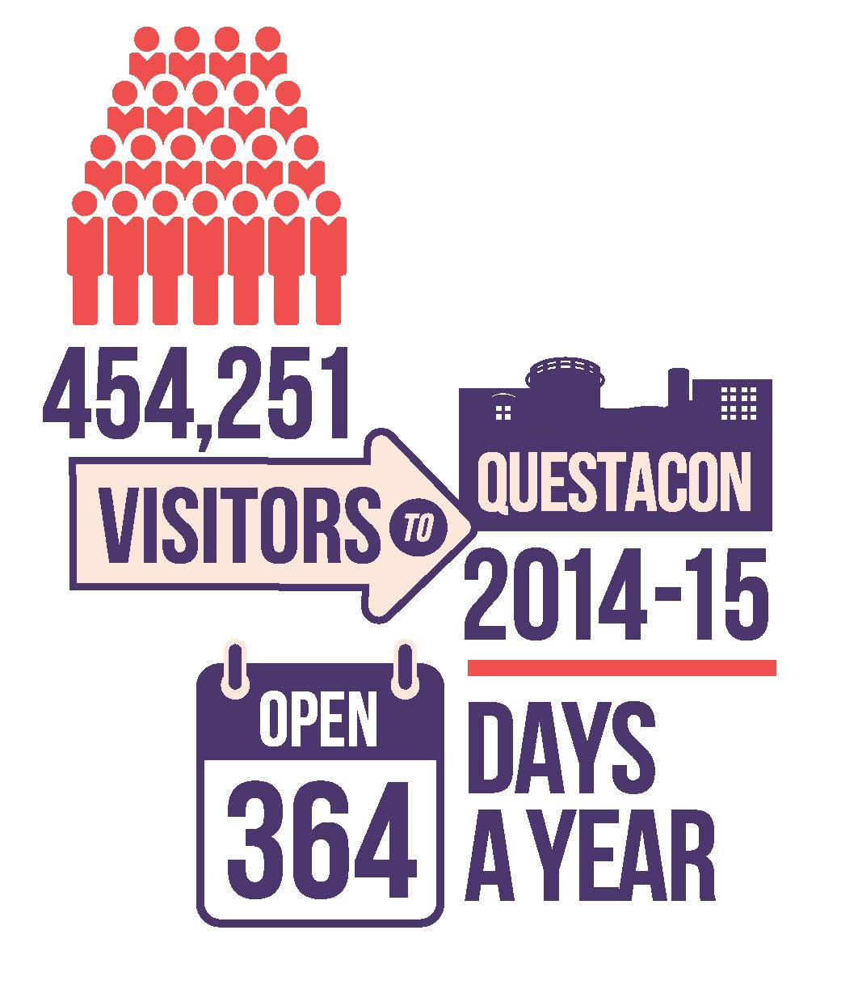

Questacon administers Inspiring Australia: a national strategy for engagement with the sciences, supported through the 2014 Science for Australia's Future election commitment providing $28 million over four years to communicate science more effectively. The Inspiring Australia strategy captures activities such as the Prime Minister's Prizes for Science and National Science Week. It is through Inspiring Australia that otherwise disparate and fragmented science communication initiatives are connected and their full potential harnessed.
Questacon is an important agent of Australia's scientific and cultural diplomacy. As a world leader in the international science centre community, Questacon has a responsibility to facilitate knowledge sharing and development in the sector. Questacon is a signatory to the Cape Town Declaration of the 6th Science Centre World Congress in which Questacon committed to assist the expansion of science centres where they are needed but not yet established. Questacon's international engagement strategy includes capacity building in Southern Africa and Asia-Pacific. Questacon has an ongoing relationship with Japan which co-funded and co-founded Questacon in 1988 as a Bicentennial project.
Questacon's success is due in part to its enduring and effective partnerships. The Shell Questacon Science Circus is in its 30th year, an enduring partnership with Shell and The Australian National University. Support from Raytheon, Samsung, IP Australia and other government agencies has enabled Questacon to take science and technology to many remote, regional and metropolitan areas of Australia and abroad. Questacon maintains partnerships with science institutions, delivers exhibition tours and capacity building projects, and participates in science conferences.

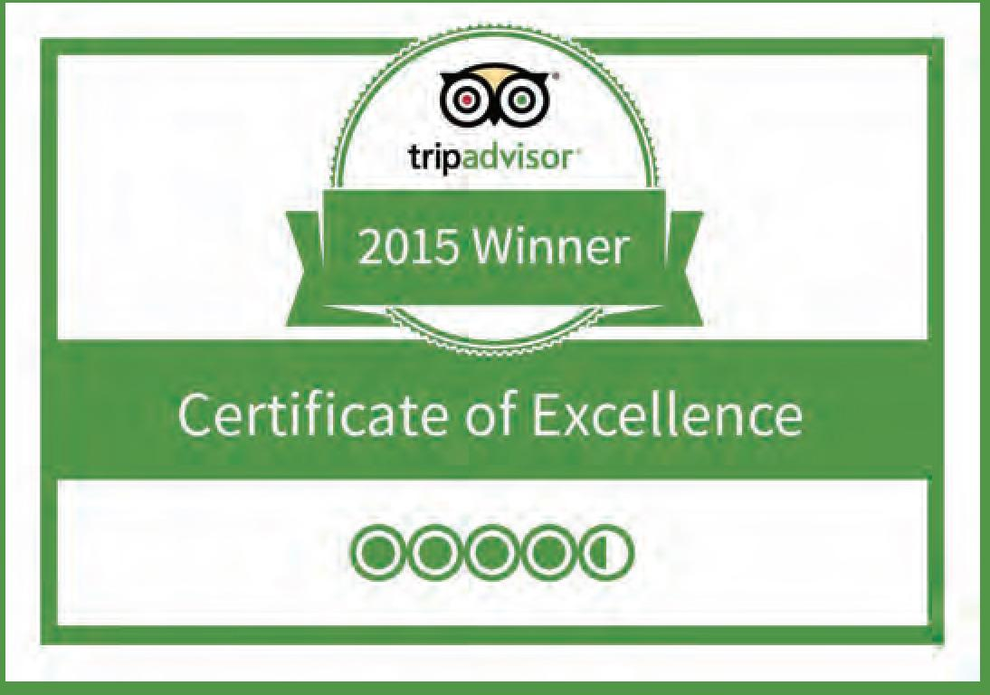

Tourism
The tourism economy in the ACT region is estimated to be $1.2 billion annually¹. As one of the suite of national institutions that are a major draw card for tourism to Canberra, Questacon contributes significantly to this economic activity and generates more each year for Canberra businesses and the ACT economy than it receives from the Federal Government.
According to the National Capital Educational Tourism Project, the educational tourism sub-sector alone contributes $105 million per annum to the ACT economy and many of the 180 000 school students who visit Canberra each year regard a visit to Questacon as one of their trip highlights².
This year for the eleventh consecutive year Questacon won the 2015 Canberra and Capital Region Tourism Award in the Tourist Attraction category. This award recognises Questacon's ongoing commitment to tourism in the region.
Questacon positively contributes to ACT tourism through its membership with the National Capital Attractions Association (NCAA). This membership based body represents local attractions, hotels and restaurants. Additionally Questacon's involvement includes the nomination of a staff member as the NCAA President, working closely with the National Tourism Alliance (NTA) allowing direct access to the Tourism Industry in Australia, keeping Questacon and Canberra in the forefront of the national tourism industry.
1 State of the Industry 2014, Tourism Research Australia,October 2014
2 Garry Watson, project leader, the National Capital
Educational Tourism Project, 2014

Q Club
Our Q Club membership currently stands at 4781 including 16 619 members. Our members come from the ACT, regional NSW and interstate to participate in Science Time and Questacon School Holiday programmes. A Q Club highlight for the year was the extremely successful Members night held on the 12 June 2015. The Centre welcomed 2600 members and friends who enjoyed a fun packed evening of special shows and activities, based around the 2015 International Year of Light.
Our Q Club members made 49 978 visits to the Centre over the year.
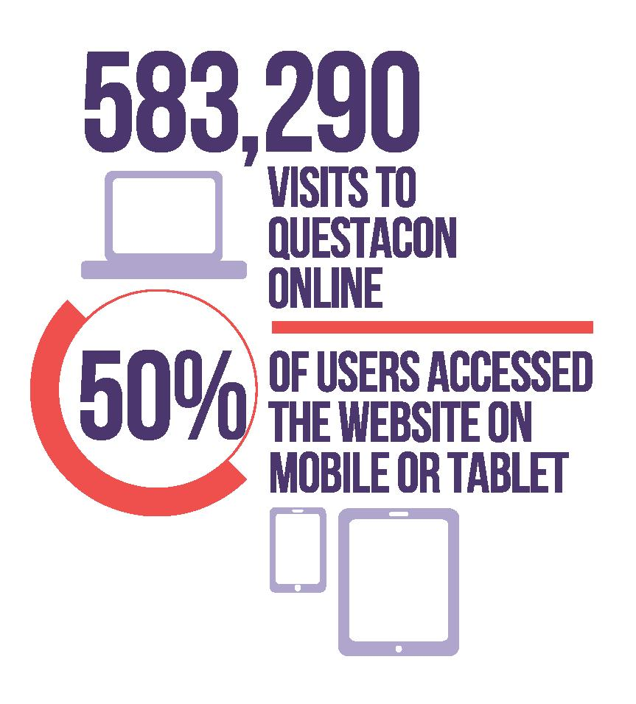
433 Positive ratings Average rating of 4.5 stars
'Who knew science could be so much fun'
'Great fun for big kids and small kids who love science'
'Quench your curiosity for science ;-)'
'Science rocks!'

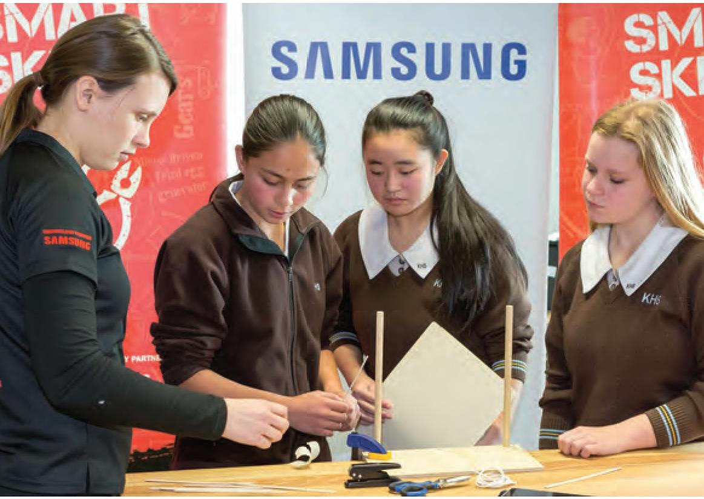

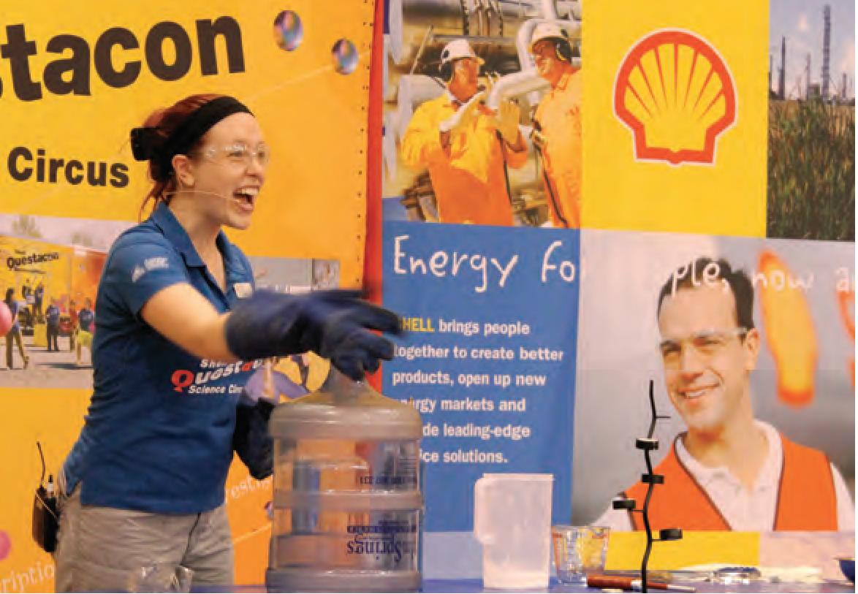
QUESTACON, POWERED BY PARTNERSHIPS

Overview
Questacon places great value on partnerships across Australian and international business, drawing links with the world's best and most innovative organisations. Through these partnerships we are able to deliver additional science, innovation and technology exhibitions and programmes to broader audiences—especially to students, teachers and children—in a way that's accessible, interactive and inspirational. New partnerships are vital to the continued expansion of Questacon's activities, in 2014-15 Questacon partnered with The Ian Potter Foundation, Samsung and IP Australia and renewed partnerships with Shell and Raytheon.

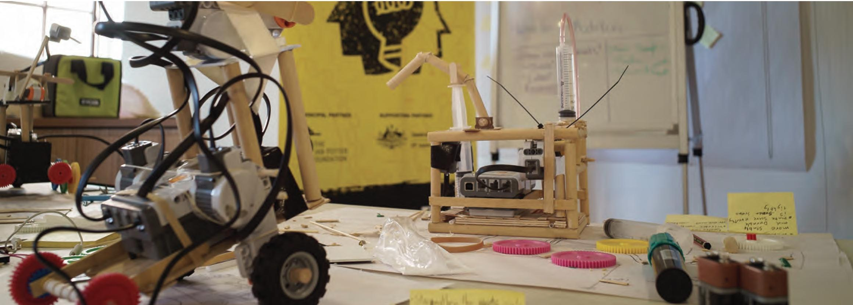
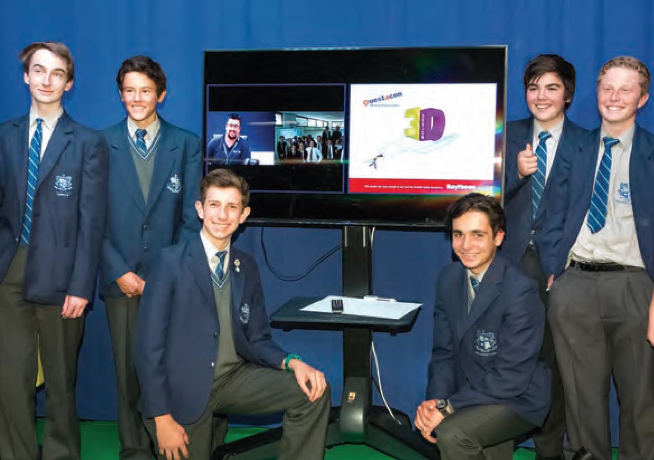

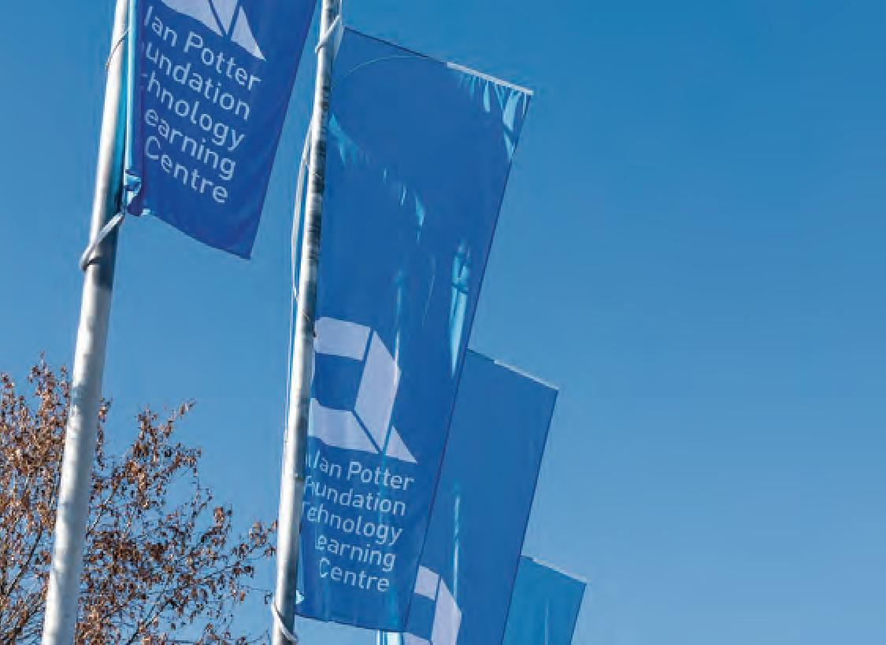
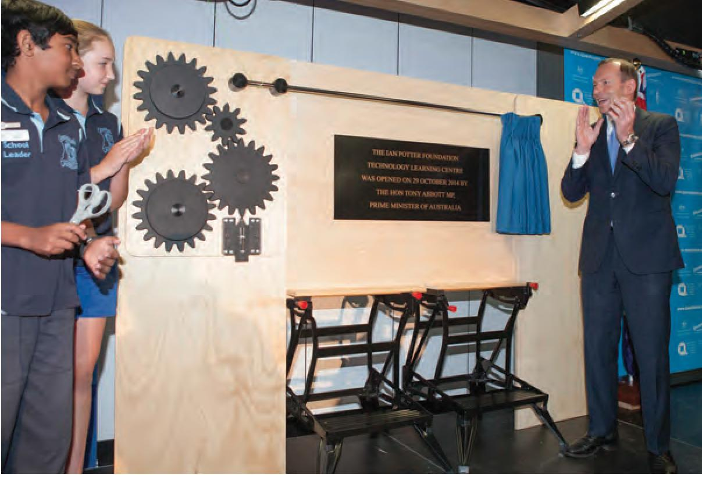
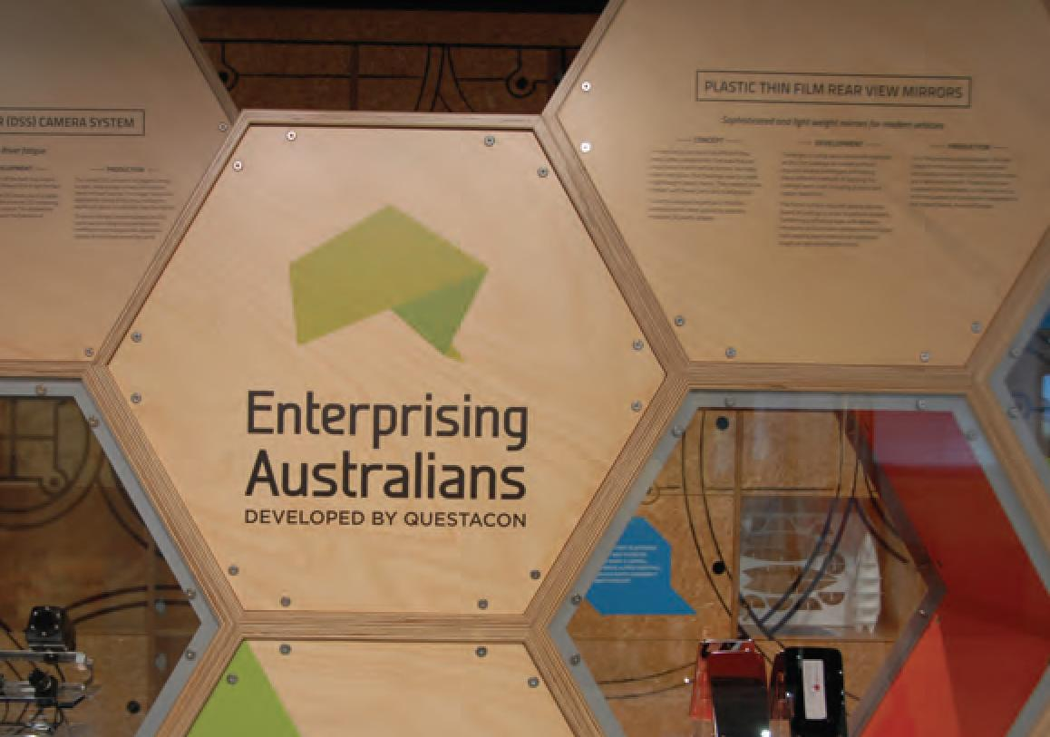
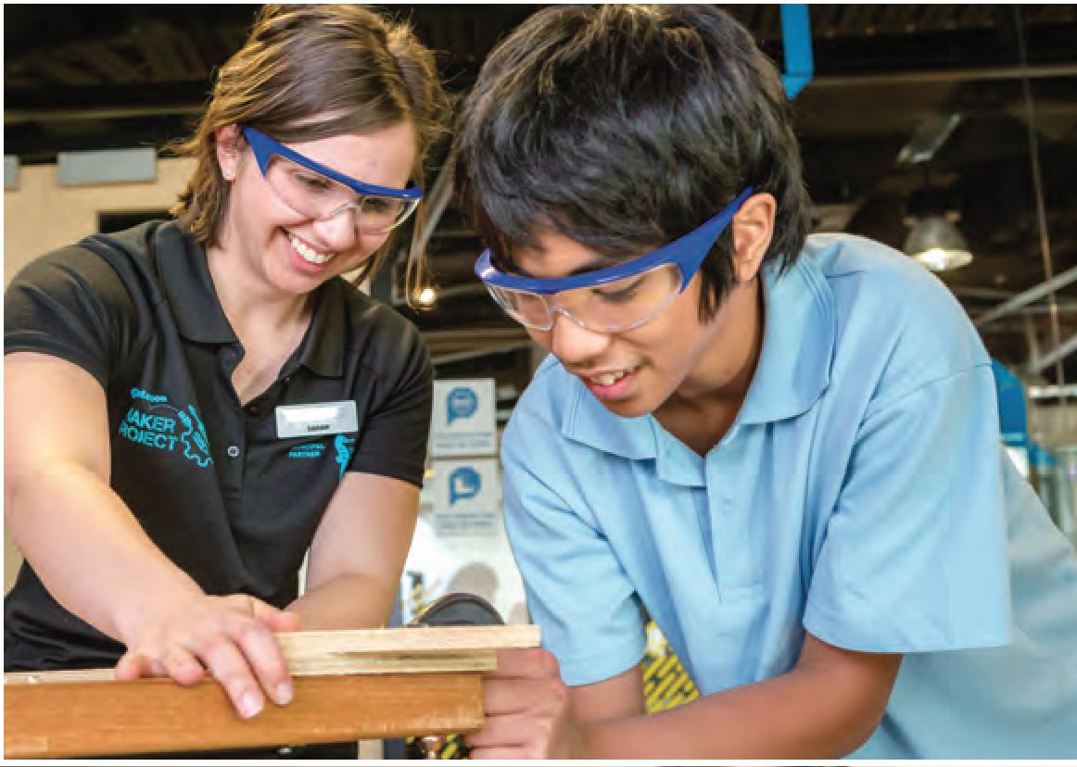
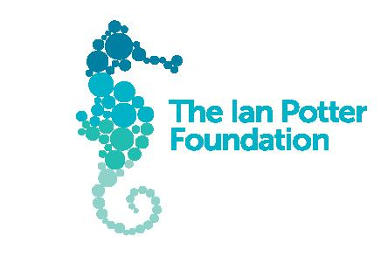
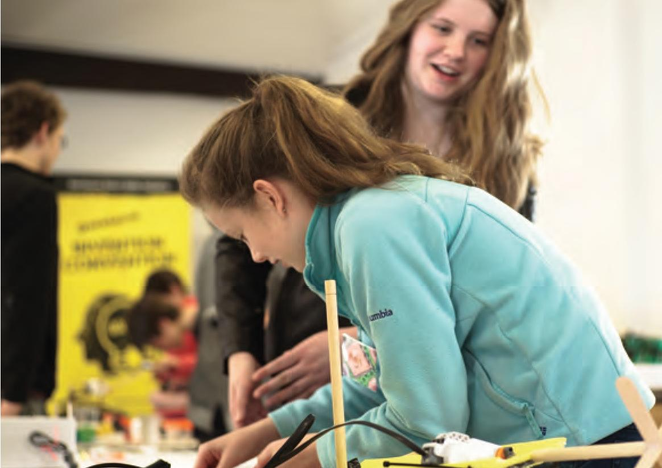

The Ian Potter Foundation
In October 2014, The Ian Potter Foundation—one of Australia's major philanthropic foundations —generously provided a grant of $7.8 million over five years to Questacon. The grant, made in the 50th anniversary year of the Foundation, is the largest awarded in the areas of science and education and the largest ever awarded outside Victoria. The grant from The Ian Potter Foundation will support Questacon's efforts to inspire and empower young people by engaging them with technology, innovation, design and entrepreneurial learning experiences.
In recognition of the generous grant from The Ian Potter Foundation, Questacon re-named the Questacon Technology Learning Centre in Deakin to The Ian Potter Foundation Technology Learning Centre (IPTLC).
The Ian Potter Foundation makes philanthropic grants to projects that contribute to a vibrant, healthy and fair Australia. The Foundation is committed to encouraging and supporting excellence and innovation in the community. The Ian Potter Foundation Technology Learning Centre and the smart skills outreach programme exemplify these principles and we are proud to have played a part in bringing these projects to fruition. These initiatives are engaging young Australians with science and technology, and encouraging enquiring minds to explore, experience and dream the ideas that might be tomorrow's reality.
—The Ian Potter Foundation

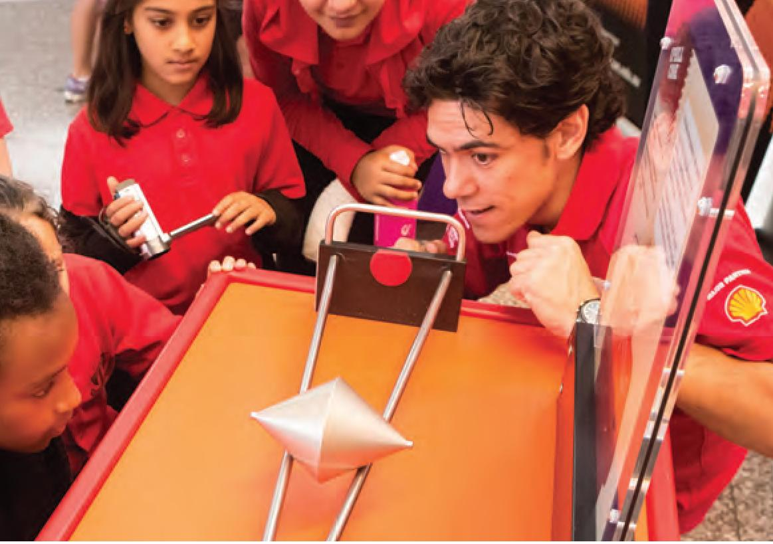
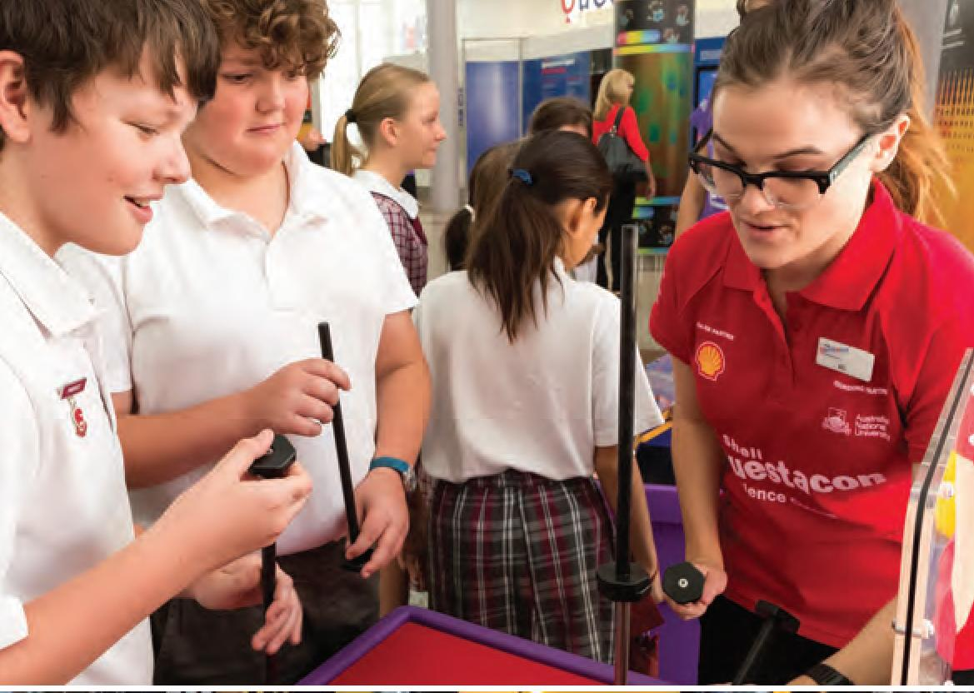
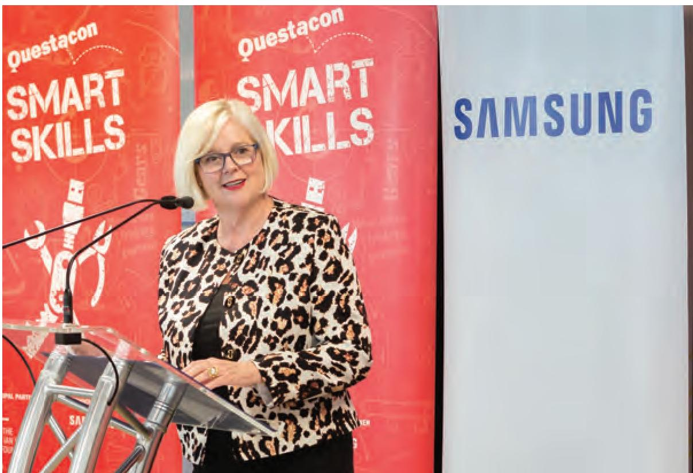
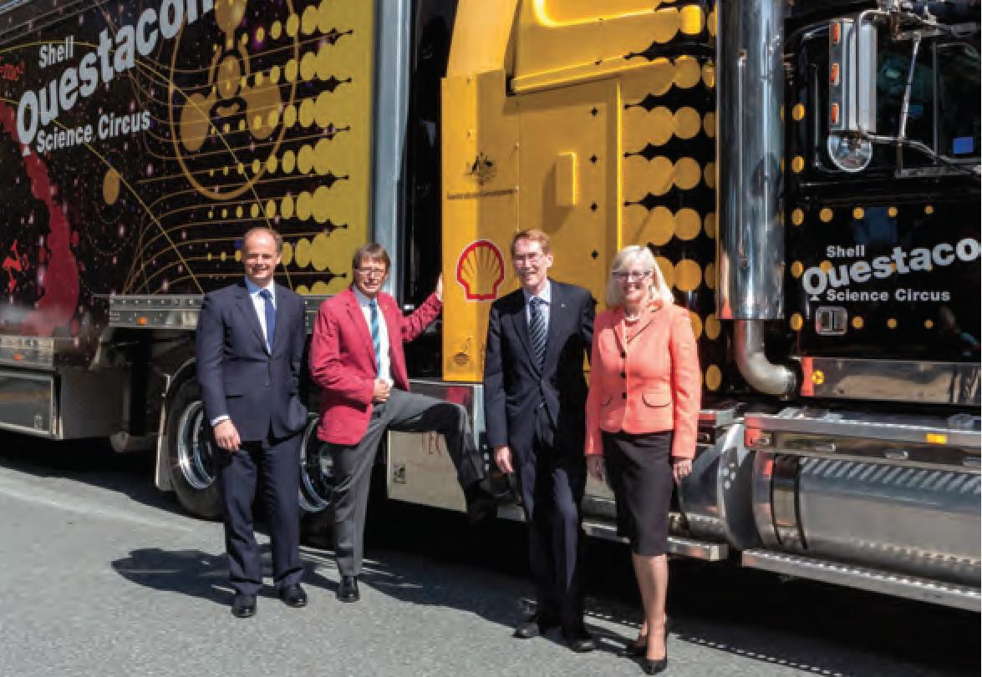

Shell Australia
In 2015, Shell renewed its long-standing sponsorship of the Shell Questacon Science Circus, extending the relationship between Shell, Questacon and ANU to a partnership of 30 years. Since beginning in 1985, the Shell Questacon Science Circus has become the most travelled and farthest-reaching programme of its kind in the world. At the core is a drive to inspire young people, primarily in regional areas of Australia, to value and engage in STEM, and the possibilities and varied career options these fields present.
The 30-year partnership has been a cornerstone of the programme's success and is an award-winning example of business, government and academia working together to deliver a programme of benefit to the community.

Australian National University
The Australian National University (ANU) is a founding partner of the Shell Questacon Science Circus. The Shell Questacon Science Circus presenting team is comprised of 16 Masters of Science Communication Outreach students who undertake their studies at the Australian National Centre for the Public Awareness of Science (CPAS). Questacon also partners with CPAS on a variety of science communication projects, including international capability development initiatives such as science circus Africa.

Samsung Electronics Australia
In 2014, Samsung Electronics Australia partnered with Questacon to support mathematics, science and innovation programmes delivered from The Ian Potter Foundation Technology Learning Centre in Canberra. In February 2015, Samsung came on board as Questacon's Technology Partner. The three-year partnership will see Samsung technology used to provide STEM-themed learning opportunities for young people via the Questacon Smart Skills in-school programme for students and Teacher workshops. Programme participants around Australia have the opportunity to learn how to harness the power of smartphones and tablets to innovate, design and experiment. As a result of this partnership, Samsung and Questacon aim to inspire and motivate the next generation of Australian technology creators and entrepreneurs.

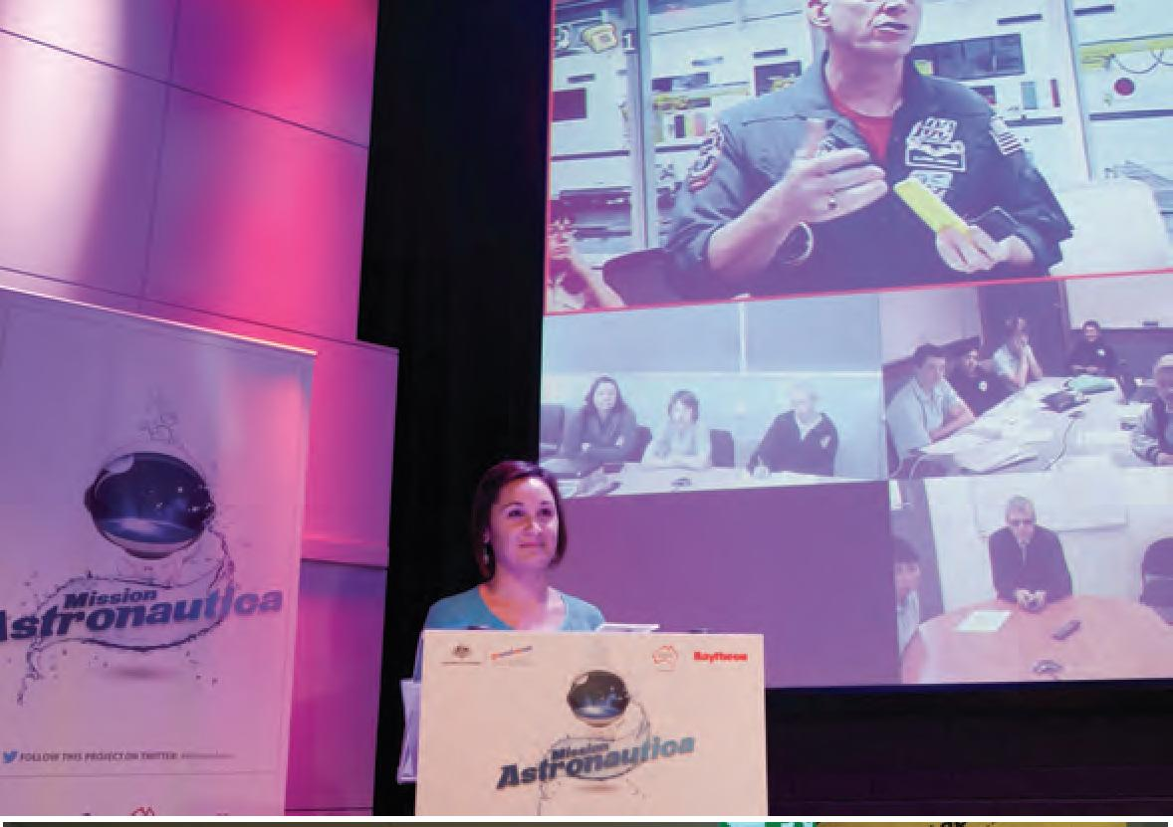
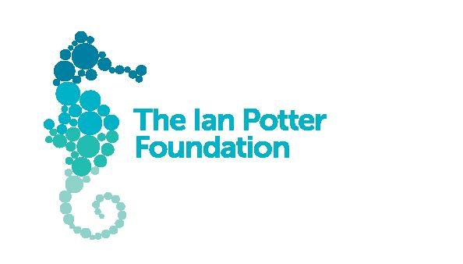

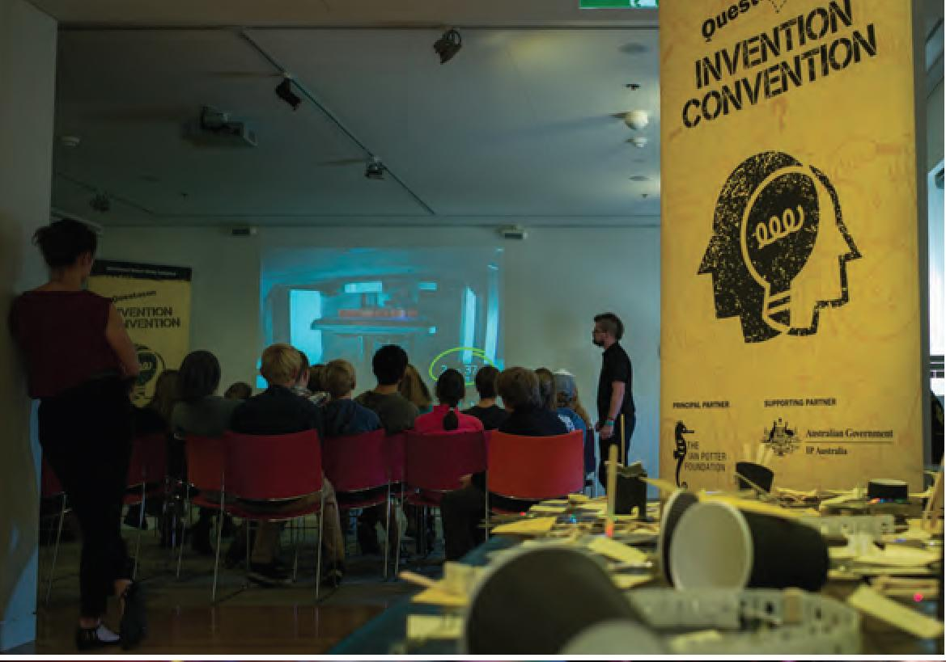



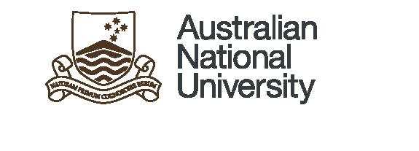
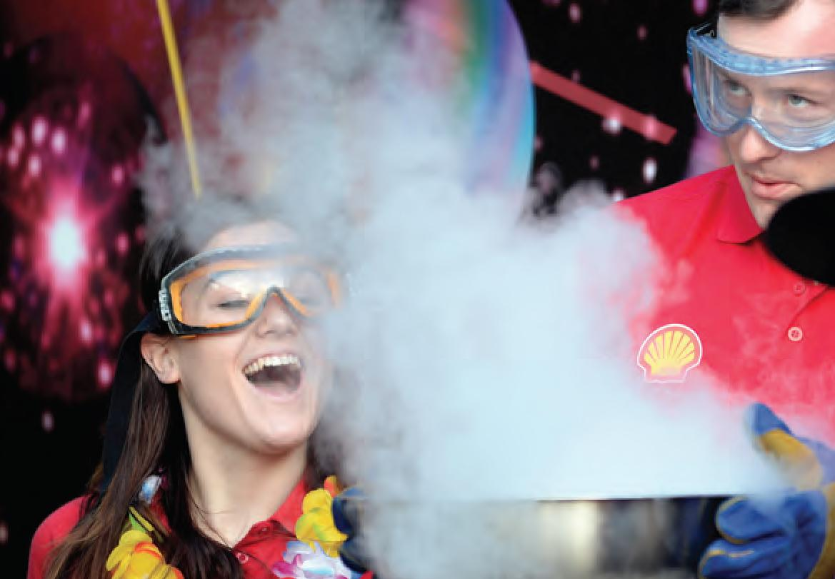



Raytheon
Following the sponsorship of Questacon's Imagination Factory—Invent and Play exhibition from 2007 to 2010, Raytheon now sponsors the Schmidt Studio and a number of virtual projects delivered via the Studio. The Schmidt Studio presents interactive and innovative STEM programmes via videoconferencing directly into classrooms across Australia. Projects such as these sponsored by Raytheon, support the vision for an Australia where the next generation of scientists and researchers is created by nurturing talent and scientific interest, and where industry and science work together to identify and respond to challenges, create and capitalise on new ideas, new products and new ways of doing things.

IP Australia
Supporting partner IP Australia and Questacon are working together to inspire young Australians and develop their confidence, creative thinking and skills, with an emphasis on active participation in the innovation process. This will be achieved through the delivery of regional Invention Conventions and an annual national Invention Convention for secondary school students. Coinciding with each regional Invention Convention, travelling modules from the Enterprising Australians exhibition will be displayed, the exhibition highlights Australian innovation and inventiveness and the importance of innovation and ideas development to Australia's prosperity.

Principal Partner

Major Partners

TECHNOLOGY PARTNER

MAJOR PARTNER

FOUNDING PARTNER

Supporting Partners

MAJOR PARTNER

MAJOR PARTNER

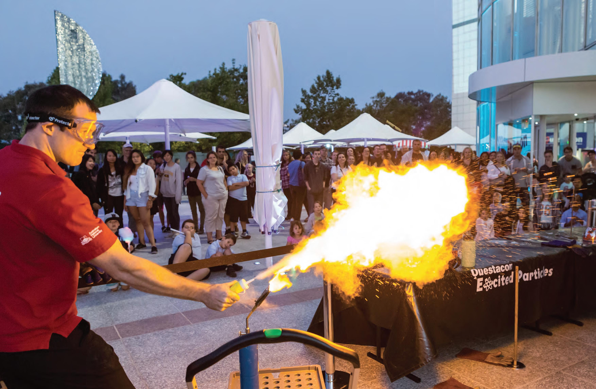

QUESTACON CANBERRA

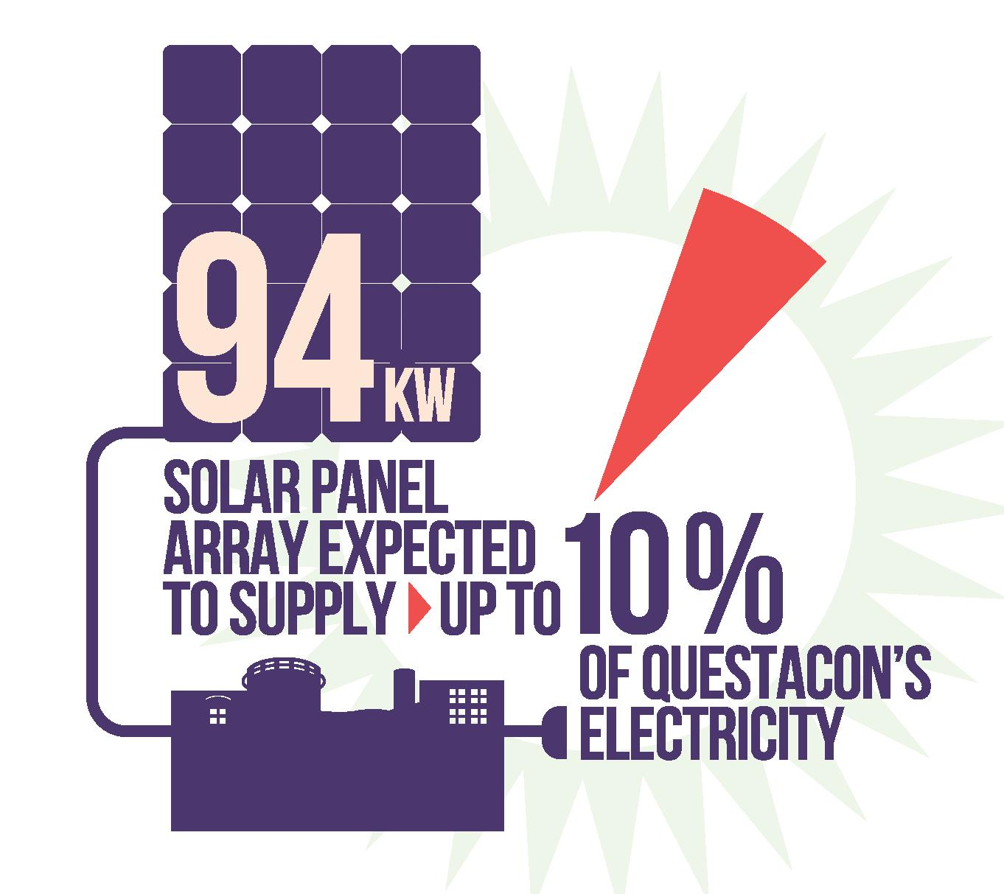

Questacon Campuses
Questacon conducts its activities from two locations: The National Science and Technology Centre in Parkes and The Ian Potter Foundation Technology Learning Centre (IPTLC) in Deakin.
As part of Questacon's ongoing building upgrade and maintenance activities, major outcomes delivered in the third and fourth quarters of 2014 and all of 2015:
- The installation of 94kW solar panel array expected to supply up to 10 per cent of Questacon's electricity usage as well as providing an opportunity to educate visitors about the operation and benefits of renewable energy technology.
- Gallery restroom upgrades which have increased baby change facilities and the number of accessible toilets within the Parkes centre.
- Improvements to lighting controls and additional LED lighting capabilities for the Rear Science Court.
- Renewal of Questacon's Environmental Management System (EMS) accreditation to international standard ISO 14001:2004.

The National Science and Technology Centre

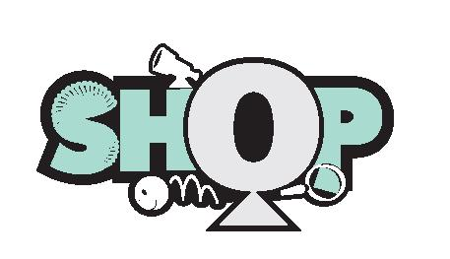
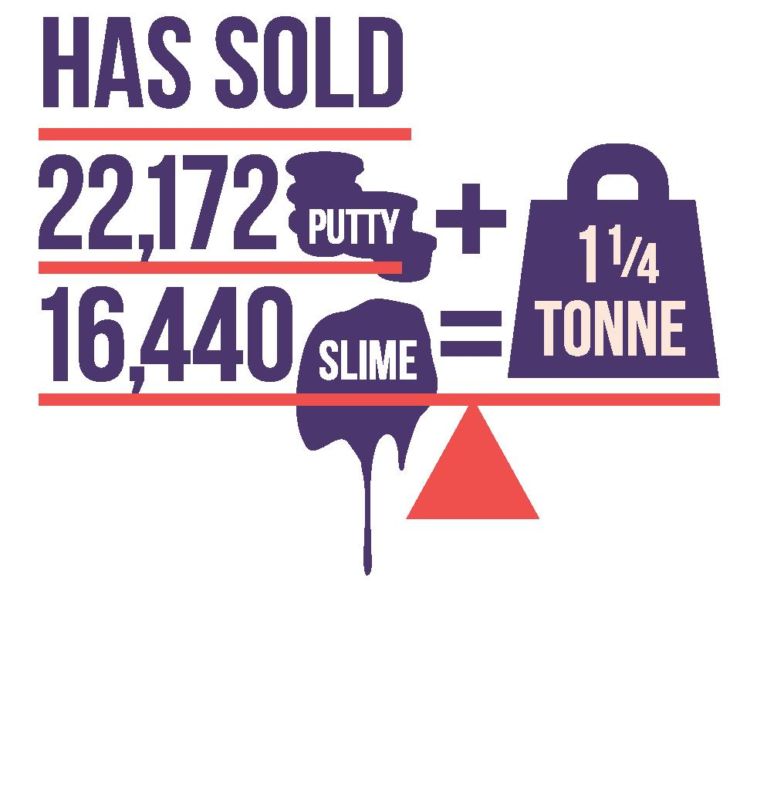
The National Science and Technology Centre was jointly funded by Australia and Japan and officially opened on 23 November 1988. The total floor space within the building is approximately 11700 square metres which includes approximately 6000 square metres of public exhibition space.
The centre is proud to offer over 200 hands-on exhibits in eight interactive galleries, allowing visitors to feel the force of an earthquake, let lightning spark their imagination, and feel adrenalin pumping as they "free fall" down a 6.7 metre slide. The centre caters for its youngest visitors with Mini Q, a custom-built environment where little scientists explore the different zones through observation, prediction, testing and refining.
Admission to the centre includes our spectacular science shows, presented by our very own science theatre troupe, the Excited Particles. Science shows cover a variety of topics such as the science of dinosaurs to household-item rockets. These shows are suitable for all ages and specific shows can be requested by school groups to best suit the topic they are currently studying.
The highly favoured Q Shop is located in the Questacon foyer and as of this year is also available online. The Q Shop hosts an extensive range of educational science-themed books, toys, gifts and souvenirs.
Also located in the Questacon foyer is the Mega Bites Café, with seating available in the Questacon foyer and the sunny outdoor science court.
Questacon hosted a number of programmes through the centre, including:
- The Q2U programme which sees Questacon Excited Particles visit schools to engage and inspire students through fascinating science shows and exciting demonstrations and experiments.
- Little scientists aged 3-6 can attend Science Time sessions held during school term to learn through reading, playing and experimenting.
- The monthly Torque seminar series provides visitors the opportunity to meet local artists, engineers, designers, scientists and general creative types to discuss their work, hobbies, and creative processes.
- Our Q by Night programme is open to all schools offering an exclusive tour of the centre after hours.
Themed SciNights throughout the year offer an adults-only audience the unique experience of exploring Questacon's hands-on exhibits, participating in activities, meeting special guests and observing demonstrations without the presence of children.

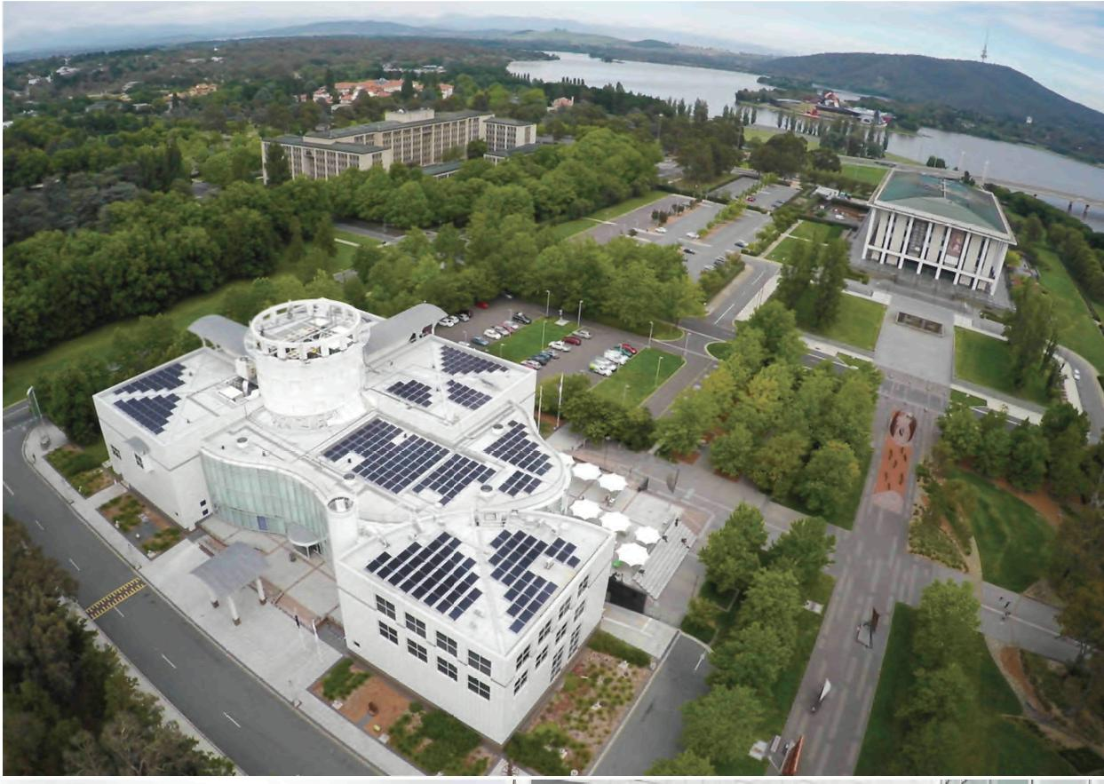
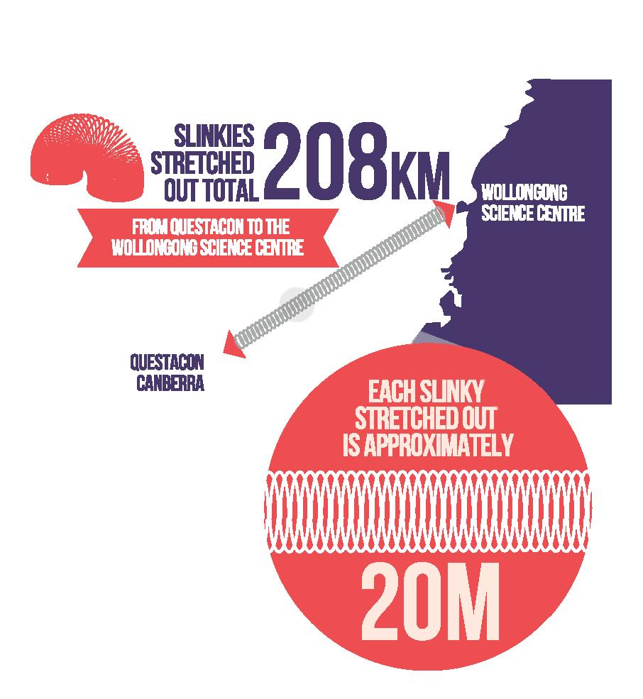
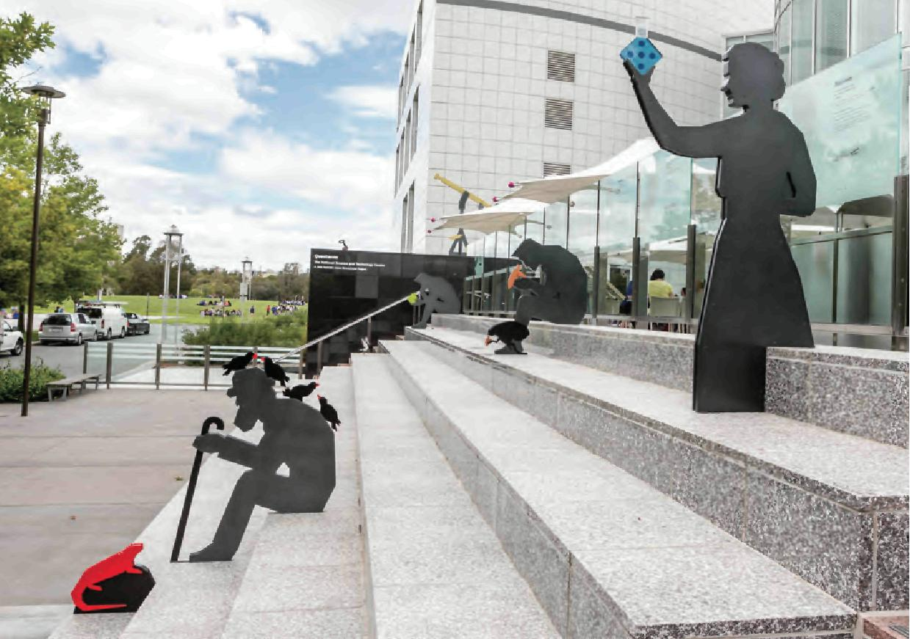

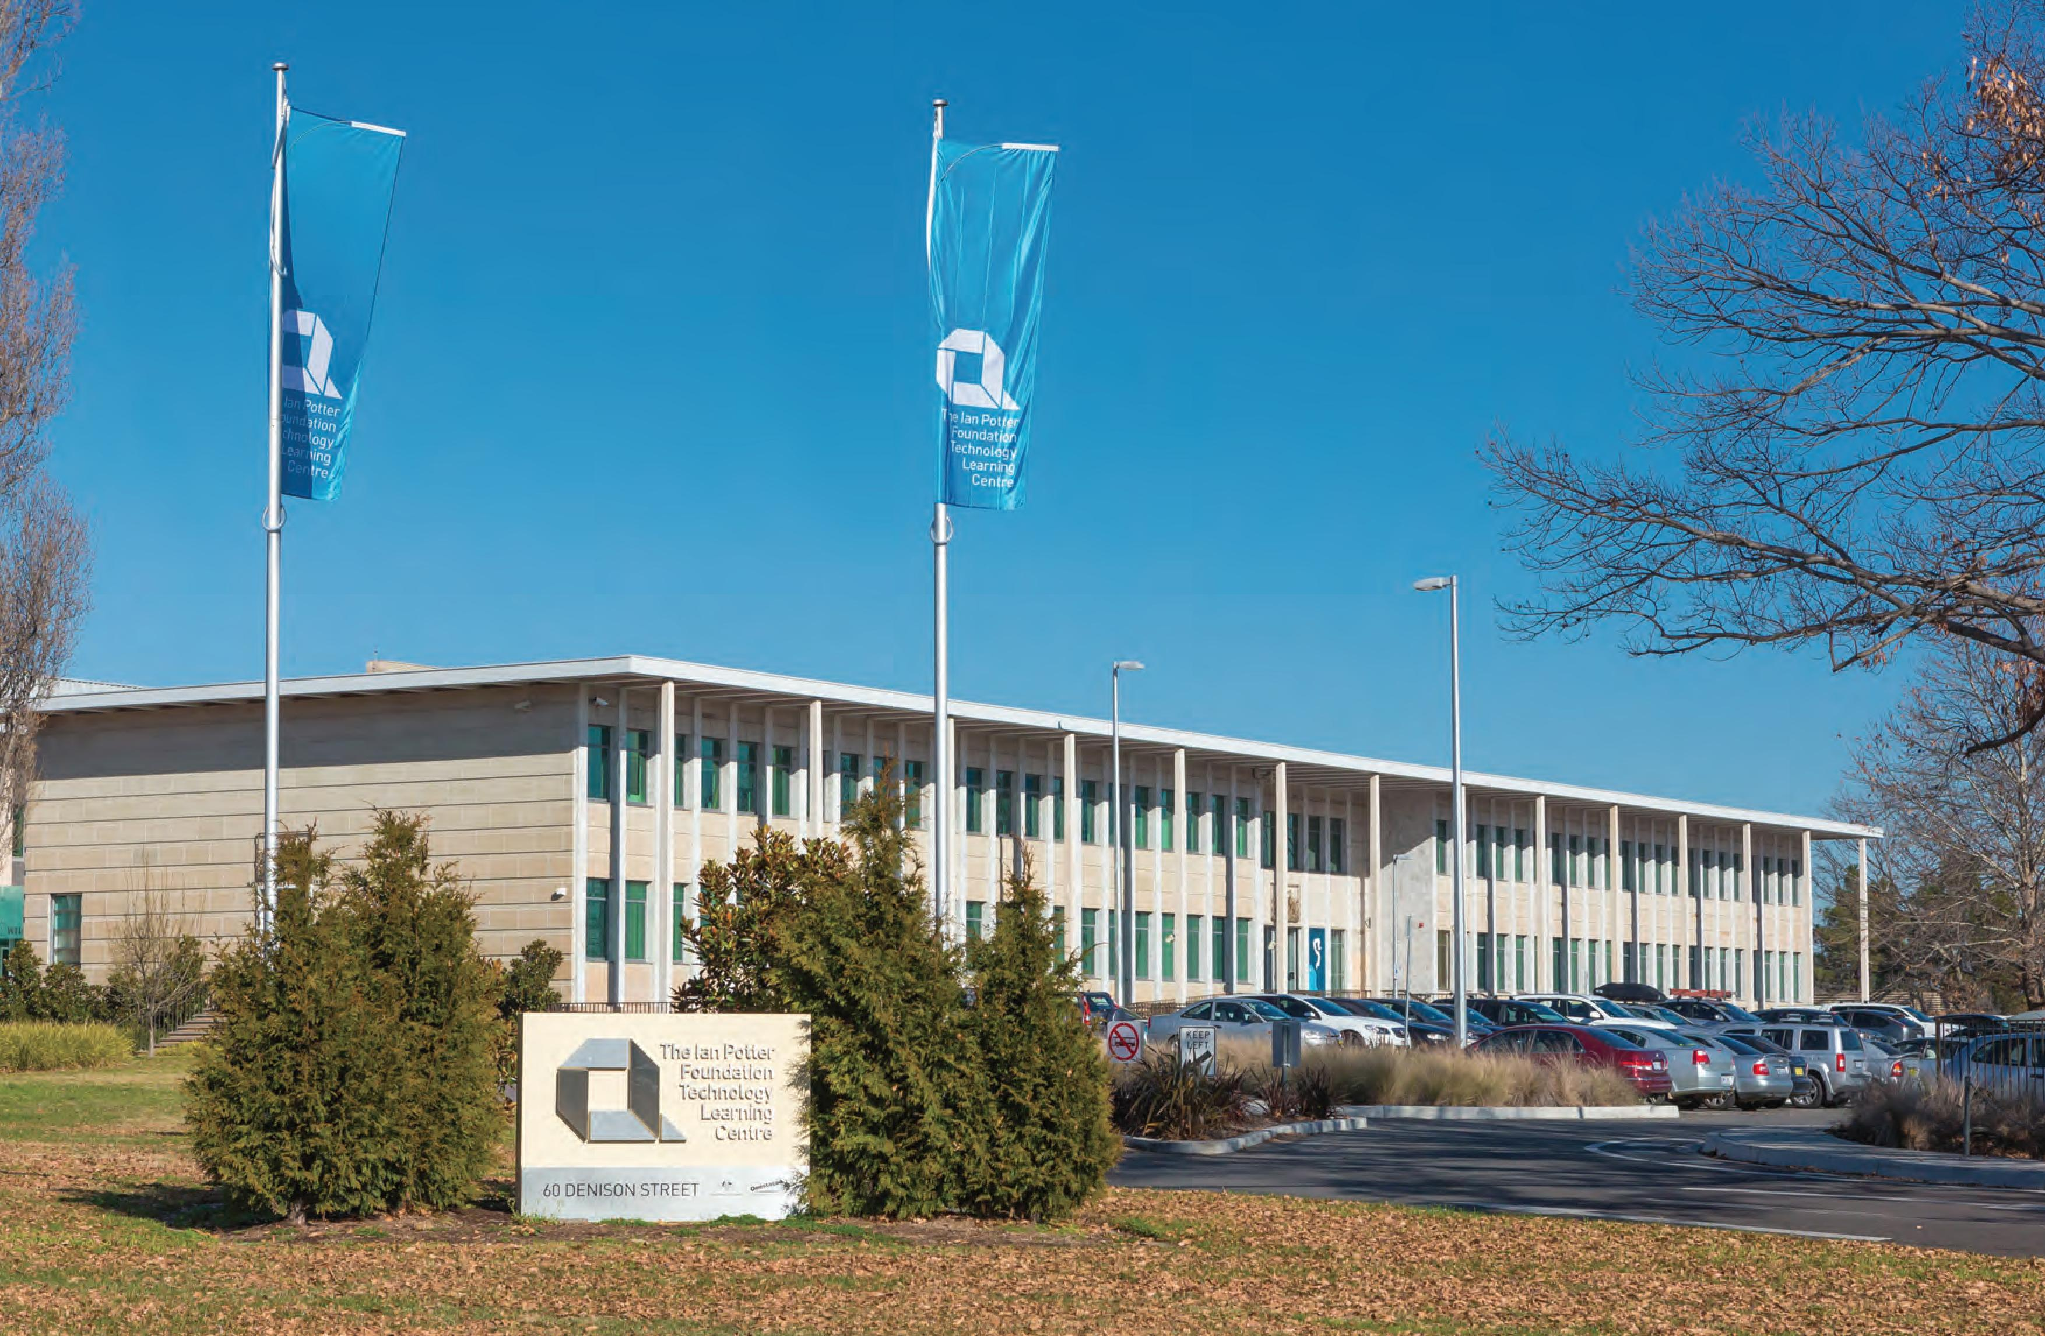

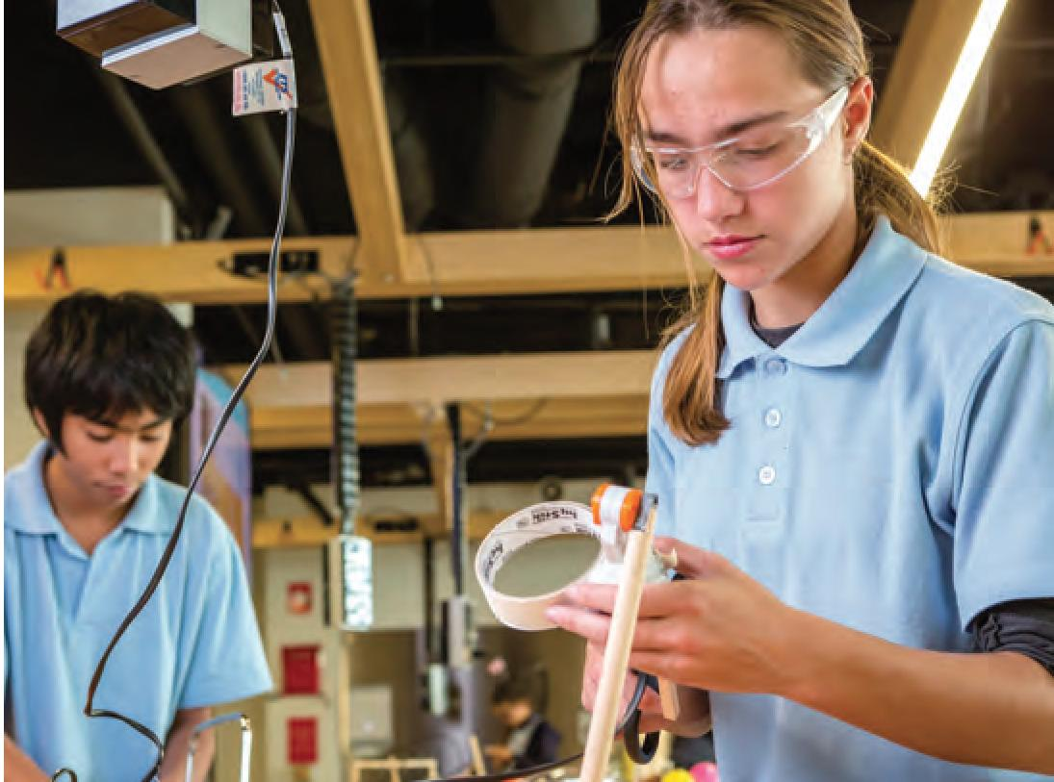
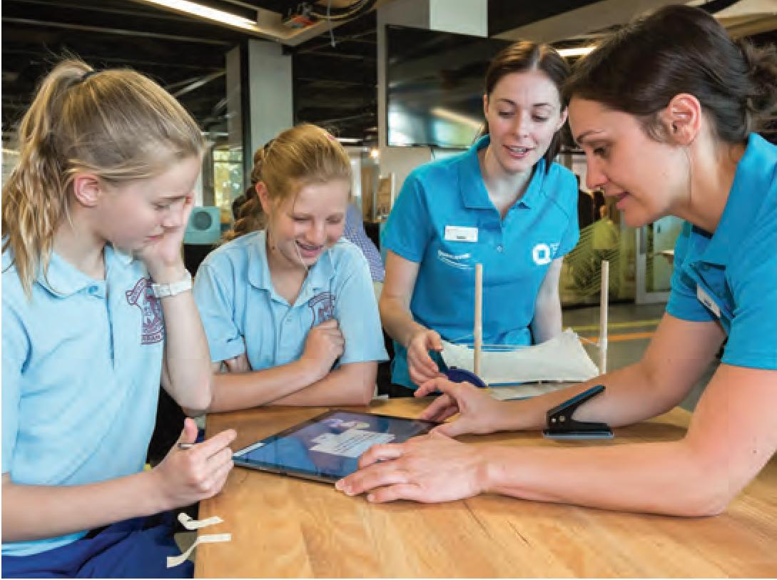
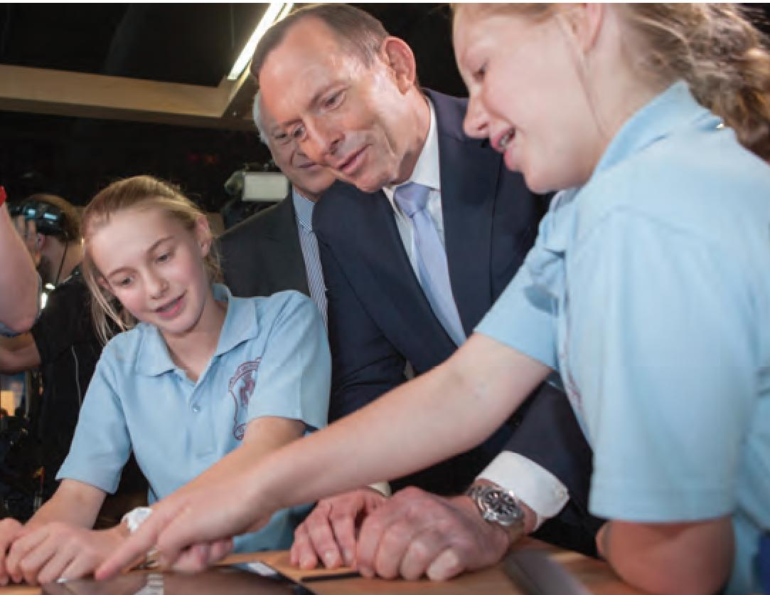

The Ian Potter Foundation Technology Learning Centre

Knowledge, skill and know-how complemented by partnerships, this is what is at the heart of The Ian Potter Foundation Technology Learning Centre (IPTLC), a facility that uses Questacon's expertise to energise technology learning across Australia and to encourage young Australians to think about opportunities in new manufacturing, brains and hands working together. We are confident that through this facility we make a difference, that in partnership with others we change lives.
The IPTLC is located in one of the ACT's historic buildings, the original Royal Australian Mint. The building was originally created to manufacture Australia's first decimal coinage, this re-purposing is symbolic of the need for our nation to change and adapt.
The IPTLC is the hub for the Questacon Smart Skills initiative, giving students across Australia, particularly in disadvantaged regions, a greater appreciation of the processes and skills involved in developing ideas and solutions to problems and refining them into useful products and processes.
The IPTLC also offers a range of onsite interactive experiences for students and the public to engage with technology and innovation.Activities are designed around a central theme: innovation fostering an interest and awareness of how things are made and how societal need drives the process of cutting-edge innovation.
The IPTLC helps strengthen the supply chain of young innovators and skilled technologists.It helps students learn to design, create, and have a go at solving problems.They also learn about making things, testing and refining them through our various workshop activities.
There is no doubt that the young visitors to this facility and those who experience the programmes will be the problem-solvers, knowledge generators, innovators and business leaders of the future.

'The best thing was probably being able to build stuff. It was good because it challenged me to think outside the box.'
—Student, Smart Skills in-school programme
'Students continue to talk about the workshop (on Monday) right until the end of the week.'
—Teacher

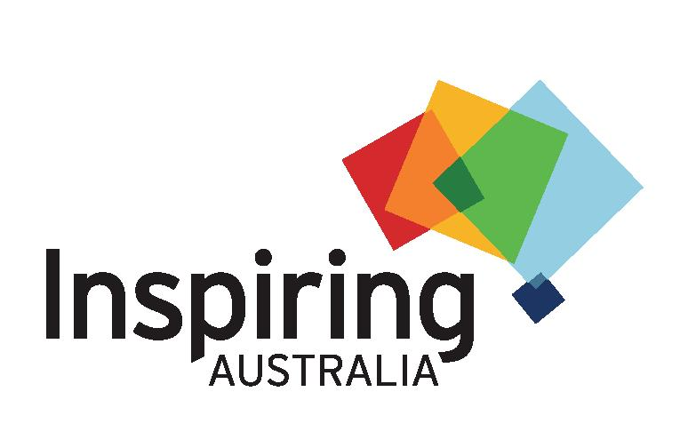
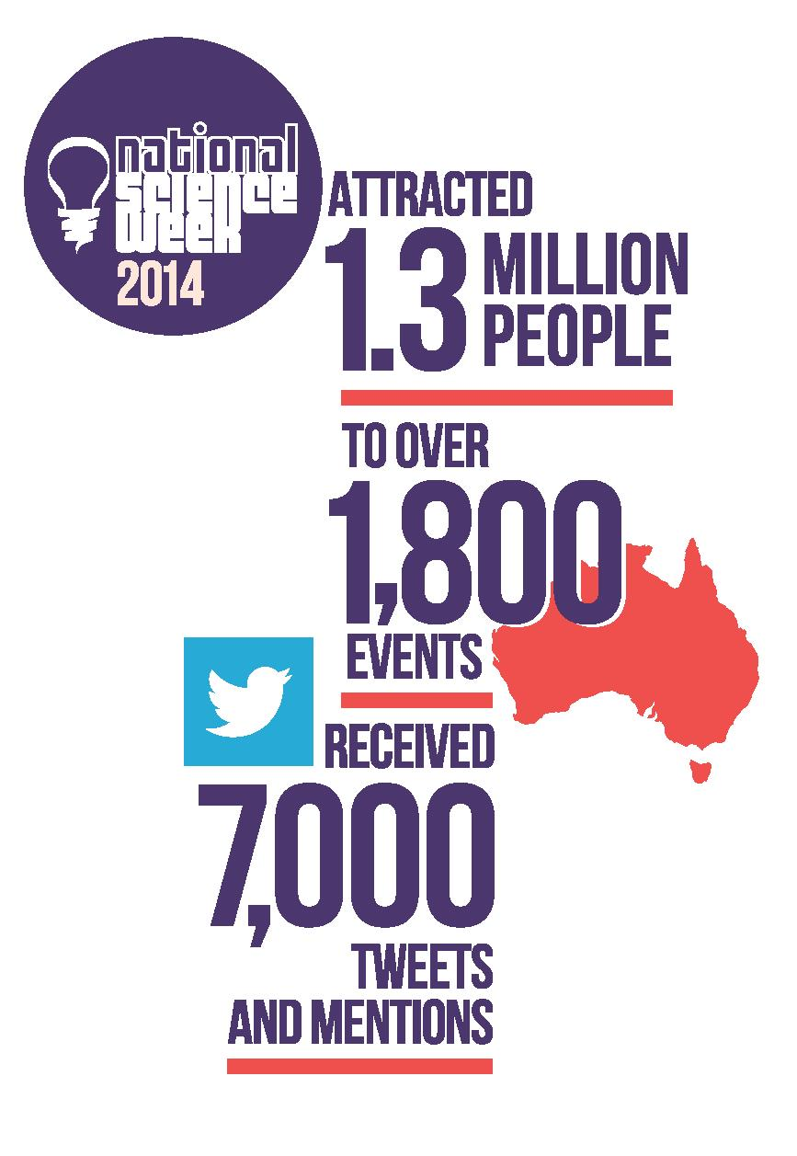

SCIENCE FOR AUSTRALIA'S FUTURE

Inspiring Australia
Questacon received $28.1 million over four years from July 2014, under the Government's Science for Australia's Future initiative. This funding builds upon and extends the Australian Government's contribution towards the delivery of the Inspiring Australia programme through to 2017-18. It also works towards enhancing STEM engagement from youth to senior decision makers and provides a nationally coordinated approach to the delivery of science engagement activities throughout Australia.

The funding supports:
- The continuation of the Prime Minister's Prizes for Science, including the introduction of a new Prime Minister's Prize for the Commercialisation of Science.
- Continuation of National Science Week, including some additional funding to increase participation to 10 percent of the Australian population.
- 2014 was a huge success as was 2015 which registered 1722 events, 148 of 150 electorates in Australia held events and there were 4356 media stories communicated reaching an audience of 36.6 million!
- Questacon education and engagement activities.
- Smart Skills
- Equity of access
- Citizen Science capability building, including projects supporting the establishment of the Australian Citizen Science Association, which has strong museum involvement in its leadership (including Australian Museum, Queensland Museum).

- Development of a model for community-based Science Clubs.
- State and territory partnerships in science engagement.
- Significant development was made this year on new initiatives in the areas of citizen science, science clubs and other national programmes, strategically targeting audiences to broaden STEM engagement opportunities. An Inspiring Australia summit was held in June 2015, the summit was attended by State and Territory Inspiring Australia managers, the Science Sector Group, the State and Territory Officers Working Group, the Commonwealth Officers Working Group, and other key partners from each state and territory.



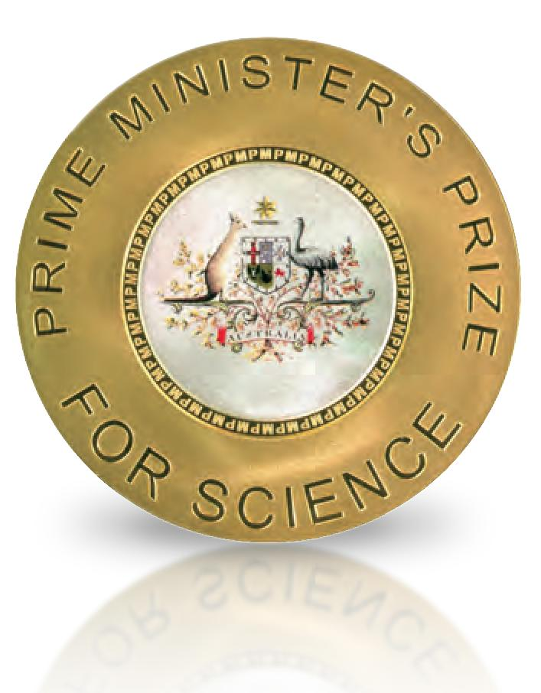

The Prime Minister's Prizes for Science 2014 and 2015

In 2015 the contribution of science to the economy was explicitly recognised with a new prize - The Prime Minister's Prize for Innovation. The new Prize highlights the importance the Government places on efforts to transform the Australian economy through the translation of research into commercial outcomes. The Prize is equal in status to The Prime Minister's Prize for Science and includes a solid gold medallion and $250 000 prize money.
Professor Ian Chubb AO, whose tenure as Chief Scientist for Australia finishes in December 2015, received a standing ovation at the 2015 awards dinner.
Details of prize recipients are at: www.science.gov.au/pmscienceprizes
Note: Because this review captures the end of 2014
and all of 2015 we have included the 2014 prize recipients
along with the 2015 winners.
2014 Prize Recipients
Professors Sam Berkovic and Ingrid Scheffer
Prime Minister's Prize for Science
Professor Ryan Lister
Frank Fenner Prize for Life Scientist of the Year
Dr Matthew Hill
Malcolm Mclntosh Prize for Physical Scientist of the Year
Mr Geoff McNamara
Prime Minister's Prize for Excellence in Science Teaching in Secondary Schools
Mr Brian Schiller
Prime Minister's Prize for Excellence in Science Teaching in Primary Schools
2015 Prize Recipients
Professor Graham Farquhar
Prime Minister's Prize for Science
Laureate Professor Graeme Jameson
Prime Minister's Prize for Innovation
Associate Cyrille Boyer
Malcolm Mclntosh Prize for Physical Scientist of the Year
Dr Jane Elith
Frank Fenner Prize for Life Scientist of the Year
Dr Ken Silburn
Prime Minister's Prize for Excellence in Science Teaching in Secondary Schools
Ms Rebecca Johnson
Prime Minister's Prize for Excellence in Science Teaching in Primary Schools

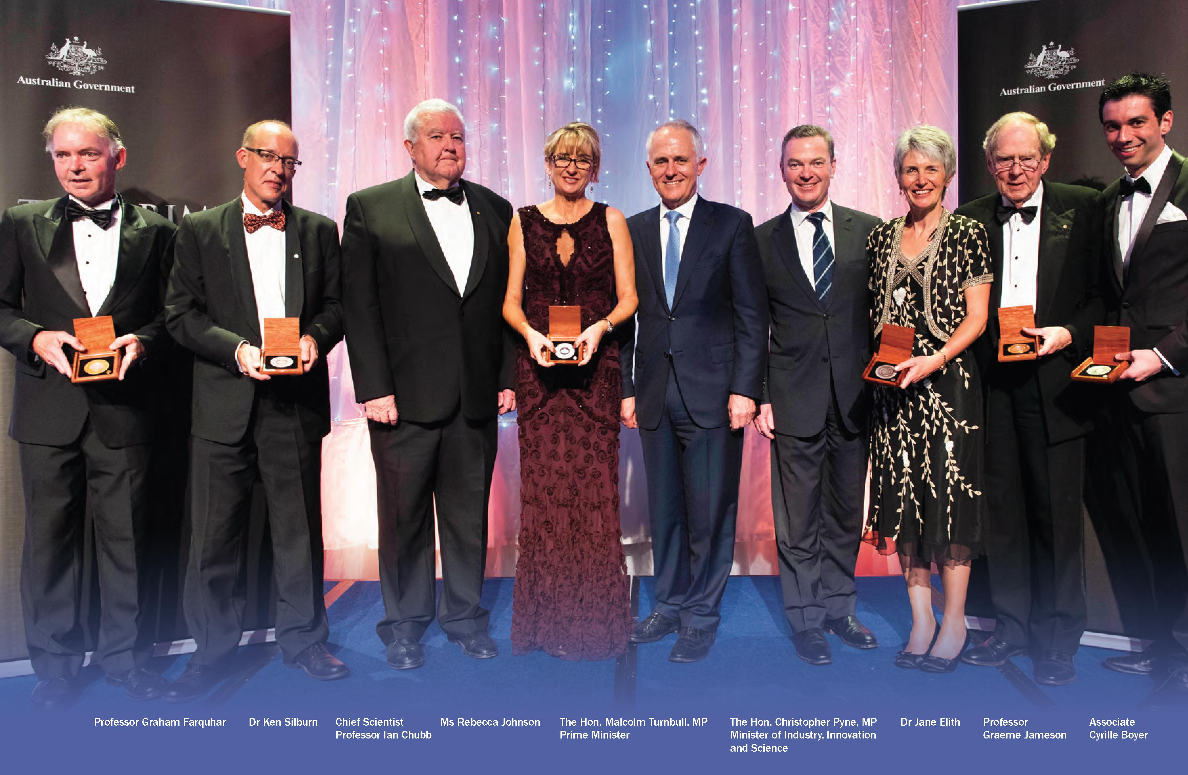

NATIONAL PROGRAMMES

Shell Questacon Science Circus - Celebrating 30 Years

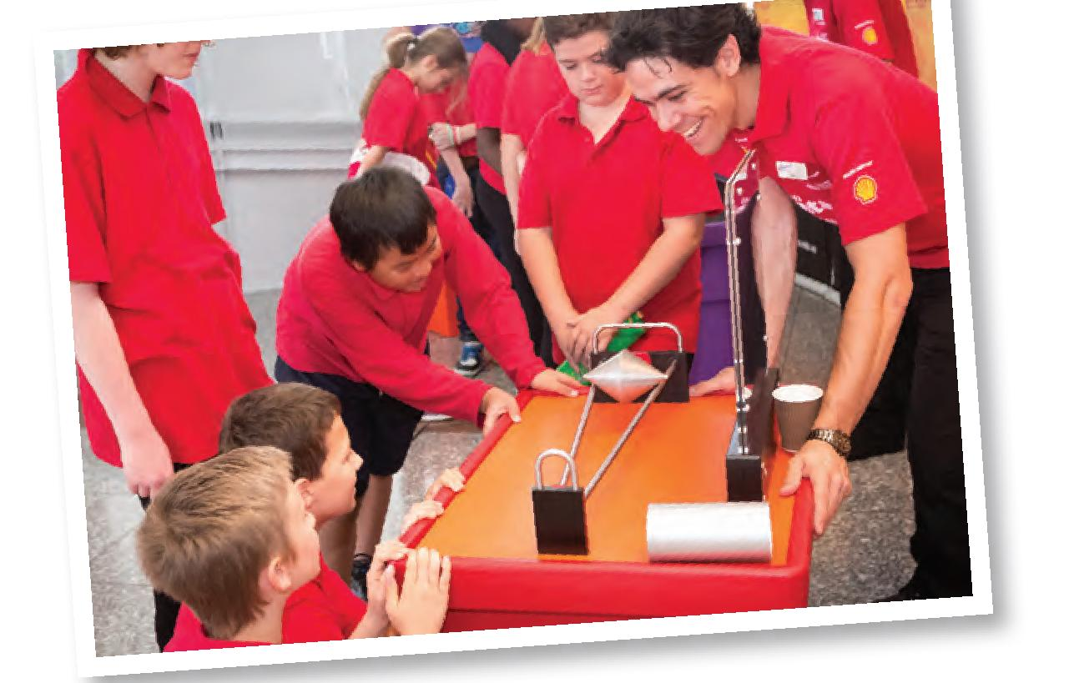
In 2015 the Shell Questacon Science Circus celebrates its 30th year as Australia's flagship science centre outreach programme. It all began in 1985 when ANU Adjunct Professor Mike Gore took a version of the original Questacon on the road to Goulburn. He led a team of ten enthusiastic ANU students with a taxi truck filled with exhibits and props performing a handful of science shows. The science circus has since become the most travelled and farthest-reaching programme of its kind in the world with many countries basing science outreach programmes on the science circus model.
From the very beginning Shell has supported the science circus as principal sponsor and this award winning partnership between Questacon, ANU and Shell has lasted 30 years—a remarkable and rare achievement.

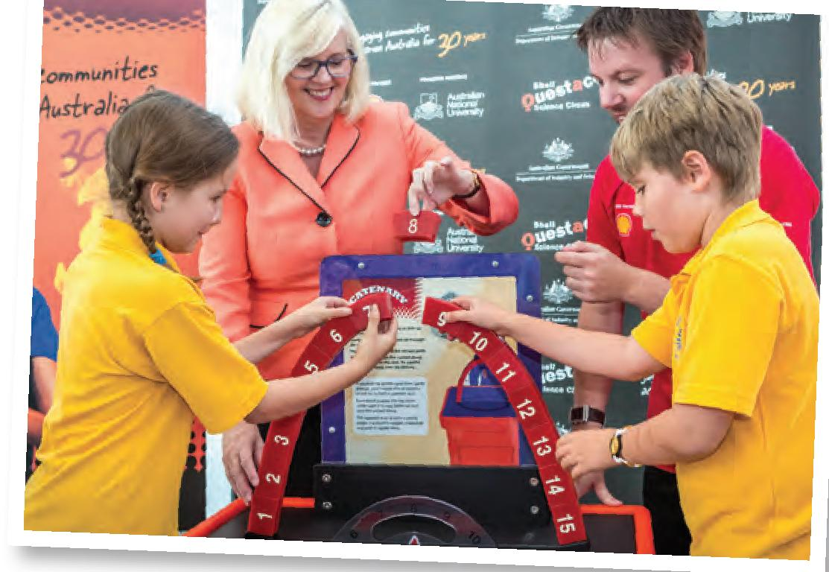
Over two million people have experienced, in their own communities, the science circus' special blend of in-school science shows, public exhibitions of around 50 exhibits and in-school workshop activities for students and teachers.
The science circus inspires young people, primarily in regional areas of Australia, to value and engage in science, technology and maths, and to see the possibilities and varied career options they present. Bubbles, explosions, liquid nitrogen and beds of nails have all been a part of enticing people young and old to see the world differently, to appreciate the art of asking questions, to wonder how the world works and to understand that science is important.

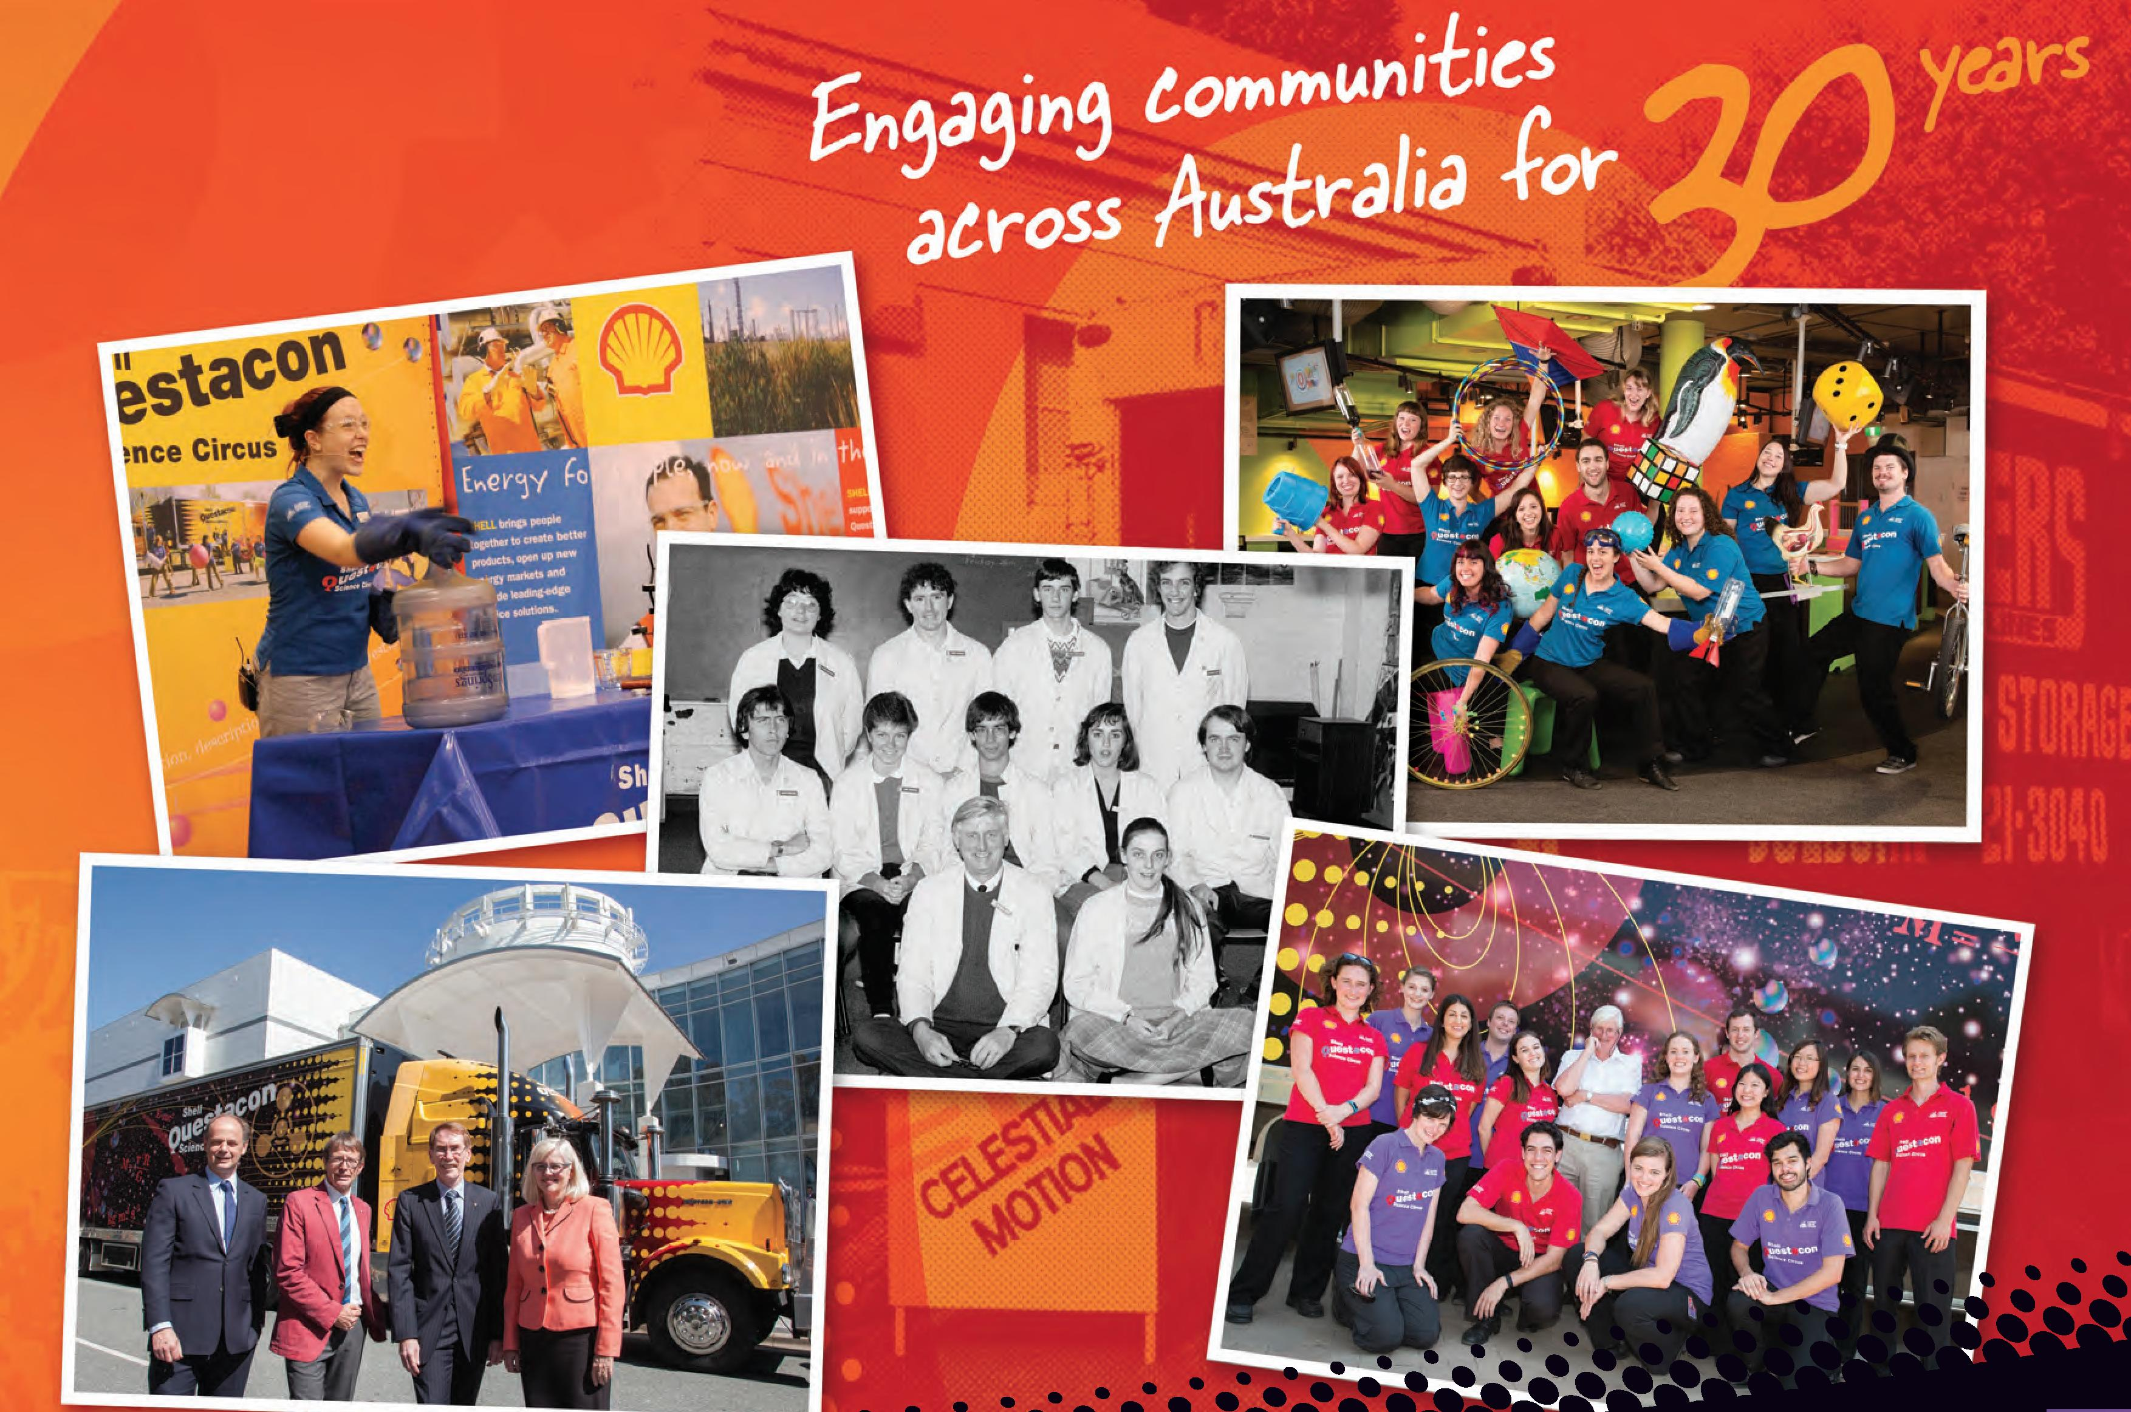
asdfasdfasdfasdfasdfddd
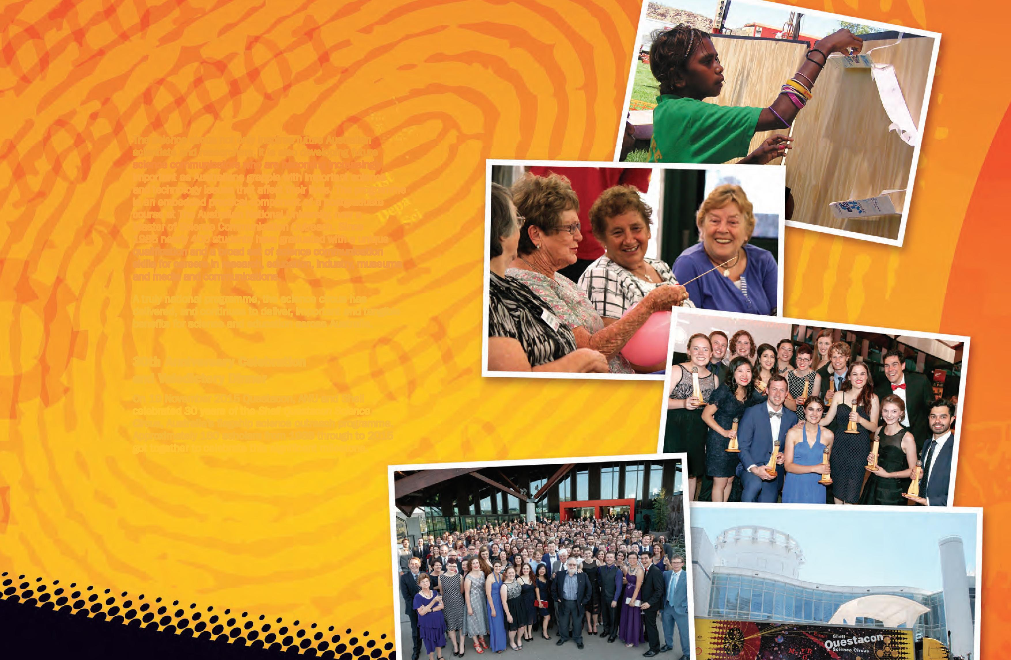
The science circus not only inspires future Australian scientists and researchers, it is also developing future science communicators who are becoming increasingly important as Australians grapple with important science and technology issues that affect their lives. The programme is an embedded practical component of a postgraduate course at The Australian National University, now a Master of Science Communication Outreach. Since 1985 nearly 400 students have graduated with a unique qualification and a broad set of science communication skills for careers in research, education, industry, museums and media and communications.
A truly national programme, the science circus has delivered, and continues to deliver, important and tangible benefits for science and education across Australia.
30th Anniversary Celebration and Valedictory Dinner
On 19 November 2015 Questacon, ANU and Shell celebrated 30 years of the Shell Questacon Science Circus, Australia's flagship science outreach programme. Approximately 160 scholars from 1988 through to 2015 got together to celebrate this significant milestone.
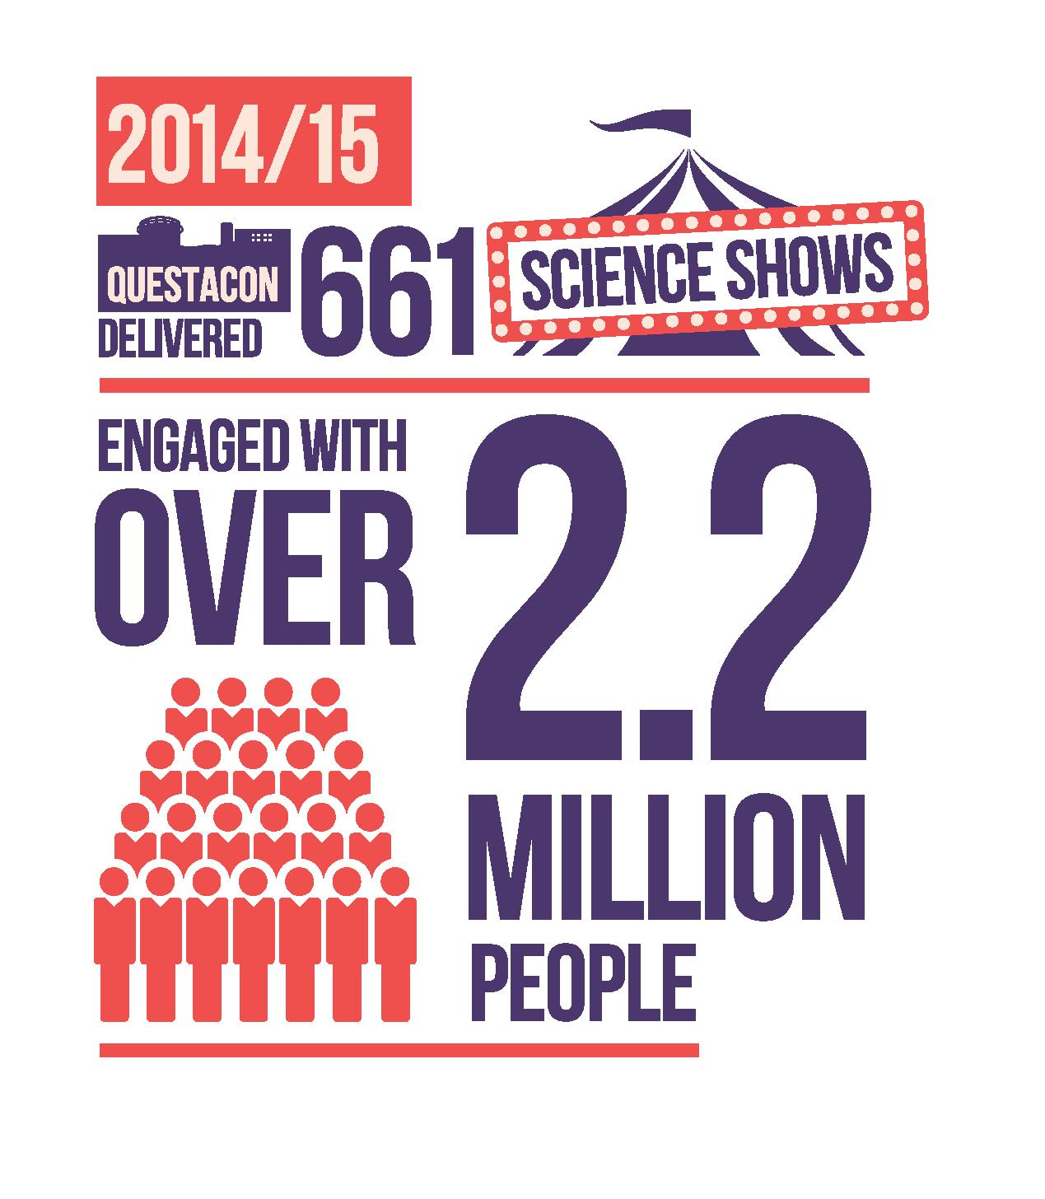

Key Statistics (1985-2015)
Since 1985 the science circus has:
- Travelled hundreds of thousands of kilometres to over 500 towns and communities multiple times including over 90 remote communities.
- Performed over 15 000 science shows in schools with 85 per cent of teachers reporting an increase in their students' enthusiasm for science.
- Encouraged and inspired over 5000 teachers in professional development workshops.
- In 2015 recorded the largest single day public exhibition attendance with 3341 people in Tamworth.
- Produced nearly 400 postgraduates in science communication.
- Formed numerous local partnerships with regional and community based organisations.
- Achieved international best practice recognition with many countries basing science outreach on the science circus model.
- Won multiple awards in education, public programmes and partnership development including a top 20 finalist in the Fundacion Telefonica Challenge.

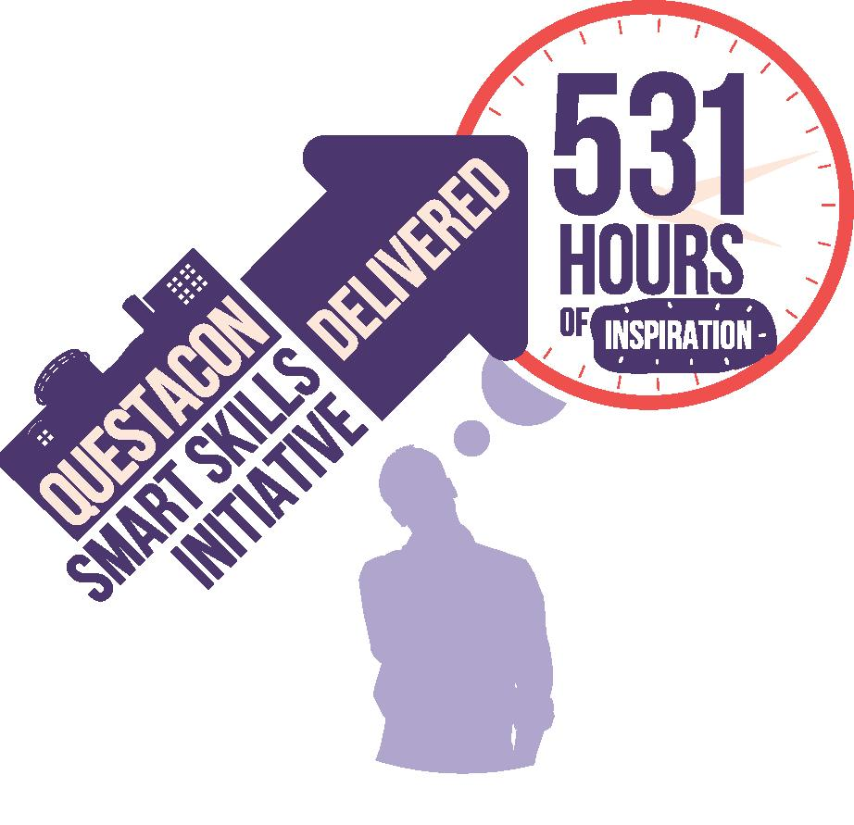

Questacon Smart Skills Initiative

Commencing in 2015 the Questacon Smart Skills initiative is a new STEM focused outreach education programme made possible through the philanthropy of The Ian Potter Foundation, funding from the Australian Government and support from Samsung and IP Australia. The initiative delivers in-school workshops, accredited teacher professional learning and youth focused enterprise education activities across Australia, particularly regional and remote communities. The programme engages with, and encourages, participants to see how STEM fits into their lives and highlights opportunities for further study and careers in STEM fields.
In 2015 the Questacon Smart Skills initiative delivered activities in the ACT, New South Wales, Tasmania and Victoria. Integral to the project is the involvement of partners to achieve the outcomes of the different activities. These partnerships involve education, business, government and philanthropy to strengthen the outcomes and to create networks that will ensure that aspects of the program continue after each completed tour.
In Tasmania the Questacon Invention Convention, a three day intensive enterprise education workshop, was delivered in cooperation with the Tasmanian Museum and Art Gallery (TMAG), University of Tasmania, CSIRO, local entrepreneurs and IP Australia. TMAG identified the need for a program that would engage children aged 14-18 during school holidays, a great success story to the initiative is the lasting legacy as TMAG have subsequently included aspects of the Invention Convention into their ongoing holiday programmes.
The Smart Skills initiative in-school workshops combine high-tech equipment in conjunction with hands-on design activities. With the addition of our Technology Partner Samsung the programme is able
to take innovative technology into schools. There is significant reward in showing students the capabilities of equipment they may see everyday but have not considered using for anything other than media consumption. Combining the technology with actual making using common materials, the program engages students through multiple pathways that can then be easily replicated by teachers. Teachers who take part in the associated professional learning can then extend these ideas with new content and are given the tools to explore new ways to bring STEM into their classroom.
In 2016 the Smart Skills initiative will expand further with the first national Invention Convention to be held in Canberra in January and will involve students from across the country. Smaller agile tours will be implemented to take the in-school workshops and teacher professional learning to smaller remote communities inspiring students to consider STEM careers no matter their location.
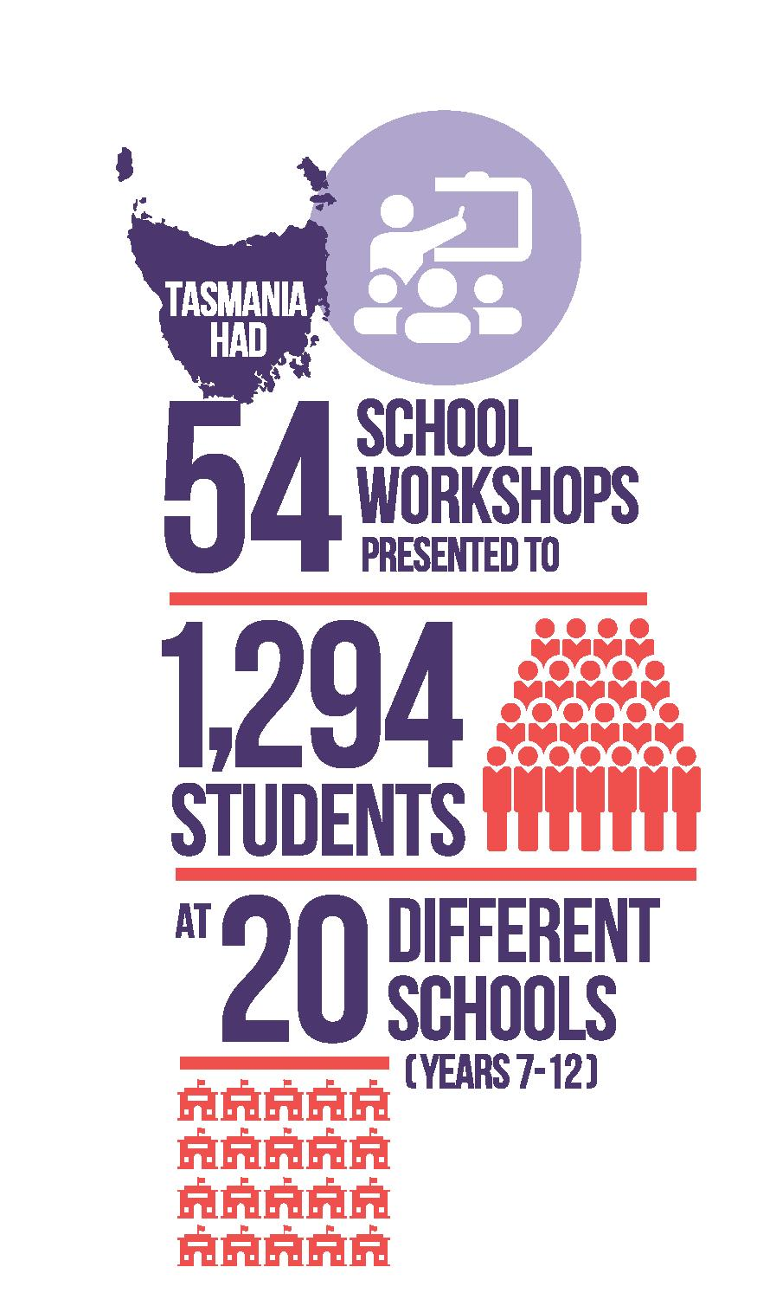
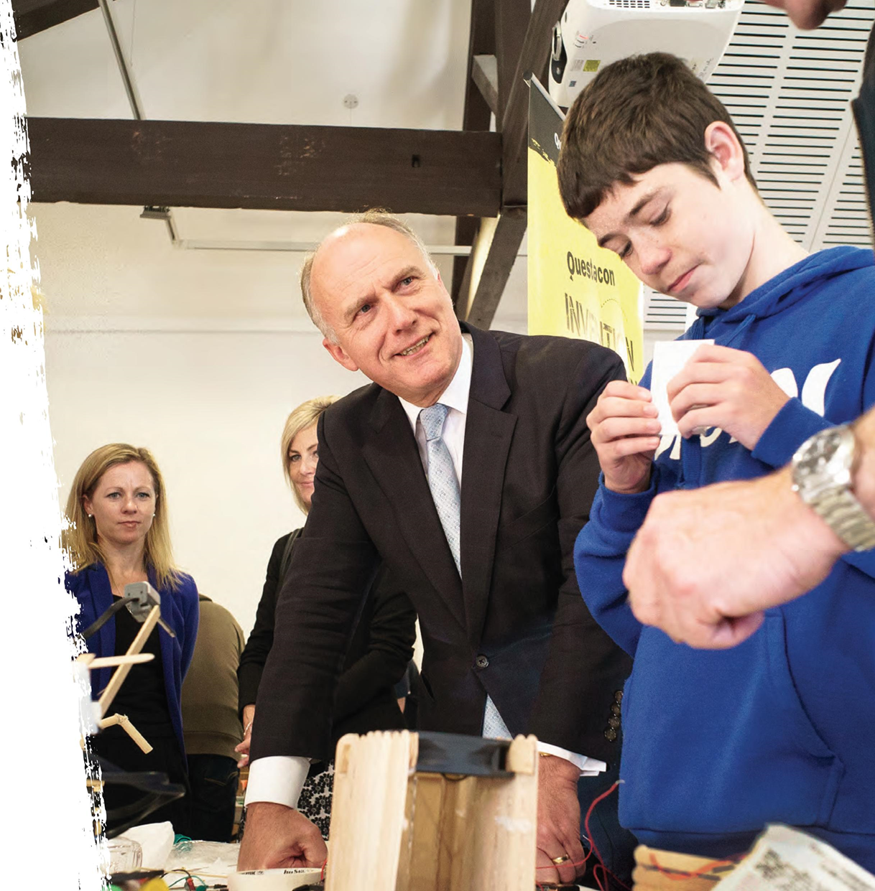
dd
100% of students felt the Invention Convention was interesting and want to participate in another one in the future.
'The hands-on work made it 100 times better compared to a science lesson.'
'The best thing was that it wasn't just scientific, it was also creative.'
'It made me want to learn more about these subjects.'

Teacher Development Strategy
Questacon has long recognised the crucial role of teachers in inspiring their students to engage in STEM subjects and Questacon has been delivering a range of teacher workshops since the early 1990s. Questacon's teacher development strategy draws upon findings by the Organisation for Economic Co-operation and Development's PISA (Programme for International Student Assessment) who have long identified teacher quality as being a major factor in student achievement and also the Australian Chief Scientist's STEM reports which highlight the 'shortages of secondary school teachers in mathematics and science' and identified the need to strengthen and support primary through to tertiary level teachers in STEM.
Questacon has extensive experience delivering teacher workshops and we have consulted with leading partners in the field of STEM education and informal science to develop and deliver a range of teacher professional learning workshops for primary and secondary teachers. Our experienced partners include the Exploratorium (San Francisco); University of Canberra; ASTA (Australian Science Teachers' Association); DATTA (Design and Technology Teachers' Association); TQI (Teacher Quality Institute in ACT); BOSTES (Board of Studies, Teaching and Educational Standards); the ACT Department of Education; the Catholic Education Archdiocese of Canberra and Goulburn and the Australian Independent Schools Association. Questacon has also collaborated with The Queensland Museum, Scienceworks and the Wollongong Science Centre and Planetarium to build teacher professional learning capacity.
Several Questacon teacher professional learning workshops have been accredited with BOSTES (in NSW) and TQI (in ACT). These teacher workshops range from inquiry-based science activities through
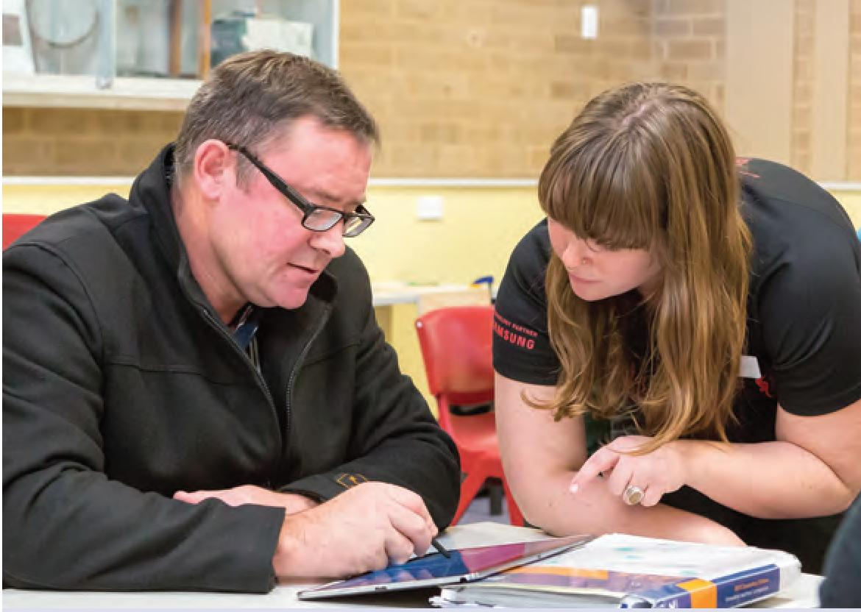
to utilising vidéoconférence facilities to allow interaction with scientists in the field, which in turn links to the Australian Curriculum Strand Science as a Human Endeavour. Feedback from more than 100 teacher workshop participants in our Deakin facility has been highly positive.
In addition to our teacher professional learning workshops delivered in Canberra, Questacon delivers professional learning workshops to teachers through our highly successful outreach programmes the Shell Questacon Science Circus and the Questacon Smart Skills programme.

Australian Maths and Science Partnership Program (AMSPP)
The AMSPP program held in late September had its intensive national residential workshop in Canberra. The event saw nearly 50 teachers mentees and mentors come together to work with ASTA, the Australian Association of Maths Teachers, the University of Canberra, The Australian National University (CPAS) and Questacon on the first phase of the mentoring for science and maths in science program. The initiative has now moved to the video conferencing and online phase with mentees receiving content workshops from Questacon and CPAS as well as and being supported by science and maths mentors via online forums.
The mentoring trial runs during 2016 with final evaluations and reports being generated in the 4th quarter of 2016. Indications to date are the mentees (early career and out of subject teachers) are finding all aspects of the program of great value.
‘I loved the hands-on aspect of this workshop. Great fun and easily transferable to the classroom. The explanations and encouragement from the presenters was especially good.'
'Thanks so much to you and all presenters for a fantastic session. It was one of the most enjoyable, Informative and useful professional development sessions I have attended In over 30 years! Video conferencing—seeing how It can provide live, useful Interaction with a scientist and their equipment. The whole session was Informative, friendly and fun!'
'Such a good challenge and this Is totally applicable In the real world.'
'The discussion with peers and Instructor, the questioning how we change the experiments, the range of resources used In experiments.'
‘I loved Ideas about construct, think, reconstruct. It has really made me rethink my practice.' —Hobart teacher
'Great example of the direction we should be taking (I.e. more hands-on tasks).' —Hobart teacher

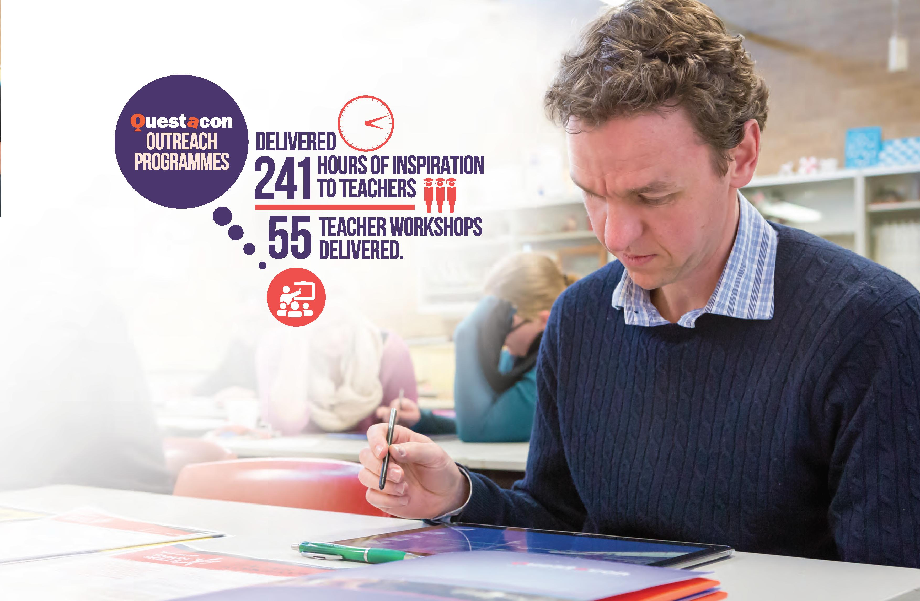
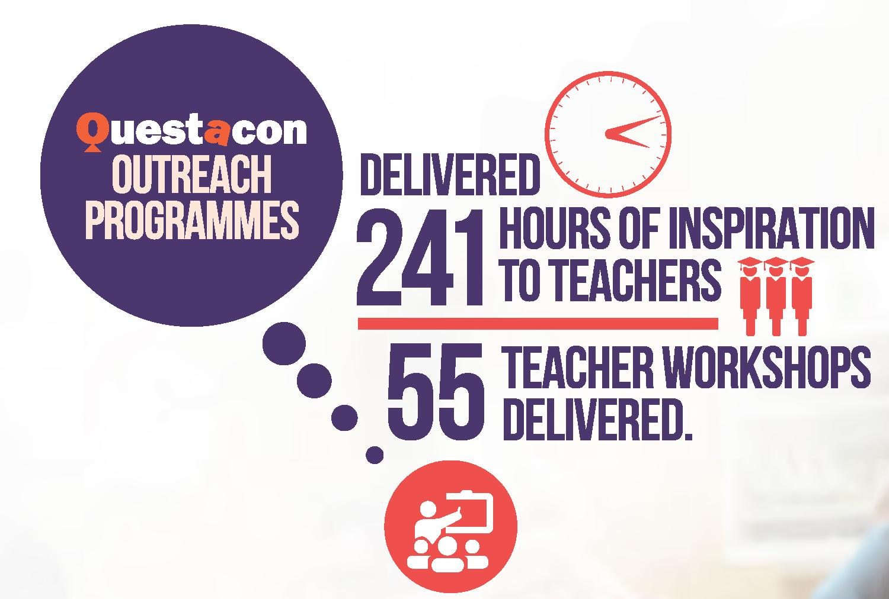

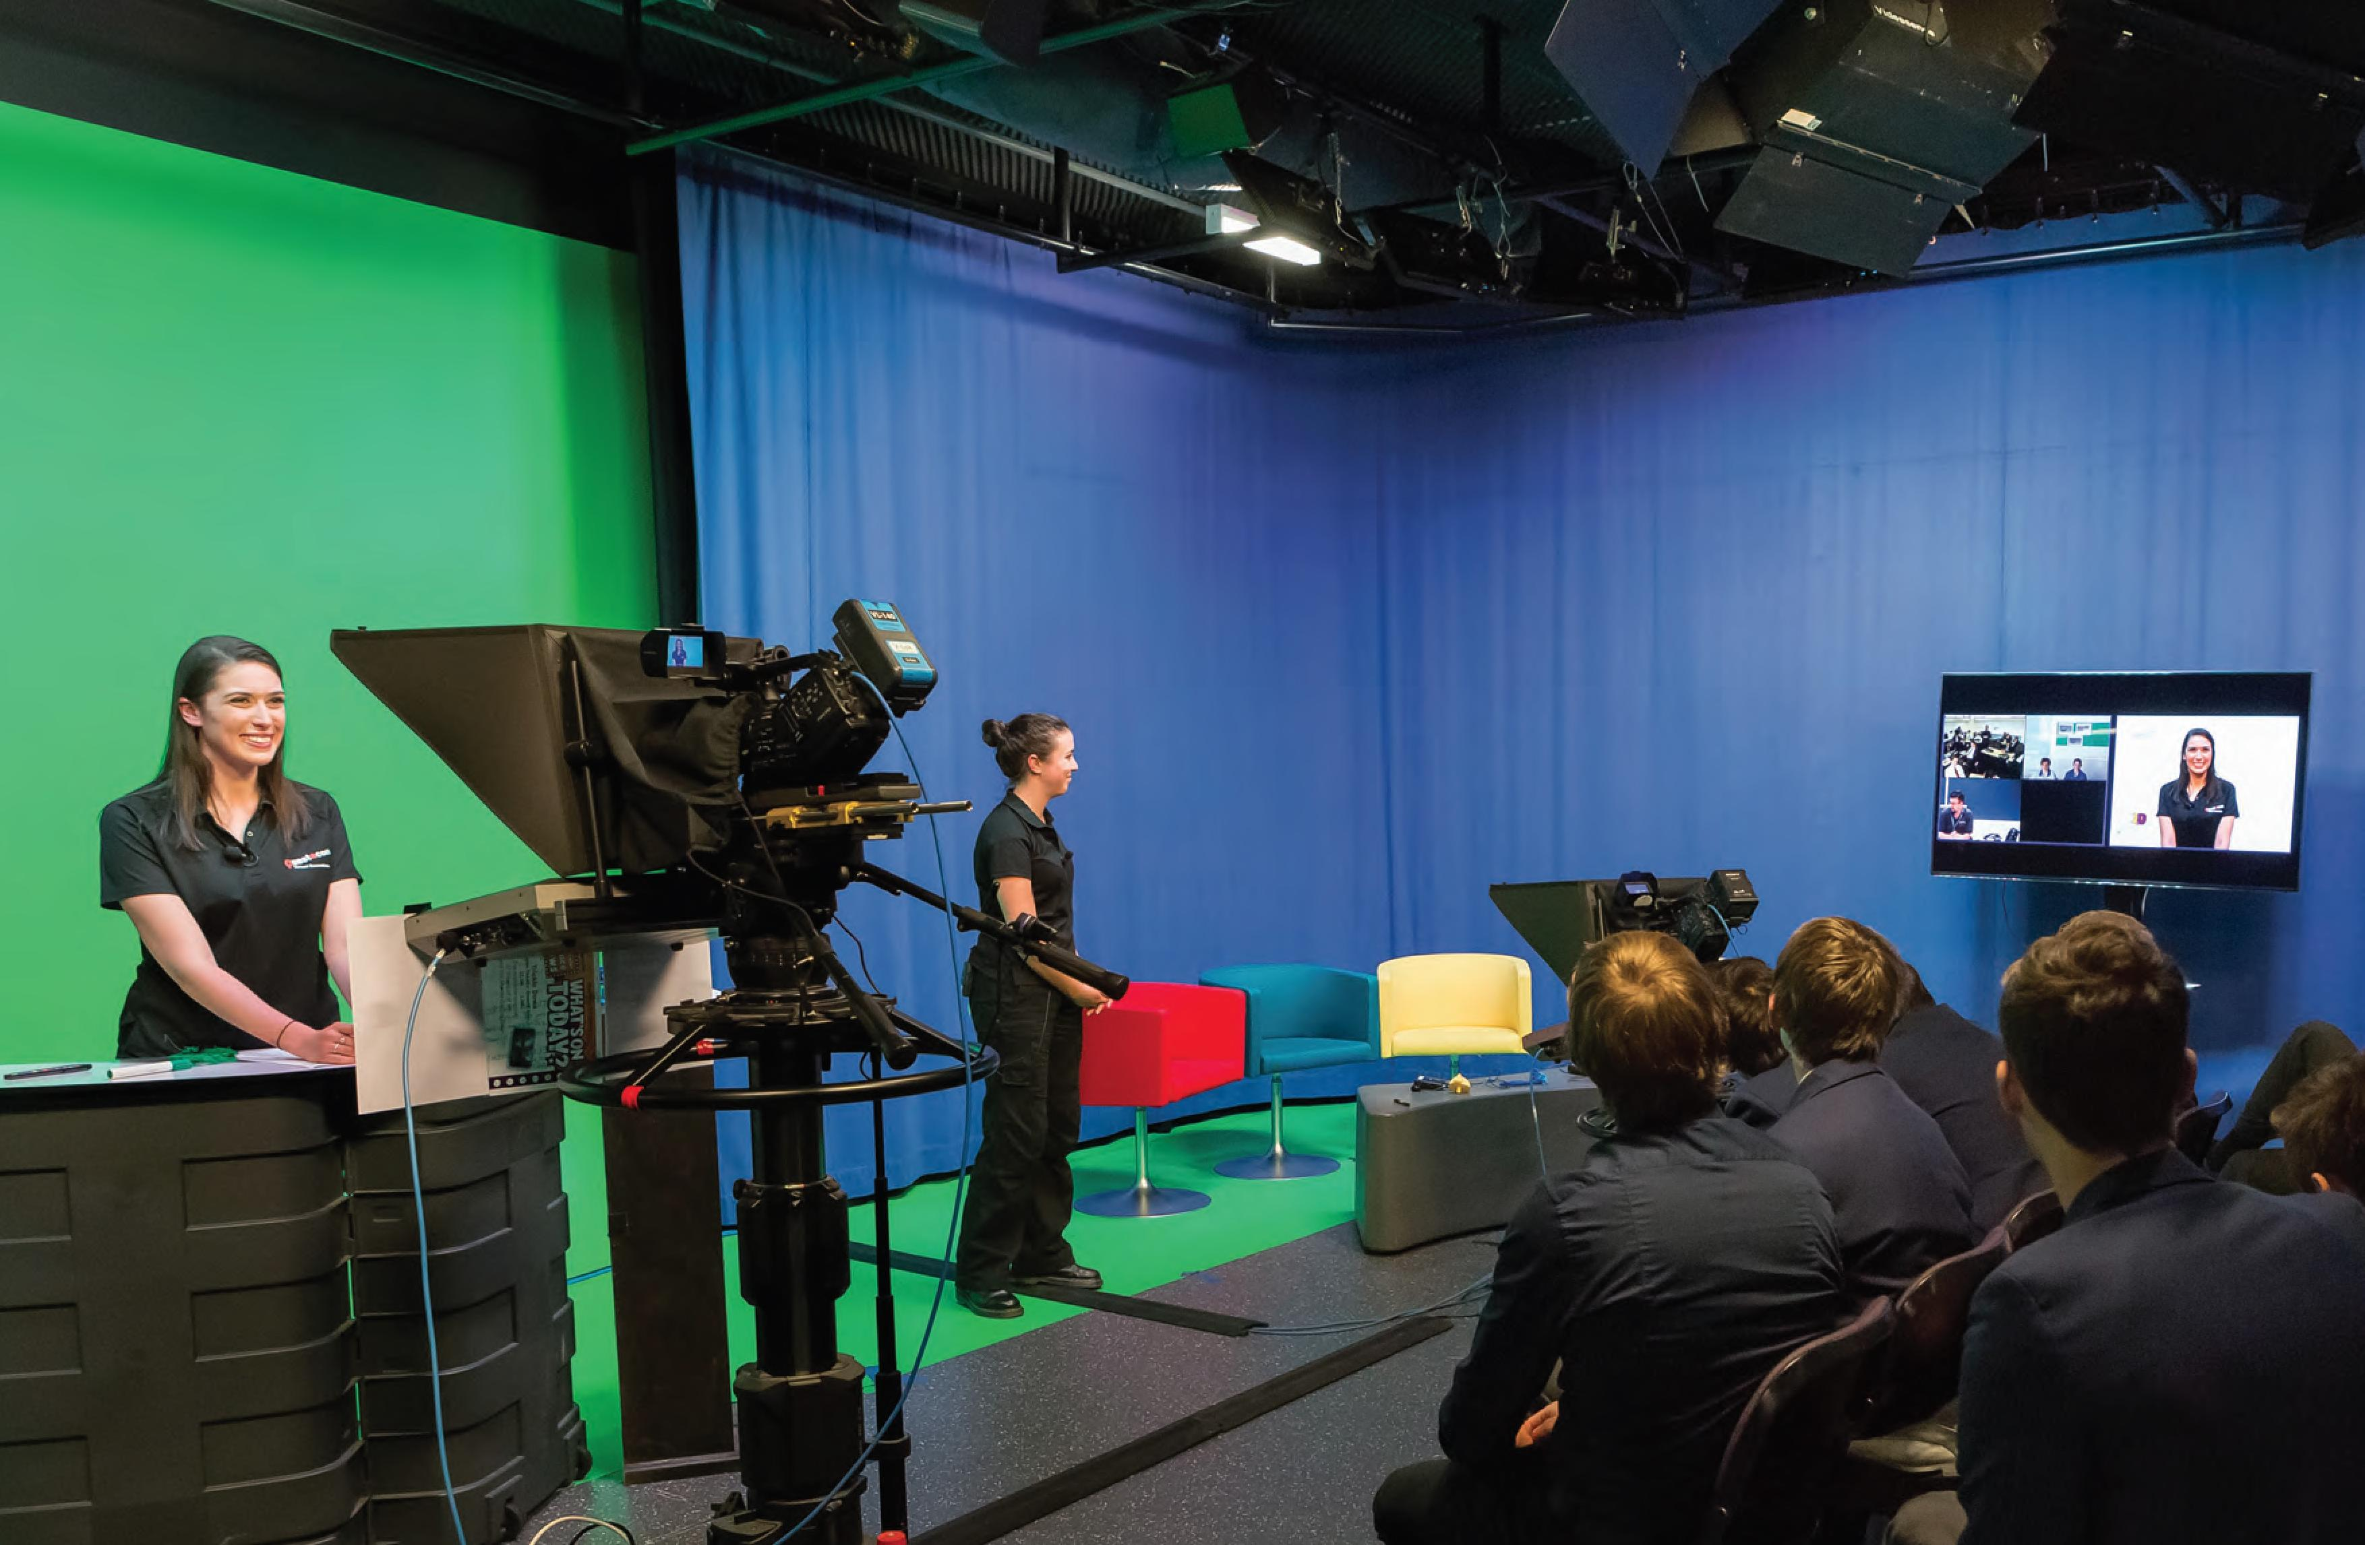

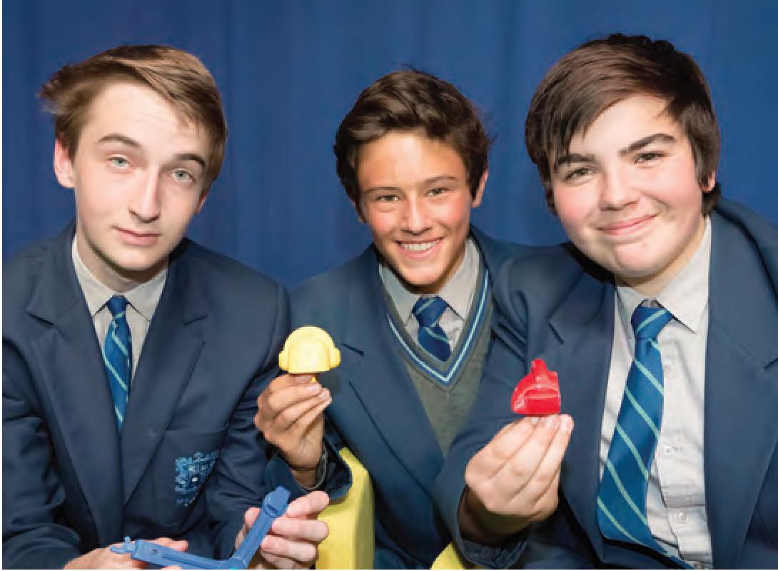
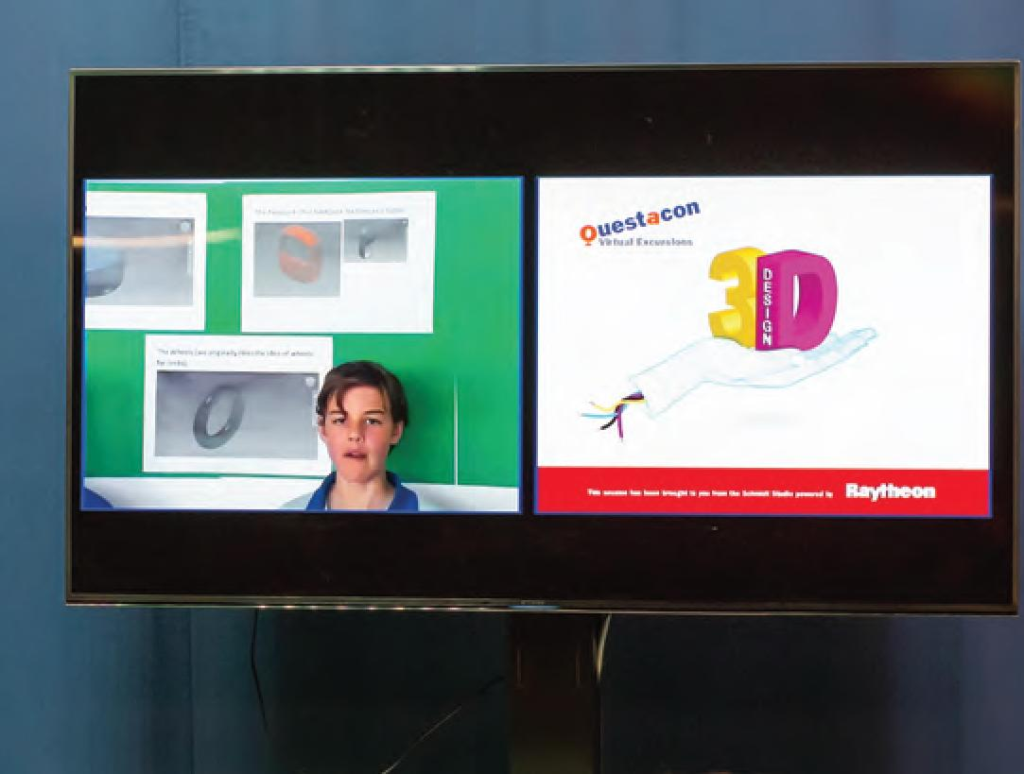


Digital Outreach
Questacon continues to provide access reaching rural and regional Australia through the Schmidt Studio (named after Professor Brian Schmidt, Nobel Prize winner and Questacon Advisory Council member) and the Japan Theatre.
Questacon's Virtual Excursions programme involves one hour hands-on workshops covering topics including environmental science, physics of flight and the innovation process. These vidéoconférence workshops are designed for students in primary and secondary school and are an effective means for schools who have limited opportunities due to their location.
Questacon's Virtual Excursions are a more engaging experience tasking students with an innovative STEM focused design challenge, giving them six weeks to complete it. There are three different projects offered each year. Up to six schools are taken through the challenge via vidéoconférence technology by a Questacon facilitator and an industry expert. The Mission Astronautica Virtual Excursion challenges students to build a neutrally buoyant object and the industry expert has been a retired NASA astronaut provided by project partner Raytheon Australia and an inventor building underwater living quarters.
Working with the Murray Darling Basin Authority's Basin Champions programme this year we made contact with almost 500 students along the river system and talked with over 2000 students across Australia with Questacon's internal Virtual Excursion programmes.
The lighting system in the Japan theatre has been upgraded to incorporate low energy LED theatre lights and a new control system that allows lighting integration into the theatre performances. In addition the projection and control systems now allow the presentation of video in 4K resolution to show our science based slow motion footage in ultra high definition.
Our filming crews have captured the excitement of hands-on learning experiences with the new generation of future scientists and the enthusiasm of the latest cohort of science circus scholars through joining them on the road to film the Shell Questacon Science Circus in various locations.
Questacon continues its relationship with the ABC and its international affiliates with the successful showing of the Excited Particles video fillers throughout Asia and the Pacific. As a result there has been an increase in internet traffic from those geographic locations.
An expanded number of videos via YouTube is available to young pre-school scientists has made Science Time videos much more popular.

Exhibitions

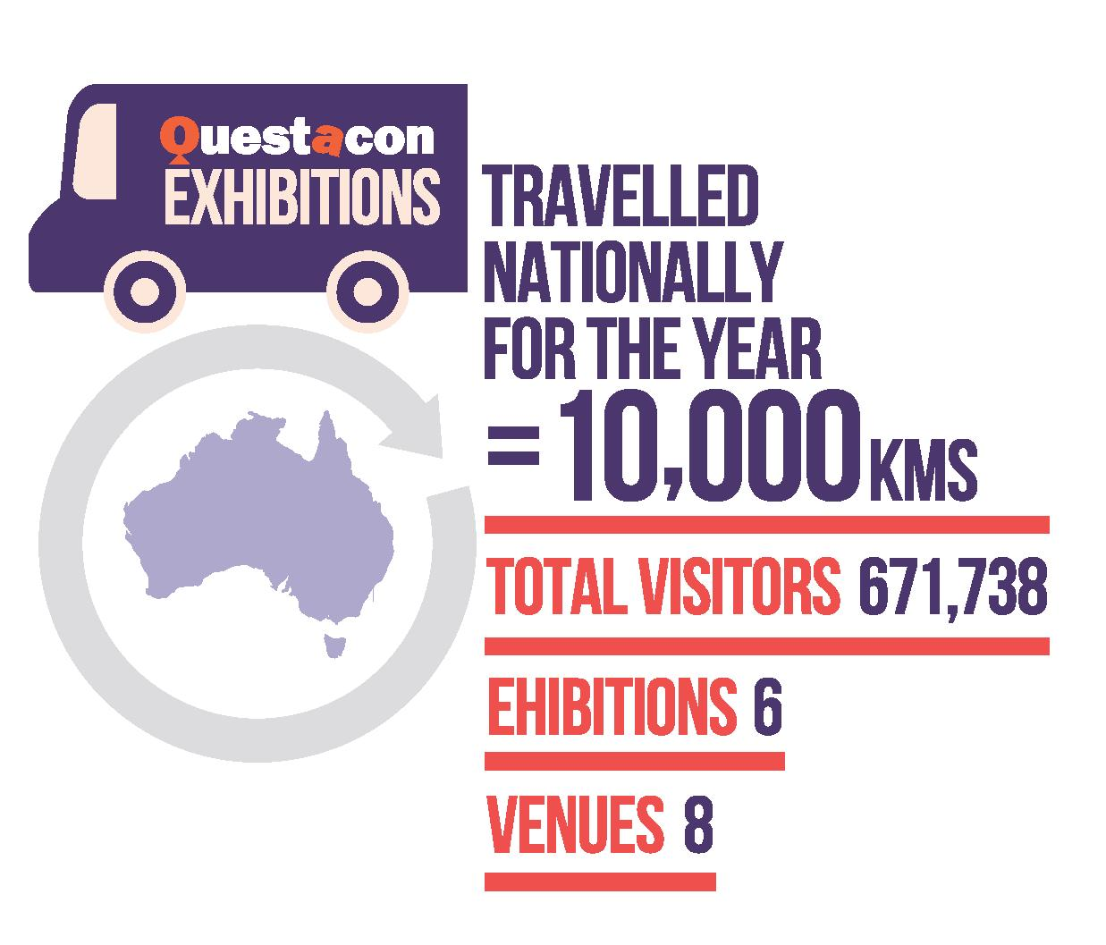

Awesome Earth
The Awesome Earth exhibition has been redeveloped to focus on natural phenomena; how geology and meteorology shape planet Earth. Visitors explore various aspects of the world around them through interactive experiences.
Awesome Earth includes the infamous Earthquake House. The original Earthquake House allowed visitors to experience an earthquake through the lens of disasters and their management. While a highly emotive and immersive experience it limited visitors ability to explore the phenomena directly.
During the redevelopment of the exhibition to a phenomena-based structure, Earthquake House was re-concepted into Earthquake Lab - a space in which visitors directly engage with the effects of earthquakes through performing facilitated, open-ended experiments. The exhibit retains its emotive immersion but adds greater exploration, creating a superior experience.

Travelling Exhibitions
Questacon provides travelling exhibitions that tour to a range of regional and metropolitan venues across Australia, fulfilling Questacon's national role and responsibility of providing access to hands-on learning that might not otherwise be easily possible. The interactive exhibitions are developed in-house by Questacon and provide engagement for all ages. During 2014-15, Questacon toured six travelling exhibitions to eight venues reaching 674 460 visitors nationally.

Spiders
The Spiders exhibition is a collaborative project between Questacon and the Australian Museum. The exhibition opened on the 24 November 2015 and will be on display until 9 October 2016. Spiders is an interactive 450 square metre travelling exhibition containing 14 interactive exhibits aiming to demonstrate how fascinating spiders are and their importance to our ecosystem. The exhibition will highlight Australian research, new discoveries and the associated science stories and will include live Australian arachnids including Tarantulas, Funnelwebs, Redbacks, Huntsman Spiders, Jumping Spiders and St Andrew's Cross web weavers.

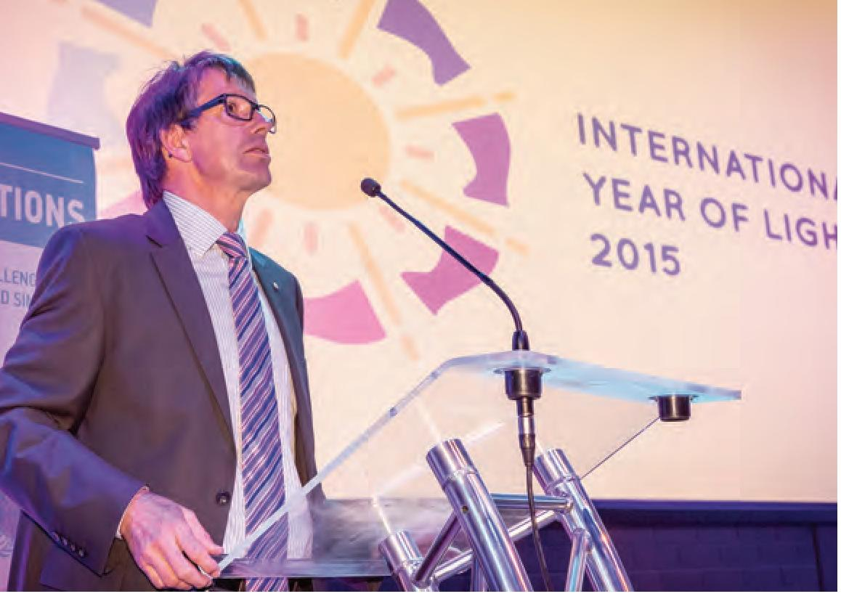
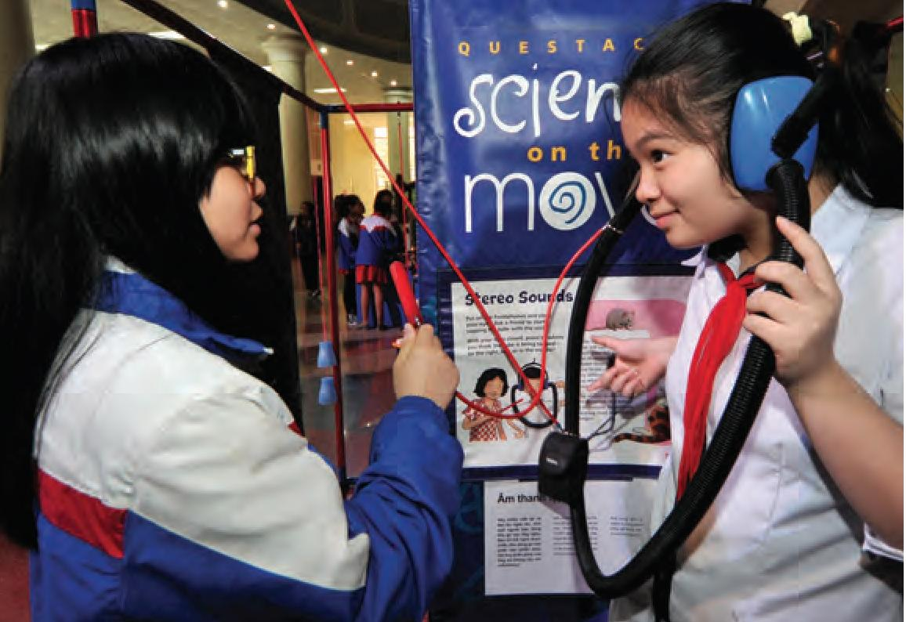
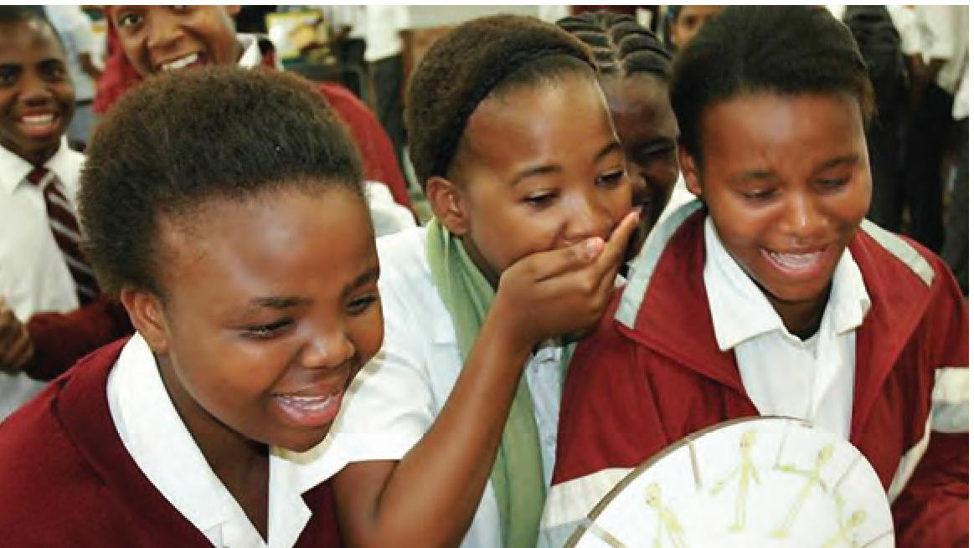

QUESTACON INTERNATIONAL
Each year citizens actively participate in the exhibitions, programmes, events and outreach initiatives organised by 3000 science centres worldwide. Increasingly, science centres are moving beyond the traditional hands-on exploration of scientific phenomena. Many centres are engaging with their audiences in the dialogues that address global challenges, and equipping them to become active players within their communities—thereby helping to achieve the current Millennium Development Goals of the United Nations, and the Sustainable Development Goals launched in 2015.
Questacon continues to be active in international engagement through a number of channels. Questacon Director Graham Durant is on the international planning committee for the Science Centre World Summit 2017 to be held in Tokyo.
Questacon is actively engaged in supporting the International Year of Light global initiative. On 2 March 2015 in collaboration with the United Nations Information Centre, Parliamentary Secretary Karen Andrews launched the International Year of Light and Light Based Technologies (IYL 2015) activities at Questacon with a science show and reception. Other international activities included a Diplomatic families and friends social event held on 26 June 2015. Embassy staff and their families were invited to the event with children being encouraged to wear national dress. The event included science demonstrations inspired by the IYL 2015 and acknowledged the 70th anniversary of the United Nations.
Questacon continues to be actively engaged in the Indo-Pacific region. A Memorandum of Understanding between Questacon and the Science Centre Singapore has been developed and was formally signed in Singapore in June 2015 on the occasion of Singapore's 50th anniversary celebrations. Both organisations share a similar mission and values, seeking to improve skills to share within their communities of practice and to strengthen the benefits their work can bring to the region and beyond.
A team of volunteer science show performers from the Osaka Science Museum spent one week at Questacon during April 2015, working with Questacon's Excited Particles. Dr Stuart Kohlhagen delivered an exhibition development clinic about effective exhibit and exhibition development at the ASPAC Conference in Manilla in May 2015. Excited Particle Alex Jordan contributed to a science show workshop for ASPAC members as part of the pre-conference workshops.
Questacon hosted a significant number of visiting delegations. Some recent delegations included the Gansu Provincial Association for Science & Technology, China; the Japanese Council of Science Museums; new Japanese Ambassador Sumio Kusaka; Dr Kaja Antlej, Endeavour Visiting Fellow (Postdoctoral Researcher).

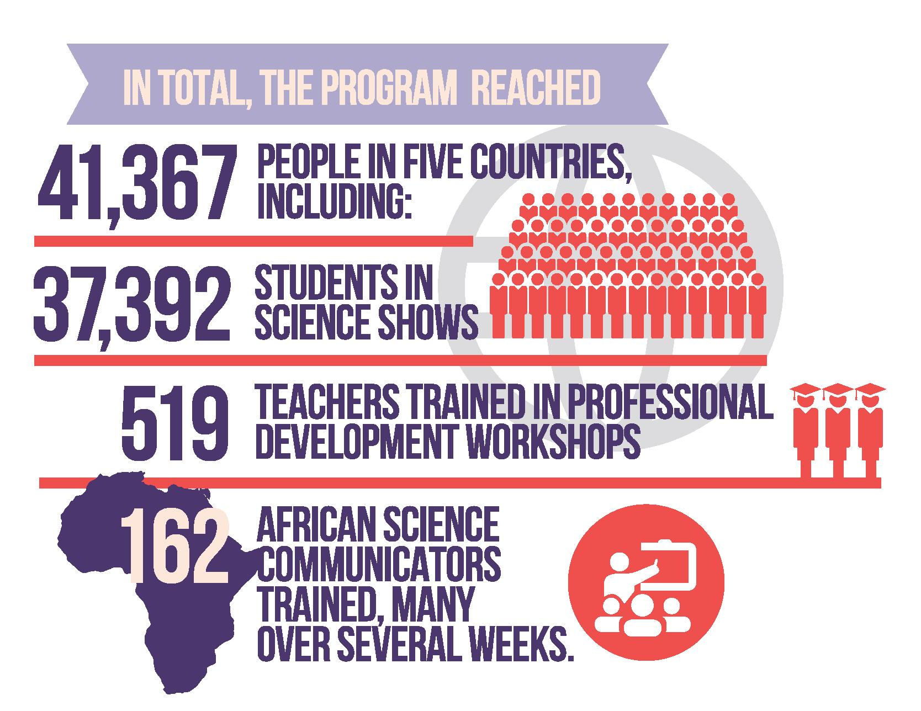

Science Circus Africa
Science circus Africa is an Australian Government funded programme taking engaging, fun science to schools, teachers and communities in five countries in southern Africa, while also training and building capacity in African staff teachers and organisations. The key programme components are science shows, teacher professional development (though workshops and distribution of resources/books), a DIY science exhibition and staff training. It is a partnership between three Australian Government missions, Questacon, The Australian National University, the Ducere Foundation and numerous African partners.
The science circus Africa tour commenced on 3 May, concluding on 14 July 2015. From 3-9 May 2015 the science circus team, hosted by the Rajiv Gandhi Science Centre, trialled exhibit development and show skills in Mauritius. A set of hands-on exhibits were developed at the start of each country tour using local materials. Upturned plastic dustbins make good exhibit bases for pop-up hands-on exhibits! The tour presented science shows and professional learning activities in South Africa, Zambia, Botswana and Malawi. The team comprised of two former science circus scholars taking the skills and experience gained from the programme to an international audience.


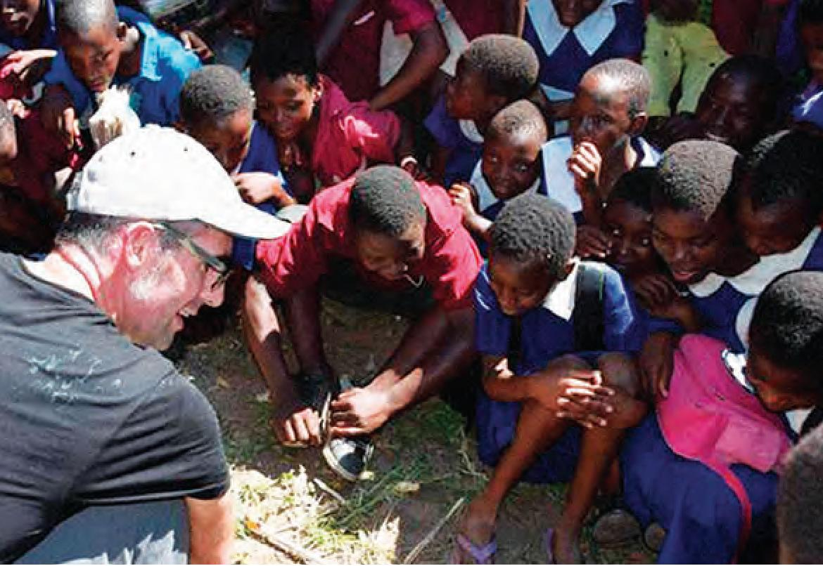
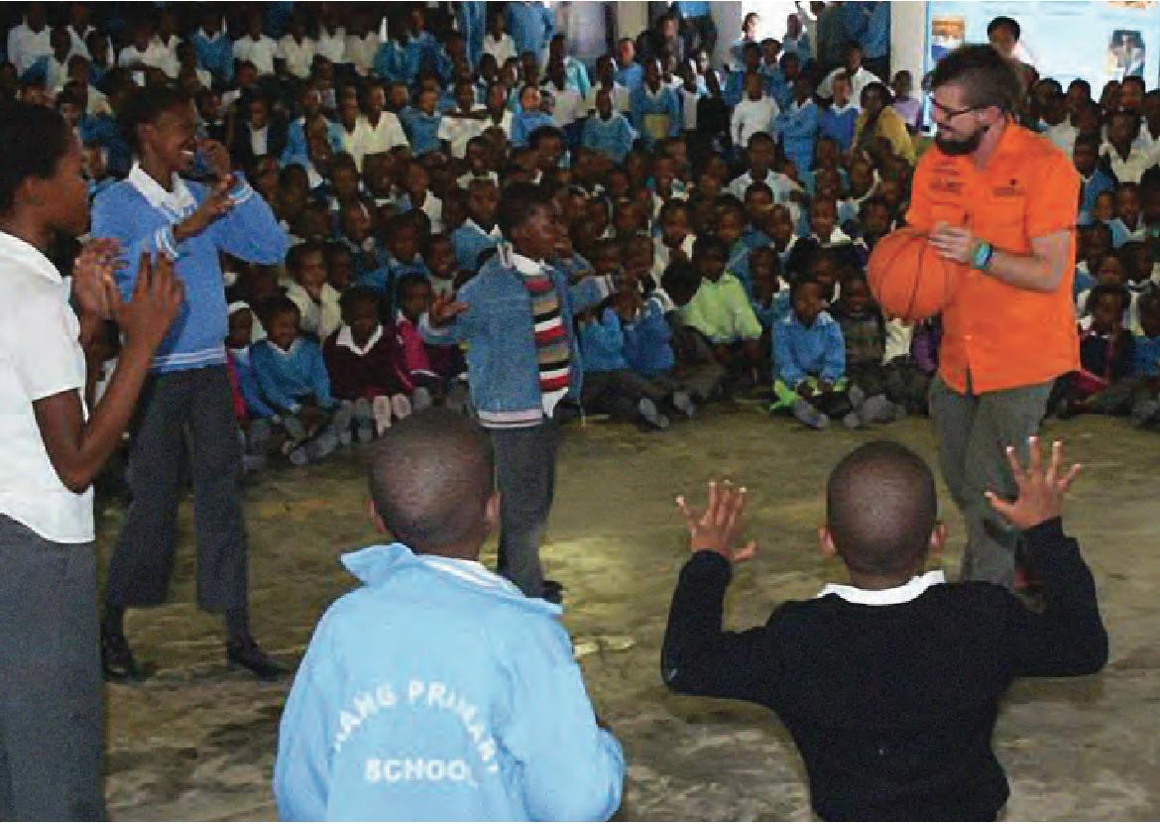
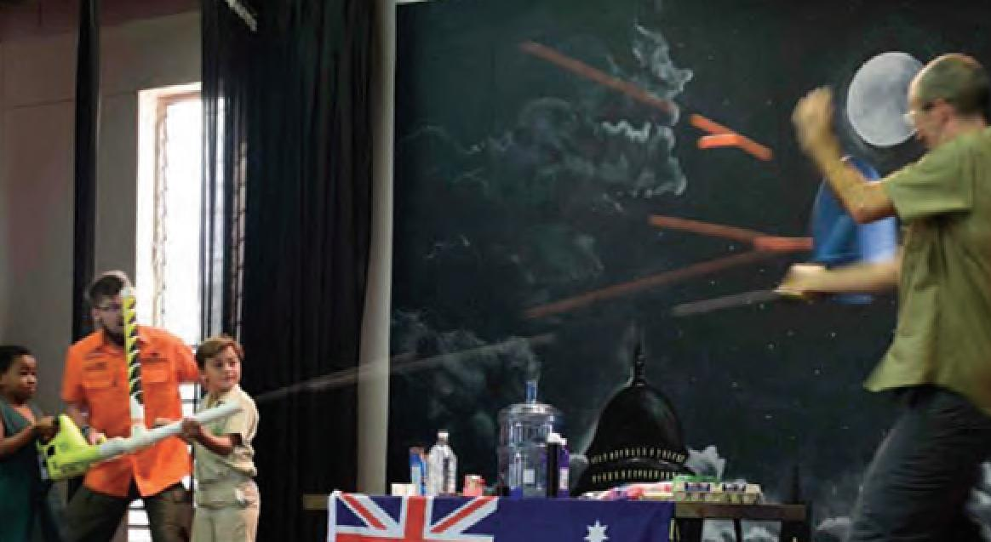

IMPORTANT EVENTS

US Ambassadors Innovation Roundtable, 30 July 2014
The Ambassador's Innovation Roundtable was presented by the US Embassy in Australia in partnership with Questacon. The event highlighted US-Australia success stories and discussed challenges in linking research and development to commercial opportunities. Priorities in STEM education and the potential of future innovation partnerships were also explored. The event was attended by approximately 50 students and 100 officials from the business community, including representatives from Google, Intel, IBM, Boeing, Microsoft, IBM and BHP Billiton.

SciNights
Questacon held four themed SciNight adult only events in 2014-15.
- Sport – 15 August 2015
This SciNight explored the world of sport and included strongwoman Penelope Asterix Vaudeville who spoke about the science of cheating, and a special collisions show featuring the Canberra Roller Derby League.
- X Rated – 15 May 2015
This SciNight featured external and internal speakers, performers and activities that examined the science of sexuality, gender and anatomy. This SciNight attracted a record attendance with over 1900 visitors.
- Good Vibrations – 14 August 2015
This SciNight kicked off National Science Week celebrations the evening featured experiments with some unconventional musical instruments and eyeball activities including the insides of a real eye ball.
- The Future is Now – 23 October 2015
This SciNight celebrated the past, present, and future. Robert Zemeckis' cinematic masterpiece Back to the Future saw Marty McFly travel back in time to 1955. Four years later, in the sequel McFly travelled 30 years into the future. That future is now with hoverboards, flying cars, and self-lacing shoes?

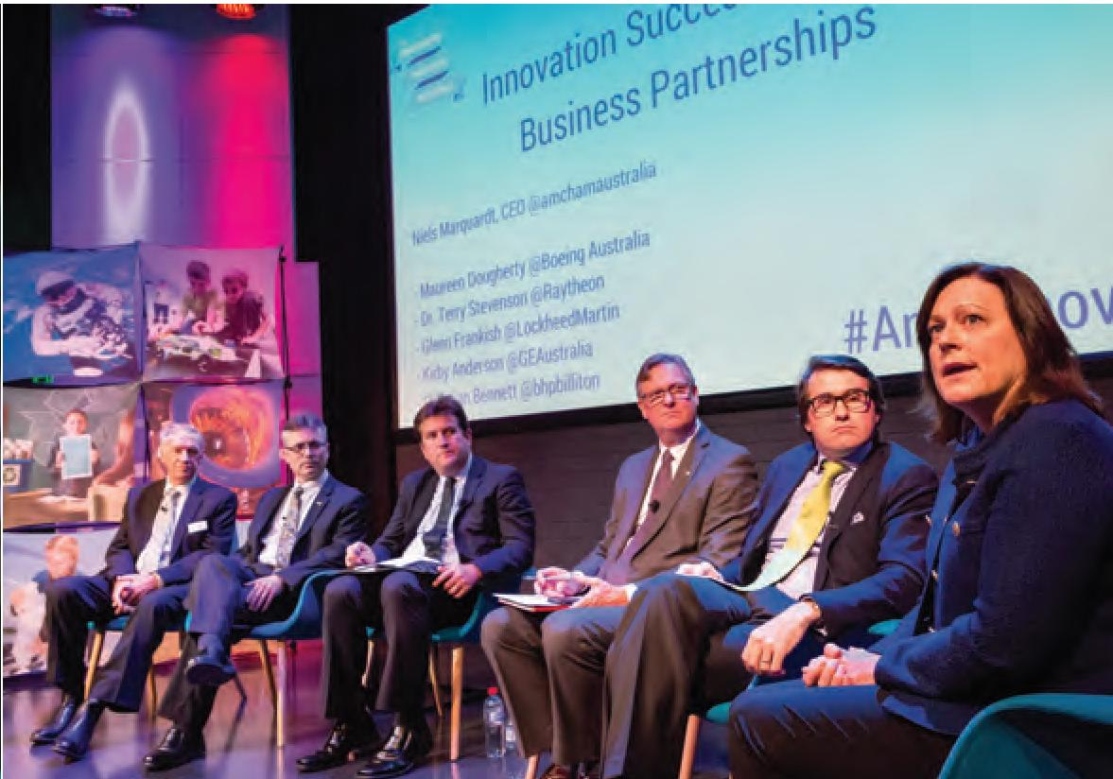
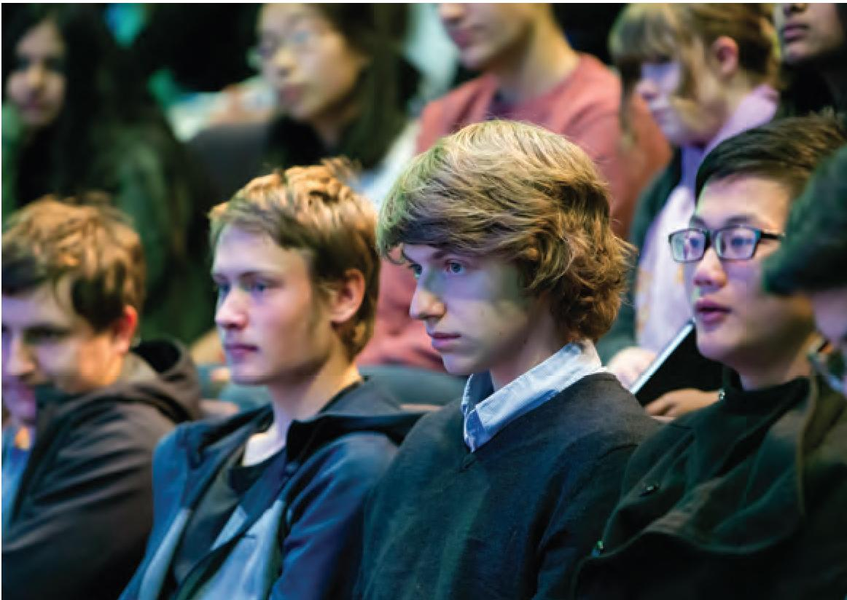
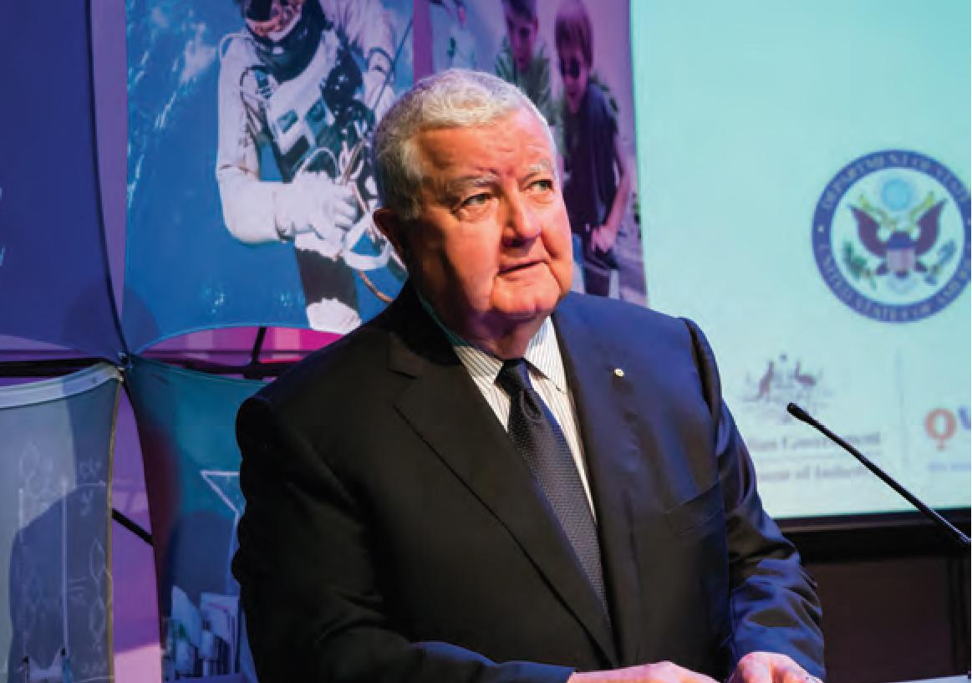

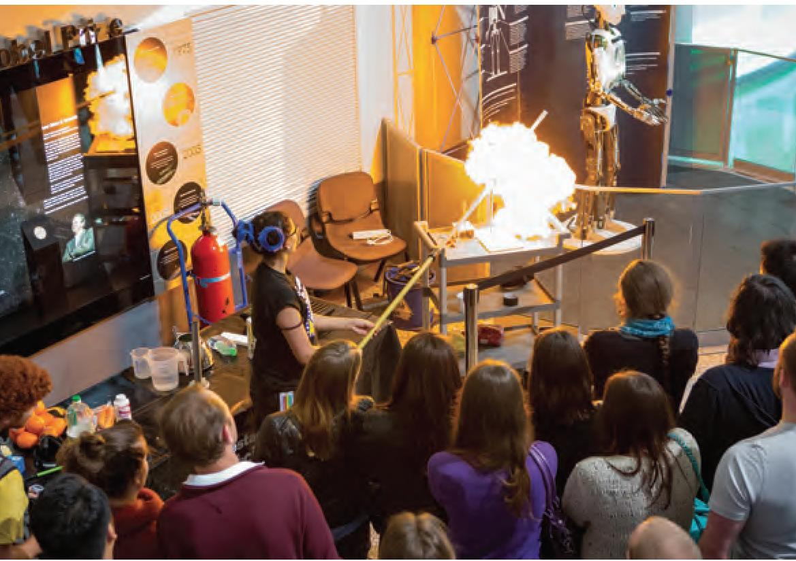

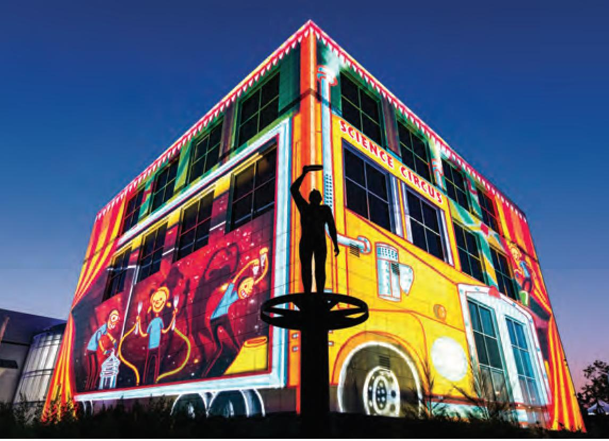

International Year of Light Launch, 2 March 2015
The United Nations International Year of Light was celebrated with an event in the Japan Theatre attended by Professor Ken Baldwin, Chair of the International Year of Light 2015 in Australia, Mr Christopher Woodthorpe, Director of the United Nations Information Centre, and The Hon. Karen Andrews, MP, former Parliamentary Secretary to the Minister for Industry and Science.

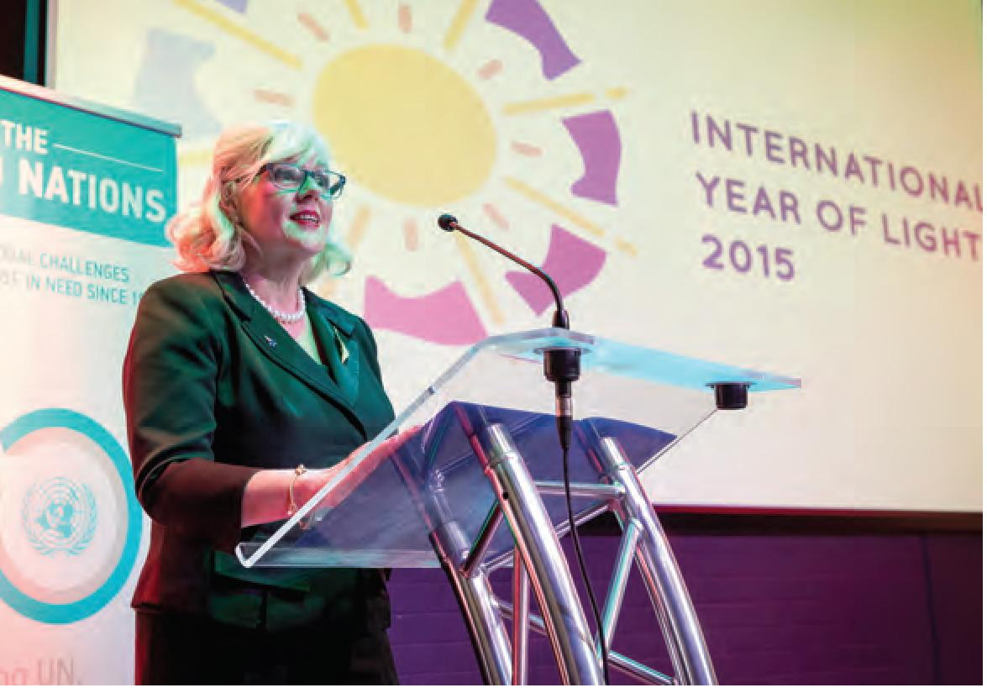

ENLIGHTEN 2015,
27-28 February and 6-7 March
ENLIGHTEN 2015 continued to be a significant event on Canberra's cultural calendar bringing live entertainment, architectural light projections and, for the first time a night noodle market to the Parliamentary Zone. Questacon implemented a series of ticketed events and free activities over four evenings including:
- Swamp Juice shadow puppet shows
- Shadow puppet construction workshops
- Night photography workshops
- Laser tag games in Awesome Earth
- Physics of Beer shows in Q Lab
- UV painting with artist George Rose
- Snake the Planet games
- Light up fairy floss and an external pop up Q Shop
- Colour and Light Shows in the Japan Theatre
- Questacon Excited Particles busking

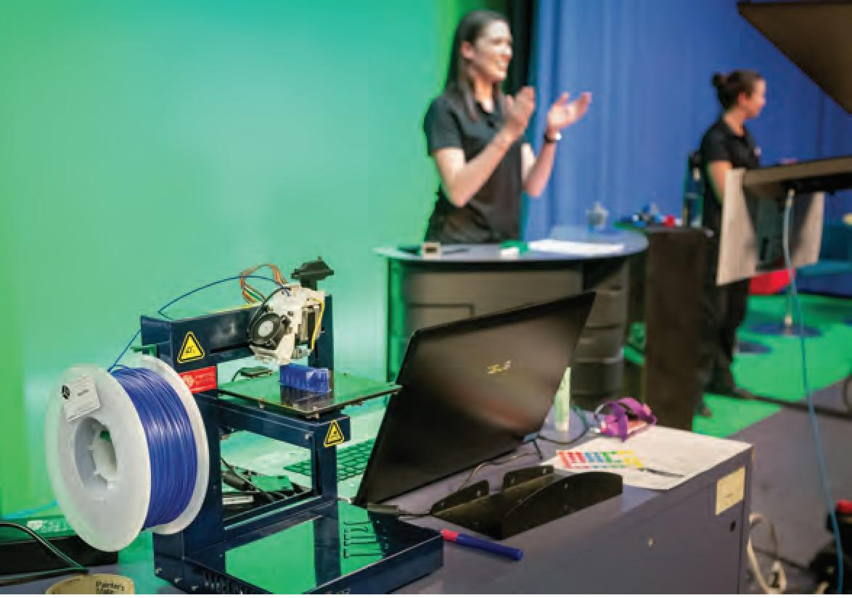

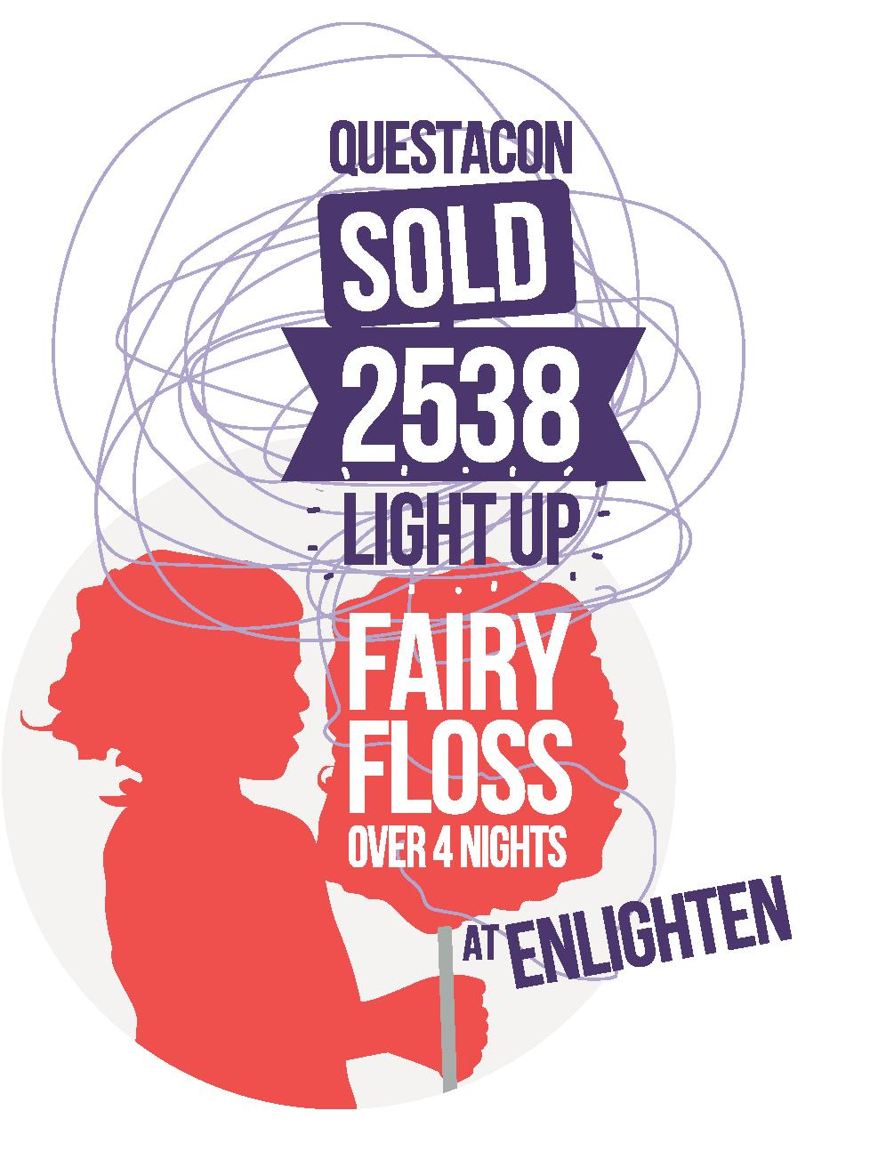
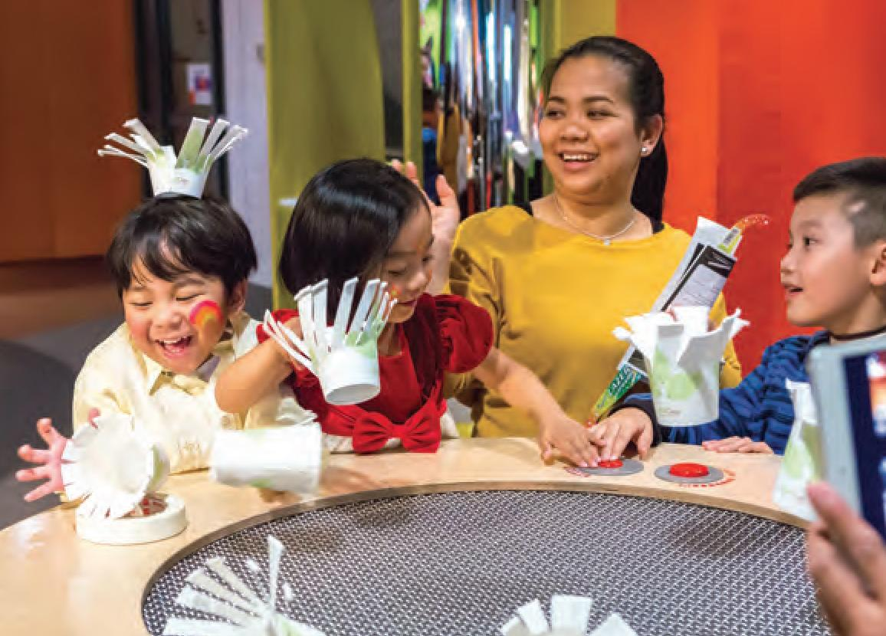

3D Design Project Finale with Raytheon, 21 May 2015
This event was the final in a series of vidéoconférences between Questacon and students from around Australia. The students presented the results of their investigations into 3D design and were able to tell the story behind their project, demonstrate their design and answer questions from representatives from Raytheon Australia, Questacon and other schools.

Members' Night, 12 June 2015
The 2015 Questacon Members' Night event provided the opportunity to thank members for their patronage with a programme of special events and activities including live reptiles, UV face painting and Exploganza shows. The 2015 Members' Night and was attended by over 2400 guests, far more than any previous members event.

Diplomatic Families and Friends Social Event, 26 June 2015
The 2015 Diplomatic family and friends social event provided an opportunity to showcase Questacon's international engagement programmes to over 500 diplomatic staff and their families representing 45 nations.

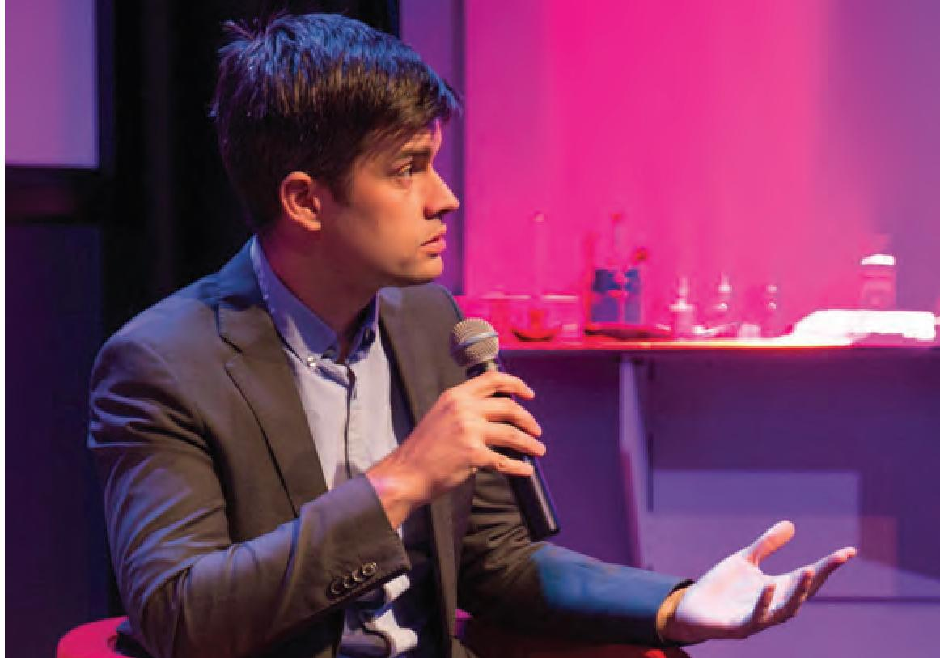
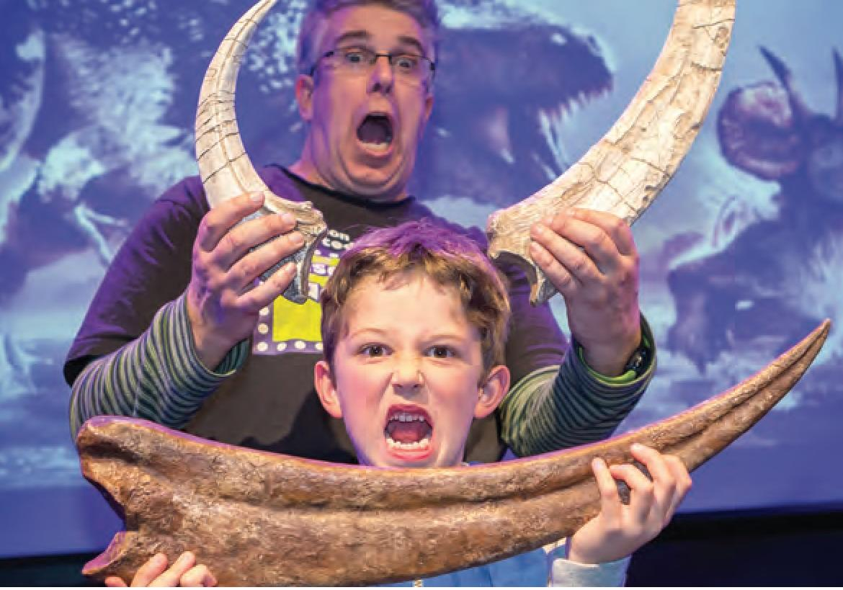

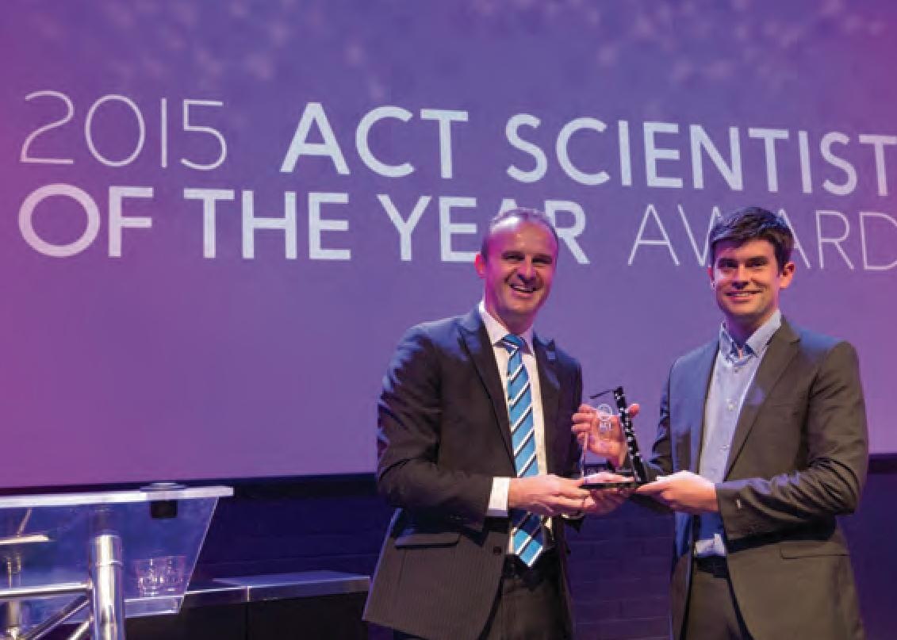

ACT Scientist of the Year Award presentation, 20 August 2014
Questacon was the venue for the announcement of Dr Colin Jackson as the inaugural ACT Scientist of the Year by Chief Minister Andrew Barr, MLA.

Australian Innovation Challenge, 25 November 2015
Questacon hosted the 2015 Australian Innovation Challenge Awards on 25 November. A partnership between Shell, The Australian and the Department of Industry, Innovation and Science. The Innovation Challenge showcases innovation and helps to create an opportunity to make a difference. The Hon. Wyatt Roy, Mf? Assistant Minister for Innovation represented the Minister for Industry, Innovation and Science at the event along with the Shell Chairman and The Australian CEO.

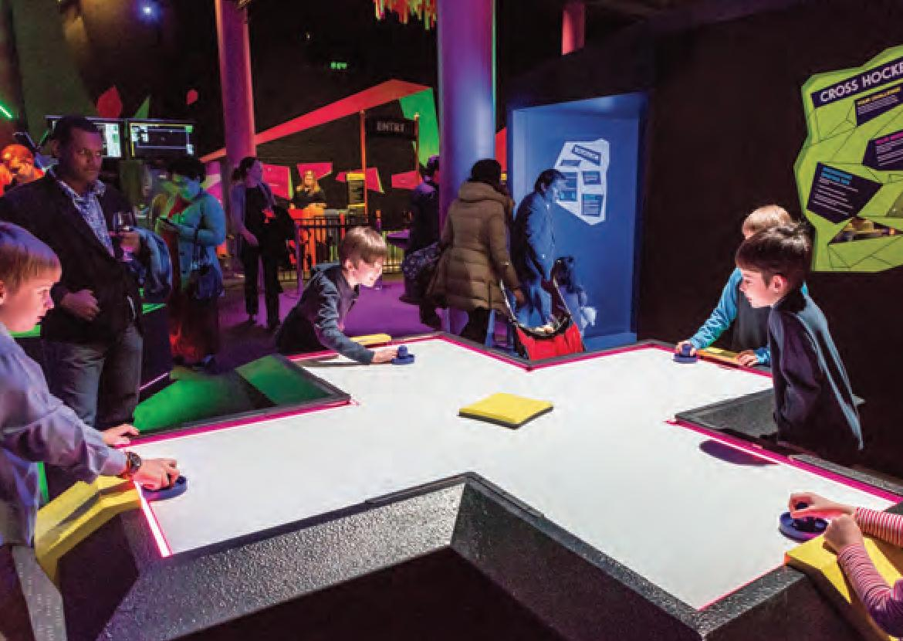
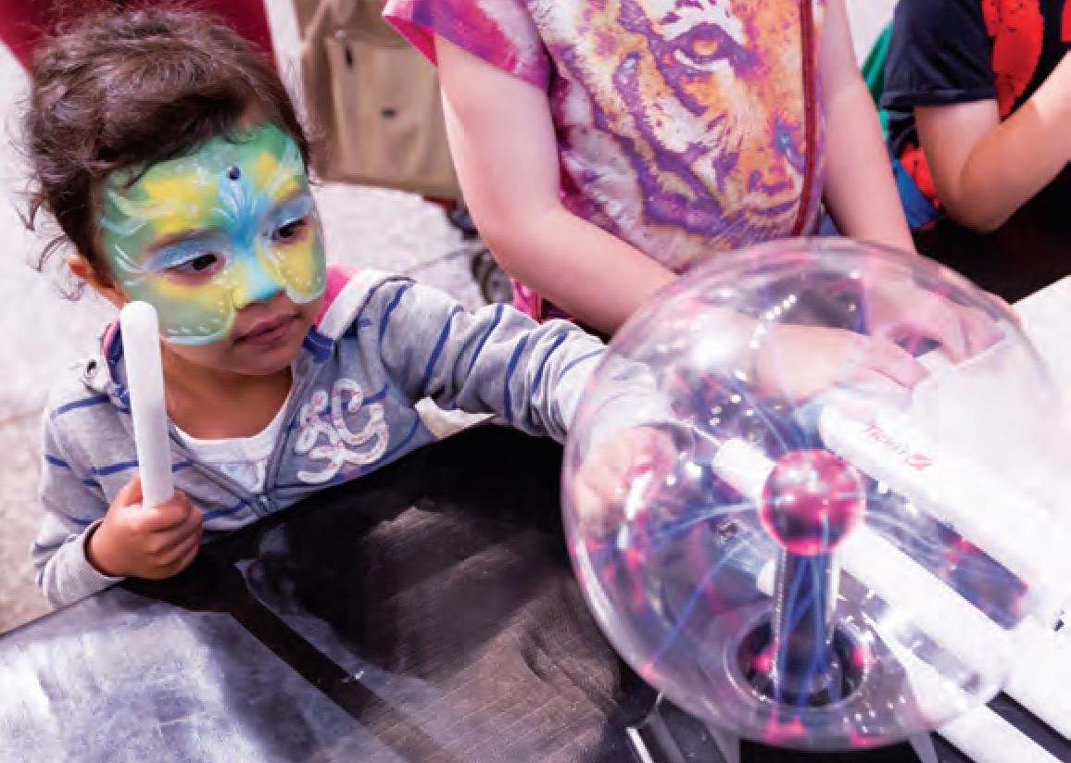

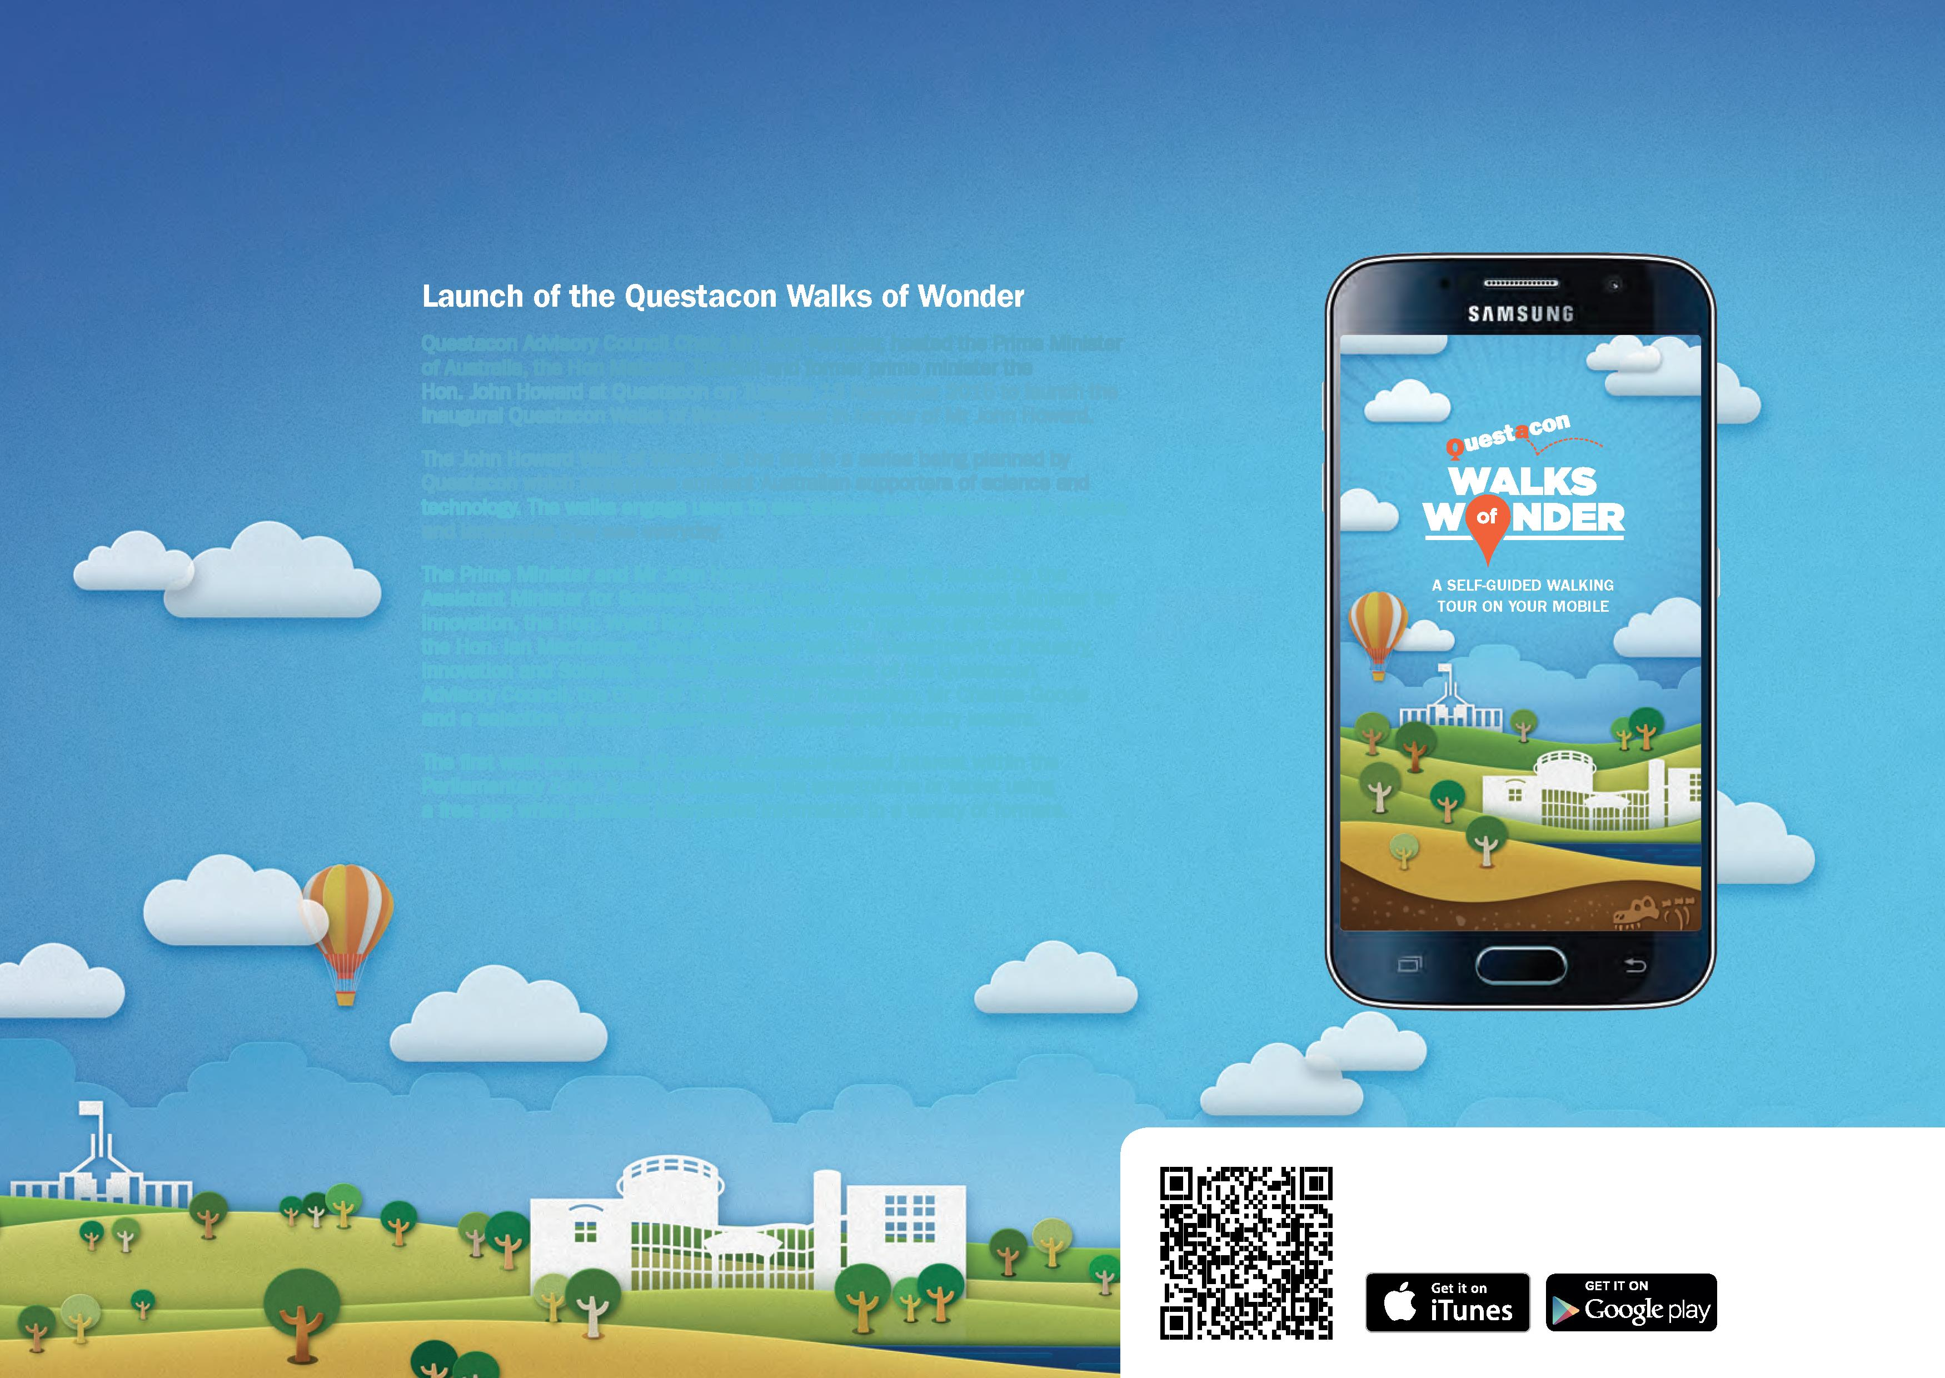
Launch of the Questacon Walks of Wonder
Questacon Advisory Council Chair, Mr Leon Kempler, hosted the Prime Minister of Australia, the Hon Malcolm Turnbull and former prime minister the Hon. John Howard at Questacon on Tuesday 13 November 2015 to launch the inaugural Questacon Walks of Wonder named in honour of Mr John Howard.
The John Howard Walk of Wonder is the first in a series being planned by Questacon which recognises eminent Australian supporters of science and technology. The walks engage users to see science and wonderment in objects and landmarks they see everyday.
The Prime Minister and Mr John Howard were joined at the launch by the Assistant Minister for Science, the Hon. Karen Andrews, Assistant Minister for Innovation, the Hon. Wyatt Roy, former minister for Industry and Science, the Hon. Ian Macfarlane, Deputy Secretary with the Department of Industry, Innovation and Science, Ms Sue Weston, members of the Questacon Advisory Council, the Chair of The Ian Potter Foundation, Mr Charles Goode and a selection of senior government, business and industry leaders.
The first walk comprises 19 points of science-related interest within the Parliamentary Zone. It can be accessed via smartphone or tablet using a free app which provides interpretive information in a variety of formats.
Scan the QR code or visit: www.questacon.edu.au/discover/qwow
to download the Questacon Walks of Wonder app.

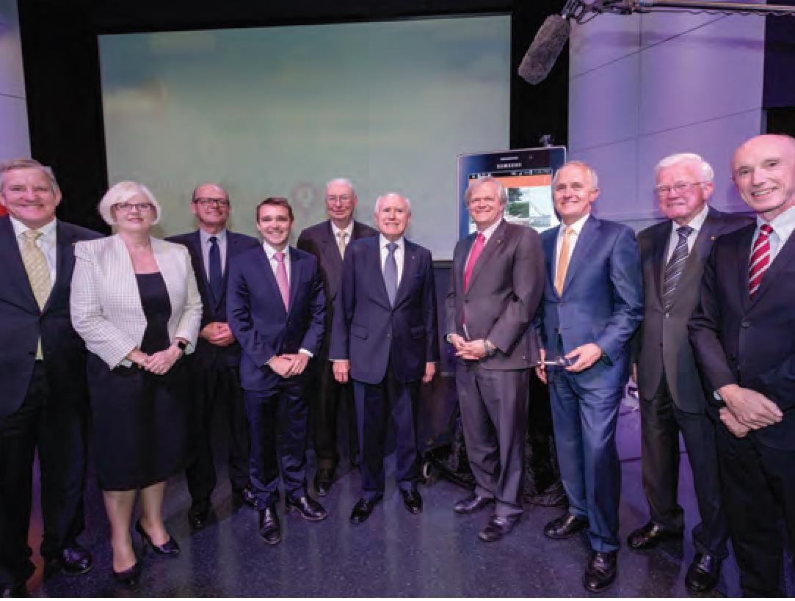
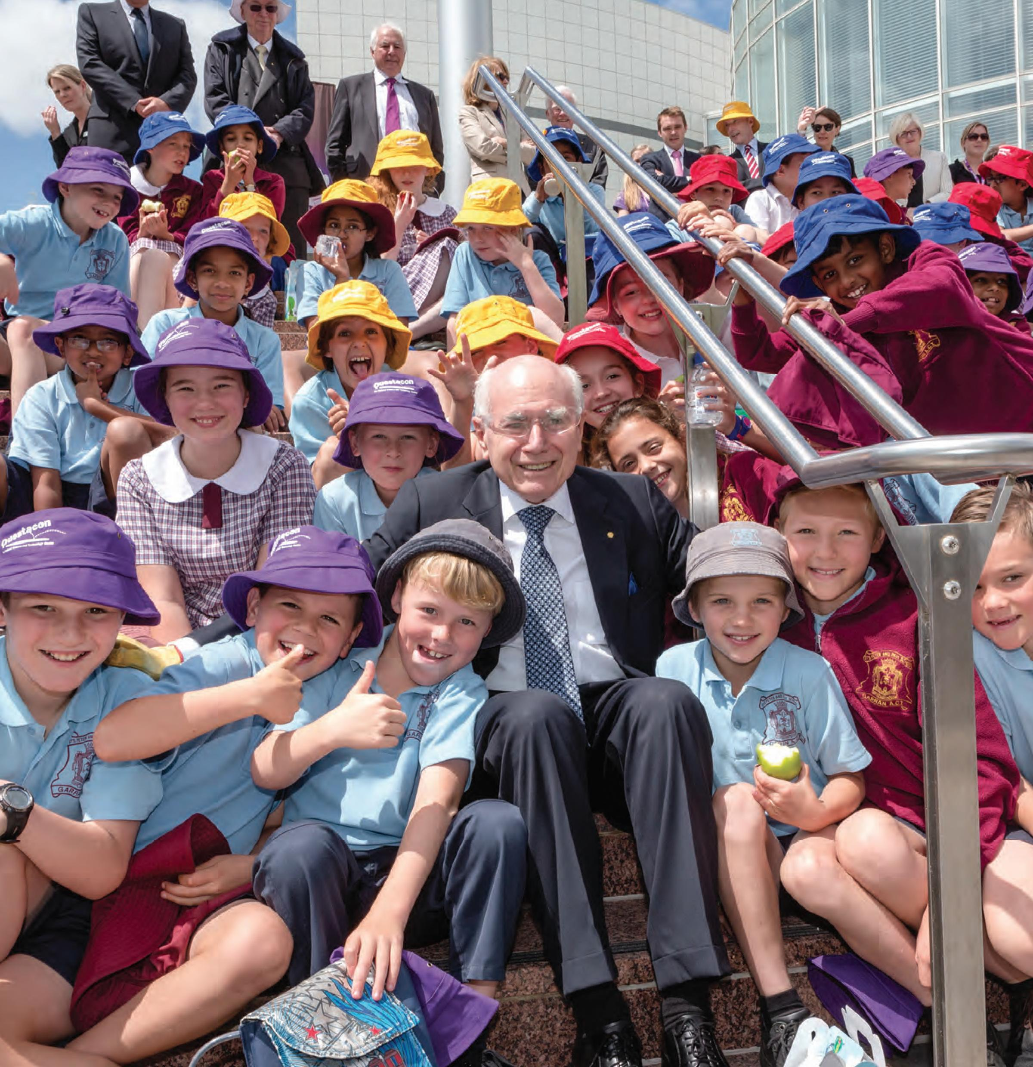
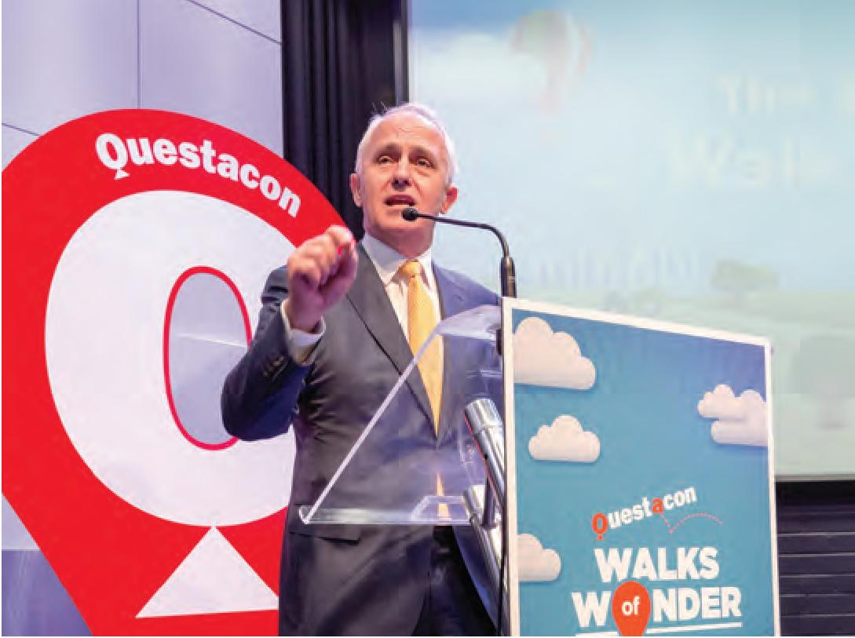

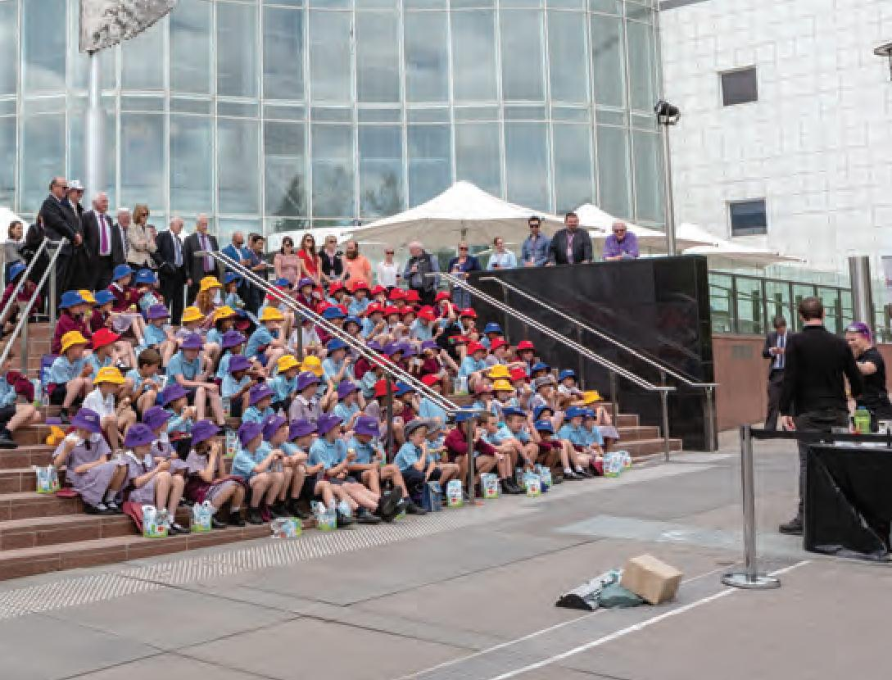

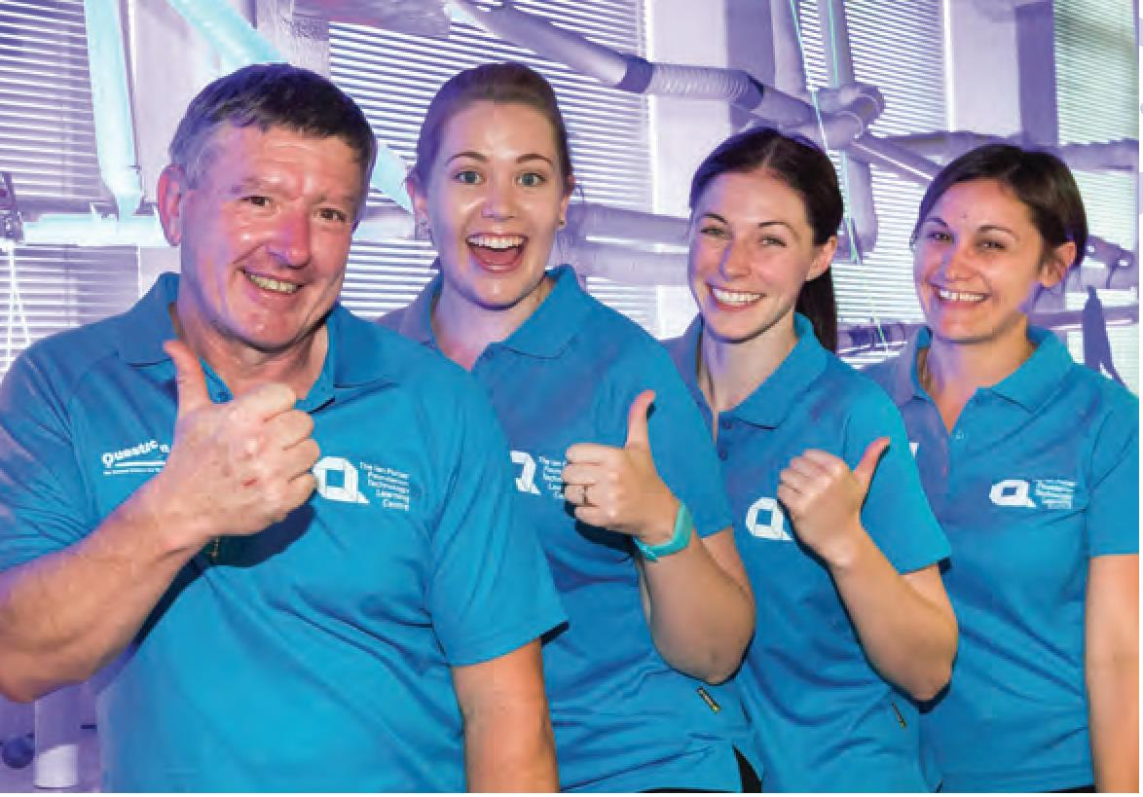
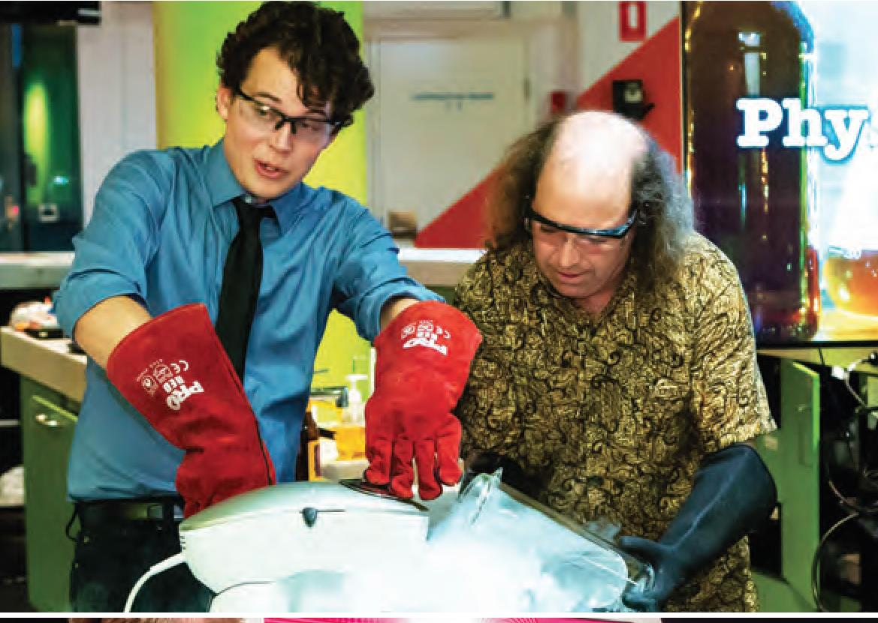
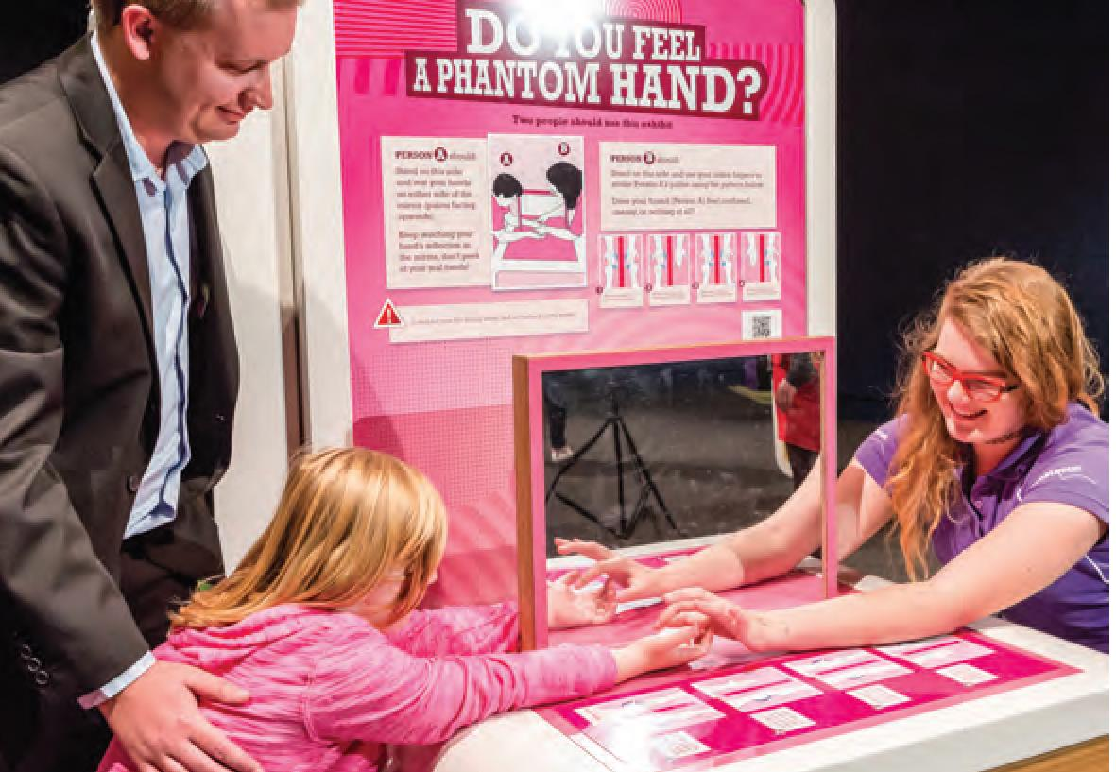

QUESTACON PEOPLE

The Questacon workforce is both culturally and professionally diverse. Questacon staff have wide ranging experience in science, customer service, design, construction, acting, education, facilities management, marketing, communication, finance, planning, IT, public administration, occupational health and safety, retail and electronics.
Questacon employs 115 staff in full-time or part-time positions with another 118 on a casual basis. Within those staff is a mixture of expertise, including Commerce, Environmental Science, Geology, Medicine, Psychology, Exercise Science, History, Teaching, Law, Sports Management, Archaeology, Acting, Business Management, Human Rights, Chemistry, Physics, Mathematics, and Engineering. Our staff are also diverse in culture with staff employed from around the world.
Questacon staff are impressive with an amazing 8 different languages spoken across the workforce, including: Italian, German, Spanish, Hebrew, Russian, Polish, Japanese, Arabian.
Questacon contributes to the development of young people in Australia by providing entry level jobs. In February 2015 Questacon welcomed aboard a new Apprentice in the Questacon Production Team. Chosen from a strong field of 75 applicants, Glen Goggin joined the exhibit production workshop in February to undertake an Apprenticeship Engineering Certificate III (Mechanical). Glen has become something of a celebrity at Questacon, getting a special welcome from the former Parliamentary Secretary for Industry and Science, the Hon. Karen Andrews, MP, when he commenced his apprenticeship. He has become known as the 'pin-up boy' of the Questacon Production Team.

Questacon has a dedicated team of gallery staff and volunteers. Together they work in the Questacon galleries providing science explanations and demonstrations to visitors. Every gallery is staffed by our enthusiastic Gallery Assistants who engage with visitors and assist with the exploration of the science behind our exhibits. Questacon also has 65 Volunteer Explainers to assist in the galleries and staff our puzzle-based Curiosity Corner. Our Volunteers have remarkably contributed to Questacon a total of 7884 hours of their time, what an achievement!

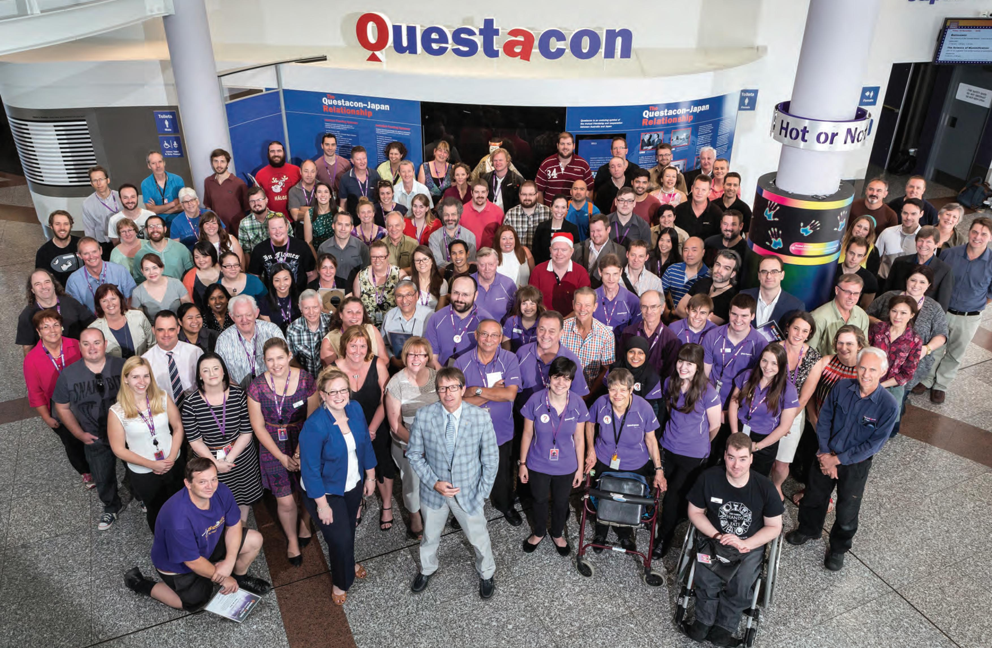

Questacon staff awards

2014
Peter Pateros
For his knowledge sharing and support of Questacon's partnership with the Australia Museum to develop and deliver the touring programme for the Deep Oceans exhibition.
Luke Hartley
For outstanding leadership, diplomatic representation during planning and delivery of the highly successful 2014 science circus Japan tour.
Ken Ross
Through his enthusiastic and upbeat approach, he has enhanced visitor experiences to Questacon by sharing his own depth and knowledge as a Gallery Assistant.
Alex de Vos
For consistent high quality performance, Alex has acted above and beyond his normal duties creating an exceptional first impression of the centre, and providing support and mentoring to other Questacon staff.
Matthew Bieniek
For his outstanding leadership, coordination and development of Questacon's 2014 Canberra Tourism Awards submission.
Michelle Canning
For her leadership and skills in coordinating the successful delivery of the launch by the former prime minister the Hon. Tony Abbott, MP, of The Ian Potter Foundation Technology Learning Centre.
Kelly Fong
For outstanding coordination and delivery of the 2014 Prime Minister's Prizes for Science Awards and Dinner.
Jamie Hartley
For consistent high quality performance and support of Questacon and the Finance Team including encouraging and mentoring staff to be the best they can be. Jamie's performance has surpassed her normal duties providing exceptional customer service to Questacon and its staff.
Ben Villani/Broderick Matthews
For their leadership and mentoring provided to the science circus scholars and for the outstanding coordination and delivery of the Shell Questacon Science Circus tour schedule.

2015
Bettina Payne
For the successful introduction of Questacon's first true e-business solution.
Geoff Crane
For his leadership in coordinating the successful delivery of the 2015 National Science Week.
Michael Bourke, Adam Leape, David Randall
For their diligence and positive approach they display towards their work always meeting operational needs and delivering high quality service to Questacon.
Sue Alexander
For consistent high quality performance and support of the Outreach Bookings Office.
Rondelle Sedan
For outstanding management and delivery of the interactive components and live specimens for the delivery of the Spiders exhibition.
Natalie Sullivan
For her exceptional work in bringing a diverse group of presenters into a cohesive team to deliver the Questacon Smart Skills initiative.
Matt Cracknell
For consistent high quality performance providing exceptional customer service for the delivery of numerous Questacon events throughout 2015

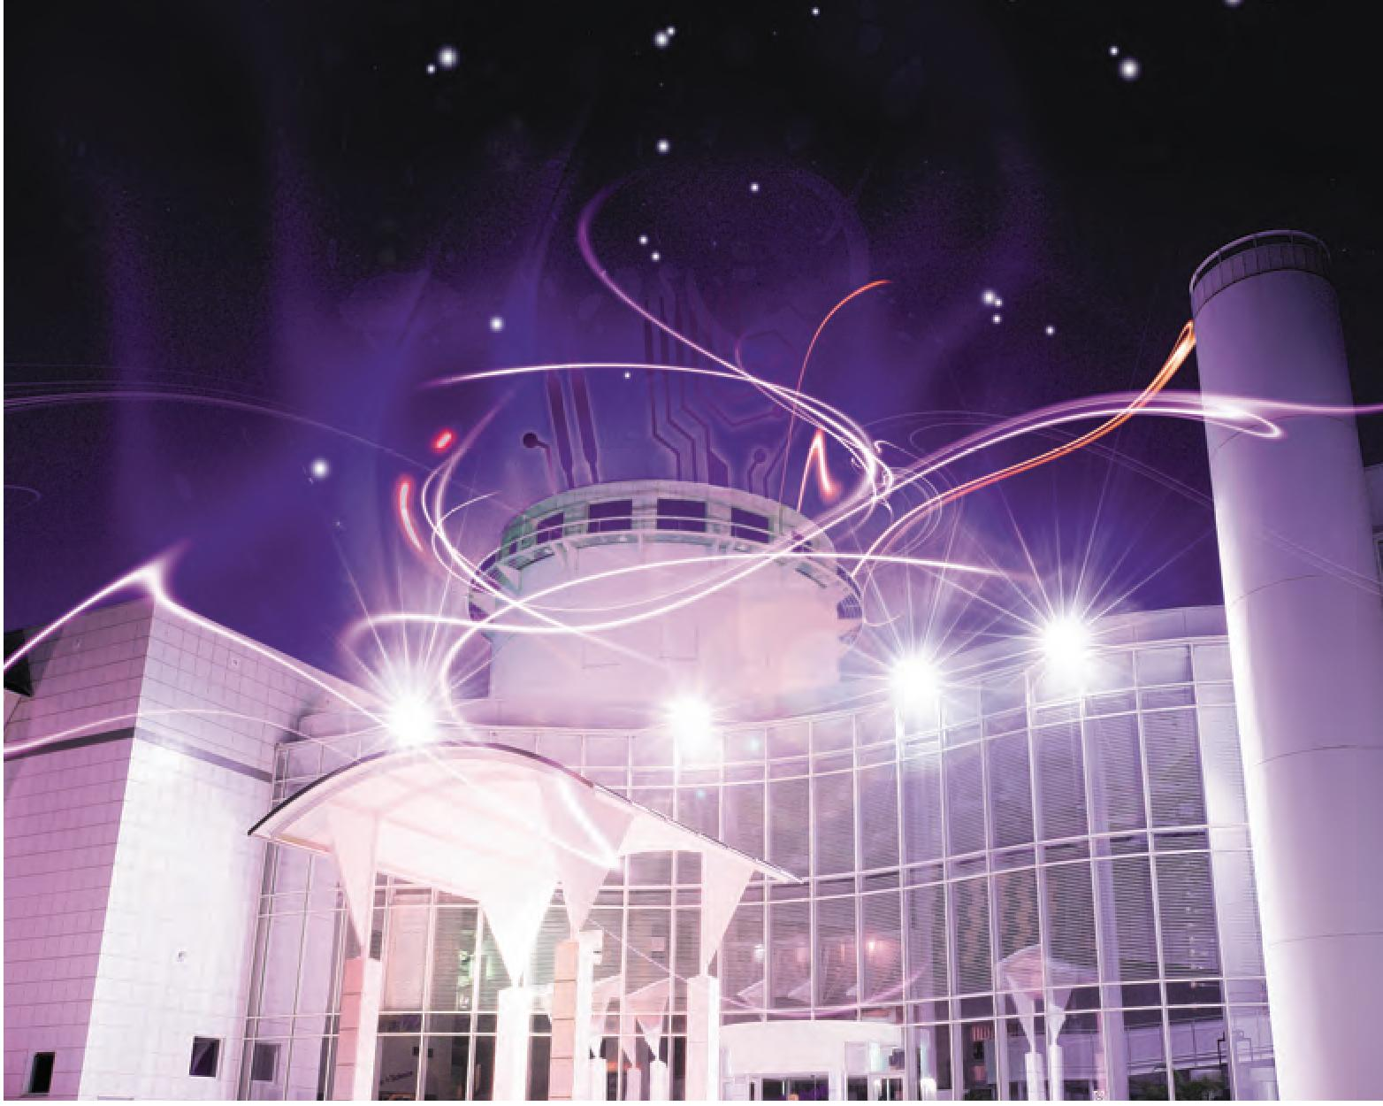
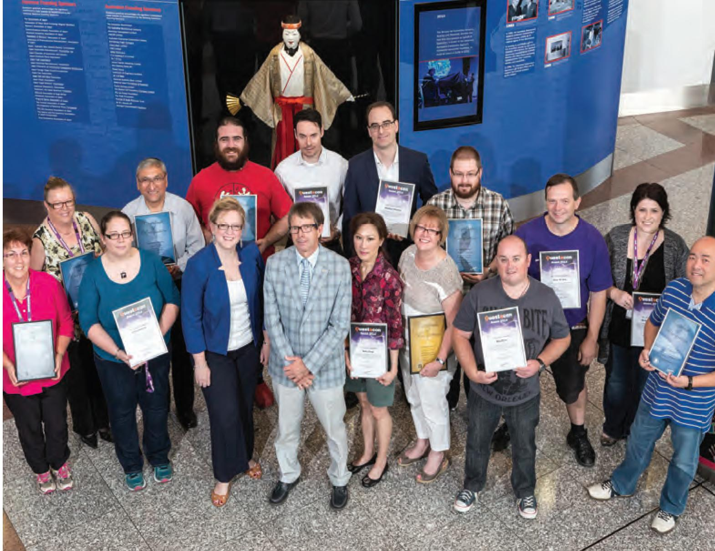

Questacon Years of Service

2014
Sally D'Addio - 25 years
Barbara Senticar - 20 years
Matthew Cracknell - 10 Years John Richardson - 10 Years
Kelinda Trungove - 10 Years
Ki Lam - 10 Years

2015
Allen Rooney - 20 years
Geoff Crane - 20 years
David Cannell - 15 years
Carolyn Moore-Crouch - 15 years
Tim Crowther - 15 years
Melissa Harvey - 15 Years
Gosia Sikorski - 15 Years
Sharren Kelly - 15 Years
Cindy Chambers - 15 years
Peter Mascini - 10 Years
Patrick Helean - 10 Years
Michelle Canning - 10 Years

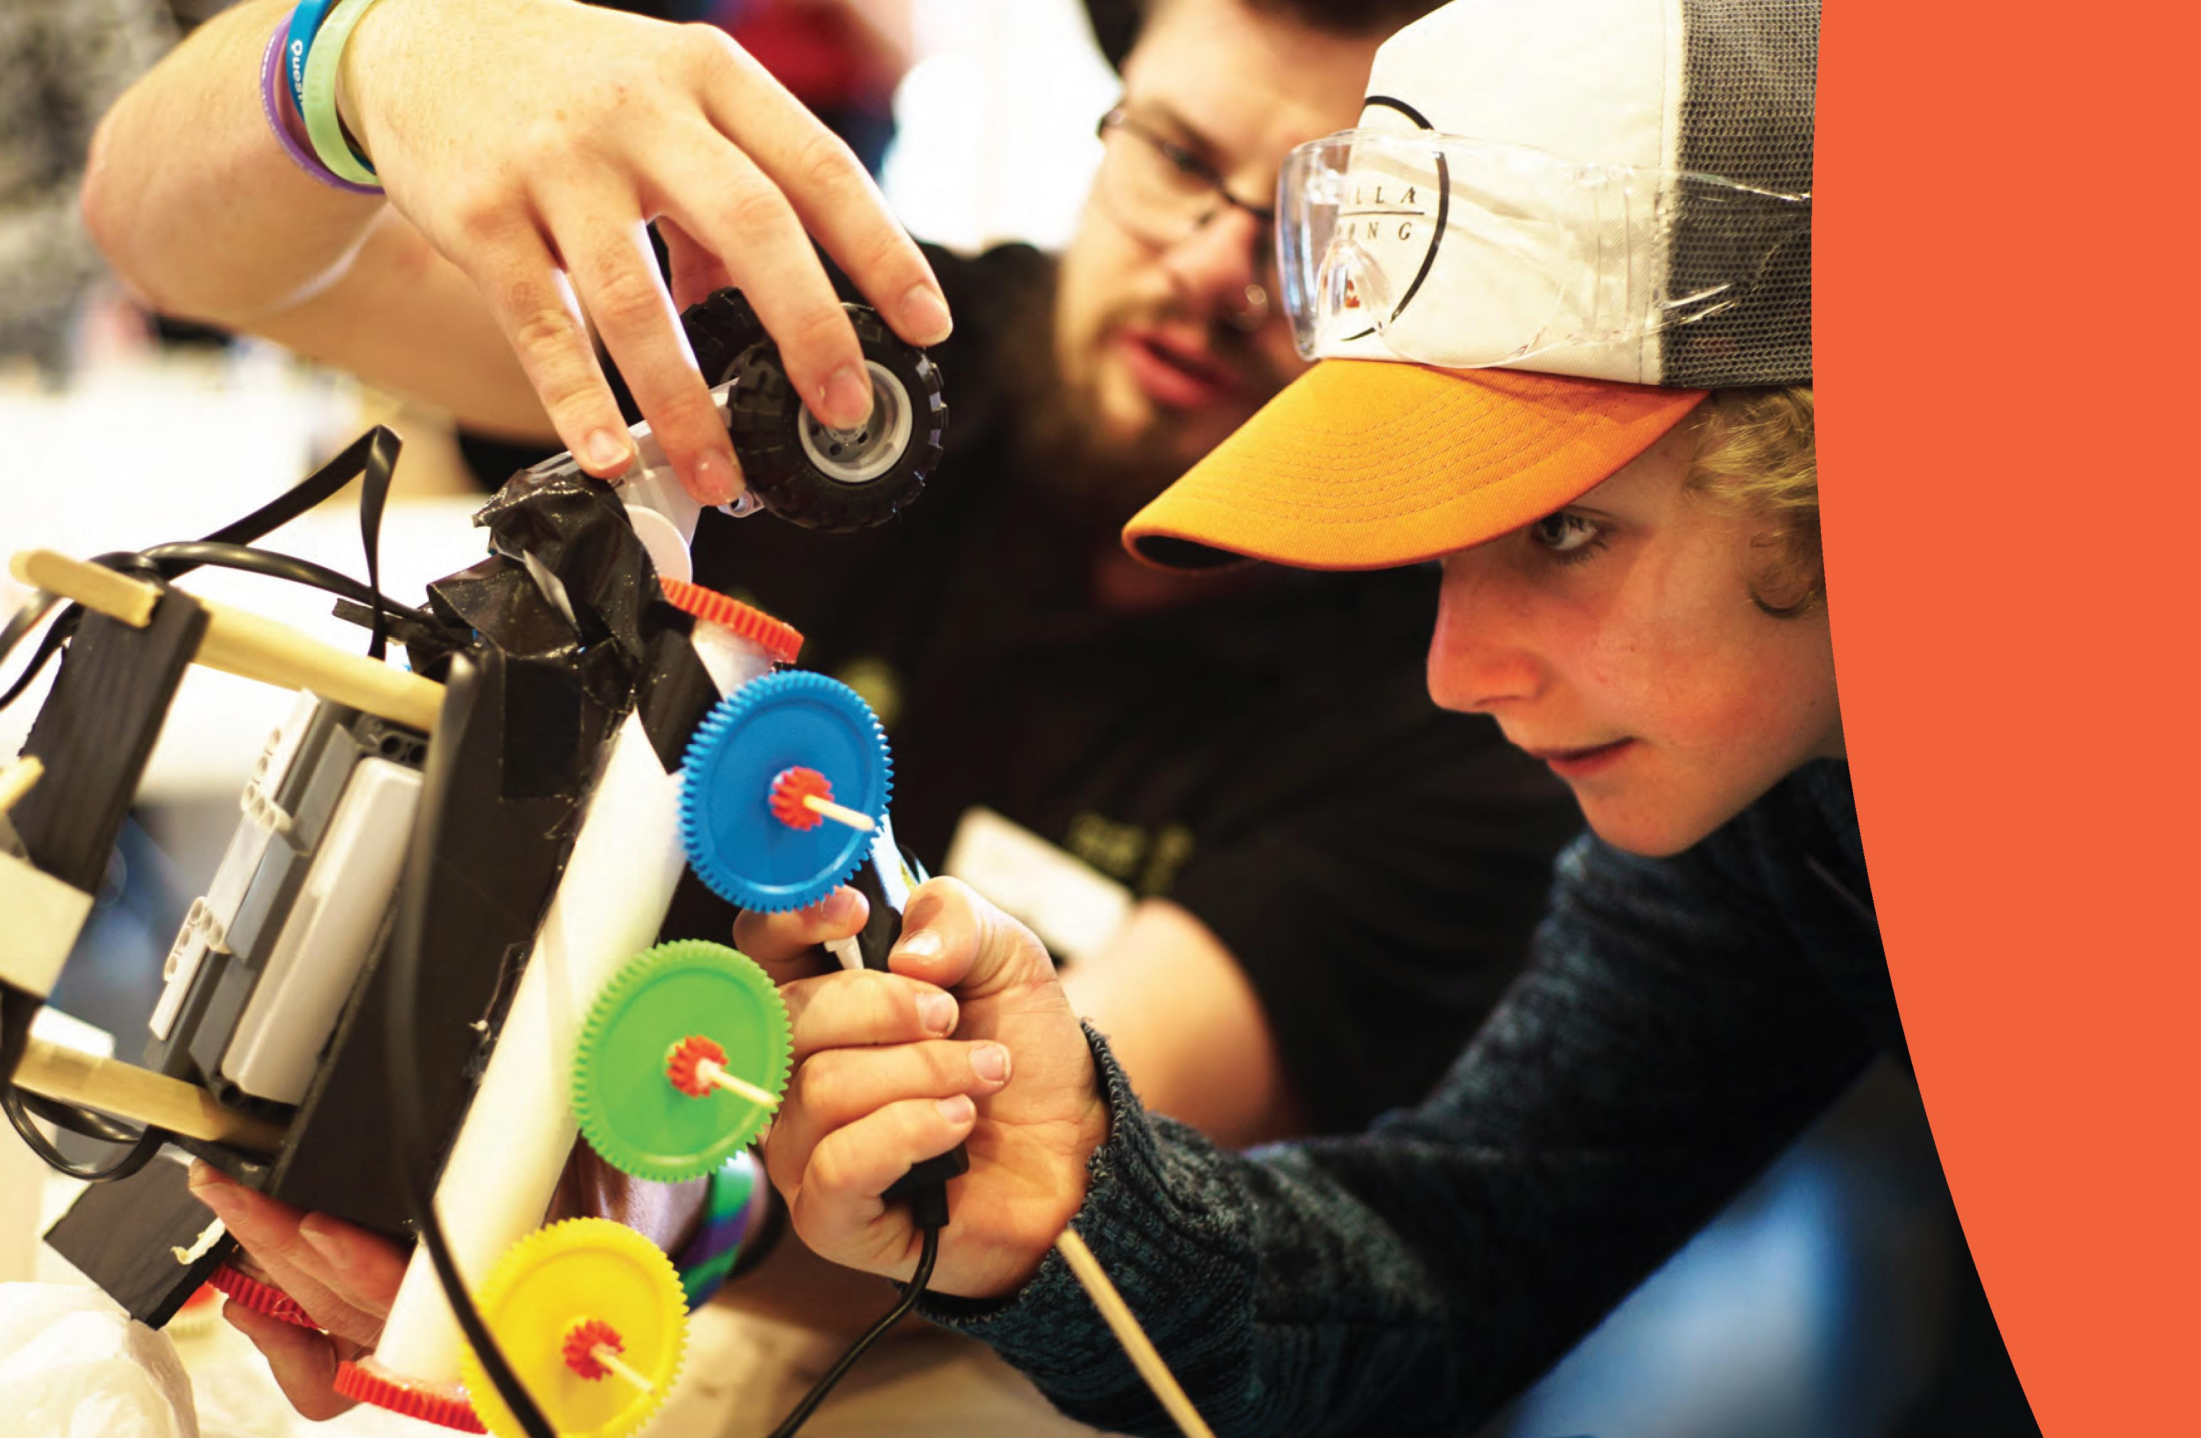



Science centres are wonderful places for communicating science. They are places that people want to go for a mix of education and entertainment and they go in large numbers.
Science centres are filled with passionate dedicated professionals who devote their lives to helping people improve their understanding of the world around them and their opportunities to make a difference within that world.
At a time when economic, political, religious and racial differences are highlighted daily and when the challenges facing life on planet Earth are becoming much clearer, science centres can play an important role in binding humanity together. With a focus on young people, families and the future, science centres are uniquely placed to work across geographic, political and economic boundaries.
Professor Graham Durant, AM Director, Questacon

Questacon - The National Science and Technology Centre
King Edward Terrace, Canberra, ACT

The Ian Potter Foundation Technology Learning Centre

60 Denison Street, Deakin, ACT
PO Box 5322, Kingston, ACT 2604
www.questacon.edu.au

PRINCIPAL PARTNER

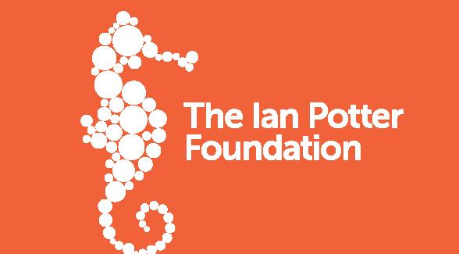
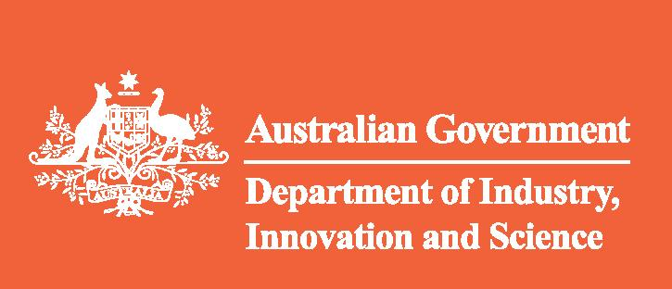
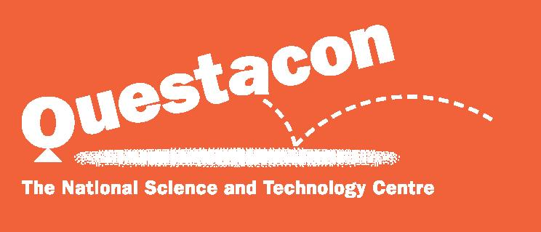

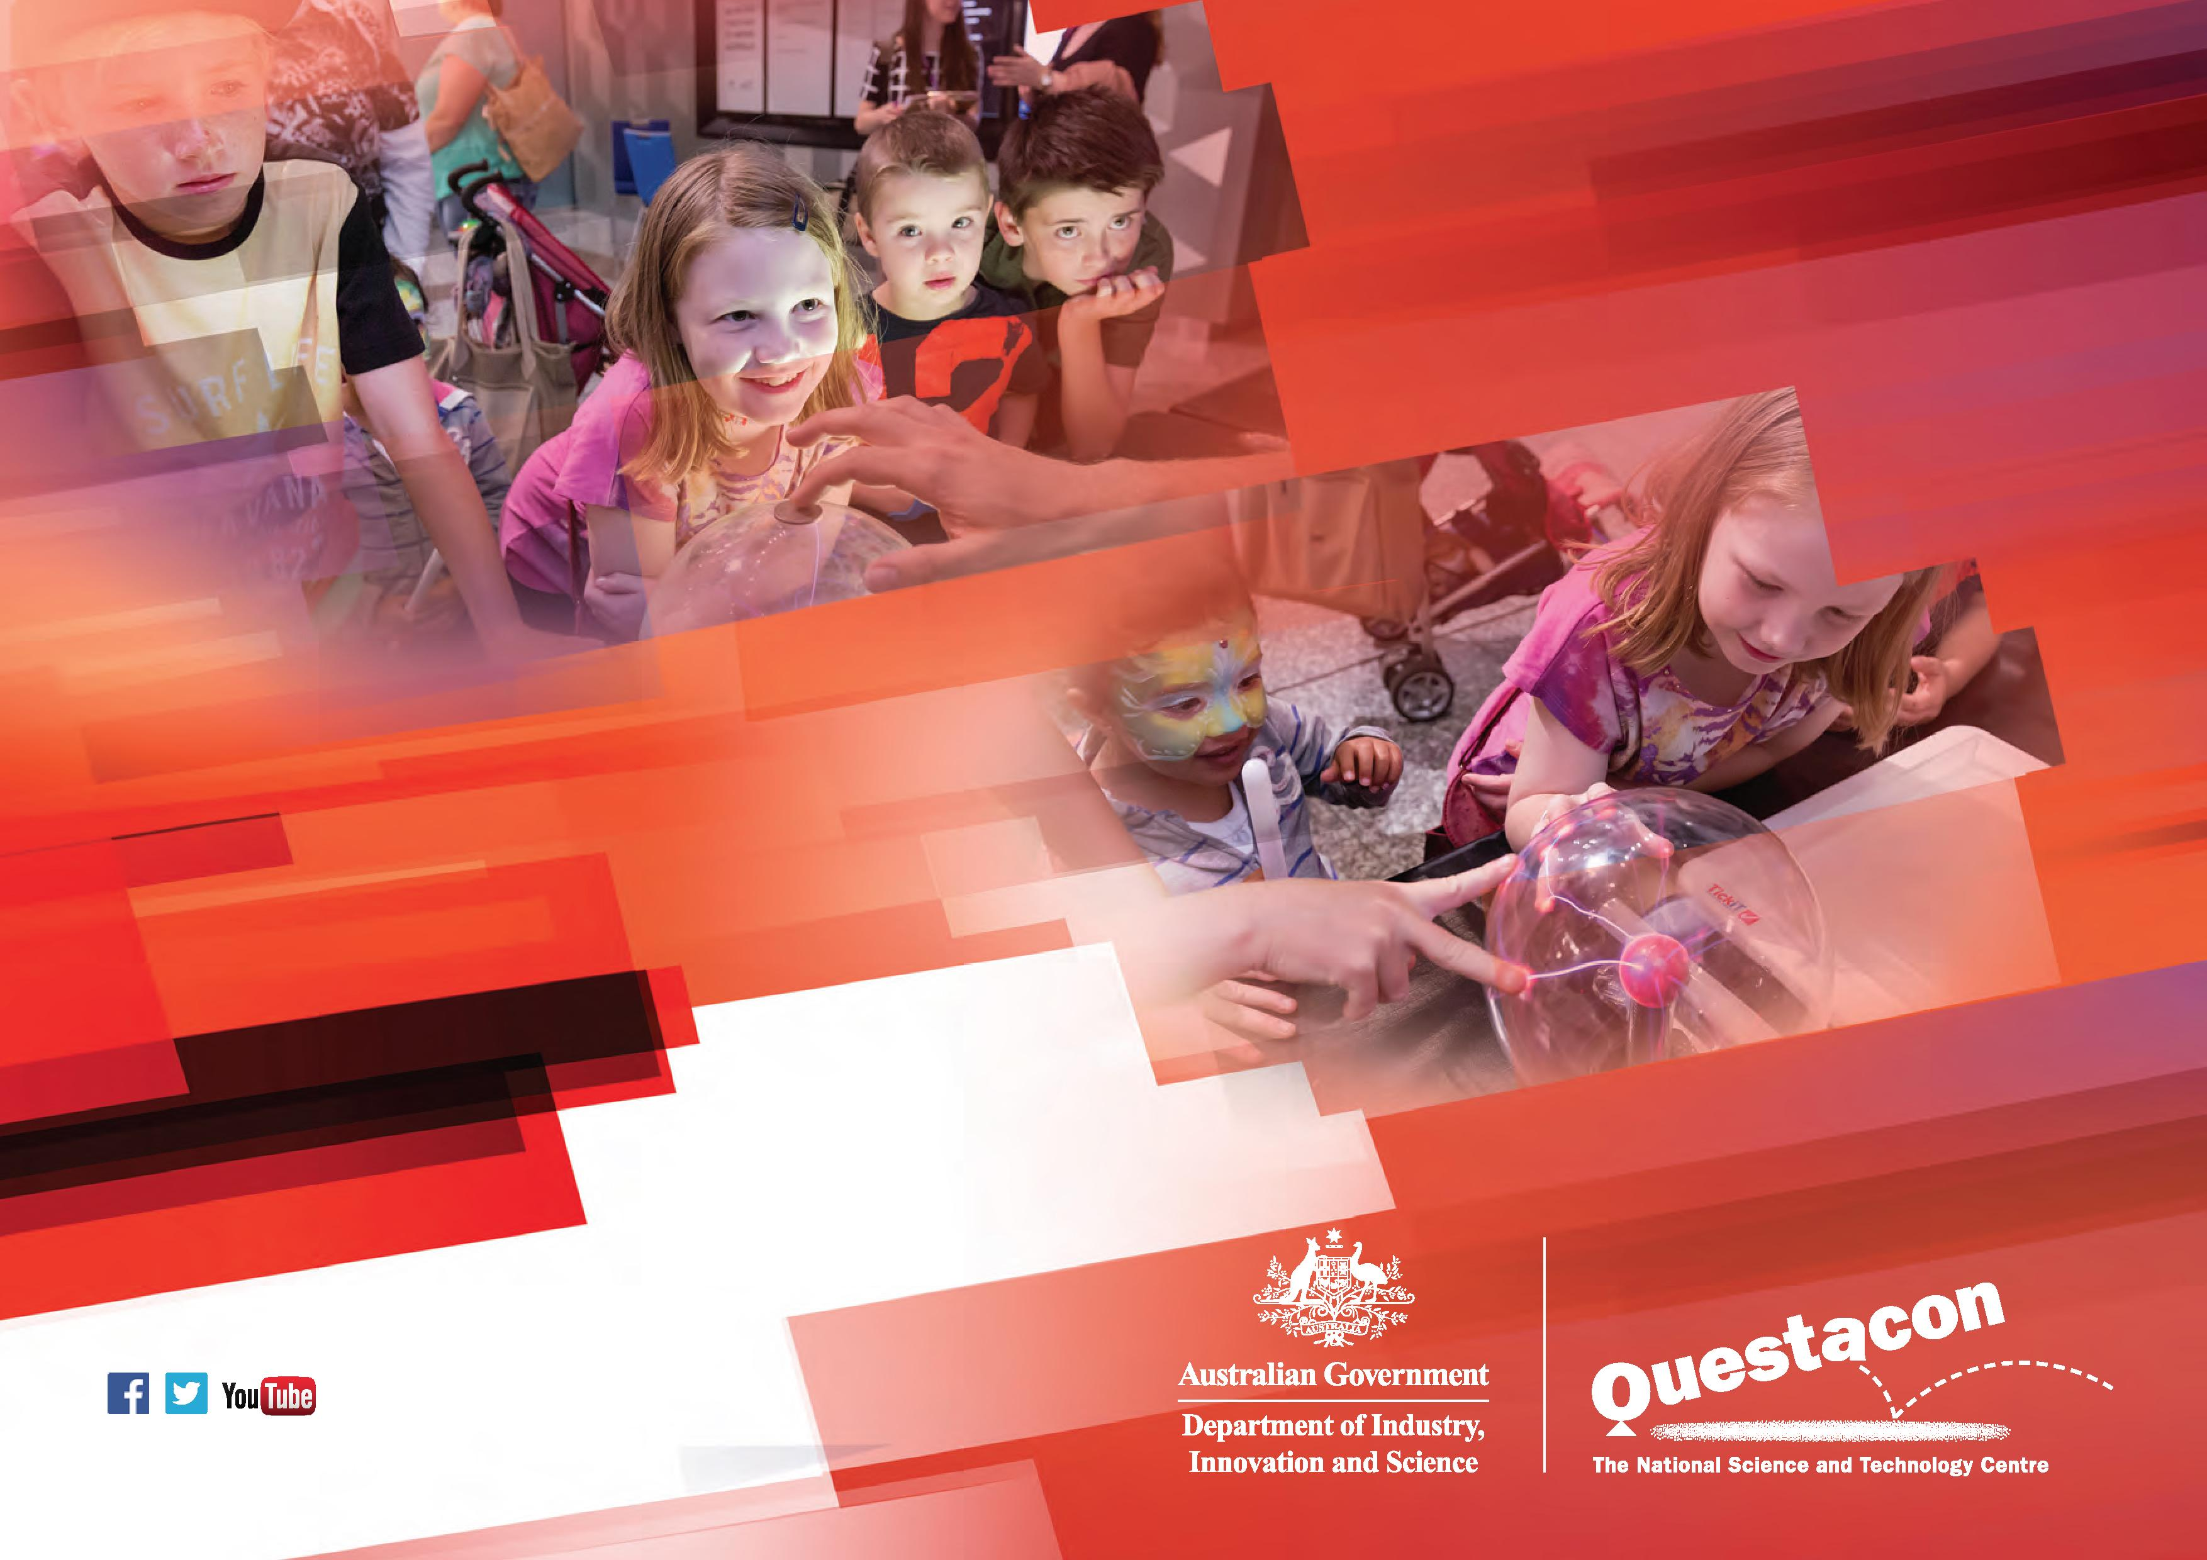
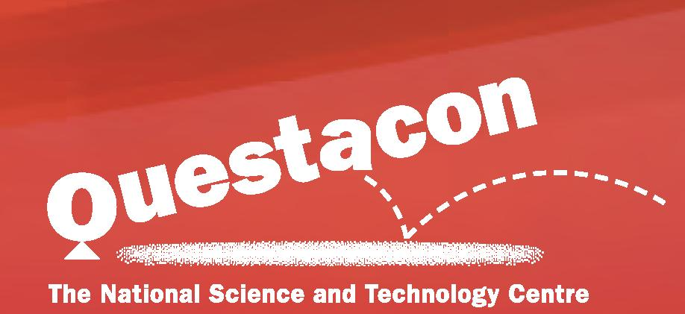
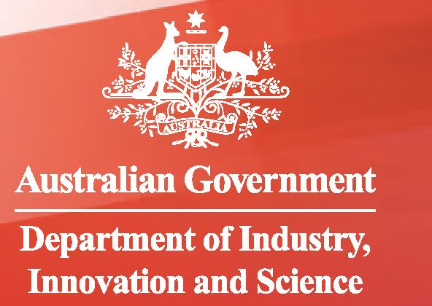



www.questacon.edu.au

