# 

# Our vision

A better future for all Australians through engagement with science, technology and innovation.

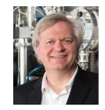

*‘We need to teach people to think through problems, to use facts and critical thought and learn about the world in which they live.’*

*– Professor Brian Schmidt AC , Nobel Prize Laureate and member of the Questacon Advisory Council*

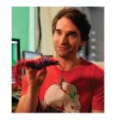

*‘To say you are not interested in science is to say you are not interested in life.’*

*– Todd Sampson, 2014 National Science Week Ambassador, science communicator and TV presenter*



*‘Australia cannot be just a quarry and service industries. It needs to be engaged in the excitement of science and innovation and have high skilled technology industries. Questacon encourages young minds to engage in problem solving and to enter the exciting world of science.’*

*– Mr Charles Goode AC , Chairman - Flagstaff Partners, Chairman - The Ian Potter Foundation*

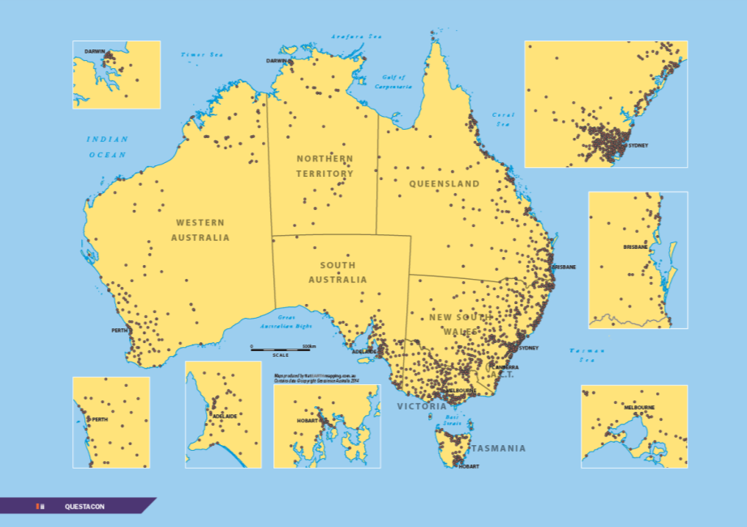

# Impacts at a glance

Questacon is a multi-award winning tourist attraction in Canberra’s Parliamentary Zone and has maintained very high visitor numbers and impacts, delivering over six million hours of inspiration to almost 430 000 visitors to the Centre in Canberra during 2013-14 (not including children under four years of age and those who only visited the café and *Q Shop).* Australia-wide Questacon programmes impact on over three million people, directly engaging with over 2.5 million people, helping to achieve its aim of building a scientifically engaged and aware Australia, that embraces innovation.

# Contents

Impacts at a glance........................................................................iii

Minister’s introduction....................................................................1

Chairman’s report...........................................................................2

Director’s report..............................................................................4

The challenge - to excite, inspire, motivate....................................6

Measuring impacts.........................................................................7

Questacon Advisory Council..........................................................9

2013-14 highlights.........................................................................10

1 Building science and innovation capability**................................**12

Case studies:

- Digital capabilities.......................................................................13

- Questacon people.......................................................................15

2 Enhancing educational outcomes**.............................................**18

Case studies:

- Travelling exhibitions...................................................................20

- Enhancing an interest in learning................................................21

- 2014 Science Circus Tour of Japan............................................22

3 Supporting economic transformation**.........................................**24

Case studies:

- The Questacon Technology Learning Centre........................... 26

- The tourism equation................................................................ 27

- Inspiring industry to inspire Australia........................................ 28

4 Leading science engagement**..................................................**30

Case studies:

- National Science Week..............................................................32

- Unlocking Australia’s Potential grants........................................33

- Prime Minister’s Prizes for Science............................................34

Celebrating 25 years....................................................................36

5 Appendices: 2013-14 programmes, people and partnerships...39

- 5.1 Programmes.........................................................................40

- 5.2 People...................................................................................50

- 5.3 Partnerships..........................................................................52

Looking to the future.....................................................................56

# Minister’s introduction

Questacon is one of Australia’s most valued assets for sharing the wonders of science throughout our community. Each year it records impressive statistics in the number of school children, parents, teachers and inquisitive community members it welcomes through its doors, but 2013–14 was a particularly big year for Questacon.

Not only did it celebrate its 25th anniversary as Australia’s National Science and Technology Centre, but it strengthened its foundation ties with Japan and engaged with almost one million people, impacting on three million. Over 25 years that figure has been about 26 million people.

That is a remarkable impact, not just in Canberra, but across Australia and internationally.

Questacon is distinctive amongst national institutions in that its impacts are so diverse. It is well-known for its science education activities, both in Canberra and around the nation, working to improve science literacy and our smart skills base, but it also plays a significant role in science diplomacy. For example, Questacon successfully interacts with, and has formed partnerships with, ambassadors, visiting government Ministers and international institutions.

Of particular note is the Centre’s relationship with Japan, which dates back to a funding gift from Japan for Australia’s Bicentenary in 1988, that went towards the building of Questacon. The relationship has continued strongly and in July this year the wife of the Japanese Prime Minister Mr Shinzo Abe, Mrs Akie Abe, visited the Centre.

As a business, Questacon also makes a significant economic contribution to the ACT. It is a multi-award winning tourist attraction, and alongside the other

national institutions in Canberra, it has a significant economic impact through income, jobs and services.

Several hundred science communicators have developed their skills in the Centre before embarking upon careers throughout Australia and the world, helping make science and technology more accessible to more people.

Questacon has grown to become one of the world’s most respected science centres, and its outreach and capacity-building programmes in particular are internationally renowned. Using the buildings in Canberra as a base, Questacon has reached out to establish closer working partnerships with centres around the country, and has toured regional locations, playing a key role in helping more Australians realise the importance of science and technology in their lives.

Questacon is also in the business of inspiring our scientific minds of the future, by challenging and supporting young people to discover the wonders of science, as well as think about how science can meet our economic and global challenges.

Science is crucial to our ongoing advances as a society and in our economy. In recognition of this, the Government is investing $28.1 million over four years in Science for Australia’s Future, which builds on the success of the Inspiring Australia programme, to promote science and reward scientific excellence. It includes funding for *National Science Week*, the *Prime Minister’s Prizes for Science* and other Questacon educational campaigns, such as the new *Questacon Smart Skills* programme.

I am confident it will be a good investment, and that Questacon will continue to show both national leadership and best-practice in achieving the outcomes

of this exciting Government initiative.

Questacon staff work closely with science and education professionals to ensure their programmes complement formal in-school education. These include encouraging more creative thinking, and encouraging careers in science, technology and business. Questacon owes much of its success to its active partnerships with many different organisations, and on behalf of the Australian Government I thank these sponsors and knowledge partners.

This year’s Annual Review highlights the many achievements Questacon has made in economic, educational and leadership goals, and showcases the broad reach of Questacon’s activities over the year.

I wish it every success over its next 25 years.



The Hon Ian Macfarlane MP Minister for Industry

# Chairman’s report

The foundation for the success of our next 25 years

It is not an understatement to say that Questacon is powered by partnerships. We have strong working relationships with organisations and individuals across government and the private sector, and we work hard to deliver on mutually beneficial outcomes.’

It has been a privilege and honour to chair Questacon’s Advisory Council through the Centre’s 25th Anniversary year as Australia’s National Science and Technology Centre.

The Centre was opened by the then Prime Minister, Mr Robert Hawke, on a very rainy night on 23 November 1988 - an occasion that was accompanied by several hundred scientists and research students, gathering outside the new building to express their concerns about the future of science in Australia.

I think most of them would be impressed by the impact that Questacon has had over this time, providing leadership in building a more scientifically-literate nation and lifting the profile and importance of science in our lives. Over its 25 years of operation as a national centre, Questacon has engaged with an estimated 26 million people - as visitors to its building in Canberra, through its many outreach programmes that traverse the country, and now through its digital media initiative.

Questacon has achieved this success with the support

of many people and organisations. In March 2014 I participated in another very memorable occasion at Questacon, a special dinner to recognise the unique relationship between Australia and Japan, and to honour Japan’s contribution to the Centre’s foundation. The generous Bicentennial gift from the Japanese Government and business community contributed half the cost of constructing the Questacon building 25 years ago.

One of the Centre’s galleries was transformed to accommodate the dinner, and several interactive exhibits were left for guests to interact with so that they could explore the wonder and pleasure that visitors to Questacon enjoy. It was a rare sight to see so many people in dinner suits and evening gowns playing with the exhibits the way children usually do.

Guests at the dinner included the Australian Minister for Industry, the Hon Ian Macfarlane M P, the Japanese ambassador, His Excellency Mr Yoshitaka Akimoto, as well as the Chairman and many members of Keidanren, the Japan Business Federation. Speakers stressed the importance of our relationship with Japan in ensuring that Questacon commences its next 25 years with the strong ongoing support of our partners.

One of the highlights of the dinner was the acknowledgment of Questacon’s *Science Circus tour to Japan*. The tour, which began in Tokyo in April, visited four tsunami-recovering communities in north-eastern Japan, as a symbolic way to showcase the value of and deep respect for our longstanding relationship. This attitude underpins all of Questacon’s diverse and vital

partnerships. It is not an understatement to say that Questacon is powered by partnerships. We have strong working relationships with organisations and individuals across government and the private sector, and we work hard to deliver on mutually beneficial outcomes.

These are two-way relationships between agencies that agree that inspiration is too important to leave to chance; that want to make science and technology more accessible; and who are committed to help Australia become a truly innovative society, able to meet the needs of a 21st century creative economy.

The challenges that were articulated in 1988 have not gone away. In some ways they have become more complex. There is still a vital need to focus our nation’s youth on the importance of understanding the impacts of science and technology on their lives, as well as further study and career options open to them in these felds. The need for a highly-skilled, innovative workforce will increase as we transition to an economy that relies less on mineral wealth and more on intellectual wealth.

‘Our future is going to be powered by creative thinking and the ability to seek high-technology solutions to emerging challenges.’

I would like to personally thank our many partners who collectively share this vision, in particular Shell and The Australian National University for their long-running and continuing support for the *Shell Questacon Science*

*Circus.* Others that deserve mention include Raytheon Australia, the Australian Bureau of Statistics, the Australian Museum and the Murray-Darling Basin Authority.

My personal thanks also goes to members of the Questacon Advisory Council for their collegiality and continuing support of Questacon: Mr John Simpson (Deputy Chairman), Associate Professor Tracey Bunda, Dr Catherine Foley, Professor Denis Goodrum and Professor Brian Schmidt.

I also thank the Minister for Industry, the Hon Mr Ian Macfarlane, for his continued support, as well as the ongoing support of the Department of Industry.

Questacon Director, Professor Graham Durant, deserves special congratulations for his leadership of Questacon through its 25th anniversary year and for the strength of his vision and passion throughout the year.

Finally I would like to thank Questacon’s many dedicated staff and volunteers. It is their daily dedication and enthusiasm to their roles that maintains Questacon as the dynamic and inspiring organisation it has been for 25 years. They are providing the foundation for the success of our next 25 years.

Signature of Leon Kempler OAM, Questacon Advisory Council Chairman


Leon Kempler OAM

Questacon Advisory Council Chairman

# Director’s report

Moving from inspiration to impact

‘We know that a visit to Questacon, or a visit by a Questacon programme to a school or community, can be a life-changing experience.’

A challenging question for everyone working at Questacon is, ‘How sure are we that we are making a difference?’ It is a question that every organisation should ask itself every now and then.

We have been successful at inspiring hundreds of thousands of individuals every year and people love Questacon and its programmes, but how well are we helping people move from inspiration to impact?

Walking around the building and talking to the many hundreds of visitors who are actively engaging with our science exhibits 364 days a year, it is easy to see these impacts. We can see it in the faces of children that light up with wonder as they observe, or come to understand, a scientific principle. We hear it from parents and teachers as they relate to us the impact a visit has had on their children. We read it in the many emails and letters of thanks we get from people who have visited us, or we have visited.

But we need to know that we are not just measuring delight on the day, and know that the way people engage with us has a catalytic effect on increasing their interest in the value of science and technology, or even prompting people to consider careers in science.

Questacon’s vision is to contribute towards a better future for all Australians through engagement with

science and technology. It is a vision our many partners share, as well as our Advisory Council, and the Government, that collectively support us.

Realising this vision is our daily challenge.

Fortunately Questacon has not just 25 years of experience in delivering hands-on programmes, but has 25 years of working with other science centres and education researchers both in Australia and around the world, to feed into making a real impact. It is not always easy, and working in tight financial circumstances makes it all the more harder, but it is something that we believe is vital.

An international report into the impact of science centres, released in February 2014, found that science centres, including Questacon, can: “state with much greater confidence that the presence of one or more healthy and active science centres within a community, region, or country represents a vital mechanism for creating and maintaining a scientifically and technologically informed, engaged and literate public.”

The ways in which Questacon does this, and how we can measure our impacts, are profiled throughout this Review.

At a national level, Questacon is a partner in a new Australian Centre for Excellence in the Science of Learning, based at the University of Queensland, that will continue research into the ways that young people process learning related to scientific reasoning, which will help us understand the best learning models for young children.

This is important, because at the local level we are quite certain that amongst the many hundreds of thousands of young visitors to Questacon each year are going to be the problem-solvers and knowledge generators of our future, people who will help establish the innovative industries we need. We need to help them step up to higher levels of learning and participation in science to help achieve this.

We know that a visit to Questacon, or a visit by a Questacon programme to a school or community, can be a life-changing experience. It may only be a subtle change in their attitude or in an interest that leads to a different direction through study and life, through discovering new options than they had considered previously. Alternatively it could provide the inspiration and motivation that leads to a career in science and technology.

And 2013-14 has been a busy year for Questacon activities. We have had continued celebrations for our 25th anniversary, two successful overseas tours to Vietnam and Japan, a visit to the Centre by the wife of the Japanese Prime Minister Mrs Akie Abe, several new exhibits, and our annual events including National Science Week, the Prime Minister’s Prizes for Science and the many Inspiring Australia events we support.

In addition we have seen the first year of operation of the new Questacon Technology Learning Centre in Canberra and the *Shell Questacon Science Circus* has visited over 330 venues, covering 20 000 kilometres around Australia, as it edges closer to celebrating 30 years of operation. More information on these is contained in this Annual Review.

Our successes are built upon the support of many people that deserve a special thanks. These include all of our partners, the Minister for Industry, the Hon Ian Macfarlane, the Australian Government Department of Industry, and our Advisory Council. Together we are working to ensure that Questacon’s impacts are as relevant to those we engage with today, as they will need to be for those we engage with in the future.

Signature of Professor Graham Durant AM Director

Professor Graham Durant AM Director

That is the motivation that keeps us going, knowing that our activities are having such impacts and that they align closely with key strategic directions such as the recommendations for a Science, Technology, Engineering and Mathematics strategy released by the Chief Scientist, Professor Ian Chubb in 2014.’

# The Challenge - to excite, inspire and motivate more Australians about science and technologies

Those who engaged least often were more likely to be less interested, more concerned about science and technology and had greater trouble understanding it.’

‘While interest in science tended to be higher amongst elder people, young people had the highest levels of disinterest in science.’

A major survey of Australian attitudes to science and technology has revealed the scope of the challenge of engaging people in science. The study was undertaken through The Australian National University’s National Centre for the Public Awareness of Science, and amongst the key findings were that:

• Most people agree that Australia should be a world leader in science research and development (8.1 on a ten point scale); and Australia should be a world leader in technology research and development (7.9).

• A majority (88%) also said that they thought that a career in science is a good choice.

• Two-thirds of people (66%) said they had visited a science centre, science museum, botanic garden, zoo or similar in the past 12 months.[1]

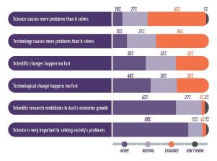

However, almost a quarter (23%) said the scientific information they found was generally hard to understand, slightly more (35%) said the pace of scientific change happened too fast for them to keep up with, and as many as four in ten (40%) were either not interested in finding out about science and technology, or were neutral on it.

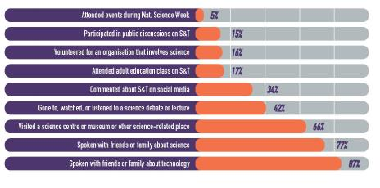

Dividing the general public into four segments, based on how frequently people engaged with science, clearly showed that people who engaged most frequently with science and technology were more interested in them. Those who engaged least often were more likely to be less interested, more concerned about science and technology and had greater trouble understanding things when they searched for information.

Added to this is the finding from a CSIRO study from 2013 that found that while interest in science tended to be moderate to high amongst elder people, young people had the lowest levels of interest in science.[2]

The challenge of exciting, inspiring and motivating more Australians about science and technologies, and young people in particular, is clearly a pressing one.

# Measuring impacts

‘For both youth and adults, visiting a science centre significantly correlated with increased science and technology knowledge and understanding.’

*International Science Centre Impact Study, 2014*

There are many challenges in measuring the long-term impacts of science centre visits. Not the least is that individuals typically acquire an understanding of scientific concepts from an accumulation of experiences and from many different sources.

However, the most comprehensive study into impacts of science centres has recently been undertaken, to determine how well experiences at science centres correlate with a range of critical public science and technology literacy outcomes. The study looked at data from 17 science centres including Questacon, from 13 countries.

The findings, released in early 2014, were very positive for science centres.[3] The study found that for ‘both youth and adults, visiting a science centre significantly correlated with increased science and technology knowledge and understanding, as well as an engagement with, and interest in, science as a school subject.’

Importantly, surveys were conducted of both the general community, as well as centre visitors, to enable meaningful comparisons.

While acknowledging that correlation was not causation, the report concluded: “Overall, the results strongly and consistently showed that for both youth and adults, science centre experiences positively correlated with science and technology-related outcomes. In particular, visiting a science centre significantly correlated with increased:

• science and technology knowledge and understanding,

• science and technology interest and curiosity,

• engagement with and interest in science as a school subject,

• engagement with science and technology-related activities out-of-school, and

• personal identity and confidence in science and technology.

‘We now have a clear indication that science centres are a relevant tool to improve scientific literacy among our population.’

*Vera Brudny, Programme for Popularising Science and Innovation, Argentina*

Using evidence of impacts

Questacon actively uses the findings of national and international studies to inform its programme design, and meet the Government’s objectives of increasing engagement in science and technology. Such findings include:

• An authoritative and extensive review on informal science learning provided by the US National Research Council (2009) concluded that there is compelling evidence of learning in settings such as science centres. Outcomes included:

- Evidence of excitement and positive emotional responses;

- Clear evidence of learning science content;

- Evidence of engagement and reflection; and

- Evidence of integrating science learning with values and identity. <http://www.nap.edu/openbook.php?record_id=12190>

• A report prepared by Frontier Economics for the British government in 2009, found:

- Science centres may improve people’s understanding of scientific issues;

- change people’s attitudes; and

- encourage children to pursue careers in science.

That report also found:

- 59% learned more than expected;

- 43% evoked thoughts about science; and

- 12% reported change of attitudes towards science.

*Assessing the impact of science centres in England,* 2009. <http://sciencecentres.org.uk/govreport/docs/impact_of_science_centres.pdf>

# Questacon Advisory Council

Photo of Mr Leon Kempler OAM, Chairman, Australia-Israel Chamber of Commerce


Mr Leon Kempler OAM

*Chairman*

*Australia-Israel Chamber of Commerce*

“Questacon is sowing the seeds of scientific curiosity and discovery.”

Photo of Mr John Simpson, Deputy Chairman, Managing Director, John P Simpson & Associates Pty Ltd


Mr John Simpson

*Deputy Chairman*

*Managing Director, John P Simpson & Associates Pty Ltd*

“Our world is changing more rapidly every year. Technology and innovation are forcing change in every aspect of life in new and exciting ways. Questacon is helping the young, and not so young, open their imaginations to possibilities which will shape our future.”

Photo of Dr Catherine Foley PSM, Deputy Director, and Science Director of CSIRO Manufacturing


Dr Catherine Foley PSM

*Deputy Director, and Science Director of CSIRO Manufacturing*

“When I visit Questacon I can see how our future generations of scientists are discovering the wonderment and power of science.”

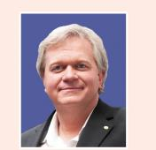

Distinguished Professor Brian Schmidt AC

*Research School of Astronomy and Astrophysics, Australian National University*

“Better understanding how science affects us enables people to make better decisions about how science should be used in society. Questacon is contributing to making people more scientifically literate, and able to better participate in decisions on our science and technological future.”

Photo of Emeritus Professor Denis Goodrum, Executive Director—Science by Doing, Australian Academy of Science


Emeritus Professor Denis Goodrum

*Executive Director—Science by Doing, Australian Academy of Science*

“It is not just the active learning at Questacon that is important, but rather the way people take those ideas home and apply them to the issues they experience in their everyday life. That’s where real impact happens.”

Ex-officio Council Members

Photo of Professor Graham Durant AM, Director of Questacon, Division Head, Department of Industry


Professor Graham Durant AM

*Director of Questacon, Division Head, Department of Industry*

Photo of Dr Subho Banerjee, Deputy Secretary, Department of Industry


Dr Subho Banerjee

*Deputy Secretary, Department of Industry*

Questacon operates as a division of the Department of Industry and contributes to the Department’s key outcomes of enabling growth and productivity for globally competitive industries through building skills and capability; supporting science and innovation; encouraging investment; and building the future of Australia’s industry.

Questacon has an Advisory Council, appointed by the Minister, comprising representatives from the business, science and education sectors. The Advisory Council assists in setting Questacon’s strategic direction by providing advice to the Director of Questacon and the Minister for Industry.

# 2013-14 Highlights

Questacon continued to be active locally, nationally and internationally, delivering exhibition tours and capability development projects around Australia, and in several countries, as well as welcoming delegations from around the world to the Centre in Canberra. Highlights of the year included:

National Science Week

In August 2013, 1.6 million people participated in over 1850 *National Science Week* events around Australia.

Prime Minister’s Prizes for Science

In October the *Prime Ministers Prizes for Science* were awarded to five outstanding Australians. The prizes are most prestigious awards for excellence in science research and science teaching and the recipients were Professor Terry Speed *(Prime Minister’s Prize for Science),* Professor Angela Moles (Frank Fenner Prize for Life Scientist of the Year), Associate Professor Andrea Morello (Malcolm McIntosh Prize for Physical Scientist of the Year), Mr Richard Johnson (Prime Minister’s Prize for Excellence in Science Teaching in Primary Schools) and Ms Sarah Chapman (Prime Minister’s Prize for Excellence in Science Teaching in Secondary Schools).

Questacon’s Birthday Bash

On Saturday 23 November 2013 Questacon celebrated the launch of its 25th anniversary. The Centre was opened on 23 November 1988 as a joint Australia-Japan Bicentennial Project.

Questacon-Japan Dinner

On the evening of 19 March 2014 Questacon hosted a dinner to welcome the Government of Japan and the Keidanren (Japan Business Federation) within the walls of the National Science and Technology Centre, that Japan was integral in founding. The dinner recognised and honoured the contribution of the Government of Japan and the Keidanren for their 1988 Bicentennial gift to establish Questacon.

Questacon Tour of Japan

Questacon toured Japan in April and May 2014, delivering a free public science exhibition and science shows for the people of the tsunami-recovering region of Thoku, in north-eastern Japan. The tour recognised Japan’s long-term investment in Australia and celebrated the 25th anniversary of Questacon, and Japan’s special role in establishing the Centre.

Questacon Wins Tourism Awards

In November Questacon won two awards at the 2013 Canberra and Capital Region Tourism Awards, winning the Tourist Attraction and Tourism Education Programme categories. The awards were in recognition of the consistently high-quality experiences given to both families and school groups who visit Canberra.

Shell Partnership

Shell has partnered with Questacon and The Australian National University to present the *Shell Questacon Science Circus* for 29 years. Questacon participated in the Shell Innovation Open House held at The National Library of Australia during November 2013. Professor Graham Durant was one of the speakers at the event

and Questacon performers interacted with attendees and Shell executives including Jorma Ollilla (Chairman, Royal Dutch Shell) and Maarten Westellar (EVP, Upstream International Integrated Gas).

International Year of Crystallography

In January Questacon held a special event to mark the UN International Year of Crystallography, and 2014 also marked 100 years since the technique was developed by Nobel Prize winning father and son team, William Henry and William Lawrence Bragg, who undertook their early work in Australia

USA Workshops

Questacon was represented at the International Public Science Events Conference (IPSEC), and the American Association for the Advancement of Science (AAAS), meeting held in Chicago, USA, in February.

Capability Workshop in Brunei

A capability development workshop was held in Brunei just ahead of the annual Asia Pacific Network of Science and Technology Centres (ASPAC) conference in M ay.

Brian Schmidt at World Congress of Science Centres

Questacon Advisory Council member, and Nobel Laureate, Professor Brian Schmidt, gave a keynote address at the World Congress of Science Centres in Brussels in March. The event was attended by other Questacon staff who also presented.

Vietnamese Diplomacy

A visit was undertaken to Vietnam in May 2014 to deliver a capacity building workshop, which was a part of Questacon’s Memorandum of Understanding with Vietnam’s Ministry of Science and Technology, along with the ANU’s Australian National Centre for Public Awareness of Science (CPAS). It was followed by a ten-person Vietnamese Ministry delegation spending two weeks in Canberra at ANU and Questacon for training in science communication.

Perception Deception Exhibition

In May the exhibition Perception Deception returned to Questacon. The exhibition explores how our sense of ‘reality’ is formed by our brains using sensory information—but our senses can sometimes deceive us. Perception Deception has been one of Questacon’s most popular travelling exhibitions, having reached over 360 000 people since it began touring in 2009.

Awesome Earth Re-opens

The very popular exhibition Awesome Earth was reopened in May after an extensive refurbishment. The exhibition highlights the mighty power and stunning beauty of our planet and the wonders of the universe through exploring natural phenomena and how they interact.

The Enterprising Australians exhibition

An exhibition on Enterprising Australians at the Questacon Technology Learning Centre was launched by the Secretary of the Department of Industry, Ms Glenys Beauchamp PSM, on 10 July 2014. The exhibition supports and highlights the stories of Australian inventors and innovators.

Watoto Children’s Choir visited Questacon

The African choir group, consisting of 22 orphaned children from 7 to 13 years of age and nine adult teachers, visited the Centre on Saturday 28 June 2014. Watoto Children’s Choirs have travelled internationally since 1994, as advocates for the estimated 50 million children in Africa, orphaned as a result of HIV/AIDS, war, poverty and disease, and present their vision and mission through their stories, music and dance.

# Impacts 1: Building science and innovation capability

Outcomes

Over the year Questacon reached over 2.5 million people, and had impact on over 3 million people.

In its first year of operation, the Questacon Technology Learning Centre (QTLC) welcomed over 1500 visitors.

This year saw an increase of Questacon’s own innovation capabilities in the social media space. Over the year our Facebook followers more than doubled from 1084 to 2334 and our YouTube channel has received over a million views.

A total of 406 636 website visitors from across Australia and around the world engaged with Questacon online in 2013-14.

Questacon is committed to contributing to the building of Australia’s science and innovation capacity. Yet two key challenges for Australia as we move further into the 21st Century are to both see global changes coming, and to be flexible enough to adapt to them quickly. Australia likes to pride itself on being an innovative nation, but the benchmark for innovation has moved a lot further beyond inventions such as the Hills Hoists or fencing-wire solutions. The global standards for innovation are now very high-tech, very adaptable and based increasingly on strong science, technology and entrepreneurship.

Building a science and innovation capability, and an entrepreneurial culture, should be a priority for a country like Australia, so that our resource booms can then be invested wisely to enable our nation to be well

positioned internationally when such booms come to an end.

Questacon, and its many partners, recognises the importance of capability building in areas of science, technology, engineering and mathematics (STEM) and know that to gain the cultural change needed across Australia, new ways of thinking need to be instilled in young people that will then follow them across their years of study and work.

Since its inception Questacon has been striving to change the cultural acceptance of science in Australia, and to steer more young people towards careers in science, though helping people to see the importance of science in their lives, and providing them with exposure to career options and role models.

In recognition of the need to address learnings about technologies and not just science, the Questacon Technology Learning Centre was opened in Canberra in mid-2013. This marked a strategic change of direction for the organisation, building on the learnings of our *Questacon Smart Moves* and *Invention Conventions*. The new *Questacon Smart Skills* programme, announced in the 2014 Federal Budget will also address these issues.

The QTLC is based upon two vital questions: Why do so many early to mid-secondary school aged children not have an opportunity to explore and understand the rewards of applied science, technology and innovation? And why are so many Australians actively interested in using technologies, but so few are interested in creating them? Over the next few years we look forward to seeing the impact of such programmes on those who take part in them.

Case study: Digital capabilities

Questacon is leading the way in areas of digital engagement, with multi-disciplinary capability in video production and videoconferencing, along with expanding communication via online and social media. Questacon’s expertise in slow motion media production, for instance, has not only been used in the growing library of slow-motion clips Questacon has produced and added to its dedicated YouTube Channel, but it has also garnered increasing interest from a variety of partners, including the ABC’s flagship science programme Catalyst, which has utilised the high speed camera for a story showing the dangers of portable lasers on eyes.

This year saw also an increase of Questacon’s activity and presence in the social media space as we sought new ways to engage audiences through new media. Although just starting out in the areas, over the year our Facebook and Twitter followers doubled. We also began using social media aggregation techniques in major event pages such as the Twenty-five Years of Inspiration page and also in many of the web pages in the Discover section. This technology is used to gather together items related to specific activities at Questacon from a broad range of social media platforms and encourages online visitors to join the conversation.

A total of 406 636 website visitors from across Australia and around the world engaged with Questacon online in 2013-14. Our website continues to grow with new content being developed daily. Some examples of this include Enlighten 2014 and *Enterprising Australians.*

As an innovative use of the website’s Content Management System, content is now being served to digital display panels in the Centre foyer and in the *Enterprising Australians* exhibition at the Questacon Technology Learning Centre. Staff are able to update information such as show times, welcome messages, *Q Shop* specials and more by logging on to the website.

Work has also commenced on developing the online *Q Shop* and this is expected to be available in 2015.

<http://www.youtube.com/user/QuestaconNSTC>[www.facebook.com/Questacon](http://www.facebook.com/Questacon) [www.twitter.com/Questacon](http://www.twitter.com/Questacon)

[www.questacon.edu.au](http://www.questacon.edu.au)

Case study: Questacon people

‘It is the staff who make Questacon the great organisation that it is.’

Questacon employed 224 staff in full-time, part-time or casual positions at the end of 2013-14. Our workforce is both culturally and professionally diverse, with wide-ranging expertise in science, customer service, design, construction, acting, education, facilities management, marketing, communication, finance, planning, information technology, public administration, occupational health and safety, retail and electronics.

Questacon also contributes to the professional development of science communicators in Australia, providing entry-level opportunities for a significant number of tertiary students and recent graduates, who are employed as gallery staff at the Centre and as presenters for Questacon’s outreach programmes.

In particular, the *Shell Questacon Science Circus,* has a staff of up to 16 science graduates from The Australian National University’s Master of Science Communication Outreach programme, run out of the ANU’s Centre for the Public Awareness of Science. The *Science Circus* work is a part of the ANU Master of Science Communication degree and the qualification offers students the opportunity to develop their science communication skills through practical experience. Since 1985 more than 350 graduates have completed the course associated with the *Shell Questacon Science Circus* programme.

Questacon also has a dedicated team of 65 volunteers, who in 2013-14 contributed a total of 10 363 hours.

Together with gallery staff, volunteers provide exhibit explanations and science demonstrations to visitors, including Discovery Trolleys (portable science exhibits) and Curiosity Corner (a hands-on science experiment station).

In addition there is the school student volunteer programme that provides a total of 40 hours work experience for about 40 year 11 and 12 students from the region each year.

Questacon staff’s expertise is widely acknowledged in the high number of local, national and international bodies and networks that they actively take part in.

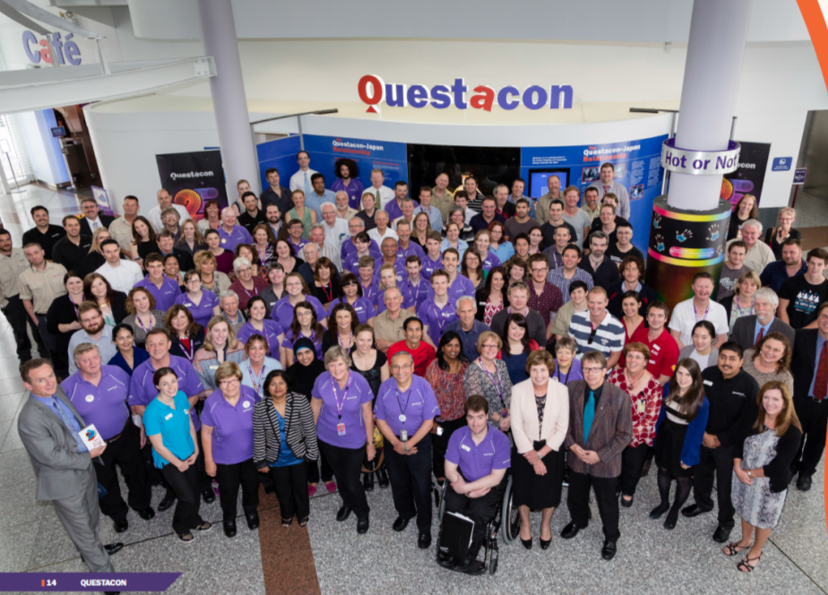

One of our amazing team - David Cannell

David Cannell, one of the *Questacon Excited Particles,* and resident dinosaur fan, took part in a dinosaur dig in Western Queensland for a week with Australian Age of Dinosaurs. David helped uncover fossil remains of a potentially new Australian sauropod (long-necked dinosaur), and he personally found and excavated a large bone thought to be the dinosaur’s coracoid bone (part of the shoulder). In all several massive rib bones, dorsal vertebra, pelvic girdle and shoulder elements were discovered.

David has since communicated his digging experiences to the public by participating in the *QTLC Torque* lecture series, and plans to turn some of the newly-learnt knowledge into a new Dinostory puppet show.

In 2014 David was awarded a People Management Award from the Department of Industry.

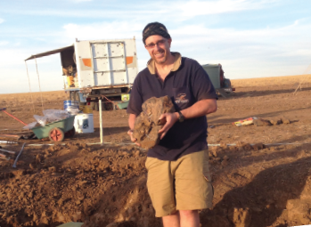

Questacon’s longest serving volunteer

Mrs Jenny Wanless OAM, is Questacon’s longest-serving volunteer, having worked with Questacon longer than the building has existed.

Mrs Wanless, who has a science degree in geology, started volunteering in March 1981, when Questacon was based in spare rooms at the Ainslie Public School in North Canberra. At one stage volunteering was a family affair, with her two sons and daughter also becoming volunteer explainers.

In 2010 Jenny Wanless received the Medal of the Order of Australia for her service to science through her voluntary roles with Questacon and to the Nature and Society Forum – which also marked the 30th Anniversary of the Questacon Volunteer Explainer Program.

Since 1980, over 4000 volunteers have been Questacon Volunteer Explainers.

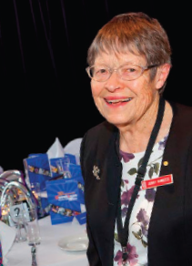

Jesse Jorgensen-Price – inspired by seeing the Science Circus

*Shell Questacon Science Circus* presenter, Jesse Jorgensen-Price, saw the *Science Circus* doing a show in the Horsham Town Hall when she was about eight-years-old, and was so impressed by it that she decided to both study science and join the *Science Circus* herself one day.

Following a Bachelor of Environmental Science in Marine Biology, she is now undertaking her Master of Science Communication degree and touring Australia with the *Shell Questacon Science Circus*.

She said that the rest of the *Science Circus* team is like an instant family, and her favourite part of the work was watching the faces of children as they were enthused and amazed by the science being demonstrated for them.

“You can see kids thinking so hard to get answers out,” she said.

“I’m really glad that the *Science Circus* came to Horsham. It changed my life and I decided I’d like to do that for other people.”



Joe Duggan - applying science communication to climate change

Joe Duggan studied Zoology and Marine Science before deciding to apply for the Master of Science Communication at the ANU.

“I did it on a whim,” he said. “I had been working as a builder’s labourer at the time, having a break from science.

“I felt I was very lucky to have gotten in. I am excited to go to work every day because I can excite kids about science.”

He said he loves the travel and the skill set that he is learning, and in applying these skills has developed a website where climate change scientists can post comments about how they feel about the science or understanding of climate change - allowing them to express their emotions, and humanising them.

<http://isthishowyoufeel.weebly.com/> has been picked up by online media including [news.com.au](news://news.com.au) and Mother Jones, and Joe says he would like to continue working on the project after he has finished his time with the *Science Circus.*

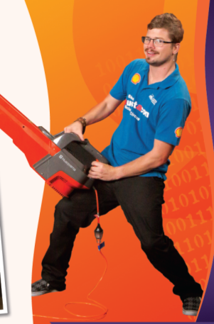

# Impacts 2: Enhancing educational outcomes

Outcomes

Questacon delivered over 6 million hours of science inspiration and engagement in 2013-14, with impacts estimated to have reached over three million people, across all activities. This included receiving 429 153 visitors to Questacon (with 127 333 school children and teachers visiting in 2260 school groups). There were also 560 257 visitors to six travelling exhibitions across Australia.

In addition, activities run under *National Science Week,* reached some 1.4 million people.

It is not an understatement to say that the challenges in effectively teaching science in Australian schools are huge. There are still too few trained science teachers in primary schools, students in high schools are often not interested in science subjects, or don’t find them relevant. The demands on teachers to be across the rapid advances in science and technology across a breadth of disciplines that they may not have studied, are constrained by limited teacher professional development opportunities.

However these issues also mean that any quality support services that can be offered are likely to have great impact.

Questacon is widely recognised as a world leader in the delivery of science outreach programmes that

enhance education outcomes across regional Australia. Questacon has always worked very closely with science teachers and organisations like the Australian Science Teachers Association (ASTA) and the Design and Technological Teachers Association (DATTA), to ensure that our programmes in science, technology, engineering and mathematics (STEM) are relevant to curriculum needs and students’ learnings.

In 2013–14, over 120 000 school children and teachers visited Questacon in over 2200 school groups, who overwhelmingly rated their experiences as positive. Questacon has the capacity to provide learning experiences and hands-on experiments that are beyond the resources of most schools, but can support in-school teaching.

Questacon’s programmes start as young as pre-school, recognising the importance of early childhood learning, running through to senior secondary school students. They have been developed to support national education priorities in early childhood, in primary science and in innovation and technology, to enhance the education outcomes of students of all ages.

Local delivery

Questacon displays more than 200 exhibits in eight galleries at any one time, and the galleries are staffed by Questacon science communicators and volunteers, who assist students and other visitors to explore and experience science through interaction with the hands-on exhibits.

Questacon also presents special events, science lectures and other activities throughout the year featuring leading Australian and international scientists and experts in a variety of felds. These special events often tie in with Canberra’s public festivals and major exhibitions in our neighbouring cultural institutions with a focus on promoting careers in science.

The Questacon Technology Learning Centre, which has now been open for a year, fills an important gap in providing late primary and secondary school students with engaging learning experiences about technologies and innovation.

Questacon even has a special exhibition space for little scientists. *Mini Q* is designed especially for babies, toddlers, pre-schoolers and school aged children up to six years old, who might be too young to fully enjoy the main galleries.

National delivery

Through its outreach programmes and through digital media technology, offering such things as interactive workshops and programmes via videoconference to schools across Australia, Questacon is able to extend its reach and impacts.

The *Shell Questacon Science Circus*, for instance, travelled approximately 20 000 kilometres and presented at 336 venues across Australia during 2013– 14. Prior to the *Science Circus* visiting these regions, many of the residents in these communities had limited access to this kind of science exposure or interaction.

During this year, 916 schools have benefited from our touring programmes with 726 teachers directly participating in our professional development *Stress Free Science* workshops. Very importantly, across both primary and high schools, teachers reported that the programme increased their student’s enthusiasm for science.

International delivery

At an international level, Questacon took part in several significant events in 2013-14 that included a tour of tsunami-recovering regions of Japan that involved many schools visits, and several international conference presentations on topics including the interface between science centres and forma l education centres.

*visiting Canberra visit*

‘A study of visitors to two Australian science centres

*Questacon*

found: “The vast majority (73%) of visitors could articulate an outcome after several months of elapsed time. Most of them reported that they gained new perspective and awareness on science.’

*(Falk, Dierking and Rennie, 2004)*

Case study: Travelling exhibitions

Questacon provides travelling exhibitions that tour to a range of regional and metropolitan venues across Australia, fulfilling Questacon’s national role and responsibility of providing access to hands-on learning that might not otherwise be easily possible. The interactive exhibitions are developed in-house by Questacon and provide engagement for all ages. During 2013–14, Questacon toured six travelling exhibitions to eight venues reaching 560 257 visitors nationally.

The travelling exhibition programme included:

• *Deep Oceans*, which toured to two national venues, Newcastle and Brisbane. Positive feedback was received regarding the exhibition and each host venue added new elements to make the exhibition their own. This exhibition was developed in partnership with the Australian Museum.

• *Mathamazing*, which saw its first year out at Scienceworks, Victoria. The exhibition experienced very high visitor numbers at Scienceworks and staff and visitors alike were keen to take on the mathematical challenges.

• *Science on the Move*, which received good media coverage, with a story on Behind the News discovering the benefits of science exhibitions in a school environment.

‘Today, there are more than 3000 science centres in the world. They are visited by more than 300 million visitors each year.’

Case Study: Enhancing an interest in learning

Questacon seeks to foster a love of learning, curiosity and questioning, across multiple learning levels. This allows students and teachers to be engaged at suitable levels, and encourages them to then deepen their learnings. Some activities have the potential to take a person through all the different levels of learning outlined in Bloom’s Taxonomy of thinking skills (see illustration below) while others might work best at particular levels. With an aim of moving people higher up the hierarchy (regardless of what level they start at) Questacon has its own categories of engagement, that are similar to Bloom’s (see illustration on right).

By providing a wide variety of educational opportunities and experiences, from hands-on activities through to Questacon maker activities or the Innovation Challenge, Questacon seeks to encourage the development of higher order thinking and doing skills.

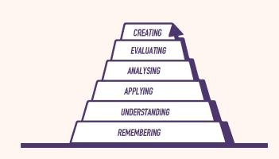

Diagram A: *Bloom’s Taxonomy of the hierarchy of higher order thinking skills*

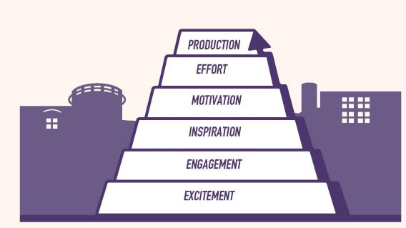

Diagram B: *Questacon’s hierarchy of higher order thinking skills*

‘The evaluation of the Informal Science Education Program of the U.S. National Science Foundation shows that of people with science careers, 85–92.9% indicated as their most memorable informal education activity from their childhood, visits to planetariums, aquariums, zoos, science museums or natural history museums.’

*(Sladek, 1998)*

Case study: 2014 Science Circus Tour of Japan

Questacon toured Japan in April and May 2014 delivering a free public science exhibition and science shows for the people of the tsunami-recovering region of Tōhoku in north-eastern Japan. The tour recognised Japan’s long-term investment in Australia and celebrated the 25th anniversary of Questacon – The National Science and Technology Centre, established in 1988 by a generous bicentennial gift to the people of Australia from the Government of Japan and Keidanren (Japan Business Federation).

Delivered in partnership with Japan’s National Museum of Emerging Science and Innovation (Miraikan) and supported by Scitech Discovery Centre (Perth), the tour introduced the successful Questacon Science Circus outreach model of science communication to Japan. The tour also contributed a significant cultural event to the Australia-Japan relationship by delivering a learning exchange through the conduit of science communication. The tour promoted the international profile of the Australian Government’s role in the global science sector.

The strategic purpose underpinning the tour supported the Government’s Australia in the Asian Century strategy relating to engaging with Japan. As the tour not only connected regional communities but strengthened Questacon’s ongoing collaborative involvement with Japanese science centres, it was funded by the Department of Industry and sponsored through a grant provided by the Department of Foreign Affairs and Trade through the Australia-Japan Foundation. Following the tour Mrs Margie Abbott, wife of the Prime Minister of Australia, accompanied

by Mrs Aki Abe, wife of the Prime Minister of Japan, visited Questacon to experience a selection of the tour’s science demonstrations.

The tour of Japan included five Japanese cities, performing to schools with a free public exhibition on weekends, and engaged an overall audience of 14 000 people. Capacity building and volunteer training sessions were also delivered in each tour location. The tour culminated in a video conference between Australia and Japan linking Australian schools to science communicators on the tour.

The 2014 Science Circus Tour of Japan stands as a case study of best-practice international science diplomacy and is a timely collaborative project ahead of the 2017 Science Centres World Summit that will be held in Tokyo.

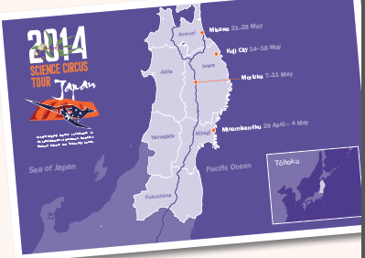

# Impacts 3: Supporting economic transformation

Outcomes

Questacon actively contributes to creating the skilled workforce of tomorrow that will be needed to support economic transformation, though engaging young people on the importance of innovation.

As a business , Questacon contributes to a strengthened Canberra economy through tourism and education , and investmentin youth.

In 2013-14, Questacon’ s turnover was $37.6 million (including $ 4.796 million of *Inspiring Australia* funding that was administered as grants). Questacon received government funding of $11.674 million in operational funding and $6.388 million in capital funding. In 2013-14, total revenue was $21.742 million, with Questacon generating 46 per cent of this from Centre admissions, fees for programmes, touring exhibitions and services, *Q Shop* sales, sponsorship, *Q Club* memberships and lease revenue.

As a tourist attraction, Questaconvisitors this year contributed to the $1.3 billion generated by Tourism in Canberra Region

In November 2013 Questacon won two awards in the Canberra and Capital Region Tourism Awards, winning the Tourist Attraction and Tourism Education Program categories.

Economic transformation is premised on the ability to move from low productive activities to higher productive activities. This demands a highly-skilled workforce, working within a suitable economic environment, generally focussed on advanced industrial development. This is one of the goals of the Australian Government, in seeking to transform Australia to a higher productive nation and increase our standards of living.

However, in a highly-competitive world, it is not enough to be just re-skilling and being more innovative than we had been previously, as the rest of the world is trying just as hard, or harder, to transform their own economies as well. It has become a fiercely competitive game, described well by economists as ‘fast lane’ and ‘slow lane’ economies. The trouble is that an isolated country like Australia can easily think it is in the fast lane, when in fact it has slipped into the slow lane.

The challenge we need to rise to has been described by the Australian Chief Scientist, Professor Ian Chubb AC, as, “The end we aim to achieve is to build a stronger Australia with a competitive economy. We will need to facilitate growth in ways and on a scale that we have never achieved before.”

Australia needs a diverse economy built on sustainable productivity growth, knowledge-based industries and high value goods and services.

It is becoming clear that a piecemeal approach will not be enough to be truly competitive, and all public institutions who can make a contribution should be working together towards a whole of government approach, keeping our eyes on the goal of economic transformation.

International competition is going to intensify as emerging markets, particularly in our region, move up the value-add chain in manufacturing and services. And as the global economy transforms, and our population ages, we will have to maintain continued improvements to our economic productivity to maintain our living standards.

Australia needs a culture of innovation to help improve our sustainability, productivity and competitiveness within the world market. According to the 2013 Global Innovation Index, Australia ranks 19th in the world for innovation, with one of our key weaknesses being the low number of graduates in science and engineering.

Questacon takes its role in contributing to economic transformation very seriously, and understands the importance of both investing young people with an interest in science and technology, and an understanding of how they can feed into the innovation process. We seek to raise the profile of scientific learning and encourage careers in science and technology. We seek to profile Australia’s successes and help younger Australians see how they can be a part of them.

Questacon is seeking to seed the values and attitudes that will be needed amongst our workforce of tomorrow and ensure that science and technology and their benefits are a part of wider thinking right across society. We want to be a part of laying the foundations for sustained economic growth and see a country that remains socially, economically and culturally wealthy.

Our country has the potential to be a significant knowledge economy in the Asian growth centre of our region of the world – but only if we are prepared for it.

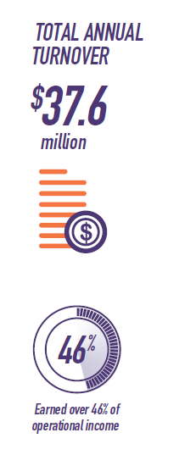

Case study: the Questacon Technology Learning Centre

The Questacon Technology Learning Centre (QTLC) has been established to expose the next generation of entrepreneurs, business people, technologists, inventors, engineers and innovators alike to the foundation of technology and the innovation process. The QTLC offers programmes and exhibitions that stimulate an interest and awareness of basic design and technology processes and encourages young people to develop skills and creativity in solving problems, showcasing how several Australian inventions have successfully navigated this pathway.

The major exhibition, *Enterprising Australians,* was launched by the Secretary of the Department of Industry, Ms Glenys Beauchamp PSM, on 10 July 2014. This exhibition supports and highlights the stories of Australian inventors and innovators in many fields from biotechnology to manufacturing and the commercial success stories from across the Australian business sector. The exhibition is designed to give visitors a greater understanding of Australia’s innovators and Australia’s place in world technology. It is hoped these inspiring stories will also help guide them in their own career choices and goals.

It builds upon the success of early exhibitions, such as *Henry Hoke: The Lost Tools of Henry Hoke,* displayed within the Gallery of Australian Inventiveness. This playful exhibition featured the astonishing creations of a fictitious forgotten Australian inventor. This travelling exhibition was developed by the Institute of Backyard Studies (which concentrates on creative output of small-scale places like backyard sheds), and was customised for its installation at the QTLC, including new interpretive panels to include a Canberra chapter to tell the tale of fictional inventor and entrepreneur Henry Hoke.

The vision for the Questacon Technology Learning Centre is to energise formal and informal technology education across Australia, through innovative partnerships, to develop a more enterprising culture.’

Case study: The tourism equation

As one of the top-rated attractions in the Canberra region, Questacon plays a significant role in the $1.3 billion of revenue that tourism contributes to the local economy each year. Questacon is a member of the National Capital Attractions Association (NCAA), which helps it leverage the menu of offerings across the region. Questacon’s Manager of Visitor and International Engagement, Craig Whelan, was Vice President of the Association this year.

Questacon takes part in major tourism initiatives supported by the ACT Government, such as Floriade, Enlighten and many other events enjoyed during the Centenary of Canberra in 2013.

Each year Questacon welcomes over 125 000 children from around Australia, who come in school group visits that are co-ordinated through the National Capital Educational Tourism Project (NCETP). These school group visits draw $105 million per annum in real terms into the ACT economy, and Questacon is one of the top three drivers for such visits.

In 2014 Questacon was awarded a TripAdvisor Certificate of Excellence Award, which recognises hospitality excellence, and is awarded to establishments that consistently achieve outstanding traveller reviews on TripAdvisor.

How Questacon rates as a top tourist attraction in Canberra

*No. 1* on [www.weekendnotes.com](http://www.weekendnotes.com)

*No. 1* on [www.hercanberra.com.au](http://www.hercanberra.com.au)

*No. 3* on [www.thetouristattractions.blogspot.com.au](http://www.thetouristattractions.blogspot.com.au)

*No. 4* on [www.tripAdvisor.com](http://www.tripAdvisor.com)

*No. 5* on [www.experienceoz.com.au](http://www.experienceoz.com.au)

*No. 7* on [www.canberra100.com.au](http://www.canberra100.com.au)

*Editor’s Pick* on [www.kidspot.com.au](http://www.kidspot.com.au)

Case study: Inspiring industry to inspire Australia

Questacon proudly runs the *Inspiring Australia* strategy on behalf of the Australian Government. Industry and business organisations play a key role in helping to achieve the *Inspiring Australia* goals of not only inspiring more Australians to become engaged in science, but to increase uptake of studies and careers in science.

A good example is the South Australian company, SAGE Automation, that is helping to grow the automotive manufacturing skills needed by industry for future manufacturing.

Not many people leave high school knowing how to assess, modify, test, disassemble and assemble an energy-efficient vehicle. But for students in northern Adelaide, the GM Holden-sponsored Volt Eco Challenge is giving them the opportunity to do just that. The programme is just one of Adelaide’s Northern Advanced Manufacturing Industry Group (NAMIG) ‘Concept2Creation’ initiatives developing science, technology, engineering and maths skills in the future local workforce.

Brett Sandercock, Group Business Manager of SAGE Automation, a national leader in industrial automation and control system integration, thinks the Volt Eco Challenge is ideal for anyone thinking of a career in the manufacturing or building industry.

“At first, it all sounds simple,” says Brett. “The students are given a Scalextric model car and track, and told to measure the car’s efficiency and to improve it. But they are soon faced with the same challenges any manufacturer faces: how do we measure efficiency accurately? What systems can improve performance? And—crucially—how can we work in a team to solve problems and build better products?”

As Brett explains, SAGE Automation provides the Volt Eco Challenge students with the technology to answer these questions.

“We supply instruments to test efficiency, so that students can take a baseline measure and decide how to modify their cars. When my colleagues and I go to see the students race their vehicles, we’re always amazed at the weird and wonderful solutions they’ve tried. But that’s the point of the exercise. Finding out what works, and what doesn’t and why, is exactly what our business does in the real world.”

The other challenge of the racing days—the complete disassembly and reassembly of the vehicles by student teams, under time pressure—develops a skill set Brett sees as ‘fundamental’.

‘Production management techniques aren’t taught in schools, but they apply to almost any science or technology-based business you can think of.’

“Our business is about developing industrial systems, from conveyer belts, to robotic arms, to the software that drives the plant. This means we don’t just need engineers, but electrical and other trade-based professionals, all working as a team to deliver a product that works on site.”

Teresa Janowski, General Manager of NAMIG, says that the support of medium businesses like SAGE Automation is fundamental to the success of the Concept2Creation programme.

“NAMIG started in 2003 with the aim of lifting the science, technology, engineering and maths skills of high school students in Northern Adelaide, to give them a better chance in the employment market,” explains Teresa. “It has evolved into something much bigger than that, thanks to the invaluable contributions of different companies, including cash donations, expertise in mentorship, and in-kind support. SAGE’s involvement has been fantastic, because they provide us with specific efficiency measuring tools designed and built just for NAMIG.”

For Brett, a room full of excited students racing model cars makes it all worthwhile.

“A lot of our employees are community-minded and want to ‘give something back’ as well as keep local manufacturing industries alive and kicking. Through the Volt Eco Challenge, we can meet both aims with negligible cost to our core operations. To see these young people get involved and exceed their own expectations is really inspiring to us.”

‘It is important that as a nation we make connections between creativity, technologies and enterprise as a catalyst for 21st century innovation.’

# Impacts 4: Leading science engagement

Outcomes

Through Questacon, the Australian Government committed $21 million over three years, through to June 2014, to *Inspiring Australia*, to help realise the social, economic and cultural benefits of the Government’s multi-billion dollar investment in science and technology. This has been supported with $45 million from partner organisations in government and industry.

Communicating the importance of science to the general public has become more vital than ever, as we engage with community debates over science-based issues that include vaccination and food and energy futures. Questacon works at the local, national and international level to provide leadership and capacity building to increase the levels and quality of science-engagement across Australia.

For only by better understanding science and taking part in public discussions on it, can people actively take part in decisions on the impacts of science on our lives. Australia’s Chief Scientist, Professor Ian Chubb, has said, “Science will be most effective when it operates with a social licence. This would mean that it works in the community’s interests according to some rules—such as having a high level of ethics—and because the community wants it, it will be more likely that it is funded properly.”

Local leadership

At the local level Questacon initiates many activities based in and around Questacon’s facilities in Canberra, that complement the wide range of science-based visitor attractions in Canberra. Organisations that Questacon works with include the CSIRO Discovery Centre, Geoscience Australia, the Academy of Science, the Universities and Mount Stromlo Observatory to name a few.

Questacon runs cutting-edge lectures, supports visits by leaders and interest groups and partners with the many institutions and organisations in the Canberra region. These include key bodies such as embassies, government departments and Parliament.

National leadership

One of Questacon’s major initiatives in this area is the *Inspiring Australia* strategy. It is a visionary concept, seeking to coordinate national engagement with the sciences, amongst disparate agencies and individuals. The initiative was developed in consultation with the science sector, and works across federal, state and territory agencies, as well as the private sector, to achieve the goals of both increasing awareness of science and research amongst the community, and targeting science awareness activities that lead to engagement.

The *Inspiring Australia* initiative has been significant on several fronts, through providing national coordination, grants, professional networks and best-practice research and practical guides.

It has sought to engender science engagement in Australia with the best of 21st Century evidence-based concepts and practices. A national network of *Inspiring Australia* officers, located in every State and Territory, have become the cornerstone for enabling effective information sharing and local collaboration across the country.

*Inspiring Australia* has developed several tools to underpin a better evidence-base for science communication and engagement in Australia, as well as forming the evidence base for future policy making and investment decisions. These include:

• a national audit of science engagement activities and subsequent development of an online database of activities;

• national data on science engagement activities and a tool-kit of best practice in Australia, including working with the media and using new media; and

• an evaluation tool for measuring the success of science engagement activities.

The most high-profile programme elements of the *Inspiring Australia* strategy are *National Science Week* and the *Prime Minister’s Prizes for Science*. *National Science Week* has grown to become Australia’s largest festival, with over 1800 registered events around the country reaching some 1.4 million people, covering events run by national institutions to grass-roots community events. [www.scienceweek.net.au](http://www.scienceweek.net.au/)

The *Prime Minister’s Prizes for Science* recognise and reward exemplary achievement amongst the very best of our scientists and teachers of science, providing both role models and profiling excellence. <http://www.industry.gov.au/scienceprizes>

*Inspiring Australia* resources can be found on <http://inspiringau>[stralia.net.au/](http://stralia.net.au/)

International leadership

At the international level, Questacon fulfills a vital role in promoting Australian science, education and innovation to the world, as well as supporting Australian diplomatic efforts. We participate in a wide variety of forums and networks, providing leadership particularly to science centres in the region, undertaking projects that share expertise and experience between established science centres and those under development.

For instance, Questacon is a founding member of the Asia Pacific Network of Science and Technology Centres (ASPAC) and gains great benefit through maintaining its leadership and support of the network. It also enables Questacon to maintain its role as a trusted and respected developer of interactive science experiences, ensuring ongoing interest in the purchase of Questacon’s exhibitions and services amongst the region.

Questacon is an influential member of the world science centre community. Director Professor Graham Durant AM is a member of Association of Science-Technology Centers (ASTC) International Committee and the International Planning Committee for the 2017 Science Centre World Summit.

Case study: National Science Week

Fast facts on Impacts

• *National Science Week* is one of Australia’s largest festivals. In 2013 it delivered more than 1850 events, attracted almost 1.6 million people, and generated 1555 media reports (40% of Australians were aware of *National Science Week* in 2013).

• More people attend *National Science Week* than the Melbourne Comedy Festival, City to Surf, Sydney Writers Festival and Floriade combined, and twice as many people attended *National Science Week* in 2013 than the 2013 Australian Open.

• Mike Hussey, former Test Cricketer for Australia and qualified science teacher, was the *National Science Week* ambassador for 2013. With Fiona Wood and former Prime Minister’s Prize for Excellence in Primary Science Teaching winner, Brooke Topelberg, they recorded radio public information messages that were played at least 4800 times on 151 stations.

• Brain Break, a free science-themed workplace morning tea programme with quizzes and activities, was held in 850 locations.

• The citizen science project Explore the Seafloor was a huge success with 9400 people registering and processing more than 300 000 images for marine scientists.

• *National Science Week* received more than

4800 ‘Likes’ on Facebook. The account was seen by more than 90 000 users during the Week, many more than visited the official website (60 000). Website statistics for July – September were: 85 615 visits (up from 60 286 in 2012), 274 758 Page views (up from 214 165).

• *National Science Week* activities generated 1555 total media stories (up from 676 in 2012), 559 radio, 437 internet, 420 print, 139 television.

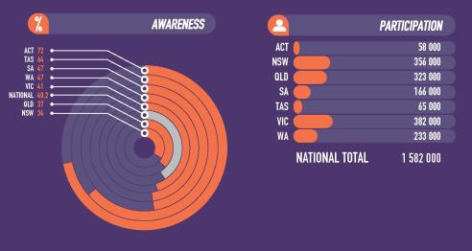

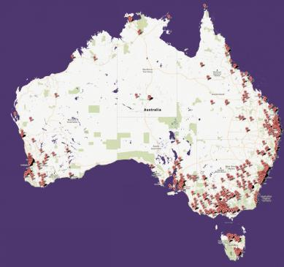

Case Study: Unlocking Australia’s Potential grants

Sixty-three Unlocking Australia’s Potential grants were delivered as a part of the *Inspiring Australia* initiative, with an aim of making science more accesisble to people who may not have interest or easy access to science engagement activities.

Rocking Climate Change

With the support of an *Inspiring Australia* Unlocking Australia’s Potential grant, CSIRO Ecosystem Sciences developed a project to engage Aboriginal Tiwi Islander communities on the issue of climate change and its potential impacts and possible adaption strategies. As a part of the project the senior girls of Tiwi College wrote a song about climate change in collaboration with the Northern Territory Music Schools VAMPtv. The music clip can be seen on YouTube at: <http://youtu.be/chwU6DLQdrk>.

Another significant outcome was the publication, Climate change in Australia’s Top End, produced by CSIRO, as a part of its then Climate Adaption Flagship.

Fireballs in the Sky

Fireballs in the Sky is a citizen-science initiative, established in regional and rural Western Australia, supported by an Unlocking Australia’s Potential grant to improve audiences’ understanding of planetary science research. Using a smartphone app, the programme allows participants to report meteorite sightings anywhere in the world. When enough observations are received, researchers can determine a trajectory and send a message back to the observer on what is known about the sighting. The project was featured on BBC News: [http://www.bbc.com/news/science-environment-25109275](http://www.bbc.com/news/scienceenvironment-25109275)

Regioneering Road Show

Engineers Without Borders used their Unlocking Australia’s Potential grant to develop a Regioneering Road Show that has travelled to more than 30 rural locations, engaging young Australians in engineering, technology and its underlying science.

• “*Inspiring Australia* has allowed us to access the networks and resources necessary to expand and grow our programme into something great. We look forward to continuing in delivering more quality workshops, to more and more students, in a greater range of topics through 2014 and beyond.”

Julian O’Shea, Director of the Engineers Without Borders Institute.

Field Guide apps to Australian Fauna

An app that can run off your phone, to help identify Australian wildlife, has been developed by the Museum of Victoria. There are eight apps, one for each state and territory, and together they feature over 2100 animals, including mammals, birds, fishes, reptiles, frogs and invertebrates from terrestrial, freshwater and marine environments.

The apps contain detailed descriptions of each species, as well as distribution maps, endangered status, audio calls and stunning imagery.

Supported by an Unlocking Australia’s Potential Grant, the app was developed in partnership between the major natural history museums in each state.

‘I wanted to again say what a terrific impact I think that Inspiring Australia is having, not only on the audiences that the programmes are reaching out to but also within the scientific community and the science communication community.’

*Lisa Jones, Unlocking Australia’s Potential grant recipient, for Parasites in Power*

‘This is the first time representatives of the whole Aboriginal community, ie leaders, children, youth and elders, have been involved in science on our own land, fostering indigenous science knowledge and presenting outcomes to families. Inspiring young Aborigines to take an early interest in natural sciences using innovative approaches will assist in achieving a scientifically engaged Aboriginal community.’

*Feedback from the Tasmanian Aboriginal Centre, recipient of a $5000 Inspiring Australia Unlocking Australia’s Potential grant, Aboriginal Discovery Centre at Risdon Cove, Tasmania*

Case Study: Prime Minister’s Prizes for Science

Questacon is responsible for administering the *Prime Minister’s Prizes for Science,* that include gathering nominations, managing the selection committees, organising the celebratory dinner event in Parliament House, as well as supporting digital media and media coverage.

Australia’s most prestigious awards for excellence in science research and science teaching are a key part of the *Inspiring Australia* strategy to recognise and tell the story of Australia’s achievements in these areas. The 2013 recipients are:

• Professor Terry Speed received the $300 000 *Prime Minister’s Prize for Science* for his work with statistics and mathematics. His work is helping to determine which cancers can be terminal and which may not need surgery. Professor Speed is based at the Walter and Eliza Hall Institute in Melbourne and at the University of California, Berkeley.

• Professor Angela Moles from UNSW received the $50 000 Frank Fenner Prize for Life Scientist of the Year, for her research into the adaptive mechanisms of plants, that is transforming our understanding of the plant world.

• Associate Professor Andrea Morello from UNSW received the $50 000 Malcolm McIntosh Prize for Physical Scientist of the Year, for his work to make quantum computing a reality, which could transform searching, modelling and cryptography.

• Mr Richard Johnson from Rostrata Primary School in Perth received the *Prime Minister’s Prize for Excellence in Science Teaching* in Primary Schools. Mr Johnson, who has been a teacher for 30 years, has created a model science laboratory that makes science fun for students and for teachers, and has been adopted by more than 40 schools.

• Ms Sarah Chapman from Townsville State High School received the *Prime Minister’s Prize for Excellence in Science Teaching* in Secondary Schools. Ms Chapman’s work to provide a learning experience where students can see and touch the science they are studying, has led to significant improvements in Year 12 science results.

# Celebrating 25 Years

On Saturday 23 November 2013 Questacon kicked off the party as it celebrated its 25th Anniversary, with a year of celebrations to follow. The Centre was opened on 23 November 1988 as a joint Australia–Japan Bicentennial Project.

Since 1988, Questacon has delivered 100 million hours of inspiration, engaging with over 26 million people and has welcomed almost 10 million people through its doors, encouraging and motivating Australia’s next generation of scientists.

The *Excited Particles* celebrated Questacon’s 25th birthday in typical style with a round of cake explosions. The cakes were an exceedingly gooey mass of sponge and icing with a surprise base consisting of balloons filled with hydrogen and oxygen in a powerful 2:1 ratio. When ignited with a sparkler the cake proved a huge success exploding in a most satisfying manner to the delight of an enthusiastic audience of Questacon visitors.

Amongst the many special events and exhibits to celebrate Questacon’s 25th Birthday during the year were:

• a dinner to recognise the Australia–Japan relationship and honour Japan’s contribution to the founding of Questacon;

• installation of the Torsional Wave outdoor exhibit, standing 12 metres tall at the front of the Questacon building;

• a public birthday party that featured a water rocket race, a 25 hydrogen balloon salute, and ice-cream making using liquid nitrogen;

• the *Q Lab* gallery took a look at the science behind birthdays with demonstrations involving coloured candle fames, balloons in liquid nitrogen and invisible fire extinguishers; and

• live radio broadcasts from the Centre.

Also, on 9 July 2014, the wives of the Australian and Japanese Prime Ministers, Mrs Margie Abbott and Mrs Aki Abe, visited Questacon. They were briefed about the role of the institution and cooperation in the area of science between the two countries.

25th Anniversary Campaign

This year we launched the 25th Anniversary Campaign which aims to raise $2.5 million dollars over 2.5 years from a range of philanthropic donations and corporate partnerships. We are seeking 100 sponsorships or donations of $25 000 to reach our target. This will enable Questacon to build an Australian society that values the environmental, social and economic benefits of investment in science and research and inspire Australians to make a difference through science, technology, engineering and mathematics (STEM). The funds raised will be to extend Questacon’s programmes and exhibitions to undeserved groups and communities.

‘Since 1988, Questacon has delivered 100 million hours of inspiration, engaging with over 26 million people and has welcomed almost 10 million people through its doors, encouraging and motivating Australia’s next generation of scientists.’

# Appendices: 2013-14 Programmes, People and Partnerships

National programmes and travelling exhibitions

Questacon delivers programmes at the local, national and international level.

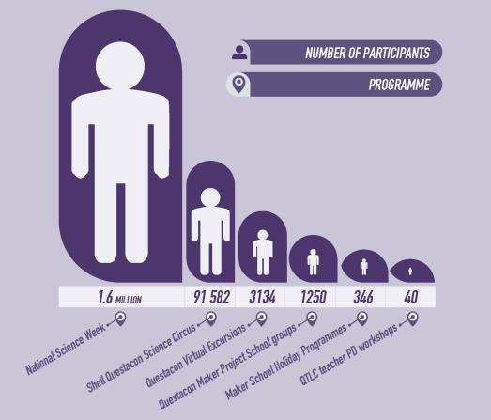

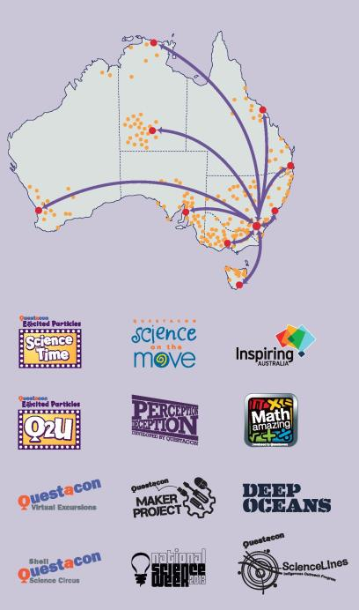

5.1 - Programmes

Local Level

Questacon gallery exhibitions

Exhibitions on display at Questacon during 2013-14 included:

• *Deep Oceans* explores the deep marine environment of Australia and the Pacific region highlighting ecology, biology, oceanography and the technology required to explore the oceans.

• *Measure Island* examines the concepts of good measurement, measurement systems and techniques in everyday life.

• *Perception Deception* explores themes of illusions through audio-language, multi-sensory, visual and social perception.

• *Wonderworks* highlights the beauty of science phenomena and their power to stimulate the imagination.

• *Awesome Earth* engages visitors with the forces that shape the earth through cyclones, earthquakes, volcanoes, thunder and lightning.

• *Q Lab* offers an ever-changing programme of activities and exhibits. Visitors can look at the world differently with microscopes and high-definition slow-motion footage. They can also enjoy live scientific demonstrations performed by Questacon’s science communicators and visiting scientists.

• *Mini Q—fun for 0-6 year olds* encourages younger visitors, along with their parents and carers, to explore science through play.

• *Excite@Q* is a complete hands-on, minds-on experience, featuring exhibits to get the adrenalin pumping such as the Freefall exhibit.

• *H20—Soak up the Science* explores how water behaves, how it shapes our world and how we use this precious resource.

Exhibition highlights

• The new upgraded Japan Wall project provides recognition of the support and cooperation Japan has provided to the success and growth of Questacon to be a leading Science Centre recognised internationally. The graphical display acknowledges significant contributions from Japanese Founding Sponsors.

• The Awards Showcase is a new purpose built showcase highlighting Questacon’s achievements and awards, delivering the needs of key stakeholders including Executive and Marketing. The showcase features an awards cabinet, brochure display, SmartGlass display case and storage.

• The new Sponsors Board titled Working Together to Inspire Australia, acknowledges the outstanding contribution of Questacon’s Major Partners, Supporting Partners and Knowledge Partners in a prominent display in Questacon’s Foyer.

• The new Robothespian—Robo Q2—was installed in the main Foyer of Questacon. This life sized humanoid robot is designed for visitor interaction and can communicate, entertain and inspire.

• The Diffusion Cloud Chamber was installed in the Window Bay between Gallery 2 and Gallery 3. This unique exhibit displays beautiful yet subtle vapour trails that are caused by natural background radiation from inner Earth and outer space.

• The Periodic Table table—a visually stunning presentation of the periodic table, this table was installed to complete the reading space within *Q Lab.* Carefully illuminated and beautifully presented beneath toughened glass, each element sample is individually embedded inside a solid acrylic block and arranged in the familiar grid of the periodic table.

• The Science Garden outside the building offers exhibits inspired by the natural elements of sun, wind, water and rock and include Icons of Inspiration, with stylised human figures representing Isaac Newton (the Thinker), Marie Curie (the Discoverer) Robert Hooke (the Innovator) and Galileo (the Observer).

• A special exhibit to celebrate Questacon’s 25th Birthday is the Torsional Wave, standing 12 metres tall at the front of the Questacon building.

• Sisyphus is a visually spectacular exhibit that surprises visitors and engages their minds as it continually carves intricate dune patterns using stored mathematical equations and themes. In its cantilevered position within the Questacon Foyer, Sisyphus offers 360° viewing access.

• Ribbon Dancer is a visually engaging exhibit where patterns are programmed using two sets of circular coordinates, one vertical and the other horizontal. This generates intricate three dimensional movements.

• Installed in February 2014, the Teachers Recognition Cabinet showcases past and present recipients of the *Prime Minister’s Prizes for Excellence in Science Teaching,* under the title Inspiring Teachers, Inspiring Australia. These medallions are awarded each year by the Prime Minister to one primary and one secondary teacher who make outstanding contributions to science education in Australia.

Questacon Maker Project

The *Questacon Maker Project Team* delivered two-hour technology education workshops to more than 800 secondary students and more than 400 upper primary students. These highly-engaging workshops are based on innovation processes and design-thinking principles, guiding students to create, build and test their own prototypes. Students investigate the possibilities of simple mechanisms such as cams and levers through to modern 3D printing. School holiday programmes held at the QTLC also focus on technology, particularly the creative re-purposing of materials.

Outside of Canberra, the *Questacon Makers* have delivered presentations and workshops at the following events:

• Bermagui community festival

• Australian Catholic University Aspirations Programme; running technology education workshops with Catholic school teachers in Young, NSW

• Sydney Maker Faire at the Powerhouse Museum.

QTLC teacher professional development (PD) workshops

In March 2014, the QTLC hosted teacher PD workshops by highly-respected science educator Coral Clark, from San Francisco USA. Coral’s expertise in inquiry-based learning was shared with Canberra-based teachers who were highly positive in their feedback:

‘We did a number of activities using everyday materials that could be used in the classroom to stimulate children to experience the discovery process of science… I also think they opened my mind to a new way of teaching through discovery and encouraging students to realise that scientific learning is open ended.’

The QTLC continued to develop a suite of teacher PD workshops designed to explore inquiry-based science, virtual excursions and hands-on science activities. The workshops are accredited by the ACT Teacher Quality Institute (TQI) and local teachers who participated responded with:

‘The hands-on component of being able to do the experiments was the most useful as it helped me think about the best way to bring it in to the classroom and adapt it to different age and skill levels. The activity worksheets were great as they will allow us to bring these experiments straight into the classroom.’

The QTLC also supported the Science Educators Association, ACT (SEA-ACT) and Design and Technology Teachers’ Association (DATTA) by hosting meetings and workshops for local members.

ClickFest 2013

As a founding member of Virtual Excursions Australia (VEA), Questacon continues to support and mentor fellow institutions in the delivery of virtual excursions. ClickFest 2013 is an annual virtual excursion festival hosted by VEA to help promote the possibilities of virtual excursions to Australian schools and other organisations.

Questacon building

Questacon’s purpose-built science centre has become an iconic national institution within Canberra’s Parliamentary Zone. Over the life of the building visitation has more than doubled, from the projected building capacity of 200 000 per year to approximately 430 000 people.

Questacon continues to deliver high levels of building amenity, environmental management and workplace health and safety in this award-winning tourist destination, and achievements during the 2013–14 financial that contribute to the quality and life of the building’s services, and safety systems include:

• Refurbishment and expansion of the toilets within the Questacon Foyer and Gallery 3, now providing greater hygiene by using door-less entry. Visitor amenity has been increased with the inclusion of a baby change room and ambulant cubicles in accordance with the Building Code of Australia. The amenities also provide a space for first aid and staff change facilities.

• Refurbishment and upgrade to fabric and plant in Gallery 3 to support the newly installed exhibition, Awesome Earth, including LED lighting to increase efficiency and reduce running costs.

• Upgrade to the security system incorporating a change to digital cameras to increase clarity and coverage.

• Changes to the air extraction system within the Questacon Technology Learning Centre workshop, and installation of a gas reticulation system to increase staff safety.

Questacon also undertook to increase the visitor amenity in the external space by consulting a landscape architect to develop designs for structures around the building precinct to provide shade and weather protection. Initial discussions have been completed with the National Capital Authority on this.

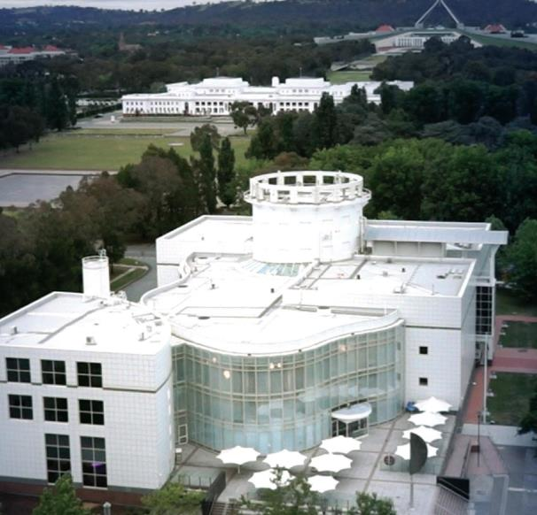

National Programmes

Inspiring Australia

*Inspiring Australia’s* Unlocking Australia’s Potential grants support increased year-round opportunities for people and communities to become involved in science-based events and activities. The Unlocking Australia’s Potential grants programme has provided a total of $5 million to 63 projects with a strong focus on providing opportunities for participation for all Australians, especially those not normally engaged in science activities including: those living in regional and remote areas, Indigenous communities, people for whom English is a second language, and people who are disabled or have limited mobility.

In addition to its highly successful working groups on key areas for collaboration and partnerships (Indigenous Australians, tropical regions, marine science, desert regions, mainstream and social media, and evidence bases for science engagement), *Inspiring Australia* has established a network of officers in each state and territory, to coordinate and support local activities.

*Inspiring Australia* has demonstrated its success through drawing together a diversity of science engagement activities and individuals, providing strategic direction and leadership, grants and resources, and enabling partnerships across a national network that shares the goals of improving the effectiveness and impact of science communication. Many of *Inspiring Australia’s* success stories can be read on its website:

[www.inspiringaustralia.net.au](http://www.inspiringaustralia.net.au)

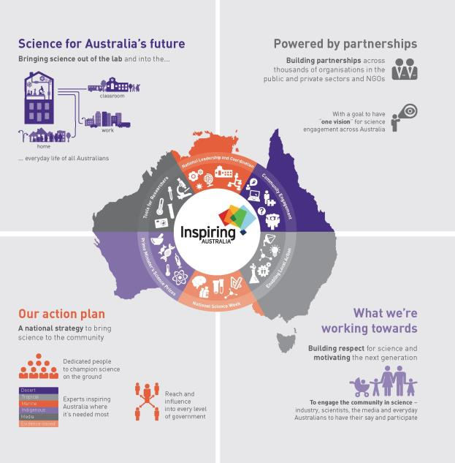

Digital Engagement

Throughout the year, Questacon’s expertise in producing, facilitating and delivering video production projects and videoconferencing events has attracted a variety of government and non-government partners. Key projects during 2013-14 included:

• Questacon filmed, edited and produced 20 two-minute videos for ABC International, to be shown on its International network throughout Asia, and have already been translated into Bahasa and broadcast in Indonesia. These videos are designed to allow children of all ages to undertake experiments with objects found around their household.

• In collaboration with the University of Wollongong’s Australian Research Council Centre of Excellence for Electromaterials Science, Questacon staff recorded and distributed the Centre’s 3D printing forum held at the Powerhouse Museum in Sydney. The forum brought together experts in the field of 3D printing and their real world application for an in-depth discussion on the topic and the ethical questions it poses.

• Undertaking the Women in Science videoconference, which showed female students the busy life of scientists on a geological survey ship in the Bering Straits. The video conference was conducted live from the Bering Sea with students fortunate to see a sea floor core sample as it arrived on deck, and the processes it was subjected to once it was safe to examine.

• Questacon produced a video introduction for the 2013 *Prime Minister’s Prizes for Science* presentation ceremony in October. This video showcased current research being conducted under the Australian Government’s Cooperative Research Centre initiative.

• Questacon continues its support of the National Youth Science Forum with its annual video conference between the student delegates and scientists from ANU and CERN’s Large Hadron Collider.

• A Questacon videoconference project, delivered with Raytheon’s support, was *Mission Astronautica*. The event, which was launched in August 2013, challenged students across Australia to team up with scientists, Astronauts and Engineers from NASA’s Neutral Buoyancy Laboratory in Houston, Texas. Six schools across Australia accepted the challenge and successfully created neutrally buoyant objects, some with the ability to navigate underwater.

• With the support of Raytheon Australia a virtual excursion connecting ACT schools to Miraikan presenters who participated in the Science Circus Japan tour. The connection was targeted toward Japanese language classes utilising science demonstrations to create opportunities to develop vocabulary.

Shell Questacon Science Circus

The *Shell Questacon Science Circus* is an outreach programme delivered in partnership with Shell and The Australian National University as part of its Master of Science Communication (Outreach). During each *Science Circus* tour, the post-graduate science communication students perform science shows in schools, host a public exhibition and facilitate teacher professional development workshops.

In July 2013 the *Science Circus* toured Central North West Queensland, covering almost two thirds of the state, including Northern, Central and Western Queensland and parts of the Northern Territory. The *Science Circus*’s Beyond School programme, held in Gladstone, forged a partnership with Central Queensland University (CQU) to showcase local science careers for secondary students.

During the Tasmanian tour, in October 2013, the public exhibition in Hobart broke a ten-year-old record with more than 3200 visitors experiencing the exhibition and science shows across six hours. Two representatives from the Brunei Oil and Gas Discovery Centre also visited the public exhibition in Hobart to learn how to deliver similar outreach programmes.

While based in Albury during the 2014 NSW tour, the *Science Circus* encountered a group from Camp Quality and voluntarily ran an impromptu workshop with the Camp Quality children, to help entertain and engage them.

Shell Questacon Science Circus tours 2013–14

|  |  |  |  |
| --- | --- | --- | --- |
| July 2013 Central North West Queensland tour base towns | July-August 2013 Indigenous tour communities | October 2013 Tasmanian tour base towns | April 2014 NSW tour base towns |
|
|
|
| Bowen | Doomadgee, Camooweal, Burketown, Croydon, Karumba, Urandangi, Dajarra and Boulia, | Launceston | Wagga Wagga |
| Collinsville | Scottsdale | Albury |
| Charters Towers | St Helens | Taree |
| Hughenden | Smithton | Port Macquarie |
| Cloncurry | QLD; Rockhampton Downs (Wogyala), Alpurrulam, Owairtilla (Canteen Creek) and Epenarra, N T. | Devonport | Coffs Harbour |
| Mount Isa | Burnie | Grafton |
| Winton | Queenstown | Lismore |
| Longreach | New Norfolk | Byron Bay |
| Muttaburra | Kingston | Ballina |
| Emerald | Hobart |  |
| Gladstone |  |  |

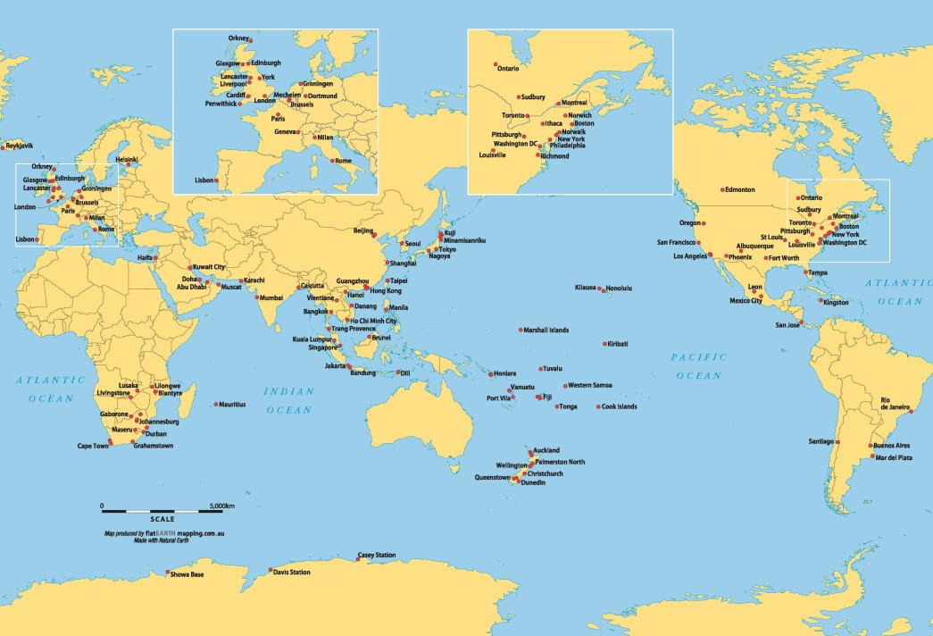

Travelling Exhibition Highlights

• *Science on the Move -* a portable exhibition which explores simple scientific principles relevant to everyday life. This exhibition was hosted by Manly West Primary School, New South Wales, between 12 August 2013 and 6 September 2013.

• *Perception Deception* explores perception and the senses, with interactive exhibits, multimedia activities, visual illusions and perception tests. The two parts of this exhibition toured separately during the year. Part A travelled to the National Wool Museum, Geelong between 28 October 2013 and 29 January 2014, and Part B had previously travelled to the Museum of Tropical Queensland between 21 July 2012 and 21 July 2013.

• *Eaten Alive—the World of Predators.* Four exhibits from this exhibition were on display at the Queen Victoria Museum and Gallery in Launceston, Tasmania between February 2011 and June 2014.

• *Mathamazing,* Questacon’s newest exhibition which discovers mathematical concepts was hosted by Scienceworks, Victoria between 24 August 2013 and 14 July 2014.

• *Deep Oceans—exploration of the deep,* was a joint partnership with Australia Museum, and toured to two locations this year. The exhibition was hosted by Newcastle Museum between 7 December 2013 and 2 March 2014 and the Queensland Museum and Sciencentre between 28 March 2014 and 6 October 2014.

• *Stem Cell Stories* was a joint collaboration between Questacon and the Australasian Society for Stem Cell Research (ASSCR), containing photographic images of how stem cell treatments may repair damaged and diseased cells in the body. The exhibition was hosted by RiAus at the Science Exchange, South Australia, between 5 June 2014 and 25 July 2014.

International Programmes

Questacon’s international activities make it a significant cultural diplomacy asset for Australia. It has a strong track record in international engagement that has been built into the Centre’s activities from the outset due to its special relationship with Japan. Questacon also has excellent relationships with Canberra’s diplomatic community and hosts many international delegations.

2014 marked the 25th Anniversary of the special relationship with Japan, commemorated by the visit of the wife of the Japanese Prime Minister, Mrs Abe, accompanied by the wife of the Australian Prime Minister, Mrs Abbott, as well as a dinner for the Japanese Business Foundation, Keidanren, in the lead up to the Questacon *Science Circus* tour to Japan in April-May 2014.

Other significant international activities included:

• The 2014 *Science Circus Tour* of Japan. The purpose and strategy underpinning the tour supported the Government’s *Australia in the new century: Japan* paper. The tour was funded by the Department of Industry and sponsored through a grant provided by the Department of Foreign Affairs and Trade through the Australian-Japan Foundation. At the end of the tour the exhibition was gifted to the four communities visited.

• Questacon’s *Measure Island* exhibition was opened at the Oil and Gas Discovery Centre in Brunei, by Hj Suhaila bin Hj Abd Karim, Deputy Permanent Secretary from the Ministry of Education, as well as being attended by the Australian High Commissioner His Excellency Todd Mercer.

• A Euroscience Week was held at Questacon in July 2014, in partnership with ANU Centre for European Studies, and was attended by several ambassadors and embassy staff members.

• Questacon attended the Science Centres World Summit 2014 in Mechelen, Belgium, and Questacon Advisory Council member and Nobel Laureate Professor Brian Schmidt participated as a member of the Science Centres World Summit Honour Committee. Jenny Odgers from Shell Australia also presented on the impact of the *Shell Questacon Science Circus.*

5.2 – People

Questacon employs 224 staff in full-time, part-time or casual positions, and several of Questacon’s staff took part in significant events and international visits during the year.

Dr Stuart Kohlhagen, the Centre’s acting General Manager of Science and Learning, for instance, travelled to the Asia Pacific Network of Science Centres, held from the 5–8 May, in Brunei. He gave keynote presentations outlining international studies into the impacts of science centre programmes and the interface between science centres and the formal education centres. He was also able to progress discussions regarding the sale and rental of Questacon exhibits, and options for enhancing the support of the Indonesian Science Centre Network regarding informal science, technology, engineering and mathematics (STEM) education. He also gave workshops on effective exhibit and exhibition development to ASPAC members.

Volunteers

Questacon has 65 regular volunteers who are active in the organisation as Science Explainers, Volunteer Tinkers, Student Explainer and *Science Time* assistants. In 2013–14 our volunteers committed 10 363 hours.

Volunteers come from all walks of life, however a background in science, technical practice, academia or a general interest in education is common. Volunteers are expected that they will volunteer a minimum of one shift (4 hours and 15 minutes) per week, with a maximum of 16 hours per week over no less than 6 months.

Volunteer Explainers also visit retirement villages or nursing homes in the ACT area to present science concepts through ways of demonstrations and explanations. In 2013–14 four communities were visited.

In 2013, 31 student volunteers graduated from the student training programme.

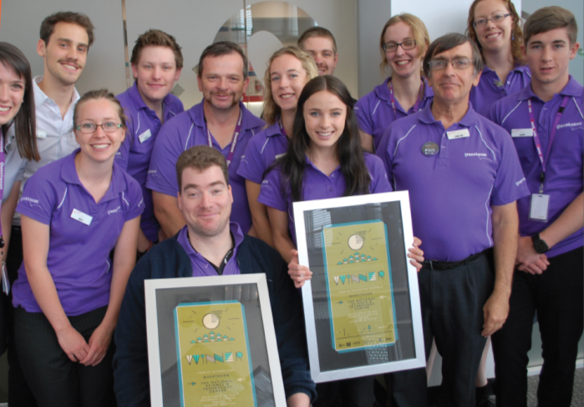

5.3 – Partnerships

Questacon partners with a range of entities including businesses, universities, foundations, other government departments and agencies, and professional organisations. We work with our partners in a variety of ways:

1. Enabling partnerships directly support the development and delivery of Questacon’s exhibitions and programmes.
2. Knowledge partnerships ensure Questacon’s exhibitions and programmes are developed using up-to-date scientific content provided by leading subject matter experts.
3. Strategic partnerships foster a culture of collaboration by supporting activities that capitalise on each partner’s complementary skills and expertise to maximise impact.

Shell Questacon Science Circus

The *Shell Questacon Science Circus* was established over 29 years ago in partnership with Shell, The Australian National University (ANU) and Questacon. During 2013-2014, over 91 500 people (the majority being school students) attended *Shell Questacon Science Circus* in-school performances, workshops, public exhibitions, events and video conference presentations. The *Shell Questacon Science Circus* travelled approximately 20 000 kilometres and presented at 336 venues across regional and remote communities.

During this year, 298 schools have benefited from this programme with 250 teachers directly participating in our professional development ‘Stress Free Science’ workshops. Very importantly, across both primary and high schools, teachers reported that the programme increased the student’s enthusiasm for science.

Throughout the partnership, the *Science Circus* has provided significant brand exposure and recognition for Shell and a tangible local demonstration of its global social commitment to science education.

Australian National University

The ANU is a founding partner of the *Shell Questacon Science Circus,* and the Circus team is comprised of 16 Masters of Science Communication students who undertake their studies at the ANU National Centre for Public Awareness of Science (CPAS). Questacon also partners with CPAS on a variety of science communication projects, including international capability development initiatives. Scientists and experts from the ANU also contribute regularly to Questacon’s visitor programmes, such as lectures and demonstrations.

Raytheon — the Schmidt Digital Studio

Raytheon Australia provided support for the Schmidt Digital Studio, which delivers interactive and innovative science, technology, engineering and maths programmes directly into secondary school classrooms across the nation, via videoconferencing. Highlights over the last year included the Mission Astronautica project and the *Science Circus* Japan Video Conference. Mission Astronautica is a two-month student research project developed by Questacon in partnership with Raytheon Australia and NASA’s Neutral Buoyancy Laboratory (NBL) in Houston, Texas. Around 150 students from eight schools in five Australian states participated in the project. The highlight of the project for the students was a videoconference mission briefing from former NASA astronaut, Clay Anderson, highlighting how astronauts are trained at the Raytheon-operated NBL.

At the conclusion of the Science Circus Tour Japan, Questacon was able to increase access of the tour to Australian audiences through the delivery of a video conference using the Schmidt Studio, supported by Raytheon. Two schools from the Canberra region were involved: Canberra Girls’ Grammar School and Radford College.

The Crown Foundation and Mesoblast

We are delighted to welcome two new partners to Questacon: the Crown Foundation and Mesoblast, who together supported the Keidanren Delegation Dinner held at Questacon on Wednesday 19 March 2014. The dinner was held to celebrate 25 years since Questacon opened as the National Science and Technology Centre in 1988, and was a tribute to the generous gift provided by the Keidanren delegation at that time to establish the building.

Murray–Darling Basin Authority — Basin Champion Schools Programme

In partnership with the Murray–Darling Basin Authority Questacon provided technical and professional expertise in videoconferencing for the Basin Champion Schools Programme. Using Questacon’s Schmidt Studio, this programme encouraged students to think about the connectivity and interdependence of environments across the Murray–Darling Basin by conducting local investigations and sharing the results. Throughout their projects, students were supported by mentors and shared their findings with other students across the Basin via interactive videoconference.

National Film and Sound Archive — Let’s Get Animated Schools Programme

*Let’s Get Animated*, video conferencing sessions feature interesting clips, amazing artefacts and the opportunity to create something special. Most importantly, this programme gives students in regional and remote areas the opportunity to interact with the National Film and Sound Archive in an engaging and inspiring way. The programme challenges students to create their own animation sequences which they share with their fellow classmates and with other schools groups.

Australian Bureau of Statistics — the Census Experience

Questacon designed, developed and constructed four interactive exhibits for the Australian Bureau of Statistics (ABS) for their Census Experience project, celebrating over 100 years of Australian Census results. These Census Experience exhibits raised awareness within the Australian population of the importance of collecting Census data, and the role played by the Australian Census in developing infrastructure within Australian towns and cities. The exhibits will enable users to compare their individual circumstances, or data, against Census data collected for the whole Australian population. The exhibition was launched at Questacon on 20 February 2014, after being shown at ABS House in Belconnen in October-November 2013.

Australian National Maritime Museum

Questacon is designing, developing and fabricating two outdoor exhibits to further engage visitors with the outdoor wharf space within the Australian National Maritime Museum. Submersible Series is an interactive exhibit that compares the corrosion and growth of marine organisms on various materials, to demonstrate which materials might be good to use for seaworthy craft. The Reverse Periscope is an interactive exhibit that enables people to discover the underwater life present at the Museum site, or view historic vessels below the waterline and learn how periscopes work.

Australian Museum

Questacon partnered with the Australian Museum for the development and tour of the *Deep Oceans* exhibition. The exhibition uses an innovative combination of interactive exhibits, objects and specimens to reveal the secrets of this fascinating environment and the mysterious creatures that make their homes within it. The exhibition was launched in June 2012. The *Deep Oceans* exhibition is currently touring nationally and has been to Newcastle, Brisbane and the Queensland Museum.

Based on the success of the *Deep Oceans* partnership model between Questacon and the Australian Museum, and the bringing together of skills and expertise from these two organisations, a new exhibition development project has begun on a spiders exhibition. The Spiders and Friends exhibition (working title) is being developed to address science and broader environmental issues such as biodiversity loss and climate change, and should be ready for launching in November 2015.

‘Across both primary and high schools, teachers reported that the programme increased the student’s enthusiasm for science.’

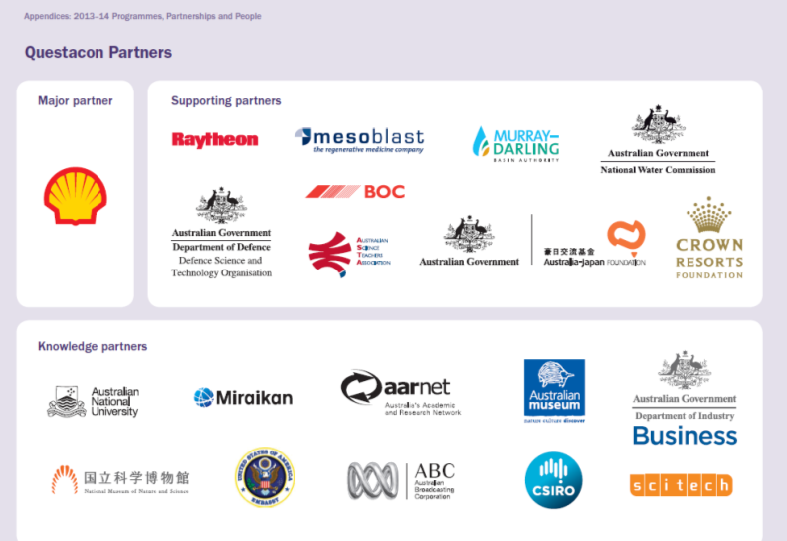

Moving from inspiration to impact 2013–14 **QUESTACON 55**

With special thanks

ACT Government

Asia Pacific Network of Science & Technology Centres

Association of Science-Technology Centers Incorporated

Atlas of Living Australia

Australasian Science and Technology Exhibitors Network

Australian Academy of Science

Australian Academy of Technological Sciences and Engineering

Australian Capital Tourism

Australian Embassy, Hanoi

Australian Embassy, Tokyo

Australian Institute of Marine Science

Australian Institute of Sport

Australian Japan Foundation (DFAT)

Australian National Botanic Gardens

Australian National Centre for the Public Awareness of Science (CPAS)

Australian National Maritime Museum

Australian Nuclear Science & Technology Organisation (ANSTO)

Australian Science Communicators

Australian Science Media Centre

Balloon Aloft

Canberra Convention Bureau

Canberra Deep Space Communication Complex, NASA

Canberra Milk

Centenary of Canberra

Charles Darwin University

Cockington Green Gardens

Council for the Arts, Humanities and Social Sciences

Econnect Communications

Embassy of Japan in Australia

Engineers Australia

Geoscience Australia

Inspiring Australia Expert Working Groups

Inspiring Australia State and Territory Contact Officers

Integrated Ocean Drilling Program

International Museum’s Theatre Alliance (Asia Pacific Region)

Japanese Department of Education

Mt Stromlo High School

Mt Stromlo Observatory

National Capital Attractions Association

National Capital Educational Tourism Project

National Film and Sound Archive

National Library of Australia

National Museum of Emerging Science & Innovation (Miraikan)

National Science Week State and Territory Coordinating Committees

National Youth Science Forum

National Zoo and Aquarium

New Scientist

NICTA

Northern Territory Department of Business

NSW Department of Trade and Investment, Regional Infrastructure and Services

Office of the Chief Scientist for Australia

Plant Energy Biology ARC Centre for Excellence

Prime Minister’s Prizes for Science: Committee for Science Prizes

Prime Minister’s Prizes for Science: Committee for Science Teaching Prizes

Queensland Department of Science, Information

Technology, Innovation and the Arts

Queensland Museum

Robogals

Royal Australian Chemical Institute

Royal Institution of Australia

Science & Technology Australia

Science Rewired

South Australian Department of Further Education, Employment, Science and Technology

Tasmanian Department of Economic Development, Tourism and the Arts

The Embassy of the United States of America

The Exploratorium

The Smith Family

The University of Sydney

University of Canberra

University of Queensland

University of Tasmania

University of Western Australia

Veritasium

Victorian Space Science Education Centre

Volunteering ACT

Western Australian Department of Commerce

Looking to the future

Questacon will continue to serve the Australian public in 2014–15, and beyond by:

* + - 1. Developing and delivering the Science for Australia’s Future measures, announced in the 2014 Budget:
      2. Including the *Questacon Smart Skills* programme, technology teacher support programmes and the *Enterprising Australians* exhibition’s ongoing activities;
  1. Driving national leadership through the *Inspiring Australia* Strategy
  2. Delivering the 2014 *Prime Minister’s Prizes for Science* and working on the introduction of a new Innovation Prize for 2015.
  3. Managing and supporting national programs including *National Science Week*.
  4. Introducing more technology-focused activities into Questacon programming and exhibits.
  5. Building technology learning experiences into existing national programmes, including the *Shell Questacon Science Circus* and *Questacon Virtual Excursions.*
  6. Continuing to invest in workforce planning and training to ensure that our skillsets and capabilities serve our strategic priorities.
  7. Delivering online shopping and progressing online ticketing and memberships as components of Questacon’s eBusiness platform.
  8. Undertaking successful activities for Floriade 2014 and Enlighten 2015.
  9. Achieving better supported teachers, more visitors and more research-based activities.
  10. Continuing to work towards increasing science and innovation engagement by more of the public.
  11. Facilitating the development of citizen science initiatives.
  12. Being an active participant in any national science, technology, engineering and maths (STEM) strategies and activities.
  13. Working to support the Department of Industry and Australian Government priorities.
  14. Building the case for expansion of the Questacon building in the Parliamentary Zone, to create space for exhibits that showcase Australian science and innovation.
  15. Developing a national technology learning initiative, with support from the philanthropic sector, industry, and government.
  16. Extending support for science and maths educators through a partnership with the University of Canberra and the Australian National University.
  17. Being an active partner in the Australian Research Council Centre of Excellence in the Science of Learning, hosted by the Queensland Brain Institute.

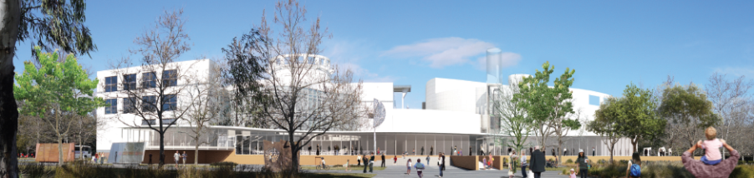

Science centres are wonderful places for communicating science. They are places that people want to go for a mix of education and entertainment and they go in large numbers.

Science centres are filled with passionate dedicated professionals who devote their lives to helping people improve their understanding of the world around them and their opportunities to make a difference within that world.

At a time when economic, political, religious and racial differences are highlighted daily and when the challenges facing life on planet Earth are becoming much clearer, science centres can play an important role in binding humanity together. With a focus on young people, families and the future, science centres are uniquely placed to work across geographic, political and economic boundaries.

Professor Graham Durant AM

Director, Questacon

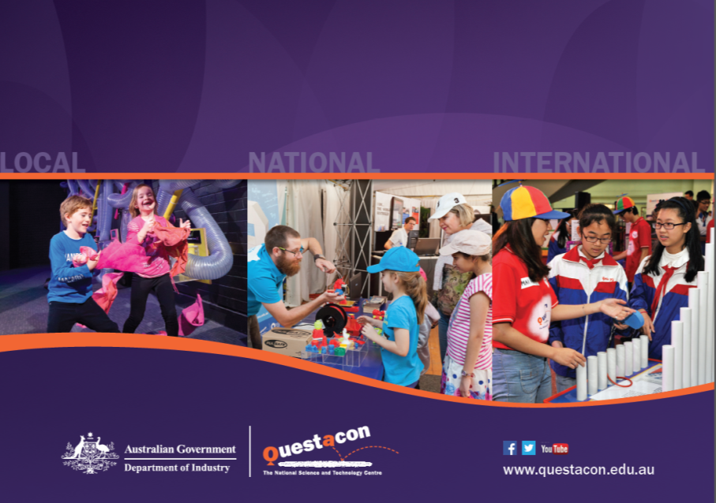

1. Searle, S, (2014) *How do Australians Engage with Science?* ANU.
2. Cormick, C, (2014) *Community Attitudes Towards Science and Technology in Australia,* CSIRO
3. Falk, J., Needham, M., Dierking, L. & Predergast, L. (2014) *International Science Centre Impact Study,* John H Falk Research, USA