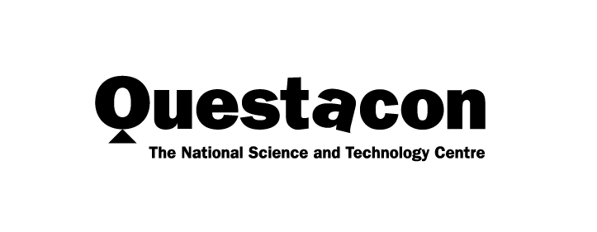

Year in Review 2021

Connecting Australia
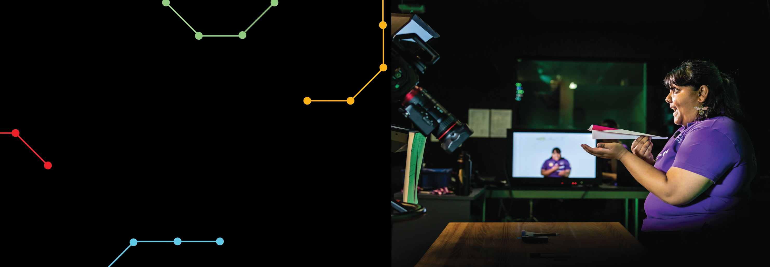
A better future for all Australians through engagement with science, technology and innovation.

Contents
Questacon Overview 1
Chairman’s Message 3
Director’s Update 4
Questacon Governance 7
Powered by Partnerships 10
Expanding Questacon’s National Presence 14
Questacon Centre Activities 32
Sustainability 42
Indigenous Engagement 44
International Engagement 46
Key Events 50
Questacon People 52

QR Codes
Look out for QR codes throughout this review to access extra videos and activities. During the COVID-19 pandemic, we used QR codes to enable contactless methods of interacting with our exhibits and to enable rich online experiences at home.
View a website
Watch a video

Questacon Overview
From the first spark of an idea in the mid-1970s to today, Questacon has always been about connecting young Australians, their families and teachers with science, technology and innovation.
Questacon is Australia’s National Science and Technology Centre. As a division of the Department of Industry, Science, Energy and Resources, we support the government’s science and commercialisation agenda.
We do this by bringing science, technology, engineering and mathematics (STEM) to life through inspiring and engaging activities, delivered both face-to-face and digitally.
Millions of Australians have experienced our interactive and immersive national programs, including the Questacon Science Circus, Engineering is Elementary, Questacon Innovation Programs and the new Questacon Cyber Program.
We have also expanded our digital reach. When the Questacon Centre had to close for 99 days during the 2021 COVID-19 lockdown, we went 100% digital – delivering virtual workshops, webinars and events to every state and territory in Australia. Young people and their families continued to enjoy the online resources we developed during the first lockdown in early 2020, including the popular Questacon at Home resources.
While our focus is on building a foundation of science knowledge and understanding in the community, our role within the sector is also pivotal.
Questacon is a leader in Australia’s informal learning sector of science centres and museums, and we contribute to the work of the other national cultural institutions in supporting the ACT tourism economy. Through our national networks, we facilitate and strengthen community STEM engagement. We continue to support the department by maintaining the Inspiring Australia managers network across all states and territories.
Our values are clear and central to everything we do. We take great pride in providing quality experiences and maintaining visitor safety as our top priority. We develop and deliver high quality creative, innovative STEM learning experiences to inspire passion for science engagement, curiosity and lifelong learning.
We demonstrate inclusion, equality and sustainability every day. We maintain a high level of female participation across the organisation, and showcase women in STEM careers. We are also actively making Questacon more sustainable through our QNetZero initiative to reduce our carbon emissions.
Importantly, we value Indigenous engagement, and are increasing the presence of Indigenous knowledge, values and people in our content, programs and workforce. This includes bringing Indigenous leaders and their knowledge into the development of our exhibition and program activities.
After the challenges of the past year, we are looking forward to seeing more visitors and school groups return to the Questacon Centre in 2022, as well as welcoming new Questacon members, and resuming face-to-face delivery of our national programs. We are committed to making the Questacon experience fun, interactive and relevant as we continue to strengthen our engagement with communities across Australia.

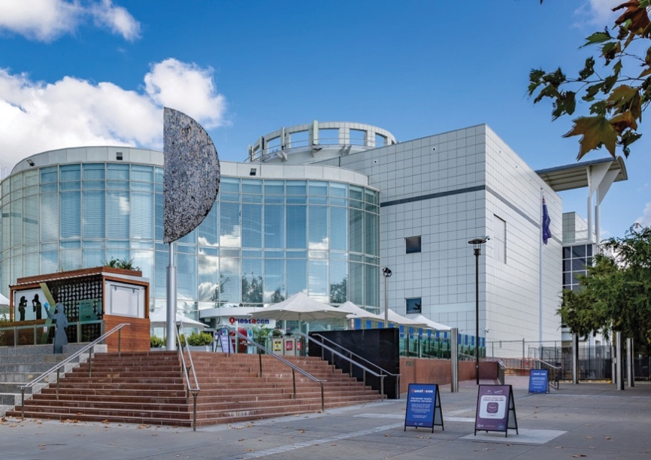

Chairman’s Message
Once again, Questacon has weathered a challenging year with a complex operating environment due to the ongoing pandemic situation. Despite the extended lockdown, it was a busy 12 months as Questacon continued to play an important role connecting Australians through science and technology.
This was possible thanks to the efforts of many. My thanks to Ms Mary-Wiley Smith, Deputy Secretary of the Department of Industry, Science, Energy and Resources, for her support and advice throughout the year. A sincere thank you also to Questacon Director, Professor Graham Durant AM and Deputy Directors, Ms Kate Driver and Dr Bobby Cerini, for their strong leadership navigating the myriad of challenges associated with the pandemic and ensuring the safety of staff and visitors at all times.
The past year also highlighted the versatility of Questacon staff, who adapted to disrupted and different working environments to ensure continuity of Questacon’s business – developing and delivering STEM engagement activities to young people, their families and teachers across Australia.
Not only that, many Questacon staff also assisted with the whole-of-government COVID response, redeploying to organisations including Services Australia and ACT Health when they were needed.
I would also like to acknowledge Questacon Advisory Council members for their valued involvement and support – Mr Eddie Kutner AM, Professor Alan Duffy, Dr Ken Dutton-Regester, Ms Lily Serna and Dr Greg Clark AC, who is retiring after 6 years. Greg’s contribution is greatly appreciated. During his term on Council, Greg upheld Questacon’s place as a leading player in the global science sector by leveraging his networks and expertise in the space industry.
We are also grateful for his ongoing advocacy and strengthening of Questacon’s reputation as a national resource to support the Australian Government’s investment in space and science, which is fundamental in ensuring Australia’s competitiveness on a global scale. Congratulations to Greg on being awarded the title of Questacon Emeritus Senior Fellow. His ongoing association with Questacon will help inspire many more people to engage with science, particularly in Australia’s rural and remote communities.
It is also my pleasure to welcome new Council member, Professor Lisa-Harvey Smith, who joined us during 2021.Questacon will benefit greatly from her expertise and industry connections.
Congratulations to everyone who ensured Questacon’s resilience during this difficult year.
I look forward to Questacon resuming full-time operations so the public can once again enjoy the full experience of Australia’s National Science and Technology Centre.
Mr Leon Kempler AM
Chairman
Questacon Advisory Council
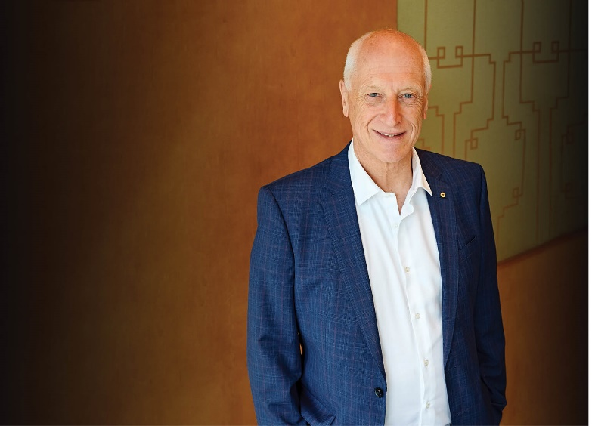

Director’s Update
2021 began on a positive note, with visitors once again able to enjoy the Questacon Centre in a COVID-safe manner. Unfortunately, the worsening COVID-19 pandemic sent the ACT back into lockdown in August 2021, with Questacon closing to the public for the second time. Using experience gained in 2020, Questacon switched to digital delivery overnight, providing virtual continuity for many of our programs. As restrictions began to ease in November, visitors were eager to return to Questacon once again. High vaccination rates in staff and the community have changed the risk profile, and Questacon has been able to remain open into 2022.
Questacon welcomed back members after an almost 2-year pause on memberships, and reopened the Mini Q gallery for our youngest scientists to explore. Questacon’s national programs, including Questacon Science Circus, Engineering is Elementary, and Questacon Innovation Programs resumed in-person workshops and activities for students and teachers across Australia. Students from the ACT and surrounding region were also able to participate in the National Questacon Invention Convention in January. These students came together to discuss real world problems and brainstorm innovative solutions. Their prototypes were displayed at the showcase event attended by His Excellency, Governor-General David Hurley, Mrs Hurley and industry stakeholders.
The Questacon Cyber Program is Questacon’s newest program for students and teachers, designed to boost cyber security skills and to prepare students for future careers in the cyber industry. The program is supported by the Department of Industry, Science, Energy and Resources, and forms an important part of Australia’s Cyber Security Strategy 2020. The program launched, and began delivering workshops in late 2021.
Questacon’s newest exhibition, Australia in Space, opened in May. The exhibition highlights Australia’s space industry, including the people and the innovations driving Australia’s role in this sector. The Australian Space Discovery Centre in Adelaide, a significant project undertaken in collaboration with the Australian Space Agency, also opened in May and expands Questacon’s reach through the Agency’s ‘Inspire’ pillar.
During the year, Questacon’s commitment to become carbon net zero by 2030 moved forward with the launch of QNetZero. It will be a significant challenge to achieve the emissions reduction goal, which will require offsets for national travelling activities, but it is one that Questacon is motivated to achieve.
As always, Questacon’s work is powered by people and partnerships. Creative and energetic staff, volunteers, Questacon Advisory Council Members, departmental colleagues and partners are the driving force for our organisation. I would like to thank the department for its continued support, particularly during the closure of Questacon’s Centre due to the COVID-19 pandemic.
National partnerships are vital to Questacon’s reach and impact. Over the years, both new and enduring partnerships have connected more Australians and amplified the importance of science, technology and innovation for our nation’s future. Questacon also values our international networks and maintain a strong relationship with Japan. The new Ambassador of Japan, His Excellency Shingo Yamagami and Mrs Kaoru Yamagami visited Questacon in late 2021.
During the year, we bid a sad farewell to Professor Emeritus Chris Bryant and Questacon founder Professor Mike Gore AO, who passed away in August 2021 and January 2022 respectively. These founders of Questacon, the Science Circus, and the ANU Centre for the Public Awareness of Science will be greatly missed. Their contribution to science communication in Australia is immense, and their legacy will live on through the work of Questacon, driven by a passionate, skilled and creative workforce.
After another year of uncertainty, we are approaching the year ahead with optimism. Questacon is well-placed to deliver on a long-standing vision for a better future for Australians through engagement with science, technology and innovation, and we look forward to continuing towards this goal.
Professor Graham Durant AM
Director, Questacon
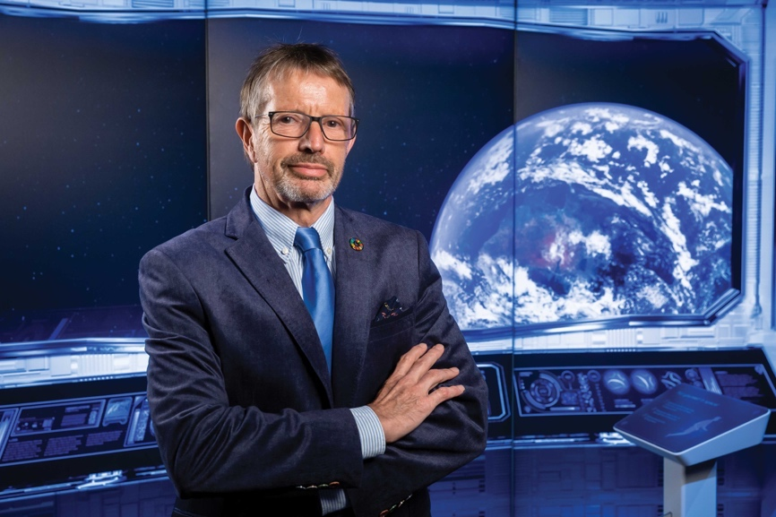

Questacon Governance

The Questacon Advisory Council
The Questacon Advisory Council is an advisory body that provides independent advice on Questacon’s work and strategic direction. The Council provides a crucial strategic connection to STEM organisations within Australia and internationally. These connections contribute important insights from the STEM sector, which informs Questacon’s current and future work.
Questacon Advisory Council members are appointed by the Minister. The Questacon Advisory Council comprises 8 members, all of whom have expertise in the STEM sector: Leon Kempler AM (Chair); Eddie Kutner AM (Deputy Chair); Lily Serna, Dr Ken Dutton-Regester; Professor Alan Duffy; Jamila Gordon; Professor Elanor Huntington; and our newest member Professor Lisa Harvey-Smith. Ex-officio members include Mary Wiley-Smith – Deputy Secretary, Department of Industry, Science, Energy and Resources; and Professor Graham Durant AM – Director, Questacon.
This year, longstanding Council member Dr Gregory Clark AC retired from the Questacon Advisory Council. Dr Clark’s business acumen coupled with his expertise in science and technology has been valuable in connecting Questacon with stakeholders and informing key strategic decisions. We thank Dr Clark for his commitment to the Questacon Advisory Council and his staunch advocacy for Questacon’s work.
In 2021, the Questacon Advisory Council increased Questacon’s connections with a diverse range of sectors including space, cyber, engineering and international engagement, enhancing Questacon’s relationships and informing program development.
In December 2021, the Questacon Advisory Council welcomed Ambassador of Japan, His Excellency Shingo Yamagami and Mrs Kaoru Yamagami for dinner in Questacon’s Mars gallery. The dinner was attended by Secretary of the Department of Industry, Science, Energy and Resources, David Fredericks, and a number of key stakeholders from government and industry. This event celebrated the longstanding relationship between Questacon and Japan; and strengthened the relationship to enable continued collaboration on future activities.
Figure 1: Questacon Advisory Council members with Questacon staff at the opening of the Australian Space Discovery Centre in Adelaide.
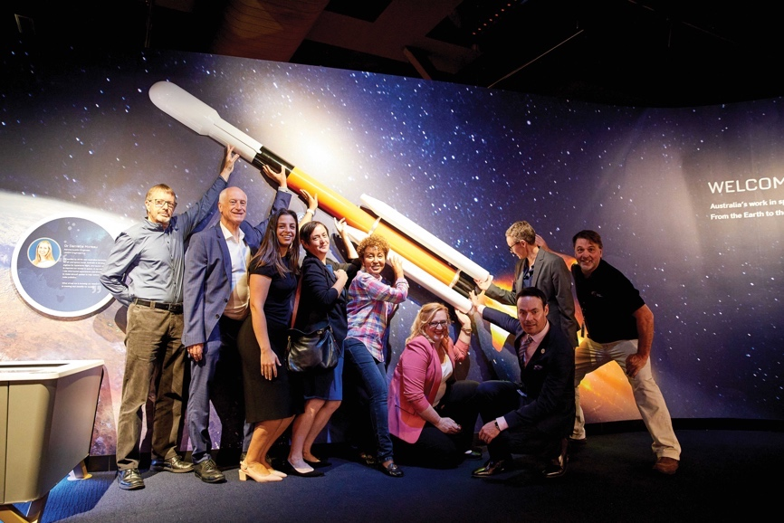

The Q Australia Foundation

Reflecting on another year, I am very proud of the achievements of the Q Australia Foundation for 2021.
The Q Australia Foundation worked hard during the year to advance science engagement and education in Australia by supporting Questacon’s work to inspire young Australians in STEM. The work of the Q Australia Foundation is supported by a dedicated Board of Directors invested in improving and increasing science engagement opportunities for young Australians.
The Q Australia Foundation supports Questacon’s work by building on the Australian Government’s seed investments by garnering additional financial support through investments and philanthropic donations.
This year, the Q Australia Foundation received a very generous donation from the Wanless family to support Questacon volunteers in their important work in Questacon’s Centre in Canberra. Mrs Jenny Wanless OAM, recently retired, was a Questacon Volunteer since March 1981. Following her retirement, Mrs Wanless, Professor Ian Wanless, David Wanless and Professor Erica Wanless made the much appreciated donation to the Q Australia Foundation to support the ongoing legacy of Questacon’s volunteers.
The donation has established the Jenny Wanless Family Endowment Fund, which will be used to build a Questacon Curiosity Rover.
This project will allow Questacon volunteers to generate curiosity and inspiration throughout the Questacon Centre, telling the story of volunteering and engaging young budding scientists in an ever changing program of science inspiration. Each year, the endowment will be used to enrich the cultural, scientific and public life of volunteers in Questacon.
This donation begins the journey for the Q Australia Foundation to build an endowment, bringing to life the dream of further supporting the work of Questacon’s volunteers into the future.
Additionally, in 2021, the Q Australia Foundation greatly enhanced how it communicates with the Australian public and promotes its cause, by establishing its own website. The website is an ideal platform to tell the story of our work and provide an avenue for the public to donate to the Q Australia Foundation, so it can continue to deliver on its vision of advancing education and engagement in science, technology, engineering and mathematics in Australia.
Although this year has been a challenging one due to the COVID-19 pandemic, I very much look forward to building on the Q Australia Foundation’s work in 2022 and beyond, to continue to support important STEM initiatives for young Australians.
Mr Eddie Kutner AM
Chairman, The Q Australia Foundation
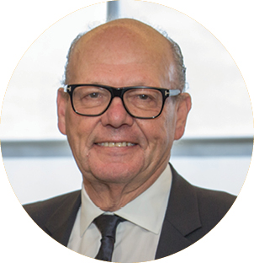

Powered by Partnerships

Australian Defence Force – Principal Partner

In 2019, the Australian Defence Force and Questacon entered into a partnership to deliver a professional learning program for primary school teachers in Australia, Engineering is Elementary. The program equips teachers with the skills and confidence to deliver STEM content in their classrooms in a fun, interactive and engaging way. This immersive professional development program was developed by EiE, a division of the Museum of Science, Boston. By providing teachers with practical resources and applications of how STEM can be used to solve real world problems, Engineering is Elementary aims to inspire students to consider future careers in a range of STEM fields.
With the support of the Australian Defence Force as Principal Partner, Questacon will deliver Engineering is Elementary workshops to 1,000 primary school teachers in approximately 500 schools across Australia over 3 years. So far, Engineering is Elementary workshops have been delivered to 972 teachers from 388 schools across every state and territory, using digital technologies to deliver workshops when in-person workshops were not possible.

The Ian Potter Foundation – Principal Partner
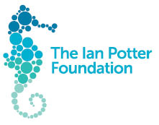
The Ian Potter Foundation became a Principal Partner of Questacon in 2014. The flagship offering, the Questacon Smart Skills Initiative, inspired over 71,000 Australians through a suite of hands-on STEM programs. The Questacon Smart Skills Initiative empowered participants to engage with innovation, technology, engineering and design thinking. With the support of The Ian Potter Foundation, Questacon delivered the National Questacon Invention Convention, in 2021 adapted to comply with COVID-19 travel restrictions across state and territory borders.
While this partnership has now concluded, its legacy and the $7.8 million grant remain. Questacon’s second centre will continue to be known as The Ian Potter Foundation Technology Learning Centre, in recognition of this generous grant. This building in Deakin, Canberra will continue to be the hub for our national engagement teams, along with exhibition development and production.

Australian National University – Founding Partner

The Australian National University, through The Australian National Centre for the Public Awareness of Science, is the Founding Partner of the Questacon Science Circus, which has inspired Australians for 36 years through inspirational STEM learning experiences.
While completing a Master of Science Communication Outreach, graduate students deliver the Questacon Science Circus program to regional, rural and remote schools and communities across Australia. The practical fieldwork component of the course allows students to develop skills in science communication with the public, as well as through media and on digital platforms, along with designing demonstrations and performance skills.
Since 1985, Questacon and The Australian National University have seen almost 500 students graduate from this program. These students have become exemplars of the program and have since contributed to the national and international capacity of science communication professionals.

INPEX – Supporting Partner

In 2019, INPEX and Questacon began a 4-year partnership to engage young Australians in conversations about energy, including how energy is used and created, the importance of energy and its role in sustainable development. Through this partnership, Questacon and INPEX aim to inspire the next generation and to increase energy literacy within Australian and Japanese communities. This partnership will deliver a suite of exciting and engaging activities including energy shows at Questacon and Questacon STEM Futures teacher workshops.
Through these events and programs, Questacon and INPEX will champion the United Nations’ Sustainable Development Goals (SDGs), specifically SDG 7: Affordable and clean energy, to highlight the sustainable development challenges faced by the global community as we move towards 2030.

National Careers Institute – Supporting Partner

The National Careers Institute (NCI) and Questacon have partnered to engage young people in innovation, technology, engineering and design thinking through exciting and interactive challenges, projects and workshops. Delivered over 2021–22, activities include regional Questacon Invention Conventions and a Questacon Smart Skills tour.
The NCI was formed in 2019–20 as part of a $585 million skills package, Delivering Skills for Today and Tomorrow. The package aims to strengthen the vocational education and training system. The NCI ensures Australians have access to reliable and accurate careers information, resources and support irrespective of their age or career stage.

Shell – Supporting Partner

Shell is Questacon’s longest standing corporate partner, having worked together for 36 years to deliver inspirational and engaging hands-on programs across regional and remote Australia. Shell’s support allowed post-graduate students from The Australian National University to reach more than 2.5 million Australians through the Shell Questacon Science Circus. Across its lifetime, the Shell Questacon Science Circus has made more than 600 visits to towns and 110 visits to remote Indigenous communities.
Shell’s partnership with Questacon is continuing over 2021–22, with a focus on building STEM capacity and empowering local community organisations in Central Queensland.

2021 Questacon National Activities
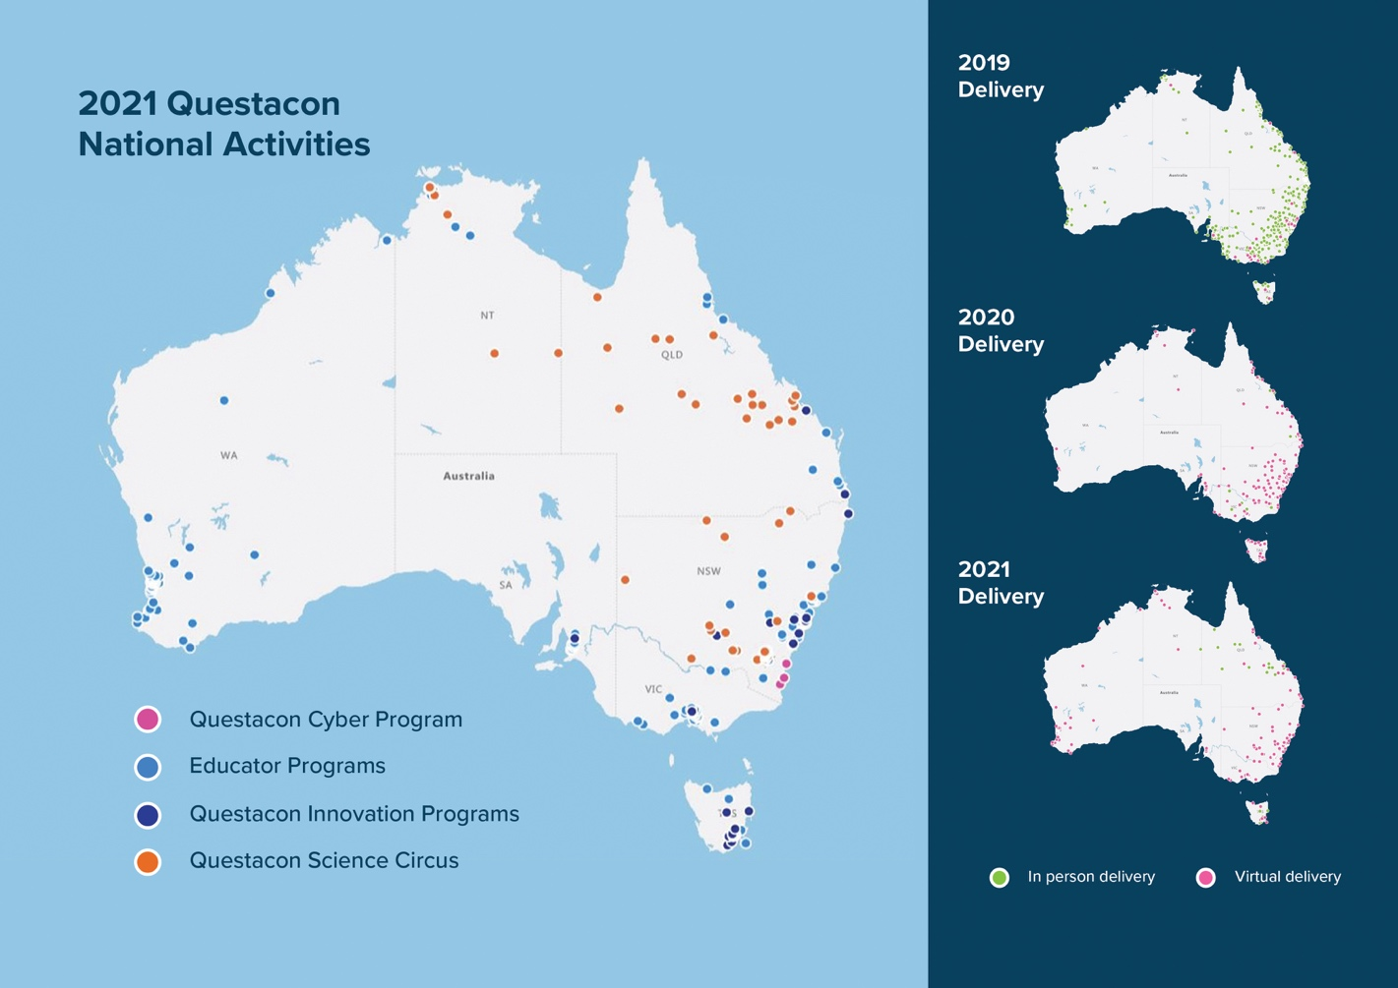

Expanding Questacon’s National Presence
Questacon has continued to connect communities across Australia with STEM engagement and learning opportunities, despite challenges due to the ongoing COVID-19 pandemic. Questacon’s activities are guided by our National Presence Strategy 2020–30, and represent the evolution of our 33-year history in science communication and STEM engagement. The strategy outlines the pathway forward for Questacon, as we endeavour to grow a network of locally-led STEM learning ecosystems that strengthen the future workforce and enrich the lives of all Australians.
Questacon takes a place-based, sustained and collaborative approach to ensure that Australians are able to access Questacon no matter where they are. This approach is spearheaded by a suite of national programs delivered in regions across Australia, including the Questacon Cyber Program, Engineering is Elementary, Questacon Science Circus and Questacon Innovation Programs. These programs are supplemented with travelling exhibitions, multi-day innovation experiences including the Questacon Invention Convention, and digital offerings such as virtual excursions.
Alongside these national programs, Questacon continues to spark excitement and enthusiasm through opportunities to experience STEM in Questacon’s Centre in Canberra. The people, programs and initiatives in the Centre support Questacon’s National Presence Strategy by engaging with visitors from across the country. From Questacon’s Spectacular Science Shows delivered in the Centre, to the Questacon Shop which allows visitors to take a piece of Questacon home with them. Every experience and memory from a visit to Questacon is taken back to communities, connecting individual experiences with future opportunities for engagement.
Now in its second year of implementation, the strategy has seen Questacon forge new and ongoing connections with regional partners, deliver a tailored suite of workshops, resources and professional learning opportunities across Australia, and inspire visitors through new exhibitions, activities and events at the Centre in Canberra.
Figure 2: Questacon staff excited for the return of in-person touring
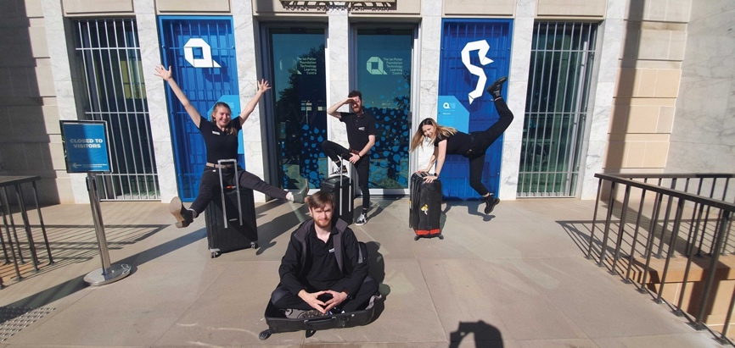
Figure 3: Questacon presenters delivering a virtual webinar in collaboration with NASA.
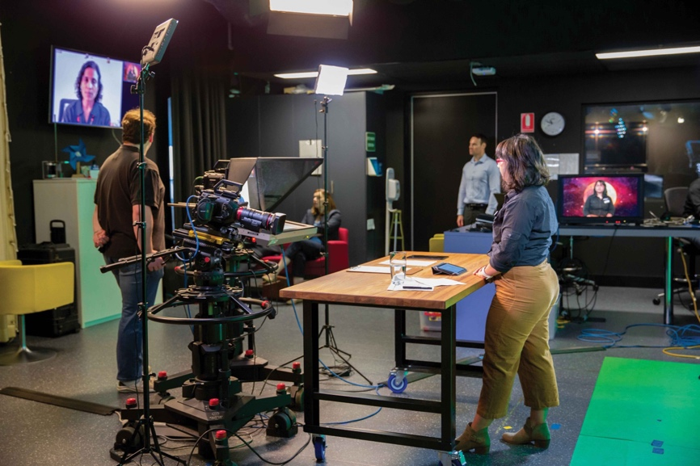

Engineering is Elementary
Since 2019, Questacon has partnered with the Australian Defence Force to boost the confidence and STEM skills of primary school teachers. This strong foundational partnership has enabled Questacon to deliver the Engineering is Elementary program in Australia, to help teachers successfully integrate engineering concepts into their school and classroom practice.
Over the last 12 months, Engineering is Elementary workshops have been delivered to over 445 teachers across Australia. The program is on track to reach its June 2022 target of engaging with 1,000 teachers in 500 schools. Post-workshop surveys have also demonstrated the program’s success in improving teachers’ knowledge, skills, and dispositions for teaching engineering in their classrooms, as well as their pedagogy and understanding for STEM more broadly.
“Today gave me the confidence to go back to school and begin the pathway to a STEM program. I can’t wait!”
(Secondary teacher,
Northern Territory)
94% of participants felt confident teaching Engineering is Elementary.
90% of participants felt the workshops enhanced their capacity for STEM pedagogy and teaching practices.
89% of teachers implemented the program in their classroom or school to some extent.
Figures 4 and 5: Educators and teachers alongside Questacon staff at an Engineering is Elementary workshop
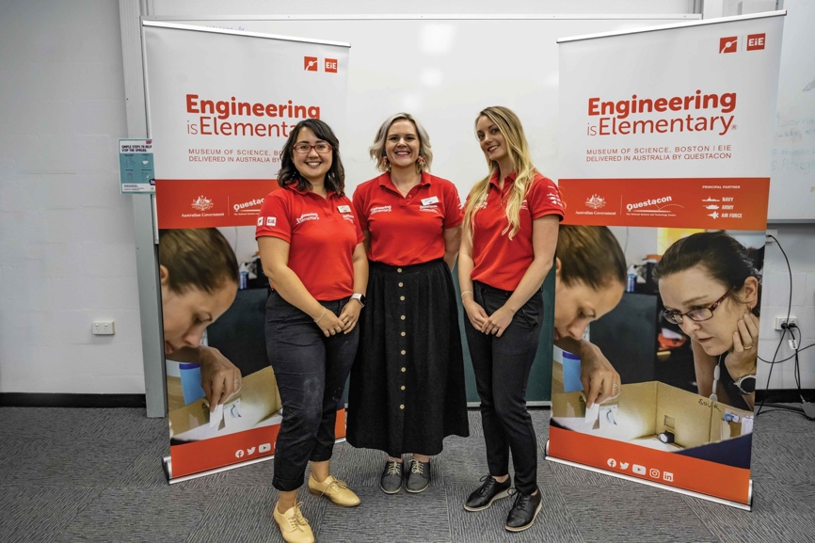
Figure 5
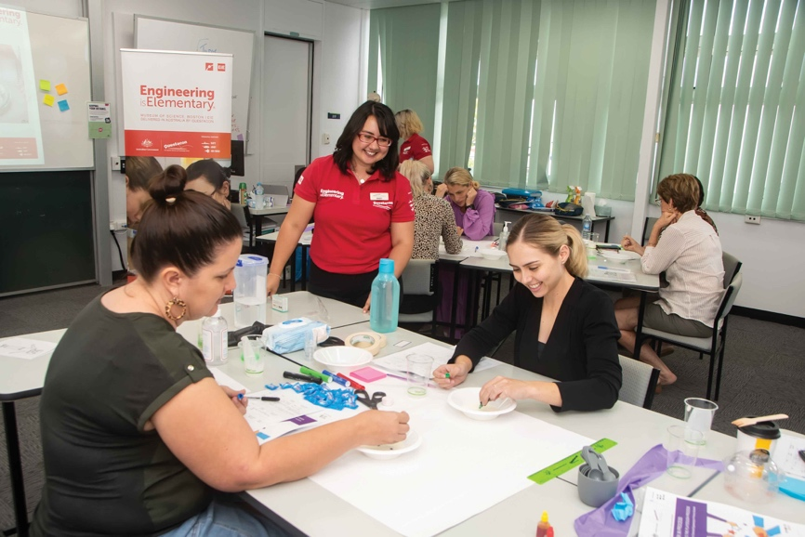


Questacon Cyber Program
The Questacon Cyber Program is delivered as part of Questacon’s National Presence Strategy, which places young people at the heart of all we do. It is an Australian Government initiative to improve cyber security skills, awareness and job readiness among the next generation of STEM leaders.
Over 5 years (2019–2024), Questacon will prepare primary, secondary and tertiary students for careers in cyber security through the delivery of student design challenges, teacher training workshops and stakeholder engagement activities.
This year, Questacon delivered virtual professional development workshops for 111 teachers across Australia. The core offering for primary teachers combines the use of BBC micro:bits with commonly available resources like paddle pop sticks and string, to model a ‘smart farm’. The workshop provides links to the Digital Technologies curriculum, and allows participants to explore basic concepts in programming, automation, sensors and networking.
Through the Cyber Design Challenge, Questacon also facilitated cyber workshops for 652 students and their 35 teachers across Australia. These workshops are designed to encourage students to identify cyber security related concepts in their lives, and to explore their ability to adopt decisions and behaviours that influence their experience in the cyber environment.
Questacon is also collaborating with other cyber organisations and programs to make a greater contribution to STEM learning ecosystems across Australia. This year, the inaugural Cyber Friends Workshop provided an opportunity to network and connect with key stakeholders and leaders in the cyber education sector.
Questacon staff facilitated workshops for 66 external stakeholders, including representatives from federal and state government departments, the cyber security industry, research and academia.
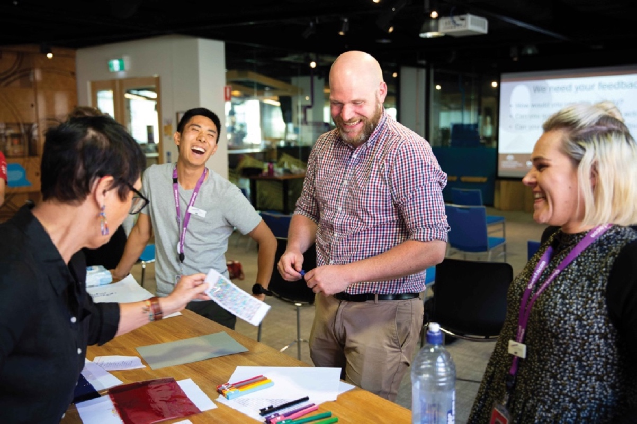
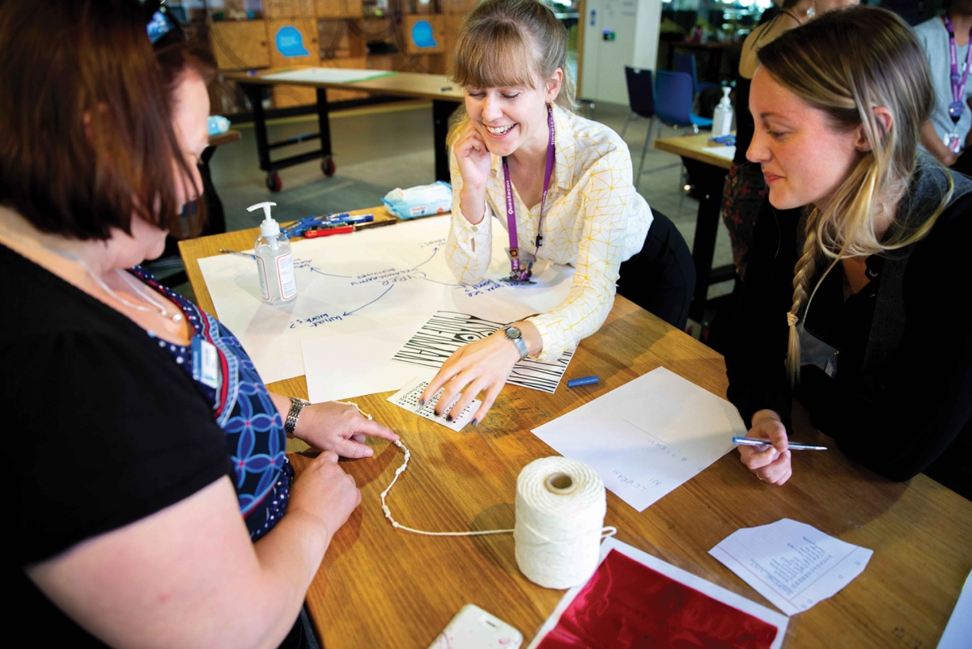
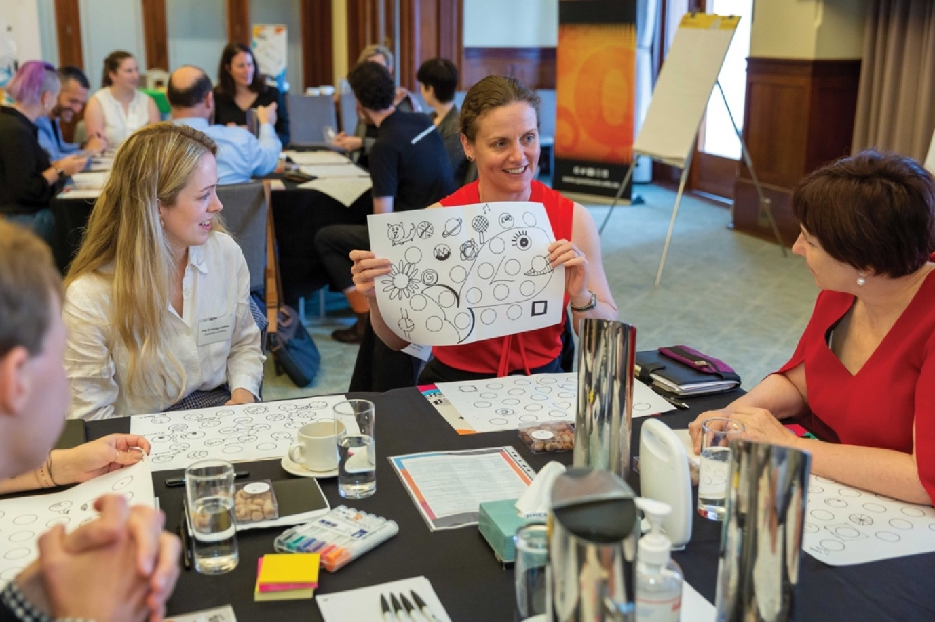
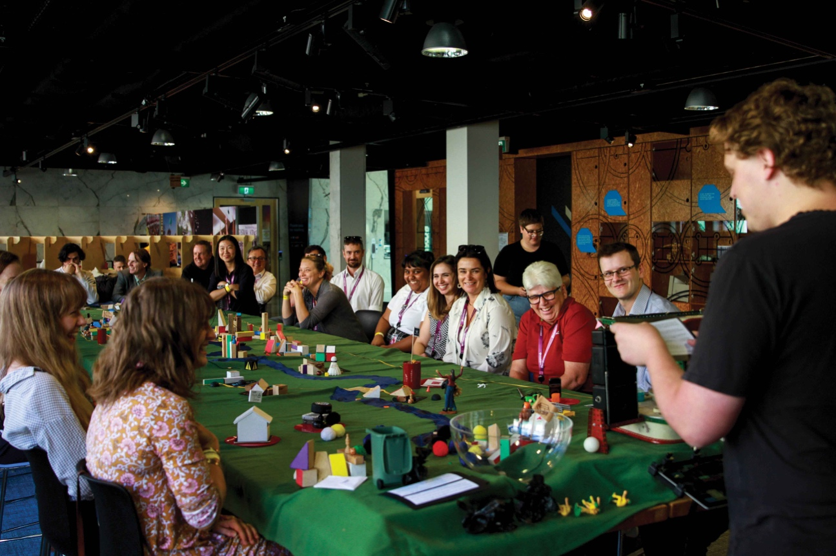
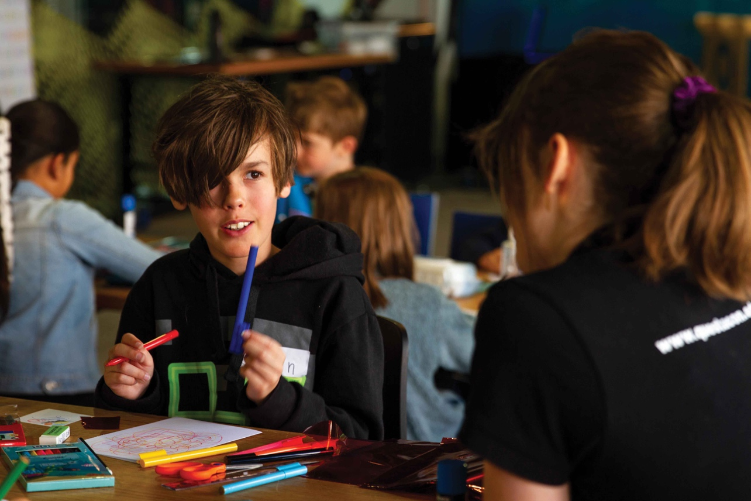

Travelling Exhibitions
Since 1990, Questacon has developed exhibitions using in-house capabilities, and toured them across Australia and internationally. This year, Questacon connected with over 40,412 visitors across Australia through the development and delivery of these travelling exhibitions:
- • Mars pop-up exhibition at Albury Library Museum
- • Born or Built? Our Robotic Future at Scienceworks Melbourne
- • Colour at Newcastle Museum and Cobb and Co Museum.
The installation of Colour at Cobb and Co Museum was a momentous occasion for Questacon. It was the first fully remote installation of a Questacon travelling exhibition, coordinated virtually due to ongoing lockdowns. This exhibition was also the first in Questacon’s innovative and flexible travelling exhibition model. The exhibition was reduced in size to be tailored to the needs of Cobb and Co, a small regional museum. This new approach ensures that regional venues with a smaller floor size are still able to access Questacon’s large-scale travelling exhibitions.
Figure 6: Questacon’s travelling exhibition Colour on tour this year.
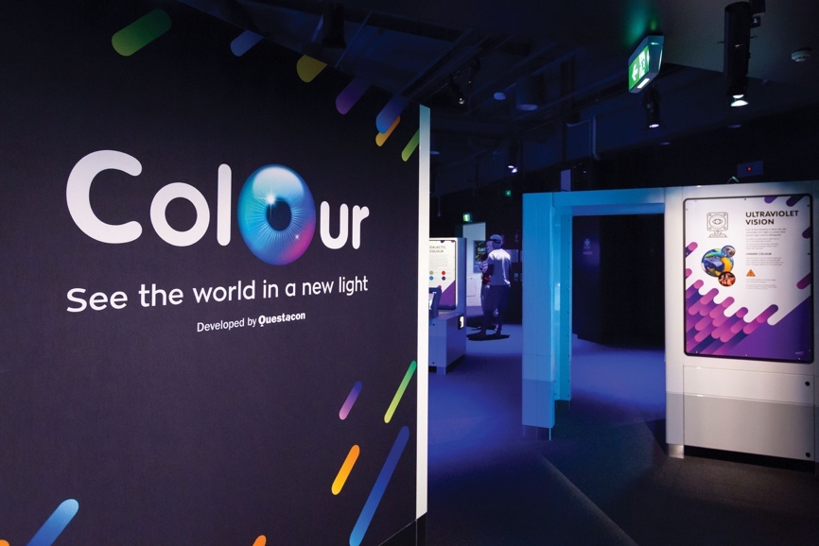

Australia in Space
In 2021 Questacon launched the Australia in Space travelling exhibition, which celebrates the Australian space sector and explores the benefits of space technologies here on Earth. Through Australia in Space, visitors can discover how Australia is contributing to the global space sector, and learn about the organisations and researchers who are growing Australia’s space industry. Australia in Space is designed to welcome space enthusiasts and newcomers alike, getting all visitors on-board with Australia’s vision for a vibrant, diverse and inclusive space sector.
On 4 May, Chief Scientist Cathy Foley helped launch the Australia in Space exhibition at a ‘Questacon in Space’ event, acknowledging the enduring partnership between Questacon and the Australian Space Agency through the presentation of a plaque to be displayed in the Australian Space Discovery Centre in Adelaide. The travelling exhibition will be located at Questacon’s Centre in Canberra for 12 months before travelling to museums across the country.
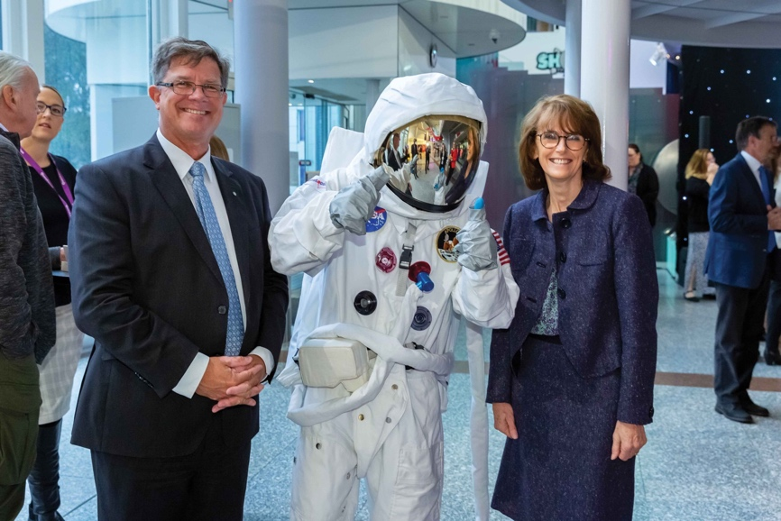

Australian Space Discovery Centre
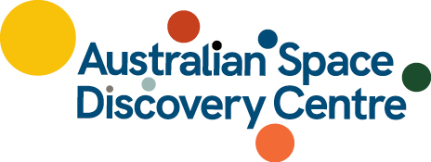
Questacon’s partnership with the Australian Space Agency led to the development of the Australian Space Discovery Centre in Adelaide. The Australian Space Discovery Centre inspires the next generation of the space workforce through stories of opportunity, curiosity and technology, and engages the Australian community with information and interactive experiences involving the national space sector.
The Australian Space Discovery Centre highlights diverse opportunities and pathways in space careers with the aim of inspiring young Australians to pursue a career in space. Questacon continues to support the Australian Space Agency through the sharing of science communication expertise and capacity building for staff.
The Australian Space Discovery Centre opened to the public on 5 May, and has since hosted 17,333 visitors, including 2,002 school students.
Figure 7: Questacon Advisory Council Member and Astrophysicist Professor Alan Duffy at the launch of the Australian Space Discovery Centre.
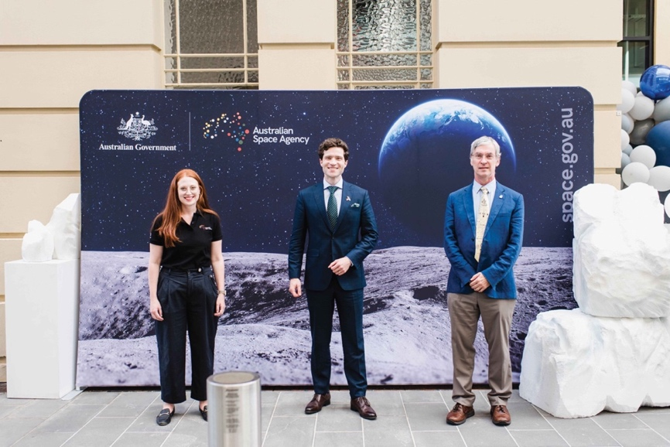
Figure 8: Young visitors exploring the wonders of space at the Australian Space Discovery Centre.
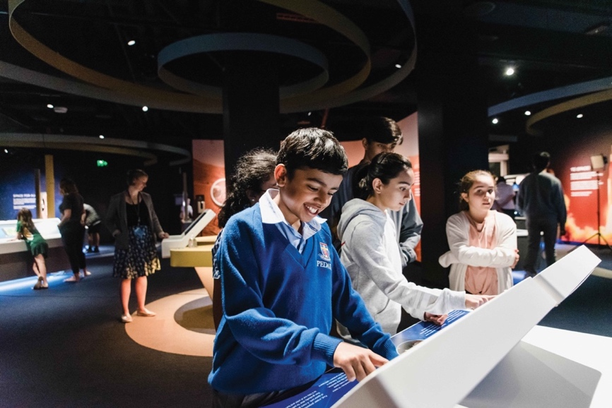
The Australian Space Discovery Centre complements Questacon’s Australia in Space travelling exhibition, together working towards the collective goal of growing the space skills pipeline in Australia.

Questacon Invention Convention
Since 2009, Questacon has delivered both regional and nationwide multi-day workshops for young people aged 14–18 years old, known as the Questacon Invention Convention. During these workshops, young people have the opportunity to work with STEM mentors and innovators to learn more about the innovation cycle and prototype their own innovative solutions to real-world challenges.
In addition to facilitating regional workshops for students in Hobart and Darwin, Questacon also hosted our annual National Questacon Invention Convention in January 2021. The National Questacon Invention Convention was successfully delivered to 19 participants, concluding with a showcase event attended by Their Excellencies, the Honourable David Hurley AC DSC (Retd), Governor-General of the Commonwealth of Australia and Mrs Linda Hurley.
Figure 9: Students at the 2021 National Invention Convention.
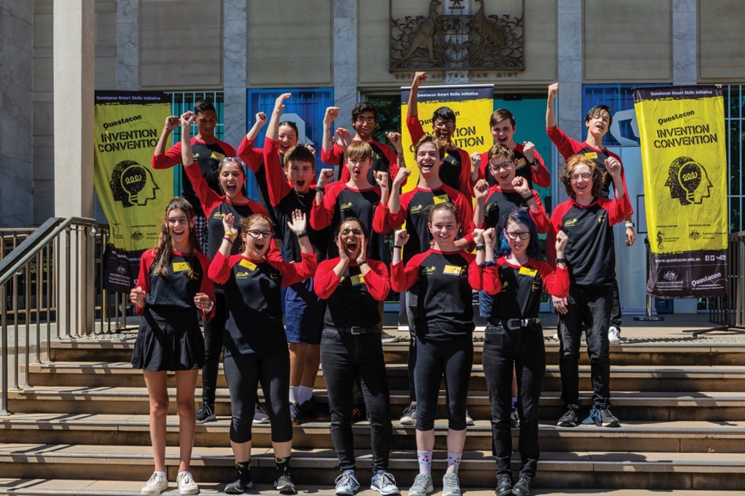
Figure 10: Their Excellencies, the Honourable David Hurley AC DSC (Retd), Governor-General of the Commonwealth of Australia and Mrs Linda Hurley at the 2021 showcase event.
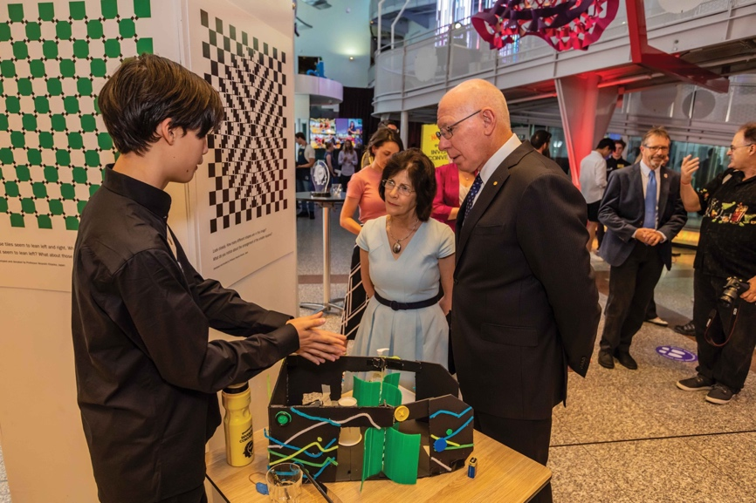



Framework for Monitoring and Evaluation
Comprehensive monitoring and evaluation are essential for our commitment to quality assurance, continuous improvement and making a valuable impact and contribution. Questacon’s evaluation framework guides a consistent and robust approach to the evaluation of Questacon’s programs and exhibitions towards their intended outcomes.
Questacon collaborates with external stakeholders to monitor and evaluate data captured from each of the activities and programs. The results of these monitoring and evaluation activities also provides accountability to external stakeholders, and informs our evidence-based approach to improvement and future direction.
Questacon measures impact through 2 avenues of analysis:
- Visitor and participant outcomes – Questacon has adopted the Generic Learning Outcomes in the Inspiring Learning for All Framework, developed by the Arts Council England for the arts and culture sector.
- Contribution to the STEM learning ecosystem – Questacon measures success by the uptake and outcomes of its individual programs, as well as our capacity to support and connect to other providers, experiences and resources in the STEM learning ecosystem.

Sample Data from Questacon’s 2021 National Activities
Breakdown of Questacon’s 2021 national activities by participant type and location. Data from Questacon Innovation Programs, Questacon Science Circus and Questacon Cyber Program. Activities include virtual and in-person workshops, shows and webinars.
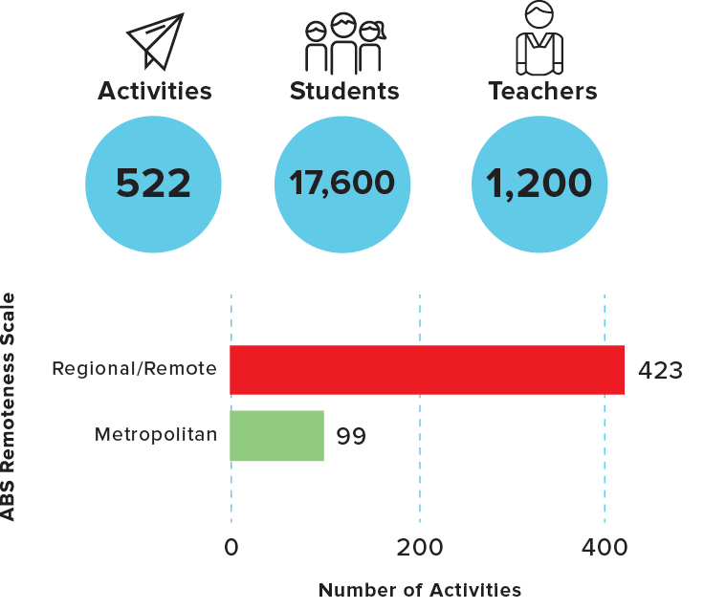

Digital Engagement
Questacon’s digital presence has enhanced community engagement with STEM by providing accessible content and enabling the delivery of remote programs to all Australians. During the COVID-19 pandemic, Questacon’s digital presence was rapidly scaled-up to support student, teacher and family STEM development, particularly for those completing at-home learning. Guided by Questacon’s National Presence Strategy, these activities connect thousands of learners across Australia with digital STEM resources, virtual excursions and workshops.
“We just wanted to express our gratitude for being a part of our ‘bringing the outside in’ virtual excursions for 2021. This year has seen some challenges as we continued to educate students through new and innovative ways during a pandemic. Thank you again for donating your time and we hope to continue working with you in the future.”
(Education Institute Team at the Royal Children’s Hospital, Melbourne)
Audience growth across social media channels increased 26% (compared with 2020.
Impressions across all social media: 1,933,619.
Website page views: 1,274,983.
17,087 Questacon at Home page views.
Figure 11: Questacon Advisory Council Member and cancer researcher Dr Ken Dutton-Regester has developed a series of augmented reality artworks called ‘Cancer ARt Gallery’.It explains the cancer biology through a series of nostalgic, pop-culture and street art styles presented on a digital platform.
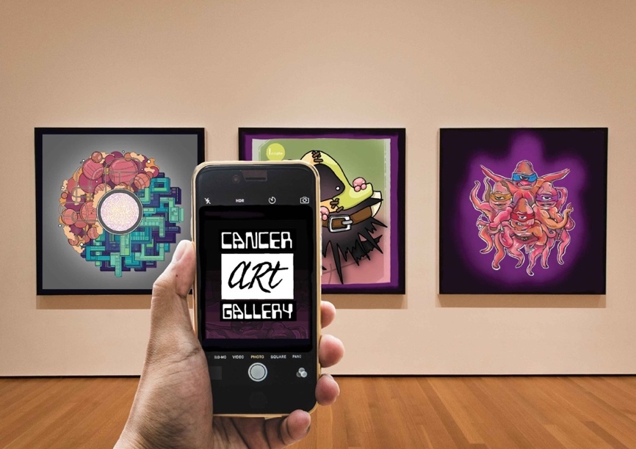
Questacon at Home provided support to families and students in lockdown with web-based self-guided learning experiences.


Backyard Bingo activity sheets encouraged students and families to look closer at their homes, gardens and surrounds for STEM learning.
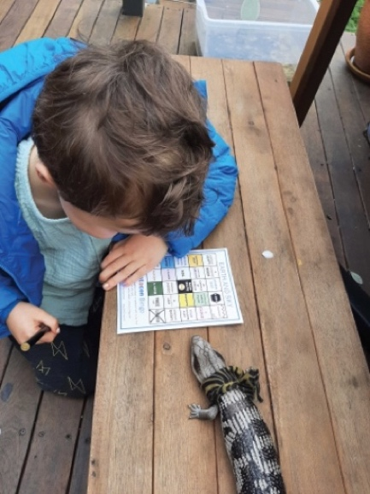
Questacon delivered 189 Virtual Excursions to 29,162 learning end points, allowing us to connect with Australians across the nation when in-person delivery was not possible.
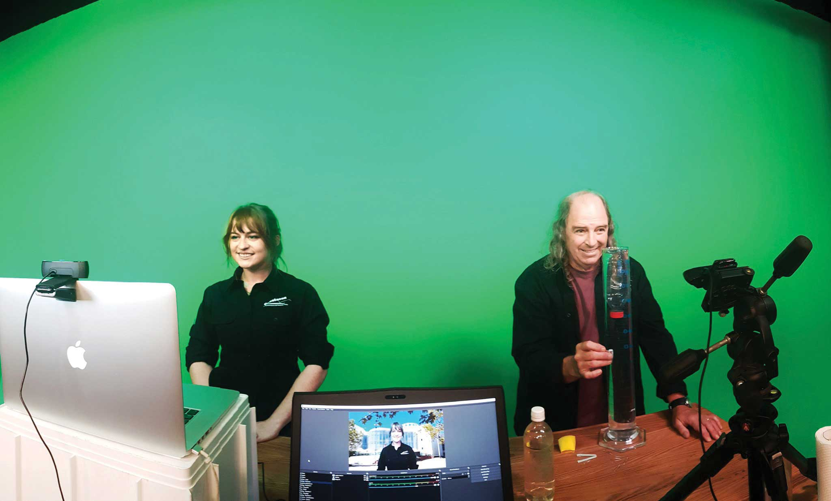

Questacon takes flight
As part of Distance and Rural Technology (DART) Learning’s ‘Virtual Week in Canberra’, Questacon hosted a one-hour webinar for school children across Australia. Over the hour, thousands of budding young aerospace engineers were connected and encouraged to creatively test and modify various paper plane designs. Questacon staff adapted to virtual delivery using remote producing software and pop-up green screen set-ups to ensure a quality experience for students despite delivering from their own living rooms.
13,000 end points connected our keen passengers to embark on the webinar about flight.
That’s enough people to fill over 35 Boeing 747 jumbo jets!

Inspiring Australia
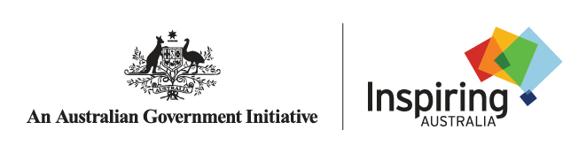
The global pandemic has highlighted the value of establishing connections, building networks and maintaining communication internally and externally. Questacon continues to collaborate with state and territory governments, STEM organisations and volunteers across Australia through the Inspiring Australia national network.
Inspiring Australia supports regional communities by providing support for innovative and community-driven STEM engagement activities. Together with science and research agencies, educators, industry and business sectors, Questacon supports Inspiring Australia to improve coordination and increase the impact of community science engagement activities.

Prime Minister’s Prizes for Science
As part of Inspiring Australia, the Prime Minister’s Prizes for Science recognises and rewards local innovation and scientific endeavours. This year, Megan Hayes was awarded the prize for Excellence in Science Teaching in Primary Schools. Megan is an alumni of the Australian Science Teachers Association’s STEM X Academy, a program delivered in conjunction with Questacon and CSIRO.
Figure 12: Megan Hayes – Prime Minister’s Prize for Excellence in Science Teaching in Primary Schools.
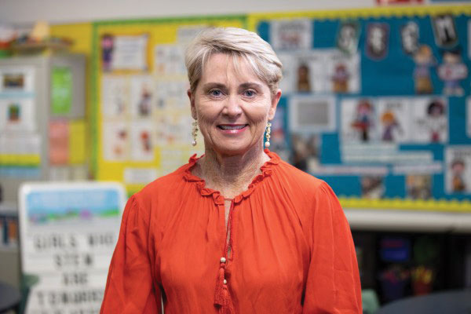

National Science Week 2021
Through the national Inspiring Australia infrastructure, Questacon coordinates National Science Week. National Science Week is Australia’s annual celebration of science and technology, and is one of the nation’s largest festivals. It is a collaborative, community-driven initiative, with active participation from museums, libraries, schools, research organisations, businesses and science clubs across Australia.
This year marked the 25th celebration of National Science Week. Events were delivered virtually and in-person, with many focused on engaging underrepresented demographics such as regional communities, young women, and Indigenous youth. National Science Week was supported by a long list of esteemed STEM Ambassadors, including Corey Tutt (proud Kamilaroi man and founder of Deadly Science), Professor Marylouise McLaws (renowned epidemiologist), Alyssa Healy (Australian cricketer and marine science student), and Dr Karl Kruszelnicki (science communicator and author).
Every year, the Australian Science Teachers Association (ASTA) produce an annual themed teaching resource book for National Science Week. This year’s theme was Food: Different by Design. The ASTA teacher resource book was downloaded 25,623 times from the National Science Week website.
Figure 13: Misha Schubert, CEO of Science and Technology Australia, at Questacon for the launch of National Science Week 2021.
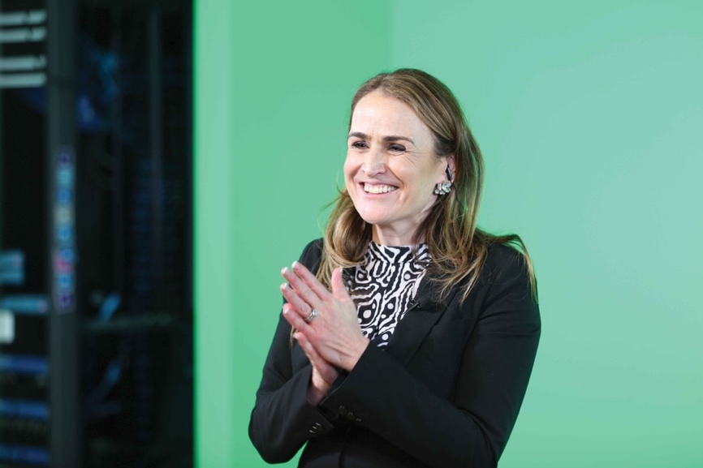
1,756 registered events in person and online across Australia.
Over 1.3 million people attended National Science Week events.

Questacon Centre Activities
As Australia’s National Science and Technology Centre, Questacon’s mission is to excite and motivate people to engage with STEM. Since 1988, Questacon has offered these inspirational STEM learning experiences to the thousands of Australians who visit Questacon’s Centre in Canberra. The Centre remains a popular destination for both locals and interstate visitors, and is a much-loved excursion for the many school students who visit Canberra from across Australia.
Centre visitation by school groups and families is a central part of Questacon’s National Presence Strategy. A key goal of the strategy is to better connect school groups and families during their visit to the Centre with travelling programs and online engagement.
While 2021 brought new and ongoing challenges, Questacon continued to adapt and evolve to improve the visitor experience in the Centre.
This year, Questacon welcomed schools back to the Centre for the first time since the beginning of the COVID-19 pandemic. School groups were eager to engage with science in extraordinary new ways with interactive exhibits and live demonstrations.
In August 2021, the Centre temporarily closed to the public in response to the COVID-19 pandemic. After 99 days, Questacon reopened our doors again. Questacon returned to operations with the safety of staff, visitors and wider community as our first priority. Additional COVID-safe measures were implemented in response to the pandemic, including pre-booked tickets, QR codes and upgraded COVID-safe interactive exhibits.
Figure 14: Questacon staff welcoming school groups back to the Centre.
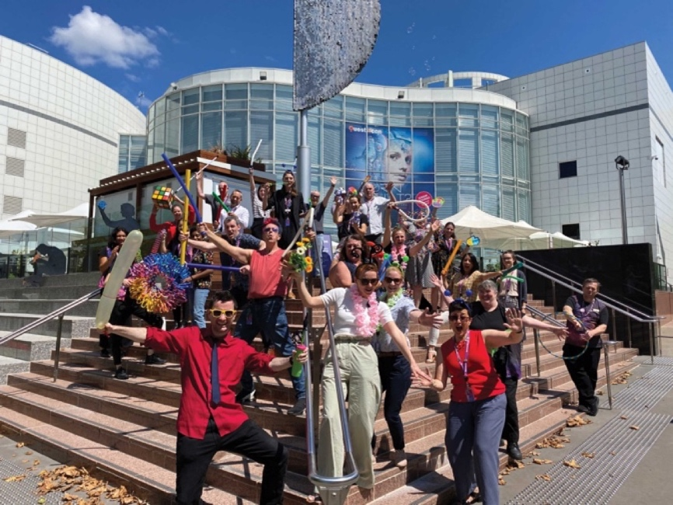

Visitor Experiences
This year, the Centre received upgrades to enhance visitor experience and to provide greater COVID-safe interactions. The fast-paced and high energy exhibit Batak was upgraded to replace the hands-on button pads with hands-off sensors. This change to the exhibit now reflects greater COVID-safe interaction with the exhibit.

Mini Q Reopens
In May, Questacon’s Mini Q gallery for children aged 0–6 years old reopened to the public for the first time since the beginning of the COVID-19 pandemic. While the gallery still offers an interactive and immersive experience for Questacon’s youngest scientists, the spaces were modified to ensure the health and safety of staff and visitors. This year, a new activity area was added to the gallery to allow further engagement opportunities between staff, and children and their carers.

Updates to Beehive Exhibit
Questacon’s live beehive exhibit, located in Q Lab, received digital updates this year to enhance visitor engagement and interactivity. The upgrades included information to facilitate discussions around environmental sustainability. A temperature graph was also installed to display data on the differences in temperature inside the hive and outside the building, and audio sounds were added to demonstrate how and why queen bees communicate inside the hive.
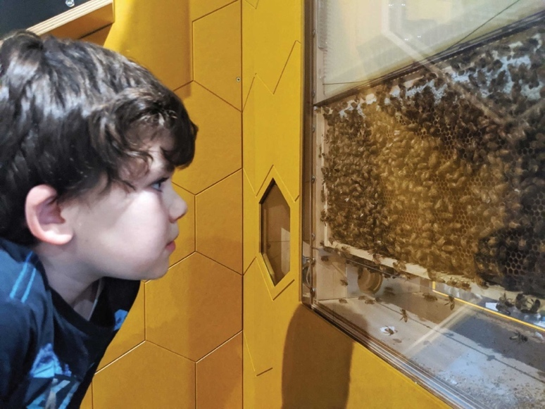

Kinetic Sculpture
Questacon installed our 3rd Kinetic sculpture at the Centre in Canberra. This mesmerising exhibit features a steampunk theme of pulleys and rotating moiré discs connected by a number of turning gears, fascinating and entertaining visitors as they enter the Centre.
“I just wanted to extend a deep thank you to your staff for being very passionate about not only their jobs, but the growing minds that they are encouraged to engage.
Not many people have the patience to listen to such young children and answer such, often comically ridiculous, questions (such as what would happen if we had six suns) with not only enthusiasm but with an intention to teach”
(Visitor feedback, 2021)

Women in STEM Exhibit
Located on the spiral ramp in the Centre, Questacon’s Women in STEM exhibit introduced 3 new panels to the display. The portraits aim to showcase women with emerging and established STEM careers to inspire visitors irrespective of their gender or background.
Figure 15: Questacon’s newest panel for the women.
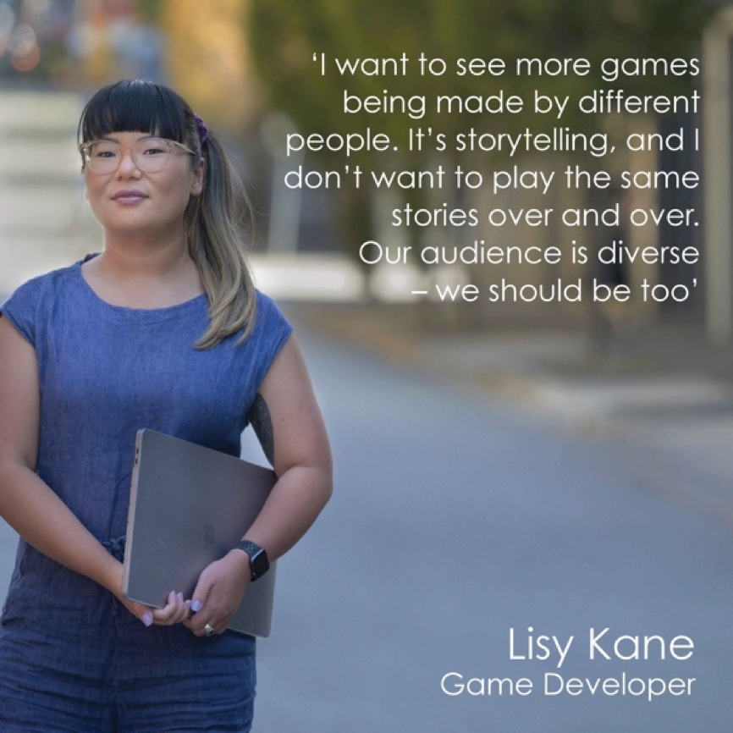

Microbial
This year, Questacon showcased the inflatable art installation Microbial. The art installation was initially created for the United Nations General Assembly as part of an exciting project that asked artists from all over the world to create works that raised awareness of the threat of antimicrobial resistance and superbugs. The artists Maurice Goldberg and Matthew Aberline collaborated with scientists to find a way to describe these microbes in an immersive and engaging way – away from the microscope.
The free standing inflatable sculpture enables the viewer to journey around, through and under a spikey, mystery virus – similar to the COVID-19 virus we all know so well.
Figure 16: Microbial on display in the Centre.
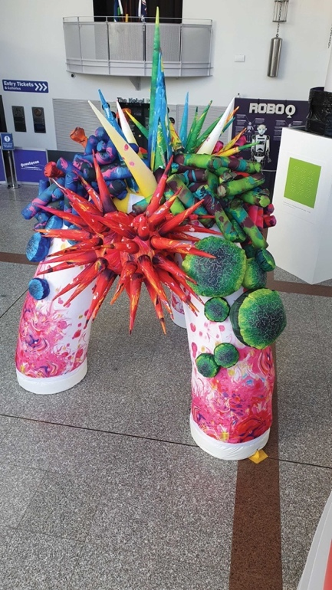

Accessibility and Inclusion
Questacon continues to champion inclusion and accessibility in both our workforce and visitor experience. The annual Autism Access Day was held in 2021 as part of an ongoing community engagement activity. Across 2 days, visitors who identify on the Autism Spectrum, along with their family and friends, were invited to join trained staff in a quiet and sensory friendly morning at Questacon.
Questacon is continuing to look for ways to improve inclusion and accessibility through staff training, consultation and activity design.
In 2021, Questacon developed a suite of accessible new tinkering activities in The Shed to ensure all visitors are able to have an engaging experience.

Q Members
Since it was launched in 1989, Questacon’s membership program (Q Club) has provided members with exclusive opportunities to experience deeper engagement with science and technology.
On 10 December this year, Questacon welcomed back Q Club members after memberships were suspended for 20-months due to COVID-19. Over 18,500 members were welcomed back with a 20 month extension to their memberships, an additional 100 day extension and a welcome back gift from the Questacon Shop to thank them for the ongoing patience, support and loyalty. Q Club members continue to be an integral part of Questacon, and our staff are thrilled tosee familiar, and new, faces exploring the galleries and engaging in science once again.
A Q Club membership provides visitors with entry to Questacon, discounts at the Questacon Shop and café, entry to a range of reciprocal partners both in Australia and overseas, a free guest pass for your friends and family, and exclusive news and invitations about upcoming events at Questacon.

Q Retail
The Questacon Shop is considered by visitors to be an important part of the Questacon experience. In 2021, the Questacon Shop operated with COVID-safe principles by offering in-person and online shopping, with a product range that continues to excite, inspire and engage our audiences. Retail products are sourced from around the world to complement Questacon’s galleries, activities and programs. In 2021, the return of school groups to the Centre further solidified the excitement that the Questacon Shop brings for our visitors.
The Questacon Shop extends the learning experiences beyond the Centre by engaging with visitors through STEM educational products. This year, the Questacon Shop developed Excursion in a Bag to connect with schools across Australia who were unable to visit Questacon, featuring a selection of Questacon’s most popular retail items, along with fun experiment cards to engage students in at-home science activities.
Figure 17: One of Questacon’s younger visitors enjoying the Questacon Shop products.
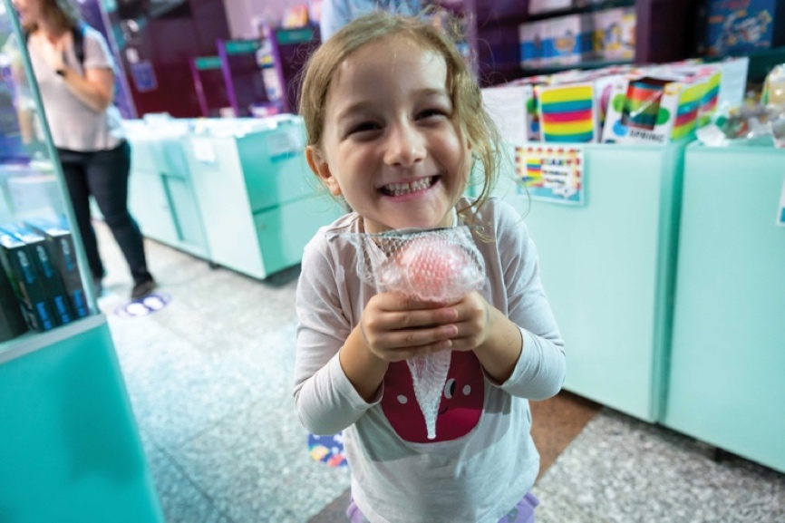
85,568 Questacon shop products sold.
7,511 units of freeze dried ice cream sold.
11,374 units of Questacon science putty sold.
439 COVID-19 Microbes sold.



Learning Programs and Events

Spectacular Science Shows
The Spectacular Science Shows returned to Questacon on 5 July 2021. While maintaining a COVID-safe environment for visitors, Questacon’s science theatre troupe, the Questacon Excited Particles, continued to entertain the audience with humour, character and live demonstrations. Since the return of shows this year, Questacon Excited Particles presented 195 shows to over 6,510 visitors.

The Tinker Space
July 2021 marked the return of Questacon’s tinkering studio to the Centre since the beginning of the pandemic. The tinkering studio, located in The Shed at the Questacon Centre, challenges visitors to create design solutions using simple everyday objects. The Shed previously centred on a suite of hands-on activities and exhibits, but has since been adapted to reflect COVID-safe interactions while still incorporating playful and iterative experimentation. In the first month of its return, we welcomed 1,358 visitors to the studio, and have continued to see high levels of visitation and engagement since. Questacon staff are busy working on new and exciting activities and challenges to incorporate into The Shed’s ever-changing program.
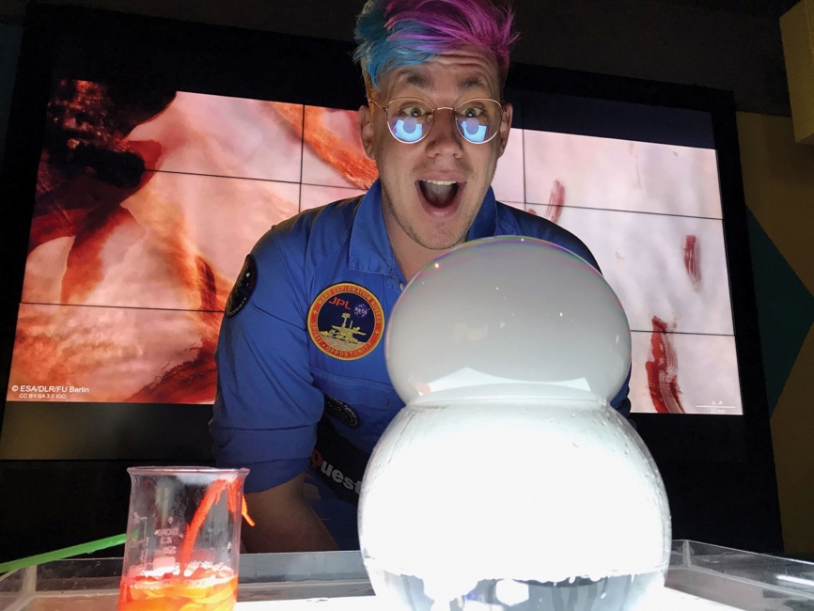

Science Sprouts
Questacon’s early childhood education program, Science Sprouts, was developed to engage our littlest scientists and their carers in interactive role play experiences.
During the sessions, children aged 3–6 years old are able to experiment, discover and ask lots of questions in a friendly, inclusive and COVID-safe environment. In 2021, children explored the world of fantastic flowers, discovered dinosaurs, learnt how to make music using household objects, researched robots and observed the magic of oceans.
Figure 18: Questacon staff and visitors at a Science Sprouts puppet show.
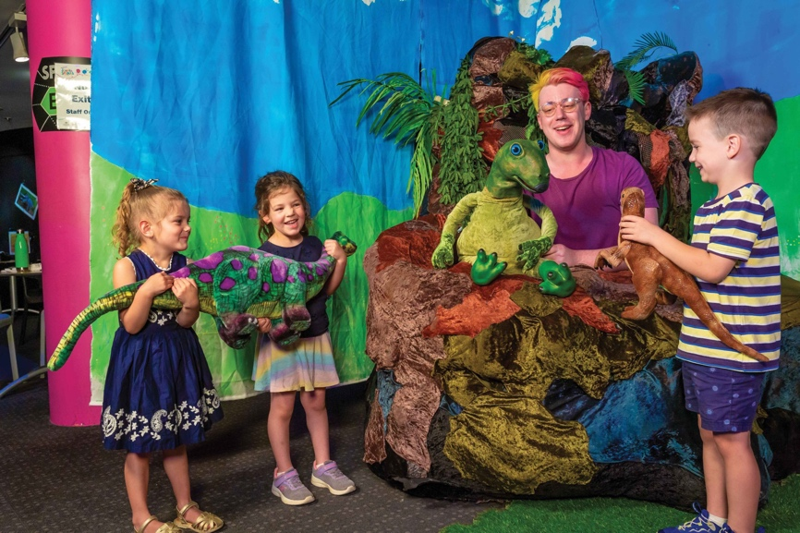

Questacon Goes Viral
On 30 July, Questacon co-hosted the ‘Questacon Goes Viral’ event with the Australian National University Research School of Population Health. The event was extremely popular, with tickets selling out within a matter of days. The night saw participants crown Mr Con Spearitzy the 2021 Miss Information Pageant winner in both sessions, explore the world of vaccines alongside our in-house Wellness Influencer, before heading into the theatre for a panel discussion on all things pandemics. The night was a great success, with collaborators from the ANU and Research School of Population Health, as well as attendees, providing positive feedback on the event.
Figures 19 and 20: Questacon staff at the Questacon Goes Viral event.
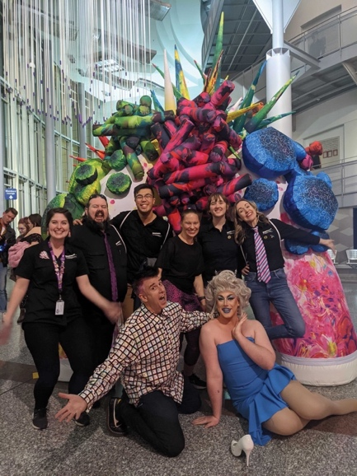
Figure 20
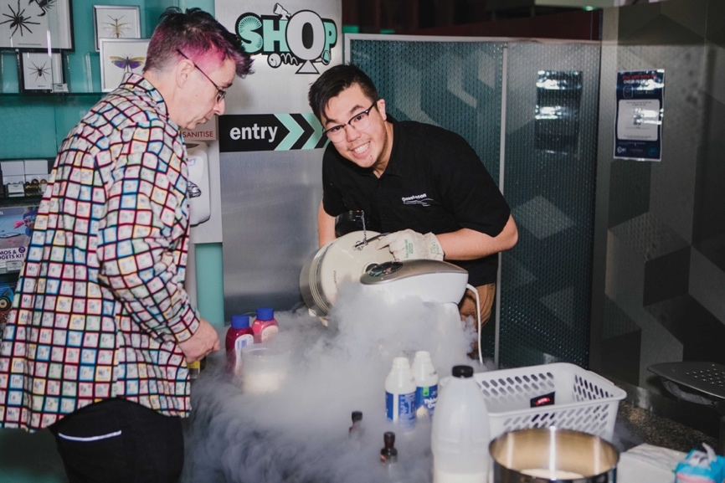

Supporting Tourism in the ACT
As a key tourist attraction in the ACT, Questacon is working closely with the local tourism sector to rebuild tourism business opportunities and explore ways to grow visitation at each of our attractions. Questacon is collaborating with Canberra’s other Cultural Institutions to promote the ACT as Canberra’s Culture Capital as part of the Cultural Icons: Made of Australia campaign.
Questacon’s inclusion in the Wotif Bucket List was also a cause for celebration. Wotif, one of Australia’s top online booking websites launched a nationwide search to find the top travel experiences young Australians want to see around the nation. After tallying the results, Questacon came out on top as one of the best experiences in Australia for kids under the age of 13.

Enlighten Festival
Canberra’s annual Enlighten Festival brought another year of exciting events and lighting displays to Questacon. We held a special showing of the family friendly science show ‘Colour!’, and a return of the popular adults-only events. This year’s ‘Pure ImaGINation’ show explored the botany, chemistry and science of gin, with 80 guests joining our Questacon presenters for an evening of excitement under the Mars exhibit.

Sunrise Weather Cross
Questacon was featured on Sunrise Breakfast, which they showcased the best attractions Australia has to offer. Questacon was featured throughout the morning with live crosses that included eye-catching experiments under the Mars exhibit and in Q Lab.

Figure 21: Questacon lights up with spectacular illuminations for the Enlighten Festival.
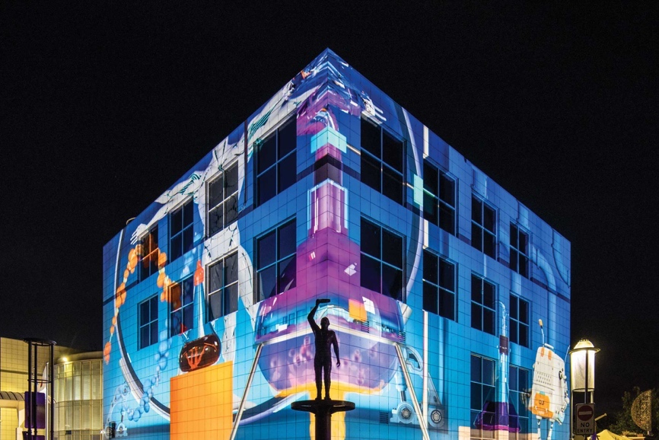

Sustainability
As a leader in the Australian science sector, Questacon is committed to promoting the 17 United Nations Sustainable Development Goals (SDGs). We are committed to communicating the broad depth of sciences encapsulated in climate change, sustainability and the SDGs in ways that are engaging, intriguing and exciting for our audiences.
Questacon’s content and activities focus on providing accessible pathways of engagement around the often complex issues associated with sustainability. Some examples of ways Questacon supported the SDGs this year include:
- Exploring climate change and sustainability in Questacon’s newest travelling exhibition, Australia in Space, and the Australian Space Discovery Centre in Adelaide.
- Developing content focused on improving energy literacy and promoting awareness to Australian and international communities of the United Nations’ SDG 7 – affordable and clean energy
- Developing a video about Eunice Newton Foote and her experiment on heat-trapping gases, which foreshadowed the biggest challenge currently facing life on Earth.
At Questacon we are also supporting the outcomes under the SDGs through our own net zero project (QNetZero), which aims to reduce and offset our environmental impact in order to achieve net zero emissions by 2030. In 2021, Questacon completed an emissions audit and identified key emissions sources as the first step to gain a carbon neutral certification. The baseline will be used to track future performance and progress towards lower emissions.
Questacon’s detailed emissions reduction plan will be established in 2022. QNetZero also aligns with Questacon’s mission and ambition to engage people in climate science and technology that will contribute to a lower carbon future.
Figure 22: On International Women and Girls in STEM Day this year, Questacon released a video about Eunice Newton Foote, which featured at-home experiments presented by Questacon Advisory Council member and Australia’s Women in STEM Ambassador, Professor Lisa Harvey Smith.
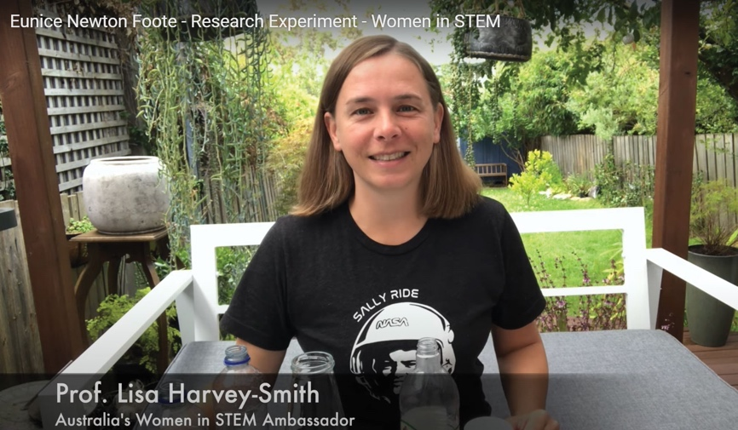
Figure 23: Questacon’s aquarium supported by corporate supporter, Icon Water, raises awareness of the importance of water management and sustainability.
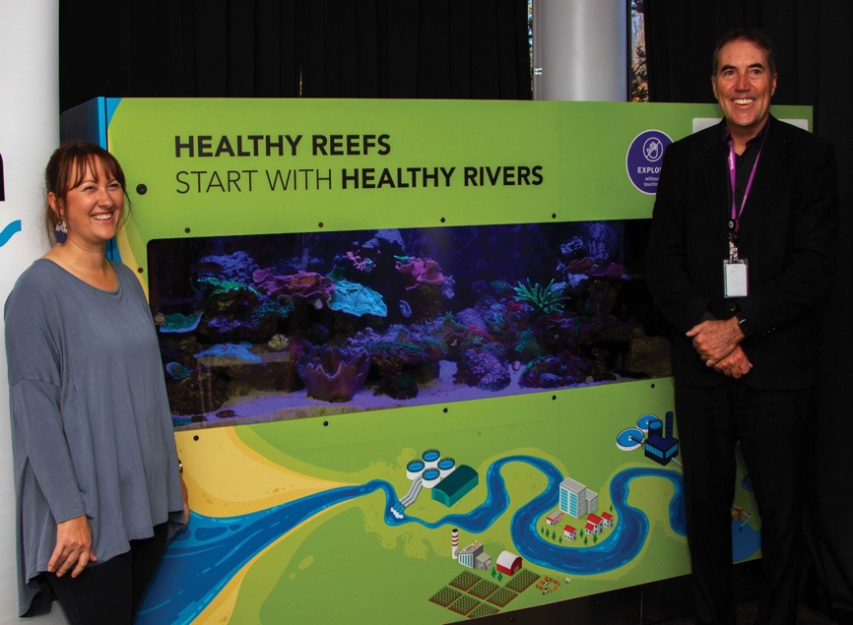

Indigenous Engagement
Questacon’s vision of a better future for all Australians through science, technology and innovation reflects the importance of STEM for national prosperity. Supporting the participation of First Nations peoples and inclusion of their millennia-old knowledge systems in our offerings benefits all Australians.
Questacon’s Indigenous Engagement Strategy 2021–2026 underpins our divisional commitment to the Department of Industry, Science, Energy and Resources Reconciliation Action Plan, and Questacon’s divisional Reconciliation Plan, which is due to be released in 2022.
Our strategy guides how we will strengthen the presence and participation of First Nations peoples in the workforce and the activities of our National Science and Technology Centre. The strategy is built on four pillars: Presence; Platform;
Programs; and People.
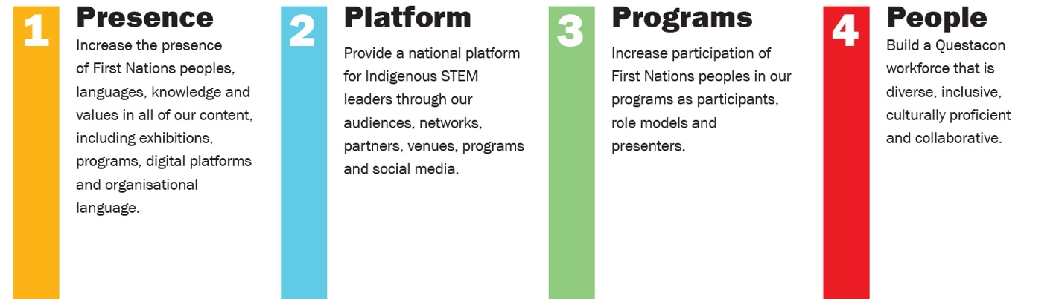

Events and Highlights

Release of our new Science in First Languages video
Questacon’s Science in First Languages videos feature short segments from First Nations scientists and students, and include words spoken in First Languages. The latest Science in First Languages video was created with the preschool class of Robinson River School in the Northern Territory, and was inspired by the 2021 NAIDOC Week theme of Heal Country. The Robinson River School is situated on Garrwa Country, and the video includes Garrwa Language.
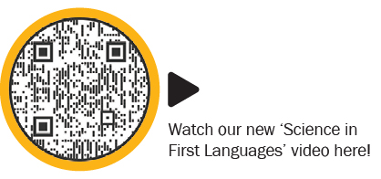

Ngunnawal words for Play, Learn, Discover
As part of the 2021 NAIDOC Week celebrations, Questacon displayed the Ngunnawal words wagabaliri (play), binyin (discover) and winanggaay (learn) at the Questacon Centre, on the Questacon website and on social media. These words will remain on display at the Centre for the foreseeable future.

Launch of First Scientists with Corey Tutt
On 21 October, Questacon hosted a virtual book launch for Corey Tutt’s highly anticipated, illustrated science book First Scientists. The live webinar was viewed by more than 548 people, as well as classrooms across Australia. Attendees also included Her Excellency Margaret Beazley Governor of New South Wales.
The launch event was shared widely through Questacon’s social media, engaging with 945 people. During the webinar, 449 questions and comments were shared by our viewers, sparking a fun and engaging dialogue with Corey about First Scientists.

Arrilla Digital Cultural Training
This year, over 80% of Questacon staff undertook the Arilla Digital Cultural Training. This effort highlights the importance of increasing cultural awareness in our community to continue to build a path towards reconciliation with First Nations people.

Indigenous Workshop Program
This year, the Questacon Science Circus developed a new program of Indigenous engagement. The Indigenous Workshop Program saw Science Circus presenters build relationships with 6 schools located on Ngemba and Gamilaraay country, all of which have high enrolments of Indigenous students. Over the course of the program, Questacon presenters developed bespoke workshops to meet the schools’ specific needs, engaging with a total of 167 students and 29 educators.
This was a powerful opportunity for the participating students and teachers, who were able to experience hands-on STEM workshops designed with their interests in mind. Science Circus presenters also had the chance to combine theory and practice in the delivery of culturally-inclusive programs and develop real-world stakeholder engagement skills.

International Engagement
Questacon has a strong track record of purposeful international engagement through 3 key objectives: connect; contribute; and support. Questacon is a cultural diplomacy asset, showcasing the capabilities of the Australian science and learning sectors through various embassies and high commissions, working closely with the Department of Foreign Affairs and Trade (DFAT).
International engagement activity for 2021 included engagement across the Asia-Pacific, the United States of America and Africa.

History with Japan
Questacon has a deep history of cooperation with Japan. Questacon’s relations began with our founding as a joint Australia-Japan Bicentennial Project on 23 November 1988. The government and business community of Japan generously contributed ¥1 billion to establish Questacon.
In years since, Questacon has collaborated on many programs with various Japanese Government agencies and organisations.
Figure 24: Professor Graham Durant with Japanese Ambassador, His Excellency Shingo Yamagami and his wife Mrs Kaoru Yamagami.
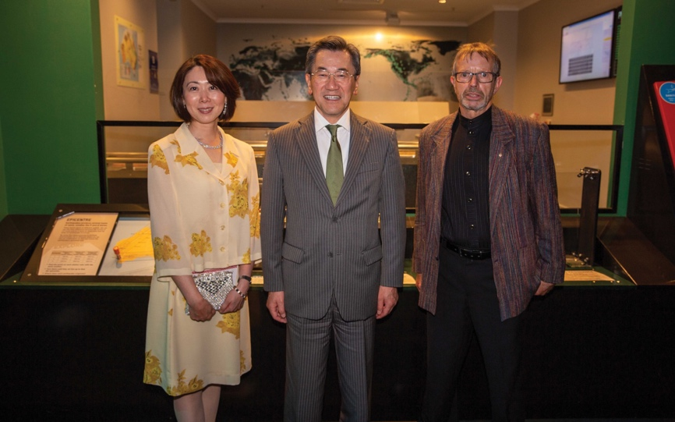

Museum of Science, Boston
Questacon’s ongoing relationship with the Museum of Science, Boston is representative of Questacon’s commitment to international engagement in the museum and cultural sector. Since 2019, Questacon has partnered with the Museum of Science to deliver the Engineering is Elementary program in Australia.
The delivery of the program has been highly collaborative, with regular meetings to discuss the challenges and opportunities of delivering STEM education programs, particularly during the COVID-19 pandemic. This includes lessons learnt from transitioning to virtual delivery.
The Museum of Science has been highly supportive of our program development and delivery, sharing both its resources and experience. It has been very interested in our experience and success in exploring new markets, such as secondary teachers and undergraduate educators.
Questacon is delighted to build on this collaborative effort between the educator teams.

Support for COP26
Questacon provided support for the Australian pavilion at the UNFCC climate conference (COP26), which took place in Glasgow this year. Questacon provided a video which showcased young entrepreneurs who are working on climate and sustainability solutions, and was displayed at the international conference.
Questacon also developed a webinar for upper primary and secondary students, held during COP26. During the webinar, participants explored soil health and ecosystems, and learnt about the steps they can take in their own communities and schools to support the United Nation’s Sustainable Development Goals to create a healthier planet.

Events and Highlights

23 February
Questacon, in partnership with the US Embassy, connected with NASA for a live virtual event. JPL Space roboticist, Dr Vandi Verma, discussed her work with the Mars 2020 Perseverance Mission with over 50 schools and 1,250 students.

25 February
Questacon mounted a Hayabusa display at the Japanese Embassy to celebrate Emperor Naruhito’s birthday. The display showcased the Australia–Japan science research cooperation treaty and the return of the Hayabusa2 mission’s payload.

18 March
Japan’s first astronaut and a close friend of Questacon, Dr Mamoru Mohri AM, retired as the CEO of Miraikan in March 2021. Questacon gifted Dr Mamoru a farewell video and letter with help from the Australian Embassy, Tokyo. On 18 March, Dr Mamoru made a surprise appearance introducing a virtual tour of Questacon for the Japan Science Museum Association (JASMA).

10 June
Questacon hosted an event on ‘the strategies and tactics of social media disinformation’, in collaboration with the US Embassy. The event engaged students from years 9–12 in a discussion about safe online behaviours.

12 August
Questacon attended a live webinar for International Youth Day, alongside 162 external stakeholders. The event was supported by Asia Pacific Network of Science and Technology Centres (ASPAC) and members of the international museum community including The Mind Museum (Philippines), National Science Museum (Thailand) and China Science and Technology Centre (China).

7 September
Questacon worked with DFAT to co-host a panel discussion with Australia’s Women in STEM Ambassador Lisa Harvey-Smith and a panel of women in STEM from around the world. The panel included Dr Fenny Dwivany from Indonesia, Ms Tagiilima Neemia from Samoa, and Ambassador Guivarra, former Ambassador to the Kingdom of Spain, Andorra and Equatorial Guinea.

27 September
Professor Graham Durant spoke at the 2nd Science Museum CEOs Dialogue, organised by the Beijing Association for Science and Technology. It was an opportunity to hear about the creativity of other science centres in the region in response to the pandemic.

5 October
Professor Graham Durant spoke at the inaugural UNEP Science Policy Business Forum for Asia and the Pacific, hosted by the Republic of Korea. Professor Durant spoke towards a healthy rebound for people, nature and economies.

17 November
Professor Graham Durant was a virtual keynote speaker at the National Science Museum in Thailand, speaking about the rise of citizen science – elevating communities to sustainable development goals on public health and the environment.

23–24 November
Questacon delivered talks at the virtual ASPAC annual conference organised by the Hong Kong Science Museum. The conference explored how other science institutions experienced and adapted to the challenges and opportunities arising from the pandemic. Professor Graham Durant and Deputy Directors Dr Bobby Cerini and Ms Kate Driver presented at the conference.

26 November
Professor Graham Durant joined an international panel hosted by Rajiv Gandhi Science Centre in Mauritius. The conference presented an opportunity for science centres in Mauritius, South Africa, US, UK, India and Australia to discuss how we can turn COVID-19 challenges into opportunities.

1 December
Questacon welcomed the Japanese Ambassador, His Excellency Shingo Yamagami to the Centre. The Ambassador, joined by his wife, Mrs Kaoru Yamagami, attended a Questacon Advisory Council dinner under the Mars exhibit.

Key Events

Questacon reopens
On 26 November 2021, Questacon officially reopened following the COVID-19 lockdown. Then Minister for Science and Technology, the Hon Melissa Price MP, joined Deputy Secretary Mary Wiley-Smith and the Questacon Executive on a tour of the Centre, including Questacon’s newest exhibition Australia in Space. Minister Price also met with Questacon staff who were redeployed to assist with the COVID-19 recovery in the ACT.

Visit with the Chief Scientist
Questacon was delighted to welcome Australia’s Chief Scientist Dr Cathy Foley for a meeting to discuss STEM engagement across Australia. Questacon also hosted a visit from the Chief Scientist’s Science Policy Fellows for 2021. This group of academic researchers have been selected for a program to enable them to understand better the interface between science and policy development. A number of the fellows have expressed an interest in continuing to work with Questacon during the year.

Governor-General’s Design Challenge
On 16 August, as part of National Science Week, Questacon collaborated with the Office of the Official Secretary to the Governor-General, to deliver the Governor-General’s Design Challenge. The challenge aims to engage students in a hands-on activity using design thinking and problem solving skills to promote deeper learning about STEM. Due to the lockdown in Canberra, the Governor-General and Mrs Hurley delivered a one-hour virtual workshop from Government House. Over 100 participants tuned into this online event to build their own water filter and learn about the importance of keeping our waterways free of pollution.
Figure 25: Their Excellencies, the honourable David Hurley AC DSC (Retd), Governor-General of the Commonwealth of Australia and Mrs Linda Hurley engaging with a Questacon staff member at the Governor-General’s Design Challenge.
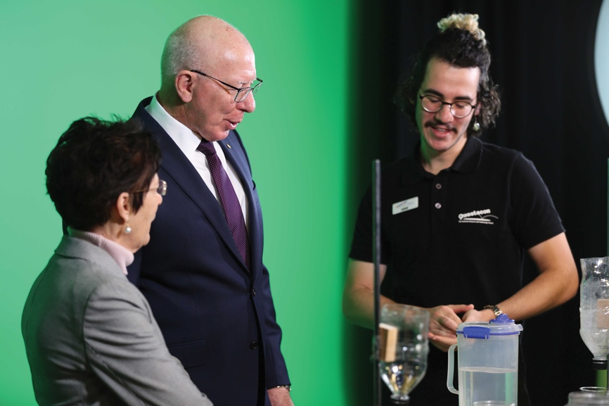

MoU with University of Canberra
On 1 November, Questacon re-signed a memorandum of understanding (MoU) with The University of Canberra. Questacon and The University of Canberra have worked together since 1998 to deliver inspirational learning experiences; from the delivery of professional workshops for future STEM teachers, to the development of the popular Articulated Head exhibit in Questacon’s Born or Built? exhibition.

Ocean Decade Australia Stakeholder Briefing
On 22 June, Questacon hosted the Ocean Decade Australia Stakeholder briefing, ‘How will we measure success for a sustainable future?’. A diverse panel discussed a range of perspectives on this topic, engaging the audience in a discussion about Australian ocean initiatives.
Since 2018, The UNSECO Intergovernmental Oceanographic Commission has been working with thousands of public and private sector stakeholders to design and develop the mission of the Ocean Decade and the outcomes required for attaining the Ocean We Want by 2030.

CEO Sleepout
On 17 June, Professor Graham Durant supported the St Vinnies CEO Sleepout to raise funds and awareness of the issue for Australia’s homeless. This is the 5th occasion Professor Durant has spent a night out on cold hard concrete with just a piece of cardboard, a sleeping bag and cup of warm soup. It is never too late to donate!

Questacon People

Ongoing Response to the COVID-19 Pandemic
In August 2021, 32 Questacon staff members volunteered to assist other agencies as part of the whole-of-government response to COVID-19. Questacon staff quickly adapted their skills from communicating science and managing the Centre’s galleries, to supporting operations at Services Australia, ACT Health, the Department of Industry, Science, Energy and Resources’ COVID taskforce, CFO group and AusIndustry.
Since the beginning of the COVID-19 pandemic, Questacon has facilitated 70 redeployments to support surge requests.

Volunteers
Questacon has a team of 44 dedicated and passionate volunteers that assist in explaining our exhibits to visitors. In 2021, our volunteers contributed 4,202 hours to engaging, motivating and inspiring visitors in STEM throughout the Questacon galleries. Despite another year of COVID-19 challenges and interruptions, our volunteers remain an essential part of Questacon’s operations.
In 2021 Questacon’s volunteers played an integral role in the development and delivery of Science Sprouts, Questacon’s early childhood program during COVID-19 restrictions. Without their assistance it wouldn’t have been possible to safely introduce these interactive sessions.
Questacon volunteers also participated in the Canberra Volunteers Expo, talking to prospective recruits and delivering science content. The Expo organisers were delighted with Questacon’s participation, stating that Questacon’s table was the most popularon the day.
During periods of lockdown the group stayed in contact through regular catch-ups held via video conference where they were frequently joined by guest speakers, including Professor Fred Watson and Professor Hans Bachor. The team also heard from many of Questacon’s own experts who discussed future exhibitions and the exciting things that were being planned for 2022.
Figures 27 and 28: Questacon volunteer cohort.
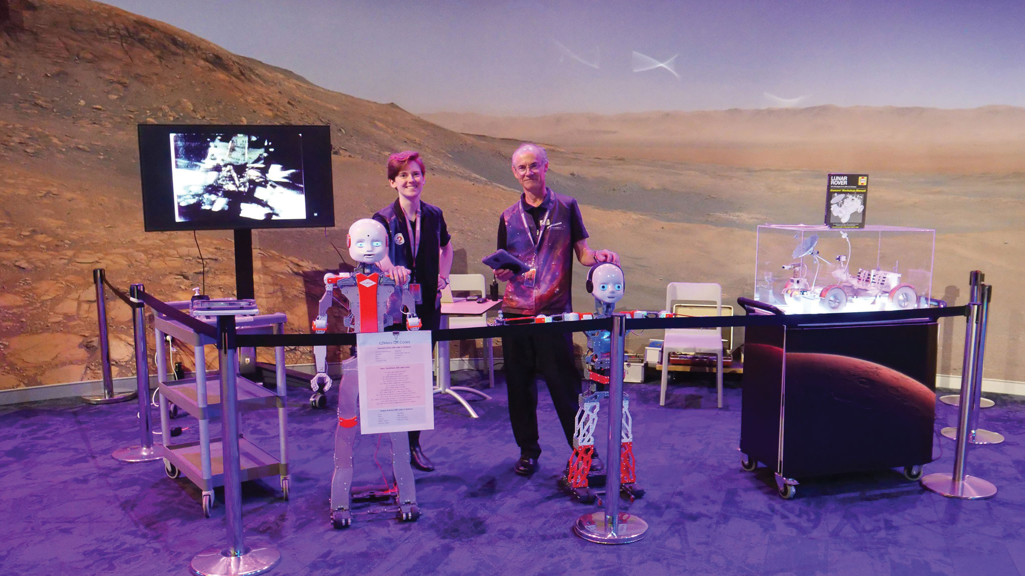
Figure 28
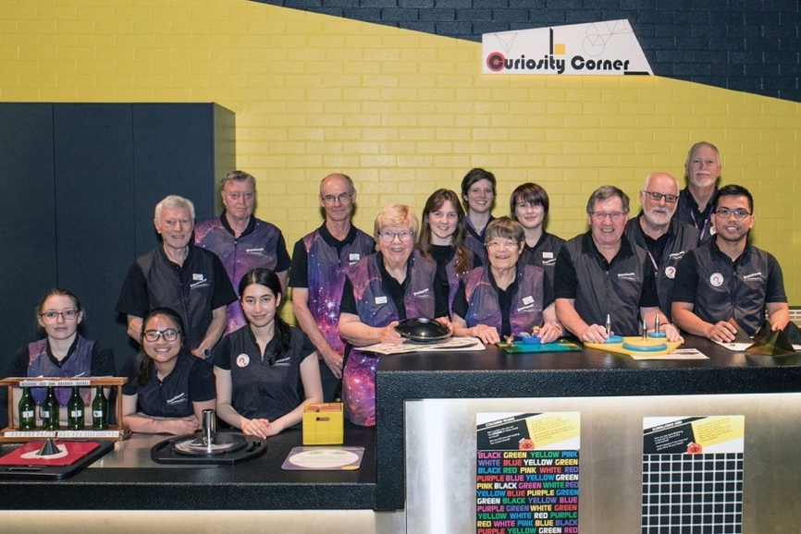

Figure 29: Questacon volunteer at the Curiosity Corner, a volunteer-led space in Questacon's Centre.
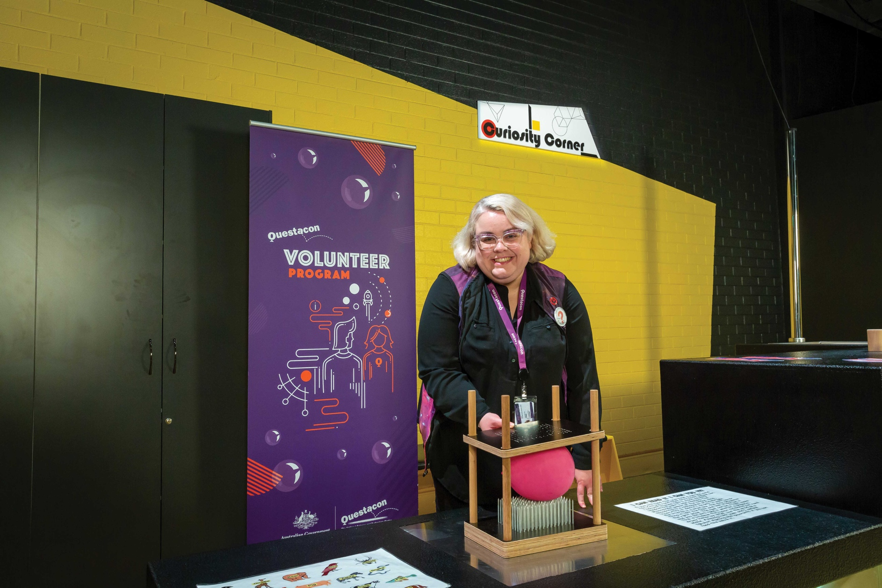

Student Training Program
Questacon provides science communication training on presentation skills, teamwork and customer service to secondary students through the Questacon Student Training Program. The 2021 participants undertook 28 hours of training before completing 40 hours of practical training in Questacon’s galleries.
As in-person activities were impacted by the COVID-19 response, the 31 participants transitioned their training to online, and designed new COVID-safe demonstrations for Curiosity Corner.
The Student Training Program provides school students an opportunity to experience the wonders of Questacon, with at least 4 former graduates still working at Questacon today.

Work Experience Program
Every year, Questacon offers school students the opportunity to gain experience in the museum sector as part of their work experience program. Students gain experience working across Questacon’s gallery and retail spaces, while learning how to engage the public in science and technology through the development and delivery of STEM-related programs.
In 2021, 10 high school students completed their work experience program at Questacon.
Figure 30: 2021 Questacon work experience students.
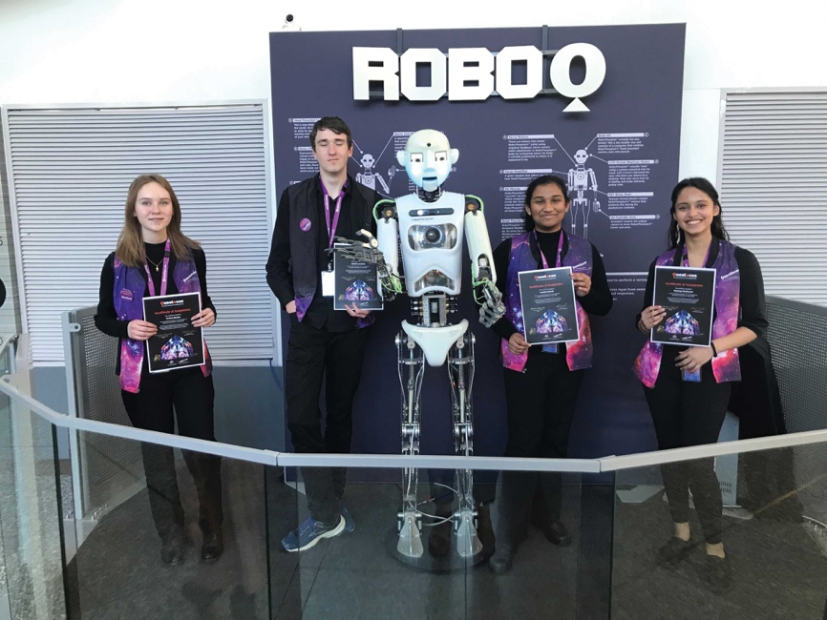

Vale

Michael Miles Gore AO

5 September 1934 – 8 January 2022
As the founder and inaugural Director of Questacon, Mike Gore’s legacy is truly remarkable. While working as a physics lecturer at The Australian National University (ANU), he planted the seed for Australia’s first interactive science centre – now known as Questacon. Mike created Questacon out of his passion for teaching physics and his love of sharing science with others.
With Mike’s persistent leadership, and support from the Canberra community, Questacon opened in 1980 in a spare classroom at the Ainslie Primary School. Questacon quickly grew in popularity, establishing hands-on learning and science demonstrations as a viable model for STEM education. In 1988, Questacon became Australia’s National Science and Technology Centre (NTSC), taking its place in a purpose-built building in the Parliamentary Zone of Canberra. Mike worked tirelessly to bring the NSTC project to fruition, persuading many others to support the project, including the Japanese Government and Australia’s business community. Mike provided a brief and worked with architect Lawrence Nield to create the southern hemisphere’s first purpose-built science centre. On opening, Mike transferred from the ANU to become the first Director of Questacon.
Mike’s legacy extends beyond Canberra, however, having also reached Australians across the nation and the world through the establishment of the Science Circus. Mike created the program to ensure people in regional and remote communities across Australia could experience Questacon. After a few successful tours, Mike encouraged Shell Australia to become a major supporter of the Science Circus, a partnership that continued for a further 36 years. He also developed a strong volunteer cohort to support Questacon’s work and a talented exhibit design and workshop team, while his love of theatre led to the founding of an in-house science theatre troupe. Mike was an enthusiastic supporter of the ANU Centre for the Public Awareness of Science (CPAS), becoming a lecturer, mentor and advocate for the graduate program. Mike also was a leader in the international outreach of science communication, both through CPAS and as a founder of the Asia-Pacific Community of Science Centres (ASPAC).
In 1986, Mike was made a Member of the Order of Australia for his services to science education, and made an Officer of the Order of Australia in 2015 for services to science communication.
Mike Gore’s legacy will live on through Questacon’s people and programs for many years to come.
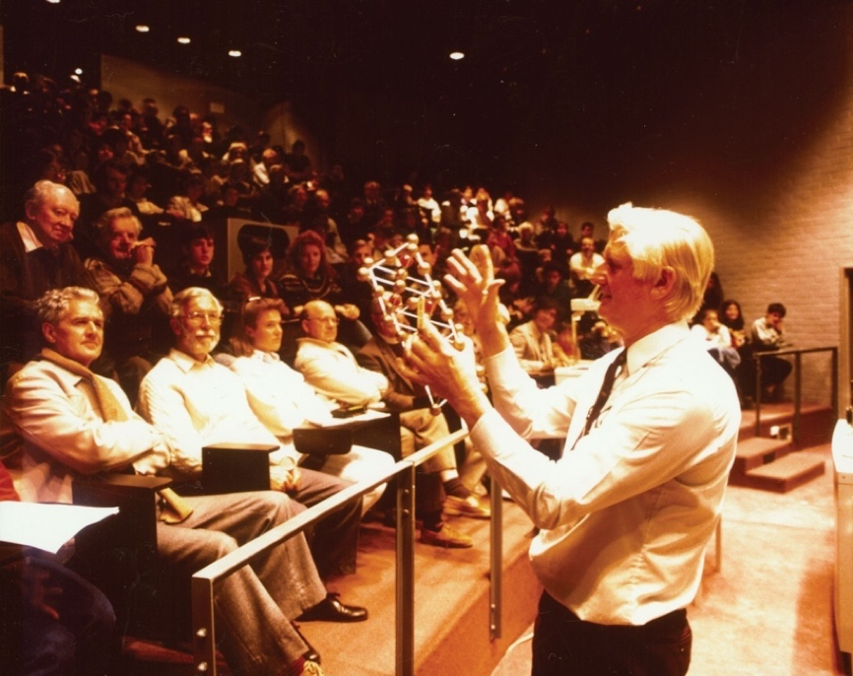
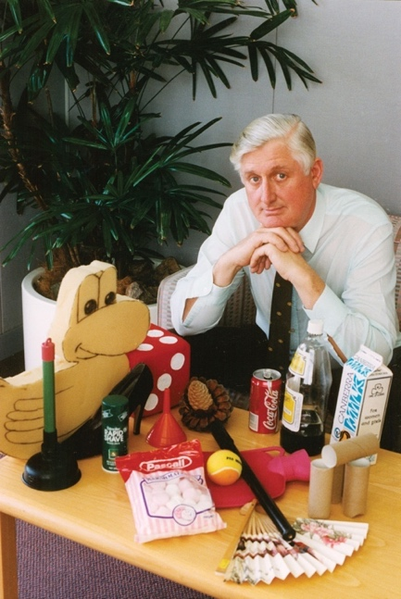
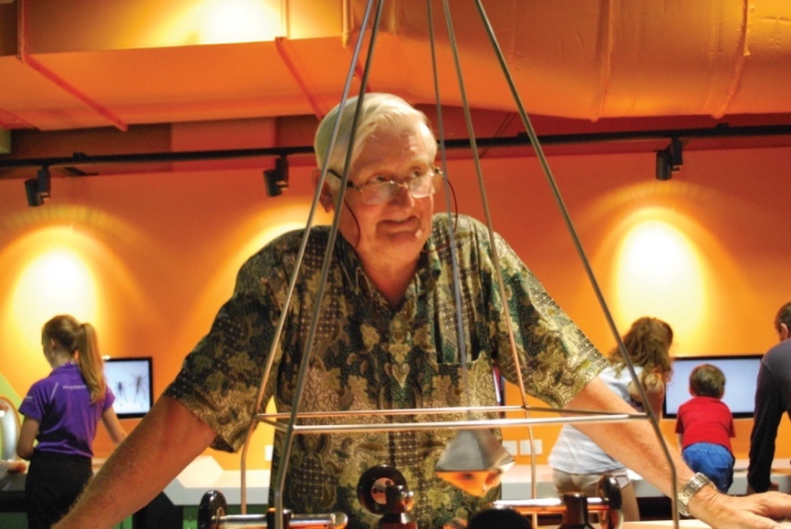
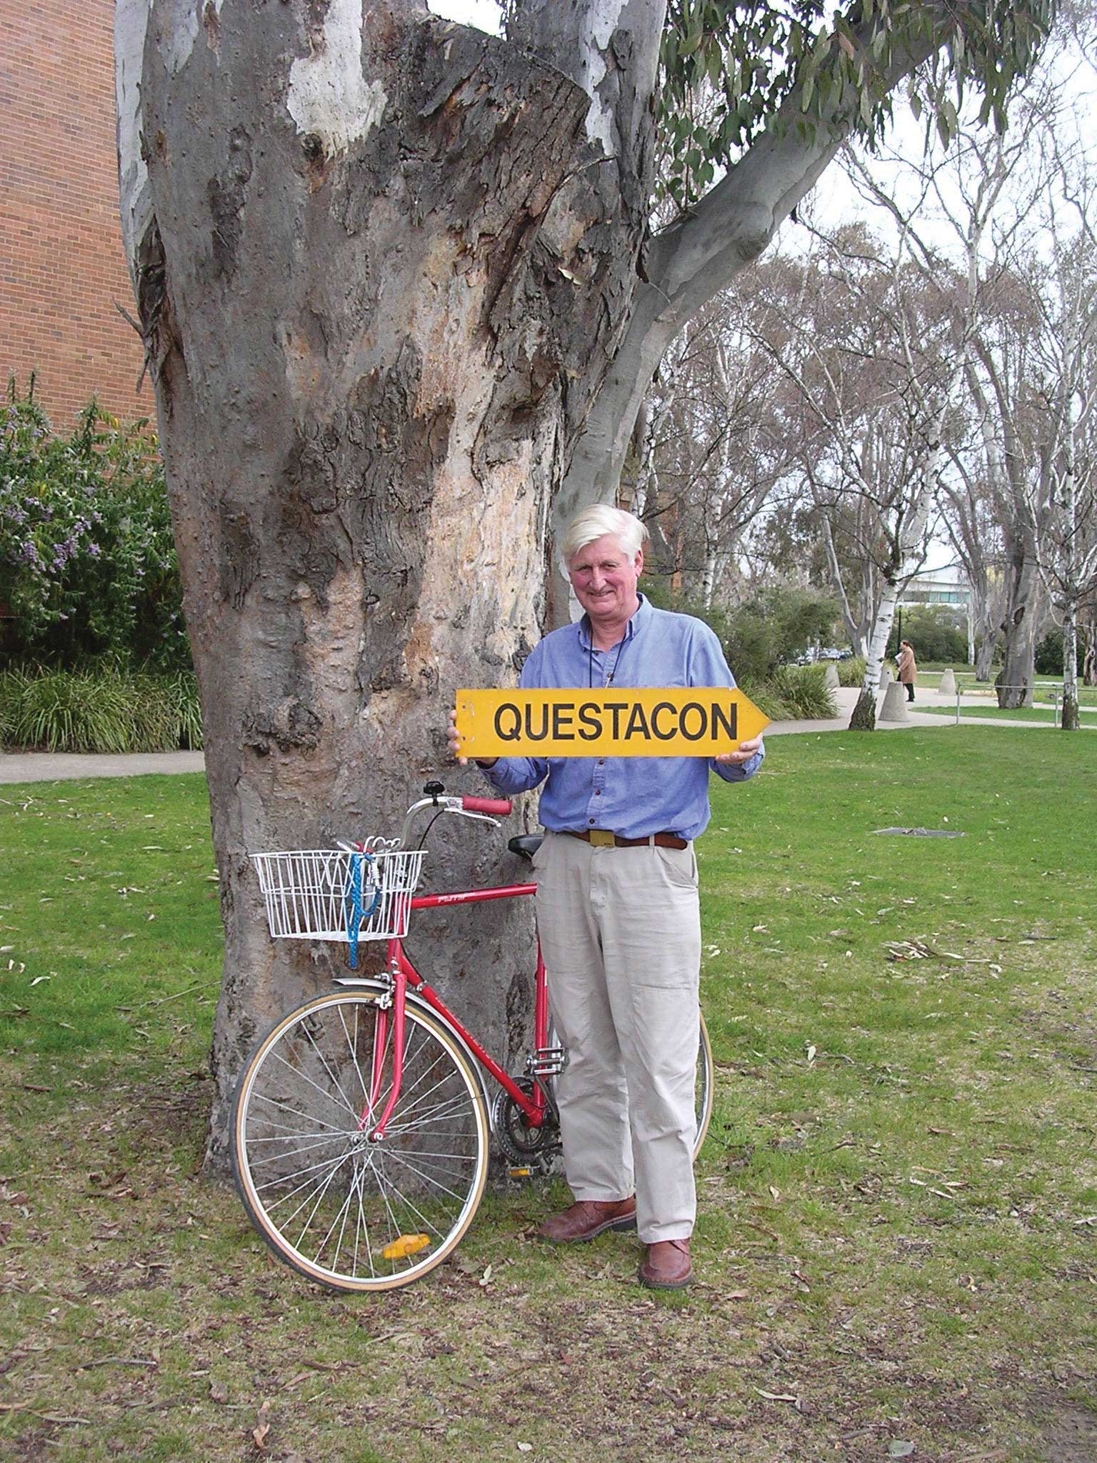

Vale

Chris Bryant AM

9 August 1936 – 15 August 2021
Chris Bryant was a vital supporter of Questacon since the very beginning. As a distinguished academic at The Australian National University (ANU) and Dean of Science, Chris provided crucial support to Mike Gore and the development of Questacon using his taxonomic expertise to come up with the name Questacon.
Chris was heavily involved in the development of the Science Circus and created a graduate program in science communication incorporating the Science Circus program. The program evolved from a graduate certificate to incorporate both masters and PhD degrees. In 1996 Chris successfully fought to establish the National Centre for the Public Awareness of Science at the ANU (CPAS) and was the inaugural director until 1998.
Chris was a pioneer in parasitological research in Australia and an innovative teacher, establishing a multimedia laboratory for his first year zoology classes at the ANU.
He was recognised for his scientific and educational contributions in both parasitology and science communication by being made a Member of the Order of Australia in 1999.
Figure 31: Mike Gore AO, Graham Walker and Chris Bryant AM.
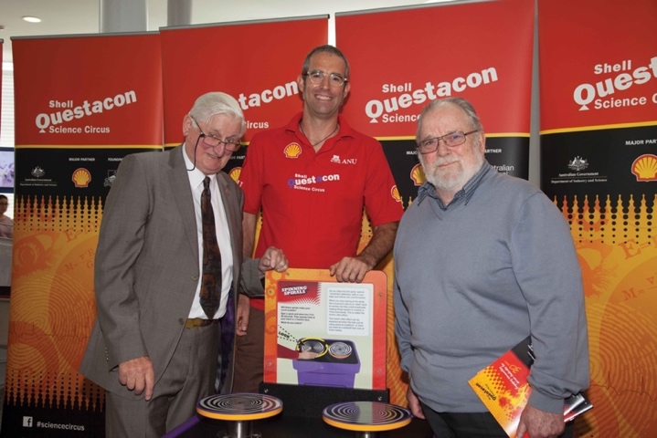

Vale

Bec Butler

1986 – 2021

Bec worked to connect Questacon’s people and programs with the broader science education community. Bec’s amazing communication skills, warmth and ability to develop connections with people were instrumental to the successes of the teams she worked with. She was an excellent problem solver, always going above and beyond to achieve positive outcomes for colleagues, students and teachers.
We remember Bec as someone who was always keen to be involved. From volunteering as an audience member in a new STEM workshop, to testing software for her colleagues, Bec approached everything in a thoughtful, creative and engaging way.
Bec was a kind colleague and friend, with a wry sense of humour and a way with words.

Rob Stanier

1938 – 2021
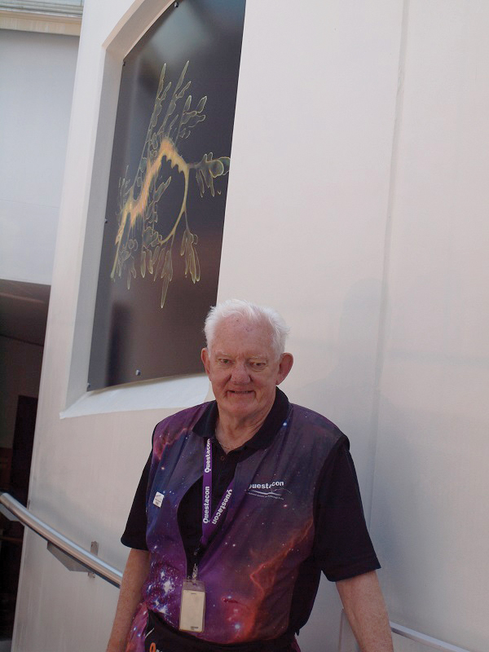
Robin was a dedicated, positive and passionate member of the Questacon team for 19 years, contributing over 3,400 hours to the volunteer program. Robin contributed his aeronautical engineering expertise to Questacon, sharing his knowledge of science, flight and the environment with both visitors and colleagues.
Robin was also a pivotal leader in the Questacon Volunteer Association, providing significant input to projects that have since become keystone features of Questacon. This legacy ranges from the design of new trolley demonstrations and displays, to the development of the Questacon Emeritus Volunteer policy.
Robin was a supportive colleague with a real passion for Questacon that shone through in everything he did.

Geoffrey Spencer

1933 – 2022
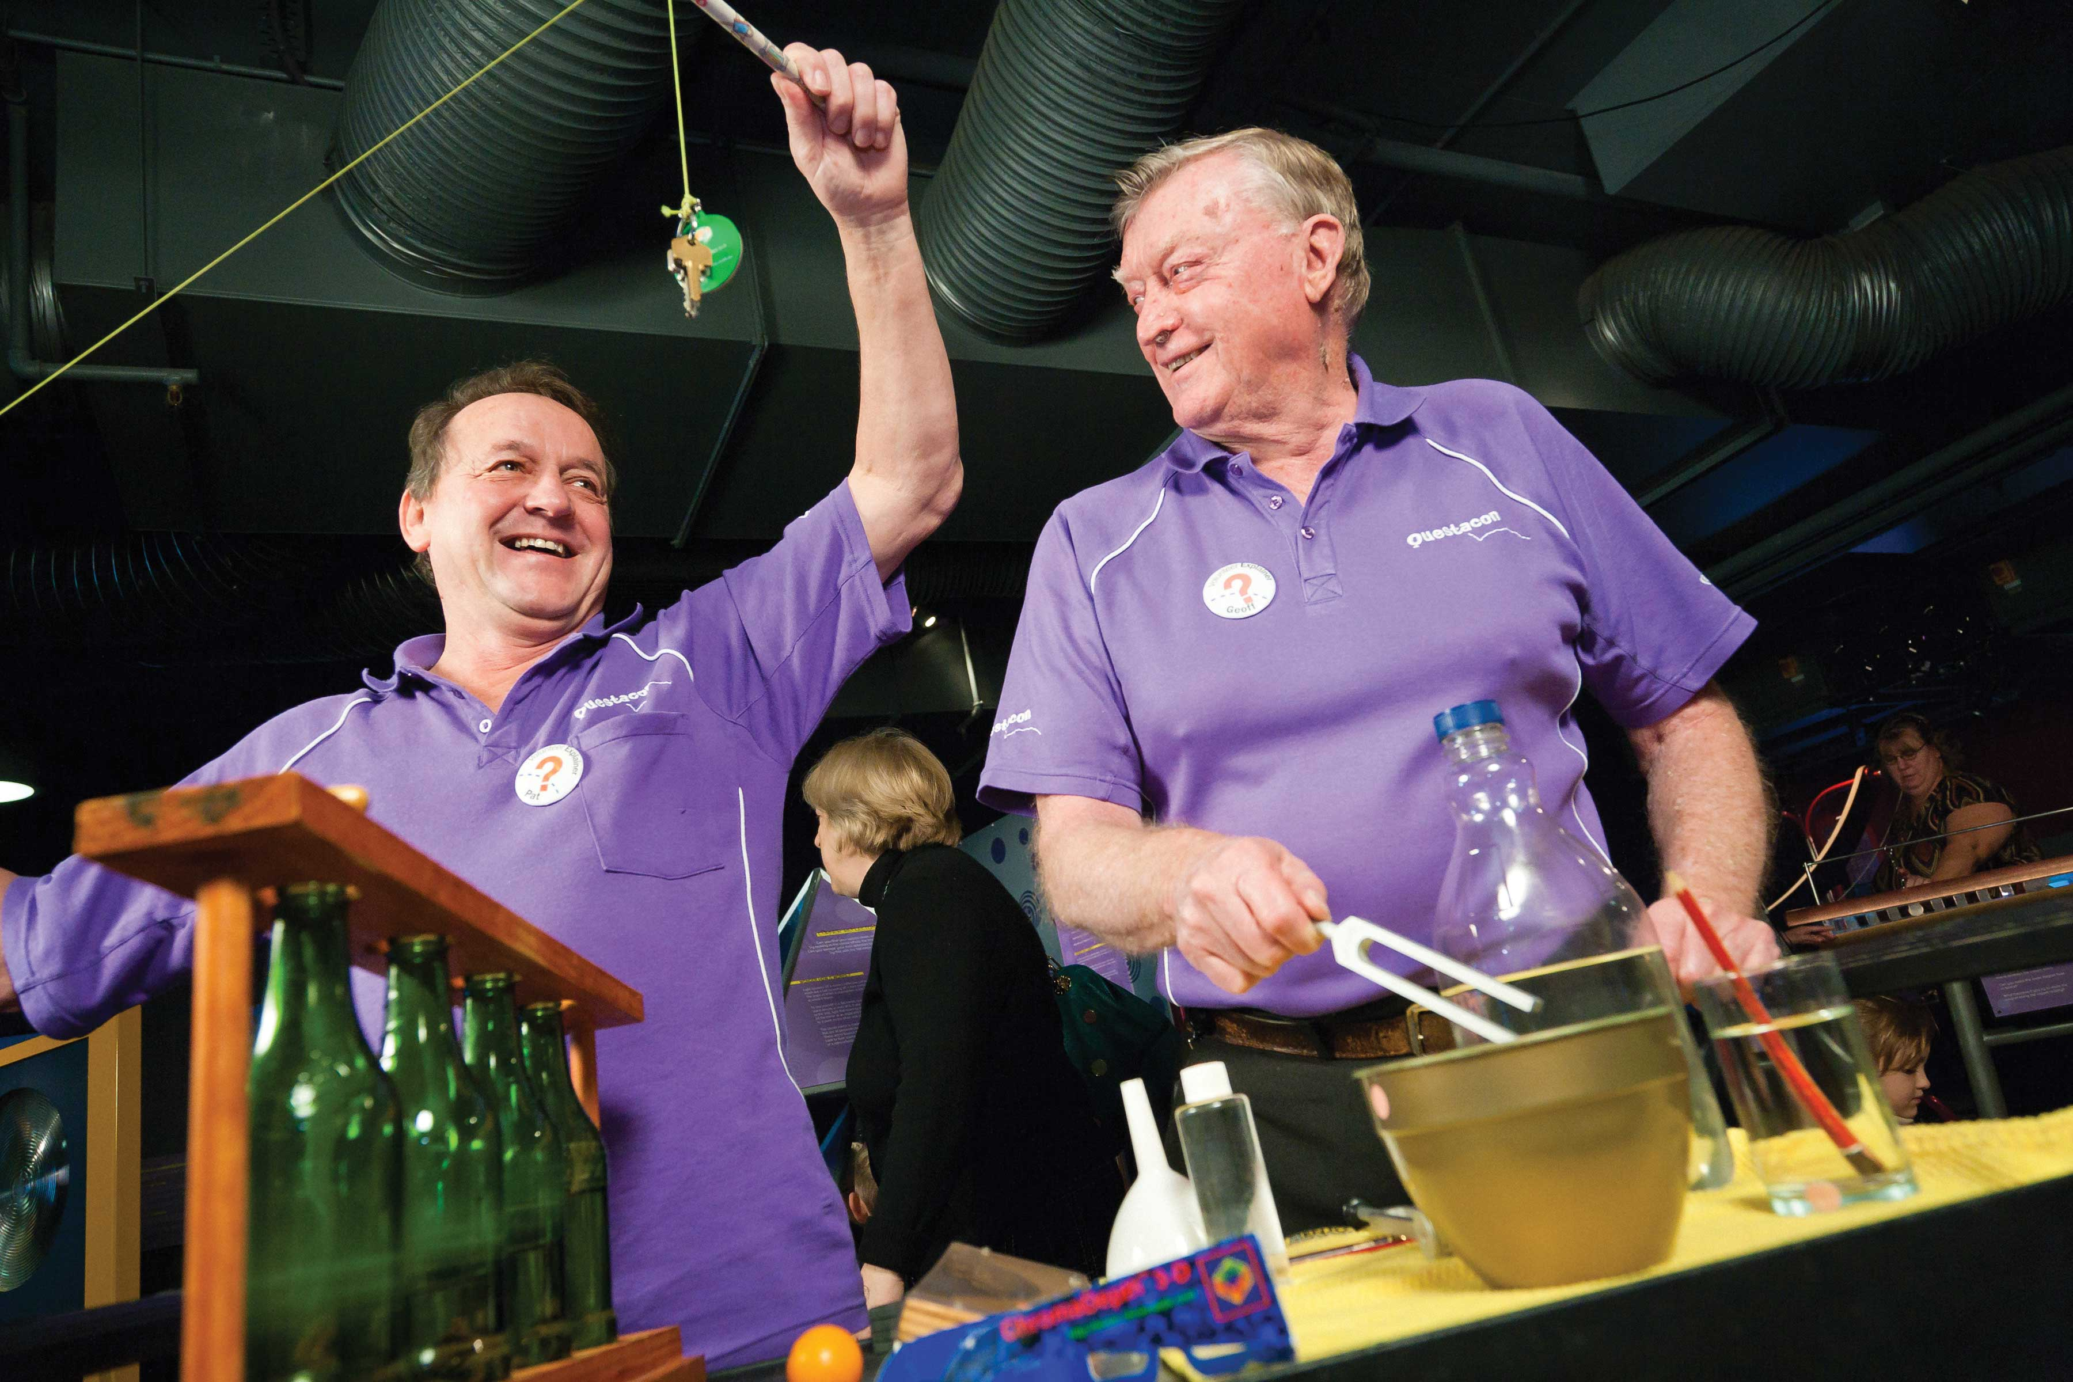
During his 21 years of service, Geoff generously contributed over 12,500 hours to Questacon’s volunteer program. Geoff was a dedicated Questacon volunteer; inspiring staff, visitors and colleagues with his enthusiasm for astronomy. He would often set up his telescope during Questacon’s astronomy-themed nights, showing visitors the wonders of the night sky. In the early days, Geoff facilitated the Star Lab exhibit at Questacon’s Centre and on travelling school visits.
Geoff was also heavily involved in the development of the Discovery Trolley program, training and mentoring other volunteers on how to deliver exciting STEM content to visitors.
Geoff will be dearly missed by all who knew him.

Staff Awards

Behind the Scenes

Rey Hopkins
Rey is the quintessential quiet achiever who consistently provides prompt, high quality design work behind the scenes. He interacts with all staff in a positive, optimistic way and is constantly looking for ways to help them or improve their experience.

Creative Approach to Science Communication

Anna Farrelly-Rosch
Anna led the Questacon Science Circus to deliver the Indigenous Workshop Project – a new approach that saw the Science Circus presenters build relationships with 6 schools with high enrolments of Indigenous students over the course of the year and develop bespoke workshops to meet their needs.

Exceeding Customer Service

Nathan Jackson
As a Gallery Assistant and Questacon Assistant Nathan consistently goes above and beyond to ensure that customers’ needs are exceeded. Additionally, Nathan stepped up to support the executive team this year. During his time in this position, Nathan was a vital member of the support team, balancing external stakeholders and Questacon’s interests.

Diversity and Inclusivity

Alex Jordan
Alex has played an influential role in increasing visibility of STEM-marginalised groups in our exhibition content, as well as in the selection of our contributing content and knowledge partners from industry and academia. Alex has helped to achieve greater representation of Indigenous content in recent exhibition projects, resulting in Indigenous content or language featured in a number of installations.

Diversity and Inclusivity

Lachy Agett and Josh Freeman
Lachy and Josh have vastly improved the understanding of inclusive practices for public-facing delivery teams by updating standard operating procedures and facilitation guides to include tangible advice on how to adapt delivery for people with impaired motor skills, Autism, neurodiversity and English as a second language. Lachy and Josh have improved the visibility of these topics by sharing opportunities to learn more via PageUp.

Driving Innovation and Sustainability

Matthew Riches
Matthew has played a pivotal role in moving Questacon towards a more sustainable future. His work to implement the Questacon QNetZero project included coordinating the contract, providing the supporting research, and analysing our current emissions. Matthew’s passion and skills are valuable to providing insights into how we can continue to improve in our sustainability efforts.

Emerging Leader

Sean de Clerck
Sean has played a key role in the collaboration between Innovation Programs, Questacon Cyber, and Science Circus teams, with his ongoing leadership resulting in all programs teams based at The Ian Potter Technology Learning Centre being more confident of the training needed to ensure safe return to great STEM education activities. Sean has established himself as a knowledge-holder and sharer in safety in the Maker Space.

Ripple Effect

Patrick Helean
Patrick plays a leading role across the organisation in building relationships with a wide variety of knowledge partners, including Questacon Minds in Residence, Ngunnawal and other First Nations people, academics, scientists, artists and performers. Patrick is always thinking about ideas for new demonstrations, new methods of delivery, and new and innovative ways to engage with audiences.

Volunteer of the Year

Peggy Horn
Peggy has contributed an outstanding 130+ hours to providing engaging experiences at Curiosity Corner this year. Peggy is consistently looking for new ideas that the Questacon Volunteers program can engage audiences with and how Questacon can grow its educational opportunities.

Director’s Award – Science and Learning Branch

Jacki Agius
Jacki went out of her way to maintain contact with people who were especially anxious, concerned or isolated throughout lockdowns. The morning phone calls, texts and messages she facilitated were vital to the National Programs section getting through 2021.

Director’s Award – Operations Branch

Kate Gorrie
Kate’s openness and willingness to support other teams is recognised within the organisation and she is always willing to support others whether the issue falls within her remit or not. There is a high level of respect for Kate’s capability as highlighted through the strong connections she has built across diverse teams and with staff at many levels.

Director’s Award – Cross Organisation

Sally D’Addio
Sally’s unwavering focus this year has been on building strong financial and strategic foundations for Questacon including building the case for support as part of the government’s mid-year economic fiscal outlook. Sally’s ability to engage with the big picture while delving deep into the detail and her openness to consultation
is appreciated by stakeholders at the highest level.

Length of service

Questacon Staff

20 years
- Rodney Pfeiffer

15 years
- Lyndell Lyons
- Matthew Riches
- Alison McGregor
- Craig Whelan
- Christopher Robertson

10 years
- Natalie Sullivan
- Rob Fuller
- Alexandra Sullivan
- Alexandra Evans-Tse
- Andrea Legen
- Adam Robbins

5 years
- Lachy Agett
- Brianna Muir
- Sabre Allum
- Islay Andrew
- Nicole Murtagh
- Emily Tugwell
- Adrian Hindes
- Boyd Preller
- Aleese Barron
- Matt Hardy
- Sarah Clark
- Sean de Clerck
- Andrew Oliver
- Brianna Keys
- Matt Dunn
- Tamara Coppa

Volunteers

35 years
- Kathryn Wingett

30 Years
- Peter Fokker

20 Years
- James Lewis

10 Years
- Himel Ghosh
- Belinda Cheong
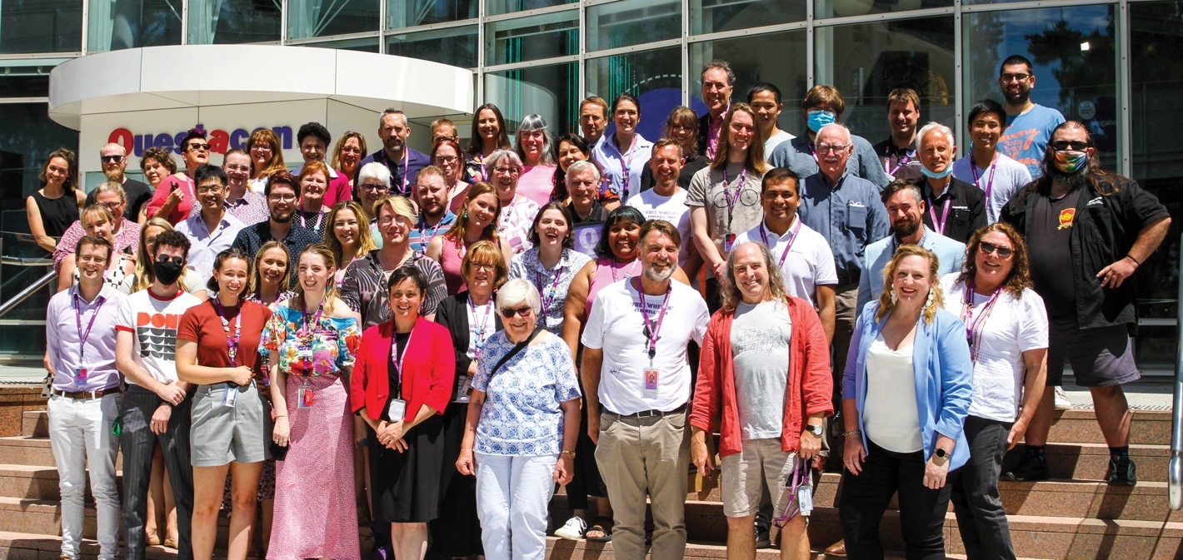

Principal Partners

Founding Partners

Supporting Partners

Collaborative Partner


Corporate Supporters



www.questacon.edu.au
