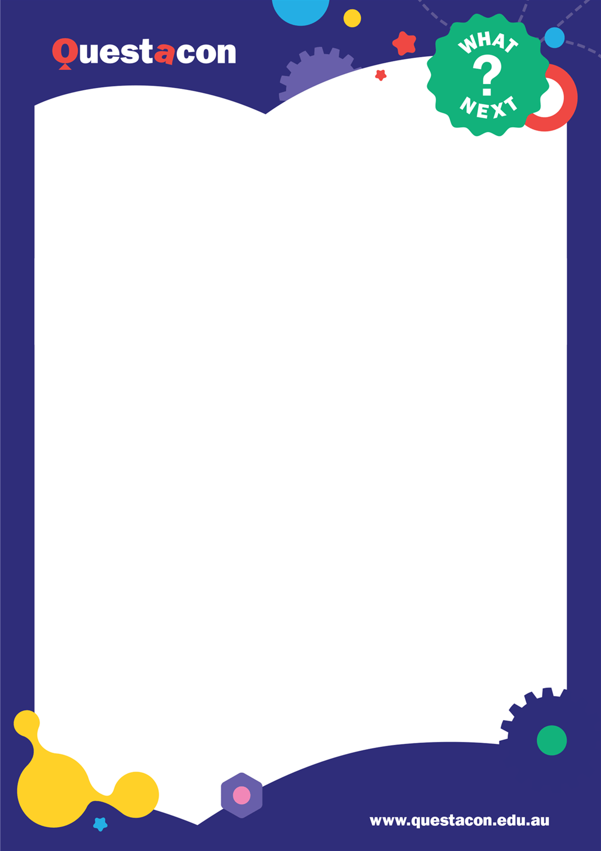
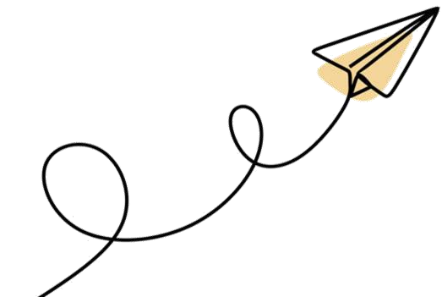
Safety
As students will be throwing paper planes, it is
suggested that the following measures are
recommended to avoid injury by a flying plane:
•
We will instruct all students fold the nose of
their plane in to avoid any pointy ends
•
Students will need to ensure the space they
are testing their planes in is clear of
obstacles and people/animals
in order to

observe how their plane flies.
•
We suggest students line up at one end of
your space, throw together and then collect to
ensure no one is hit.
On the day
•
Make sure you have materials on hand
. The
presenter will give verbal cues as to which
activities will be coming up next and go
through the activity instructions with the
students.
•
Your role during the session will be to
help
students through activities and facilitate
discussions.
•
You’ll need a ‘runway’ or area to test
student planes. This can be the classroom
or a larger space nearby. Be aware planes
often fly higher than expected and can get
stuck in vents/trees or on roofs.
•

Stay by the keyboard as you'll be your
classrooms voice when it comes to
answering
polls or

posting observations
and
questions in the Q and A.
What to Expect
In this webinar students will investigate two
different types of paper planes: darts and
gliders. Students will explore how various
design features such as wing size, shape and
angle can affect stability and drag. Students
will be encouraged to experiment with different
elements of their paper plane to make it fly just
the way they want.
Materials
Each student will require:
•
2
x A4 paper
•
1
x Scissors (can be shared across
students)
•
)
1
x Pencil/Pen (can be shared
Welcome to Questacon’s
webinar
,

Foldable Flight
. In this session, students will investigate the engineering
and physics of flight by constructing their own paper planes. This document provides information to
prepare you and your students for the session.
Included in this document is an outline for the
session
, materials list, safety considerations, and ideas for
extension activities to help maximise your students’ learning.
Activities and Resources
Foldable Flight
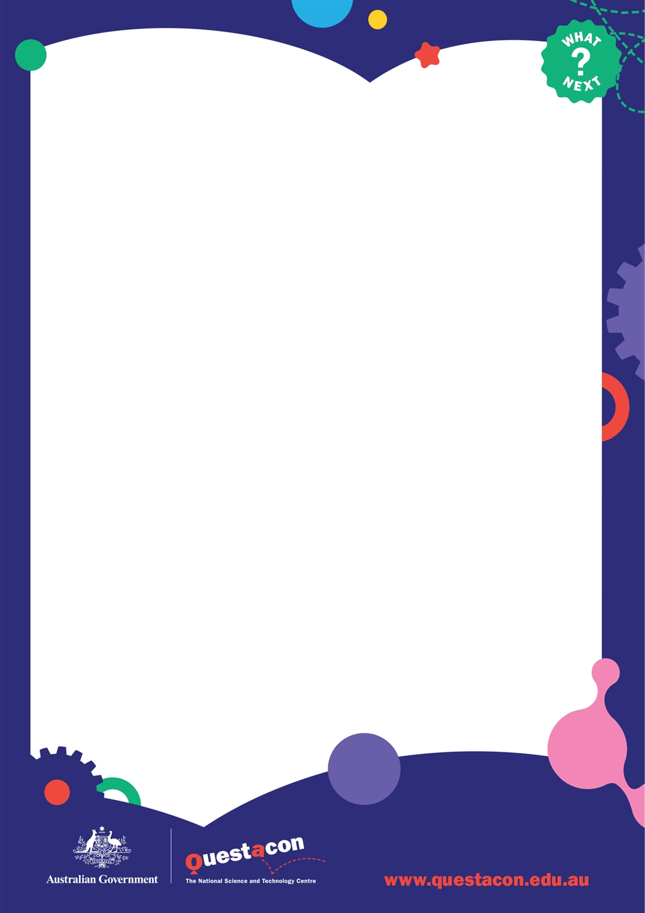
Time
Segment
Description
Notes
min
5
BEFORE
Audio visual
check
Session will open for classroom to join. This is a good opportunity to
ensure your whole class can see and hear the webinar, you can test
the audio and adjust your spea
kers in Zoom.
0
-
min
10
Introduction to
session
Introduction to
planes
The presenter will quickly run through the features of the webinar and
how they will be interacting throughout the session.
We will be asking students to nominate what parts of the plane they
have heard of and discuss their various functions. We will also discuss
the forces at work in flight.
10
-
15
min
Dart plane build
Presenter will walk through the steps of making the Dart plane slowly.
Written instructions are included in this document.
15
-
20
min
Dart test flight
Students are to test fly their planes in a safe place and observe how
they fly.
20
-
27
min
Test flight
debrief
Students will be asked what their plane did whilst in flight. Presenter
will go through observation and suggest reasons why flights may have
differed from expectations. They will also go through some other plane
features students may wish to test out on their dart planes.
27
-
35
min
Tinker time
Time for students to modify and test fly their planes.
35
-
38
min
Tinker time
debrief
Students given opportunity to share what their plane did and how that
changed between modifications.
38
-
45
min
Glider plane
build
Presenter instructs students through folding the glider and how to
“launch” it.
45
-
50
min
Glider test flight
Students test fly their glider.
50
-
60
min
Reflection and
conclusion
Presenter will use student observations to compare and contrast the
different paper plane styles, and summarise key concepts covered.
Runtime: 60 minutes
Please note these times are approximations, and programming on the day may change to give
participants the most impactful and enjoyable experience possible.
Activities and Resources
Foldable Flight
–

Run Sheet
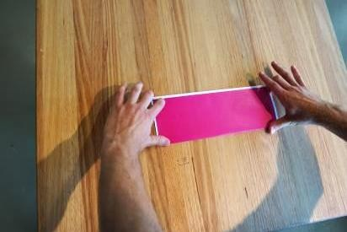
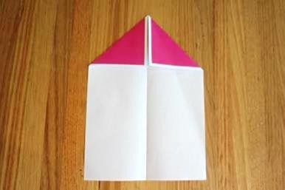
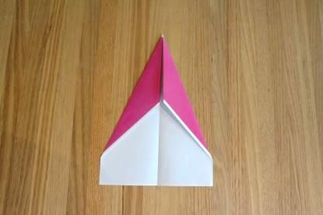
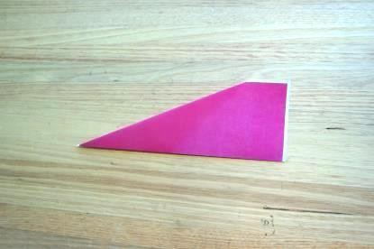
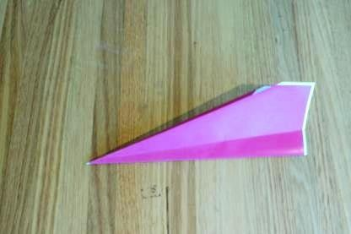
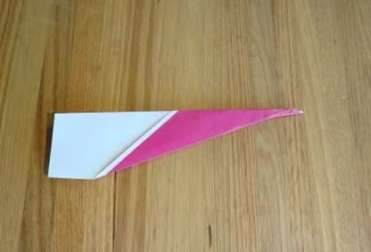
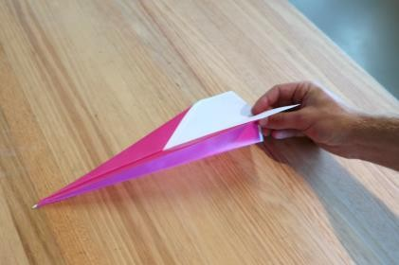
Activities and Resources
Foldable Flight
–

Dart Plane
1)
Using one
A4

sheet of paper, fold in half
lengthways and open out again.
2)
Fold the top corners of each half of the
paper to the middle as shown.
3)
Take the new corners that you just created
and fold them in again to the centre, so it
becomes pointier, like a dart.
4)
Fold the plane in half along the centre line.
5)
To create your first wing, fold down one
long edge to the centre line, in an angle
similar to that shown in the picture below:
6)
To fold the second wing down, flip your
plane over and repeat on the other side,
trying to get the fold exactly the same as
the first one.
7)
Once you have folded both wings you can
adjust their angle so they aren’t sitting
too close to the body of the plane . Your
dart plane should now look like this!
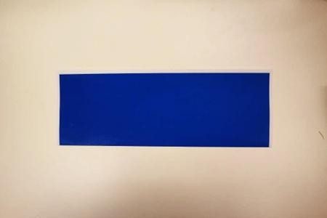
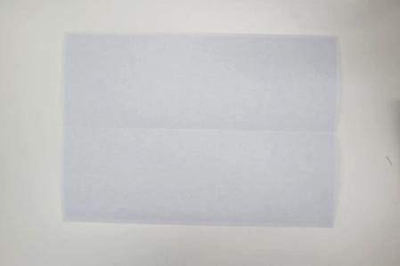
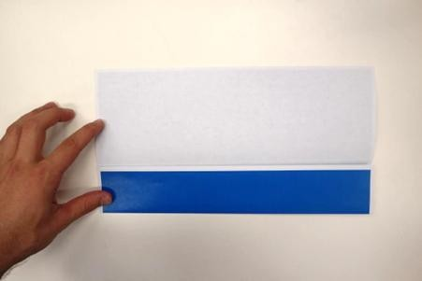
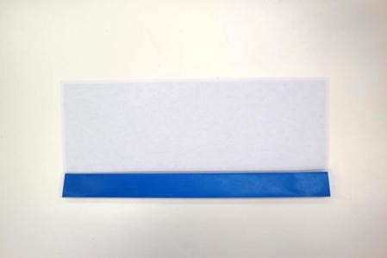
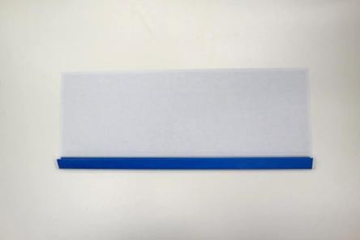
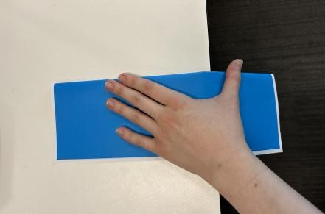
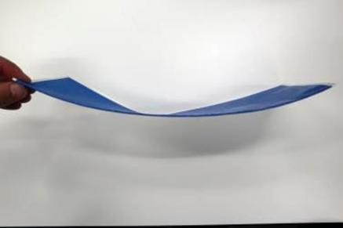
Activities and Resources
Foldable Flight
–

Glider
1)
Using one
A4

sheet of paper, fold in half
lengthways and open out again.
2)
Fold the bottom edge up to the centre line.
3)
Take the new bottom edge and fold this up
to the centre line as well.
4)
Fold the bottom half (the blue section)
over the centre line onto the white
section.
5)
With the folded side down, pull the wing
over the edge of a table to curve it.
6)
Your Glider should now look like this!
Build a cargo carrier
Paper planes
-

particularly darts, are models of
planes but one big difference is the reduced
weight in their fuselage. Challenge the
students to reach the furthest distance with
’cargo’. Start by getting them to mark out a line

metres from their launch point and add
3.5
‘cargo’ to their plane until their plane can no
longer make the distance. You can use
whatever you have on hand as representative
cargo. We’ve found coins work well, as the
weight can be adjusted easily and good
symmetry can be achieved between the sides
of the plane. Students will require tape to
secure the coins. Compete to see who can fly
with the most cargo. In this challenge,
encourage the students to think about the
importance of weight distribution across the
plane, and the impact this has on the flight
path. Launch technique is also an important
factor!

Aerodynamics
Anything that wants to fly needs to create lift.
As we discussed in the workshop, planes can
create lift through the shape of their wings, but
there are many factors which can also affect
lift.
Start by looking at aerodynamics
–

if you drop
two sheets of paper from the same height, at
the same time, which one will hit the ground
first? What if one of the pieces of paper is
scrunched up into a ball? The difference
between the two sheets of paper is not the
weight, but the shape
–

the paper ball is more
aerodynamic! Have students try and make
something that will take the longest possible
time to hit the ground using common
household items, experimenting with different
shapes, materials, and
loads.
World record planes
People might think paper planes are just for
fun, but the folks who compete in Paper Plane
competitions are very serious! John Collins, the
world record paper plane folder studied
aerospace engineering and origami to make
the perfect paper plane, and he has made his
instructions available online. Though it looks
simple, be warned it’s a pretty technical plane!
Challenge your students to have a go building
the perfect plane:
c
https://youtu.be/EDiC9iMcWT

Design competition
This activity is designed to prompt your
students towards thinking about some of the
design elements explored in the virtual
excursion that will affect the paper plane flight.
Using one A4 sheet of paper, the students
need to design their own paper aeroplane. This
can be a modified version of a plane that
already exists (such as those that were
discussed during the workshop) or a
completely new design. You can then
challenge your students to create a plane that
flies in the straightest line, for the longest
distance, stays in the air the longest, does the
most loop de loops, turns left or right, the
possibilities are endless!
Listed below are some optional extension activities to further your students’ learning. The activities utilise
play and enquiry to explore physics and experiment with different design features. They can be completed
independently and in any order.
Activities and Resources
Foldable Flight
–

Extension Activities
Centre of
lift
The centre of
lift
or centre of
(
pressure
of a
)
paper plane can generally be found as the
middle point of its silhouette. The relationship
between this and the plane’s centre of gravity
controls the inherent stability of a plane,
whether paper or real.
This video simply defines the centre of
pressure and how it compares to the centre of
gravity:
q
https://www.youtube.com/watch?v=cyC0i_zO
g
k

This video explains the stability profile of
normal planes compared to fighter planes:
3
https://www.youtube.com/watch?v=VImEvFg
Q
sm

Centre of lift continued…
The stability profile of a plane is generally
determined by where the centre of gravity is in
relation to the centre of pressure. The centre
of pressure is the average location of different
pressure on an objects surface, where
aerodynamic forces act. The centre of gravity
in an aircraft acts as a fulcrum around which
the plane pitches up or down. This can
sometimes be moved forwards and backwards
in a plane depending on where the luggage
and fuel are stored and where people are
located while the centre of lift remains the
same. The stability in an aircraft is generally
achieved if the centre of lift is behind the
centre of gravity. You can see this in the way
many commercial aircraft fly with a slight tilt
-
the tail is slightly lower than the nose.
This is the same for paper planes. It means
that if the nose gets tilted up the increased lift
this creates tilts the nose of the plane back
down. If the lift was in front of the centre of
gravity the increased lift would just keep tilting
the nose of the plane up until it ‘stalls’. This
often occurs if you have got these two centres
around the wrong way in a paper plane you
have created yourself. To correct it, add more
weight (more folds or
Blutac
)
toward the front
of the plane. This alters the weight distribution
of the paper plane so that the centre of gravity
is now in front of the centre of lift and can lead
to a longer flight time.
Winged seeds
There are other mechanisms for flight in nature
apart from birds and bats. The Javanese
cucumber has seeds which are built similar to
our glider plane, allowing it to travel long
distances before it reaches the ground. There
are other plants that have seeds that spin like
helicopter blades! You can collect these seeds
or make models to compare how they interact
with the forces of flight: gravity, lift, thrust, and
drag. A template for one kind of seed spinner
can be found here:
https://www.questacon.edu.au/lear
n
-
an
d
-
d
play/activities/see
-
spinner
s

Listed below are some optional extension activities to further your students’ learning. The activities utilise
play and enquiry to explore physics and experiment with different design features. They can be completed
independently and in any order.
Activities and Resources
Foldable Flight
–

Extension Activities
Year 5/6
Investigate how scientific knowledge is used
by individuals and communities to
identify problems, consider responses
and make decisions (AC9S5H02)
Science Inquiry Skills
This virtual excursion’s activities relate to
science inquiry skills across all year levels. In
the session, students will make and refine two
different paper plane designs, and are
encouraged to make
predictions

and
observations, use safe and accurate testing
techniques, and communicate their findings.
All year levels
•
Evaluating
•
Questioning and predicting
•
Planning and conducting
•
Communicating
•
Processing and analysing data and
information.
Science
Science Understanding
This virtual excursion links to the
physical
sciences

sub
-
strand of science understanding.
Students explore four forces that affect the
movement of aeroplanes; thrust, gravity, lift
and drag,
Year 4
Identify how
forces
can be exerted by one
object on another and investigate the
effect of frictional, gravitational and
magnetic
forces
on the motion of objects
(
AC9S
4U03)
Science as a human endeavour
This virtual excursion explores the practical
applications of aeroplanes, and how different
planes are suitable for different needs.
Students also discuss the various design
features of a commercial aeroplane and how
these make it fit for purpose.
Year 3/4
Consider how people use scientific
explanations to meet a need or solve a
problem (AC9S4H02)
Listed below are links to curriculum to inform the connection between our interactive session and how they
could apply to further learning in the classroom. These links are drawn from two areas of the Australian
curriculum, ‘Science’ and ‘Design and Technology’.
Activities and Resources
Foldable Flight
–

Curriculum Links
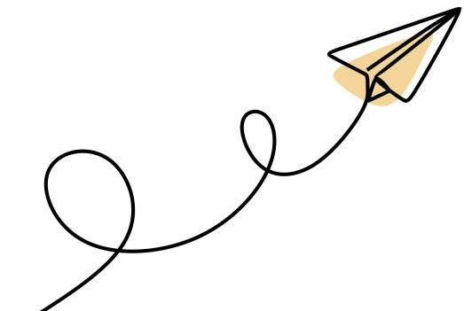
Year 5/6
Investigate needs or opportunities for
designing, and the materials,
components, tools, equipment and
processes needed to create
designed
solutions (AC9TDE6P01)
Select and use suitable materials,
components, tools, equipment and
techniques to safely make
designed
solutions (AC9TDE6P03)
Design and Technology
In this virtual excursion, students will explore
the different functional features of aeroplanes,
and how these affect movement of the plane.
Students will also consider the movement of a
model paper plane, and how we can alter the
materials and techniques used to achieve a
specific outcome.
Knowledge and understanding
Year 3/4
Investigate how forces and the properties of
materials affect the behaviour of
a
product
or
system
(
ACTDEK
011)
Process and production
Year 3/4
Explore needs or opportunities for designing,
and test materials, components, tools,
equipment and processes needed to
create
designed solutions (AC9TDE4P01)
Select and use materials, components, tools,
equipment and techniques to safely
make
designed solutions (AC9TDE4P03)
Listed below are links to curriculum to inform the connection between our interactive session and how they
could apply to further learning in the classroom. These links are drawn from two areas of the Australian
curriculum, ‘Science’ and ‘Design and Technology’.
Activities and Resources
Foldable Flight
–

Curriculum Links

