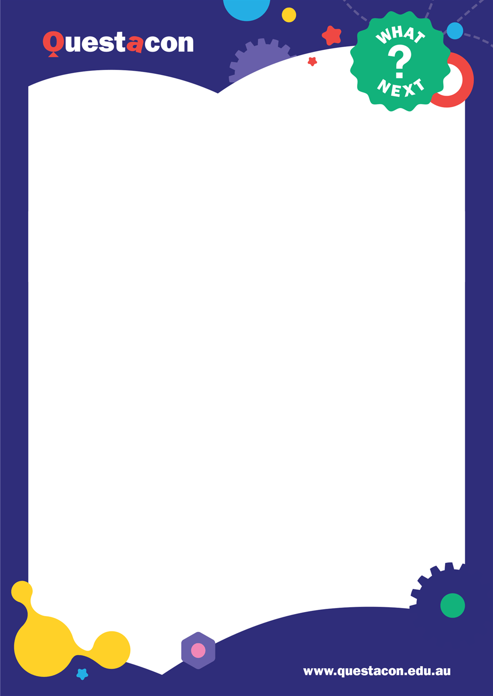
Safety
The risk of injury while participating in the
experiments is low. Be mindful that students
are acting with care with materials, and that
they are supervised while conducting their
investigations.
If you have concerns about how your students
will handle some information, speak to our
presenters at the start of the session or email
us.
On the day
•
Make sure you have materials on hand
. The
presenter will give verbal cues as to which
activities will be coming up next and go
through the activity instructions with the
students.
•
Your role during the virtual excursion will be
to help facilitate students through activities
and act as your class’s ‘voice’.
•
Stay by the keyboard as you’ll need to enter
student answers or observations using our
polls and the Q and A.
What to Expect
In this session, students will learn what coral
are, the different methods used to collect data
and study Australia’s reefs, and the best
conditions for coral to thrive in.
Students will investigate how the different
properties of materials impact the tools and
technologies used to study the reefs, and
model research practices using everyday
materials.
Materials
For Paper Polyps each student will require:
•
Coloured paper
•
Coloured markers
•
Safety scissors
•
Tape or glue
•
An object to build on (e.g. chair, lunchbox)
For Float or Sink? each class will require:
•
Container of water
•
Items that can be placed in water
•
Towel to clean any spills
Welcome to Questacon’s
Under the Sea: Coral Reefs
. In this session, students will investigate the different
ways that scientists study coral reefs and explore
how coral are affected by changing conditions
. This
document provides information to prepare you and your students for the session.
Included in this document is an outline for the webinar, materials list, safety considerations, and ideas for
extension activities to help maximise your students’ learning from our virtual excursion.
Activities and Resources
Under the Sea: Coral Reefs
Contact us!
Have any questions? Email us at:
digitaloutreach@questacon.edu.au

Time
Segment
Description
Notes
min
5
BEFORE
Audio visual
check
Session will open for classroom to join. This is a good opportunity to
ensure your tech set up works and your whole class can see and hear the
presenter.
0
-
3
min
Introduction to
excursion
The facilitator will quickly run through the features of the webinar and
how they will be interacting throughout the session.
3
-
min
9
Coral reef
ecology and
physiology
Facilitator will discuss with students the structure of coral reefs, the
inhabitants of coral reefs, and how they contribute to the overall
environment.
9
-
23
min
Activity: Paper
Polyps.
Modelling coral
reefs
Facilitator will demonstrate how to construct a paper coral
polyp

and
participants can create their own to build a model coral reef. Then we'll
discuss how scientists use models to understand scientific concepts.
23
-
29
min
Studying the
Great Barrier
Reef with AIMS
Facilitator introduces the Australian Institute of Marine Science and their
programs. We'll explore
different methods of surveying reef health, and
some of the jobs and tools
required.
29
-
44
min
Activity: Float or
sink?
Students explore properties of different materials and consider their
suitability for use as tools for underwater exploration.
44
–
47

min
Environmental
factors that
affect coral
Presenter discusses coral bleaching and environmental conditions like
ocean temperature and pH that affect coral health.
47
-
53
min
Testing pH
Presenter explains pH and demonstrates how to use red cabbage
indicator to test pH levels of common household substances.
53
-
60
min
Reflection and
conclusion
Presenter will summarise the excursion, highlighting the various roles
involved in coral reef conservation.
Runtime: 60 minutes
Please note these times are approximations, and programming on the day may change to give
participants the most impactful and enjoyable experience possible.
Activities and Resources
Under the Sea: Coral Reefs
–

Run Sheet
Activities and Resources
Under the Sea: Coral Reefs
–

Paper Polyps
Before the session:
Gather your materials:
•
Coloured paper/plain paper
•
Safety

scissors
•
Coloured

markers
•
Tape
/
glue
•
An object to build on (e.g. chair, lunchbox)
During the session:
1.
Cut paper into small pieces, for example cut
an A4 paper into 8 small rectangles.
2.
Mark small dots all over both sides of the
paper with a coloured marker.
These
represent the polyp’s zooxanthellae.
3.
Cut part
-
way along the length of the paper at
even intervals to create a fringe. These will
become the polyp’s tentacles.
4.
Roll the fringed paper into a tube.
5.
Secure the roll with tape or glue.
6.
Gently separate the fringe sections.
7.
Attach coral polyp to chosen object with tape
or glue.
8.
Repeat as desired.
Under the Sea: Coral
Reefs
–

Float or Sink?
Before the session:
Gather your materials
:
•
Container of water (Can also fill up a sink)
•
Items that can be placed in water
Towel to
clean up any spills
•
Towels to clean up any spills
During the session:
1.
Collect a variety of different objects to test in
the water. Test objects of different sizes,
shapes, materials etc.
2.
Before placing an object in the water, guess
whether it will float or sink.
3.
Place each object in the water and observe
what it does, did it match your guess?
Extension ideas:
•
Try to find materials that will float or
sink
depending on their shape. A ball of
plasticine will behave differently to a
plasticine boat of the same weight.
•
Try changing the density of the water by
adding salt (make a 5% salt solution by
adding 25g of salt to 500ml of water).
Compare how your objects float or sink now
to what they did in fresh water. Did anything
change?
•
Make models of boats/subs that we might
use to study the reef and seabed. Can you
adjust the buoyancy so it both sinks and
floats as needed?
More experiments
Visit the Questacon website for more activities:
n
https://www.questacon.edu.au/lear
-
an
d
-
s
play/activitie
Extension ideas:
•
Add models of other animals to your coral reef
ecosystem.
•
Try different ideas to represent a coral’s
exoskeleton.
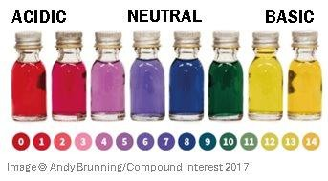


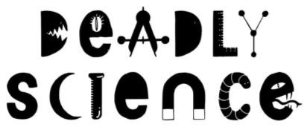
Red cabbage indicator
Equipment:
•
Chopped red cabbage
•
Heat resistant container
•
Hot water
•
Containers for testing substances
•
Acidic substances (e.g. lemon juice, vinegar)
•
Alkaline/basic substances (e.g. bicarbonate
soda, washing powder)
Instructions:
•
Place chopped cabbage into heat resistant
container.
•
Cover with hot water for 10
-
15
minutes.
•
(
Optional) Strain to separate cabbage from
liquid.
•
T
est the pH of substances in separate
containers.
•
Compare colour to chart below to determine
pH, from very acidic (1), to neutral (7), to very
basic (14)
Tip
Dissolving powdered substances into water first
may yield clearer colour changes.
Listed below are optional extension activities and links to further your students’ learning.
Activities and Resources
Under the Sea: Coral Reefs
–

Extension Activities
The Australian Institute of Marine Science’s
research supports the sustainable use and
protection of our oceans.
Find out more at

:
/
https://www.aims.gov.au

Deadly Science

delivers resources and
programs to ensure regional and remote
schools can create effective STEM learning
experiences that include First Nations science.
Find out more at:
u
http://deadlyscience.org.a

SeaWeek

is coordinated by the Australian
Association for Environmental Education.
For more
SeaWeek

resources visit:
https://www.aaee.org.au/seaweek/newresour
c
es
/

Year 3/4
Nature and development of science
-

examine
how people use data to develop scientific
explanations. (AC9S3H01, AC9S4H01)
Use and influence of science
-

consider how
people use scientific explanations to meet a
need or solve a problem. (AC9S3H02,
AC9S4H02)
Year 5/6
Nature and development of science
-

examine
why advances in science are often the result of
collaboration or build on the work of others
AC9S5H01, AC9S
(
6H01)
Investigate how scientific knowledge is used by
individuals and communities to identify
problems, consider responses and make
decisions (AC9S5H02, AC9S6H02)
Science inquiry
In the virtual excursion, students participate in
a range of activities to build their inquiry skills.
The skills range from modelling to represent
coral reef structure, conducting open
-
ended
investigations on material properties and how
they may impact the development of scientific
technology, and using both qualitative and
quantitative data to understand how changes in
the environment impact coral health.
All year levels
•
Questioning and
predicting
•
Planning

and
conducting
•
Processing
, modelling and
analysing
•
Evaluating
•
Communicating
Science
Science understanding (Biological
sciences)
In the virtual excursion, students explore the
key features of coral as an animal, how coral
changes throughout its life, the relationships
coral can have with other organisms, and
how they are impacted by changes in their
environment.
Year 3
-

Living things can be grouped
on the
basis of

observable features and can be
distinguished from non
-
living things.
ACSSU
(
044)
Year 4

-

Living things have life cycles.
072)
ACSSU
(
Year 5

-

Living things have structural
features and adaptations that help them to
survive in their environment. (ACSSU043)
Year 6

-

The growth and survival of living
things are affected by physical conditions of
their environment. (ACSSU094)
Science as a human endeavour
In the virtual excursion, students look at how
data can inform understanding of coral reef
health, as well as exploring scientists may
use scientific knowledge to identify problems
and
develop

solutions.
Listed below are links to curriculum to inform the connection between our interactive session and how
they could apply to further learning in the classroom. These links are drawn from
ACARA’s Science

curriculum (Version 9.0).
Activities and Resources
Under the Sea: Coral Reefs
–

Curriculum Links
Contact us!
Have any questions? Email us at:
digitaloutreach@questacon.edu.au

