Questacon Smart Skills Initiative
National Questacon Invention Convention
15-19 January 2018

Application Pack
All expenses paid
Suitable for students aged between 14-18 years old.
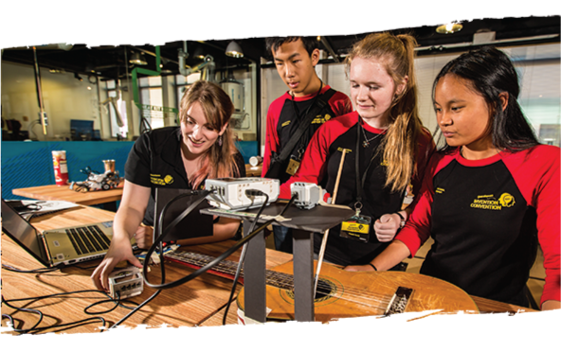

Information

What is the National Questacon Invention Convention?
The annual National Questacon Invention Convention is an all expenses paid, five day workshop in Canberra, held every January. It’s immersive, but also fun – play, make, design and laugh your way through a week of inspiration and creativity. This year we will be exploring innovative ways to create, make and prototype solutions to problems that fall under our theme: Future Earth.

What to expect:
We’ll start by – helping you come up with a new idea for an invention.
Bring your invention to life – Prototype your ideas and get them off the page and into your hands.
Build stuff – Use anything from robotics and electronics to hot glue, hammer, and nails.
Meet cool people – Professional innovators, designers and communicators, as well as 24 young people just like you! You might come alone, but you’ll leave with 24 new friends!
Celebrate your achievements – enjoy a gala event with your new friends, mentors and other VIP. This is an all expenses paid event. All travel, accommodation and meals will be organised by Questacon.

Who is eligible?
If you are a student aged 14–18 in January 2018 and attend an Australian secondary school, you are eligible to apply for the National Questacon Invention Convention.

How do I apply?
To apply all you need to do is complete the registration form with your personal details and answer ONE of the two application questions on the next page. Then send through your responses, the completed form and a recent photo of yourself to the address listed below. Places are limited (maximum 25) and participants will be selected based on their responses to the application questions. Your responses can include images and video.
“Everyone who I talked to during the week was impactful. I find it too hard to think of
a single person, everyone made me think of different things that I could do”.
—Phoebe, Delegate
“He looks at the world in a different way, opened his mind up to possibilities, more creativity and innovation. Confidence has grown :) Not so afraid to have a go in case he’s wrong”.
—Jan, Parent
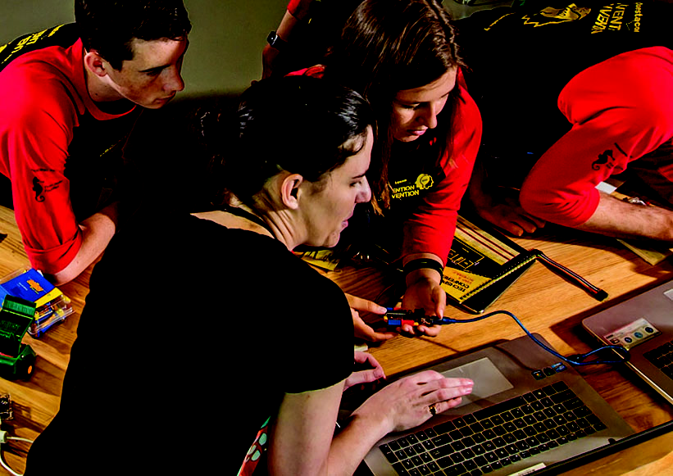
For more information about the National Questacon Invention Convention or on how to apply, please contact us on:
Phone: 1800 889 995
Email: outreach.bookings@questacon.edu.au
So, are you ready to apply?

Tell us about your ideas

Only answer Question 1 OR Question 2.
The more information you can provide about your idea, the easier it will be for us to understand its potential. We’ll be looking for responses that give clear explanations and plenty of relevant details. You can probably do this in less than 500 words or in about three minutes, but don’t stress about the length of your application – the most important thing is that we can see how your idea works. Are you better at drawing your ideas? Include a diagram. Have you built a prototype? Take a photo. Or better yet, show us in a video! Additional video tips are provided on our website.
These inventions and ideas will not necessarily be what you will work on during the National Questacon Invention Convention and they don’t have to be related to this year’s theme! So let your imagination run wild!

Question 1: Do you enjoy Making/Tinkering?
- Show us something you’ve created. Maybe you’ve made a prototype for a completely new invention, or perhaps you’ve tinkered with something to improve its design. What does it do? How does it work? You can describe it in writing, send us a picture or make a video.
- What problem does your creation address? Who would use it and how would it benefit them?
- How would you go about refining or improving your creation? What equipment/materials/technology/skills might help? Refining your creation could include making it out of more suitable materials, incorporating electronics and/or more advanced technology.
- In a couple of sentences, let us know why you want to come to the National Invention Convention.

Question 2: Do you enjoy coming up with new ideas?
- Tell us about an idea for an invention. This can be a completely new invention or an improvement of an existing design. What would it do? How would it work? You can describe it in writing, send us a picture or make a video.
- What problem does your idea address? Who would use your idea and how would it benefit them?
- How would you prototype your idea? What equipment/materials/technology/skills might help? A prototype is an early or simple version of what you want to make. It doesn’t have to be perfect but it should show how your idea works.
- In a couple of sentences, let us know why you want to come to the National Invention Convention.

Submitting your application
If you are under 18, both you and your parent or guardian will need to sign the registration form. Bonus points are allocated to Aboriginal and Torres Strait Islander students, students with disability, students from regional/remote areas. We encourage applicants to include this information in their application. Send the completed and signed registration form and responses to the application questions to the below address by 5pm 16 October 2017:
Email: outreach.bookings@questacon.edu.au
Post: Questacon Invention Convention, LOC 940, PO Box 5322, Kingston ACT 2604
We will confirm that we have received your application within two business days of receiving it. Successful applicants will be contacted by 3 November 2017 and provided further information on accommodation and transport. Unsuccessful applicants will be notified via email.
Please attach any additional images or documents as required with clear labels or titles. Videos must be submitted via YouTube or Vimeo. Simply include the URL link and password in the registration form. We recommend using an ‘unlisted’ video on YouTube or a video with password protection on Vimeo. Instructions on how to do this are available on our webpage.

Registration form
To be submitted with your responses to the application questions and a recent photo of yourself.

Participant’s details

Given name:
Surname:
Date of birth: Male Female Unspecified
Are you of Aboriginal or Torres Strait Islander origin? Yes No Prefer not to answer
Is English the main language you speak at home? Yes No Prefer not to answer
School: T shirt size:
Tell us something interesting about you – got a hidden talent? Been anywhere cool? Got a favourite food?

Address details

Apartment/Unit: Street number:
Street name:
Suburb/Town:
State: Postcode:
Where is your nearest airport?
If you are successful can we share your details with other successful participants? Yes No

(This will help us to put you in touch with other participants from your area who are also travelling to Canberra)

How did you answer the application questions?

Written application (attached)
Video URL link: Password: (if required)
Other (please provide details)

Parent/Guardian contact details (if under 18 years of age)

Name:
Daytime phone: Mobile:
Email:
How did you or the participant find out about the Invention Convention?

General Information

Special Requirements
Does the participant require any adjustments, or have any allergies (food or other) that we need to be aware of?

Accessibility adjustments:
Allergies (food or other): If yes, Epi-pen?
Medical conditions:
Medication requirements:
Dietary requirements and preferences:
Do you have any travel considerations we need to be aware of?

Note – if a child has to travel with medication, it is an airline requirement to be able to administer the medication on their own. Please ensure the applicant has a doctor’s certificate (current, in English) to present at check in, confirming the child can recognise the need and administer medication if required.

Parent/guardian signature (if under 18 years of age)
I am aware that my child has applied for the National Questacon Invention Convention and give them permission to attend. If their application is successful, I acknowledge I have read and agree to the Invention Convention Terms and Conditions, including Questacon’s Privacy Policy.

Name:
Signature:
Date:

Participant’s signature
I have read and agree to the National Questacon Invention Convention Terms and Conditions, including the Code of Conduct and Questacon’s Privacy Policy.

Name:
Signature:
Date:
I would like to be contacted about future Invention Convention events

Terms and Conditions

Code of conduct
- Participants must obey all lawful instructions from the workshop Manager and Support Staff such as (but not limited to) all reasonable instructions, directions and procedures relating to work health and safety in operation at our premises.
- Participants must not consume alcohol, use illegal substances, or smoke cigarettes whilst participating in the workshop in any capacity.
- Once registered with the Invention Convention Supervisor, Participants must not depart from the workshop environment without the approval of the Invention Convention Supervisor or the Support Staff.
- Participants are representing their school, family, organisation or business and Questacon. No disrepute should be brought to either of the above. Behaviour befitting a Participant will be required at all times.
- No disrespect to persons involved in the event will be tolerated under any circumstances.
- If Participants have any problems, they are to report them to the workshop Manager as soon as possible.
- There is to be:
  - Respect for the venue and all property;
  - No interference with other people’s property;
  - No use of venue telephones and other services (except at the Participant’s expense).
- The Participant or their parent(s)/guardian will be liable for any damage or loss caused to Questacon’s property and premises resulting from the Participant’s conduct.
- Once signed in, Participants must attend all approved activities unless given permission to do otherwise.
- Participants agree to wear enclosed footwear and any other stipulated uniform compliance.
- Participants agree to demonstrate punctuality as required by the workshop Manager.
- Participants are required to take care of their possessions whilst at the workshop. Questacon will not be held liable for any loss or damage to Participants’ possessions.
Breaches of any Code of Conduct rules may lead to immediate expulsion from the workshop. Should expulsion occur, the Participant or their parent(s)/guardian will be contacted and appropriate travel arrangements will be made. Any and all additional expenses incurred will be the responsibility of the Participant’s parent(s)/guardian.

Consent to apply first aid
In the event of any emergency, injury or illness, you authorise any Questacon Invention Convention official, to obtain on your behalf and at your expense, any medical assistance, treatment and transportation as deemed necessary.

Daily registration and transport
For duty of care purposes, parents/guardians of Participants (or Participants, if 18 years of age or over) will be required to register Participants daily. This is to ensure all Participants are accounted for throughout the day and leave the workshop premises safely. Exceptions to daily registration can be made if agreed in writing, prior to the event.
All transportation to and from the Questacon Invention Convention Venue will need to be arranged by the Participant or their parent/guardian. If the Participant is using public transport please check local timetables. For the avoidance of doubt, it should be understood that Participants are not within the duty of care of Questacon when travelling to and from the event.
Please ensure that the Participant arrives 15 minutes prior to the start of first session to allow for registration. The first session of the day will commence at 9 am. The last session of the day will finish at 4 pm. Please ensure that the Participant arrives on time. More information about the programme and sessions will be sent to the Participant once the registration form is received.

Privacy collection statement and consent
Questacon is a division of the Department of Industry, Innovation and Science (the Department) and as such is bound by the Australian Privacy Principles (APPs) outlined in Schedule 1 of the Privacy Act 1988 (Cth) (Privacy Act). These principles regulate how Questacon collects, uses, discloses and stores personal information. As you would be aware your child is applying to participate in a Questacon Invention Convention (Invention Convention). This requires the collection of your and your child’s personal information.
The personal information collected on the attached form includes your contact details, emergency contact details, your child’s name, the name of your child’s school, your child’s age, state or territory location of residence, postal address, any special requirements, dietary requirements. Questacon may use this personal information in printed and digital materials and websites produced for the Department and related Ministers’ offices including reports, brochures, magazines, newspapers, newsletters, posters, fact sheets, websites, social media applications (such as Facebook, Twitter and YouTube), case studies, promotional videos and multimedia presentations. This personal information may also be used by media outlets in the form of media releases including participant’s, name and school to broadcast, advertise and promote the Questacon Invention Convention.
Questacon may use your personal details to notify your local Member of Parliament about your child’s participation in the Invention Convention.
Personal details may also be used to contact the Participant regarding future Questacon events and programmes.
The information will only be used for the purposes outlined above, except where authorised or required by law.
For further information, please refer to the Department’s Privacy Policy on the Department of Industry, Innovation and Science website. This policy contains information about how you may access the personal information Questacon holds about you, and how you may correct any inaccuracies in that information. It also includes information as to how you may make a complaint about a breach of the Privacy Act, and how Questacon will respond to such a complaint.
If you have an enquiry or request relating to your personal information, please contact:
Privacy Contact Officer
Legal Services Branch
Corporate Division
Department of Industry, Innovation and Science
GPO Box 9839
CANBERRA ACT 2601
AUSTRALIA
Email: privacy@industry.gov.au
More information about the Privacy Act can be obtained from the Office of the Australian Information Commissioner’s website.
Personal Information obtained will also be stored and held in accordance with Questacon’s obligations under the Archives Act 1983 (Cth).
Questacon understands that you may not want Questacon to use your child’s personal information in printed and digital materials and websites.

