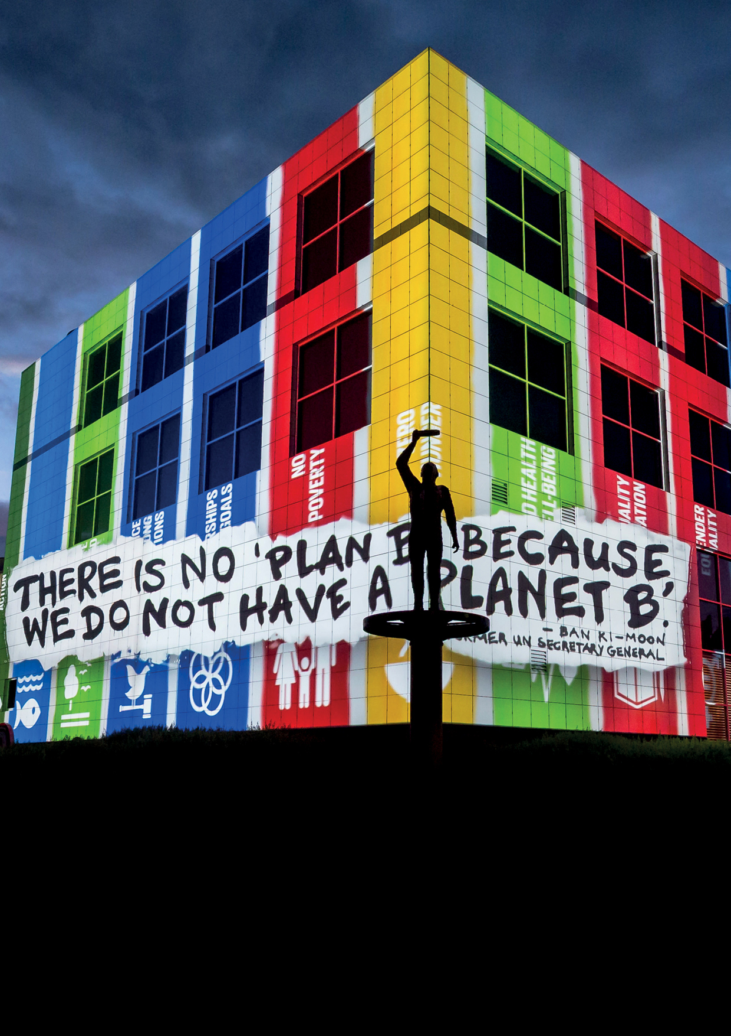


Questacon Year in Review 2017
Creativity, Imagination and Enterprise

Questacon Overview 1
Sustainable Development Goals 2
Key Statistics for 2017 3
Minister’s Introduction 1
Assistant Minister’s Introduction 3
Chairman’s Message 5
Questacon Advisory Council 7
Director’s Report 9
The National and Science and Technology Centre 12
Colour—See the World in a New Light 12
Fundamental 13
Above and Beyond 14
Environmental management 15
Questacon Partners 17
Raytheon 17
The Ian Potter Foundation 19
Samsung 20
Shell Australia 21
Australian National University 23
IP Australia 23
Outreach and National Programs 25
Smart Skills 25
Smart Skills Student Workshops 26
Smart Skills Teacher Workshops 27
Smart Skills Invention Convention 28
Maker Project 29
Enterprising Australians 30
Shell Questacon Science Circus 33
Learning Programs 36
STEM X Academy 36
Engineering is Elementary 37
Pilot Primary STEM Program 38
Social Ventures Australia Thought Leadership Gathering 39
Inspiring Australia 40
Activities in 2017 40
Staff highlights 40
Prime Ministers Prizes for Science highlights 41
National Science Week highlights 43
Citizen science highlights 46
Science clubs highlights 47
Science tourism highlights 47
Questacon International 49
Young Australians’ Plan for the Planet 49
International Science Centre and Science Museum Day 2017 50
International exhibitions 50
Science Centre World Summit 2017—Tokyo 51
International delegations and visit highlights 52
Winner of the National Tourism Award 55
Regional tourism win 56
Key Events 58
National Questacon Invention Convention 58
Above and Beyond announcement 58
ENLIGHTEN 2017 59
ONTHEGO Partnership Launch 59
Above and Beyond VIP 60
Take Flight @ Questacon 60
11 millionth visitor 61
Air & Space Speaker Series 61
Monopoly Board 62
Channel Nine’s The Today Show 62
Fun Science with Traditional Toys 63
ABC News Breakfast—National Science Week 65
Visit from the Governor-General 66
EuroScience 2017 66
Questacon People 67
Volunteers 67
Volunteer profile: Jennifer Wanless 68
CERTIII Customer Engagement 68
Q Staff Awards 70
Length of Service 71
Volunteers Length of Service 71

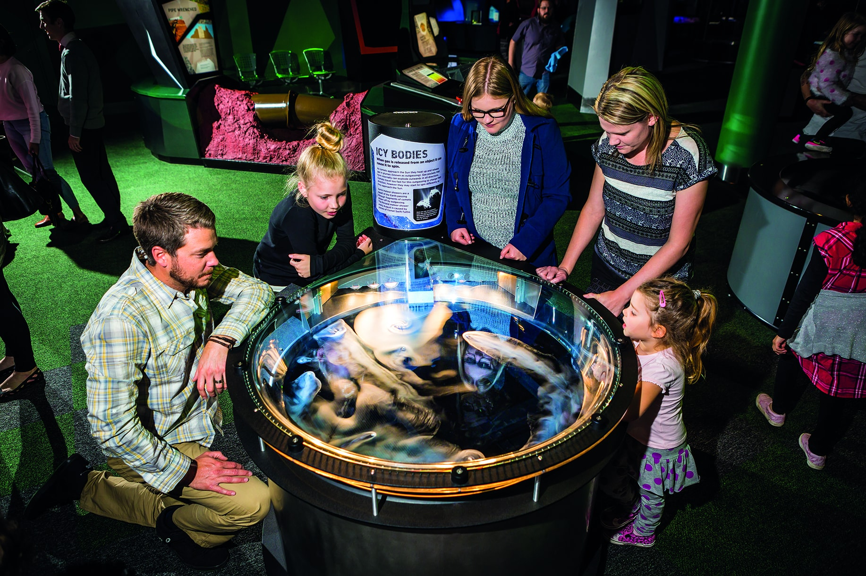
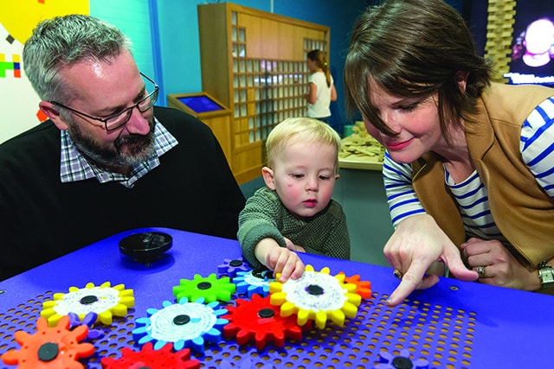

Questacon Overview
Questacon—The National Science and Technology Centre is Australia’s National Science Engagement organisation. We operate from our Canberra headquarters as a division of the Department of Industry, Innovation and Science. Working towards our vision of a better future for all Australians through engagement with science, technology and innovation, we deliver inspirational learning experiences across Australia and globally.
We are empowered by the Australian Government to engage, connect and inspire all Australians in science, technology, engineering and maths (STEM) through a journey of lifelong learning. As Australia’s economy continually transforms and evolves over the coming generations, our aim is to help inspire and equip tomorrow’s leaders with the enterprise skills necessary to navigate and flourish in an uncertain world.
From The Ian Potter Foundation Technology Learning Centre, we design, develop and build many of our exhibitions, often working with partner institutions across Australia and internationally. Here we work with students, teachers, high school innovators and tomorrow’s entrepreneurs. This centre is also our base for national outreach activities. Our outreach programs work in partnership with local institutions, teachers, researchers and businesses, to ensure the inspiration from a visiting program turns into something enduring well beyond our visit.
Questacon is responsible for delivering the Inspiring Australia network, in collaboration with the state and territories. The Inspiring Australia initiative—delivered against a National Framework for Local Action—ensures the outstanding work of passionate individuals and organisations across Australia is connected to a broader ecosystem, while remaining relevant to their own community’s needs.
As an influential voice in the global Science Centre community, Questacon is a vehicle for delivering activities to support the Australian Government’s science agendas, as well as contributing to the work of the United Nations in Science Centre capacity building and implementing the 17 Sustainable Development Goals.
Questacon delivers activities across Australia with support of our partners who are committed to investing in Australia’s young people. The organisations Questacon works with share our common vision. Our partners see the value of long-term and sustained investment in the future, with partnerships typically spanning years and a variety of activities. Our partners make our achievements and successes possible.
Questacon is proud of our achievements and we look forward to the year ahead as we continue to chase our dream of a better future for all Australians through engagement with science, technology and innovation.

Sustainable Development Goals
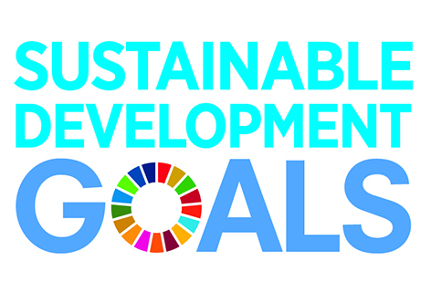

17 Goals To Transform Our World
Around the world governments, businesses and civil society together with the United Nations are mobilising efforts to achieve the Sustainable Development Agenda by 2030. Universal, inclusive and indivisible, the Agenda calls for action by all countries to improve the lives of people everywhere.
This involves working towards 17 Sustainable Development Goals agreed to in 2015, as well as the 2016 Paris Agreement on climate change.
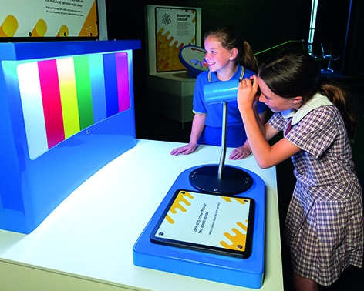

Key Statistics for 2017
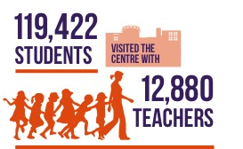

Minister’s Introduction
Science is crucial to shaping our nation’s wellbeing and prosperity, and our position in the world.
Australian ingenuity has given the world WiFi, cochlear implants, aircraft black box recorders, electronic pacemakers, even the electric drill. Science, technology and innovation are behind these and many more home-grown innovations with global impact.
These advances require more than aptitude for the technical, an interest in mechanics or a scientific inclination. They spring from a deep curiosity and drive to explore, understand, challenge and create. It is essential we nurture these qualities in the children who will become the innovators of our nation’s future.
Children have a natural curiosity about the world around them. Questacon cultivates this by making science interactive, accessible and fun. In doing so, Questacon is inspiring the next generation of enquiring minds–the scientists, technologists, engineers and researchers who will help shape out future.
Women are under-represented in these fields so it is particularly important to engage more girls and women in STEM, starting with the school years and continuing through to TAFE and university, and on into the workforce. We want to encourage and develop the wides pool of the best possible talent.
On 10 November 2017 Questacon celebrated the International Day of Science Centres and Science Museums through the development and launch of videos of Questacon’s ‘Women in STEM’ to contribute to UNESCO and UN Women’s continuous stream of stories and short videos of women in STEM in science centres who are passionate about science. Supporting Goal 5 of the Global Goals – Achieve gender equality and empower all women and girls – Questacon brought together women and girls working, living, learning and influenced in STEM to share their message through this platform. This type of activity is critical to inspiring the next generation.
Many of the jobs of the future will require a STEM-based education. Questacon plays a key role instilling a passion for science and technology from an early age. By ensuring a strong education and lifelong interest in STEM, we are preparing our young people for the future. It deepens their understanding of the world around them, equipping them to tackle the challenges, excel in the workforce, innovate and create opportunities in their rapidly changing world.
Congratulations to all involved on another outstanding 12 months. I am sure the year ahead will see even further success.
Senator the Hon Michaelia Cash
Minister for Jobs and Innovation
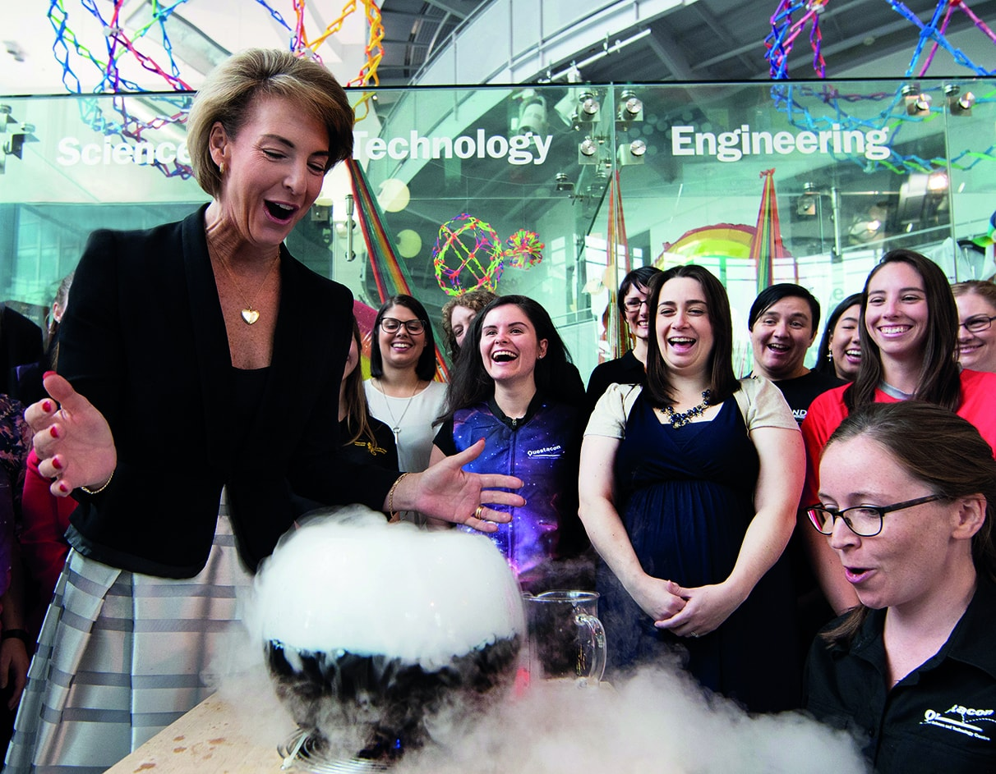

Assistant Minister’s Introduction
Questacon is one of Australia’s great national cultural institutions. For over three decades it has been creating opportunities to engage Australians in science, technology, engineering and mathematics (STEM) and entertaining visitors, particularly school kids, from all around Australia.
As a born-and-bred Canberran, I have had the special privilege of having Questacon as one of the unique institutions that give our nation’s capital its vibrancy and identity. Now, as a parent, I’ve been able to see my own children visit Questacon over the years and experience for themselves the creativity and imagination that go into the hands-on exhibitions and science shows.
As the Annual Review 2017 demonstrates, though, Questacon is much more than just a tourist attraction. Questacon supports early and active learning through its creative Smart Skills program, the Inspiring Australia initiatives, and the Shell Questacon Science Circus.
Questacon also continues to do vital work supporting regional and rural Australia in building STEM capabilities for both teachers and students.
By ensuring a strong education and lifelong interest in STEM, we are preparing our young people for the future. This makes Questacon’s role in communicating and engaging young people in science, technology, and innovation more crucial than ever before.
In 2017 Questacon welcomed the 11 millionth visitor to their Canberra building and won the Canberra Regional Tourist Attraction category award for the 13th year running, and, for the fifth time, took home a National Tourism Award.
These great achievements augur well for the year ahead and I look forward to seeing Questacon go from strength to strength in 2018.
Senator the Hon Zed Seselja
Assistant Minister for Science, Jobs and Innovation
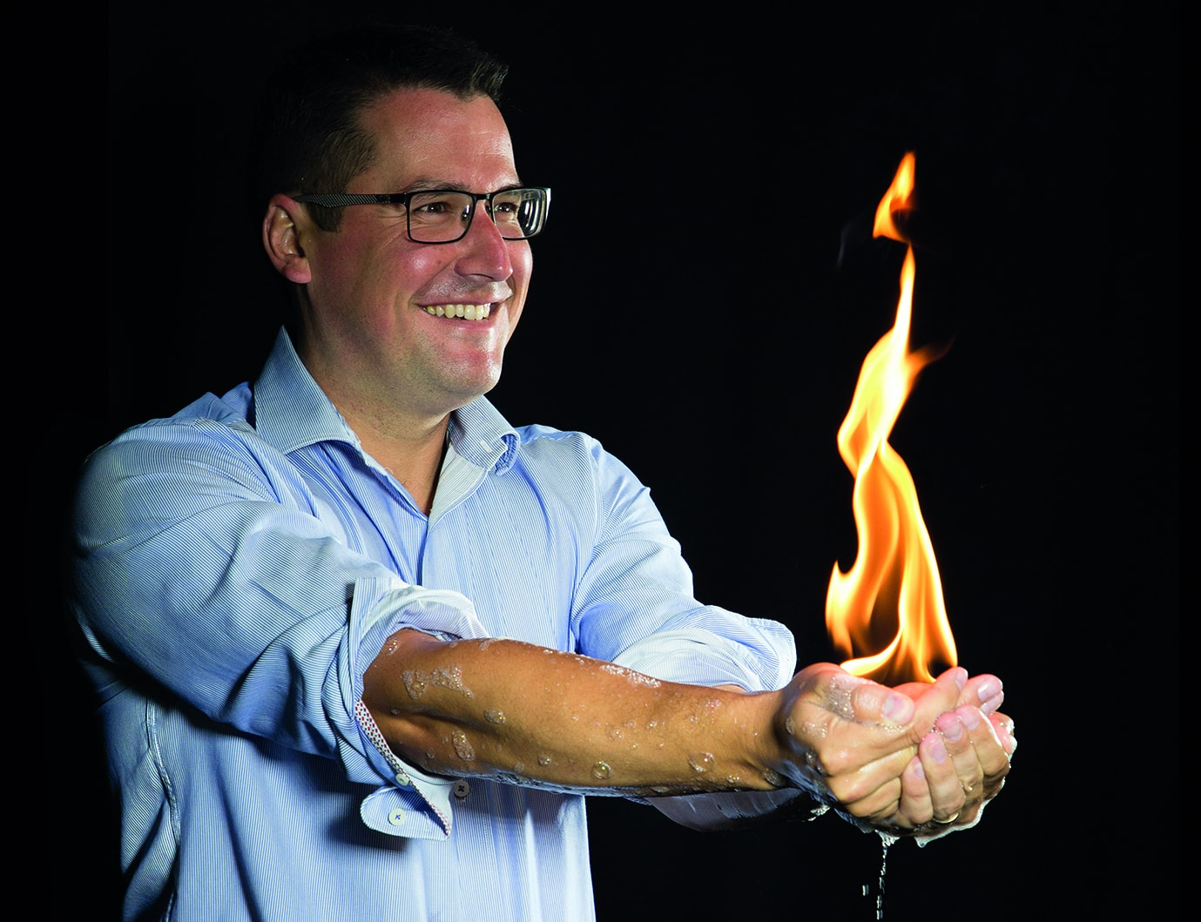

Chairman’s Message
From day one, Questacon has set out to provide unique experiences to inspire discovery and study of science and technology.
Each year, Questacon explores new ways of connecting people with STEM. Reflecting on 2017, I am delighted to report Questacon has once again delivered on its aim—exceeding expectations and engaging millions of Australians in the wonderment and value of science, technology and innovation.
Partnerships make this possible and are central to Questacon’s ethos and ongoing success.
Partners range from government and industry to academia and philanthropic organisations. The common ground is a shared vision for a better future for all Australians through direct engagement with STEM.
I am pleased to report Cabinet have asked Questacon to establish the Q Foundation. The pace, scope and impact of the technological revolution is unprecedented. Valued partnerships and networks enrich the experiences Questacon can offer and amplify its reach and ability to equip tomorrow’s leaders with the foundation skills necessary to navigate, respond to and flourish in this rapidly changing world. The Q Foundation is a critical element of continuing to build upon those partnerships.
The founding directors of the Q Foundation are Mr Eddie Kutner (Chair), Professor Adrienne Clarke AC, Mr John Ralph AC, Dr Cathy Foley, the Hon Dr Annabelle Bennett AO, Dr Gregory Clark AC and Mr Leon Kempler AM.
Through collaborations and partnerships Questacon progressively connects an increasing number of Australians and helps develop the skills and knowledge the science and technology industry needs to imagine and create a better future.
In an increasingly globalised environment, international partnerships are also critical. During 2017 Questacon also enhanced Australia’s international relationships and cemented its own leadership role in science centre networks, sharing best practice and showcasing our country’s capabilities on the world stage.
I would like to sincerely thank all Questacon partners and collaborators for their vision and support. My gratitude also to the members of the Questacon Advisory Council—Mr Eddie Kutner (Deputy Chair), the Hon Dr Annabelle Bennett AO, Professor Karin Barovich, Dr Gregory Clark AC, Dr Sarah Pearson, Professor Ian Young AO, for their commitment, advice and insight.
Finally, Professor Graham Durant and the leadership team, staff and volunteers are to be commended for their unwavering enthusiasm, dedication and passion for science. This concerted effort is what has made it possible to engage with more than 33 million people since that day 29 years ago when Questacon first opened its doors.
Leon Kempler AM
Chairman, Questacon Advisory Council
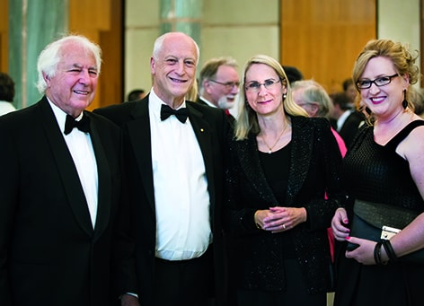

Questacon Advisory Council
Questacon is supported by an Advisory Council appointed by the Minister and Prime Minister. The role of the Advisory Council is to advocate for, and advise, Questacon. Membership is drawn from eminent scientists, and academic and business leaders and philanthropists, who all share a passion for Questacon’s vision and mission.
The Advisory Council members work together to:
- serve as a source of independent advice to the Director and Executive of Questacon
- raise the profile and build the brand of Questacon
- engage with stakeholders and advocate for the work of Questacon.
Questacon Advisory Council membership is:
- Mr Leon Kempler AM—Chair
- Mr Eddie Kutner, Businessman and Philanthropist—Deputy Chair
- Dr Gregory Clark AC—Visiting Fellow of the Australian University
- Dr Sarah Pearson—Pro Vice-Chancellor Industry Engagement & Innovation at University of Newcastle
- the Hon Dr Annabelle Bennett AO—former Federal Court judge
- Professor Ian Young AO—former Australian National University Vice Chancellor
- Professor Karin Barovich—Department of Earth Sciences, University of Adelaide
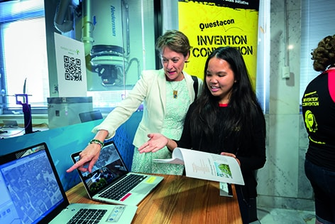
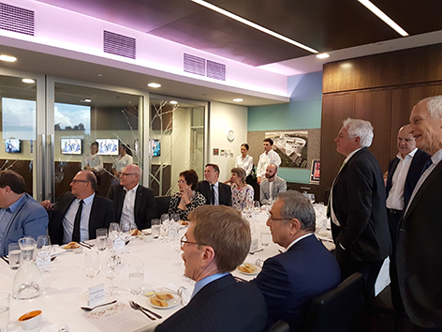
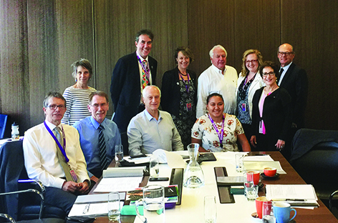
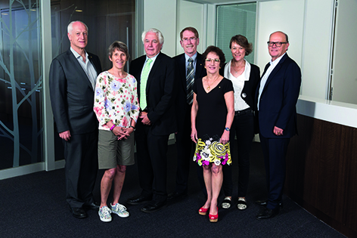

Director’s Report
Creativity. Imagination. Enterprise. Questacon is engaging Australians in STEM to stimulate creativity, spark imagination and encourage the enterprise needed to meet the challenges of the future. At a time of unparalleled change, challenge and opportunity, these are essential qualities for Australia’s future leaders.
Throughout 2017 Questacon showed what is possible when these qualities come together.
The year started with the blockbuster international aviation and aerospace exhibition, Above and Beyond. Presented by Boeing, and developed in collaboration with NASA and the Smithsonian National Air and Space Museum, Above and Beyond investigated the past, present and future of space exploration and flight. From flying cars and supersonic planes to space elevators and mega-rockets, this immersive exhibition engaged visitors of all ages and interests with both the innovation and science behind flight—demonstrating that the sky was never the limit.
We also revisited fundamentals this year. A new permanent exhibition, Fundamental, explores simple scientific principles and phenomena through a mix of classic and new Questacon exhibits, each demonstrating a fundamental principle of science through educational hands-on and provoking activities, encouraging imagination and rewarding repeated exploration.
These two exhibitions proved extremely popular. To accommodate more visitors, Questacon extended opening hours, adding evening winter activities and food offerings during the July school holidays. This contributed to a peak in visitor numbers in mid-2017, and a record half a million visitors coming through the doors of Questacon Centre over the course of the year.
Continuing to drive momentum, Questacon’s newest exhibition, Colour—See the World in a New Light, explores the origins of colour in the natural and human-made worlds as well as personal relationships with colour. This exhibition is a collaboration with other Australian scientific organisations, Australian National Insect Collection, CSIRO, Geoscience Australia and the ARC Centre of Excellence in Exciton Science. It aims to encourage visitors to share and compare their perceptions of colour, create experiences that challenge assumptions and beliefs about the world, and show the variety and extent of colour usage and experience in other animals and in the natural world.
The successful exhibitions were complemented by a full program of Smart Skills workshops, Regional and the National Invention Convention, STEM X Academy and maker workshops at Questacon’s second campus, The Ian Potter Foundation Technology Learning Centre, as well as numerous travelling exhibitions and special events such as National Science Week which engaged over 1.2million people, that’s 20% of the Australian population!
It was rewarding to see the support of Questacon’s partners and the hard work of all staff and volunteers recognised in February this year when Questacon won the national Tourist Attractions category at the 2016 Australian Tourism Awards, and again in October 2017 when Questacon won the Canberra Regional Tourist Attraction category for the 13th consecutive year.
I had the privilege this year of sitting on the international planning committee for the Science Centre World Summit held in Tokyo, Japan. The Summit involved some 500 delegates from 94 countries.
One of the achievements of the World Summit was the acceptance of the Tokyo Protocol. This was signed by all of the heads of the science centre regional networks and Professor Tit Meng Lim, CEO of Science Centre Singapore and President of ASPAC, signed on behalf of our regional network. Questacon is now committed to working towards the Tokyo Protocol and will be asked to report activities and progress in the lead up to the next World Summit in Mexico 2020.
Towards the end of the year, Dr Heather Smith PSM was appointed as the new Secretary of the Department of Industry, Innovation and Science. Questacon looks forward to working closely with Dr Smith and thanks the Department for its ongoing support.
I would like to acknowledge former Minister for Industry, Innovation and Science, the Hon Arthur Sinodinos who we worked closely with over 2017. Looking into 2018 we look forward to working with Minister Cash, Minister for Jobs and Innovation and Senator Seselja, Assistant Minister for Science, Innovation and Jobs.
While it may be a challenge to top a year with two blockbuster exhibitions, a record number of visitors, expanded activities and two major tourism awards, I have every confidence Questacon is up to the task.
Professor Graham Durant, AM
Director, Questacon
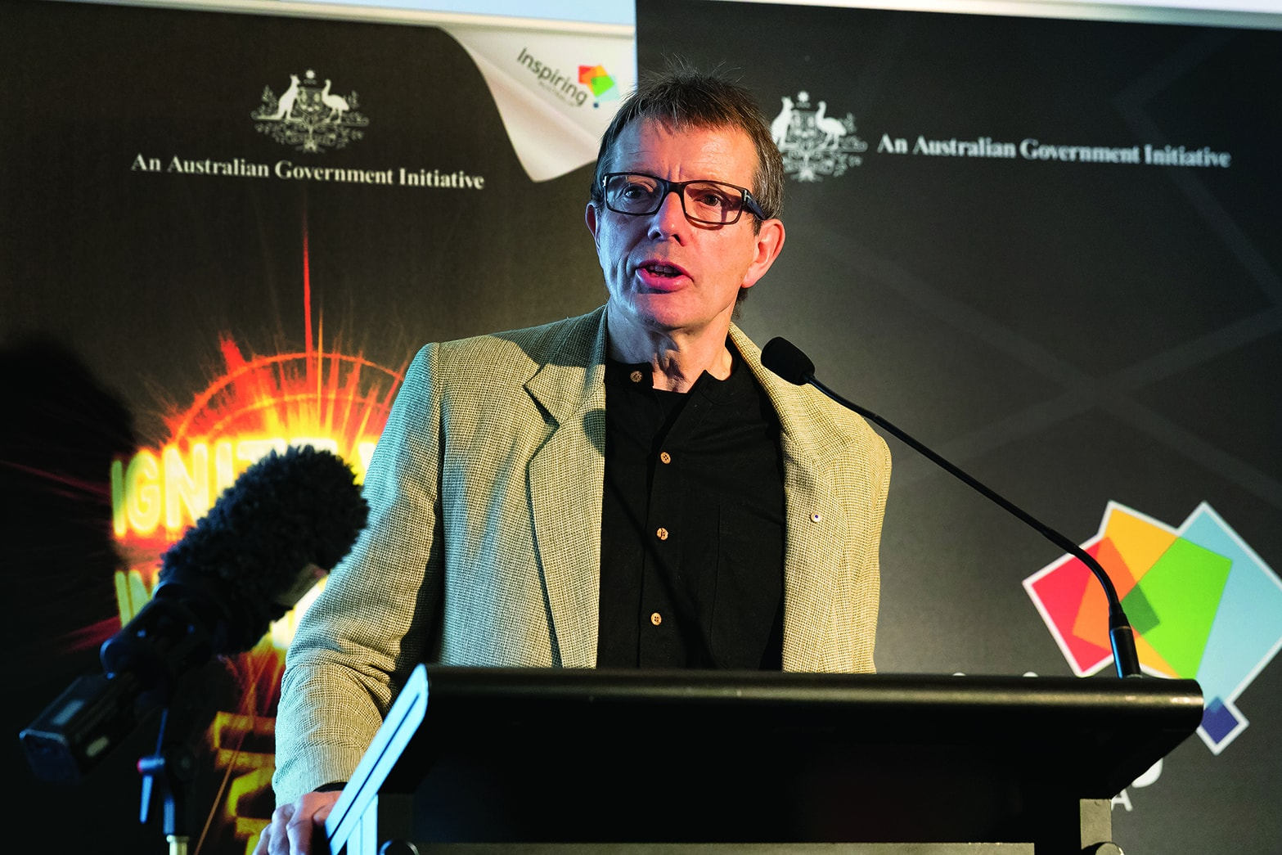

The National and Science and Technology Centre
Questacon—The National Science and Technology Centre is located in Canberra’s Parliamentary Triangle. Attracting more than 11 million visitors since opening in 1988, Questacon has welcomed at least three generations of Australians to be inspired and engaged with hands-on learning, enquiry and wonder. The Centre showcases and brings to life the fundamental phenomena that make up our world through exhibitions, presentations and workshops, science shows, demonstrations and special events. Questacon is a leading Australian tourism destination, as well as a much-loved school excursion highlight to hundreds of thousands of the Australian students who travel to Canberra each year.
The Centre is open 364 days a year with a visitor satisfaction rating of 92 per cent. The dedicated staff and volunteers who work in the Centre every day look forward to welcoming generations to come.

Colour—See the World in a New Light
On average, Questacon develops a new travelling exhibition every 1–2 years. In 2017, we developed Colour—See the World in a New Light, which was installed into one of our galleries in October 2017.
The exhibition encourages visitors to see colour as they have never seen it before. The 25 interactive experiences range from colour bubbles to iridescent insects and colour illusions.
Colour, as a topic, lies at the intersection of many disciplines—physics and chemistry, biology and anatomy, neurology, sociology and technology. To celebrate this diversity of science, the exhibition is divided into four themed areas with related experiences:
Coloured Light: Colour begins with light, and all light has colour. Ranging from the everyday to the exotic, experiences include seeing white light split into a rainbow to exploring glowing quantum nanomaterials that change colour with crystal size.
Controlling Colour: The colours of the world around us come from materials interacting with light. Experiences in this area include watching a clear liquid change a butterfly from blue to green and exploring the Room of Missing Colours.
Making Sense of Colour: Colour affects our mood, our language, our decision making and more. This area provides experiences where paying attention to colour is all-important, that explore the links between colour and culture, and tell the strange stories of people who see colours in music.
Seeing Colour: Human, animal and machine vision—we all see colour differently. In this area, visitors can explore a false-colour galaxy, use colour-blindness simulators, and ‘see like a bee’ with the ultraviolet camera.
Colour has provided a wonderful opportunity for Questacon to collaborate with other Australian scientific organisations. The Australian National Insect Collection, CSIRO, Geoscience Australia, and the ARC Centre of Excellence in Exciton Science generously loaned us spectacular specimens and materials that are on display in the exhibition, some for the first time.
To supplement the experience for younger audiences, ‘hidden colour’ artwork has been placed at kid-friendly heights on 12 of the exhibits. These comprise polarised light artwork of Australian flora and fauna. Appearing as white, backlit squares to the naked eye, when seen through polarised glasses the shapes and colours of Australian icons appear, revealing images of the rainbow lorikeet, clownfish, saltwater crocodile, golden wattle and more.
Colour is on display at Questacon until February 2019 before starting a national tour.
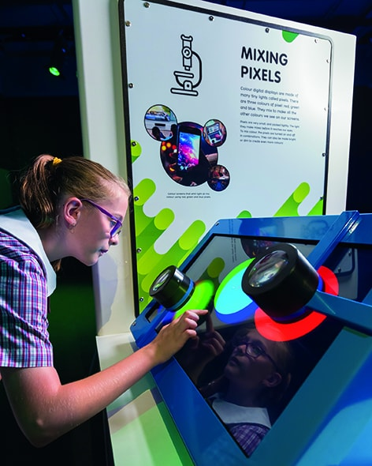

Fundamental
Fundamental is Questacon’s newest permanent exhibition, exploring classic science including forces, momentum and electromagnetism. Fundamental was designed to provide an easily accessible space where visitors can engage and experiment directly with scientific phenomena.
The renewed look and feel of Fundamental provides updated educational content and a richer, open-ended experience.
Fundamental has retained some past favourites, while adding new experiences. Highlights include: Turntable and Concave Dish—exhibits that allow visitors to conduct their own experiments with momentum and gravity; Ferrofluid’s magnetic liquid creates a mesmerising visualisation of magnetic fields that visitors can manipulate; and Persistence of Vision uses a feature of the human eye to hide images in plain sight, creating great moments of self-discovery for visitors.
A revitalised Curiosity Corner allows our enthusiastic Volunteer Explainers to take the content further, demonstrating fascinating phenomena and pulling visitors deeper into Fundamental science.
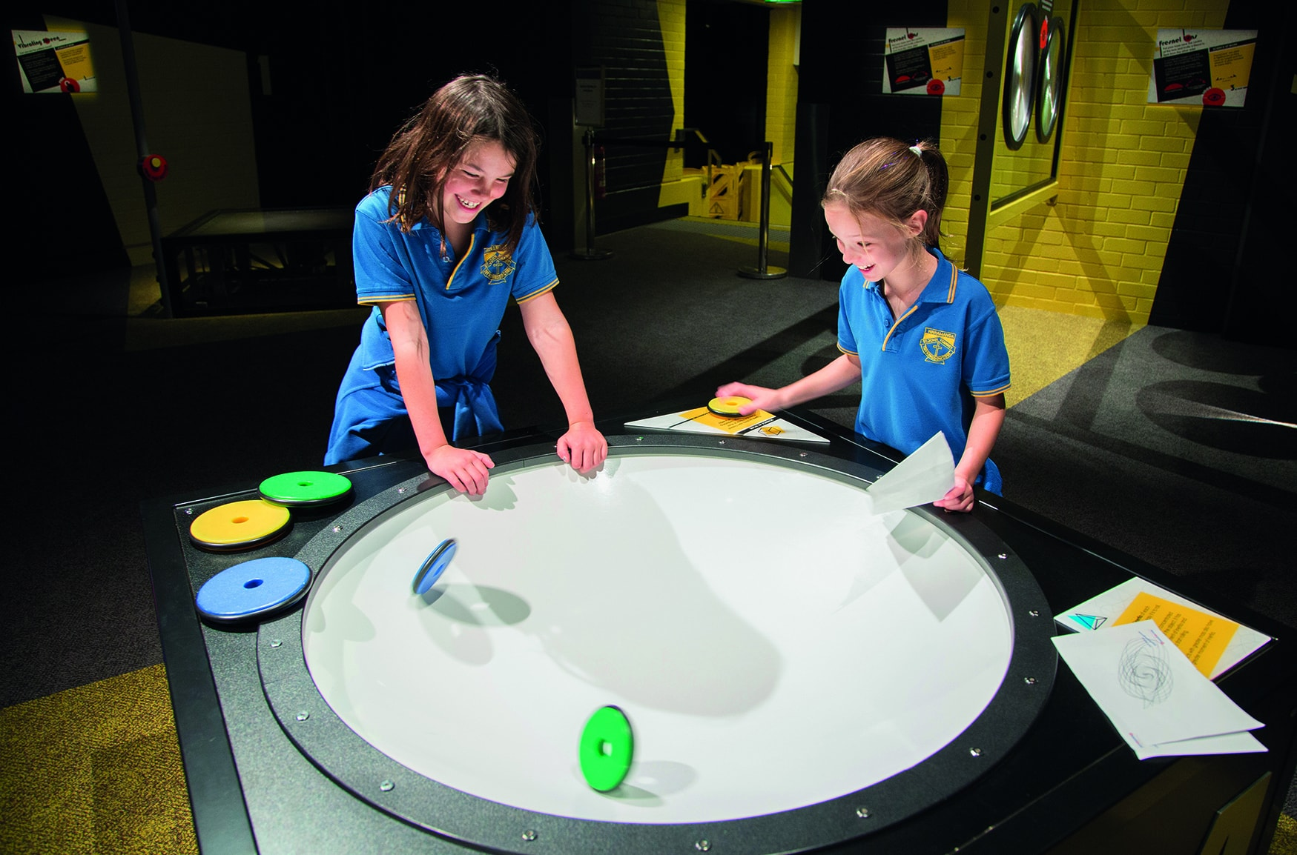

Above and Beyond
Above and Beyond is an international aviation and aerospace exhibition. Presented by Boeing, and developed in collaboration with NASA and the Smithsonian National Air and Space Museum, Above and Beyond was showcased for the first time in Australia at Questacon.
Launched by the Minister for Industry, Innovation and Science, Above and Beyond targeted school-aged children, families, young adults, teachers and aviation enthusiasts. Above and Beyond took visitors on a journey to investigate the past, present and future of space exploration and flight.
The exhibition received positive feedback from the public and was a successful example of government and industry working together for positive outcomes.
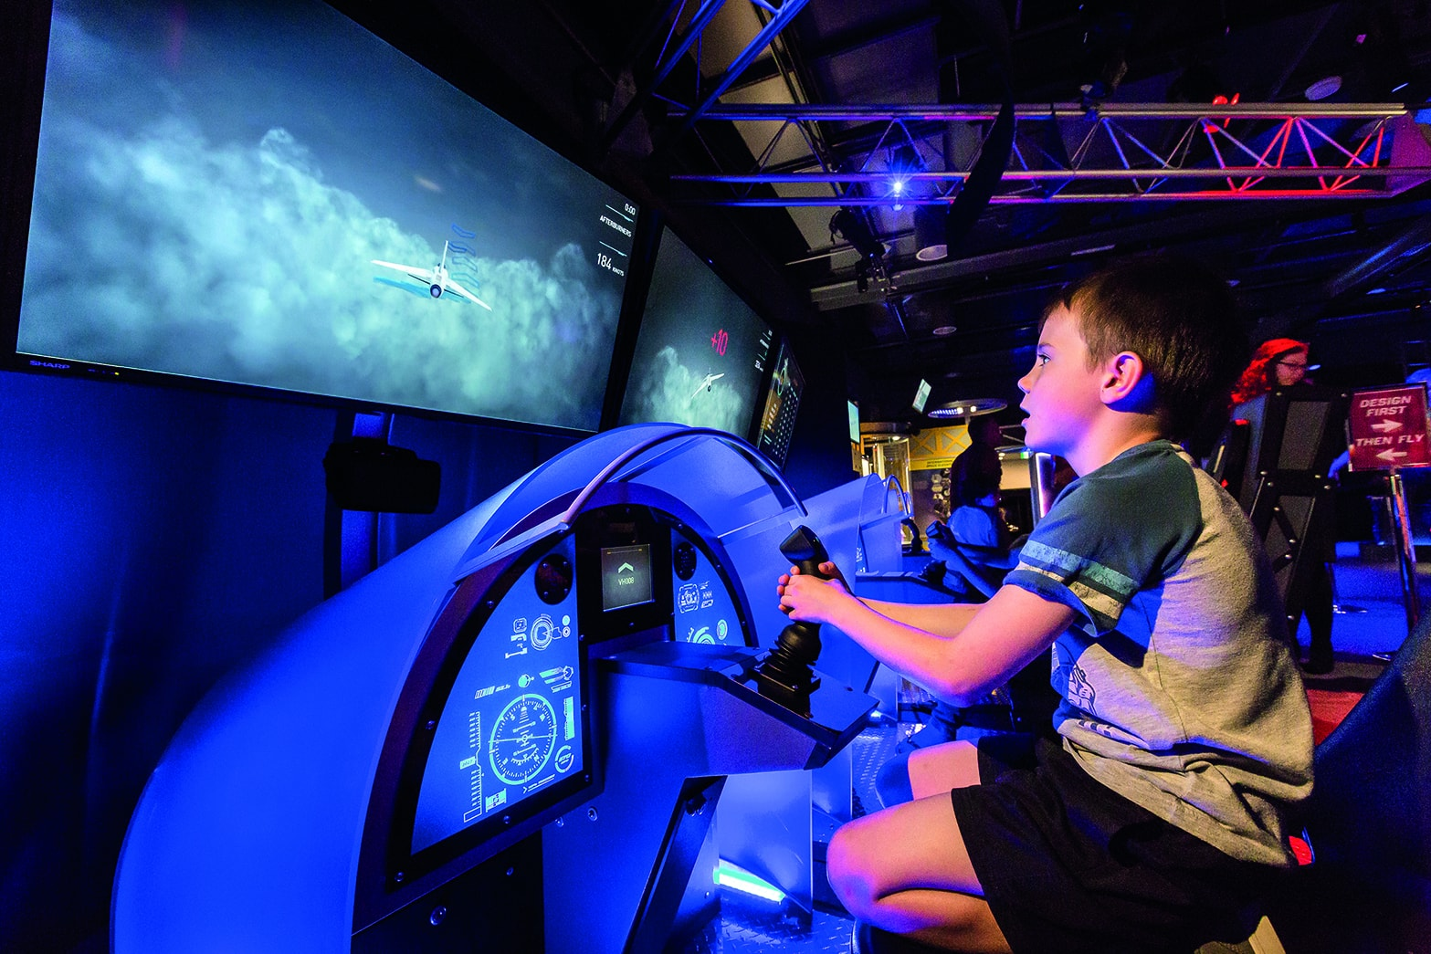

Environmental management
Improvements have been made to Questacon’s environmental management system to bring it in line with the new environmental standard ISO 14001-2015.
These system improvements include introducing a Questacon Environmental Policy that better reflects the context and goals of the organisation, and the establishing the Questacon Sustainability Champions Group to improve environmental communications and awareness.
One of the environmental engagement projects we completed in 2017 was the installation of a solar panel display that provides real-time information on the energy produced by Questacon’s 95 kilowatt solar panel array as well as general information on solar panel technology.
Combined with our support for the United Nations’ Sustainability Development Goals, the Environmental Management System aims to ensure that environmental awareness continues to play a part in Questacon’s future exhibitions and science communication programs and initiatives.
We are also finalising an arrangement with Pollinate Energy for the sale of solar lamps in the Q Shop. Through the arrangement we will demonstrate the benefits of solar energy while supporting Pollinate Energy. Pollinate Energy will use money from the sale of lamps to provide access to sustainable products and improve the lives of urban communities in India.
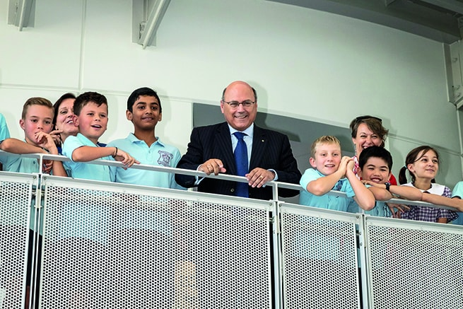

Questacon Partners

Raytheon

In 2017 Questacon and Raytheon celebrated 10 years of partnership. From supporting Questacon exhibitions across Australia, to virtually connecting students with industry experts around the world, Raytheon’s support has contributed to engaging hundreds of thousands of future leaders in STEM.
The partnership began in 2007 when the then Prime Minister the Hon John Howard AC officially opened the Imagination Factory—Invent and Play exhibition at Questacon, proudly supported by Raytheon. Following its display at Questacon, the exhibition went onto tour Australia, engaging more than 600,000 visitors.
In 2011, Raytheon supported Questacon’s state-of-the- art broadcasting facility, the Schmidt Studio, enabling Questacon to deliver activities including project-based virtual excursions and videoconferences to students, teachers and communities across Australia. From 2011 to 2015 the Schmidt studio reached more than 13,500 students and 387 schools.
In 2016, Raytheon supported the redevelopment and tour of the Questacon travelling exhibition Innovation Factory—Invent and Play to Adelaide. Hosted by the University of South Australia, Innovation Factory engaged more than 5,000 visitors during the tour. The exhibition was launched by the then Minister for Industry, Innovation and Science the Hon Christopher Pyne MP.
Building on the success of the decade-long partnership, Raytheon is now supporting a 12-month pilot of the Engineering is Elementary program. Engineering is Elementary provides teachers with a framework to deliver science and maths content using engineering activities. Developed by the Museum of Science, Boston, Engineering is Elementary was aligned with the Australian Curriculum for delivery to Australian primary school teachers by Questacon throughout 2017 and 2018.
Raytheon’s continued support of Questacon demonstrates its ongoing commitment to ensuring the next generation of Australians have the skills necessary to be successful. With the support of Raytheon, we continue to find new ways to inspire and engage all Australians in science, technology, engineering and mathematics.

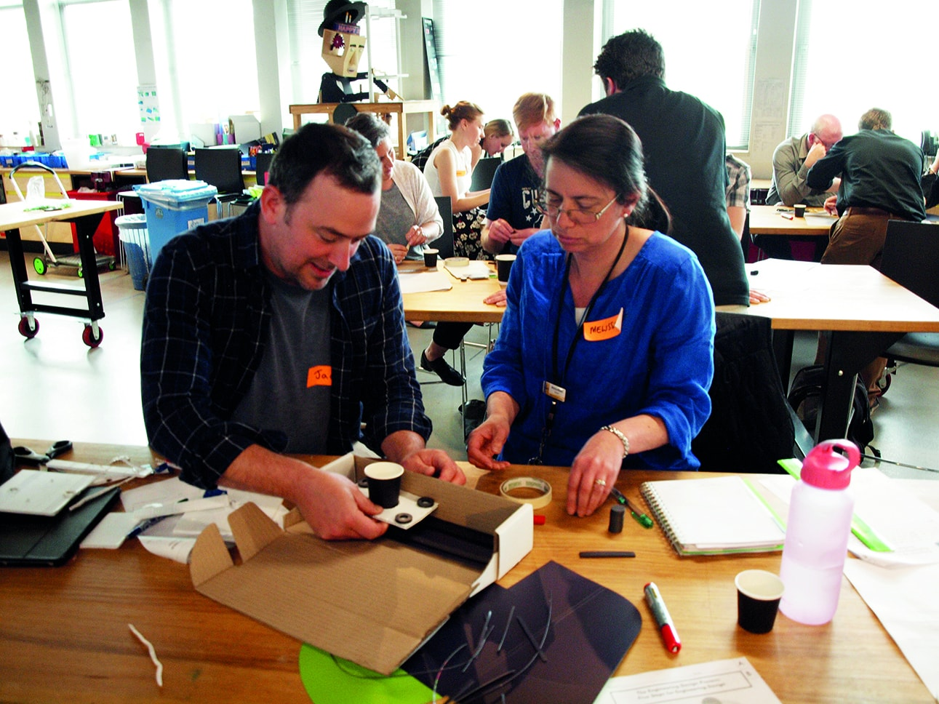
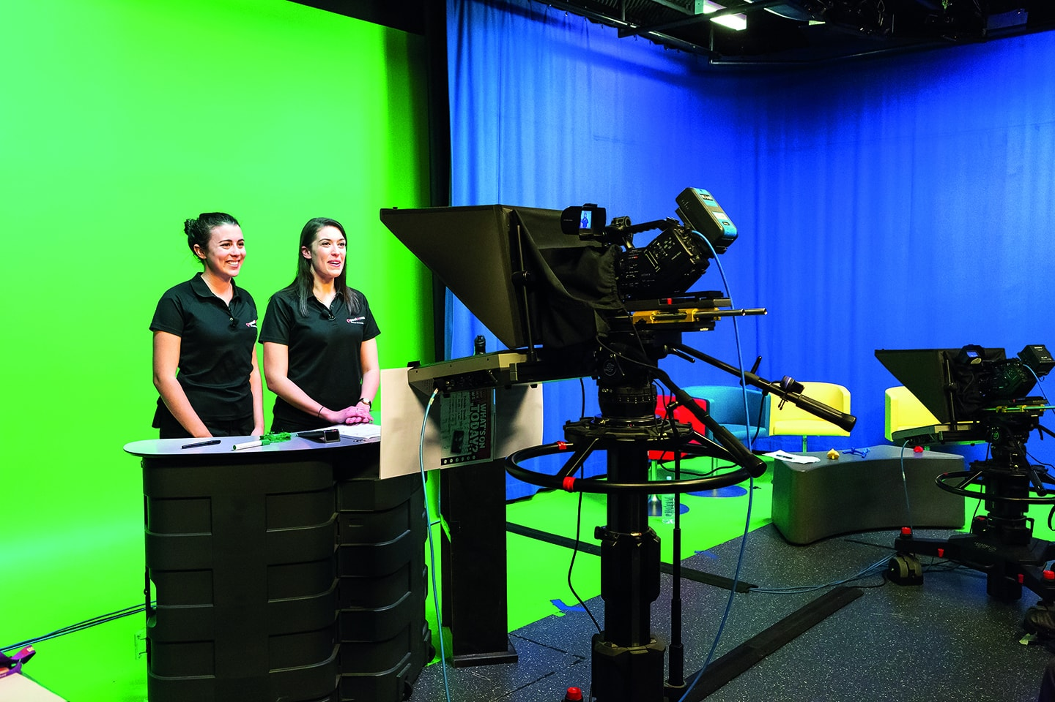
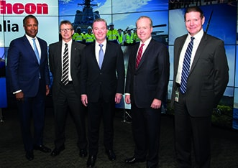

The Ian Potter Foundation
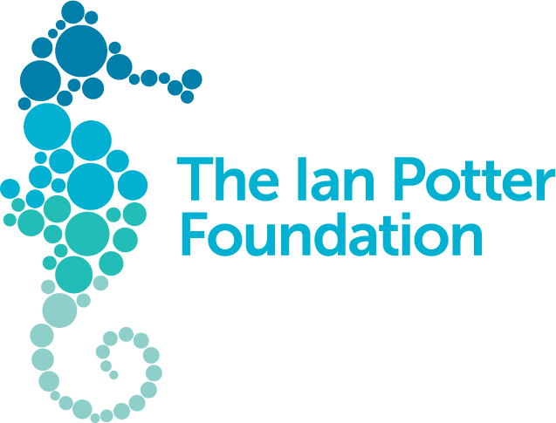
The Ian Potter Foundation is Questacon’s Principal Partner. We work together to deliver the Foundation’s flagship program in STEM across Australia.
In October 2014, The Ian Potter Foundation—one of Australia’s major philanthropic foundations—generously provided a grant of $7.8 million over five years to Questacon. This is the largest grant the Foundation has awarded in the areas of science and education, and the largest ever awarded outside Victoria. In recognition of the grant, our second facility in Canberra is named The Ian Potter Foundation Technology Learning Centre. The grant supports our efforts to inspire and empower young people by engaging them with technology, innovation, design and entrepreneurial learning experiences through delivery of the Questacon Smart Skills Initiative.
Since it started in 2015, the Smart Skills Initiative has delivered inspirational hands-on workshops to more than 31,000 students and teachers across Australia. A further 23,000 have engaged with Enterprising Australians online.

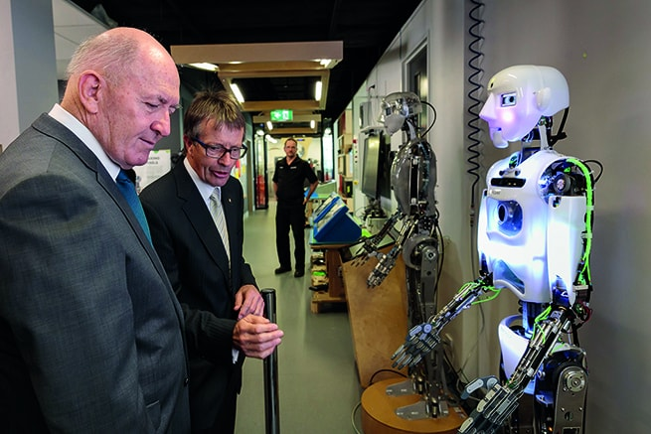

Samsung

Samsung and Questacon have been working together since 2014 with the goal to inspire and motivate the next generation of Australian technology creators and entrepreneurs.
As Questacon’s Technology Partner, Samsung supports the delivery of Questacon Smart Skills in-school workshop and Questacon Smart Skills Teacher Workshop program to regional communities across Australia. Integrating Samsung’s technology into student and teacher workshops has enabled Samsung and Questacon to be at the forefront of inspiring students and teachers in interactive and challenging STEM-themed workshops.
Over the course of the three-year partnership, the Smart Skills program has engaged 20,808 students and 1,186 teachers from 290 schools. A further 875 have teachers participated in Smart Skills Teacher Workshops.
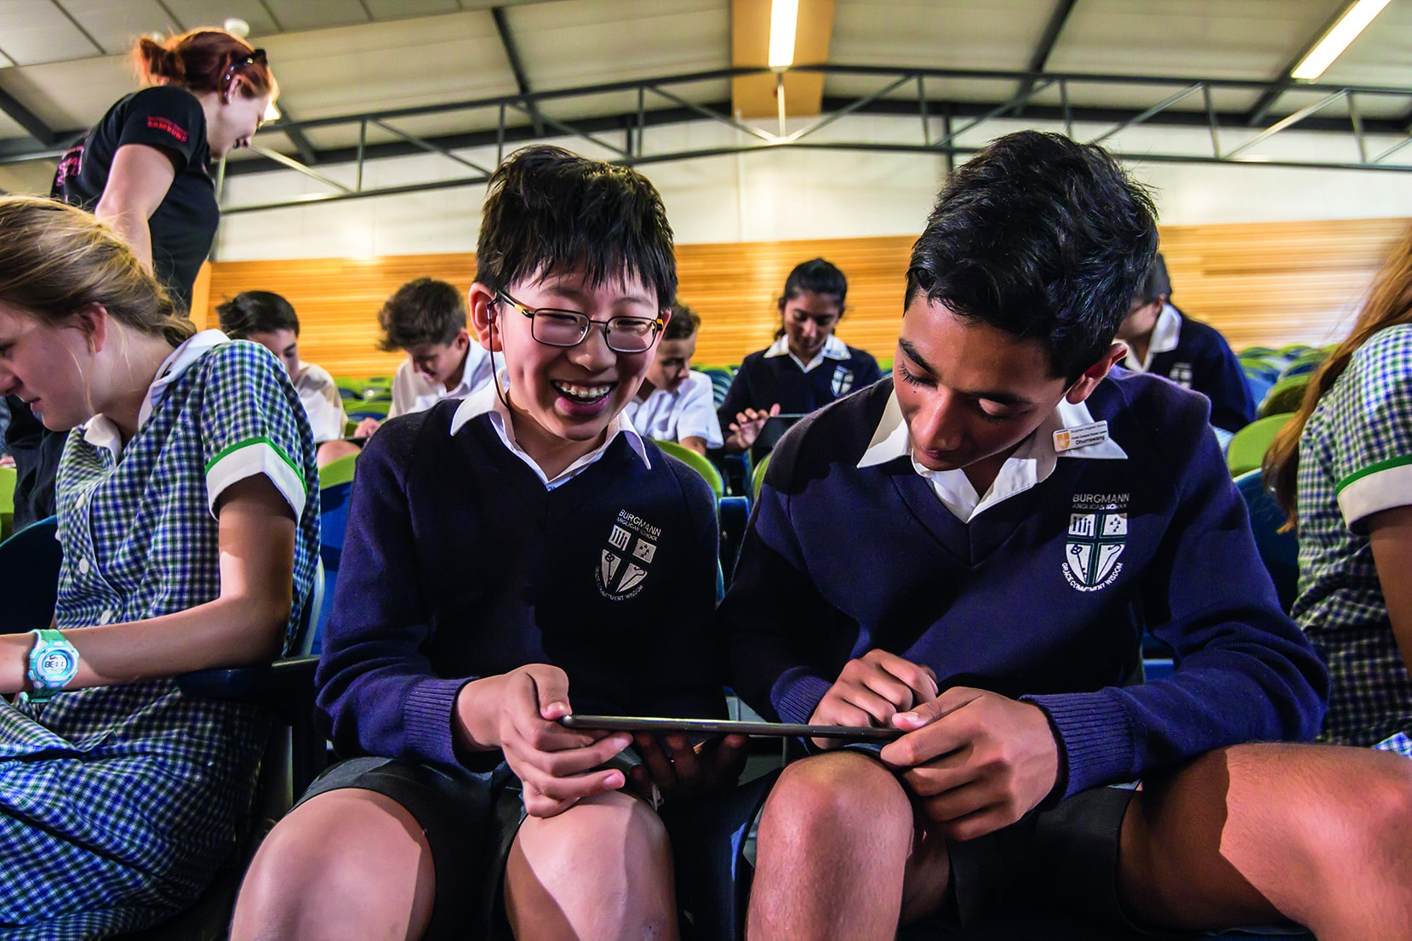
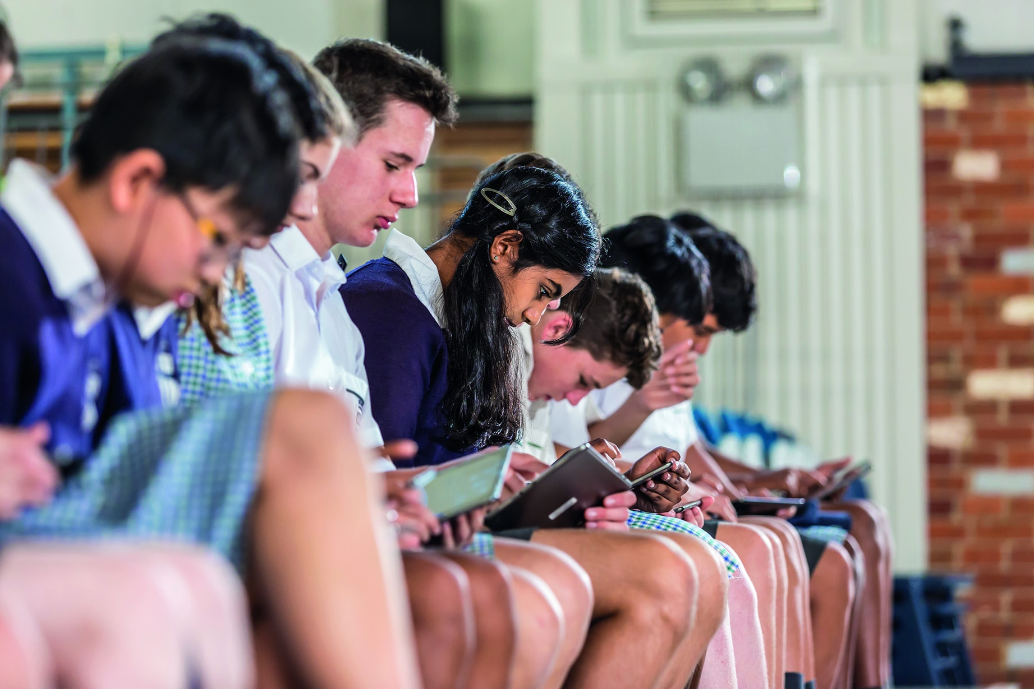

Shell Australia

Shell Australia is Questacon’s longest-standing corporate partner, working together for over three decades to engage and inspire generations of young Australians and their communities in science.
In 2017, Questacon, Shell and the Australian National University delivered the 32nd year of the Shell Questacon Science Circus, continuing one of the world’s longest-running science outreach programs. Since beginning in 1985, the Science Circus has become the most travelled and farthest-reaching program of its kind in the world.
At the core is a drive to inspire young people, primarily in regional areas of Australia, to value and engage in science, technology, engineering and mathematics, and the possibilities and varied career options these fields present.
Over 400 Science Circus program alumni have gone on to work with science centres, research and development organisations, media organisations, government and industry both in Australia and overseas. Over the lifetime of the program the Science Circus has reached more than 2.2 million people with multiple visits to over 500 towns and 90 remote indigenous communities.
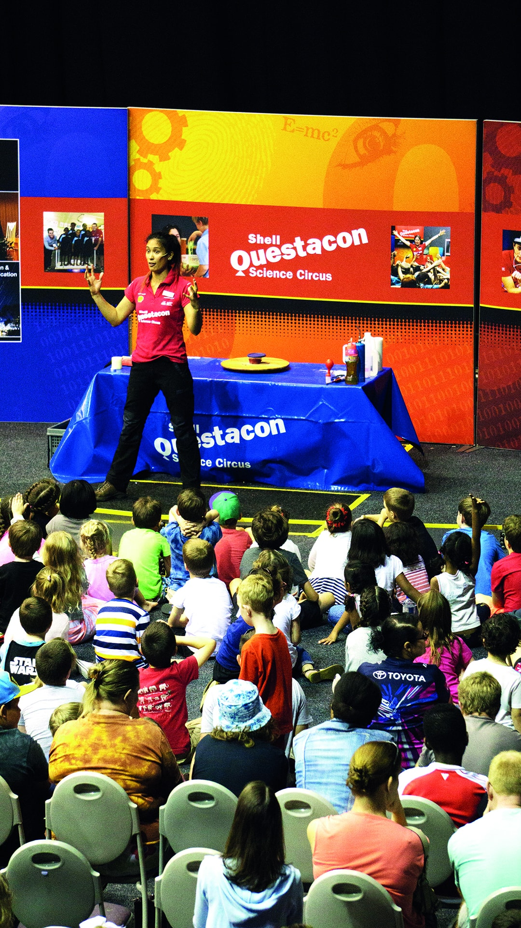
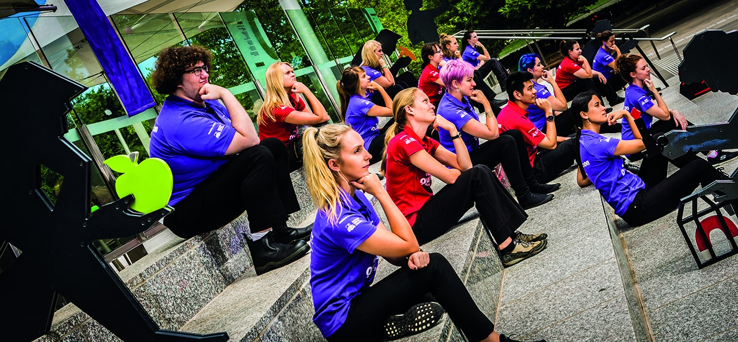

Australian National University
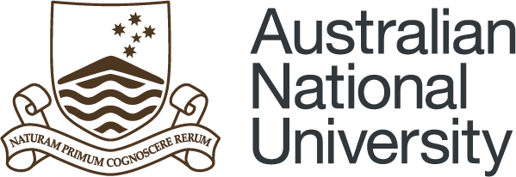
As the founding delivery partner of the Shell Questacon Science Circus, the Australian National University (ANU), through the Centre for Public Awareness of Science (CPAS) continued to deliver the 32nd year of the program in partnership with Shell and Questacon in 2017. The Science Circus team comprises 16 Masters of Science Communication (Outreach) students who undertake their studies at CPAS and deliver the Science Circus across Australia as part of practical fieldwork course components. Having together graduated over 400 students from the program during the partnership, Questacon and the ANU continued to contribute to the national and international capacity of science communication professionals during 2017.

IP Australia
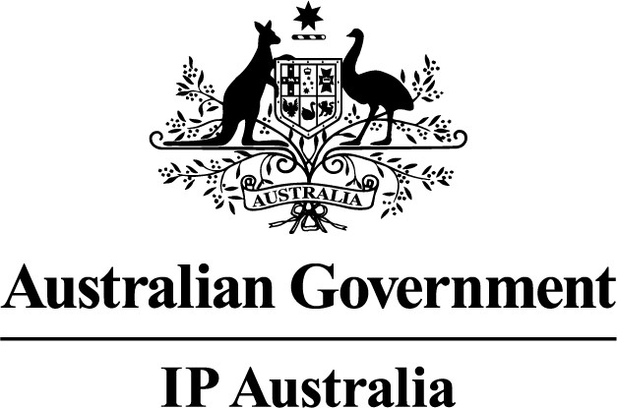
IP Australia and Questacon continued to work in partnership to encourage an innovative nation with intellectual property awareness and to assist the youngest Australian innovators and inventors. Our partnership with IP Australia finished in June 2017.
Over the course of the partnership, IP Australia and Questacon worked together to deliver seven regional Questacon Invention Conventions and two annual National Questacon Invention Conventions. Questacon is grateful for the support of IP Australia over the course of the partnership.
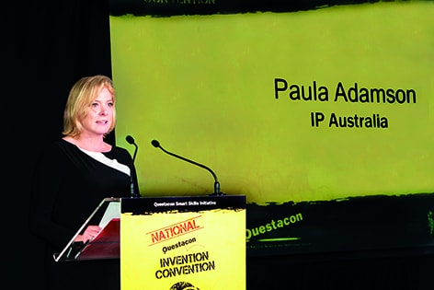

Outreach and National Programs
Questacon’s second facility, The Ian Potter Foundation Technology Learning Centre, is the home of our outreach and national programs.
Whether students are travelling to Canberra for hands-on innovation workshops or Questacon teams are travelling to schools and communities across Australia, Questacon outreach and national programs are in operation every week to reach tomorrow’s entrepreneurs, scientists and innovators.
In 2017, we delivered programs in partnership with local institutions, teachers, researchers and the Inspiring Australia network to reach every Australian state and territory. Through these partnerships we continue our work to ensure our programs inspire an enduring interest in science and technology.

Smart Skills
The National Questacon Smart Skills Initiative engages young people in STEM, creativity and innovation. Australia’s future as a knowledge economy depends on our emerging generations having foundations skills in these areas.
The Smart Skills Initiative delivers hands-on, inquiry-based workshops to students across Australia, building supportive environments and inviting students to learn from their failures and develop the skills necessary to succeed in the emerging job market. It offers accredited teacher workshops and youth-focused enterprise education activities, creating networks within communities and leaving a legacy of STEM engagement. For a student participating in these programs, each step along the pathway brings greater skill development and confidence in design thinking, ideation, prototyping and working with technologies.
Regional engagement is a cornerstone of the Smart Skills Initiative. Questacon aims to foster STEM activity in remote areas, inspiring students and the wider community to see how STEM fits into their everyday lives, and inspiring children to pursue STEM careers, no matter their location.
The Smart Skills Initiative is made possible through support from The Ian Potter Foundation, funding from the Australian Government and support from Samsung Electronics Australia.
Since its inception in 2015 the program has engaged with 54,183 people.

Smart Skills Student Workshops
Questacon Smart Skills delivers free workshops in schools throughout regional Australia to immerse students in ideas, technology and creativity. By encouraging students to play with technology and prototype inventive creations, these workshops engage and challenge them to find the innovator within.
The interactive STEM-themed workshops expose students to the process of innovation through set challenges. Each workshop equips students with the confidence to test and refine ideas through hands-on digital and practical prototyping, developing the logical and creative thinking skills students need to tackle problems across the curriculum and beyond.
In 2017, the Smart Skills program engaged 7,260 students across New South Wales, the Northern Territory and Western Australia.
‘I felt happy, excited and clever. It is like a mystery that you need to discover and come up with ideas to solve it.’
Student, Year 10
Smart Skills Workshop
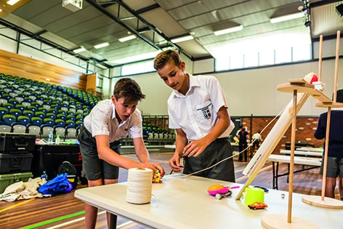
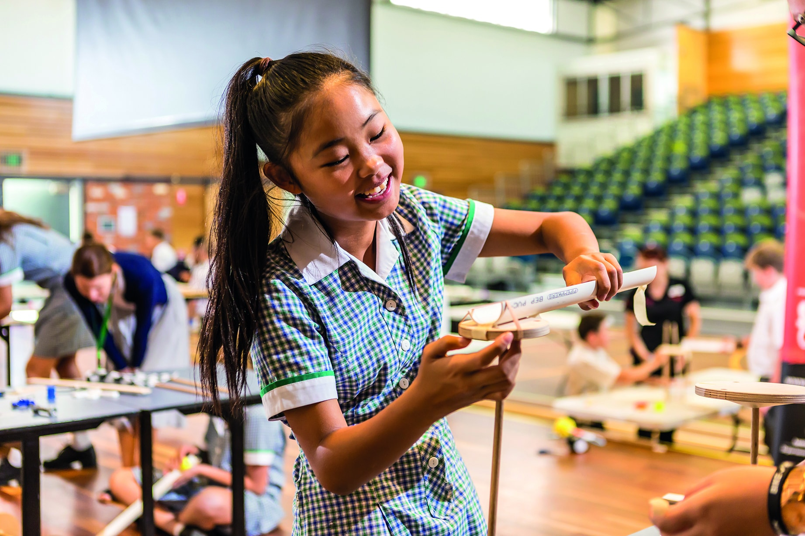
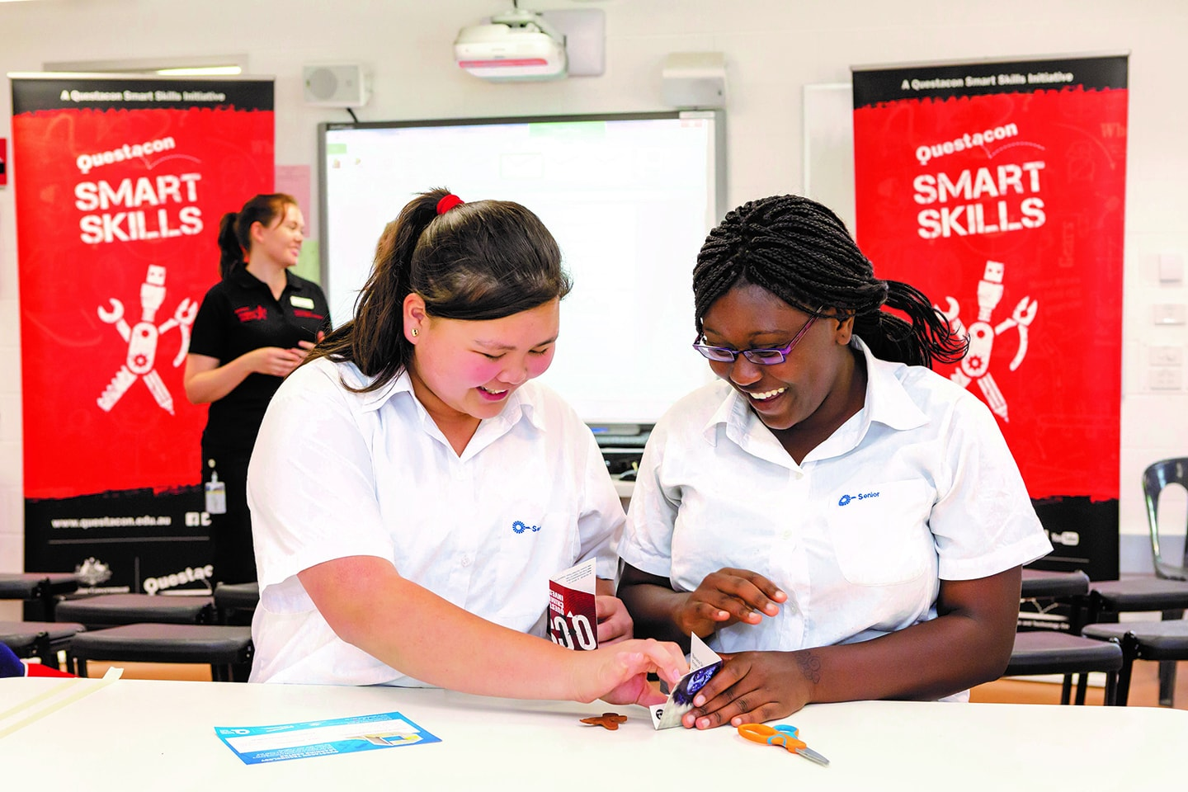
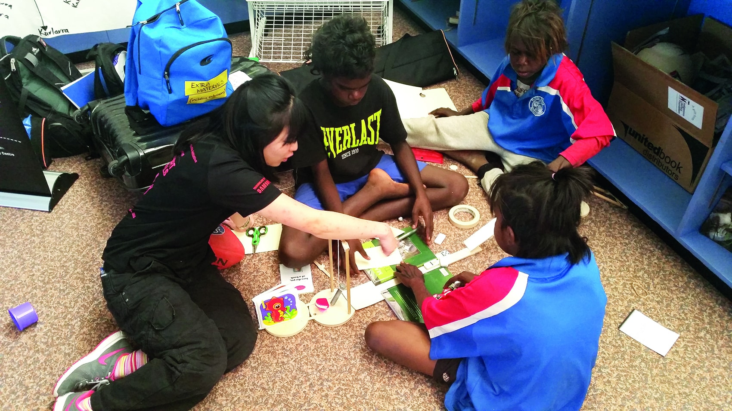

Smart Skills Teacher Workshops
Smart Skills incorporates a teacher support program, acknowledging that while Questacon staff can inspire hundreds of students within a school, a teacher can inspire thousands. Questacon Smart Skills Teacher Workshops motivate teachers to combine digital technology with hands-on learning, encouraging them to implement inquiry-based activities and equipping them with the tools and knowledge to bring more STEM into the classroom.
Smart Skills and Smart Skills Teacher Workshops are supported by Questacon’s technology partner, Samsung Electronics Australia. Samsung technology has been integrated into the workshops, providing an opportunity for teachers and students to learn how to harness the power of smartphones and tablets to innovate, design and experiment.
In 2017, Smart Skills Teacher Workshops engaged 271 teachers across New South Wales, the Northern Territory and Western Australia.
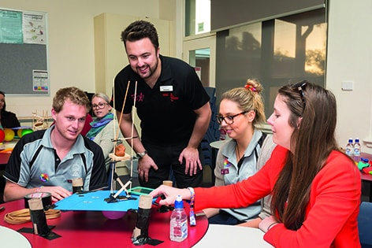

Smart Skills Invention Convention
The Invention Convention is an intensive multi-day workshop that gives secondary students a practical insight into innovation and entrepreneurship. Students work with Questacon facilitators and local innovators, STEM professionals and entrepreneurs, to turn their ideas into reality and make connections between STEM skills, career opportunities and commercial realities in their own community.
The National Invention Convention brought together 26 delegates from six states and territories, as well as three ambassadors–delegates from the previous year who returned to share their skills and mentor the new cohort. The week-long event provided an opportunity for delegates to build confidence in prototyping their own ideas around a central theme. In 2017, their inventions sought to help a growing world address challenges around food, water and shelter. Guest speakers including engineers and entrepreneurs added context to this theme by sharing their knowledge and experience.
In 2017, the Smart Skills Initiative delivered three regional Invention Conventions in Newcastle, Darwin and Albany and a National Invention Convention in Canberra.
‘At the Albany Invention Convention, I learnt so much that I even surprised myself and I would like to be pushed further to my limits.’
Student
Albany Invention Convention
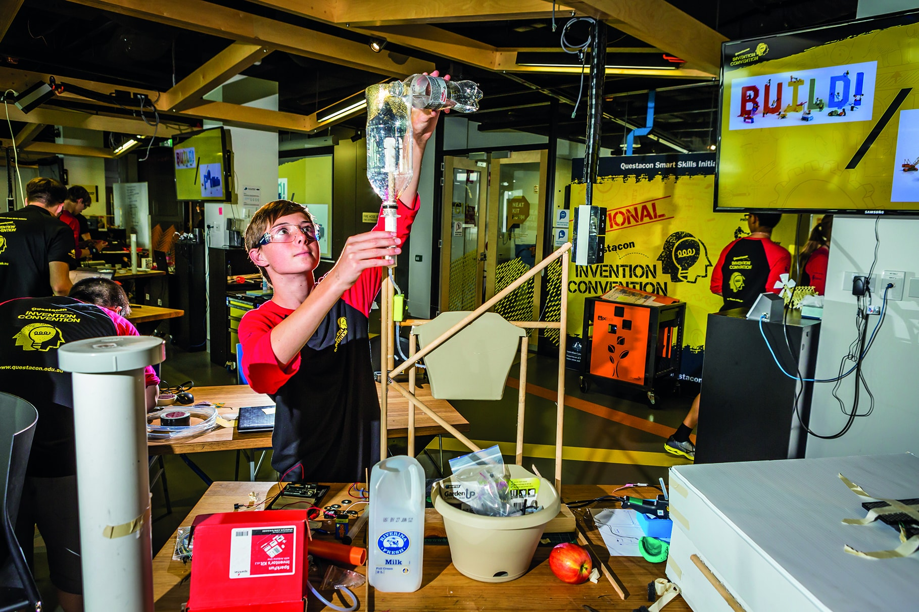

Maker Project
Questacon Maker Project workshops explore creative thinking using simple tools, materials, and emerging technology. The interactive workshops and activities developed especially for school students in Years 6–12 immerse students in ideas, tools and creativity with strong links to the Australian Curriculum.
Maker Project workshops are free two-hour workshops presented in the purpose-built Maker Space at The Ian Potter Foundation Technology Learning Centre in Canberra. Delivered by a team of young professional facilitators, this national program exposes visiting students from around Australia to the innovation principles of need, think, make, try and refine.
For schools unable to visit The Ian Potter Foundation Technology Learning Centre, Questacon Maker Project virtual excursions allow students access to hands-on STEM workshops via videoconference technology.
In 2017 the Maker Project engaged 6,858 students from around the country in hands-on workshops and virtual excursions.
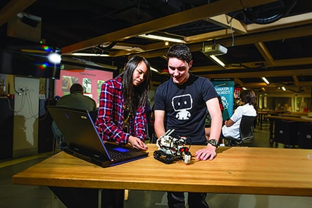

Enterprising Australians
All over the country, talented professionals and enthusiastic amateurs are working busily from their studios, backyards and kitchen tables to create brilliant new innovations. Enterprising Australians raises community awareness of innovation and entrepreneurial activities by sharing these innovators stories—highlighting how they developed their ideas, the problems they ran into and the way they solved them.
Enterprising Australians showcases contemporary and relatable examples of innovation in the form of short videos featured on the Questacon website, in social media and as part of a travelling exhibition. These stories have been designed to appeal to a wide audience and connect young people to the real-world innovation happening in their own backyard.
Since we launched the Enterprising Australians digital platform was launched in September 2016, the stories have amassed more than 28,900 online views.
The Enterprising Australians travelling exhibition provides a public extension to in-school activities that engage the broader community with inspiring stories of technological innovation. The exhibition separates into modules enabling setup in community venues such as local libraries or universities.
Some Australian innovators featured in 2017 were:

Solange Cunin—Cuberider
Solange coordinates programs in Australian high schools where teenagers can learn to program hardware that collects real data from space. Cuberider’s 2016 launch was the first ever Australian payload to reach the International Space Station, and the data gathered is helping students answer their own questions about the nature of space.

Mel Fuller—Ability Mate
Mel hopes to revolutionise the production of ankle and foot orthoses for people who need help to walk. The current process is time consuming and expensive, and can be quite confronting for children (who may require new orthoses every few months) Mel and her team are using 3D scanners and 3D printers to make this process faster and cheaper for everyone—and they hope to make their new process the global status-quo.

Mikaela Jade—InDigital
Mikaela developed a mobile phone app that uses augmented reality to bring to life Aboriginal sites of cultural significance through storytelling, songs and animation. A Cabrogal woman, Mikaela is passionate about helping to preserve indigenous culture through digital technology.
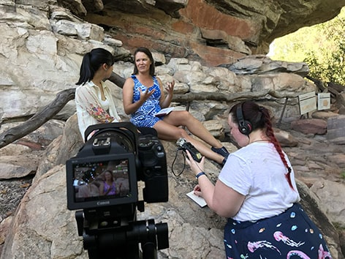
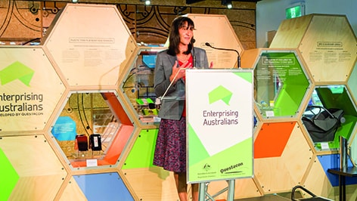
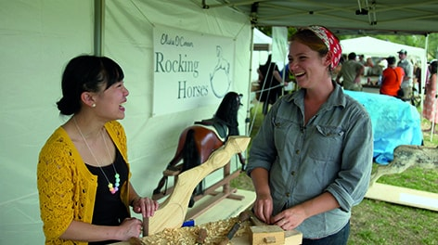
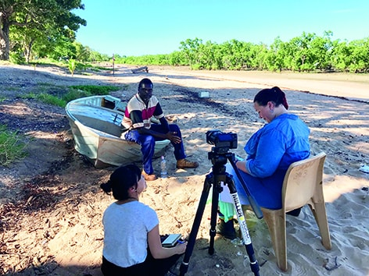
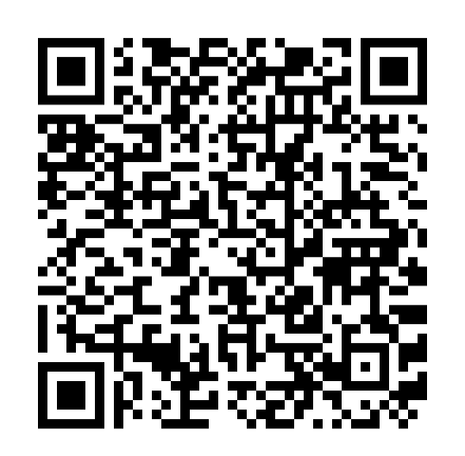
Scan QR code for more Enterprising Australian stories

Shell Questacon Science Circus
The Shell Questacon Science Circus is one of the most widely travelled and recognised science outreach programs in the world. For the past 32 years, the Science Circus has travelled throughout regional and remote Australia bringing science to local communities.
The Science Circus strives to inspire and engage all Australians through interactive exhibitions, school incursions, professional learning workshops for teachers and specialist programs for Indigenous audiences.
The Science Circus also forms a major component of the Australian National University’s Master of Science Communication Outreach. Each year up to 16 graduates take part in the Science Circus to complete their Masters degree. The qualification offers students the opportunity to develop their science communication skills through practical experience. Science Circus presenters have gone on to work with science centres, research and development organisations, media organisations, government and industry in Australia and overseas.
In 2017, the Science Circus visited more than 289 schools, attracting 57,142 students, and engaged a total of 101,248 people.
The Science Circus is now looking to 2018 and beyond, building strong relationships with partners and redesigning its offerings to remain the gold standard in science outreach for decades to come.
‘Many years ago when Questacon first opened in Ainslie, I took my son there and he was four years old. I now live in Orange and today I am here with my grandson, and he is also four years old. Congratulations on your wonderful program.’
Grandmother attending our public exhibition in Orange, NSW
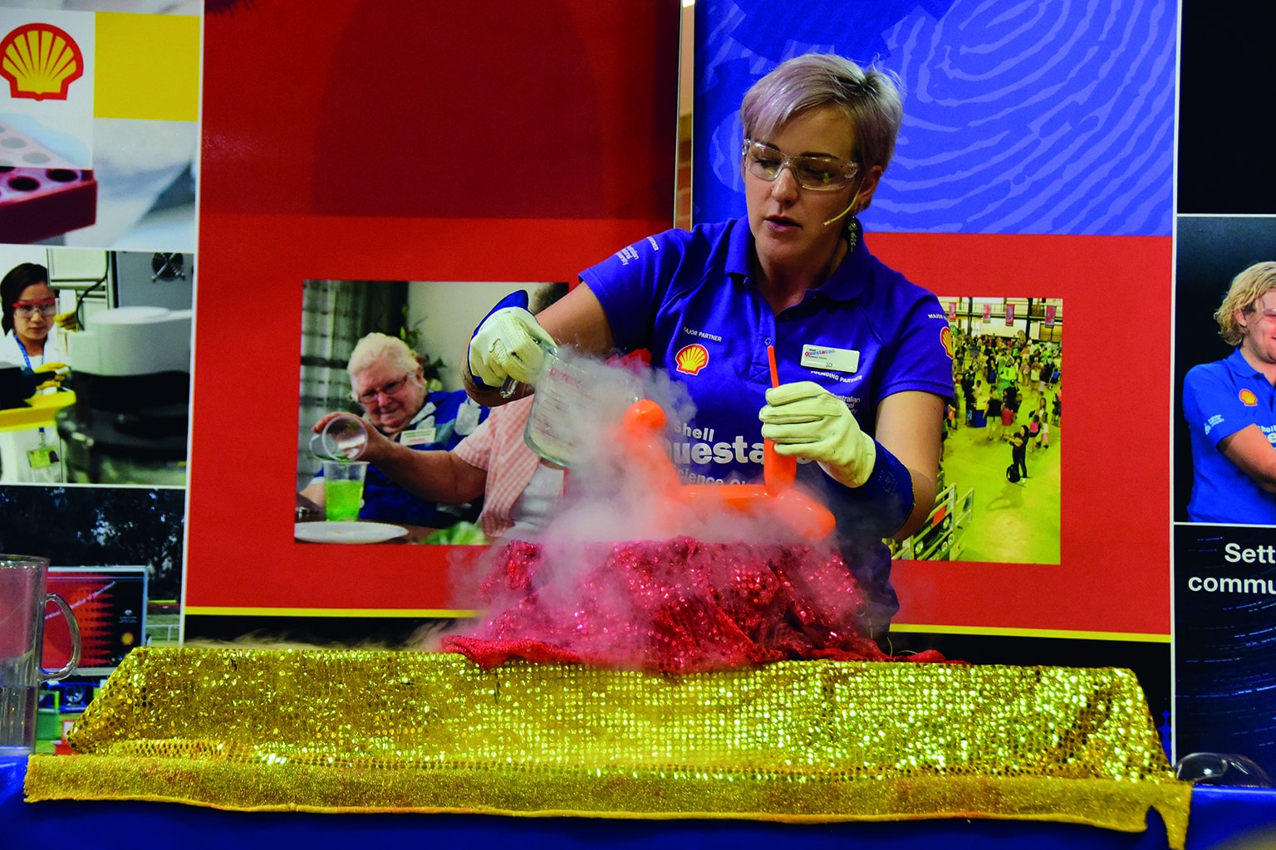
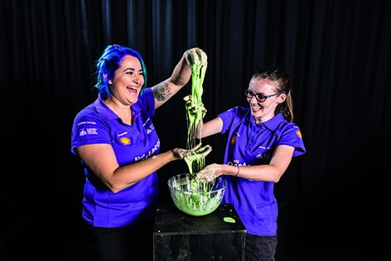
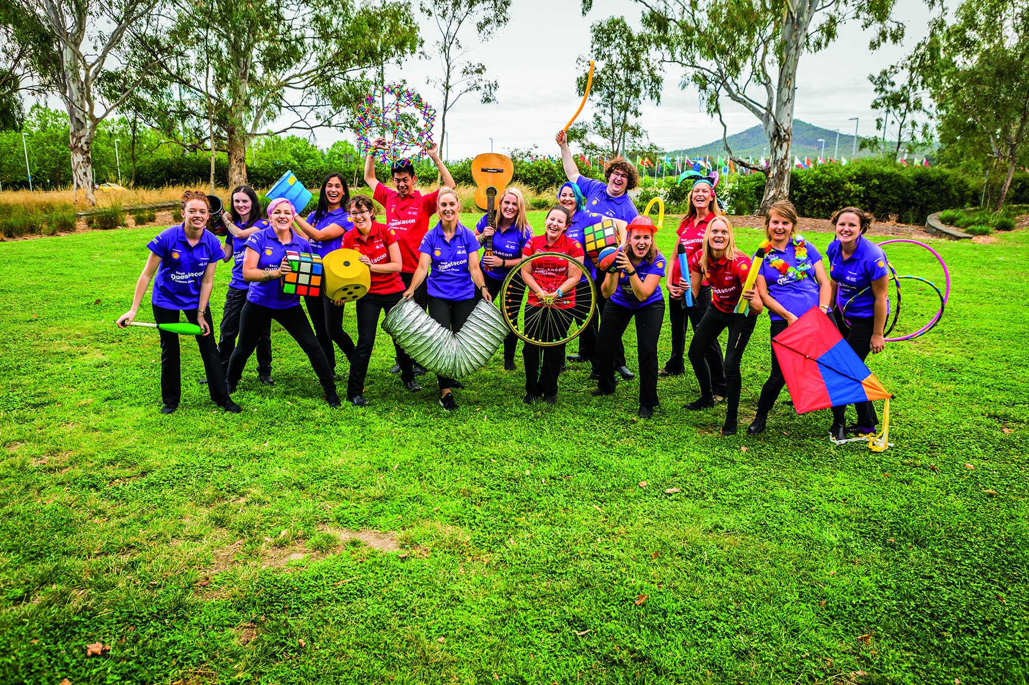

Learning Programs
For over 30 years Questacon has been supporting teachers in the delivery of science, technology and mathematics in the classroom. Through delivering confidence and skill-building professional learning activities, we are able to increase the legacy of our touring national outreach programs as well as delivering dedicated activities to teachers in underserved locations across Australia.
In 2017, we continued to deliver high-quality teacher professional learning programs including in partnership with the Australian Science Teachers Association, CSIRO, Social Ventures Australia and the Museum of Science, Boston.
Key to the approach across our learning programs is the concept of STEM not as an acronym for science, technology, engineering and mathematics but rather a way of approaching learning and discovery that focuses on 21st century skills and the learning and application of knowledge across multiple content areas.

STEM X Academy
The 2017 STEM X Academy was held across five days in late January, bringing 70 teachers from across Australia to Canberra to boost the teaching of STEM in schools across Australia. The STEM X Academy was established by Questacon and the Australian Science Teachers Association. In 2017, we welcomed CSIRO as a third delivery partner. With the introduction of CSIRO the STEM X Academy could double the intake of teachers and expand engagement with industry and researchers.
The STEM X Academy continues to grow. In 2017, we received more than 350 applications for the 70 available places. This demonstrates a desire among teachers to connect with science and technology organisations and be introduced to new approaches, new research and new resources that they can implement in the classroom.
STEM Xr—a two day regional professional learning program modelled on the STEM X Academy—was also delivered in both Darwin and Alice Springs. The regional version takes a distinctly local approach with participating teachers introduced to content and researchers from their community. In this case, the Darwin and Alice Springs Desert Parks were involved.
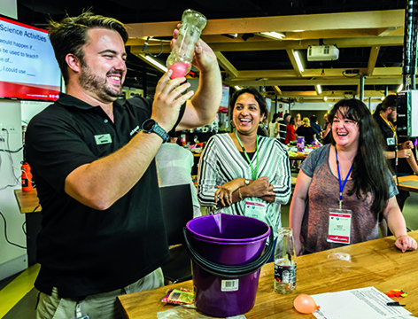
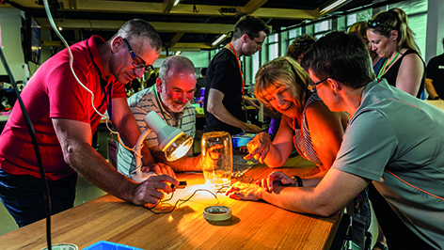

Engineering is Elementary
In 2017, Questacon will be introducing Engineering is Elementary to primary school teachers in the Australian Capital Territory and South Australia. Working with state and federal government departments, Engineering is Elementary is an initiative of the Museum of Science, Boston, and the program and associated resources have been used in schools across the United States for over 10 years.
Engineering is Elementary is an integrated approach to the delivery of STEM content and concepts using a framework of engineering processes. With the support of Raytheon Australia, Questacon is undertaking a 12-month pilot to see if Engineering is Elementary is a way to address the lack of STEM knowledge and skills in primary school teachers. We support teachers to implement Engineering is Elementary through professional learning sessions, the provision of additional content and the establishment of a community of practice.
A total of 70 teachers from 20 primary schools across the Australian Capital Territory and South Australia delivered Engineering is Elementary units to their students in Year 2 and Year 4 classes.
These teachers have been provided free of charge with all the materials and teacher resources to teach the units.
We have been working with South Australian Teacher, Charlene McGrath, to map the existing Engineering is Elementary units to the Australian Curriculum Learning Areas and the General Capabilities and provide additional resources to support teachers in delivering the units.
We plan to expand the pilot into New South Wales and Queensland during 2018.
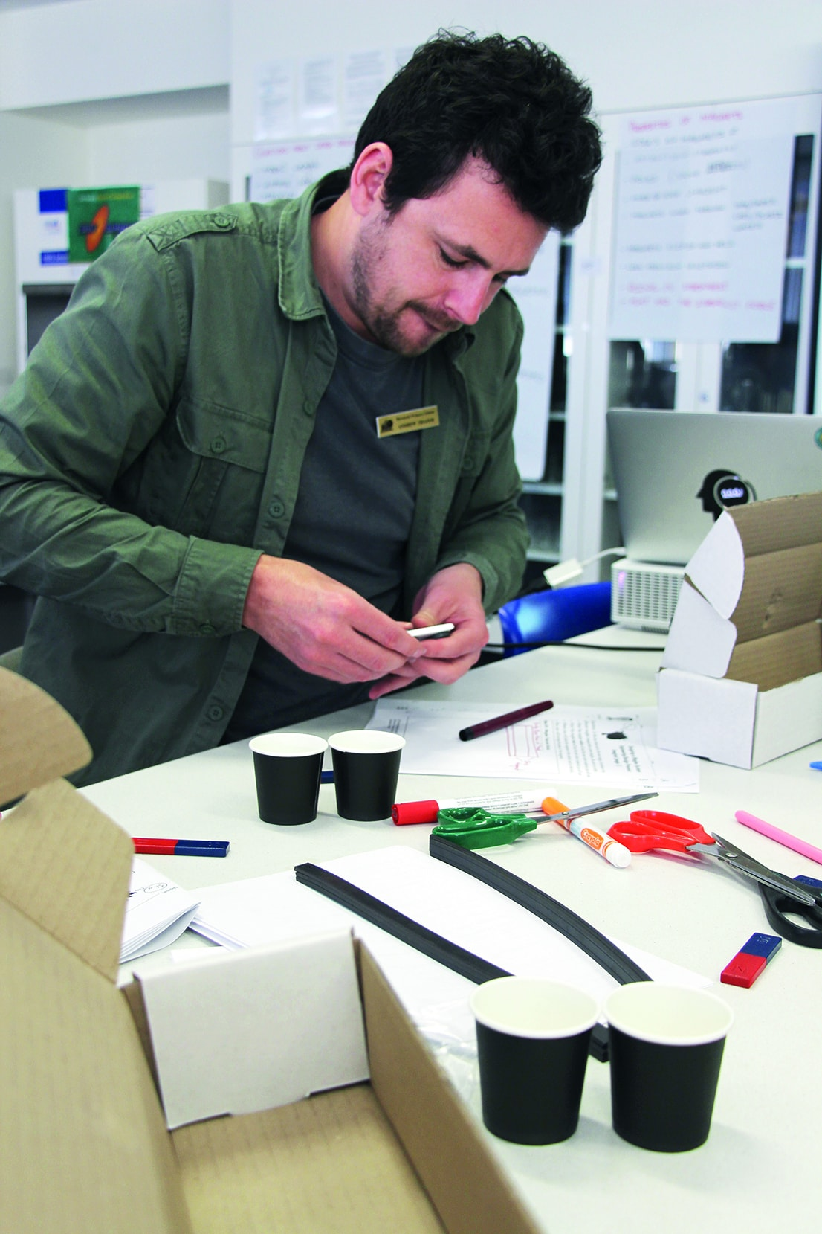

Pilot Primary STEM Program
Through this program, We have been working with two, St John Vianny primary school and St Peter and Paul primary school in Canberra, to build the confidence and capability within the entire teaching cohort. Both schools took a significant step in supporting their teacher’s journey in STEM by having Questacon deliver multiple workshops over the school year. Teachers have been introduced to classroom ready STEM activities, pedagogical practice and frameworks to develop their own STEM projects. The program has demonstrated that a whole-of-school approach is needed to change practice and develop a STEM culture in schools.
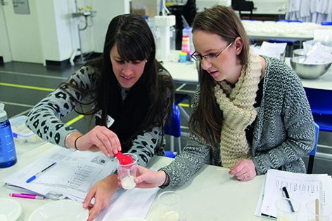

Social Ventures Australia Thought Leadership Gathering
Questacon was invited to deliver STEM activities to the schools taking part in a Social Ventures Australia Thought Leadership Gathering in September 2017.
Social Ventures Australia is a social purpose organisation that works in education and employment.
We will continue to be involved with Social Ventures Australian and its STEM Bright Spots program in 2018, providing advice and activities to the teachers, students and schools involved in the program.

Inspiring Australia

Inspiring Australia is the national science engagement strategy, delivered using a national framework for local action approach. Since 2010, Questacon has led implementation of the strategy and we have developed strong partnerships with many different organisations from state and territory governments, universities, cultural organisations, scientific research agencies, innovation networks and educational, community and media organisations. Today, Inspiring Australia reaches millions of Australians through a diverse range of activities, with Questacon acting as the national hub and central coordination point for a growing network of program managers and activity providers. We also provide strategic input to the ongoing development of science engagement activities and strategy at both federal and state level, and represent the Commonwealth on program boards and committees in all jurisdictions.

Activities in 2017
Program activities took place across the nation throughout 2017. Our Inspiring Australia team worked closely with colleagues across the Department of Industry, Innovation and Science to implement the Inspiring Australia—Science Engagement Programme, which funds a wide array of activities. Flagship activities supported in 2017 included National Science Week, the Prime Minister’s Prizes for Science, the Australian Museum Eureka Prizes, Citizen Science projects delivered by publicly funded research agencies, and Maker Projects in schools and communities. Inspiring Australia also supported a range of initiatives delivering targeted science communication outcomes, including the national Inspiring Australia Managers Network, a Science Clubs framework and pilot activities, decision-maker engagement events including Science Meets Parliament and Science Meets Business, and pilot programs such as the Young Australians’ Plan for the Planet.

Staff highlights
In January 2017, Questacon’s senior manager for Inspiring Australia, Dr Bobby Cerini, was acknowledged with an Australia Day medal. During the year, Dr Cerini also addressed 200 scientists at the annual Science Meets Parliament event, presented a progress report, together with our Director, Professor Graham Durant, to the Forum of Australian Chief Scientists, presented to program boards in all states and territories, and represented Inspiring Australia at events throughout the year including as MC for Plastic Fantastic, the Australian Academy of Science’s public lecture series on polymer science.
In February 2017, Mr Geoff Crane, Manager of National Science Week, received the Australian Science Communicators’ award Australia’s 2016 Unsung Hero of Science Communication, acknowledging his reputation for excellence. Mr Crane further developed the reach and impact of National Science Week, supporting strong relationships with volunteer Science Week Coordination Committees in all states and territories, and enabling a significant increase in the number of events and activities taking place.
Also during the year, the National Networks and Partnerships team made significant inroads completing the national network of Inspiring Australia managers, working closely with the Victorian Government and other key stakeholders to develop a full program of activities for delivery across the state in partnership with the Royal Society of Victoria. The Acting Minister for Industry, Innovation and Science, Senator the Hon Michaelia Cash, announced Commonwealth funding for the state program in December 2017, while new Victorian Government funding was also confirmed.
Inspiring Australia team members also broke new ground, trialling new approaches to program data visualisation and online content production, and leading the redevelopment and refresh of the Inspiring Australia website, assisted by Questacon’s digital service team.
International interest in Inspiring Australia remained high throughout 2017. The team responded to requests for information from program planners and policy makers in Canada, Finland, South Korea, Egypt and South Africa, and delivered presentations about the program to international conferences in Canada and Japan.

Prime Ministers Prizes for Science highlights
The Prime Minister’s Prizes for Science are Australia’s pre-eminent annual awards for outstanding achievement in science, innovation and science teaching. Each year, Questacon’s Inspiring Australia team coordinates the gala awards event, attended by 500 of Australia’s most eminent scientists, innovators, science teachers, MPs and business and industry leaders.
The six recipients of the 2017 Prime Minister’s Prizes for Science hailed from Brisbane, Sydney, Wollongong and Melbourne, and included the first woman to receive the $250,000 Prime Minister’s Prize for Science.
The top prize recognised Professor Jenny Graves AO for her work unravelling the secrets of the human genome with the help of Australian wallabies, increasing our understanding of our X and Y sex chromosomes, our immune system and the human brain. Her work also sheds light on how bearded dragons change sex in response to temperature, a critical issue as the climate warms.
Professor Eric Reynolds AO received the $250,000 Prime Minister’s Prize for Innovation, in recognition of his discovery and commercialisation of a protein in dairy milk that strengthens and repairs teeth. Sold as Recaldent, this protein now consumed by millions of people worldwide in the form of tooth-repairing chewing gum, dental mousse and toothpaste, generating more than $2 billion in sales to date.
The other 2017 prize winners were:
- Professor Jian Yang from The University of Queensland, recipient of the $50,000 Frank Fenner Prize for Life Scientist of the Year, for creating tools to unravel the complex heritability of height, intelligence, obesity, schizophrenia and other traits.
- Professor Dayong Jin from the University of Technology Sydney, who received the $50,000 Malcolm McIntosh Prize for Physical Scientist of the Year for creating new ways to visualise the processes of life and creating low cost portable technologies for disease detection.
- Mr Brett McKay from Kirrawee High School in Sydney, who received the $50,000 Prime Minister’s Prize for Excellence in Science Teaching in Secondary Schools for inspiring his students with physics and science.
- Mr Neil Bramsen from Mount Ousley Public School in Wollongong, who received the $50,000 Prime Minister’s Prize for Excellence in Science Teaching in Primary Schools for using science to enable learning across the curriculum.
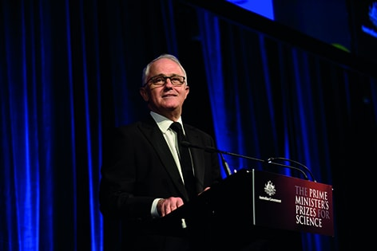
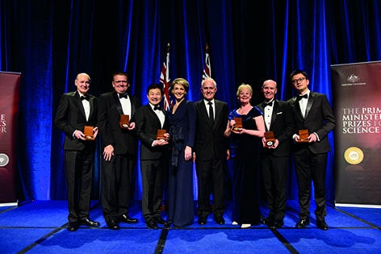

National Science Week highlights
National Science Week runs annually as a nationwide celebration of science and technology, highlighting Australian science and innovation and providing opportunities for everybody in the community to participate in science engagement activities, locally and nationally. In 2017—the 20th anniversary of National Science Week—the festival expanded with the most activities ever registered on the National Science Week website.
National Science Week launched nationally with a gala breakfast at Parliament House coordinated by Questacon’s Inspiring Australia team. The launch was attended by Members of Parliament, Senators and student delegates from schools across the country, who presented the inaugural Young Australians’ Plan for the Planet to the Minister for Industry, Innovation and Science, the Hon Arthur Sinodinos. Key achievements during National Science Week 2017 included:
- 2,157 events registered
- 1.2 million people participated
- 3,036 media stories reported, up from 2,600+ in 2016
- an estimated cumulative audience of 26.5 million people
- an estimated media value of $4.5 million
- 28 000 tweets using the hashtag #natsciwk (or similar), up from 23 000 in 2016
- $1.1 million in grants funding, enabling activity by volunteer Coordination Committees and major science week projects in all states and territories.
The Inspiring Australia—Science Engagement Programme also supported many long-running partnerships for National Science Week, and our Inspiring Australia team worked closely with the Australian Science Teachers Association, the ABC and CSIRO to deliver major projects and enable millions of people to participate.
As a result:
- Educators and students got involved, with around 12,000 schools receiving updates from the the Australian Science Teachers Association, and 280 schools receiving small grants to deliver Science Week projects. The 2017 schools resource book on the theme of Future Earth proved very popular, resulting in many projects based on wildlife, recycling and upcycling. Preschools also got involved for the first time in 2017, signalling an increasing interest in early childhood engagement.
- The ABC delivered a national Smart Phone Survey, with 14,600 people participating. The broadcaster also featured science content across many channels, including a pop-up channel appearing on iView, many science-related interviews on Radio National, and educational resources and a schools video competition linked to the Future Earth theme appearing on ABC Splash! A new-look Catalyst documentary program also premiered in National Science Week.
- All federal MPs were provided with opportunities to participate in National Science Week, with many parliamentarians attending events and activities in their local communities. Both Questacon and CSIRO facilitated event invitations, as well as providing support for the volunteer Science Week Coordinating Committee for Victoria, and delivered hosting and support for the National Science Week website.
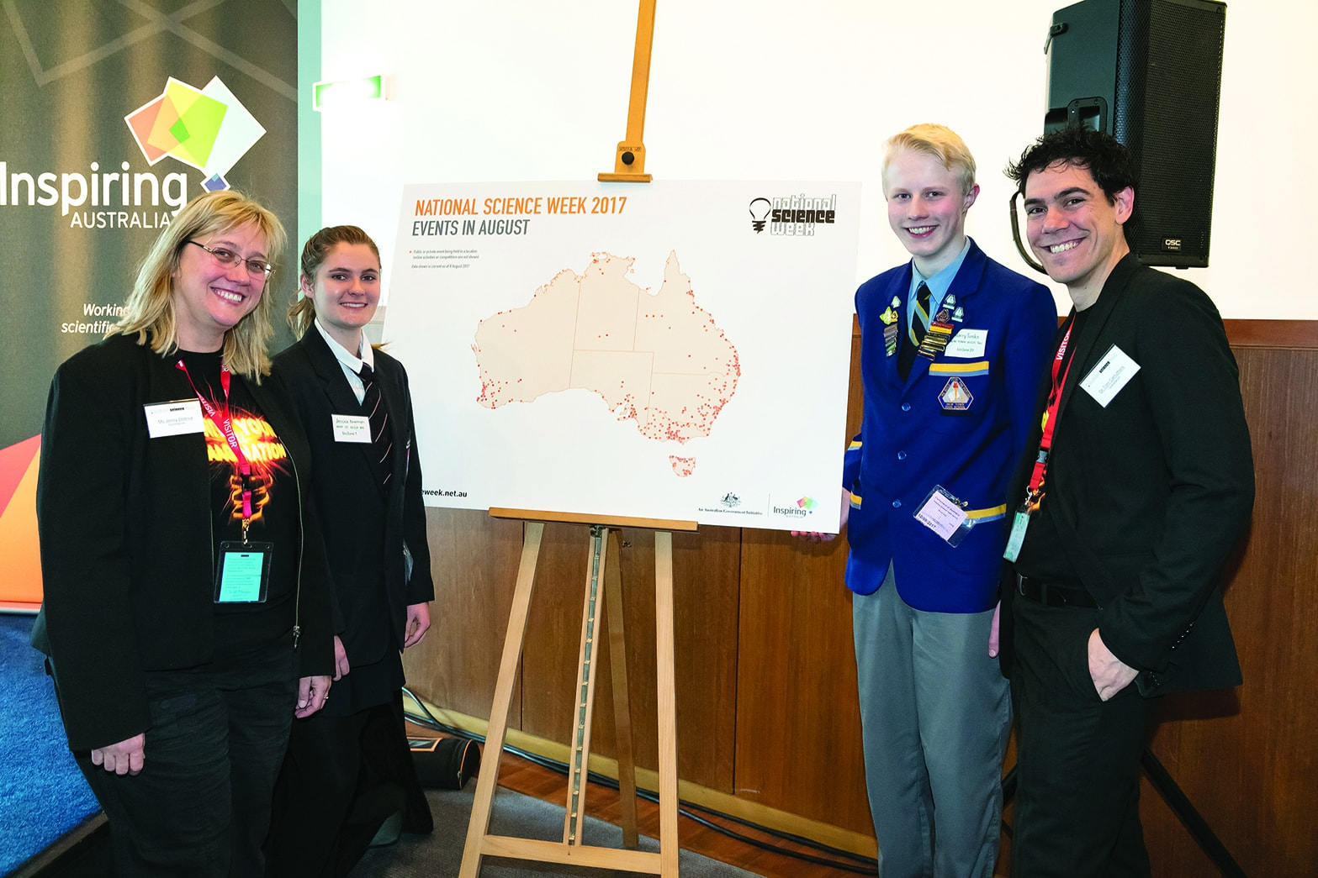
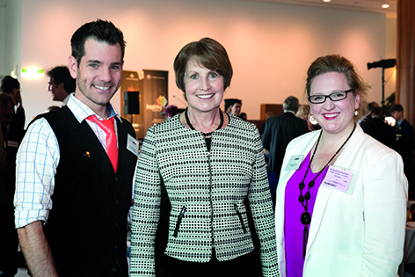
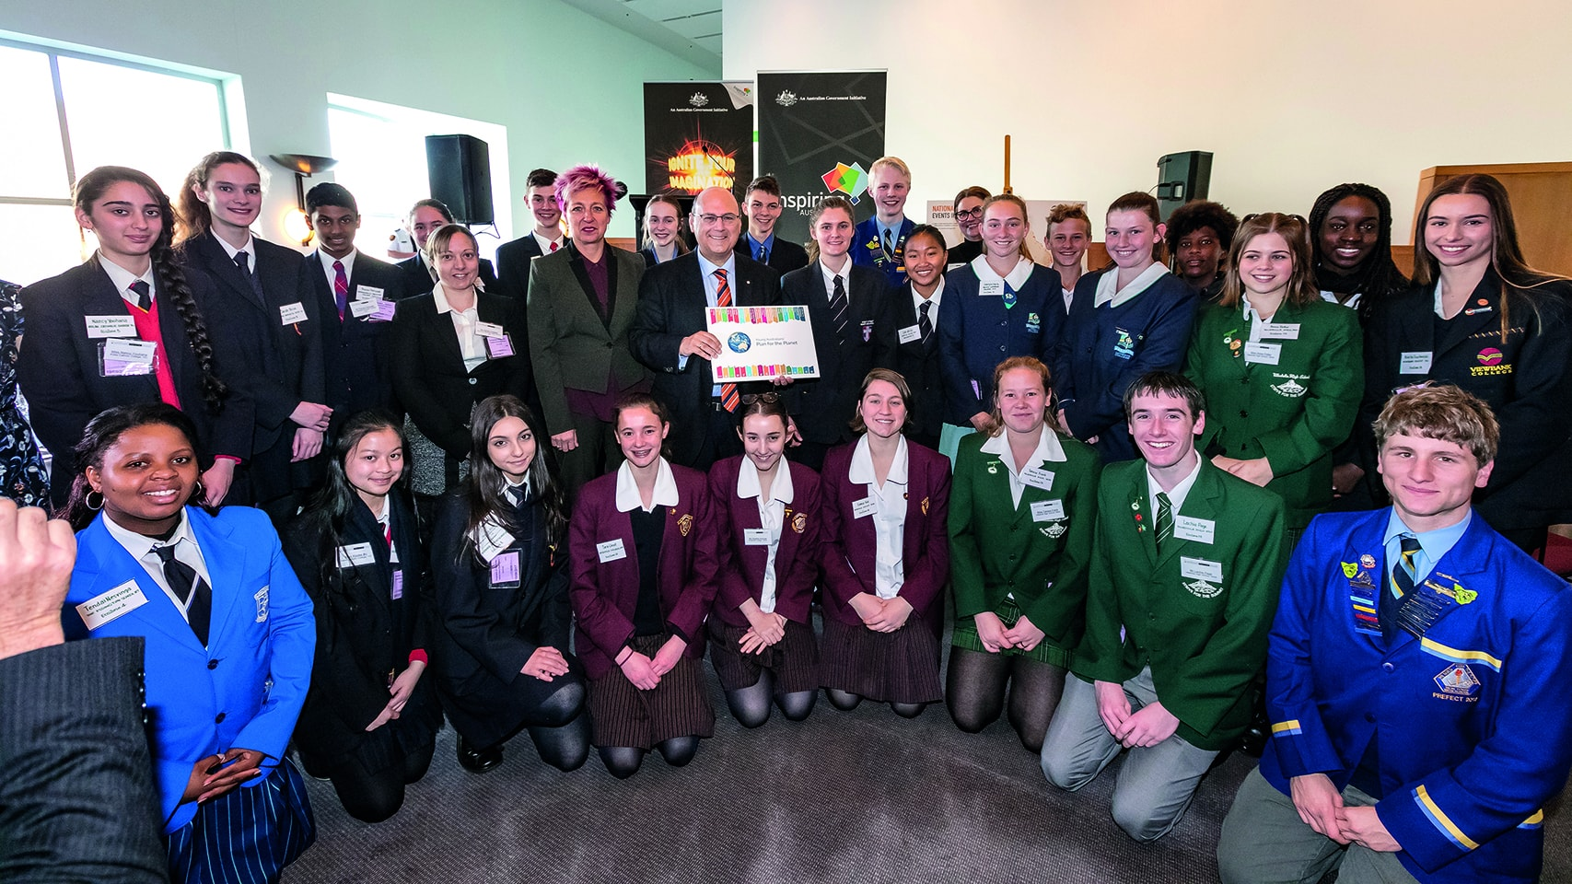
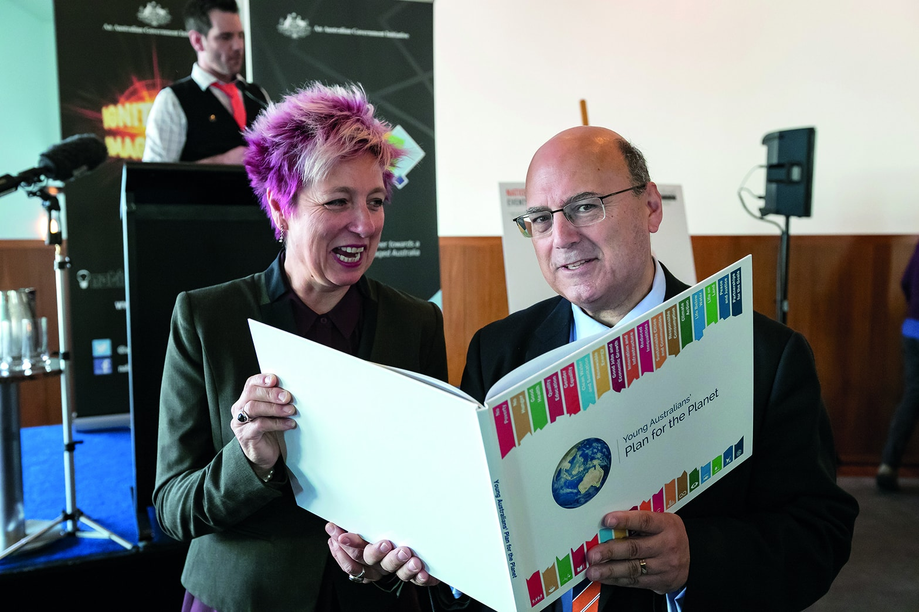

Citizen science highlights
Inspiring Australia continued its support for building national Citizen Science capability, starting 2017 with the announcement of 18 major projects funded through the Inspiring Australia—Science Engagement Programme. Questacon’s Inspiring Australia team also provided advice to the Australian Citizen Science Association, supporting its ongoing development as the lead organisation for citizen science in Australia, and built new connections with many citizen science project organisers and advocates across Australia. The team also supported the Eureka Prize for Excellence in Citizen Science, hosted by the Australian Museum, with Questacon Director, Professor Graham Durant, continuing in his role as a member of the expert judging panel.
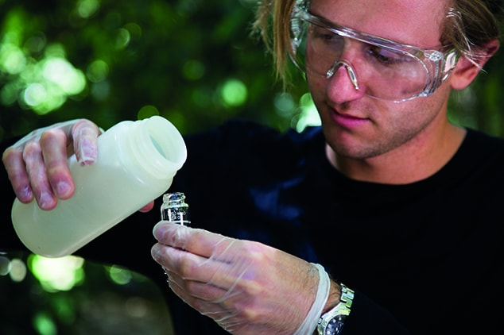
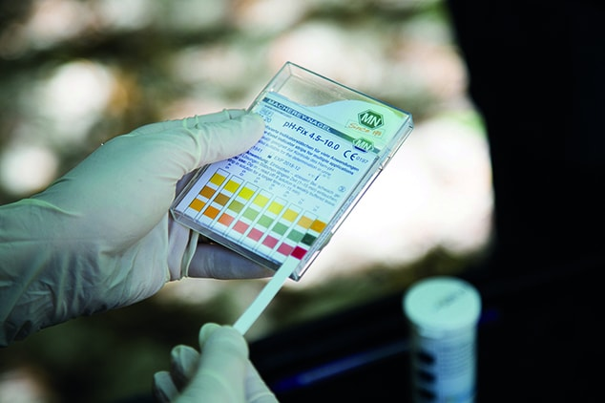

Science clubs highlights
Team members engaged with science and coding club providers across Australia, with the aim of developing a national framework that links existing STEM clubs together and supports parents and organisations to establish clubs in a wide range of informal learning environments. Six modules of new club activities were developed in partnership with the University of Newcastle’s SMART program and evaluated with the assistance of SciScouts, an initiative of Scouting ACT. Team members also developed an open-source logo for use by clubs, with assistance from Questacon’s graphic design team, investigated licensing options for sharing content more freely between clubs, and attended a science clubs forum hosted by the Queensland Museum Network.

Science tourism highlights
Extending Questacon’s pilot work on science tourism for the Australian Capital Territory, our Inspiring Australia team continued exploring the potential for a draft national science tourism framework, in consultation with Inspiring Australia boards in Queensland, New South Wales, South Australia and Tasmania. The draft framework seeks to leverage existing tourism strategies and destination experiences that incorporate, relate to or are underpinned by STEM, and enable the development of a national Discover and Learn tourism narrative that can promote and package existing tourism products in new ways. The framework aims to maximise and link existing science tourism activity in all jurisdictions, increase STEM engagement in the wider community, and realise economic benefits from growth in tourism income, including in regional and remote areas.
These are just a few of many highlights from the Inspiring Australia program in 2017. For more information about the program email: inspiring.australia@industry.gov.au

Questacon International
As Australia’s National Science and Technology Centre, Questacon has a responsibility to be a contributor on the international stage, sharing good practice and showcasing the capabilities of the Australian science centre sector to the world.
We use our position in the world science centre sector to provide leadership in science engagement and informal learning in Australia and around the world.

Young Australians’ Plan for the Planet
Starting in 2016, the Young Australians’ Plan for the Planet seeks to connect senior school students through the development of a strategic plan addressing global issues. We support this program, which is led by The Crawford School of Public Policy at the Australian National University.
The 2016–17 Australian pilot program operated as an extracurricular program involving 20 schools across Australia. Each school developed a sustainable development plan for their regional EcoZone and then combined their individual plans into a National sustainable development plan—the Young Australians’ Plan for the Planet.
The Plan for the Planet approach has been adopted to promote and deliver the United Nations’ Sustainable Development Goals, based on its integration of science, mathematics and geography knowledge and focus on leveraging business management, leadership and teamwork principles and practice to develop and deliver local, regional and globally sustainable outcomes. The program and website have been developed to be replicated and scalable beyond Australia, facilitating use by other countries. The potential outcome over a three year period is a global Plan for the Planet to achieve the successful delivery of the Sustainable Development Goals to 2030, and global sustainable development to 2050.
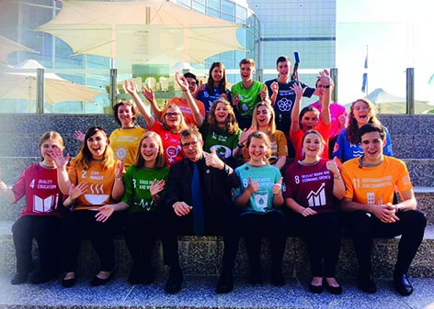

International Science Centre and Science Museum Day 2017
On 10 November, the World Science Day for Peace and Development, the United Nations Educational, Scientific, and Cultural Organization (UNESCO) and the International Council of Museums, science centers, science museums, and their networks worldwide celebrate the International Science Centre and Science Museum Day.
For the second year running, Questacon took part in celebrations. Each year the day is themed around the 17 Sustainable Development Goals. The purpose of this international event is to illustrate the impact and reach globally of all the world’s science centres and science museums. It also highlights the role of these institutions, play with their millions of visitors, in raising awareness of—and engagement in—sustainable development and the solutions to worldwide challenges.
In 2017, the day was used to raise awareness that The GLOBE Observer app now includes the Mosquito Habitat Mapper, supporting citizen scientists to map, count and identify mosquito larvae found in breeding sites.
Questacon celebrated the day with talks on mosquitos in our QLab facility in the Centre, a graphic panel exhibition with interesting mosquito facts and a special all staff meeting focusing on the importance of the day. We also celebrated the day by launching our ‘Women in STEM’ videos.
UNESCO and UN Women celebrated the day by leading a continuous stream of stories and short videos on the Association of Science and Technology Centre’s website, of women in STEM in science centres who are passionate about science.

International exhibitions
We develop and produce exhibitions for display in the Centre to travel across Australian locations, and to travel around the world. In 2017, Questacon exhibitions travelled internationally reaching an estimated 117,717 people and domestically reaching an estimated 366,134 people.
The Fascinating Science travelling exhibition was on display at the Gwacheon National Science Museum in South Korea from January to April 2017. The exhibition was then hosted by Korea’s Daegu National Science Museum from May to August 2017.
The Earthquest exhibition toured at the Oil and Gas Discovery Centre (ODCG) in Brunei from November 2016 to May 2017.

Science Centre World Summit 2017—Tokyo
From 13–19 November, Questacon’s Director, Professor Graham Durant, attended the Science Centre World Summit 2017 in Tokyo, Japan, hosted by the science centre, Miraikan.
The Summit is a global meeting of professionals of science centres and their networks from around the world, convened every three years. The first Science Centres World Conference met in Finland in 1996 followed by Calcutta (1999), Canberra (2002), Rio de Janeiro (2005), Toronto (2008), Cape Town (2011) and Belgium (2014). The meeting changed from a world conference to a world summit in 2014.
The Summit provided an opportunity for science centres to discuss their strategies for their new roles in society. Representatives of participating science centres held discussions with scientists and educators as well as other stakeholders in society, including policymakers, international institutions, industry and citizens communities, and build varied partnerships to create new approaches to global issues, followed by concrete actions.
One of the achievements of the Summit was the acceptance of the Tokyo Protocol. This was signed by all of the heads of the science centre regional networks, and Professor Tit Meng Lim, CEO of Science Centre Singapore and President of ASPAC, signed on behalf of our regional network. Questacon is now committed to working towards the Tokyo Protocol and will be asked to report activities and progress in the lead up to the next World Summit in Mexico 2020.
The Tokyo Protocol is at: https://scws2017.org/tokyo_protocol/
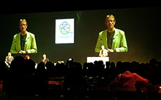

International delegations and visit highlights
- In January 2017, Questacon welcomed Professor Per-Edvin Persson, President and CEO, Oy Per Edvin Persson Consulting Ltd Ab. Professor Per-Edvin Persson is one of the world’s leading experts on science centres and museums, and was Director of Heureka, the Finnish Science Centre, from 1991 until 2013. He delivered a presentation on science centre impact to senior Questacon management.
- In February 2017, a Japanese delegation from the Tsunami affected area visited Questacon to tour the facilities.
- Also in February 2017, Questacon welcomed Ioannis Miaoulis, the CEO of the Boston Museum of Science visiting Australia to try and build some interest in their Engineering is Elementary students curriculum developed through the Museum’s National Centre for Technological Literacy.
- During April 2017, and May 2017 an African delegation, supported by the Department of Foreign Affairs and Trade and the Australian National University visited Questacon to tour the facilities, learn from our staff and engage in exhibit design and build workshops.
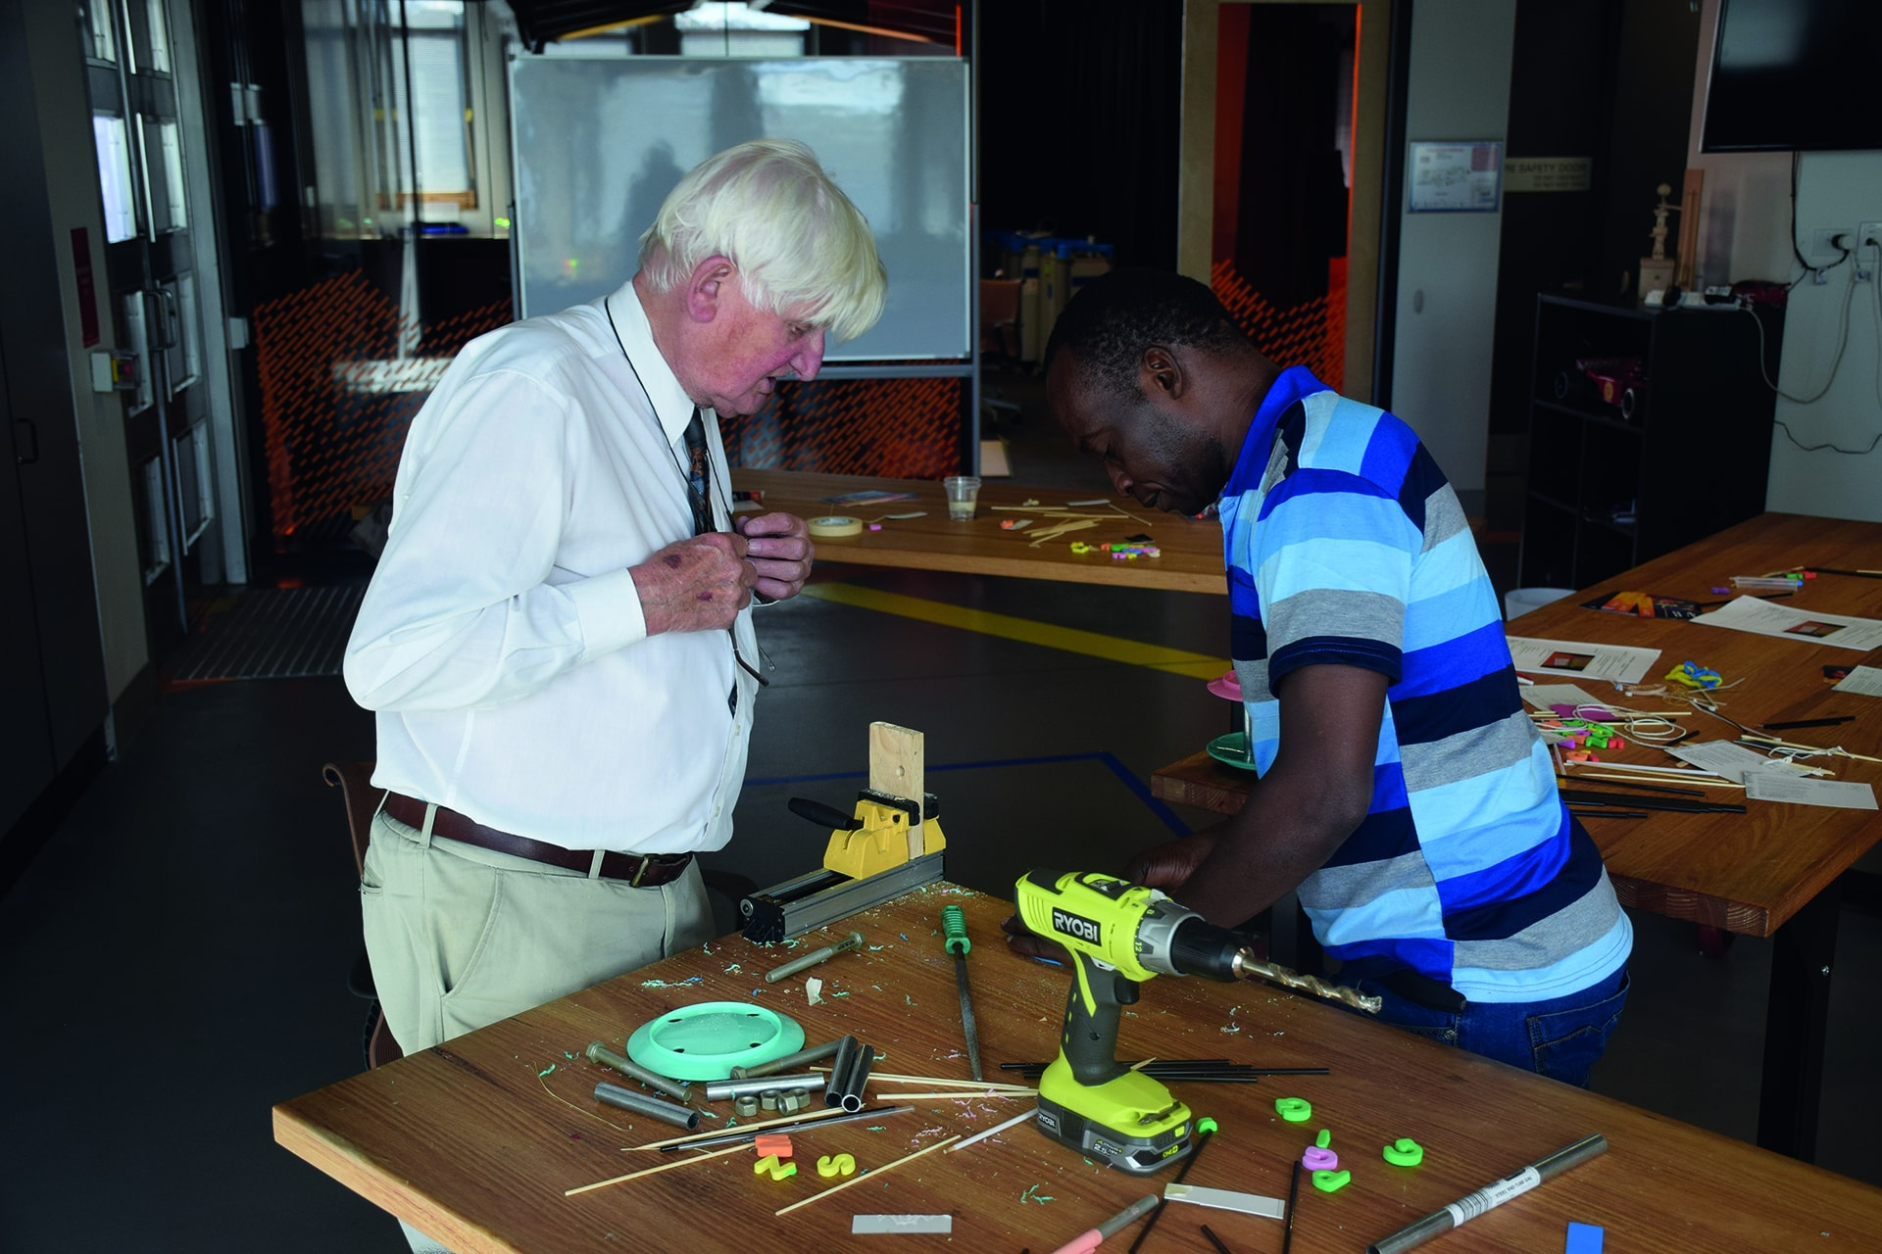
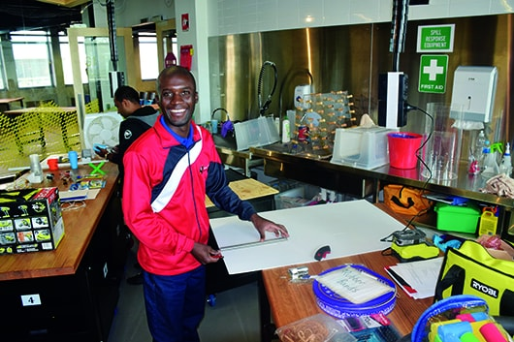
- In June 2017, Counsellor Takashu Yokoyama, Director—Information and Cultural Centre, Japanese Embassy, visited Questacon.
- On 7 August 2017 – Author, Ms Dava Sobel held a panel discussion and Q&A at Questacon. Ms Sobel discussed her work to date and highlighted the release of her new book The Glass Universe, as part of the Canberra Writers Festival.
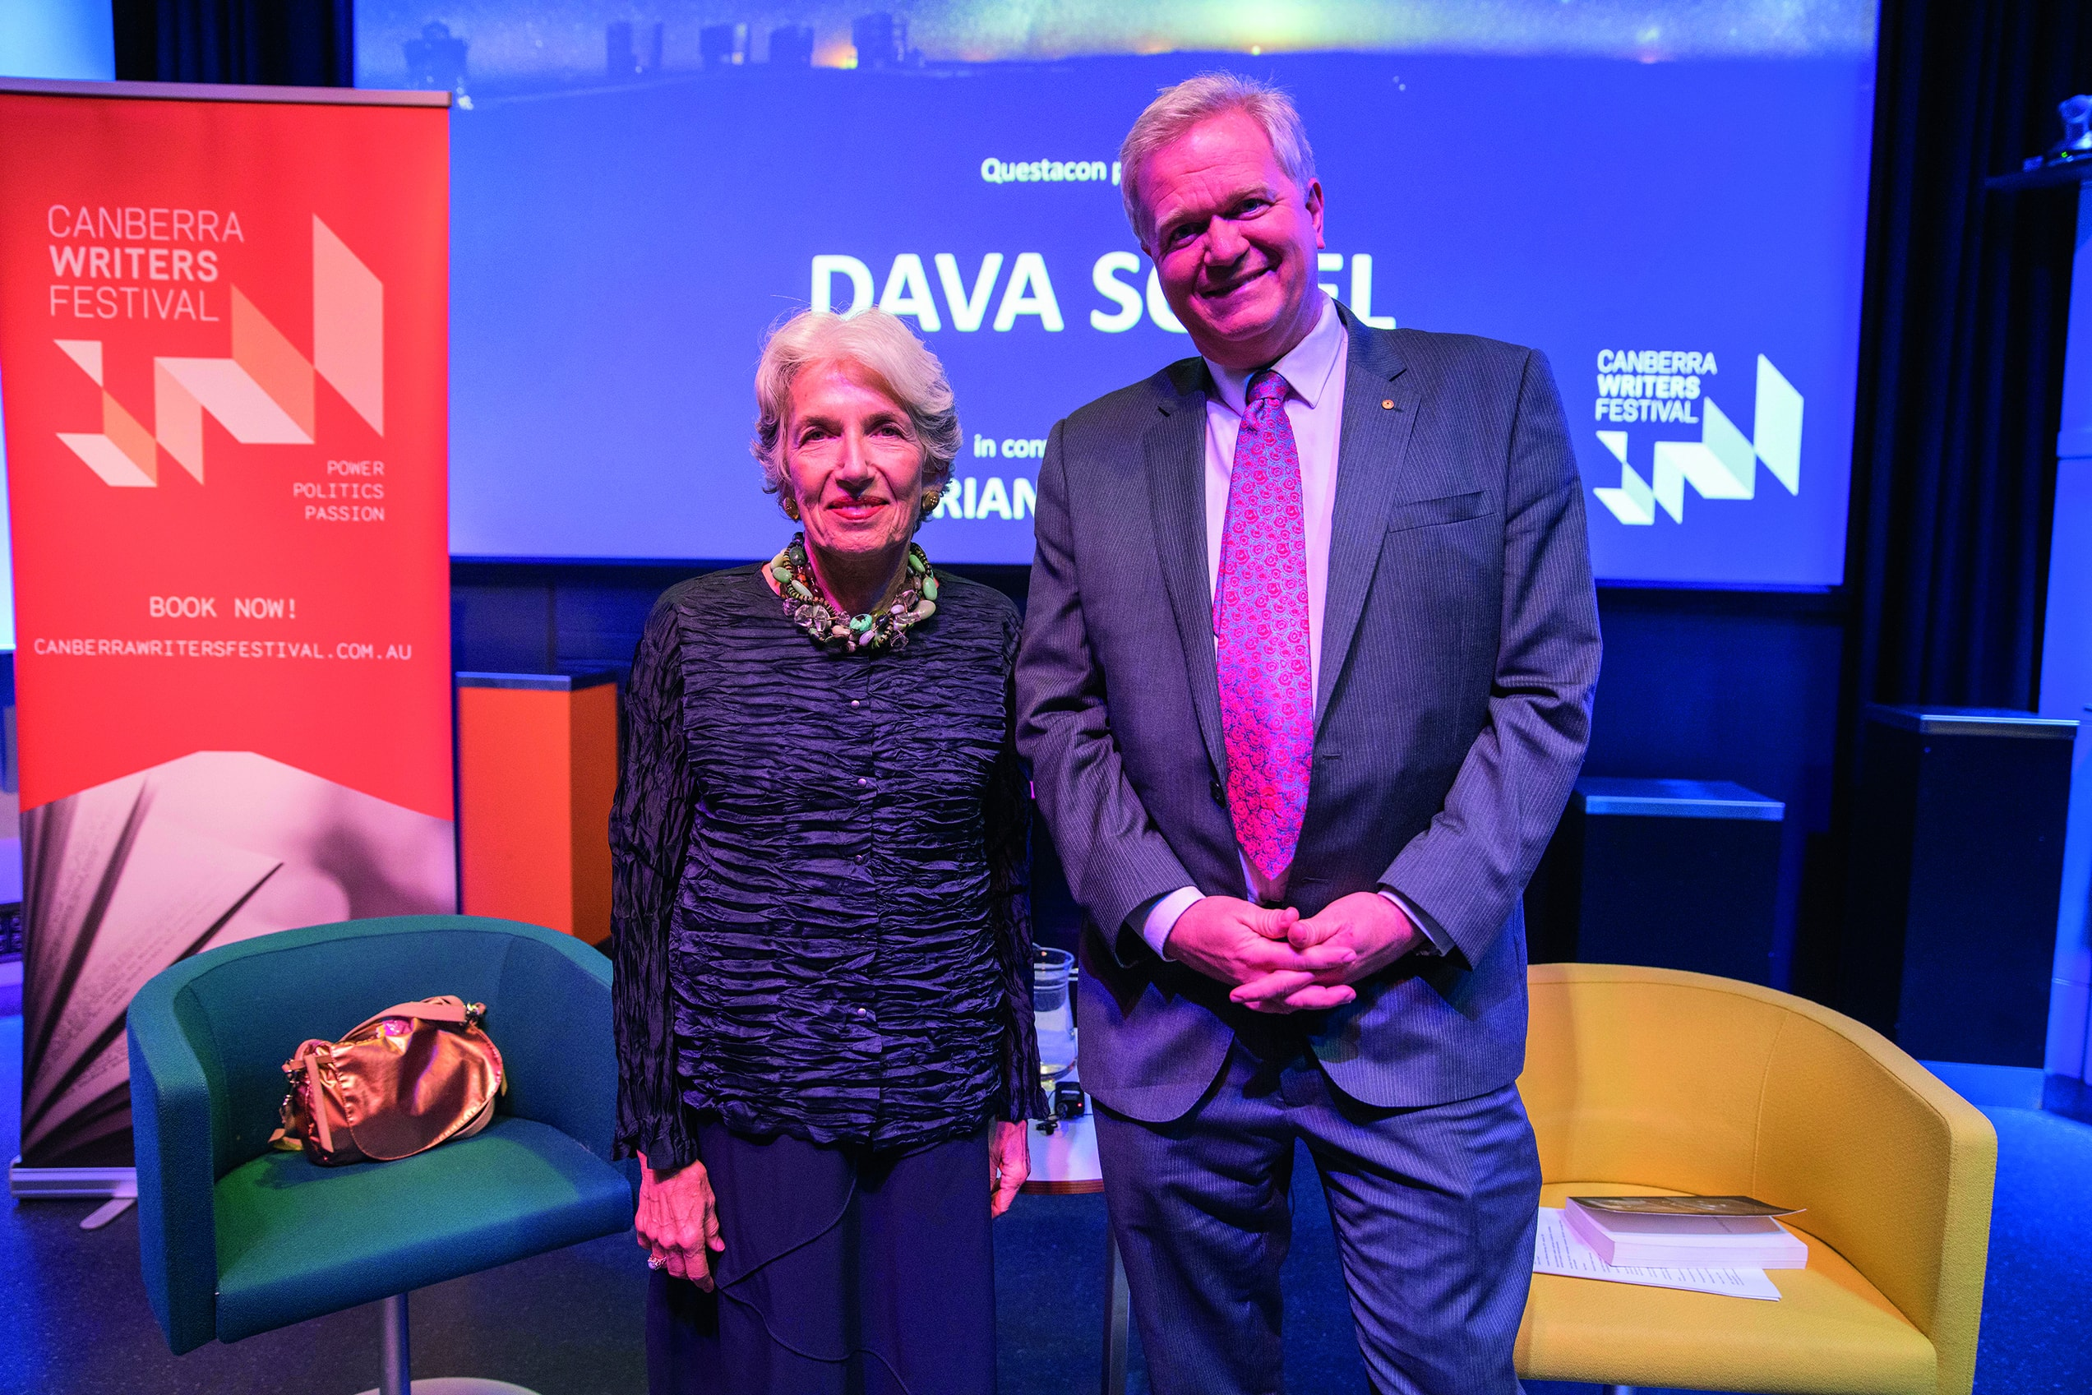
- During August 2017, MIKTA—a partnership between Mexico, Indonesia, South Korea, Turkey and Australia led by Foreign Ministers—visited Questacon’s Deakin facility to inform their program, which is seeking to inspire young innovators.
- Also during August 2017, Mr Kisaburo Tokai, former Minister of Education, Culture, Sport, Science and Technology, Japan, visited Questacon and met with senior managers.
- In September 2017, Dr Simonetta Di Pippo, Director of the United Nations Office for Outer-Space Affairs visited Questacon in collaboration with the United Nations information Office South Pacific. A public lecture was held as well as a videoconference via YouTube.
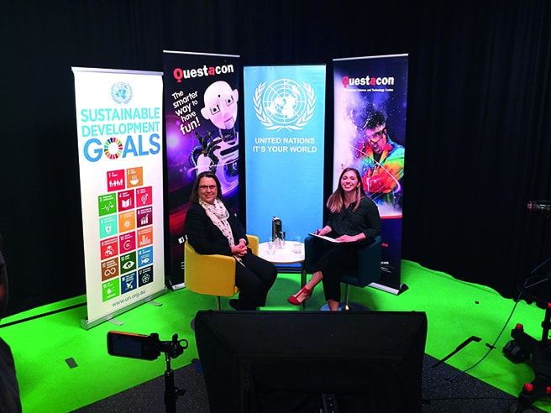
- In October 2017, Dr Marc-Andre Bernier held a public lecture at Questacon. We facilited the visit in collaboration with the Canadian High Commission.

Winner of the National Tourism Award
In February 2017, Questacon was named the best tourist attraction in Australia, winning gold at the Australian Tourism Awards.
After taking home four awards at the November 2016 Canberra Region Tourism Awards, including Outstanding Contribution by an Individual to Questacon Director Professor Graham Durant and best tourist attraction in the ACT, Questacon progressed to the 2016 Qantas Australian Tourism Awards held in Darwin on Friday 24 February 2017.
Competitors in the tourist attraction category included Calypso Star Charters in South Australia, which won Bronze, and two-time Australian Tourism Award winner Bruney Island Cruises from Tasmania, which won the silver.
The gold award recognises our commitment to providing tourism excellence for our half a million annual local, national and international visitors through our passionate staff, exciting exhibits, spectacular science shows and interesting experiences we offer. The award also acknowledges Questacon’s dedication to building and continuously improving the tourism industry in Canberra, where tourism contributes $2 billion annually to the local economy, and in Australia.
ACT Chief Minister Andrew Barr MLA helped us celebrate our tourism award win, visiting the Centre on 10 March 2017 to congratulate staff, discuss new and exciting upcoming exhibitions and place the trophy into the cabinet to display and share with our new and repeat visitors.
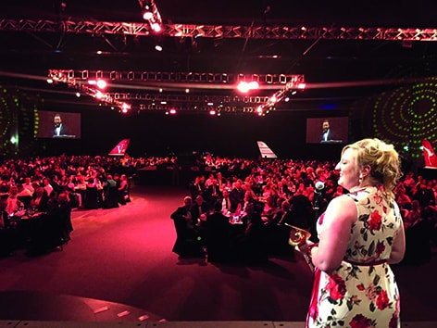
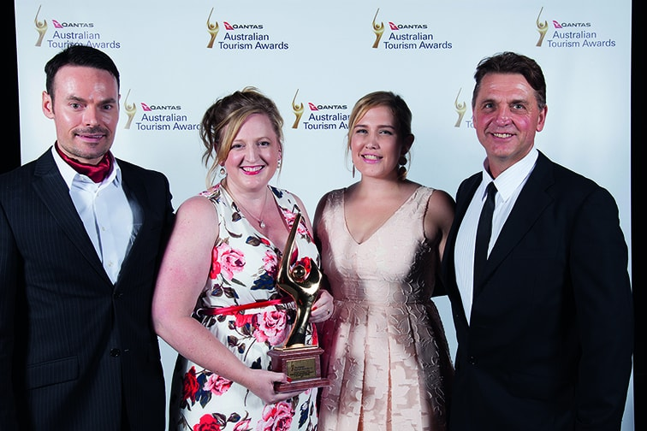

Regional tourism win
On 17 November 2017, Questacon won the award for best Tourist Attraction at the 2017 Canberra and Capital Region Tourism Awards held at the National Museum of Australia. We are proud to have won the best Tourist Attraction award for 13 consecutive years. The award recognised Questacon’s long-standing commitment to tourism excellence, driving visitation and economic benefits to the Canberra region.
It also acknowledged Questacon’s dedication to the community by providing for visitors with specific needs, engaging with the local community through fundraising efforts, such as the Big Heart Project, and environmental endeavours such as ACTSmart accreditation and use of solar panels to help power our building.
‘…as the winner of the Tourist Attractions category, this has come after a string of successes at the local level, and cements Questacon’s place as one of the country’s leaders in providing unparalleled tourism excellence.’
Canberra Region Tourism Awards
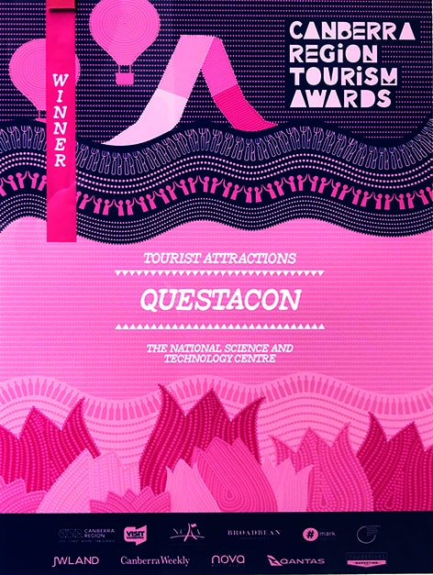
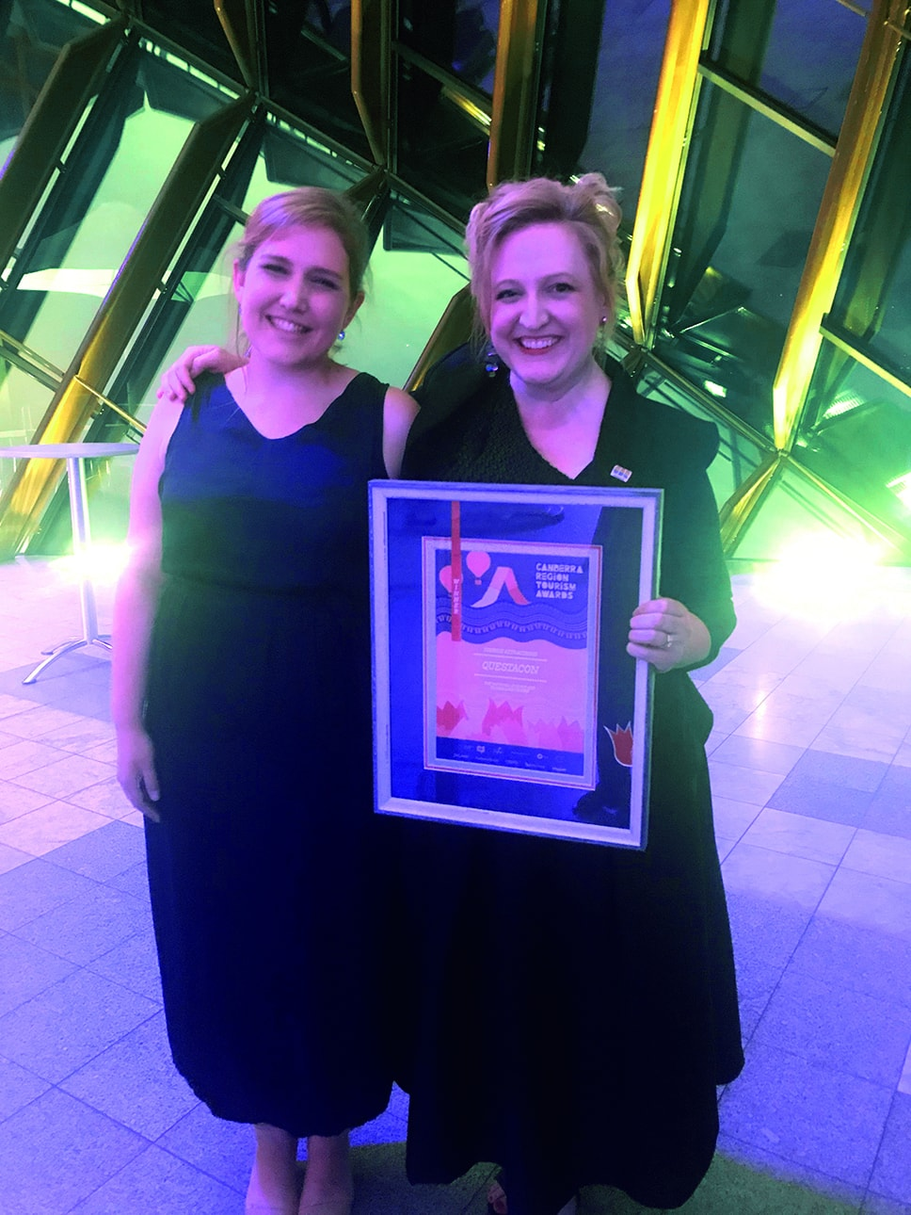

Key Events

National Questacon Invention Convention

16–20 January 2017
The Questacon Smart Skills Initiative delivered the 2017 National Questacon Invention Convention. The five-day program brought 26 young delegates from across Australia to Canberra to innovate their own ideas and solutions around the theme: Food, Water, Shelter. The delegates received training and mentoring from Questacon staff as well as entrepreneurs, researchers and local business people who shared not only their skills but also the stories of their personal and professional journeys.
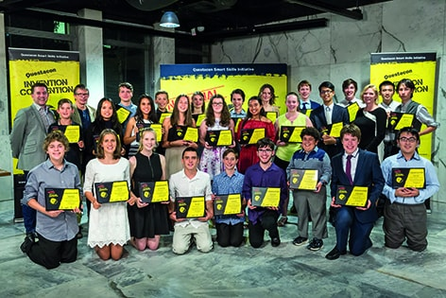

Above and Beyond announcement

9 February 2017
We held a special media event to mark the opening of blockbuster international exhibition Above and Beyond. This included speeches from the Minister for Industry, Innovation and Science Senator the Hon Arthur Sinodinos AO, Questacon Director, Professor Graham Durant, and President of Boeing Australia, New Zealand & South Pacific, Maureen Dougherty. The Minister and Maureen Dougherty, along with a local school group, then constructed Boeing Balsa Wood gliders and launched them into the Questacon foyer.

ENLIGHTEN 2017

3–12 March 2017
ENLIGHTEN 2017 illuminated the Parliamentary Zone and satellite venues across Canberra with architectural projections, performances, Night Noodle Markets and events over 10 nights.
Thousands of attendees experienced the spectacular ENLIGHTEN activities hosted by Questacon including Sustainable Development Goals architectural projections inspired by Anna Trundle and Ian Dudley’s artwork, Questacon’s night photography workshops by local photographer Hilary Wardaugh, Pure ImaGINations: The Science of Gin workshops, the ‘Best Of’ busking by the Questacon Excited Particles and Questacon’s popular flashing fairy floss.
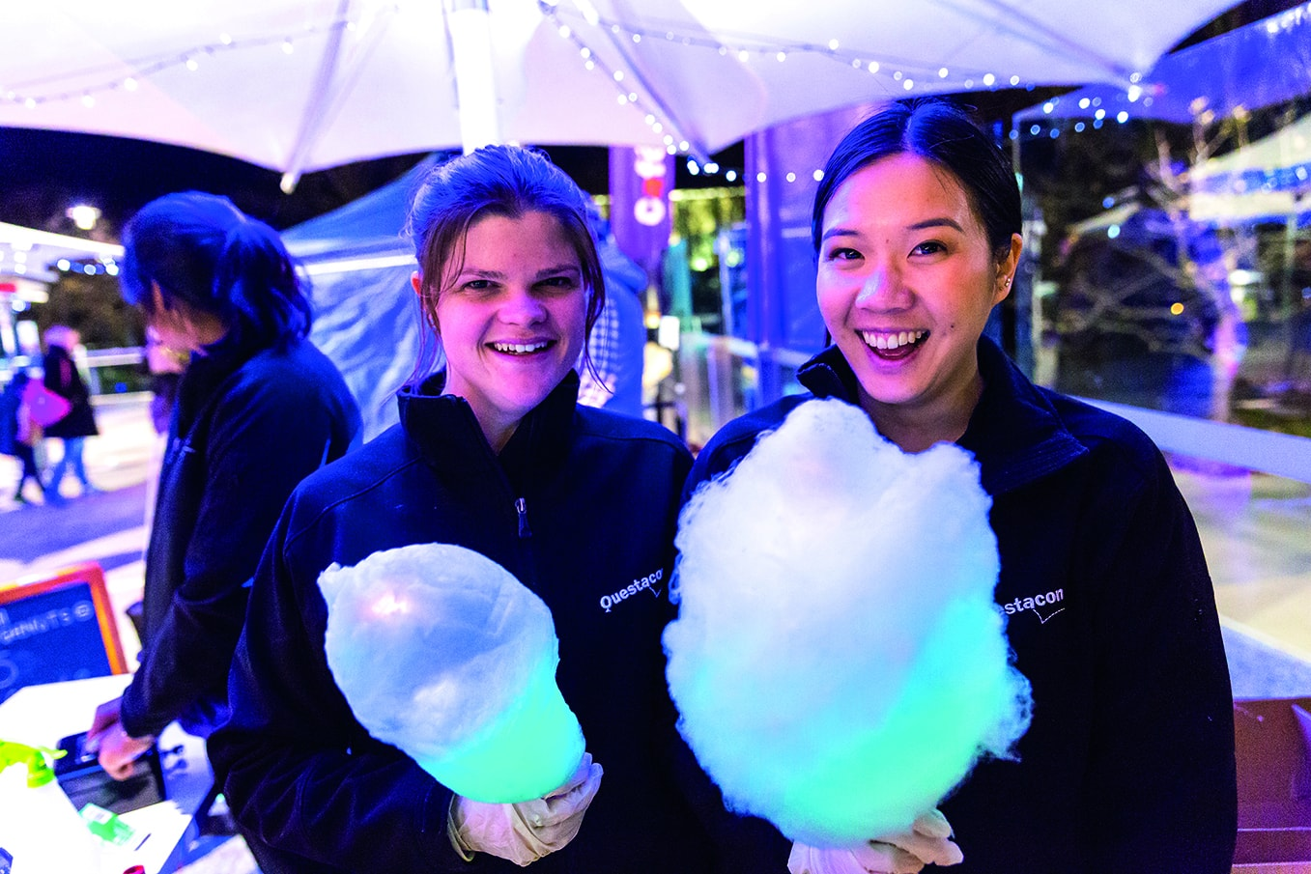

ONTHEGO Partnership Launch

14 March 2017
Questacon announced a new Entrepreneurial Partnership with Canberra sportswear company, ONTHEGO Sports. This is a first for Questacon and supports small businesses and their entrepreneurial journey. As ONTHEGO Sports developed the new uniforms for Questacon’s front of house, volunteer, shop and gallery staff, the launch event officially showcased the new uniforms.
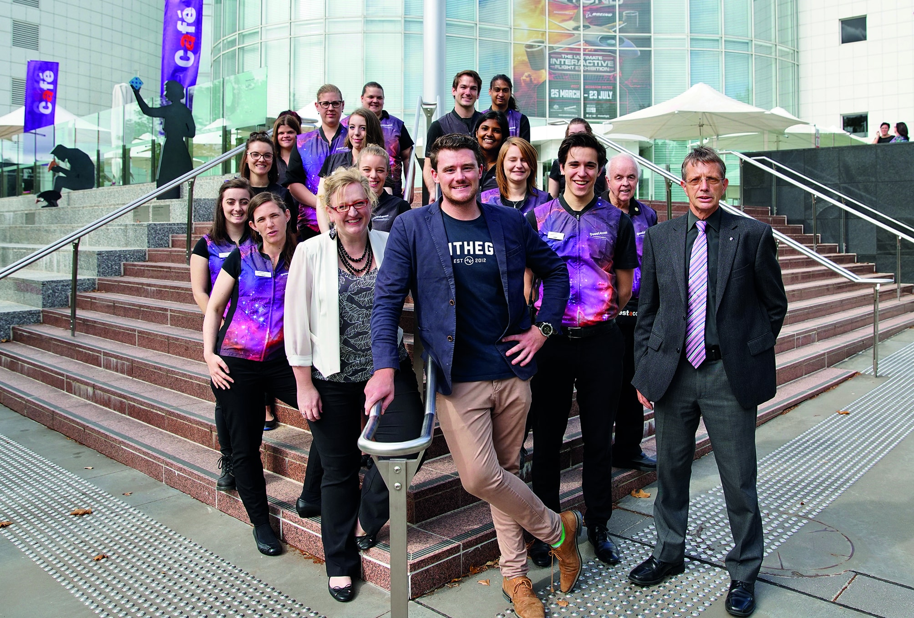

Above and Beyond VIP

23 March 2017
Questacon and co-host Boeing held a VIP preview event prior to the Above and Beyond exhibition opening to the public. VIP guests included President of Boeing Australia, New Zealand & South Pacific, Maureen Dougherty, and Chargé d’Affaires from the Embassy of the United States of America and Deputy Associate Administrator for Space Communications and Navigation, NASA, Mr Badri Younes.

Take Flight @ Questacon

25 March 2017
On the opening day of Above and Beyond, Questacon delivered a special event called Take Flight @ Questacon. We took over the lawns opposite the building to welcome more than, 3000 visitors throughout the day. Event attendees immersed themselves in a fun-filled day of interactive flight featuring activities from some of Australia’s most well regarded aviation and aerospace organisations.
Activities included a Super Hornet flight simulator, tethered balloon rides in the Questacon hot air balloons, a range of unmanned aerial systems on display and a special presentation from Mr Badri Younes, Deputy Associate Administrator for Space Communications and Navigation NASA.
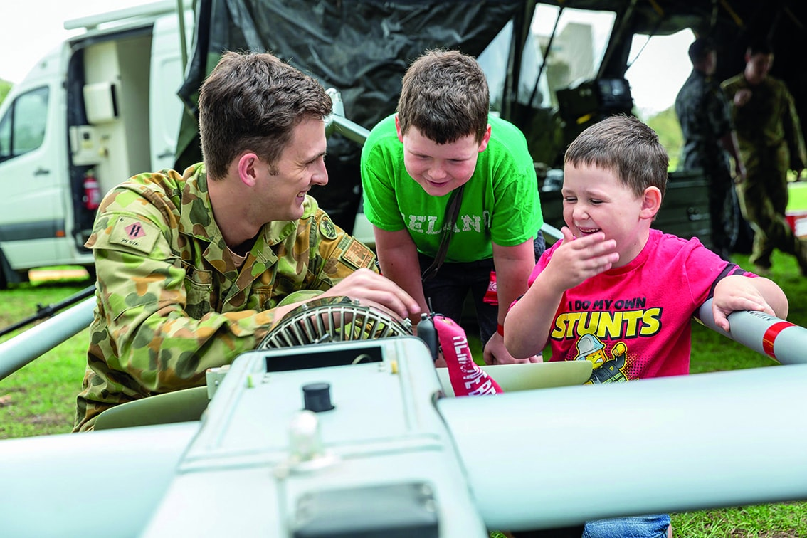

11 millionth visitor

31 March 2017
In 2017, Questacon welcomed our 11 millionth visitor to the Centre. The lucky visitor was a young boy from interstate visiting with his family. He was presented with a prize pack and took part in a demonstration featuring a hydrogen balloon explosion and confetti cannons.
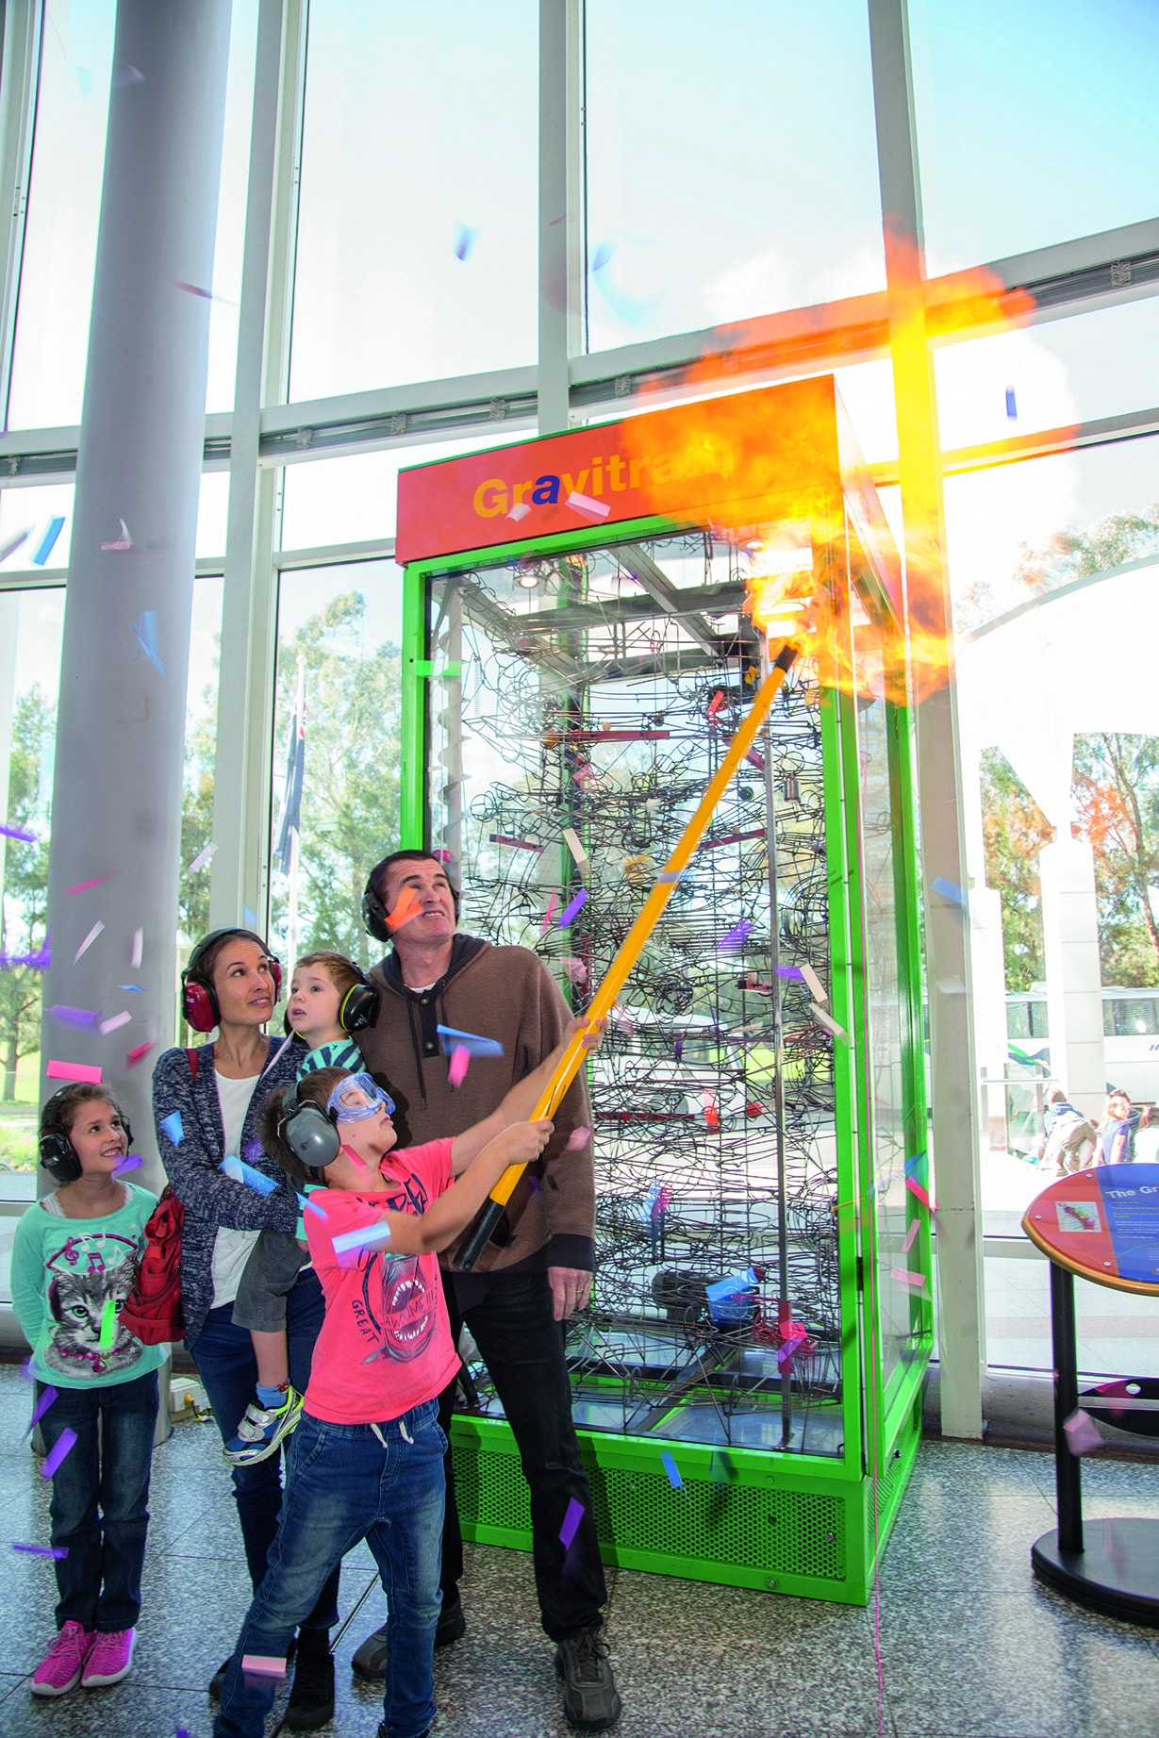

Air & Space Speaker Series

May–August 2017
To align with the Above and Beyond exhibition, we ran a free public lecture series themed around aviation and aerospace. Dr Brad Tucker from the Australian National University kicked off the series with a presentation on the future of space and astronomy. Associate Professor Andrew Neely from the University of New South Wales spoke about the science of (very) high speed flight, and Squadron Leader Marija Jovanovich from the Royal Australian Air Force spoke about her adventures as an Air Force test pilot.

Monopoly Board

14 June 2017
In 2017, a new Australian edition of Monopoly was announced by Hasbro Australia, featuring Questacon on prime real estate on the famous board game. Fans from around the country were invited to vote for their favourite iconic Australian destination. A total of 35,768 votes were cast for the 40 shortlisted landmarks, and just 22 were featured on the final board. Questacon joined Canberra and the Australian War Memorial on the Australian Capital Territory section of the new Australian Monopoly board, with Questacon landing the coveted red ‘Trafalgar Square’ position.
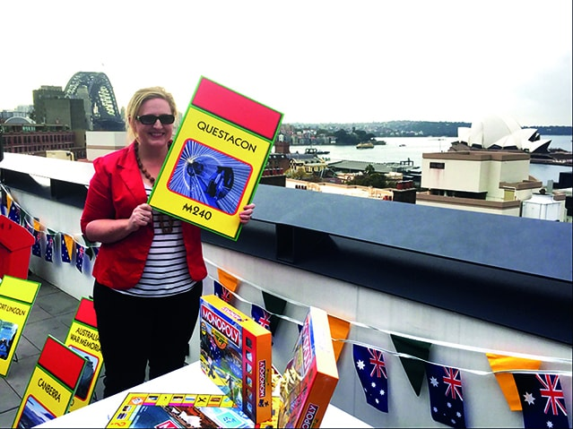

Channel Nine’s The Today Show

12 July 2017
Due to the success of Above and Beyond, we extended the exhibition and provided The Today Show with an exclusive opportunity to announce the extension live on air. Weather presenter, Natalia Cooper spent the morning in the Above and Beyond gallery with a group of local children experimenting with the exhibits and participating in flight science demonstrations. The exhibition extension was then announced live on air to more than 1.7 million viewers.
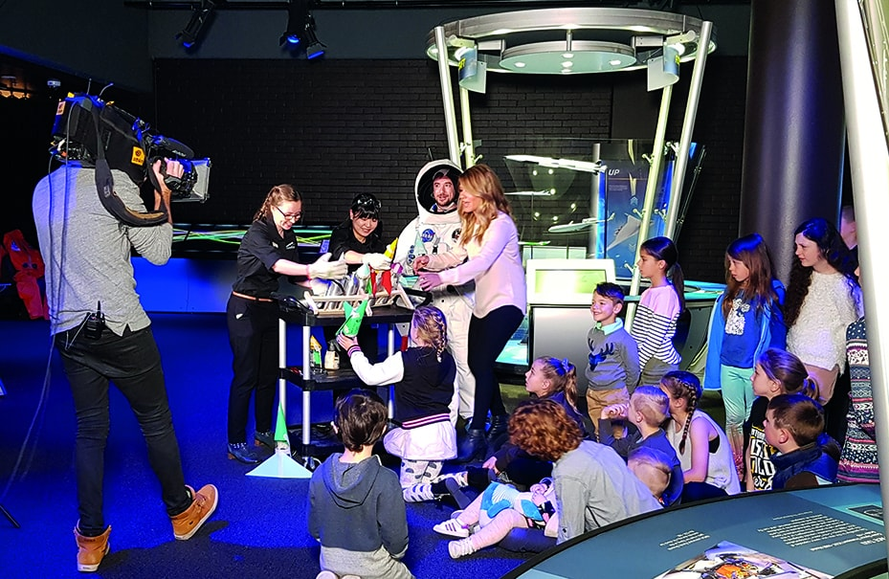

Fun Science with Traditional Toys

19 July 2017
The Fun Science with Traditional Toys travelling exhibition was displayed at Questacon from 9 July to 15 October 2017 in partnership with the National Science Museum Thailand. The exhibition explored the science and innovation behind simple toys made by children in villages across Thailand for hundreds of years. The launch was attended by VIP guests including Mr Pawat Raungvichatron, First Secretary from the Royal Thai Embassy, and Mr Suwarong Wongsiri, Vice President of the National Science Museum Thailand.
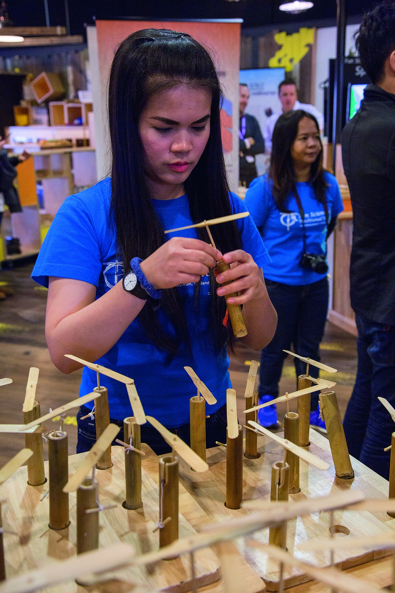
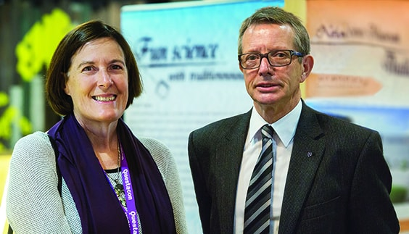
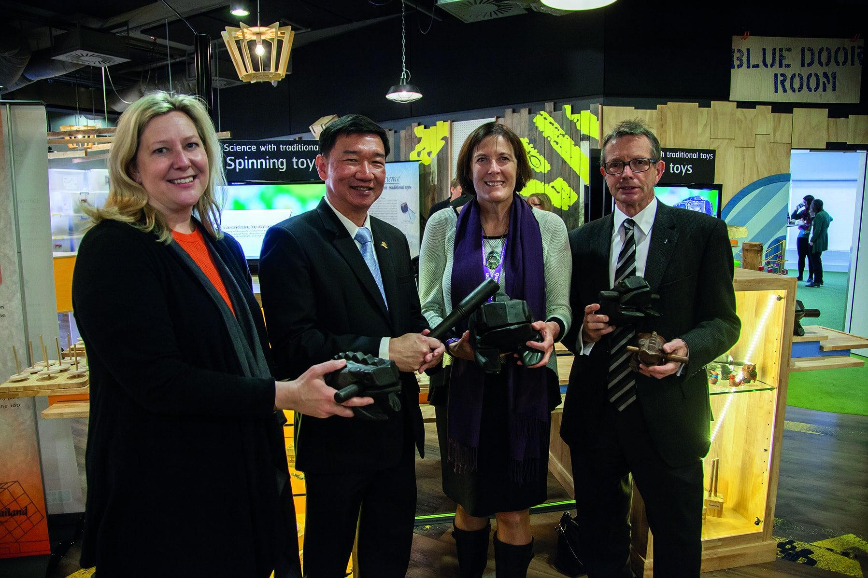

ABC News Breakfast—National Science Week

11 August 2017
During National Science Week the ABC News Breakfast show visited Questacon. Nate Byrne delivered the weather live from the Questacon galleries and more than 1.7 million viewers tuned in during the morning. The Shell Questacon Science Circus smashed a brick on Nate’s chest while he lay on a bed of nails and the Questacon Excited Particles set Nate’s hands on fire as a group excited of local school students watched on.
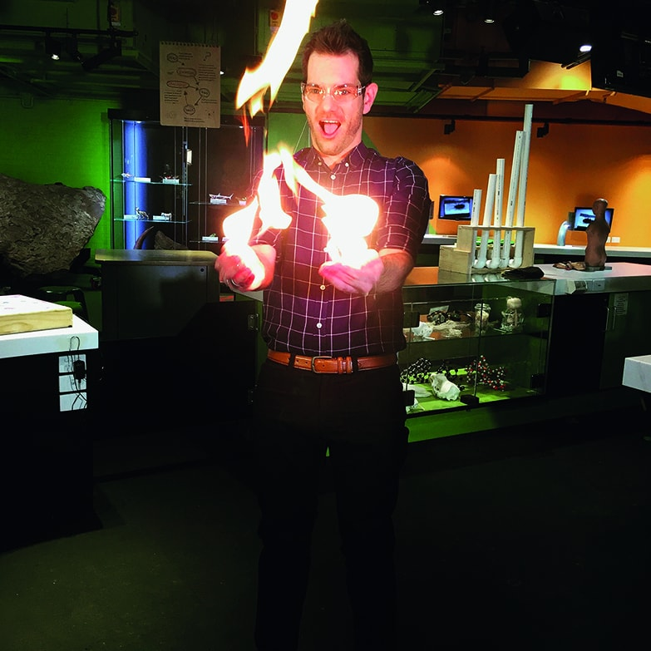

Visit from the Governor-General

19 August 2017
The Governor-General, His Excellency General the Honourable Sir Peter Cosgrove AK MC (Retd) and Lady Cosgrove visited The Ian Potter Foundation Technology Learning Centre to celebrate National Science Week. They engaged with a group of visiting students participating in a Questacon Maker Project workshop. They also visited the Production Workshop taking the opportunity to meet our production team and see first-hand a Questacon exhibition being developed. Before departing the Governor-General presented Questacon’s first apprentice (now qualified) Glen Goggin and Questacon Director, Professor Graham Durant, with a Governor General’s Medallion.
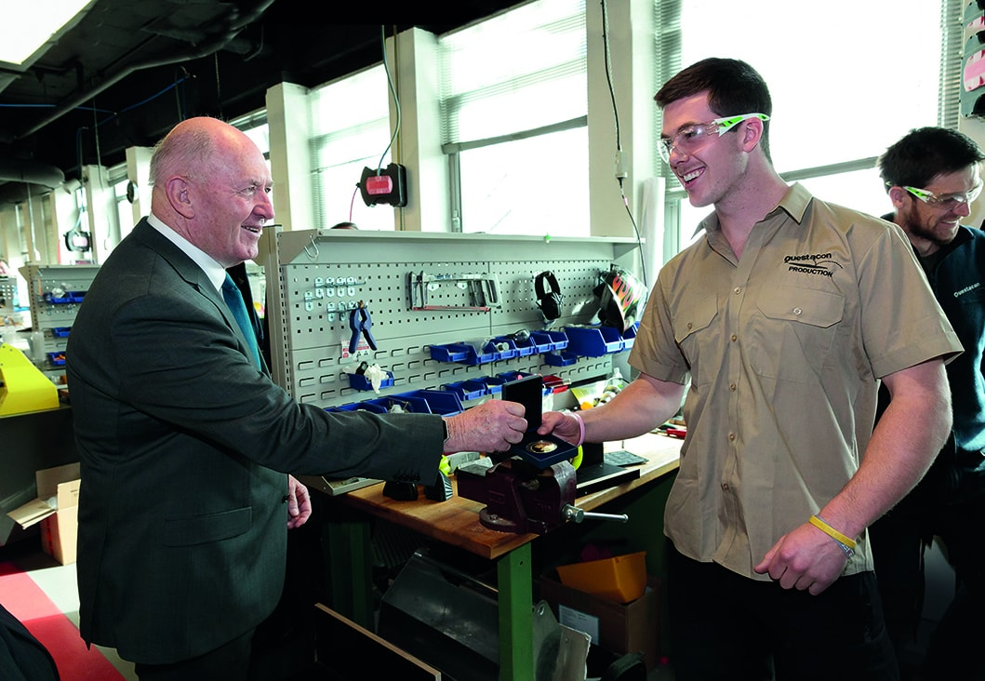

EuroScience 2017

25–30 September 2017
Questacon, in partnership with the European Union Delegation to Australia and the Australian National University Centre for European Studies (ANUCES), delivered a special program of events to 13,242 visitors over six days in September 2017. From the heroes of European science history, to space exploration and the future of world energy generation, EuroScience at Questacon 2017 explored the ground-breaking scientific achievements and collaborations between Europe and Australia.
EuroScience at Questacon incorporated science demonstrations, live presentations by scientists and researchers, spectacular shows and tinkering with the Danish product, LEGO.

Questacon People

Volunteers
Questacon has 65 regular volunteers who are active in the organisation as Science Explainers, Science Time volunteers and Outreach volunteers. In 2017, our volunteers provided more than 10,274 hours.
Volunteers come from all walks of life with backgrounds in science, technical roles, academia and education. They provide exhibit explanations and science demonstrations for visitors, and roam with Discovery Trolleys or at integrated spaces such as Curiosity Corner. Our volunteers are passionate about the organisation and committed to the search for new ways to communicate with visitors and enhance programs delivered at Questacon. Volunteers are advocates for Questacon, and are regularly involved in community outreach events at schools and retirement homes.
In 2017 we saw the largest ever group of Student Training Program participants, graduating 53 local year 11 and 12 student volunteers from this unique program—shaping them into the science communicators of tomorrow.
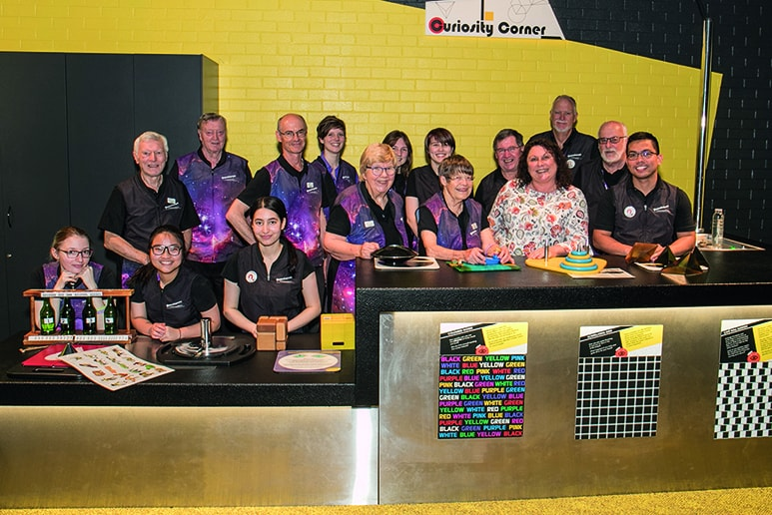

Volunteer profile: Jennifer Wanless
Ms Jennifer Wanless has been a volunteer with Questacon for 36 years, starting in March 1981 at the original Questacon facilities at Ainslie Public School. In her role as an explainer, it has been her job and passion to bring Questacon’s exhibits to life and reveal the many mysteries of science they explore.
As a former science teacher, Ms Wanless brings genuine enthusiasm to our dynamic team of volunteers, based on a desire to ensure every visitor is fully engaged in the Questacon experience.
Ms Wanless was awarded the Medal of the Order of Australia in 2010 in recognition of her life-long commitment to science.
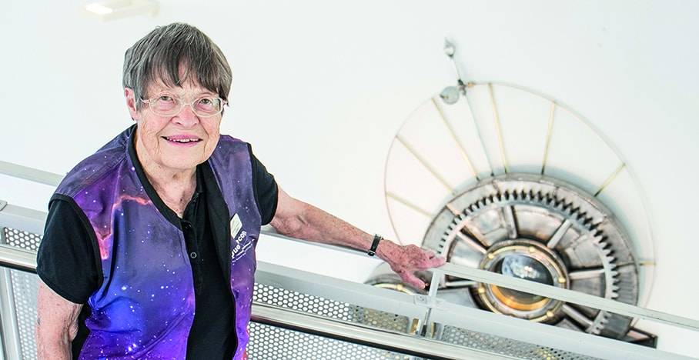

CERTIII Customer Engagement
In November 2017, a group of 10 service delivery managers from our Retail and Tourism Section completed a Certificate III in Customer Engagement. This 11-month program is funded through the ACT Government’s traineeship scheme. It has delivered leadership development for staff and an enhanced visitor experience through new customer service initiatives and audience development strategies, including phased visitation and extended hours and new evening offering to reduce congestion, and STEM retail product development.
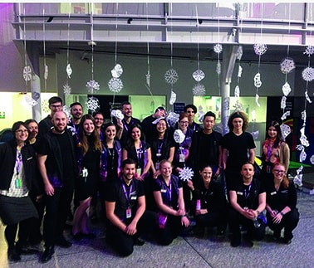
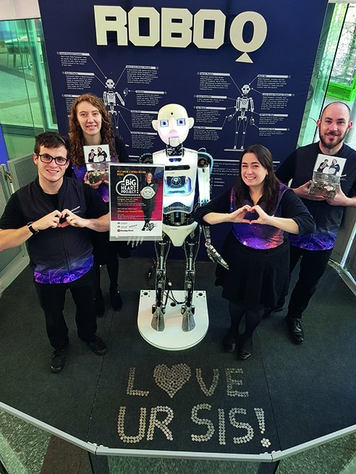

Q Staff Awards

Sam Needham
For providing exemplary training and service to the Visitor Services team, and for delivery an outstanding program and science demonstrations in the QLab.

Shannon Cook
For outstanding performance, development and growth of Questacon’s social media profile while consistently delivering professional communication.

Smart Skills (Sean de Clerck, Joshua Ezackial, David Watts)
For the professional development and training provided to staff while providing leadership and mentoring through a series of workshops within the Questacon Smart Skills Initiative and Teacher Programs.

Russell Galloway
In recognition of his dedication to Questacon and valuable work within the Production Team over the past nine years.

Lauren Ambrose
For transitioning the Executive office into a full service support capability, enabling high quality service for the Executive and high profile stakeholders visiting Questacon.

Kate McKenzie
For consistently demonstrating commitment to a positive safety culture and environment, and working tirelessly towards Questacon receiving 100 per cent in the 2017 Comcare Work Health and Safety Audit.

Eloise Brennan-Tucker
For the ongoing commitment and passion for creating and implementing product ideas, specifically for collaborating and delivery of the teachers’ Q Shop catalogue.

Nicole Murtagh
For continuous professionalism, enthusiasm and flexibility within the Members Reception and Front of House teams and willingness to contribute to the development and training of other staff.

Freya Ries
For her dedication and ongoing voluntary work on a number of projects, and consultative committees throughout 2017.

Alexandra Evans-Tse
For consistently delivering outstanding business administration and attentive customer service to visitors through the Schools Experience Program

Tour Coordinators (Aidan Murray, Joe Duggan, Benjamin de Vos, Matthew Dunn)
For leadership and mentoring provided to the Science Circus Masters Students and for the outstanding coordination and delivery of the Shell Questacon Science Circus tour schedule.

Length of Service

Questacon Staff—10 years
Jessica Ward
Derek Flannery
Kelly Fong
Jo Hancox
Michael Bennett
Alexander De Vos
Jamie Hartley
Kaitlyn Bowden
Jason Hill

Questacon Staff—15 years
Jason Judd
Belinda Anyos
Richard Conan-Davies

Volunteers Length of Service
Bert Klaassen - 10 years
Geoff Spencer - 20 years
Yagna Ablamowicz - 20 years
Jenny Wanless - 35 years
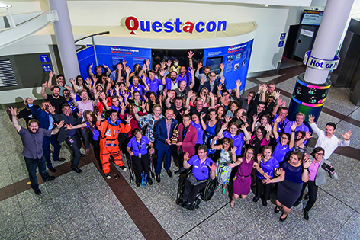
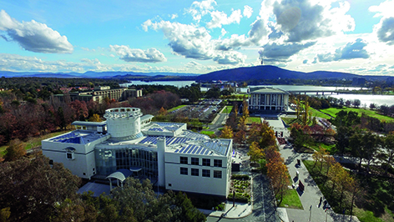



Questacon supports the sustainable development goals

www.questacon.edu.au

