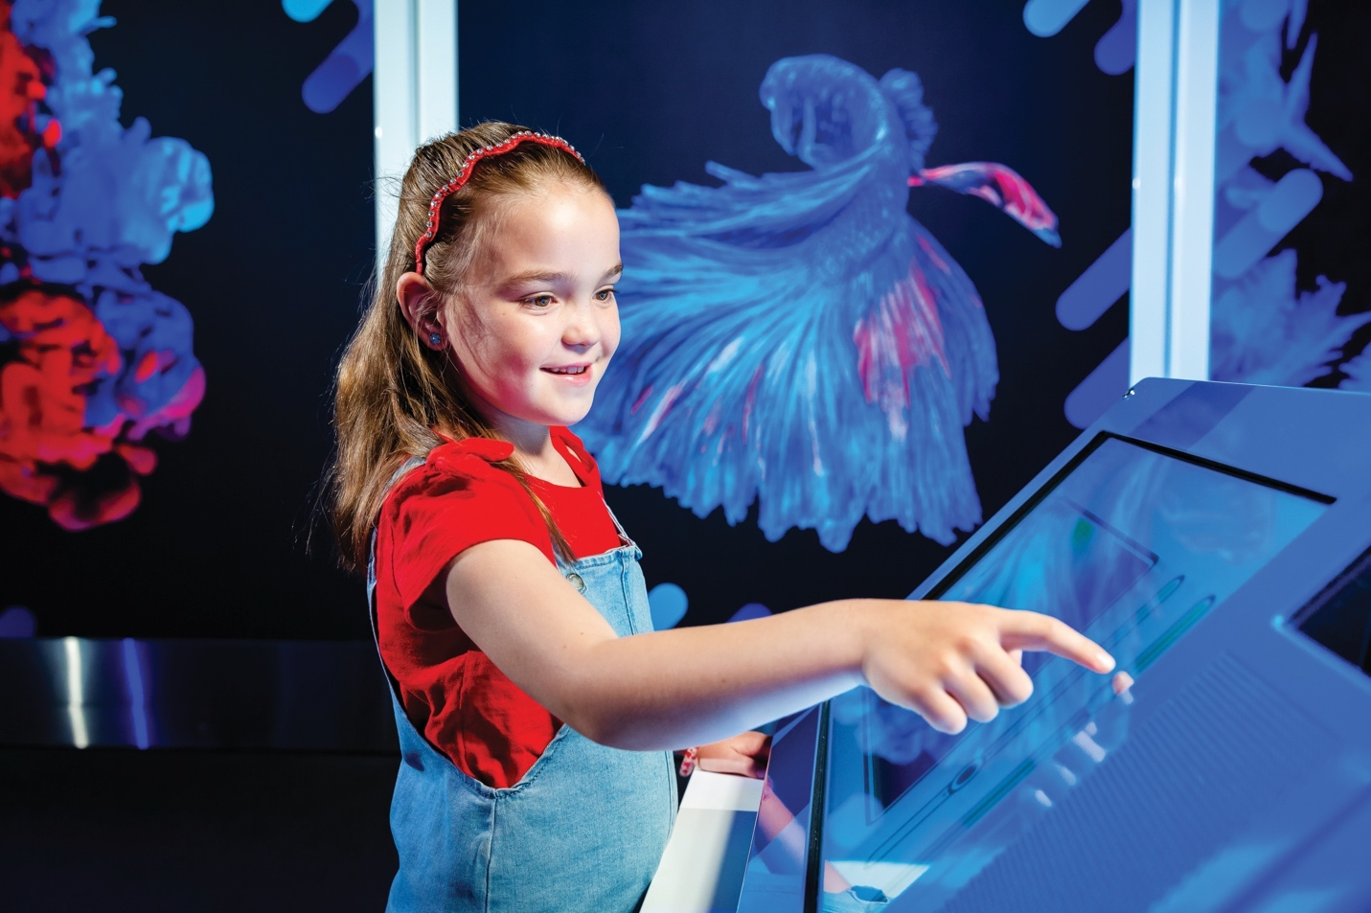
Creativity
Imagination
Enterprise
at and beyond the frontiers
2018 – Year in Review

OUR VISION
A better future for all Australians through engagement with science, technology and innovation.
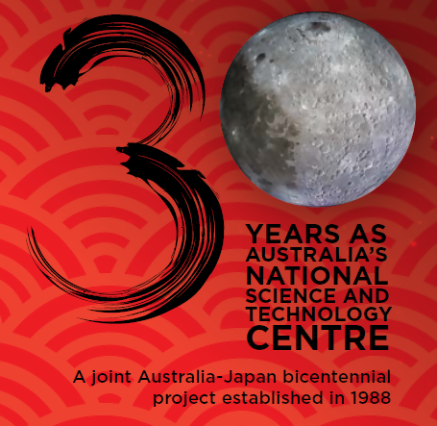

Contents
Questacon Overview 4
Minister’s Introduction 6
Australia’s Chief Scientist Foreword 8
Chairman’s Message 10
Director’s Report 12
Questacon Advisory Council 15
Questacon - The National Science and Technology Centre 17
Questacon’s Centre Activities 32
Powered by Partnerships 38
National Programs 42
Teacher Support Activities 50
Inspiring Australia 53
Digital Engagement 56
International Engagement 59
Science Circus Japan Tour 2018 63
Key Events 65
Tourism Awards 70
Questacon People 71
Vale 76

Questacon Overview
Questacon - The National Science and Technology Centre is an asset of the Australian Government, helping to build a foundation of science engagement. Operating as a division of the Department of Industry, Innovation and Science, Questacon's vision is for a better future for all Australians through engagement with science, technology and innovation. We work with partners and supporters to deliver inspirational learning experiences to young Australians, their teachers, families and communities, and across the globe.
Through our Statement of Authority, we are empowered by the Australian Government to engage, connect and inspire all Australians in science, technology, engineering and maths (STEM) through a journey of lifelong learning. As Australia's economy continually transforms and evolves over the coming generations, our aim is to help inspire, spark curiosity and wonder and equip tomorrow's leaders with the enterprise skills necessary to navigate and flourish in the future world.
Our main Centre in the Parliamentary Triangle in the nation's capital houses more than 200 hands-on exhibits, engaging over half a million visitors each year. The Centre hosts our exhibitions, which includes our most recently installed, Colour exhibition and The Moon.
From our second facility in Canberra, The Ian Potter Foundation Technology Learning Centre, we design, develop and build many of our own exhibitions, working with partner institutions across Australia and internationally. Through these collaborations we work with students, teachers, high school innovators and tomorrow's entrepreneurs. The Ian Potter Foundation Technology Learning Centre is also the base for our national outreach programs. These outreach programs work in partnership with local institutions, teachers, researchers and businesses, to ensure the inspiration from our touring program transforms into an enduring legacy lasting well beyond our visit.

Questacon is responsible for delivering the Inspiring Australia network, in collaboration with all Australian state and territories and governments. Working in collaboration with multiple divisions across the Department of Industry, Innovation and Science, this National Framework for Local Action ensures the outstanding work of passionate individuals and organisations across Australia connects to a broader STEM ecosystem, while remaining relevant to their own community's needs.
As an influential voice in the global science centre community, Questacon is a vehicle for delivering activities to support the Australian Government's science agendas, as well as contributing to the work of the United Nations in a science centre capacity building and implementing the 17 Sustainable Development Goals.
Questacon delivers activities across Australia with support of our partners who are committed to investing in Australia's young people. The organisations Questacon works with share our common vision. Our partners see the value of long-term and sustained investment in the future, with partnerships typically spanning multiple years through a variety of activities and programs locally and nationally. Our partners make our achievements and successes possible.
Questacon is exceptionally proud of our achievements, its staff and volunteers, partners and supporters, and in 2018, we celebrate our 30th year as Australia's National Science and Technology Centre. We look forward to the years ahead as we continue to chase our dream of a better future for all Australians through engagement with science, technology and innovation.

Minister’s Introduction
As an engineer - and the Minister for Industry, Science and Technology - I am passionate about science, technology, engineering and mathematics (STEM). The exciting and endless possibilities of science, technology and innovation are so important for our economy and our quality of life.
Exploring everything from robots and drones to space and spiders, Questacon - The National Science and Technology Centre captures the imaginations of all ages and inspires our future scientists, technologists, engineers and researchers.
During 2018 I had the pleasure of visiting Questacon several times and seeing the opportunities it creates for young people, families, teachers and communities to get excited about science. This included participating in Questacon's 30th anniversary celebration in November.
One of my key priorities is reducing gender inequity in STEM. I am very proud of the opportunities Questacon gives young girls and women to be engaged with science and technology. As our leading national science engagement organisation, Questacon is a critical part of our agenda to ensure all Australians have the opportunity to be inspired by science.
The particular emphasis on STEM engagement through national networks and flagship activities will be of great benefit in ensuring that women and girls are equally engaged in emerging science and technology.
This year has also seen the launch of the Australian Space Agency, an exciting development not only for scientists, but for the nation in general. The Government's aim in establishing the agency is to make Australia a leader in space industries.
Questacon's moon exhibit is an excellent way to open young minds to space - it allows visitors to experience the wonderment of the moon through a quiet immersive experience. The Centre's suspended replica moon also brings home to us that 2019 marks the 50th anniversary of humankind's first steps on the moon.
From early inspiration such as this, our young people can learn about the vital role space technologies play in everyday life and the work of the Australian Space Agency.
I look forward to further cooperation between Questacon and the Australian Space Agency to bring the wonders of our universe to young Australians.
Congratulations to Questacon on this milestone year. I am sure the year ahead will bring even more successes worth celebrating.
The Hon Karen Andrews MP
Minister for Industry, Science and Technology
"As an engineer, I am passionate about STEM education and can personally attest to the benefits of studying these subjects. These skills are so important for securing the jobs of the future for our children and those that have participated in the STEM Xprogram know this."
–– The Hon Karen Andrews MP

Australia’s Chief Scientist Foreword
As Australia's Chief Scientist, I think of myself as an Ambassador of the Future. Unlike most ambassadors, I wasn't born in the place I represent - but I travel there constantly in my mind. It's my job to share some of the potential I've glimpsed and encourage our leaders to keep the interests of our future citizens constantly in view.
Hundreds pass through Questacon's doors every day, travelling, just like me, to that astonishing place that science might one day help us to reach. And there they encounter our A-team of Future Envoys: the passionate, articulate and endlessly creative Questacon staff. For me, as for so many Australians, they are really the staff of our Embassy of the Future in Canberra.
What do I see when I look out to 2048? A zero-emissions planet? Human colonies in space? Healthy centenarians enjoying time with their great-great-grandchildren? Exoskeletons controlled by our brainwaves, giving us super strength and speed?
No one has a crystal ball, because everyone has choices - and the future is ultimately the sum total of all the decisions we make.
Still, as unofficial Future Ambassador, there are two things I'm prepared to say with confidence.
First, educating humans will be always be critical, in any sort of world in which humans would want to live. Yes, we will have to share many of our phenomenal mental abilities with different forms of artificial intelligence; and yes, there are jobs we do today that technology will do far more efficiently tomorrow. But robots can't tell us how to build the society we want. Robots can't replace the incredible package deal of a human brain, a human conscience and a human heart. And robots can't make humans redundant - unless we first give up on ourselves.
When we educate a child, we give them a stake in the future. That won't change. And how will we educate our human children in 2048? That's my second certainty: we'll always need the magic of human teachers.
Just ask the many parents who've had the pleasure of bringing a child to Questacon, and then returned, at that child's insistence, again and again; or the many adults who trace their love of science back to that one special visit from the Science Circus. The magic is the hands-on, human-to-human experience.
Questacon is always tweaking the formula, but for 30 years, the basic ingredients have remained exactly the same. And I promise, it will be just as thrilling for the children of 2048 as it was to their grandparents in 1988.
To all the Future Envoys of Questacon, congratulations. With your help, we'll be proud to call the future home.
Dr Alan Finkel AO
Chief Scientist of Australia
"Surround yourself with people who challenge you, and inspire you."
–– Dr Alan Finkel AO

Chairman’s Message
One of my favourite Chinese proverbs is "When I hear, I forget. When I see, I remember. When I do, I understand". I believe this quote fully captures and embodies Questacon's ethos. For three decades, Questacon has sparked the intellectual curiosity of the nation.
International connections have been integral from the beginning. Thirty years ago, the National Science and Technology Centre started as a joint Australia-Japan Bicentennial Project. Questacon has continued to influence, and be influenced by, the international science centre sector. This sector comprises more than 2,500 centres around the world and attracts more than 310 million visitors annually. Questacon is regarded as a leading example in the sector and, as a result, influences an enormous number of people across the globe.
Under the inspiring leadership of Questacon's Director, Professor Graham Durant AM and Deputy Directors Ms Kate Driver and Dr Bobby Cerini, supported by a team of passionate leaders, staff and volunteers, Questacon continues to invest in delivering creative and inspirational learning experiences for all Australians.
Questacon also reaches out through innovation-themed workshops for students and teachers, taking science on the road in travelling exhibitions that visit communities right around Australia.
Behind the scenes, staff continually conceive and build fresh imaginative exhibitions and develop new programs to provide memorable experiences.
As a leader in its field, Questacon also connects key players and initiatives in science communication to improve coordination of science engagement activities nationally, and share best practice internationally.
I am delighted to report that in 2018, with the support of the Prime Minister and Minister for Industry, Science and Technology, The Q Australia Foundation Ltd was established. Under the leadership of Mr Eddie Kutner, this independent Foundation has the potential to source additional philanthropic funds to support Questacon's valuable science inspiration. The Questacon Advisory Council will continue to work and provide advocacy advice for the Foundation's future activities.
I am proud to say Questacon has consistently achieved its aim and deliver on its mission to excite and motivate people through inspirational learning experiences.
As we celebrate Questacon's 30th year, I am deeply appreciative of the dedication and passion of staff and fellow Council members, whose enthusiasm is at the heart of everything Questacon does to give all Australians a chance to explore science and its place in our lives. It is those people who bring the inspiration of Questacon to life. They are placing the right tools in the hands of our future leaders, but more importantly, they are inspiring those young people to imagine a better future.
My sincere appreciation to the very proactive Members of Council, Mr Eddie Kutner, Dr Gregory Clark AC, the Hon Dr Annabelle Bennett AO SC, Professor Ian Young AO and Professor Karin Barovich, and advisors to the Council from across the Australian Public Service, including the wonderful support of CSIRO Chief Scientist, Dr Cathy Foley and Department of Foreign Affairs and Trade Chief Innovation Officer, Dr Sarah Pearson.
Leon Kempler AM
Chairman, Questacon Advisory Council
“When I hear, I forget.
When I see, I remember.
When I do, I understand.”

Director’s Report
What are science centres really for, and how will they adapt to remain relevant and useful in the future? These are the questions that I have been considering for much of my professional life and for entire time I have had the privilege of being Questacon's Director. This year's 30th anniversary of Questacon, as Australia's National Science and Technology Centre, provided an excellent opportunity to reflect upon Questacon's achievements to date, to consider the relevance of our current activities and to put affirmative plans in place for the future.
Science, technology, engineering and maths will play a vital role in the nation's future. Questacon is an important national asset, not only for exciting, inspiring and motivating young students in Canberra and across the nation, but also because it is well-placed to work alongside the science research sectors so we can share our stories of discovery, endeavour and enterprise.
Our 34-year partnership with Shell Australia and the Centre for the Public Awareness of Science at the Australian National University, enables the Shell Questacon Science Circus to visit students, teachers and families in regional and remote communities. During 2018, new and important partnerships were established with the Australian Space Agency and the University of Canberra.
Partnerships between government, industry, philanthropic sector and science communication organisations will be critical to delivering a national STEM agenda. Australia needs to step-up to realise its full potential so that young people have the knowledge and skills to help them realise their potential, hopes and dreams for the future.
We are very grateful for the support of our partners who make it possible to extend Questacon's reach into the community, supporting students, teachers and families across Australia. In 2018, the establishment of a Foundation to support Questacon activities was a highlight of the Questacon Advisory Council's work.
From the outset, the relationships and links with Japan have been a vehicle for Questacon to drive and focus its international activities, working with global science centres and communities with a central focus on education, youth and the future. Through Questacon's leadership in the Asia-Pacific region of the science centre sector, Science Circus diplomacy has become an incredible asset for Australian-foreign relationships.
National Science Week is a brilliant example of how many different community organisations can come together with government support to raise the profile of science. Questacon plays an important role in encouraging Science Week activities and is proud to have organised the first Governor-General's Design Challenge in the 2018 National Science Week.
The next few years will have a significant focus on space exploration, with Questacon working in partnership with the Australian Space Agency to promote space science education and awareness. The spectacular new Moon exhibit will provide an essential focal point for activities and events.
Encouraging more girls to consider studying STEM subjects and selecting careers in STEM will remain an important part of Questacon's forward agenda, to include the promotion of female role models, including those who work at Questacon.
Questacon's future is assured with such a passionate and committed workforce. It is a privilege to work daily with the team. As Director, I am blessed to work in a world of smiles from staff and visitors alike.
Thinking about Questacon's functions and objectives, leads one to immediately consider the service provided for our members and visitors. Excellent exhibits and science shows form the core of what we offer, however, it is the high quality interaction with our staff that attracts such positive comments through social media. This is a great credit to the front- of-house staff who interact with hundreds of thousands of visitors each year. These interactions are the key element leading to Questacon's success in National Tourism Awards.
Questacon has had some significant achievements over the past 30 years, growing from a small local science centre into a national institution with global reach and influence. The stage is set to power ahead over the next 30 years, as Australia and the world rises to address the global challenges of sustainable prosperity and equality of opportunity. The best is yet to come. We are ready. Just watch us go!
Professor Graham Durant AM
Director, Questacon

Key stats for 2018

Questacon Advisory Council
Questacon Advisory Council Members:
Mr Leon Kempler AM
Chair
Mr Eddie Kutner
Deputy Chair
Dr Gregory Clark AC
Visiting Fellow of the Australian National University
the Hon Dr Annabelle Bennett AO SC
former Federal Court Judge
Professor Ian Young AO
Former Vice Chancellor Australian National University
Professor Karin Barovich
Department of Earth Sciences University of Adelaide
In March 2018, the Questacon Advisory Council farewelled Council member Dr Sarah Pearson, as she was appointed the Chief Innovation Officer at the Department of Foreign Affairs and Trade. In 2019, Professor Elanor Huntington and Ms Jamila Gordon were formally appointed to the Questacon Advisory Council. Professor Huntington and Ms Gordon bring a wealth of knowledge and experience to Council. Throughout 2018, at the invitation of the Chair, Dr Cathy Foley, CSIRO Chief Scientist, Dr Sarah Pearson, Chief Innovation Officer at the Department of Foreign Affairs and Trade, Ms Margaret Leggett, Branch Manager at the Department of Education and Training and Ms Rebecca Manen and Dr Sarojini Mitchell, General Managers at the Department of Industry, Innovation and Science, have attended Council meetings and also continue to serve as advisors to the Council.
Left and centre images: Questacon Advisory Council members and VIP guests attending Questacon’s 30th anniversary gala. Right image: Dr Greg Clark AC, Council Member, Mr Leon Kempler AM, Chairman of Questacon Council, Dr Heather Smith PSM, Secretary of Department of Industry, Innovation and Science and Ms Kate Driver, Deputy Director of Questacon attending the Prime Minister’s Prizes for Science 2017.
Questacon is supported by an Advisory Council appointed by the Prime Minister and Minister. The role of the Advisory Council is to advocate for, and advise, Questacon. Membership is drawn from eminent scientists, academics, business leaders and philanthropists who all share a passion for Questacon's vision and mission.
The Advisory Council members work together to serve as a source of independent advise to the Director and Executive of Questacon, raise the profile and build the brand of Questacon, and engage with stakeholders and advocate for the work of Questacon.
Throughout the year, Advisory Council members attended key events including the National Invention Convention Innovation Showcase in January 2018. The National Invention Convention is a program within the Questacon Smart Skills Initiative. This showcase event provides an opportunity for sponsors and stakeholders to see the creative talents of young entrepreneurs. Council members engaged with the Invention Convention delegates about their creative journeys undertaken to develop and construct their ideas.
On 22 November 2018, Council members attended the 30th anniversary Gala celebrations with Questacon's sponsors, stakeholders, volunteers, associates, staff and members, to acknowledge Questacon's achievements and recognise the valuable partnerships who have made Questacon such a success.
Council Members: Mr Leon Kempler AM, Professor Karin Barovich, Dr Gregory Clark AC, Professor Ian Young AO, the Hon Dr Annabelle Bennett AO SC, Dr Sarah Pearson and Mr Eddie Kutner.

Questacon - The National Science and Technology Centre

30 Years of Australian Science Inspiration
Prior to the National Science and Technology Centre being opened in 1988, Questacon spent its first eight years as a project in an unused space at Canberra's Ainslie Public School between 1980-1988. Founded by Dr Mike Gore AO, 'The Questacon', as it was first known, was staffed entirely by volunteers. The idea for Questacon was inspired by Dr Gore's visit to San Francisco's science centre, the Exploratorium in 1976.
On 11 October 1988, Questacon first opened its doors as Australia's National Science and Technology Centre, and on 23 November 1988, Prime Minister Bob Hawke officially opened the Centre to the public. In 2018, Questacon celebrated its 30th anniversary as the National Science and Technology Centre. Questacon's 30th anniversary acknowledges and celebrates a rich and productive history in science communication, outreach activities and engagement across Australia and globally.
Questacon was established as a Bicentennial project with the support of the governments and business communities of Australia and Japan.
Over 30 years Questacon has welcomed 12 million visitors to the Centre. Questacon has produced countless hands-on exhibits and performed thousands of science shows and demonstrations. Questacon has been a pioneer in many science communication activities, locally, nationally and internationally, connecting with millions of Australians in their own communities including regional and remote Australia, through science engagement and outreach programs such as the Shell Questacon Science Circus and the Questacon Smart Skills Initiative.
The Centre has won six national tourism awards and 14 regional tourism awards, contributing nearly $1 billion to the ACT tourism community.
Through our relationships with science agencies, science centres and museums across Australia, we have inspired countless people across Australia to grow National Science Week as Australia's largest science festival.
Many of Questacon's programs and activities are powered through people and partnerships including our current partners; Shell, Raytheon, Samsung, the Australian National University and The Ian Potter Foundation.
We take the time and opportunity for this special milestone to acknowledge the many successes of the first 30 years, and, importantly, to start the journey of another 30 years to Questacon's future in 2048.
“...this year marks the 30th anniversary of Questacon, Japan’s 1988 bicentennial gift to Australia and a great symbol of our friendship. I'm pleased to announce Australia has gifted three Questacon exhibitions to Japanese museums that participated in Questacon's Science Circus of Japan this year. I hope this gift inspires future generations of scientists."
— Joint press statement by Australian Prime Minister, the Hon Scott Morrison MP and Prime Minister of Japan His Excellency Shinzo Abe, 16 November 2018

30th anniversary gala celebration
On 22 November 2018, more than 700 guests celebrated Questacon's 30th anniversary as the National Science and Technology Centre, with a special ceremony and festivities on offer throughout the Centre. Distinguished guests include the Minister for Industry, Science and Technology the Hon Karen Andrews MP, Japanese Ambassadors, His Excellency Mr Sumio Kusaka and Mrs Ikuko Kusaka, the Governor- General, Sir Peter Cosgrove AK MC (Retd) and Lady Cosgrove, and Questacon Founder, Dr Mike Gore. Questacon's key stakeholders including partners, sponsors and professional associates from local and national organisations, as well as Members of Parliament with close relationships with the Centre, also attended the event to support Questacon's exceptional work over the last 30 years.
Questacon members, staff, volunteers, and friends were treated to a night of gourmet food, spectacular science demonstrations by the Excited Particles and a traditional Japanese drumming performance.
The evening concluded with the launch of Questacon's newest exhibit, Ledusa, by the Governor-General, Sir Peter Cosgrove AK MC (Retd) and Lady Cosgrove.
The Gala included a special showcase, highlighting Questacon's current programs, activities and partnerships which support and promote Questacon's commitment to engage all Australians in STEM through science communication.
Mr Leon Kempler AM, Mr Eddie Kutner, Professor Brian Schmidt AC, Minister for Industry, Science and Technology the Hon Karen Andrews MP, Governor- General Sir Peter Cosgrove AK MC (Retd), Lady Cosgrove, Japanese Ambassador His Excellency Mr Sumio Kusaka and Mrs Ikuko Kusaka, Questacon Executive Ms Kate Driver and Professor Graham Durant AM.

The Questacon Festival
Following the anniversary gala event, on 24 November 2018, Questacon wanted to say thank you to the community, so we opened our doors for a free all-day festival at the Centre, inviting the public to explore and participate in a number of exciting activities. Spectacular science shows were performed with science workshops and crafting stations all around the Centre, with special activities tailored for the early learning visitors. Volunteer staff circulated the Centre's galleries, and a special robot demonstration and interactive play zone were set up in the main foyer. Visitors were captivated by the new exhibition, The Moon, the only one of its kind in the Southern hemisphere.
A range of activities outside the Centre included the Science Circus truck and exhibits on display, in addition to a collection of the Circus' best performances held every 20 minutes. The Festival bought together food and merchandise vendors, a pop-up Q Shop, giant bubble-blowing, as well as the chance to design, make and launch paper rockets with the Maker Project team.
There were a number of other stalls from community organisations such as SciScouts, Citizen Science Project, Australian Space Agency, and Rat Patrol. Throughout the day, there were 8,925 visitors to Questacon setting a new record in visitation numbers.

Aunty Agnes Shea, Ngunnawal elder,
‘Welcome to Country’at the Questacon Festival.

The Original Exhibits
As part of Questacon's celebrations, our exhibition and production teams completed extraordinary work in upgrading and acknowledging the original exhibits, which were part of Questacon's journey from the very first day. Some exhibits such as the Earthquake Lab, have seen significant transformations throughout the years but remains a favourite for many visitors.

The original Gravitram, 1988, created by Shab Levy.

Another of these original exhibits is the Gravitram, which continues to stand proudly in the foyer welcoming visitors to the Centre. In 1988, Gravitram 5, as it was originally named, was built by Shab Levy from Levy Design Inc, Oregon, USA. It was the fifth and tallest version ever attempted at that time and, during 2018, was updated with full refurbishment replacing and updating the graphics and mechanical track system. Questacon's Gravitram features additional tricks and rapid descent tubes using helical construction, and swinging and rotating gates which had not been attempted before. You can view the history and story of Shab Levy's Gravitram online at www.gravitram.com.
Individual 30th anniversary plaques now acknowledge these original 16 exhibits:
- Gravitram
- Whispering Dishes
- Angry Arms
- Harmonograph
- Frozen Shadows
- Bubble Tower
- Corner Reflections
- Polarised Light
- Slow Flow
- Gravity Well
- Earthquake Lab
- Bernouli Blower
- Hand Batter
- Swinging Rings
- Small Jacobs Ladder
- Speed Ball.

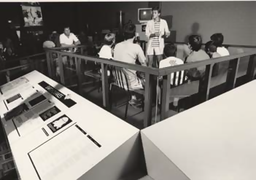
The Earthquake Lab, transforming over time 1988-2018.

Ledusa
The new Ledusa exhibit and light installation in Questacon's main foyer celebrates Questacon's 30-year milestone, and looks to where Questacon will be in the next 30 years. Designed and developed by Questacon's Production team, this exhibit was officially launched by the Governor-General, Sir Peter Cosgrove AK MC (Retd) and Lady Cosgrove at the 30th anniversary gala celebration. The Ledusa provides an immediate visually stimulating impact as people first arrive in the foyer, enhancing each visitor's expectations of Questacon and the sensations they will experience in the Centre.
The exhibit is designed in an arrangement of 45,000 LED lights forming a chandelier from the ceiling.

Karakuri Puppet Restoration
In 1988 the Japanese Government and business community gifted two traditional Karakuri puppets to the Australian people. The puppets' original function and operation was to demonstrate Japanese culture and technology to Australians through Questacon's Science and Technology Centre.
One of the traditional puppets remain on display in Questacon's foyer, while the mechanical puppet has not been on display since the early 1990's. In preparation for Questacon's 30th anniversary an assessment of the mechanical puppet was completed. Curators from the National Museum of Australia provided support in the assessment focusing on restoring the 'injured' puppet to enable a basic level of non-synchronised movement.
Questacon's Production team completed a restoration and upgrade to repair and replace parts essential to the integrity of the puppet. In addition, a mobility base was built so the puppet can be used and displayed for special occasions through the use of its mechanical pulley system.
The story of our Karakuri puppets has been shared with the Japanese Embassy in Canberra and stakeholders in Japan including the original puppet makers.

1980-1990
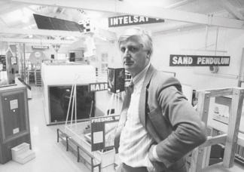 | 18 SEPTEMBER 1980 – The birth of Questacon  Questacon opens as an Australian National University project with 15 exhibits in spare space in the old Ainslie Public School in Canberra. The name Questacon is created by Professor Chris Bryant, ANU. ‘Quest’ means ‘to search, to discover’. ‘Con’ means ‘to study, to examine’.
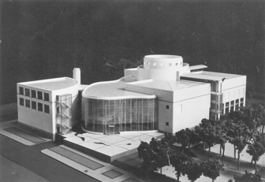 | JULY 1982 – The concept for a national science centre  The Australian Bicentennial Authority proposes that the Australian Government establish a national science centre to encourage learning about science and technology. The proposed national science centre would be a lasting memorial to the 1988 Bicentenary of Australia.
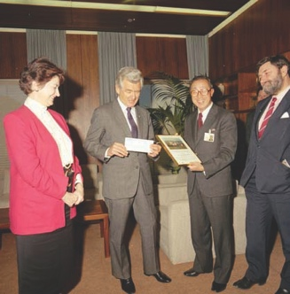 | 4 SEPTEMBER 1984 – Announcement to establish a national science centre  On 4 September 1984, the Minister for Science and Technology, Barry Jones, the Minister for Territories and Local Government, Tom Uren, and the Minister for Home Affairs and Environment, Barry Cohen, jointly announce the Government has agreed to start negotiations to establish a national science centre as a Bicentennial Project.
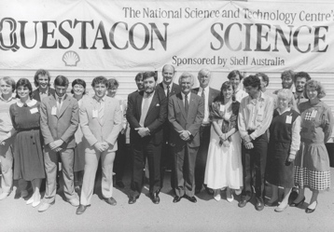 | 1985 – Shell Australia sponsors the Science Circus  In 1985, Shell Australia comes on board as the major sponsor, with an honorary name change to the Shell Questacon Science Circus. In 1987, Shell Australia agrees to sponsor the Circus for five years.
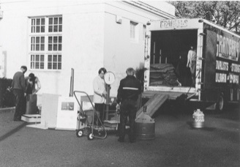 | JULY 1985 – Questacon on the road  The first iteration of the Science Circus takes the hands‑on experience of Questacon to communities and schools outside the nation’s capital. Staffed by 10 energetic young Questacon explainers who are studying at the Australian National University, the Science Circus transports 25 portable exhibits to Goulburn, New South Wales.
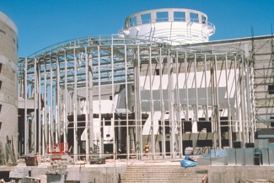 | JUNE 1986 – Construction begins  The Australian and Japanese governments agree to start construction of Questacon. Japan donates one billion yen, half the construction cost as a major Bicentennial gift to Australia. The first sod on site is turned by Prime Minister, the Hon Bob Hawke MP.
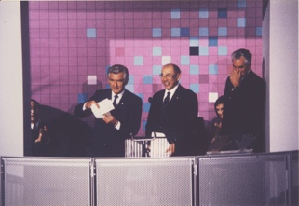 | 23 NOVEMBER 1988 – Centre officially opens  Questacon – The National Science and Technology Centre is officially opened by the Prime Minister, the Hon Bob Hawke MP, with the first exhibitions including Dinosaurs Alive, IBM Mathematica, Force and Waves. Operated by 58 staff, Questacon attracts 365,132 visitors in the first eight months.
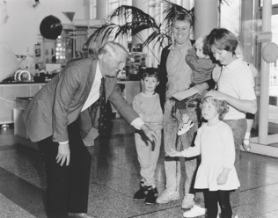 | SEPTEMBER 1989 – Launch of Questacon Membership scheme  The membership scheme is launched by the Chief Minister of the ACT, Ms Rosemary Follett MLA. In less than a year, by 30 June 1990, there were 412 memberships, covering approximately 1,500 people.
1991-2000
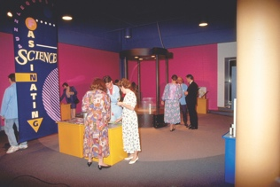 | MARCH 1992 – Fascinating Science exhibition opens  The Fascinating Science exhibition opens with more than 60 exhibits.

1992 – ABC Eureka Prize for Promotion of Science

Professor Mike Gore and Questacon are awarded the ABC Eureka Prize for the Public Promotion of Science.
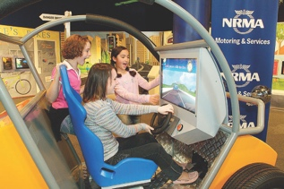 | 1994 – NRMA Tomorrow’s Drivers travelling exhibition  Questacon’s exhibition, NRMA Tomorrow’s Drivers, is developed in the Centre and launched as a new travelling exhibition.
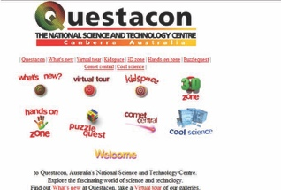 | MAY 1995 – Questacon online  Questacon’s website is launched with interactive online activities, making Questacon one of the world’s first science centres to create ‘virtual interactives’.
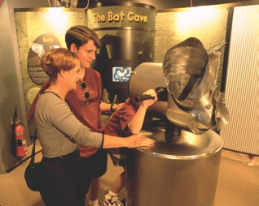 | SEPTEMBER 1996 – BHP WildScience exhibition opens  Questacon’s biggest and most ambitious exhibition to date, BHP WildScience, is launched at the Centre. BHP WildScience is developed with $2 million in sponsorship from BHP and in collaboration with 14 Australian science centres and museums.

JANUARY 1997 – Science on the Move exhibition

Deputy Prime Minister, the Hon Tim Fischer MP, launches Science on the Move, with promotion from local media sponsorship including Prime TV, Radio FM 104.7 and 2CA.

FEBRUARY 1998 – Taking flight

Flight is officially launched by world renowned balloonist, Mr John Wallington. The launch is broadcast live nationally from the Flight gallery on Channel 9’s The Today Show.
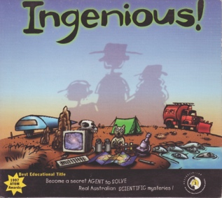 | MAY 1998 – The Ingenious!  The Ingenious! CD‑ROM developed by Questacon, the ABC and Radiant Productions, is launched in May 1998. Ingenious! was awarded best educational title by the Australian Teachers of Media.
2001-2010
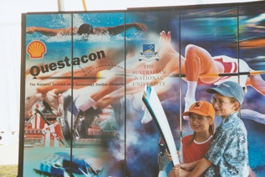 | JUNE 2000 – Questacon at the Olympics  Questacon participates in the Sydney 2000 Olympic torch relay celebrations around Australia and the Sydney 2000 Olympic Games at Homebush. The Shell Questacon Science Circus presents shows on the science behind sport in the Olympic Games main Stadium.
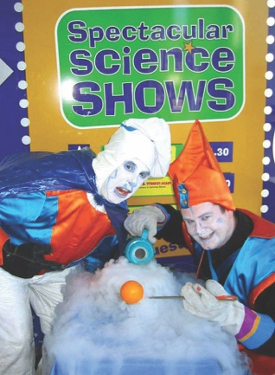 | 1 SEPTEMBER 2000 – The Questacon Excited Particles are founded  With a flash of light and a rather loud bang, Questacon’s in‑house performance troupe, the Excited Particles is formed.
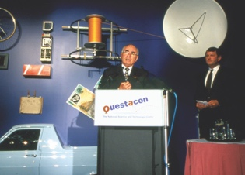 | 24 JANUARY 2001 – Clever Country  To celebrate Australia’s Centenary of Federation, Prime Minister, the Hon John Howard MP, opens the exhibition, Our Clever Country.
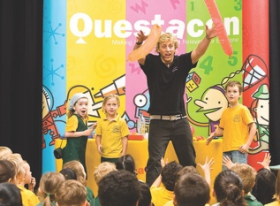 | MARCH 2001 – Questacon Science Squad established  Based in Sydney, the Questacon Science Squad starts delivering in‑school presentations to inspire students to take a positive interest in science.
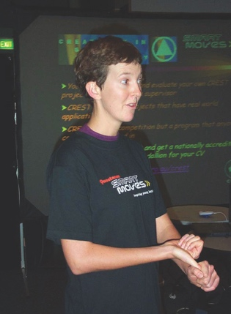 | 21 FEBRUARY 2002 – Questacon Smart Moves begins  The Questacon Smart Moves outreach program, a national strategy to inspire scientific innovation and entrepreneurship in young Australians, is launched by Minister for Communications, Information Technology and the Arts, Senator the Hon Richard Alston.
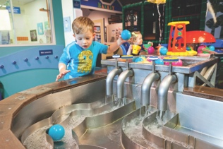 | 15 DECEMBER 2004 – Questacon goes mini  Mini Q – Fun for 0–6 year olds is launched by Dorothy the Dinosaur from The Wiggles. Mini Q introduces younger children to a stimulating and tactile environment, helping them develop coordination and confidence.
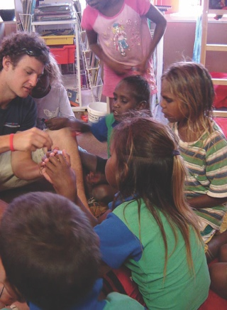 | DECEMBER 2005 – Science Lines program launched  Specifically developed with Indigenous communities in remote areas, the Science Lines outreach program aims to develop scientific literacy in Indigenous communities and increase student retention rates for science and maths courses.
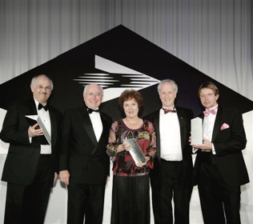 | 2006 – Prime Minister’s Awards for Excellence  Questacon, the Shell Companies in Australia and the Australian National University joint partnership receives the Special Award – Longevity at the 2006 Prime Minister’s Awards for Excellence in Community Business Partnerships for the Shell Questacon Science Circus.
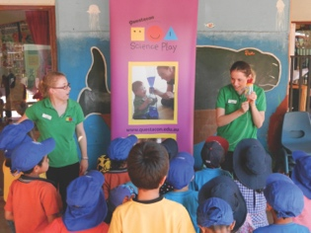 | JANUARY 2007 – Questacon Science Play program launched  Questacon Science Play is launched. This early childhood travelling program delivers play‑based science sessions for young children and their parents, educators and carers in regional and metropolitan areas.
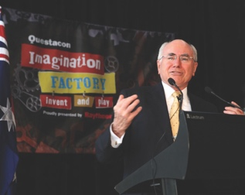 | JUNE 2007 – Imagination Factory exhibition launched  The Prime Minister the Hon John Howard MP, launches the Imagination Factory exhibition. A partnership with Raytheon Australia, this exhibition allows visitors to explore simple machines and how they can be put together to create more complex machines.
 | MARCH 2008 – Science Time program commences  The Excited Particles launch the Science Time interactive program for 3–6 year olds.
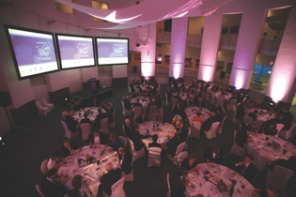 | DECEMBER 2008 – 20th anniversary  Questacon’s 20th anniversary celebration is launched by Minister for Small Business, the Hon Craig Emerson MP, and Japanese Ambassador, His Excellency Mr Takaaki Kojima. Anniversary events include the:  - gala dinner hosted by the Minister for Innovation, Industry, Science and Research, Senator the Hon Kim Carr  - visit to Questacon by Dr Mamoru Mohri, Executive Director of Miraikan and Japanese astronaut  - visit by Master Shobei Tamaya IX, a 9th generation Karakuri Ningyo craftsman and last remaining Karakuri master
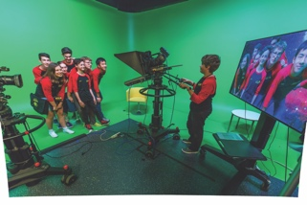 | MARCH 2009 – Digital Studio  Questacon’s reach becomes truly global with the completion of Questacon’s digital studio. The digital studio is a world‑class video filming and production studio and a hub for interactive videoconferences linking schools from around the world with Questacon.
2011-2017
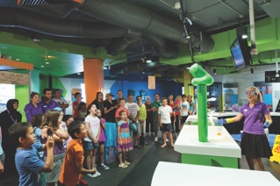 | SEPTEMBER 2011 – Q Lab opens  Q Lab is opened at Questacon, bringing a new approach to the Centre’s exhibitions.
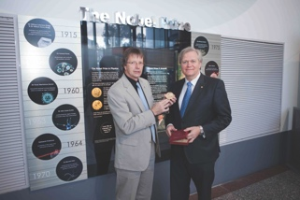 | JULY 2012 – Nobel Prize Medal display  Professor Brian Schmidt AC presents his Nobel Prize Medal to Questacon for permanent display in the foyer.
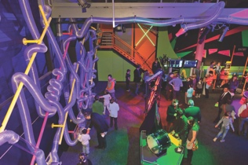 | MARCH 2012 – Excite@Q exhibition opens  After 10 years as Questacon’s most popular exhibition, Sideshow is closed in to make way for Excite@Q.
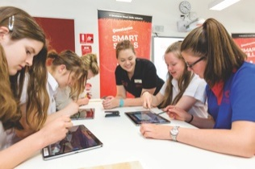 | 2014 – Questacon Smart Skills Initiative  The Questacon Smart Skills Initiative program is funded by the Australian Government and The Ian Potter Foundation, and formally named The Ian Potter Foundation Technology Learning Centre.
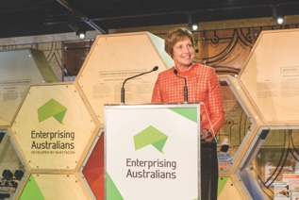 | 26 JUNE 2014 – Enterprising Australians  A new exhibition, Enterprising Australians, is launched at The Ian Potter Foundation Technology Learning Centre by the Secretary of the Department of Industry, Ms Glenys Beauchamp.
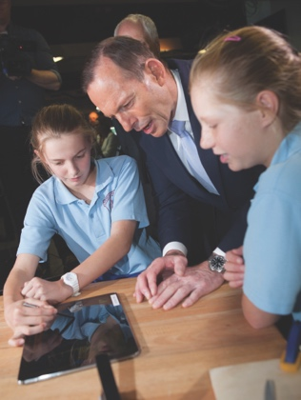 | 29 OCTOBER 2014 – The Ian Potter Foundation Technology Learning Centre Opens  Located next to the Royal Australian Mint, the Questacon Technology Learning Centre is officially opened by the Prime Minister, the Hon Tony Abbott MP.
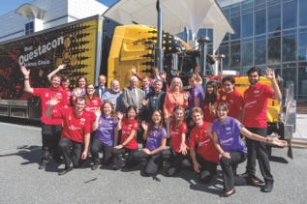 | 2015 – Shell Questacon Science Circus celebrates 30 years  The Shell Questacon Science Circus celebrates 30 years as Australia’s flagship science centre outreach program. From the very beginning, Shell has supported the Science Circus as principal sponsor and this award‑winning partnership between Questacon, the Australian National University and Shell Australia has lasted 30 years – a remarkable and rare achievement.
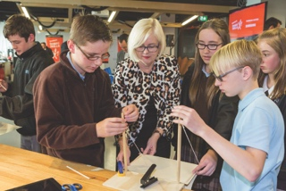 | FEBRUARY 2015 – Samsung Technology Partner  In February 2015, Samsung comes on board as Questacon’s Technology Partner. The partnership aims to inspire and motivate the next generation of Australian technology creators and entrepreneurs.
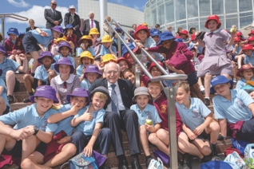 | 13 OCTOBER 2015 – Questacon Walks of Wonder launched  Questacon Advisory Council Chair, Mr Leon Kempler, hosts Prime Minister the Hon Malcolm Turnbull MP and former Prime Minister the Hon John Howard MP at Questacon to launch the Walks of Wonder named in honour of Mr Howard.
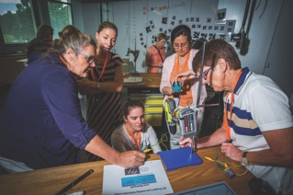 | 10–15 JANUARY 2016 – STEM X Academy  The new STEM X Academy is launched, developed by Questacon and the Australian Science Teachers Association (ASTA) to bring teachers together.
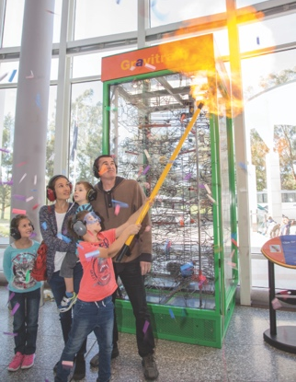 | 31 MARCH 2017 – 11 millionth visitor  Questacon welcomes our 11 millionth visitor to the Centre. The lucky boy visiting from interstate with his family is presented with a prize pack and takes part in a demonstration featuring a hydrogen balloon explosion and confetti cannons.
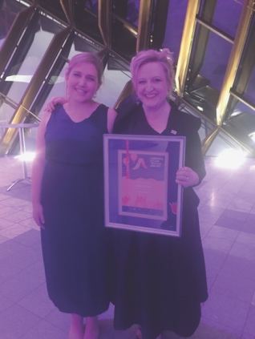 | 17 NOVEMBER 2017 – Canberra Region Tourism Awards  Questacon is honoured to win the Best Tourist Attraction category at the 2017 Canberra and Capital Region Tourism awards for the 13th consecutive year.
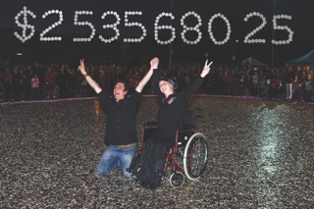 | 11 MAY 2017 – Big Heart Project  Through Questacon’s support, The Big Heart Project was a fundraising initiative by the Love Your Sister foundation, which overall, raised more than $2.5 million for cancer research at the Garvan Institute of Medical Research.
2018 and beyond
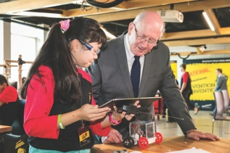 | 22 JANUARY 2018 – Governor-General at National Invention Convention  The Governor‑General, Sir Peter Cosgrove AK MC (Retd), visits The Ian Potter Foundation Technology Learning Centre to meet the 25 delegates of the 2018 National Invention Convention.
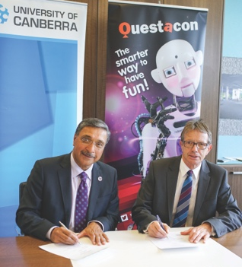 | 1 FEBRUARY 2018 – University of Canberra partnership renewed  Questacon renews its partnership agreement with the University of Canberra, providing the opportunity for collaboration in tourism research, economic impact studies, early childhood education, and science communication activities.
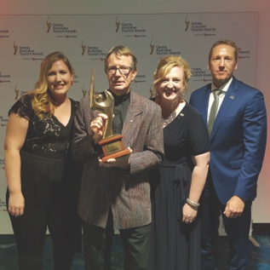 | 28 FEBRUARY 2018 – National Tourism Awards  Questacon wins Gold in the Tourism Attraction category for the 2017 Qantas Australian National Tourism Awards for the second consecutive year.
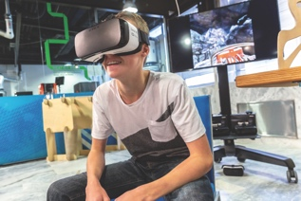 | 4 MAY 2018 – Samsung Partnership Renewal  Questacon and Samsung renew our technology partnership for the Questacon Smart Skills Initiative. Questacon and Samsung hold a roundtable discussion on the role of creativity in STEM at The Ian Potter Foundation Technology and Learning Centre.
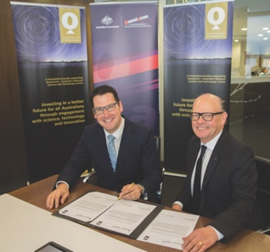 | 21 MAY 2018 – Q Australia Foundation  Assistant Minister for Science, Jobs and Innovation, the Hon Senator Zed Seselja and Chairman of the Q Australia Foundation, Mr Eddie Kutner, acknowledge the establishment of the Q Australia Foundation.
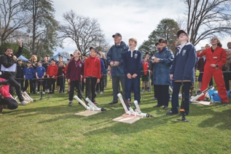 | 15 AUGUST 2018 – Governor-General’s Rocket Design Challenge  Governor‑General, Sir Peter Cosgrove AK MC (Retd) and Lady Cosgrove celebrated National Science Week by launching the Governor-General’s Rocket Design Challenge. The inaugural event invites 100 local school students to participate and spark ideas in design and technology by making their own paper rockets. Using pressurised air, students launched their inventions on the lawns of Government House.
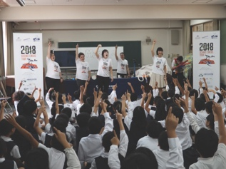 | OCTOBER–NOVEMBER 2018 – Science Circus Japan Tour 2018  In partnership with the Centre for Public Awareness of Science (Australian National University) and the Osaka Science Museum, the Science Circus tours western Japan, delivering science shows to 4,700 students from 12 Japanese schools in addition to exhibitions in regional communities. Through the support of the ACT Government, Nara City and a number of Japanese science centres, the tour is a success in capacity building between Australia and Japan science communicators.
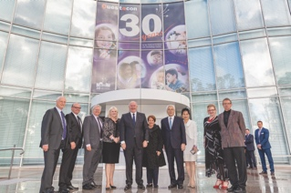 | 22 NOVEMBER 2018 – Questacon’s 30th anniversary celebration  Celebrating 30 years as the National Science and Technology Centre, 720 invited guests attend the formal ceremony with many festivities held throughout the Centre. Distinguished guests include the Minister for Industry, Science and Technology, the Hon Karen Andrews, Japanese Ambassadors, His Excellency Mr Sumio Kusaka and Mrs Ikuko Kusaka, the Governor General, Sir Peter Cosgrove AK MC (Retd) and Lady Cosgrove and Questacon Founder, Dr Mike Gore AO.
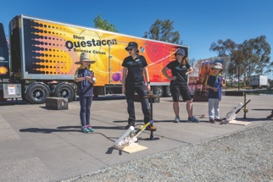 | 24 NOVEMBER 2018 – Questacon Festival  For Questacon’s 30th anniversary, an all‑day festival opens the Centre to the public at no cost, inviting visitors to learn, engage and explore through a number of science activities. The festival was a great success with a record 8,925 visitors.
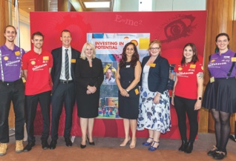 | 28 NOVEMBER 2018 – Shell Partnership Renewal  Questacon and Shell renew our partnership for the Shell Questacon Science Circus. The special event was launched by Minister for Industry, Science and Technology the Hon Karen Andrews MP at Parliament House.

Questacon’s Centre Activities
Questacon - The National Science and Technology Centre is located in Canberra's Parliamentary Triangle. Attracting more than 12 million visitors since opening in 1988, Questacon has welcomed at least three generations of Australians to be inspired and engaged with hands-on learning, enquiry and wonder.
The Centre showcases and brings to life the fundamental phenomena that make up our world through exhibitions, presentations and workshops, science shows, demonstrations and special events. Questacon is a leading Australian tourism destination, as well as a much-loved school excursion highlight for hundreds of thousands of the Australian students who travel to Canberra each year.
The Centre is open 364 days a year, with a visitor satisfaction rating of 95 per cent. The dedicated staff and volunteers who work in the Centre every day look forward to welcoming generations to come.

The Moon Exhibition
Over the centuries, people have used the moon as a timekeeper, a calendar and for navigation. Throughout history the moon has inspired artists, poets, scientists, writers and musicians around the world. Different cultures around the world have their own historical, cultural, scientific and religious relationships with the moon. In the lead up to the 50th anniversary of the Apollo 11 moon landing, The Moon exhibition was installed in Gallery 8, and officially launched on 13 November 2018.
The Moon exhibition is a quiet, contemplative space where visitors can slow down and observe the seven-metre sculpture of the Earth's nearest celestial neighbour. Questacon's spiral ramp surrounding the Gallery enables views from all angles as visitors move throughout the Centre.
Created by United Kingdom artist, Luke Jerram, The Moon features detailed imagery of the southern hemisphere lunar I surface taken by NASA's Lunar Reconnaissance Orbiter. At a scale of 1:500 000, each square centimetre of the sculpture represents five square kilometres of the real lunar surface.

Visitor Experience
In 2018, Questacon's visitor satisfaction rating achieved record-breaking results of 95 per cent. This amazing feat was achieved by offering a suite of new public events and activities, introducing new customer service initiatives, and developing innovative methods to manage congestion during peak periods.
In addition, the Questacon's Visitor Services team delivered continuous positive customer service by applying strategies learnt through the Customer Engagement Certificate III course. The team has actively driven community engagement, attracting new audiences to the Centre by holding specialised events throughout the year. Events such as the Little Explorers' Day, Sunset Drinks during the Enlighten festival and Questacon's Mid-Winter Nights have brought more than 7,000 visitors through the Centre's doors.
The Questacon Disability Confidence Champions Group and Visitor Services team partnered with the Marymead Autism Centre to deliver two Autism Access days in 2018. The Centre opened early exclusively for families connected with Marymead Autism Centre, with Questacon and Marymead working together to create the best experience for our visitors with autism. This involved staff training, creating sensory maps, developing a tailored science show and modifying some of the exhibits. The Centre also held a Vision Access day working with Vision Australia, supporting visitors with specialised needs.
In May 2018, the Membership team partnered with the Learning Programs and Digital Teams to deliver May for Members. This program offered 19 exclusive events and activities to Members, including Members' high tea, Volunteer Showcase Tours, Tinkering by Light and a film documentary Lions, Icebergs and Drones.

Questacon Retail
Q Shop continues to be a consistent source of educational, fun and innovative STEM products. The Q Shop promotes hands-on science activities by leveraging Questacon's ability to reach and engage with more people in science and technology at home and in the classroom.
A trip to the Q Shop is an energetic and effervescent experience. Groups visiting the Centre can schedule a visit to the shop, further enhancing the visitor experience. Product development ramped up in 2018 with a special range of commemorative merchandise with a nostalgic feel to help visitors celebrate and reminisce the past 30 years at Questacon.
The online Q Shop has spent considerable time developing and sourcing specific products that link to the national science curriculum. We have expanded and connected with more educators around Australia, demonstrating how these products could be used as teaching tools.
Q Shop proudly supports local businesses. During 2018, Q Shop collaborated with several local businesses including Rosebury Street Bakehouse, Enigma Chocolates and Shirty Science, to develop unique and relevant products for Questacon.
Q Shop is very proud of this year's initiative in collaborating with social enterprise, Pollinate Energy, in the development of a solar light, with all profits raised going to help eradicate kerosene lamps around the world. This aligns with Questacon's aim of supporting and promoting the United Nations Sustainable Development Goals.
Head to Questacon's online store at shop.questacon.edu.au.

Questacon Members
Questacon's membership program (Q Club) was launched by the ACT Chief Minister, Ms Rosemary Follett MLA, in September 1989. The program provides deeper engagement with science. In 2018, members received invitations to attend special programs and events throughout the year, recognising their support and contribution to the Centre.
The Q Club strives to provide the best experience for our members by maximising value and flexibility. A Q membership provides unlimited entry to Questacon, discounts at the Q Shop and Cafe, a complimentary free pass, exclusive invitations to members-only events, and discounts to Questacon's School Holiday Program.
In 1989, less than 12 months after the program started, Q Club had 412 memberships covering approximately 1,500 people locally and nationally. Since then, more than 200,000 people have been Questacon members for at least one year. In 2018, Q Club exceeded our record number of new and returning members, reaching 21,000 memberships across every state and territory for the first time.
As part of Questacon's 30th anniversary program, Q Club invited members to May for Members month, delivering a full program of exclusive special events.
- Scavenger Hunt
- Lions, Icebergs and Drones with film maker, Abraham Joffe, ACS
- Members High Tea
- Ice-creamology
- The Tequila Show - the science of mezcal
- Volunteers Showcase
- Drawing Competition
- Tinkering with Light
- Mission Control - an evening with NASA astronauts
- Living Universe movie preview
- Whale Snot - An evening with Vanessa Pirotta
- Lego Robotics Workshop
“My family and I thoroughly enjoyed the May for Members month. It was exciting and informative. I was thrilled for my children to absorb different elements of science over the month. It made the membership price absolutely worth it for the year.
A highlight was the Lions and Drones discussion - such an amazing opportunity to be able to meet Abraham and I felt so proud that Questacon had contributed to the African work he has been involved in. I like to think that just a few dollars of our fees had been included in the expedition so that we had been a part of it too!"
— Audience member from the Lions, Icebergs and Drones event

Powered by Partnerships

The Ian Potter Foundation
The Ian Potter Foundation has been Questacon's Principal Partner since 2014, working together to deliver the Questacon Smart Skills Initiative. This flagship STEM program allows Questacon to inspire and empower young people across Australia by engaging them with technology, innovation, design and entrepreneurial learning experiences.
The Questacon Smart Skills Initiative started in 2015, thanks to the $7.8 million grant from The Ian Potter Foundation. Questacon's second facility, The Ian Potter Foundation Technology Learning Centre, was named in recognition of this generous grant and is the hub for our outreach activities and exhibition development and fabrication.
These engaging STEM programs encourage young people to develop an interest and passion in STEM and see how STEM intersects with their everyday lives. The Questacon Smart Skills Initiative has delivered inspirational hands-on workshops to more than 57,700 students and teachers across Australia.
Questacon Director, Professor Graham Durant AM,
Governor-General Sir Peter Cosgrove AK MC (Retd),
Ian Potter Foundation CEO, Mr Craig Connelly with
National Questacon Invention Convention delegates.

Samsung
Samsung and Questacon have been working in partnership since 2014 to inspire and motivate the next generation of Australian technology creators and entrepreneurs. In 2018, Samsung and Questacon renewed our Technology Partnership for a further two years.
As Questacon's Technology Partner, Samsung's support allows us to incorporate the latest technology into Questacon Smart Skills in-school workshops and teacher workshops, and into the hands of thousands of students and teachers. The workshops seamlessly blend technology and hands-on activities to encourage students and teachers to engage in STEM in a variety of ways and shift their perceptions about what STEM means.

Shell Australia
Shell Australia is Questacon's longest-standing corporate partner, having worked together for 33 years to deliver the Shell Questacon Science Circus across Australia. This program is one of the world's longest running science outreach programs, engaging and inspiring young people and their communities in STEM.
This partnership, along with the support from the Australian National University, has allowed the Shell Questacon Science Circus to reach more than 2.2 million Australians, with visits to more than 500 towns and 90 remote Indigenous communities.
The Shell Questacon Science Circus aims to inspire young people, particularly in regional and remote areas of Australia, to value and engage with STEM and the possibilities and career opportunities these fields present.
On 28 November 2018, Shell, Questacon and the Australian National University held a Partnership Renewal Event in the Great Hall at Parliament House, announcing Shell will be the Principal Partner of the Shell Questacon Science Circus commencing in 2019.

Australian National University
The Australian National University is the Founding Partner of the Shell Questacon Science Circus and, through the Centre of Public Awareness of Science, has worked in partnership with Questacon and Shell to deliver 33 years of the Science Circus. The 16 Masters of Science Communication (Outreach) students studying at CPAS deliver the Science Circus program across the country as part of their practical fieldwork course components.
Having worked together since 1985, Questacon and the Australian National University have seen more than 400 students graduate from this program and go on to contribute to the national and international capacity of science communication professionals.

Raytheon
Raytheon and Questacon have worked together for more than a decade across a variety of STEM programs and exhibitions. In 2017 and 2018, Raytheon supported Questacon to deliver the Australian pilot of the Engineering is Elementary program.
This program, developed by the Museum of Science, Boston, provides primary school teachers with a framework to deliver STEM content using engineering activities. Raytheon's support of this program in Australia allowed 147 teachers from 46 schools across four states and territories to be trained in delivering at least one Engineering is Elementary unit and implement the content in their own classrooms.

National Programs
Questacon's outreach and national programs operate out of The Ian Potter Foundation Technology Learning Centre. Whether students are travelling to Canberra for hands-on innovation workshops or Questacon teams are travelling to schools and communities across Australia, Questacon outreach and national programs operate every week to inspire tomorrow's entrepreneurs, scientists and innovators.
In 2018, Questacon delivered programs in partnership with local institutions, teachers, researchers and the Inspiring Australia network to reach every Australian state and territory. These noteworthy collaborations support Questacon to transform moments of inspiration into an enduring legacy of engagement with science, technology and innovation.

Questacon Smart Skills Initiative
Australia's future as a knowledge economy depends on emerging generations combining foundation skills in STEM with enterprise skills including creativity, problem solving and critical thinking, to succeed in the changing future workforce. The Questacon Smart Skills Initiative engages with young people through a range of national programs to develop these core innovative skills.
The initiative delivers hands-on, inquiry-based workshops to students across Australia, building supportive environments to invite students to learn from their failures and develop the skills necessary to succeed in their emerging careers. It also offers accredited teacher workshops and youth-focused enterprise education activities, creating networks within communities, and leaving behind a legacy of STEM engagement. Participation in these programs encourages greater skills-development and confidence in design thinking, ideation, prototyping and working with technologies.
Regional engagement is a cornerstone of the Questacon Smart Skills Initiative. Questacon aims to foster STEM activity in regional and remote areas, inspiring students and the wider community to see how STEM fits into their everyday lives, and inspiring young people to pursue STEM careers, no matter their location.
The Questacon Smart Skills Initiative is made possible through support from Principal Partner, The Ian Potter Foundation and funding from the Australian Government.

Smart Skills Student Workshops
Questacon Smart Skills delivers free workshops in schools throughout regional Australia, immersing students in creativity, design thinking and problem solving. By encouraging students to play with technology and prototype new ideas, these workshops engage and challenge them to find the innovator within.
The hands-on workshops expose students to the process of innovation through set challenges. Each workshop equips students with the confidence to test and refine ideas through digital and physical prototyping, developing the logical and creative thinking skills students need to tackle problems across the curriculum and beyond.
In 2018, the Smart Skills program engaged 7,645 students across Victoria, Queensland and New South Wales.

Smart Skills Teacher Professional Learning Workshops
Smart Skills incorporates a teacher support program, acknowledging that while Questacon staff can inspire hundreds of students within a school, a teacher can inspire thousands. These Teacher Workshops motivate teachers to combine digital technology with hands-on learning, encouraging them to implement inquiry-based activities and equipping them with the tools and knowledge to bring more STEM into the classroom.
In 2018, Smart Skills Teacher Workshops delivered in-person and via videoconference engaged 410 teachers across Victoria, Queensland and New South Wales.
Smart Skills Student and Teacher Workshops are supported by Technology Partner, Samsung Australia. Incorporating Samsung technology into the workshops provides an opportunity for teachers and students to learn how to harness the power of smartphones and tablets to innovate, design and experiment.
“It was a great experience that helped me realise that I have the capability to problem solve in more than just theoretical realms."
— Smart Skills participant

Questacon Invention Convention
The Questacon Invention Convention is an intensive multi-day workshop that gives secondary students a practical insight into innovation and entrepreneurship. Working with Questacon facilitators, local innovators, STEM professionals and entrepreneurs, students turn their ideas into reality and make connections between STEM skills and the impact STEM has in their own communities. In 2018, the Questacon Smart Skills Initiative delivered three regional Invention Conventions in Gippsland, Townsville and Armidale, as well as our National Questacon Invention Convention in Canberra, reaching a total of 82 young innovators across Australia.
The 2018 National Questacon Invention Convention brought together 25 delegates from six states and territories, as well as three ambassadors - delegates from the previous year who returned to share their skills and mentor the new cohort. The week-long event provided an opportunity for delegates to build confidence in prototyping their own ideas around a central theme of 'Future Earth'. Delegates were inspired by guest speakers including designers, entrepreneurs and scientists to consider the challenges humanity might face over the coming decades, and to create inventions to support these issues.
Governor-General, Sir Peter Cosgrove AK MC (Retd) visited the 2018 delegates during their final prototyping session. His Excellency spoke to each delegate about their prototypes and concluded his visit by awarding the 2018 Innovation Ambassadors with medallions.
In 2018, regional Invention Conventions returned the focus back to the participants' local community, challenging them to consider the issues they care about, and prototype innovative solutions to real challenges identified by members of the local community from and across Australia.
This year, the STEM Network Showcase hosted representatives from nine previous Invention Convention delivery partners, to share experiences and enhance capability in regional STEM providers.
“There are so many possibilities of where you can go, and what you can learn.... Your small contributions can really help the world and the people in it"
— Armidale Invention Convention delegate

Maker Project
Questacon Maker Project workshops explore creative thinking using simple tools, materials, and emerging technology. With targeted activities for school students in Years 6-12, these free, two-hour workshops support classroom education through links to the Australian Curriculum.
Delivered by a team of professional facilitators in the purpose-built Maker Space at The Ian Potter Foundation Technology Learning Centre, this national program exposes visiting students to the innovation principles of need, think, make, try and refine. In 2018, this program reached every Australian state and territory, with 89 per cent of Maker Project participants visiting from interstate.
For schools unable to visit The Ian Potter Foundation Technology Learning Centre, Maker Project virtual excursions allow students access to hands-on STEM workshops via videoconference into classrooms around Australia. In 2018, the Maker Project engaged 6,967 students and 660 teachers in hands-on workshops and virtual excursions.
“I learned that you can try anything and even if you fail you can try it again and try to improve."
— Maker Project participant
Image: Enterprising Australian, Ms Olympia Yarger

Enterprising Australians
All over the country, everyday Australians are working busily from their studios, laboratories, sheds and kitchen tables to create brilliant enterprise opportunities and commercial innovations. The Enterprising Australians digital exhibition shares their stories to help young people discover real-world innovation happening in their neighbourhood.
Enterprising Australians showcases contemporary and relatable examples of innovation in the form of short videos featured on Questacon's website and through digital and social media. This digital exhibition highlights how the innovators developed their ideas, the problems they encountered and the way they solved them, to help others understand how they too can bring an idea to life.
Since the digital platform was launched in September 2016, the stories have amassed more than 55,000 online views. Some 2018 Australian innovators include:
Hamish Finlayson (Townsville, QLD)
Living with Autism Spectrum Disorder (ASD), Hamish is passionate about using his ICT skills to promote understanding of autism. He has developed an app that helps users experience aspects of what it is like to live with ASD.
Sandra Eadey and the community of Uralla (Uralla, NSW)
Sandra is the president of Z-NET Uralla, a group of volunteers who are working towards making Uralla Australia's first zero net energy town. Z-NET's vision is to assist the people of the Uralla Shire, including local businesses, property owners and families, to transition to energy self-sufficiency and participate in the unfolding revolution in energy technologies.
Olympia Yarger (Canberra, ACT)
Who knew maggots could turn out to be the key to revolutionising how we think about waste and protein sources? Olympia's vision is to provide an affordable solution to turn food waste into sustainable livestock feed.
Follow the stories of these Enterprising Australians, and others online at www.questacon.edu.au/outreach/programmes/questacon-smart-skills-initiative/enterprising-australians

Shell Questacon Science Circus
The Shell Questacon Science Circus is one of the most widely travelled and recognised science outreach programs in the world. For the past 33 years, the Science Circus has travelled throughout regional and remote Australia, bringing science to local communities.
The Shell Questacon Science Circus strives to inspire and engage all Australians through interactive pop-up science centres, school incursions, professional learning workshops for teachers and specialist programs for Indigenous audiences.
The Science Circus also forms a major component of the Australian National Centre for the Public Awareness of Science's Master of Science Communication Outreach. In 2018, 16 graduates took part in the Shell Questacon Science Circus to complete their Master's degrees. The qualification offers students the opportunity to develop their science communication skills through practical experience. Shell Questacon Science Circus presenters have gone on to work with science centres, research and development organisations, media organisations, government and industry in Australia and overseas.
In 2018, the Shell Questacon Science Circus toured to the Australian Capital Territory, New South Wales, Queensland and Victoria - visiting more than 340 schools, attracting 63,584 students, and engaging a total of 83,493 people.
Shell Australia is Questacon's longest standing corporate partner, working together with our delivery partner the Australian National University, for more than three decades to inspire generations of young Australians and their communities in science. The partnership is one of the longest standing corporate sponsorships in Australian history and underlines the vision of long-term, inter-generational investment in the critical skills for Australian industry. The Shell Questacon Science Circus is now looking to 2019 and beyond, continuing to build strong relationships with partners and redesigning its offerings to remain the gold standard in science outreach for decades to come.
“Our staff were reflecting on the recent Questacon visit to Echuca and to our school and we just wanted to express our deep appreciation for the outreach service that you offer. The shows in our school, the professional development run for staff in the town, and the show at the local basketball stadium were all excellent and we felt privileged to have all of this in our own backyard."
— School Principal, Victoria
“Today my Ayr old brought 5 friends here for his 12th birthday party..[Port Macquarie exhibition]. ...They all loved it."
— Parent, New South Wales

Travelling the country for 33 years
In July 1985, the first iteration of the Science Circus hit the road. Staffed by 10 energetic young Questacon explainers, the Science Circus hired a removalist truck and took portable interactive science exhibits to Goulburn, New South Wales. In 1988, the Shell Questacon. Science Circus set up a new base of operations at the just opened National Science and Technology Centre.
The Centre was, and continues to be, a well-equipped and perfectly positioned site for Science Circus scholars to refine their craft and learn from countless experts and audience members. The creation of the Centre has been integral in enabling the Shell Questacon Science Circus to have a truly national reach and ongoing impact. Over the past 33 years this innovative Science Circus has become the most travelled and farthest-reaching program of its kind in the world. At the core is a drive to inspire young people, primarily in regional areas of Australia, to value and engage in science, technology, engineering and mathematics, and the possibilities and varied career options these fields present.
More than 400 Science Circus program alumni have gone on to work with science centres, research and development organisations, media organisations, government and industry, both in Australia and overseas. Over the lifetime of the program the Science Circus has reached more than 2.2 million people with multiple visits to more than 500 towns and 90 remote Indigenous communities.

“Lots of interaction between presenters and students. Great hands-on activities - very engaging!”
— Teacher
“The Shell Questacon Science Circus gave me the opportunity to look deep within myself to see my strengths, my weaknesses and ultimately, that I could make a difference to children’s lives"
— Science Circus presenter

Teacher Support Activities
Questacon's Learning Experiences team continues to support teachers through our professional learning activities, equipping them with the skills and confidence to deliver engaging, hands-on science and technology activities in their classrooms. By building the capacity of teachers in their classrooms, we are able to increase the legacy of our touring national programs and foster STEM activity in regional and remote areas of Australia.
Our partnerships with other institutions have allowed us to extend the reach and impact of our teacher professional learning programs. In 2018, we worked with a range of organisations including the Australian Science Teachers' Association, the Science Educators' Association of the ACT, the Design and Technology Teachers' Association, the University of Canberra, CSIRO, and the Museum of Science, Boston.
The Learning Programs team is committed to developing STEM capability in a truly integrated way - embracing the concept that STEM is not merely an acronym for science, technology, engineering and mathematics, but rather as an approach to education that places 21st Century skills at the forefront of learning and the application of knowledge across diverse content areas.

STEM X Academy
The STEM X Academy is a partnership between the Australian Science Teachers' Association, CSIRO and Questacon. It aims to engage teachers in STEM education in order to further develop their capacity as science teachers.
In January 2018, 70 teachers from all states and territories in Australia participated in the five-day program. STEM X also welcomed back two alumni participants, returning to the 2018 event to share their experiences as STEM leaders in their school communities. Our 30th anniversary saw a continued partnership with CSIRO, allowing the program to continue the expanded engagement with industry and researchers, which began in 2017.
STEM X not only gives teachers new tools and resources to integrate STEM into their classrooms, but also promotes a network of STEM experts across the nation. Teachers from STEM X Academy actively swap ideas and collaboratively brainstorm content over social media and in person at other events such as CONASTA (the annual science education conference of the Australian Science Teachers' Association).
With more than 300 applications for STEM X 2019, the program continues to be highly sought after as a place for teachers to connect with science and technology organisations and be introduced to new ways of approaching STEM implementation in their classroom and across their school communities.

Engineering Is Elementary
Following the successful pilot of Engineering is Elementary program, Questacon delivered the program for a second year to primary school teachers across Australia in 2018. Engineering is Elementary was developed in 2003 by the Museum of Science, Boston, and is delivered exclusively in Australia by Questacon with the support of Raytheon Australia. Questacon piloted in the program in 2017, with teachers participating from Australian Capital Territory, New South Wales, South Australia and Queensland.
Engineering is Elementary is a whole-of-school approach for teachers with and without specialised skills in science, engineering and maths. Using engineering design challenges to engage students, the program builds confidence, skills and content knowledge to enable teachers to deliver STEM lessons. This provides real-world examples of STEM content and showcases potential workforce opportunities for primary school students.
Engineering is Elementary aims to remove the barriers of teaching STEM in the classroom. In conjunction with South Australian teacher, Charlene McGrath, all the Engineering is Elementary units were mapped to the Australian Curriculum Learning Areas and General Capabilities, and further support resources were created. In addition, Questacon provided a resource kit to all teachers undertaking the Engineering is Elementary professional learning. The kit contained all the materials they needed to teach the unit in their classroom.
The delivery of Engineering is Elementary as a professional learning unit increased teachers' confidence in STEM. After the workshops, 92 per cent of teachers reported feeling confident in their understanding of engineering, and most teachers reported an increase in how science, technology and engineering interrelate.
“[The workshop made] the teaching of engineering less daunting and more easily accessible for classroom teaching."
— Workshop participant

Supporting Local Schools And Community
Through 2018, Questacon broadened visibility and support for local schools and the community.
Questacon's Teacher Professional Learning team has taken hands- on inquiry activities in STEM to staff and young people in the Bimberi Youth Justice Centre. These activities continue the learning experiences for young people aged between 10 and 21 years, and the staff that support these young people. Additionally, the team has been working with special needs students and educators at Malkara School in Canberra and Mater Dei Special School in Sydney.
Questacon has also brought together Canberra-based STEM teacher professional learning organisations to develop a professional learning community that will provide coordination and support activities to local and national teachers of STEM.

Inspiring Australia
The National Science Statement sets out the Government's vision for an Australian society engaged in and enriched by science. Inspiring Australia plays a key leadership role in this vision, supporting and funding coordinated and consistent science engagement activities at a national level.
Since 2010, Questacon has played a pivotal role in implementing Inspiring Australia's national framework for the delivery of local initiatives across the nation. Questacon works with local communities, science and research agencies, education providers, industry and business sectors, cultural and community organisations and many others, to support Inspiring Australia in facilitating opportunities for millions of Australians to get involved in STEM activities such as after-school science clubs, science events and tours of local industry and universities.
Using a 'National Framework - Local Action' approach, Inspiring Australia seeks to support effective, systematic, high impact and coordinated science engagement activities. Inspiring Australia harnesses the strengths of the science engagement community, builds on existing achievements and addresses the challenges of national coordination to reduce duplication of effort across Australia.
It does this by:
- developing stakeholder networks to improve awareness of existing activities, identifying gaps,
- and leveraging non-government support for science engagement and advocacy
- promoting nationally consistent approaches to science engagement and advocacy
- supporting evidence gathering and evaluation to identify activities suitable for scaling-up
- identifying partnerships and linkages to address priority needs and communities
- facilitating year-round opportunities for targeted audiences.
The Questacon Inspiring Australia team worked closely with colleagues across the Department of Industry, Innovation and Science throughout 2018 in delivering the Inspiring Australia - Science Engagement Program suite of funding measures supporting Australian engagement with STEM.

National Science Week 2018
National Science Week runs annually as a nationwide celebration of science and technology. It highlights Australian science and innovation and provides opportunities for the community to participate in science engagement activities, locally and nationally. The 2018 event marked the 21st anniversary of National Science Week.
In August 2018, National Science Week was launched by Prime Minister the Hon Malcolm Turnbull MP and Minister for Jobs and Innovation, Senator the Hon Michaelia Cash, during a CSIRO STEM in Schools event at Kent Street Senior High School in Perth, Western Australia. The Perth high school supported previous winner of the 2016 Prime Minister's Prize for Secondary Science Teaching, Suzy Urbaniak, in the development and launch of the Centre of Resources Excellence (CoRE) science program, and was specifically chosen by the Prime Minister for the location of the National Science Week 2018 launch.
Key achievements during National Science Week 2018 included:
- 1.2 million people participated with 21 per cent of all Australians aware of National Science Week
- $600,020 national grant round funded with 45 projects delivered online and in all states and territories
- 3,130 press, TV, radio and online media stories, with an estimated cumulative audience of 32.4 million people and an estimated media value of $7.64 million
- 23,000 tweets using Science Week hashtags
The Inspiring Australia - Science Engagement Program also supported many long-running partnerships for National Science Week, and our Inspiring Australia team worked closely with the Australian Science Teachers Association, the ABC and CSIRO to deliver major projects and enable regional participation.

As a result:
- educators and students got involved - all preschools, primary schools and high schools received updates from the Australian Science Teachers Association, and 365 schools received small grants to deliver Science Week projects. The 2018 Australian Science Teachers Association free schools resource, the 80-page book, Game Changers and Change Makers, is available online.
- Libraries contributed 340 events, more than double the number from 2017. These events included talks by authors, hands-on activities, story times for young children, coding, virtual reality, robotics and exhibitions.
- The ABC delivered the Virtual Reef Diver citizen science project, with 61,000 people participating. The broadcaster also featured science content across its networks, including a special channel on iView, many science-related interviews on Radio National, and Science Week content for educators. In addition, Search for Second Earth premiered on ABC TV in National Science Week as well as Unsung Secrets, a series of short stories shared online.

Digital Engagement
Questacon is recognised globally by a broad audience as a clever, connected and creative organisation fuelled by excellence in the delivery of digital STEM and engagement, with the ability to travel externally to attend science activities and produce informative videos for children, adults, teachers and stakeholders.
Our multidisciplinary Digital Engagement team provides Questacon and our partners with access to industry leading video production and online services, with a mission to develop digital media and online content - supporting Questacon's activities and outreach programs to enhance science engagement.
Projects range from pre- and post-video production and large-scale live events to videoconferencing and connecting people around the world. Questacon continues to create networking and partnership opportunities through the use of high-speed, HD and 4K production capabilities, through our state of the art broadcast studio and live theatre.
Throughout 2018, the Digital Engagement team partnered with organisations including GeoScience Australia, Enterprising Australians, the Australian National University and Shell Australia. Through these partnerships, a number of special projects were completed and showcased on Questacon's website and Youtube channel including a series of carbon dioxide experiments filmed with a special CO₂ Camera, eight new Enterprising Australian stories, and a collection of science stories from rural and remote communities highlighting Australian innovation.
Each month, Questacon live-broadcasts sessions from the Schmidt Studio for the Young Australian's Plan for the Planet program, to primary schools across Australia. Through the support of the Australian National University and the United Nations Information Centre (Canberra), the program focuses on promoting the United Nations Sustainable Development Goals nationally and internationally - with the Australian pilot launching in 2017, the Mauritius pilot commencing in 2018 and a number of South-Pacific countries currently developing their program strategies.
The Digital Engagement team also supported a wide range of internal and external coordinated events in Questacon's theatre including:
- Indigenous Science Conversations - NAIDOC Week 2018
- The Sun Rises for Free - Professor Albert Polman
- Whale Snot! - Marine Biologist Vanessa Pirotta
- Lions Icebergs and Drones - Natural Science Cinematographer Abraham Joffe
- The Rotary Science Forum
- Royal Aeronautical Society Eminent Speaker Series
- Marc Andre Bernier - Underwater Archaeologist
- The Making of Questacon - Mike Gore, Founder and Graham Durant, Director.
Collaborating with other teams, the Digital Engagement team produced a variety of professional videos for internal and external use, and advocacy content for formal presentations. Throughout 2018, key projects included:
- filming and producing a video on the Governor-General's Rocket Design Challenge as part of National Science Week 2018
- producing an advocacy video for Questacon's 30th anniversary celebration on the restoration of the Karakuri Puppet, highlighting the Questacon-Japan relationship
- filming and producing a promotional video for the Shell Questacon Science Circus, in partnership with Shell Australia
- filming and editing videos for Questacon's Colour exhibition, for the colour blindness, colour deficient and synesthesia exhibits.

International Engagement
As Australia's National Science and Technology Centre, Questacon has a responsibility to be a contributor on the international stage, sharing good practice and showcasing the capabilities of the Australian science centre sector to the world. We use our position in the world science centre sector to provide leadership in science engagement and informal learning in Australia and around the world.

International Science Centre And Science Museum Day 2018
On 10 November 2018, for the third consecutive year, Questacon joined the world's community to promote diversity and inclusion by participating in International Science Centre and Science Museum Day (ISCSMD) 2018. Each year, ISCSMD is themed around the United Nations 17 Sustainable Development Goals, as the largest annual joint project launched by the world's science learning institutions.
The 2018 ISCSMD was united with the United Nations World Science Day for Peace and Development. Questacon's activities embraced the theme 'Science is a Human Right' to celebrate the 70th anniversary of the Universal Declaration of Human Rights (Article 27). We welcomed families of Canberra's diplomatic community, engaging them in science demonstrations and experiments in our Centre, jointly exploring how society uses science, technology, innovation, and individual action to help solve the planet's challenges.

Young Persons' Plan for the Planet
Commencing in 2016, the Young Person's Plan for the Planet first piloted in Australia, connecting secondary and senior school students to develop a strategic plan addressing global issues. The program is led and directed by The Crawford School of Public Policy at the Australian National University and supported by Questacon. The program has been structured around the United Nations 17 Sustainable Development Goals and is expected to run to 2030. The program seeks to empower, connect and harness the enthusiasm of senior school students through the development of strategic plans addressing global issues in their local context.
In 2018, the Young Australians' Plan for the Planet connected with 262 students from 15 schools across Australia through live broadcasting sessions filmed in Questacon's Schmidt Studio. During the year, students from participating schools embraced the program as future designers and implementers of our sustainable future Earth, developing and implementing plans against the Sustainable Development Goals for each Australian state and territory.
In July 2018, the Young Mauritians' Plan for the Planet was piloted with 120 students from 10 schools, through the support of the Rajiv Gandhi Science Centre, Mauritius. Following the launch, the national plan was developed and distributed to all Mauritius Members of Parliament. The Young Persons' Plan for the Planet held its first international conference, It's our Future Earth, in November 2018 at the Mauritius Rajiv Gandhi Science Centre, bringing together delegates from the Australian and Mauritius programs and the Australian National University.

International Exhibitions
We develop and produce exhibitions for display in the Centre to travel across Australian locations, and to travel around the world. In 2018, Questacon exhibitions travelled internationally reaching an estimated 376,535 people domestically and an estimated 280,036 people globally.
The Mathamazing travelling exhibition was on display at the Guangdong Science Centre in Guangzhou, China from February to July 2018.
The Science on the Move travelling exhibition was on display at the Daejeon National Science Museum in South Korea from January to March 2018. The exhibition was then hosted by Korea's Daegu National Science Museum from March to June 2018.

International Delegation Visit Highlights
- Between 19-24 January 2018, Questacon welcomed back Professor Pelle Persson, CEO of Per Edvin Persson Consulting Ltd and previous CEO of Heureka Science Centre, and Lesley Lewis, the previous CEO of the Ontario Science Centre, to undertake a Peer Review of Questacon.
- On 24 January 2018, Professor Albert Polman, of the Amsterdam University, the Netherlands, performed a theatrical science demonstration with lasers and how the world could be powered by the sun.
- On 12 April 2018, Mr Ju Han Kim, President of the Daegu National Science Museum, South Korea, visited the Questacon Centre and The Ian Potter Foundation Technology Learning Centre.
- On 23 April 2018, Ms Manal Ataya, Director-General of the Sharjah Museums Authority, United Arab Emirates, visited Questacon.
- On 5 May 2018, Michael Frawley, CEO of the Museum of Transport and Technology, New Zealand, visited Questacon.
- On 15 May 2018, Questacon welcomed the Executive delegation from the Japan Aerospace Exploration Agency (JAXA) - Vice President, Mr Masato Nakamura, accompanied by the Japanese Embassy Minister, Mr Takashi Katae Deputy Chief of Mission. The delegation viewed Questacon's newest exhibition, The Moon, and discussed our Apollo 11 anniversary celebrations and our vision for the display of the Hayabusa I and II models, donated by JAXA.
- On 30 August 2018, Questacon's Executive welcomed Ms Noriko Miyagawa, Japanese Vice-Minister for Education, Culture, Sports, Science and Technology and the Japanese Embassy Minister, Mr Takashi Katae, Deputy Chief of Mission, to Questacon to discuss participation of women in STEM pathways.
- On 27 October 2018, Questacon Director, Professor Graham Durant hosted the Japanese Mayor of Nara City, Mr Gen Nakagawa, to Questacon on a tour of the Centre. Professor Durant and Mr Nakagawa also attended the Canberra Nara Candle Festival.
- On 8 November 2018, Questacon's Executive met with Professors from the Shanghai Jaio Tong University, China, hosted by the University of New South Wales for a tour of The Ian Potter Foundation Technology Learning Centre.
- In November 2018, the Japanese Ambassador, His Excellency Sumio Kusaka, Japanese Minister and Deputy Chief of Mission, Mr Shutaro Ohmura, visited Questacon for a gifting ceremony with Mary-Ann O'Loughlin AM, Deputy Secretary of the Department of Industry, Innovation and Science and Questacon's Director, Professor Graham Durant AM. Also present were Executive representatives from the Department of the Prime Minister and Cabinet, Department of Foreign Affairs and Trade, Woodlands and Wetlands Trust, to present a gift to the Ambassador acknowledging the strong Australia-Japan relationship as well as the continuing collaboration between Australian and Japanese science centres and the legacy of the Science Circus Japan Tour2018.
- On 18 December 2018, Professor Durant and Dr Cerini hosted Ms Fedora Zulkifli, CEO of Science Discovery Centre, Petrasains, Kuala Lumpur for a tour of the Questacon Centre and Deakin facilities.
Questacon Karakuri puppet and Robo Q, taking a selfie in Questacon-style on International Selfie Museum Day 2018.

Science Circus Japan Tour 2018
The Shell Questacon Science Circus, toured western Japan as part of our 30th anniversary year supported by grants from the Australia-Japan Foundation and the ACT Government. The tour was to acknowledge the Japanese contribution to the founding of the National Science and Technology Centre in 1988 and it aligned with the Australian Government's Australia Now, 2018 Country of Focus for Public Diplomacy, with the priorities to expand interpersonal and institutional links through programs and partnerships based on people-to-people exchanges.
The tour was supported by two key partners, the Centre for Public Awareness of Science (CPAS) at the Australian National University, and the Osaka Science Museum in Japan. Other partners supporting the tour included Nara City in the 25th year of the Canberra-Nara sister city relationship, Nagoya City Science Museum, Kochi MIRAI Science Center, the Japanese Science Museums Association, Morioka Children's Science Museum and Misawa Aviation and Science Museum, Nara University High School and Osaka Municipal Central Library.
The Japan tour was launched on 12 October 2018, at Osaka City Hall by Mr Takeshi Kagita, Vice Mayor for Osaka City, Ms Peta Arbuckle, Education and Science Counsellor from the Australian Embassy in Japan, Mr Kazuhide Ishikawa, Kansai Region Ambassador, Ministry of Foreign Affairs of Japan, Mr Andrew Barr MLA, ACT Chief Minister, Dr Yoshihiko Saito, Director of Osaka Science Museum and Mr Craig Whelan, Senior Manager of Questacon.
A total of 29 Australian and Japanese science communicators attended intensive science theatre training across two days before public shows commenced. Two science shows (the Extraordinary Science of Everyday Objects, directed by Dr Graham Walker from CPAS, and Questacon's Music Show) were modified to incorporate new content from the Japanese science communicators.
In Nara City, the touring staff visited three schools and held a public science exhibition at Nara City Hall. The Mayor of Nara City, Mr Gen Nakagawa had previously visited Questacon in Canberra along with 80 students from Nara City University High School on the occasion of the Canberra-Nara Candle Festival.
The Science Circus Japan Tour 2018 then visited the Nagoya City Science Museum and the MIRAI Science Centre in Kochi. In every venue there were enthusiastic audiences and Japanese television media crews. The visits to Osaka, Nara City, Nagoya and Kochi cemented Questacon's strong relationship with Japan through the Science Circus, with a combined vision to engage all people in science, technology and innovation. In all, 4,700 students from 12 schools were able to experience the joint presentations from Australian and Japanese science communicators.
“Because I, the Director of Osaka Science Museum, have learned the Questacon spirit, Osaka Science Museum will change."
— Dr Yoshihiko Saito

Key Events
STEM X Academy
8-12 January 2018
The STEM X Academy is a joint initiative of the Australian Science Teachers Association, Questacon and CSIRO. In 2018, 70 teachers attended the five-day residential, professional development workshop, increasing the teachers' confidence and ability in teaching of STEM education in the classroom.
National Questacon Invention Convention
15-19 January 2018
The Questacon Smart Skills Initiative delivered the 2018 National Questacon Invention Convention. The 25 delegates received training and mentoring over a five-day program from Questacon staff as well as entrepreneurs, researchers and local businesspeople who shared their skills, experiences and stories of personal and professional achievements.
Governor-General visit to the National Questacon Invention Convention
22 January 2018
The Governor-General, Sir Peter Cosgrove AK MC (Retd), visited The Ian Potter Foundation Technology Centre to meet the 25 delegates of the 2018 National Questacon Invention Convention, talking with each delegate about their ideas, prototypes and future aspirations.
University of Canberra Partnership
1 February 2018
Questacon established a formal partnership agreement with the University of Canberra, providing the opportunity for collaboration in tourism research, economic impact studies, early childhood education, and science communication activities.

UNESCO International Day of Women and Girls in Science
11 February 2018
Questacon in collaboration with Science and Technology Australia, hosted the Minister for Jobs and Innovation the Hon Michaelia Cash, for this UNESCO event.
Community Access Days
11 February and 30 June Autism Access
16 September Vision Access
Questacon opened the Centre for community members with special needs in February, June and September 2018. Collaborating with Vision Australia and the Marymead Autism Centre, the Centre made specific adjustments to cater for the needs of visitors to improve their experience with the exhibitions and shows.
Superstars of STEM
13 February 2018
Questacon hosted the Superstars of STEM breakfast for the newly announced 2018 Superstars of STEM. Minister for Jobs and Innovation the Hon Michaelia Cash attended the breakfast coordinated by Science and Technology Australia.
Little Explorers Day
26 February 2018
Questacon dedicated a day for its youngest visitors aged 0-6 years, and their carers, to explore the Centre without the 'big kids'. The day featured a number of community group displays including ACT Playgroups, Canberra Bushwalking Club, Kidsafe, Australian Breastfeeding Association, Nature Play CBR, PANDSI, Child and Family Centres, Libraries ACT and Child Development Service.
National Tourism Awards
28 February 2018
Questacon won Gold in the Tourism Attraction category at the 2017 Qantas Australian Tourism Awards. This was the second year Questacon received this national prize.
Final Balloon Flight
16 March 2018
The Hon Senator Zed Seselja, previous Assistant Minister for Science, Jobs and Innovation and Professor Graham Durant embarked on the final balloon journey for the Questacon Balloon at the Canberra Balloon Aloft Festival. The Senator was invited take part in the inflation of the balloon and participated in the hour long flight over Canberra's Parliamentary triangle and Lake Burley Griffin.
Science Time 10th Birthday
17 March 2018
Science Time provided interactive learning experiences for little scientists aged 3-6 years. For over 10 years, the program has inspired 121,795 people, encouraging children and their carers to get hands-on with science to spark curiosity and develop questioning skills in a friendly environment.4
Questacon and Samsung Partnership Renewal and Panel Discussion
4 May 2018
Questacon and Samsung celebrated the extension of our technology partnership by hosting a panel discussion in the Maker Space at The Ian Potter Foundation Technology Learning Centre. The panel was joined by an audience of educators, students, academic and industry representatives to discuss creativity, STEM and future opportunities.
Establishment of the Q Australia Foundation
21 May 2018
The Q Foundation was established by a group of Australian philanthropists who wish to support the activities of Questacon, as an investment in the future of the Australian STEM workforce. Mr Eddie Kutner, Chair of the Q Australia Foundation and Assistant Minister for Science, Jobs and Innovation the Hon Zed Seselja, attended a ceremonial signing to acknowledge the formation of the Q Australia Foundation.
National Aboriginal and Torres Strait Islander Children’s Day
4 August 2018
Questacon celebrated National Aboriginal and Torres Strait Islander Children's Day with a community fun day. Canberra families who work with The Smith Family's Growing Healthy Families visited Questacon. Visitors had the opportunity to participate in cultural workshops on modern weaving techniques and boomerang making with local Indigenous leaders, Yvonne Norris and Richie Allen.
IPAA Innovation Awards
7 August 2018
Questacon hosted the presentation ceremony and showcase event for the IPAA Innovation Awards. These awards were created to recognise and celebrate the innovative work which occurs in the public space, to share innovative approaches across Commonwealth and ACT Governments. The trophies were designed and made by Questacon's production team, which were awarded by the Hon Senator Zed Seselja.

Indigenous Science Conversations
15 August 2018
Questacon partnered with, and hosted the National Environmental Science Programme (NESP) to host a conversation on Indigenous Science, as part of 2018 National Science Week. The event held a panel discussion with representatives from NESP, Indigi Lab and the Australian National University's National Centre for Indigenous Studies.
Governor-General’s Design Challenge
15 August 2018
The inaugural Governor-General's Rocket Design Challenge was launched at Government House during National Science Week2018. More than 100 students from 27 schools in Canberra designed, constructed and tested their paper rockets using pressurised air. The event was attended by a number of VIPs including the Governor-General, Sir Peter Cosgrove AK MC (Retd), Lady Cosgrove and Anthony Murfett, Deputy Head of the Australian Space Agency. The event was supported by delivery partners Canberra Deep Space Communications Complex, Research School of Physics and Engineering Australian National University, Mt Stromlo Observatory Australian National University, Geospatial Intelligence, University of New South Wales Canberra, and the Civil Aviation Safety Authority.
“[National Science Week] is a week where we stop to think how important science is to our lives... In so many ways it makes our lives so much better. It is the key to our future. Who knows what amazing things lie ahead?"
— Governor-General, Sir Peter Cosgrove AK MC (Retd)
Royal Australian Mint launches commemorative AC/DC 50 cent coin
2 October 2018
The Royal Australian Mint produced and launched a limited edition 50 cent coin celebrating the 45th anniversary of AC/DC. The new coin was struck with lightning using Questacon's Tesla Coil Lightning Cage.
EuroScience Week 2018
8-12 October 2018
Questacon, in partnership with the European Union Delegation to Australia and the Australian National University Centre for European Studies, delivered a five-day program of events. From the heroes of European science history, to space exploration and the future of world energy generation, EuroScience 2018 explored ground-breaking scientific achievements and collaborations between Australia and Europe.

The Making of Questacon
10 October 2018
A conversation with Questacon Founder, Dr Mike Gore, current Director, Professor Graham Durant and Deputy Director Dr Bobby Cerini, on the anniversary of Questacon first opening its doors to the public on 10 October 1988.
Shell Australia Partnership Renewal
28 November 2018
Questacon and Shell Australia renewed the partnership for the Shell Questacon Science Circus at Parliament House. Minister for Industry, Science and Technology the Hon Karen Andrews MP, Director of the Centre for Public Awareness of Science, Australian National University Professor Joan Leach attended the event with National Government Relations Manager, Nilofar Morgan and Senior Social Performance Advisor Shane Boladeras from Shell Australia.
Questacon 30th Anniversary Events
22 and 24 November 2018
On 22 November 2018, The National Science and Technology Centre celebrated its 30th anniversary, with more than 700 invited guests including stakeholders, partners, sponsors, staff, volunteers, and Members of Parliament who have supported Questacon's exceptional work over the last 30 years. Following this, on 24 November, the Centre opened its doors to the public for a free, all-day festival, inviting our visitors to explore and participate in activities and discover our interactive programs through our Visitor Programs, Shell Questacon Science Circus and the Questacon Smart Skills Initiative.

Tourism Awards
In February 2018, Questacon attended the Qantas Australian Tourism Awards and was awarded the Best Tourist Attraction in Australia for 2017. This is now the second year in a row Questacon has won this prestigious award.
Competitors in the tourist attraction category included Calypso Star Charters in South Australia, which won a Silver award for the second year running and Sealy Lookout, Orana East State Forest, which won the Bronze award.
The Gold award recognises Questacon's commitment to providing tourism excellence for our half a million annual local, national and international visitors through our passionate staff, exciting exhibits and spectacular science shows. The award also acknowledges Questacon's dedication to the tourism industry in Canberra, where tourism contributes $2 billion annually to the ACT economy, and in Australia.
Later in 2018, on 23 November, Questacon was awarded the Best Tourist attraction at the Canberra and Capital Region Tourism Awards 2018. We are proud to have won the Best Tourist Attraction award for 14 consecutive years. The award recognised Questacon's long-standing commitment to driving visitation and economic benefits to the Canberra region.
The win also acknowledges Questacon's commitment and diversity by delivering training programs to its staff including Disability Confidence training in partnership with Marymead, Mental Health First Aid training to provide initial support to colleagues and visitors, and customised training for all staff in a variety of topics tailored to their specific interests and requirements. These programs facilitated the development of Questacon staff and enhanced the experience delivered to the Centre's visitors.

Questacon People

Q STAFF AWARDS
Alex Jordan for his leadership, skill and dedication in resolving complex design and delivery issues as well as his enthusiastic advocacy for Questacon.
Karina Judd for her successful planning, coordination and delivery of the inaugural Governor-General's Rocket Design Challenge.
Doug Newton-Walters and Matt Cracknell for leadership and commitment in delivering a highly successful partnership with the ANU 'Techlauncher Program'.
Christopher Robertson for the exceptional skill and enthusiasm he demonstrated in his approach and execution of the Karakuri puppet restoration project.
Sue Alexander for her outstanding contribution to the National Outreach programs and using her skills as 'the school whisperer'.
Jared Wilkins for his exceptional leadership during the development and delivery of the successful Governor-General's Rocket Design Challenge during National Science Week.
Ken Ross for his great skills and 'cool head' when providing genuine care for our visitors. Ken was instrumental in delivering successful initiatives as a member of the Disability Confidence Champions group.
Jennifer Wong for her tireless passion for Questacon's vision, dedication to our members, as well as the genuine care she provides to those around her.
Enamul Islam for initiating positive changes within the Questacon IT team, which has created more efficient and effective internal network outcomes for the organisation.
Elisha Deschamps for her successful delivery of the 30th anniversary Festival of Questacon that entertained and inspired a record 8,925 visitors.
Edith Aloise King for her leadership in effectively managing the change process of the NCETP Booking Portal and ensuring it will be a useful product for Questacon.
Sarah Clark for stepping up to a leadership role in the Smart Skills team, especially in developing her team and implementing the new regional Invention Convention program.
Aimee Bond for exemplary skills in managing competing priorities and working with stakeholders, including Executive, to deliver high quality outcomes such as the 2017 Annual Review.

Length of Service
Questacon Staff 20 years
Peter Pateros
Questacon Staff 15 years
Greg McLellan
Elena Grigorieva
Questacon Staff 10 years
Alexander Jordan
Joel Barcham
Joseph Ingster
Questacon Staff 5 years
Theresa Miller
Drew Wade
Jenna McCulloch
Perry Butler
Daniel Power
Joanna Smith
Chloe Yin
Ken Ross
Sam Needham
Tilly Avery
Jacob Brown
Brent Brosnan
Emma Cocks
Ximena Briceno

Volunteers
Questacon's modest beginnings, as a volunteer-run project, helped create a team that stands out for their enthusiasm, creativity and diversity. Volunteers underpinned Questacon's early days at the Ainslie Primary School, developing and building exhibits while also helping visitors to understand the science behind the displays. Their knowledge and experience helped shape the new Questacon - National Science and Technology Centre that opened in 1988, and they remain a vital part of Questacon today.
Questacon's dedicated team of 65 volunteers, who in 2017-18 contributed a total of 10,000 hours, provide exhibit explanations and science demonstrations to visitors, including the Centre's mobile Explainer trolleys, Curiosity Corner, Robotic Team and Outreach Program.
Questacon also provides science communication training focusing on presenting skills, teamwork and customer service to secondary students through the Questacon Student Training Program. In 2017-18, 33 students from 10 Canberra senior high schools participated in the program, earning credit for their Year 12 Certificates The students volunteered in two streams operating across the Centre in Parkes and The Ian Potter Foundation Technology Learning Centre, contributing a total of 1,320 hours of their time.
In 2018, Questacon recognised the following volunteers and thanked them for their milestone years of service.
Marion Williams | 30 years
Michael White | 30 years
Peter Cudmore | 25 years
John Mclnerney | 20 years
Shirley Good | 5 years
Peggy Horn | 5 years
Andrew Corson | 5 years
Stephen James | 5 years
Yu Ge | 5 years

Vale

Cindy Chambers
1969-2018
Cindy was an outstanding role model and mentor for so many for 20 years. She worked with exhibition design and development, the concepts team, outreach, education programs, and in later years was instrumental in developing Questacon's expanding teacher programs. In recognition of Cindy's contribution to inspiring STEM professional development for teachers in the ACT, the Cindy Chambers Scholarship has been established on behalf of the Science Educators Association of the ACT (SEAACT). It will be awarded each year to a SEAACT member to attend the annual SEAACT Conference and the annual National Science Education Conference of the Australian Science Teachers Association (ASTA).
Her legacy in science related education cannot be underestimated, and is probably best summed up by a teacher who wrote:
“She challenged me to be the best science teacher I could be, by inspiring me to take risks, question the status quo and do my absolute best to make science education exciting and relevant for my students and staff."

Geoffrey Duggan
1938-2018
Geoff was a long-standing and beloved member of the Questacon family for 20 years. He was a bright, funny and thoughtful Gallery Assistant who enjoyed engaging with the Centre's visitors. Geoff was a person who could always be relied upon, being a strong advocate and mentor to many Questacon staff.
In recognition of Geoff's contribution to inspiring the next generation of young entrepreneurs and innovators, Questacon established the annual Geoff Duggan Bird Photography Competition. The photography competition (for children 12 and under) aims to spark curiosity in nature, encouraging young children to take photographs of birds in their home or neighbourhood, and discover as well as learn a new fact about that bird.
When staff that were close with Geoff, ever encountered or experienced something amazing and interesting, they would say, “Geoff would love that."

Principal Partner
Technology Partner
Major Partner
Supporting Partner
Founding Partner
Corporate Supporter
Media Partner

