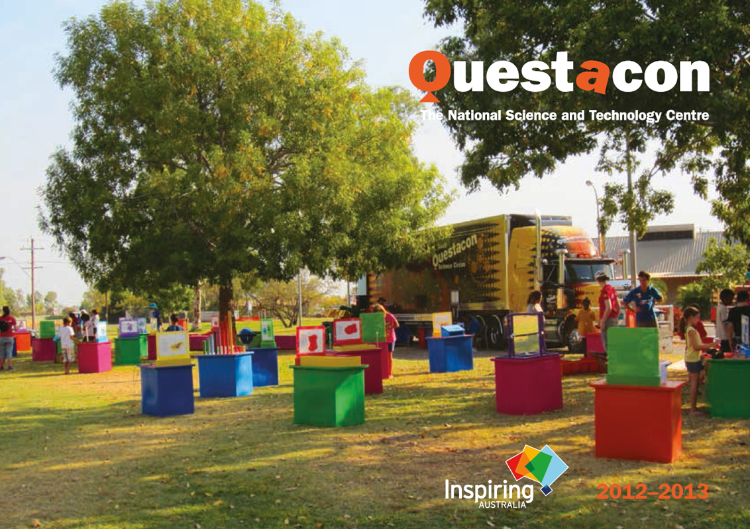

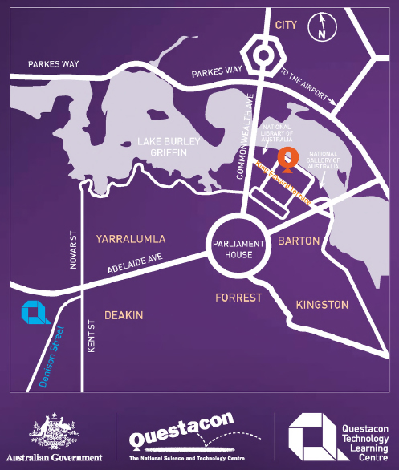
Questacon – The National Science and Technology Centre
King Edward Terrace, Canberra
PO Box 5322, Kingston, ACT
Questacon Technology Learning Centre
60 Denison Street, Deakin, ACT
www.questacon.edu.au

Our vision
A better future for all Australians through engagement with science, technology and innovation.
‘Science needs our support, in order to support us. We need more people to be generating ideas that can be fed into a society ready to accept and analyse them. As the world becomes ever more complex, the community will be increasingly asked to decide between options. Our community will be better, our democracy more robust, our future more secure, if our citizens are able to make better informed decisions.’
– Professor Ian Chubb AC, Australia’s Chief Scientist

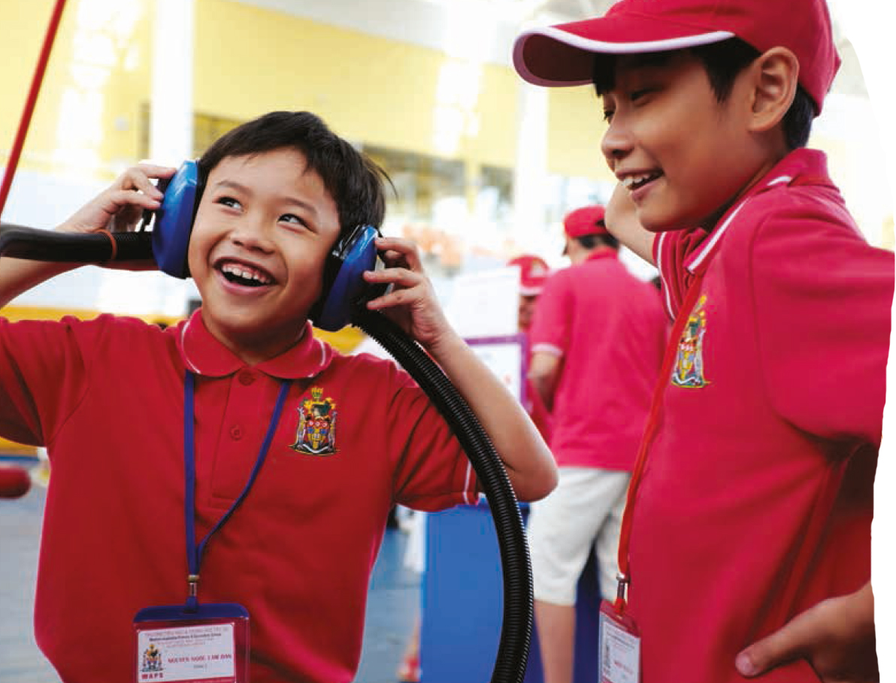

Questacon 2012–13
• Delivered over 6 million hours of inspiration  • Received 433 000 visitors to Questacon – The National Science and Technology Centre  • Impacted over 3 million people across all programs | • Active locally—a multi-award winning tourist attraction located amongst national cultural institutions in Canberra’s Parliamentary Zone.
• 220 staff, 125 directly engaging with visitors  • 65 volunteers contributing over 8000 hours | • Active nationally—helping to build a scientifically engaged and aware Australia that embraces innovation through the Inspiring Australia program.
• $37.6 million annual turnover  • Earned 46% of operational income  • Questacon is the third most popular attraction for school groups visiting Canberra, with over 88% visiting. Educational tourism draws $105 million per annum into the ACT economy. | • Active internationally—building relationships across the world to enhance the capability of the global science centre community.
EXCITEMENT > ENGAGEMENT > INSPIRATION > MOTIVATION > EFFORT > PRODUCTIVITY

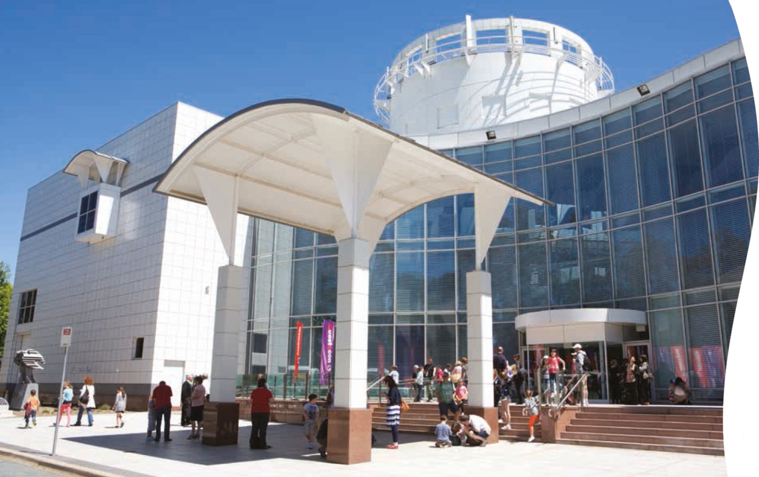

Contents
Minister’s introduction . . . . . . . . . . . . . . . . . . . . . . . . . . . . . . . . . . . . . . . . . . . . . . . . . . . . . . . . . . . . . . . . . . . . 9
Chairman’s message . . . . . . . . . . . . . . . . . . . . . . . . . . . . . . . . . . . . . . . . . . . . . . . . . . . . . . . . . . . . . . . . . . . . 10
Director’s report . . . . . . . . . . . . . . . . . . . . . . . . . . . . . . . . . . . . . . . . . . . . . . . . . . . . . . . . . . . . . . . . . . . . . . . . 13
Highlights 2012–13 . . . . . . . . . . . . . . . . . . . . . . . . . . . . . . . . . . . . . . . . . . . . . . . . . . . . . . . . . . . . . . . . . . . . . 15
Questacon statistics. . . . . . . . . . . . . . . . . . . . . . . . . . . . . . . . . . . . . . . . . . . . . . . . . . . . . . . . . . . . . . . . . . . . . .24
Questacon overview. . . . . . . . . . . . . . . . . . . . . . . . . . . . . . . . . . . . . . . . . . . . . . . . . . . . . . . . . . . . . . . . . . . . . .26
Partnerships . . . . . . . . . . . . . . . . . . . . . . . . . . . . . . . . . . . . . . . . . . . . . . . . . . . . . . . . . . . . . . . . . . . . . . . . . . . .36
National leadership. . . . . . . . . . . . . . . . . . . . . . . . . . . . . . . . . . . . . . . . . . . . . . . . . . . . . . . . . . . . . . . . . . . . . .40
Inspiring Australia . . . . . . . . . . . . . . . . . . . . . . . . . . . . . . . . . . . . . . . . . . . . . . . . . . . . . . . . . . . . . . . . . . . . . . 42
Questacon gallery exhibitions . . . . . . . . . . . . . . . . . . . . . . . . . . . . . . . . . . . . . . . . . . . . . . . . . . . . . . . . . . . . 52
Questacon—the tourism equation . . . . . . . . . . . . . . . . . . . . . . . . . . . . . . . . . . . . . . . . . . . . . . . . . . . . . . . . . .60
Visitor experience programs and events . . . . . . . . . . . . . . . . . . . . . . . . . . . . . . . . . . . . . . . . . . . . . . . . . . . 64
Questacon building . . . . . . . . . . . . . . . . . . . . . . . . . . . . . . . . . . . . . . . . . . . . . . . . . . . . . . . . . . . . . . . . . . . . . . 68
Questacon Technology Learning Centre . . . . . . . . . . . . . . . . . . . . . . . . . . . . . . . . . . . . . . . . . . . . . . . . . . . . 70
Questacon national programs . . . . . . . . . . . . . . . . . . . . . . . . . . . . . . . . . . . . . . . . . . . . . . . . . . . . . . . . . . . 77
Travelling exhibitions . . . . . . . . . . . . . . . . . . . . . . . . . . . . . . . . . . . . . . . . . . . . . . . . . . . . . . . . . . . . . . . . . . . 87
Questacon digital communications . . . . . . . . . . . . . . . . . . . . . . . . . . . . . . . . . . . . . . . . . . . . . . . . . . . . . . . . 89
National reach. . . . . . . . . . . . . . . . . . . . . . . . . . . . . . . . . . . .. . . . . . . . . . . . . . . . . . . . . . . . . . . . . . . . . . . . . . 94
Questacon international . . . . . . . . . . . . . . . . . . . . . . . . . . . . . . . . . . . . . . . . . . . . . . . . . . . . . . . . . . . . . . . . . 96
Questacon 25th Anniversary . . . . . . . . . . . . . . . . . . . . . . . . . . . . . . . . . . . . . . . . . . . . . . . . . . . . . . . . . . . . . 102
Questacon—the year ahead. . . . . . . . . . . . . . . . . . . . . . . . . . . . . . . . . . . . . . . . . . . . . . . . . . . . . . . . . . . . . . . 103

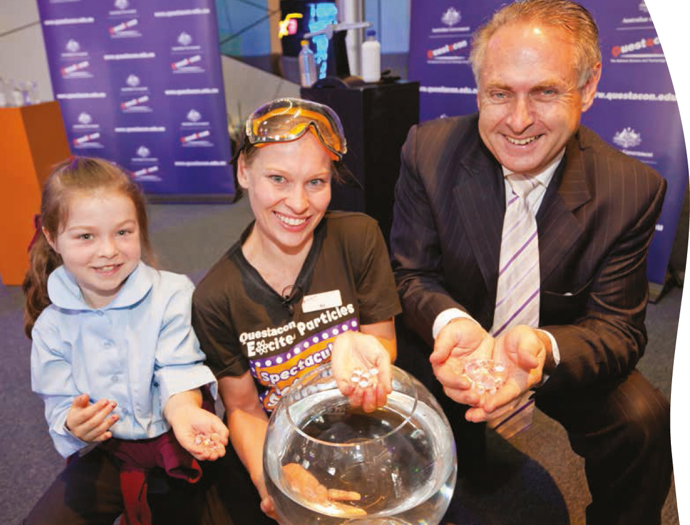

Minister’s introduction
In 2013, Questacon celebrates its 25th anniversary as Australia’s National Science and Technology Centre. Over that period Questacon has had remarkable impact in Canberra, across Australia and internationally. This success follows on from its founding at The Australian National University and, importantly, from the co-investment by the Australian and Japanese governments and business communities that led to the establishment of Questacon’s current facility in the Parliamentary Zone of the national capital.
Questacon has grown into one of the world’s most respected science centres and is internationally renowned for its outreach and capacity-building programs. Some 26 million people have interacted with Questacon’s various activities and several hundred science communicators have developed skills in the Centre before embarking upon careers throughout the world.
Questacon is in the business of inspiring and encouraging young people to embark on a journey of discovery and learning. In this time of economic transformation and global challenges, our country’s success requires a workforce with the skills and creativity for the jobs and challenges of the future. Questacon’s role in motivating young students is paramount.
Questacon also makes a tremendous economic contribution in the ACT. As a multi-award winning tourist attraction alongside the other national institutions in Canberra, Questacon has a significant economic impact in the region through income, jobs and services.
Questacon’s leadership of the Australian Government’s $21 million Inspiring Australia initiative has ignited the imagination of young and old, in classrooms, boardrooms and lounge rooms. Many excellent organisations have worked with Questacon to engage more people in the sciences than could have been achieved if any one organisation was working alone.
This year’s Annual Review showcases the broad reach of Questacon’s activities, from remote areas of Australia to communities abroad, and highlights another year of high achievement. Questacon’s growing roles in science diplomacy, digital communication and technology education are to be commended. These roles reveal an organisation aligning itself with key national challenges and well-equipped to remain at the forefront of science centre developments.
Questacon staff and partner organisations are to be congratulated on the opening of the new Questacon Technology Learning Centre, which brings one of Canberra’s landmark buildings back into productive public life. This Centre aims to energise learning about technology and innovation across Australia. It is positioned to develop creative young people, immerse them in innovation, and encourage careers in science, technology and entrepreneurialism. Hands-on, inquiry-based learning remains the core philosophy of Questacon. This aptly complements the formal in-school education system and will serve Questacon well into the future.
Questacon achieves much through its partnerships with many different organisations and on behalf of the Australian Government I thank these sponsors and knowledge partners.
Questacon has achieved great outcomes for 2012–13 and I am confident it will continue to inspire tomorrow’s scientists and innovators for many years to come.

Senator the Hon Don Farrell
Minister for Science and Research

Chairman’s message
‘The need for a highly skilled, innovative workforce has never been greater. Science remains critical to ensure Australia can stay ahead of the game, and make best use of our intellectual wealth.’
It has been my pleasure to chair Questacon’s Advisory Council for another year, and to see Questacon enter its 25th year as Australia’s National Science and Technology Centre.
Whenever I speak with friends and colleagues about Questacon I frequently hear about the rich and diverse experiences they have had at Questacon and that have given science a new meaning in their lives.
People who visited Questacon as children now bring their own children to the Centre in Canberra or interact with the many activities Questacon delivers around the nation. Decades later they are still immersed in the imagination, curiosity and wonderment that only science and Australia’s National Science and Technology Centre can offer. The question “why is it so” is still as important today as it was when it was coined by Professor Julius Sumner Miller in the 1960s.
The hands on, interactive activities offered by Questacon continue to complement and enhance science teaching offered in the formal school system. When students are exposed to quality teaching both inside and outside of the school system, they have their best chance of developing a lifelong love for science which equips them with lifelong skills. Important skills like problem solving and an ability to interrogate information to help them make informed decisions.
In the lead up to the 25th anniversary of Questacon as Australia’s National Science and Technology Centre in November 2013, it’s timely to reflect on its growth, impact and reach over the past 25 years. It is hard to believe that the prominent national institution in Canberra that we all know and love and that welcomes over 430 000 visitors every year began its life in the Ainslie Public School in 1980! Even more remarkable is its impact beyond Australia. As a world leading science centre, Questacon assists other nations which have identified the need to establish their own centres and build capability in science communication.
Throughout the last 25 years, Questacon has continually changed and evolved its offerings to engage existing audiences and reach new ones. This Annual Review highlights how this has been achieved over this past year.
A remarkable achievement in 2012-13 was the launch of Questacon’s new facility, the Questacon Technology Learning Centre (QTLC) in Deakin in the ACT. The QTLC’s workshops and programs target secondary school aged students and offer them an opportunity to invent and innovate. It immerses young minds in the process of innovation and encourages them to design, experiment, explore and create. The activities encourage students to create technology, rather than just consume it. It’s a space that allows them to use creative thinking to solve design challenges—essential foundation skills for careers in design, manufacturing, engineering and technology. I look forward meeting tomorrow’s entrepreneurs as they start their journey at QTLC. I also look forward to doing what I can so that students across the nation can access this wonderful facility and the opportunities it offers.
During the year I have also been delighted to see the growth of the Questacon Science Garden, Questacon’s interactive outdoor science exhibits. 2012-13 saw the installation of NKRYPT which exposes visitors to the mysteries of cryptography; the Fundials illustrating the wonders of light and shadows; and the first in the Icons of Inspiration sculpture series which remind us of how science has inspired millions of people over time.
It is intended that each figure in the Icons of Inspiration series will be dedicated to people and organisations that have provided inspiration and support for Questacon’s broad vision.
The first figure, ‘The Thinker’, makes reference to Rodin’s famous artwork and the story of Isaac Newton, with his moment of inspiration said to have been drawn from the observation of a falling apple. The figure is dedicated to Mr John Ralph AC, Chairman Australia-Japan Business Co-operation Committee from 1991–1999, for services to science, technology and education. Mr Ralph unveiled the Icon in June (pictured right).
It is also timely to look to the future and ensure Questacon is well positioned over the next 25 years to meet the national interest and ensure the National Science and Technology Centre can play its part in inspiring the next generation of scientists and innovators. The need for a highly skilled, innovative workforce has never been greater. Science remains critical to ensure Australia can stay ahead of the game, and make best use of our intellectual wealth.
Partnerships have always been essential to Questacon’s ongoing success. I thank our valued partners Shell and The Australian National University for their long-running and continuing support for the Shell Questacon Science Circus.
Questacon has been the partner of choice for a number of other organisations during the year, including Raytheon Australia, the Australian Bureau of Statistics, the Murray–Darling Basin Authority and many others. I thank these organisations for their support and collaboration with Questacon.
My personal thanks also goes to members of the Questacon Advisory Council for their collegiality and continuing support of Questacon: Mr John Simpson (Deputy Chairman), Associate Professor Tracey Bunda, Dr Catherine Foley, Professor Denis Goodrum and Professor Brian Schmidt.
I thank Senator the Hon Chris Evans, the Hon Chris Bowen MP, and Senator the Hon Don Farrell for their support in the Science and Research portfolio. I also acknowledge the ongoing support from the Australian Government Department of Industry, Innovation, Climate Change, Science, Research and Tertiary Education.
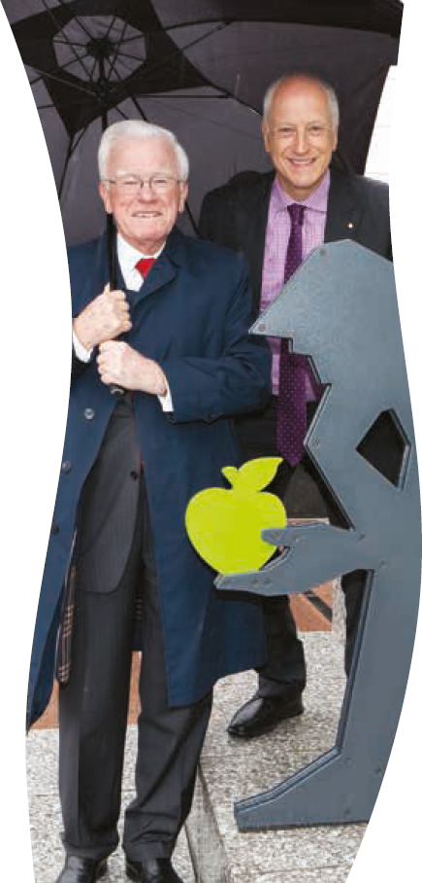
Questacon Director, Professor Graham Durant, continues to be a driving force in positioning Questacon both as a national leader in science engagement and communication and for the development of the international science centre sector. I acknowledge and thank Professor Durant for his vision, passion and leadership throughout the year.
In January 2013, Graham Smith retired from his role as Questacon General Manager. My congratulations and thanks to Graham for his loyal and dedicated service over the last 22 years, most notably in the early years of Questacon’s outreach programs.
I welcome Anna-Maria Arabia to the role of General Manager – Strategy and Partnerships, and thank her, along with Lorraine Neish, General Manager – Operations for their work in supporting and realising Questacon’s goals.
Finally, I thankfully acknowledge Questacon’s dedicated staff and volunteers. Their daily dedication and enthusiasm maintains Questacon as the dynamic and inspiring organisation it has been for 25 years and will continue to be for many more years to come.
Leon Kempler OAM
Questacon Advisory Council Chairman

Director’s report
‘Questacon has a particular noise—the sound of excited and energetic children....Observing visitors and their expressions of delight make me proud to lead Questacon’s talented and hard-working team.’
One of the great pleasures of being Director of Questacon is being able to walk around the exhibition galleries, watching and listening to visitors. Questacon has a particular noise—the sound of excited and energetic children. For me, it is always the perfect antidote to too many meetings or too many emails. It serves to remind me of why we exist and why what we do is so important.
Amongst the young visitors to Questacon will be the problem-solvers and knowledge generators of the future. They are growing up at an exciting time for the planet; a time of great challenge and a time of great opportunity. For some, the visit to Questacon or a visit by a Questacon program to their school or community will be a life-changing experience. It may be a subtle change in attitude or interest that leads to a different direction through study and life. The visit could deliver the inspiration and motivation that leads to more effort in studying. Observing visitors and their expressions of delight make me proud to lead Questacon’s talented and hard-working team.
Questacon has had another productive year in 2012–13. Opening the new Questacon Technology Learning Centre (QTLC) has been one highlight. This new facility will transform technology learning across Australia through catalytic actions and new partnerships. The opening of the QTLC by the Minister for Science and Research, Senator the Hon Don Farrell on 27 June ends the year on a highpoint of national significance. The opening marks the end of a successful project phase during the fit-out of the premises, and the start of the operating phase. Encouraging young people to be creative and imaginative are critical goals and success will be measured by such impact.
The remarkable success of the Inspiring Australia initiative is another source of great pride.
Questacon has been managing this national science communication strategy on behalf of the Australian Government. The initiative has energised and galvanised the Australian science communication community. It has led to significant community outcomes and provided the focus and leadership lacking from previous efforts.
There are some people who think that I have the best job in the world. On some days I am sure that is true but, of course, there are other days when it can be pretty tough. Taking the decision to close our Sydney operation after 11 years was one of those tough days. This decision was necessary because of the budget situation, and because of the introduction of our new Questacon Technology Learning Centre that marked a strategic change of direction for the organisation.
The achievements of Questacon’s Sydney-based Science Squad and Science Play teams over the years should be acknowledged. A remarkable team of young presenters has delivered thousands of science shows to school and community groups and developed new methods of delivery to early childhood groups.
Questacon is active in Canberra, across Australia and internationally. The Shell Questacon Science Circus is in its 28th year of operation and continues to deliver exciting hands-on activities in regional communities. This year the program has received more support from Shell which is gratefully acknowledged.
The Science Circus touring exhibition model continues to attract interest from abroad, with visitors from China and Japan joining parts of Science Circus tours in Queensland and on the New South Wales south coast. This style of ultra-portable, hands-on exhibits was also used to good effect during a tour to three cities in Vietnam, delivered in partnership with the Department of Foreign Affairs and Trade and the Australian Embassy in Vietnam, as part of celebrating the 40th Anniversary of Diplomatic Relations between the two countries. The highly successful tour reinforces Questacon’s important cultural diplomacy role.
Questacon’s success is built upon the support of many different organisations. I would like to thank all of our valuable knowledge and enabling partners for their continuing support. Together we are making a real difference to students, teachers and families across Australia.
I would like to thank the three Ministers who have had responsibility for Questacon throughout the year. I also wish to acknowledge and thank the Questacon Advisory Council for their advice and advocacy, and colleagues in the Department of Industry, Innovation, Climate Change, Science, Research and Tertiary Education who have provided resources and support. On a personal level, I am particularly grateful for the support of Questacon colleagues and a superb senior management team who make my job so much easier.
2013 marks Canberra’s Centenary year and also Questacon’s 25th anniversary as Australia’s National Science and Technology Centre. The original investment in the Centre by the Australian and Japanese governments and businesses has generated rich returns, some 100 million hours of inspiration. The second 25 years to 2038 will see Questacon continue to experiment with new media for communicating science and grow as a major facility for informal learning, tourism and telling stories of Australian research endeavour.
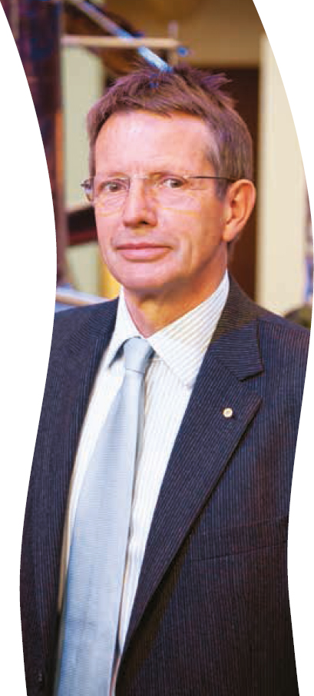

Professor Graham Durant AM
Director

Highlights 2012–13
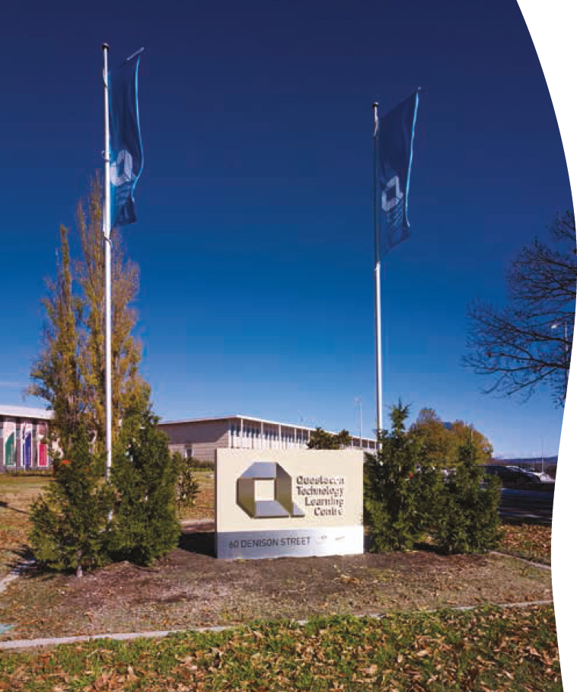
Questacon’s newest facility, the Questacon Technology Learning Centre (QTLC) was officially opened on 27 June 2013 by the Minister for Science and Research, Senator the Hon Don Farrell.

Visitor experience
• Questacon’s newest facility, the Questacon Technology Learning Centre (QTLC) was officially opened on 27 June 2013 by the Minister for Science and Research, Senator the Hon Don Farrell. The QTLC is located next to the Royal Australian Mint in Deakin, Canberra, and offers unique educational and public programs with a technology, innovation and design focus, using Questacon’s proven approach of engagement through hands-on interactivity.
• In July 2012, Professor Brian Schmidt AC presented his Nobel Prize Medal to Questacon for permanent display in the foyer. Professor Schmidt and his team won the 2011 Nobel Physics Prize for their groundbreaking discovery that the expansion of the universe is accelerating. The Nobel Prize display outlines Professor Schmidt’s life and work and lists other Australian Nobel Prize winners.
• The Deep Oceans exhibition—co-developed by Questacon and the Australian Museum—opened at Questacon in November 2012. The exhibition explores the mysterious deep oceans of Australia and the Pacific through a unique combination of interactive exhibits and flora and fauna specimens.
• Questacon’s Excited Particles provided roving science busking for the Governor General’s Christmas Party in December 2012. The party was enjoyed by over 1000 primary school students, their parents and carers from Canberra and the surrounding region.
• Two new additions to the Questacon Science Garden were installed in March 2013. The NKRYPT exhibit was launched by Senator the Hon Kate Lundy, Senator for the ACT. NKRYPT contains many separate codes and ciphers, laser cut into eight stainless steel poles. This exhibit is supported by Leon Kempler OAM (Questacon Advisory Council Chairman) and Eddie Kutner. The first of the new Icons of Inspiration outdoor sculptures was launched in June 2013 by John Ralph.
• In June 2013, Questacon launched its redeveloped website which provides an improved user experience and more in-depth content. The site presents tailored content based on the user’s identity, such as educator, student or parent, and is responsive to use on mobile devices.

Tourism
• Questacon was awarded the 2012 Canberra and Capital Region Tourism Award in the Tourist Attraction category in November for the eighth consecutive time, along with the Bronze Award in the Tourist Attraction category at the 2012 Australian Tourism Awards, presented in March 2013 in Hobart.
• Questacon was a key destination for Australian Capital Tourism’s Human Brochure campaign over two weekends in October 2012 and February 2013. Questacon hosted around 100 ‘Humans’ visiting Canberra for each weekend to experience the region’s tourist attractions and to share their experiences via social media. These families enjoyed exploring the galleries, Excited Particles science shows and demonstrations, and a specially-themed dinner in the foyer, transformed into ‘Einstein’s Kitchen’.
• The Enlighten Festival in March presented Questacon in a whole new light to visitors and locals alike. The Questacon building was lit up with projected artworks along with many other national institutions in Canberra’s Parliamentary Zone. Questacon also presented an entertainment program that included a Mongolian folk music performance with a modern twist, late night openings of the galleries, and the sold-out Universe in a local wine glass wine tasting journey with astrophysicist and winemaker Professor Brian Schmidt.
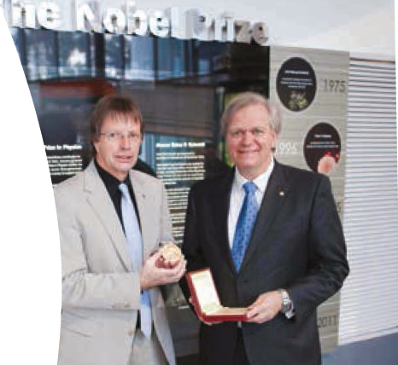
‘I feel, in a way, that the medal belongs to Australia and so should be somewhere where Australians can see it.’
Professor Brian Schmidt on the presentation of his Nobel Prize medal to Questacon for permanent display.

Centenary of Canberra
• At the NKRYPT launch in March, Senator Lundy announced the 2013 Centenary Code Challenge. This challenge offered a prize to the first person to solve the code within the exhibit that relates to the Centenary of Canberra. The NKRYPT exhibit and the challenge have generated significant interest amongst amateur codebreakers, who have created social media pages and websites to share clues, ideas and solutions with each other to solve the codes. The Centenary Code Challenge remains unsolved at the time of publication.

• Questacon also presented a range of special events and activities for the Centenary of Canberra throughout 2013, highlighting the important role of science in the capital and beyond. The 100°C—Stories of 100 Canberra Scientists event series brought scientists from a range of fields to Questacon to talk about their life, work and connections to Canberra. Notable 100°C events in the first half of 2013 included: a talk on painting conservation by David Wise from the National Gallery of Australia; an overview of the current state of climate change with Professor Janette Lindesay from The Australian National University (ANU); a Laserfest show by Professor Hans Bachor, ANU; and an introduction to The Atlas of Living Australia by project director Dr John La Salle.
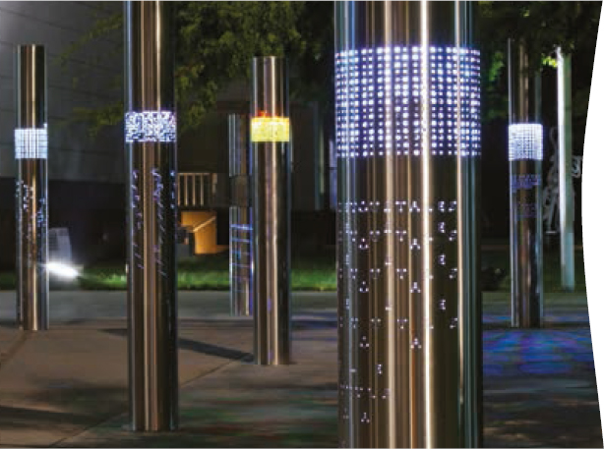
• Other Questacon activities for the Centenary of Canberra included a Science Sport Spectacular@Questacon Day in February, which included talks by sports science experts from the Australian Institute of Sport and the University of Canberra, Tae Kwan Do demonstrations and talent identification activities from the ACT Academy of Sport. A second @Questacon Day was held in June, exploring Cutting Edge Science. This event featured presentations and demonstrations on a range of topics including bionic eyes, unmanned aerial drones and the latest in solar energy technologies.
• Two SciNight events were held during the year, providing an opportunity for an adult audience to explore Questacon’s galleries after hours. These events also included entertaining talks and demonstrations with Beach Party (November) and Food and Wine (June) themes.
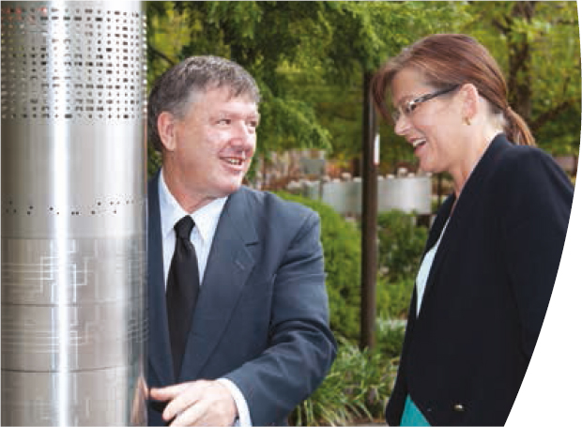

National programs
• As part of the Inspiring Australia initiative, Questacon coordinated several national programs, including:
– the 2012 Prime Minister’s Prizes for Science, Australia’s most prestigious awards for excellence in science research and science teaching.
– National Science Week, which attracted more than 1.4 million people of all ages to over 1000 events across the length and breadth of the nation.
– providing $5 million in support under the Unlocking Australia’s Potential grants program for 63 projects across Australia. These projects provide opportunities for participation for all Australians, especially those not normally engaged in science activities.
• In addition to regional touring, in August 2012 the Shell Questacon Science Circus took part in one of Australia’s largest science festivals, Science Alive! This large-scale event, held annually in Adelaide, showcased the Science Circus to 20 000 visitors over three days, and included a careers day targeting high school students.
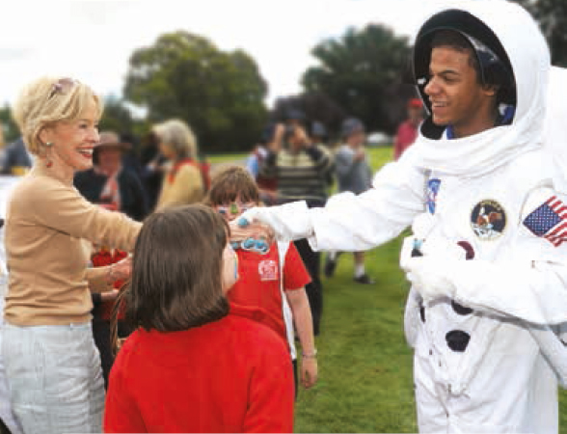

International
• Questacon continued to be active internationally, delivering exhibition tours and capability development projects in several countries, as well as welcoming delegations from around the world to the Centre in Canberra.
• Major projects included a two-week capability development workshop at PP-IPTEK science centre in Indonesia in November 2012 in collaboration with the ANU Australian National Centre for Public Awareness of Science (CPAS).
• Questacon also delivered a three-week tour to Vietnam of an interactive science program comprising a travelling exhibition, science shows and teacher workshops. The Vietnam tour was presented in collaboration with the Department of Foreign Affairs and Trade to mark the 40th Anniversary of Diplomatic Relations between Australia and Vietnam, and included a series of discussions around Questacon’s ability to support the development of the science centre sector in Vietnam.
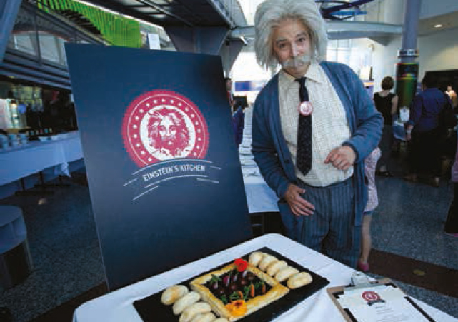
‘Questacon plays a vital role in encouraging our young people, and those not so young, to be inquisitive and anxious to learn more. Through its many exhibits and programs, it has demonstrated over the years how to energise students and their teachers to realise that science can be fun, while adding to knowledge. As such Questacon is a truly valuable resource.’
John Ralph AC, Past President of the Australia Japan Business Co-operation Committee

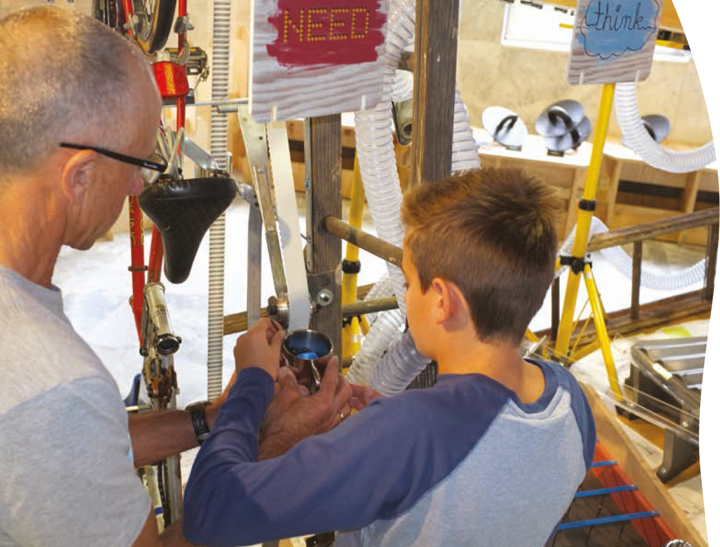

Questacon statistics
Total visitors to all exhibitions and programs | 912 998
Visitors to the Centre | 433 145
School visitors | 124 282 school children and teachers in 2311 school groups from across Australia visited Questacon.
Q Club Membership | 5045 memberships—a total of 17 772 members.
National programs | Presentations delivered to 116 317 visitors from 867 schools and other venues.
Travelling exhibitions | 363 536 visitors to travelling exhibitions—seven exhibitions travelled to 11 venues across Australia and internationally.
Questacon websites | 1 007 210 total visitor sessions to websites administered by Questacon.
Visitor satisfaction | 94% of visitors surveyed responded positively.
Staff | 220 staff in full-time, part-time or casual positions employed by Questacon (162 average full-time equivalent).
Volunteers | 8055 hours contributed by 65 volunteers.
‘I had incredibly fond memories of Questacon from when I visited as a kid. Even with a couple of decades in between, it didn’t disappoint. Such a fun place where you can still learn a thing or two—even if you are a big kid now.’
Trip Advisor Review, April 2013

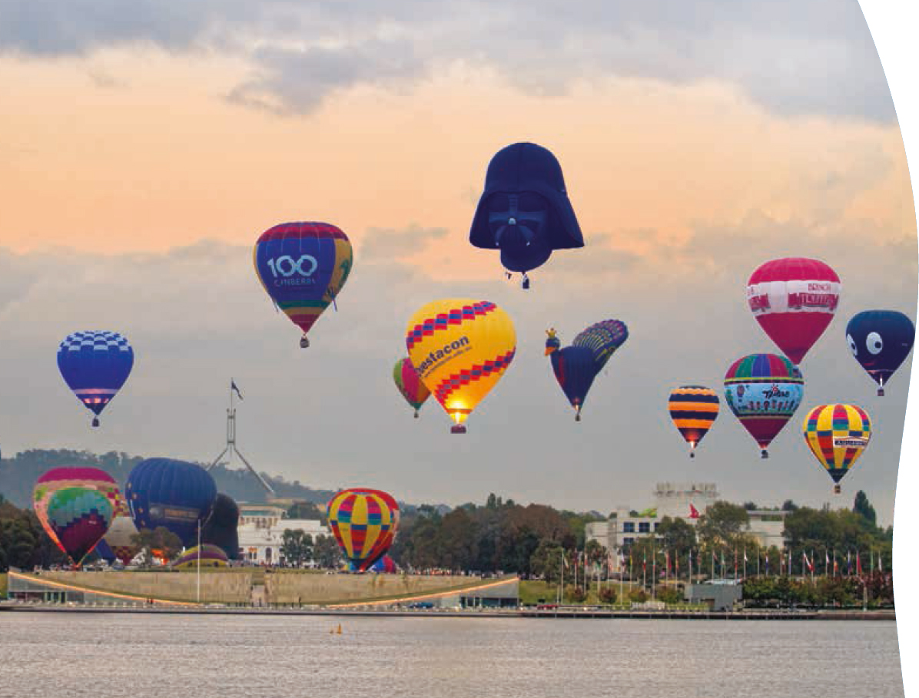
‘I hear and I forget
I see and I remember
I do and I understand
I create and my mind opens
I innovate and the world opens’
Based on an ancient Chinese proverb and modified by the Ontario Science Centre

Questacon overview
Questacon – The National Science and Technology Centre believes that harnessing the power and potential of science, technology and innovation is critical to Australia’s ongoing prosperity. This is why Questacon is working to increase awareness of science in the Australian community by providing engaging and exciting experiences to inspire interest, highlight relevance and promote positive associations with science and technology.
Questacon reaches a broad audience by offering a diverse range of experiences, such as:
• The iconic Questacon Centre, located beside Lake Burley Griffin in the Parliamentary Zone of Canberra, featuring eight galleries and over 200 interactive exhibits.
• The Questacon Technology Learning Centre in Deakin, Canberra, which offers programs and exhibitions that stimulate an interest and awareness of basic design and technology processes and encourage young people to develop skills and creativity in solving problems.
• Interactive travelling exhibitions, which tour to museums and galleries in regional and metropolitan centres across Australia and internationally.
• In-school visits and public exhibitions in regional and remote Australia by Questacon’s touring national programs.
• Educational videoconferences and an interactive website.
• Inspiring Australia or National Science Week community events.
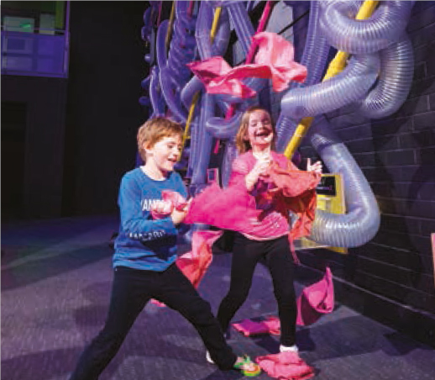
Questacon’s approach is based on the proven educational value of hands-on activities supported by face-to-face science demonstrations. Questacon’s informal learning approach complements more structured learning in schools.
Questacon’s programs and exhibitions are developed in response to the Australian Government’s strategic priorities. Questacon is helping to tackle skill shortages in science and technology by engaging, inspiring and motivating students to study science, technology, engineering and maths, and by highlighting the diversity of careers available in these fields.
Questacon works to foster positive public attitudes towards science. Questacon aims to help people understand scientific advances and the way that science affects their lives, enabling them to engage with current science and technology-based issues in society.
Questacon is also active internationally, fostering the development of science centres in countries where the sector is emergent.
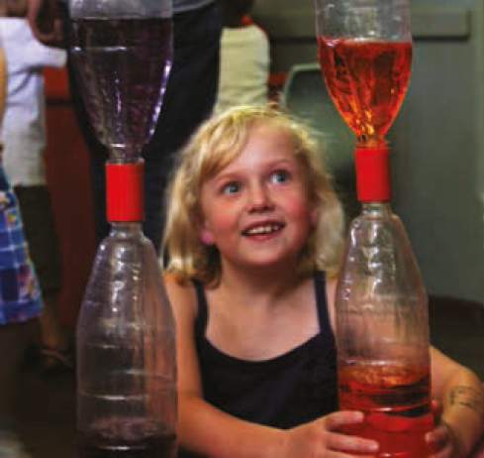

Questacon in Canberra
Questacon was originally founded in 1980 by The Australian National University as a small science centre at Ainslie Public School. In November 1988, Questacon was opened in its current location as Australia’s National Science and Technology Centre. The Questacon building was completed as a jointly funded Australia–Japan Bicentennial project.
Over the past quarter-century, Questacon has been recognised as a world-leader in presenting innovative, interactive science exhibitions and programs, and the Centre in Canberra is a multi-award winning tourist destination.
Questacon’s exhibitions—both travelling and in-Centre—are designed to present scientific concepts in an entertaining way and encourage visitors to engage and experiment. At the Centre, gallery staff and volunteer explainers are on hand to enhance visitors’ enjoyment. Daily Spectacular Science Shows presented by the in-house performance troupe, the Questacon Excited Particles, provide further interpretation and exploration of the science behind the exhibitions.
Questacon’s exhibitions—both travelling and in-Centre—are designed to present scientific concepts in an entertaining way and encourage visitors to engage and experiment. At the Centre, gallery staff and volunteer explainers are on hand to enhance visitors’ enjoyment. Daily Spectacular Science Shows presented by the in-house performance troupe, the Questacon Excited Particles, provide further interpretation and exploration of the science behind the exhibitions.
Questacon’s newest facility, the Questacon Technology Learning Centre (QTLC) delivers programs that stimulate an awareness of basic design and technology processes, encouraging young people to develop skills and creativity in solving problems. The QTLC offers workshops for secondary school students, activities for community groups, and regular public seminars and talks from visiting experts. The Gallery of Australian Inventiveness hosts visiting exhibitions and also features permanent exhibits exploring the invention process and the stories of Australian inventors.

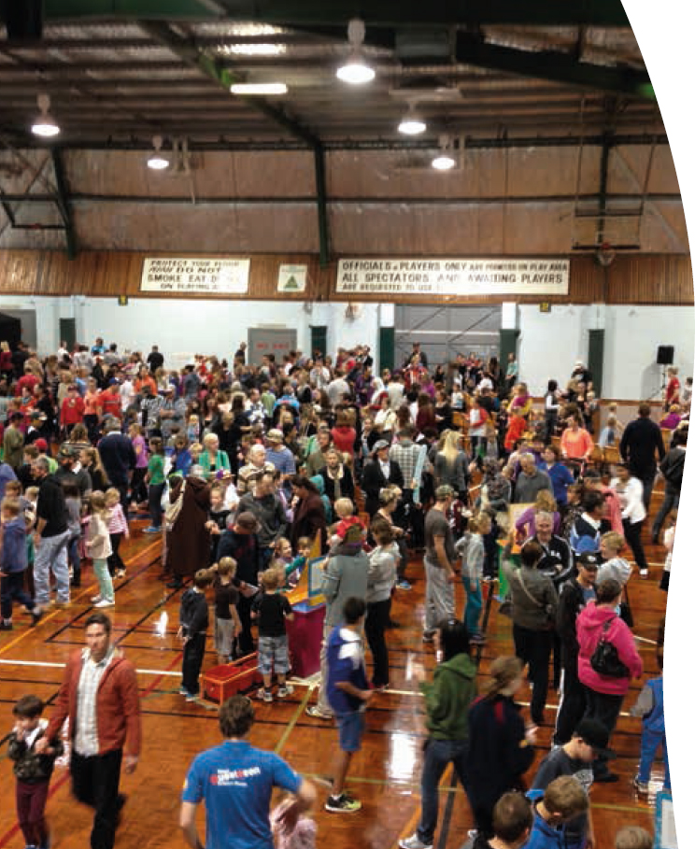
‘Awesome, awesome experience for regional, rural families’
Visitor to Shell Questacon Science Circus public exhibition

Questacon nationally
Questacon is a recognised world leader in the delivery of science outreach programs. Each year Questacon takes its national programs to regional, remote and Indigenous communities across Australia. These programs present science shows and hands-on workshops in schools, as well as public exhibitions featuring interactive, portable science exhibits. In-school programs cater for students from pre-school through to senior secondary school and have been developed to support national education priorities in innovation and technology, early childhood and primary science.
Questacon complements face-to-face experiences with activities delivered online and through digital media technology. Questacon offers interactive workshops and programs via videoconference to schools across Australia, and the Questacon website contains educational materials to supplement exhibitions and programs.
Questacon also tours interactive travelling exhibitions to a range of regional and metropolitan venues across Australia and internationally.
Questacon also leads the $21 million Inspiring Australia initiative achieving a co-ordinated and coherent science communication strategy for Australia.

Questacon internationally
Questacon plays a leading role in building the capability of the science centre sector globally, undertaking projects that share expertise and experience between established science centres and those under development.
Questacon continually monitors emerging global trends and maintains strong connections with international science centre networks. These networks allow Questacon to participate in the exchange of ideas and global projects, promote Australian science, education and innovation, and benchmark with the best in the world.
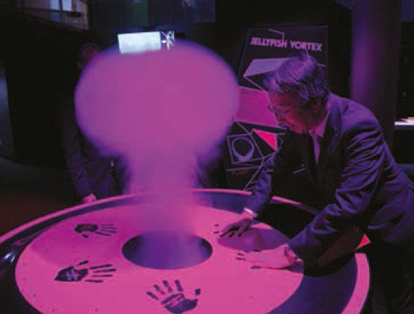

Partnerships
Questacon’s partnerships are vital in achieving our strategic goals. Long-running partnerships with corporate Australia (including Shell) enable Questacon to deliver science engagement experiences in even the remotest parts of the country. Questacon also works closely with many other organisations, including government agencies such as the Australian Bureau of Statistics, state science centres, the business community, universities and research organisations.
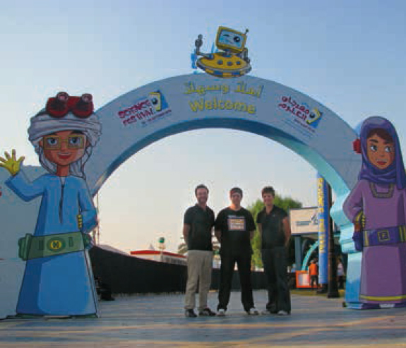

Questacon governance and financial management
Questacon is a division of the Department of Industry, Innovation, Climate Change, Science, Research and Tertiary Education (DIICCSRTE). Questacon has an Advisory Council, appointed by the Minister, comprising of representatives from the business, science and education sectors. The Advisory Council assists in setting Questacon’s strategic direction by providing advice to the Director of Questacon and the Minister for Science and Research.
In 2012–13, Questacon’s turnover was $37.6 million, with operating revenue of $23 million. Questacon received government funding of $12 million in operational funding and $9 million in capital funding. A further $4.8 million is administered as grants through the Inspiring Australia program. In 2012–13, Questacon generated 46 per cent of its operating revenue, earning revenue of $10.68 million from Centre admissions, fees for programs, touring exhibitions and services, Q Shop sales, sponsorship, Q Club memberships and lease revenue.

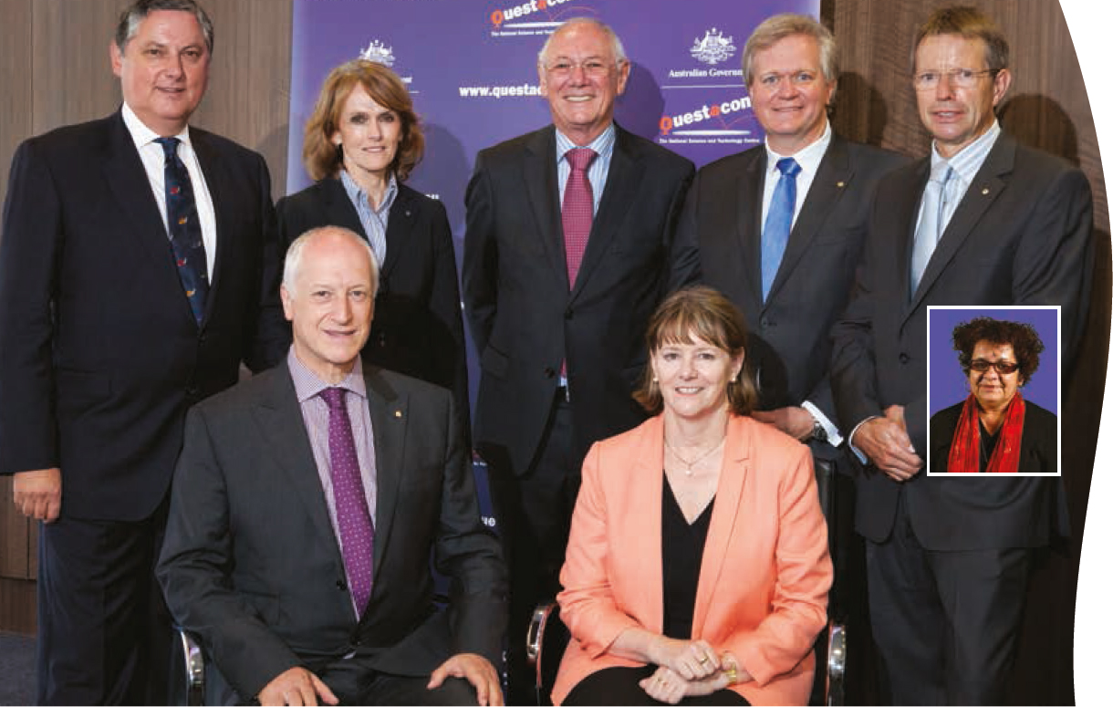

Questacon Advisory Council

Mr Leon Kempler OAM
(Chairman)
Australia–Israel Chamber of Commerce
“Questacon is a destination where people have a Eureka moment and a life is changed forevermore.”

Mr John Simpson
(Deputy Chairman)
Managing Director, John P Simpson & Associates Pty Ltd
“Young people across Australia are asking “why” more often and with louder voices. Frequently, the answer involves science—or should involve science. Questacon has been central in providing more accessible communication of science & technology for more than 25 years. As more and more ask “why” Questacon’s work becomes all the more important.”

Dr Catherine Foley PSM
Chief, CSIRO Materials Science and Engineering
“Questacon is one of my favourite places. Where else in Australia do we inspire the future generations of the wonderment and power of science to create a great future for us all?”

Professor Brian Schmidt AC
Research School of Astronomy and Astrophysics, Australian National University
“Questacon brings the scientific world alive for Australian children.”

Professor Denis Goodrum
Executive Director—Science by Doing, Australian Academy of Science
“With the wisdom of a child my granddaughter believes Questacon should be called the ‘lots of fun place’—a place where it is fun to learn. Questacon has achieved the ultimate balance between science entertainment and science education for young and old.”

Associate Professor Tracey Bunda
(Council member to June 2013)
Chair for Indigenous Knowledge Systems, Institute for Koori Education, Deakin University.
“Questacon is an important space within the nation’s landscape. It is a rich space of knowledge and where a dedicated commitment ensures that the wonder of science is brought to communities at local, national and international levels. The work of making science fun is most evident in the delighted faces of the many children who visit Questacon.”
Ex-officio Council Members:
Professor Graham Durant AM
Ms Patricia Kelly PSM

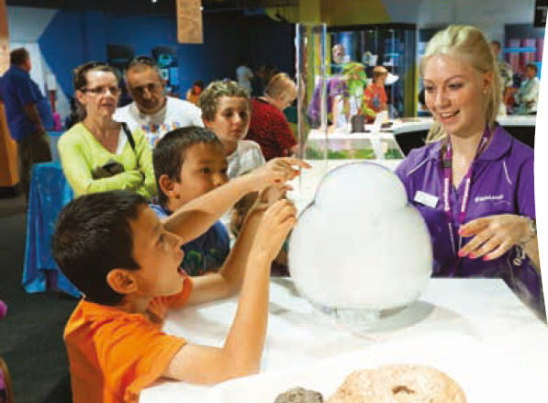

Questacon people
Questacon employs 220 staff in full-time, part-time or casual positions.
The Questacon workforce is both culturally and professionally diverse, with wide-ranging expertise in science, customer service, design, construction, acting, education, facilities management, marketing, communication, finance, planning, information technology, public administration, occupational health and safety, retail and electronics.
Questacon contributes to the professional development of science communicators in Australia, providing entry-level opportunities for a significant number of tertiary students and recent graduates, who are employed as gallery staff at the Centre and as presenters for Questacon’s outreach programs.
Questacon also has a dedicated team of 65 volunteers, who in 2012–13 contributed a total of 8055 hours. Together with gallery staff, volunteers provide exhibit explanations and science demonstrations to visitors, including Discovery Trolleys (portable science exhibits) and Curiosity Corner (a hands-on science experiment station).
The staff and volunteers working throughout the public spaces at Questacon are expert at welcoming visitors and safely guiding and assisting them throughout the galleries whilst taking every opportunity to communicate science.
Questacon also provides training in science communication, presenting skills, teamwork and customer service to secondary students through the Schools’ Training Program. In 2012–13, 28 students from nine Canberra schools participated in the program, earning credit for their Year 12 certificates. The students worked in two streams operating across the Centre in Parkes and the Questacon Technology Learning Centre, and contributed 1120 hours of their time.
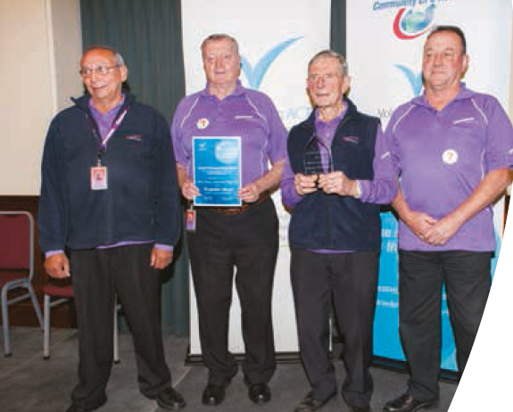
‘It is the energetic and knowledgeable staff that makes Questacon a place to come to time after time.’
Visitor feedback, September 2012

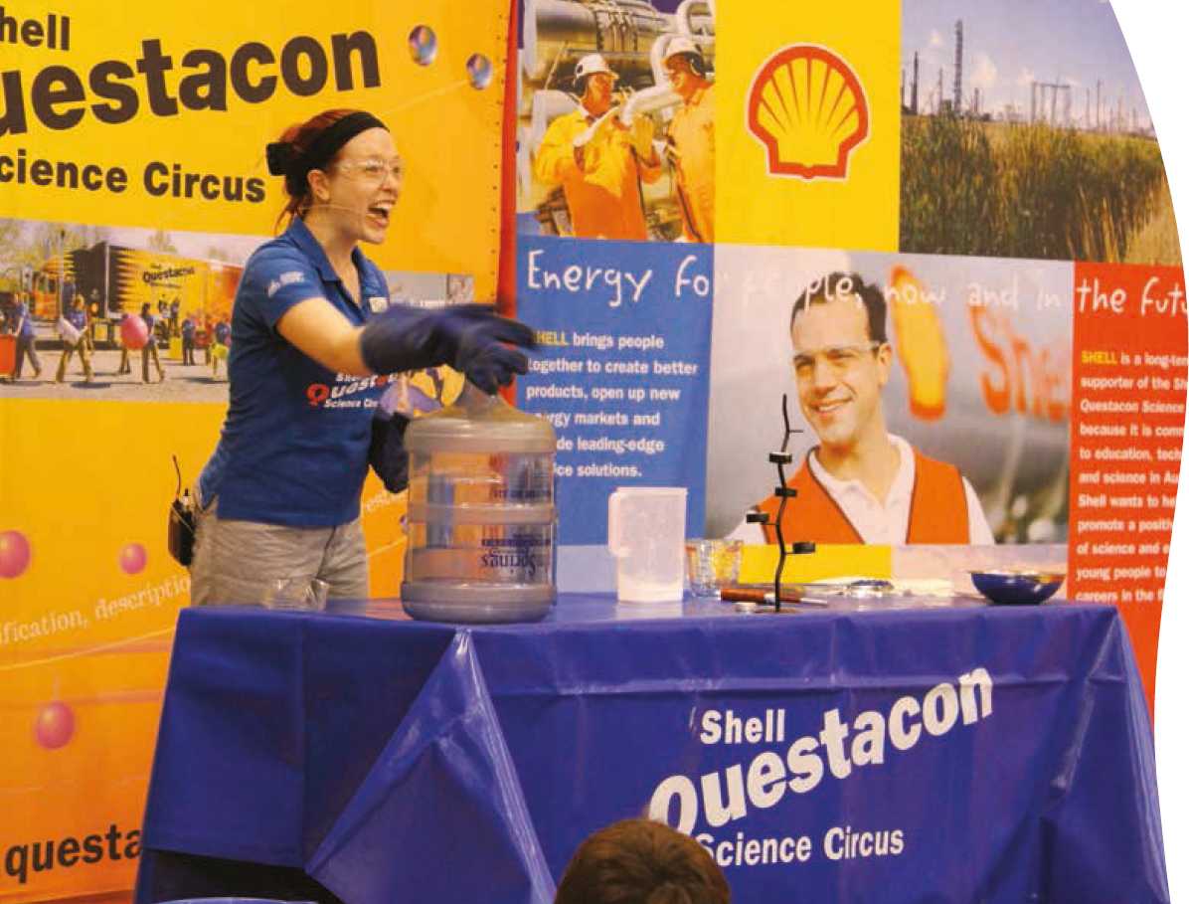
‘…Questacon is providing more opportunities for Australians in metropolitan, regional and remote areas to engage with science…’

Partnerships
Partnerships are essential to Questacon’s ongoing success. We work with our partners in a variety of ways:
• Enabling partnerships directly support the development and delivery of Questacon’s exhibitions and programs.
• Knowledge partnerships ensure Questacon’s exhibitions and programs are developed using up-to-date scientific content provided by leading subject matter experts.
• Strategic partnerships foster a culture of collaboration by supporting activities that capitalise on each partner’s complementary skills and expertise to maximise impact.
Questacon partners with a range of organisations including businesses, universities, other government departments and agencies, and professional organisations. Through these partnerships, Questacon is providing more opportunities for Australians in metropolitan, regional and remote areas to engage with science, innovation and technology in a positive and enjoyable way.

Shell—The Shell Questacon Science Circus
The Shell Questacon Science Circus was established over 28 years ago in partnership with Shell, The Australian National University (ANU) and Questacon. Shell has extended their support for the program through to June 2014. This continued support has enabled the expansion of the program to increase its impact in the communities it visits, through activities to engage older Australians and primary carers of children, as well as events that highlight science careers and successful science role models.

The Australian National University
The ANU is a founding partner of the Shell Questacon Science Circus. Each year, the Science Circus team is comprised of up to 16 Master of Science Communication Outreach students who undertake their studies at the ANU Australian National Centre for the Public Awareness of Science (CPAS). Questacon also partners with CPAS on a variety of science communication projects, including international capability development initiatives. Scientists and experts from ANU also contribute regularly to Questacon’s visitor programs, such as lectures and demonstrations.

Raytheon—the Schmidt Digital Studio
Raytheon Australia is providing support for the Schmidt Digital Studio programs. Officially named in honour of Professor Brian Schmidt, Australia’s 2011 Nobel Laureate in Physics, the Schmidt Studio uses interactive videoconferencing to deliver innovative science, technology, engineering and maths programs directly into secondary school classrooms across the nation. As more schools are becoming connected by broadband, these programs are linking young Australians to scientists. The Studio is also strengthening international linkages by connecting students to scientific events in other countries.
During 2012–13, Questacon provided videoconferencing support via the Schmidt Studio for programs delivered by partner organisations, as detailed below.

Murray–Darling Basin Authority—Basin Champion Schools Program
In partnership with the Murray–Darling Basin Authority Questacon provided technical and professional expertise in videoconferencing for the Basin Champion Schools Program. This program encouraged students to think about the connectivity and interdependence of environments across the Murray–Darling Basin by conducting localised investigations and sharing the results. Throughout their projects, students were supported by mentors and shared their findings with other students across the Basin via interactive videoconference.

National Film and Sound Archive—Let’s Get Animated!
In collaboration with the National Film and Sound Archive (NFSA), Questacon facilitated a digital music-making videoconference workshop featuring 2013 Grammy Award winner Gotye, Former Minister for the Arts Simon Crean and NFSA CEO Michael Loebenstein. Gotye talked to students from five schools in Queensland, Victoria and New South Wales about his approaches to composition and performance. Questacon also partnered with the NFSA to deliver the Let’s Get Animated! program to schools across New South Wales. The two-part workshop incorporated an in-class student project based around creating an animation of a scientific concept.
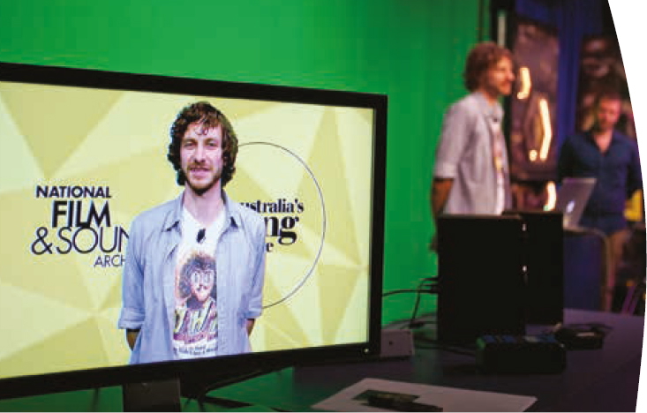

Australian Bureau of Statistics—The Census Experience
Questacon is designing, developing and constructing four interactive exhibits for the Australian Bureau of Statistics (ABS) for their Census Experience project, celebrating 100 years of Australian Census results (1911–2011). These Census Experience exhibits will raise awareness within the Australian population of the importance of collecting Census data, and the role played by the Australian Census in developing infrastructure within Australian towns and cities. The exhibits will enable users to compare their individual circumstances or data against Census data collected for the whole Australian population. The ABS will tour the Census Experience exhibits to Australian metropolitan centres.
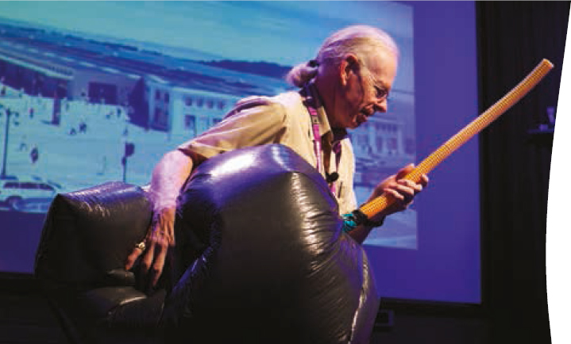

The Australian Museum—Deep Oceans Exhibition
Questacon partnered with the Australian Museum for the development and tour of the Deep Oceans exhibition. The exhibition uses an innovative combination of interactive exhibits, objects and specimens to reveal the secrets of this fascinating environment and the mysterious creatures that make their homes within it. The exhibition partnership commenced in June 2011 and brought together the two organisations’ skills and expertise in the development of world-class science exhibitions. Deep Oceans was launched in June 2012 at the Australian Museum and then opened at Questacon in November 2012. It will remain at Questacon until November 2013.

Defence Science and Technology Organisation (DSTO)
During the year a partnership was established with DSTO to provide new opportunities for public engagement with innovative technologies, showcasing examples of how these technologies can deliver real benefits to many areas of Australians’ lives.
This partnership will enable jointly-developed displays and exhibits within the Gallery of Australian Inventiveness at the QTLC. These exhibits will highlight the life-cycle of several products through the development stages, from conceptualising through to prototyping, testing and re-developing that leads to the final products.
The partnership with DSTO will also support showcasing manufacturing techniques such as 3D printing. This new technology allows objects to be printed directly from design software using an increasingly sophisticated range of materials. These systems are transforming product development processes and enabling custom manufacturing previously not feasible through traditional approaches. For example, printing of biological tissues, prosthetics, and spare parts for machines in remote locations are all now reality.
DSTO and its partners will be working with Questacon to bring an understanding of these new manufacturing opportunities to the Australian public.

Tourism partners
Questacon continues to work collaboratively with industry and regional tourism bodies to position Questacon and Canberra as a significant tourist destination. In particular, Questacon is represented by Craig Whelan, Manager – Visitor and International Engagement, on the Executive Committee of the National Capital Attractions Association (NCAA) and is a member of the ACT Branch of the Australian Tourism Export Council. Questacon General Manager Lorraine Neish is the Chair of the National Capital Educational Tourism Project (NCETP). Questacon actively supports these bodies’ work to encourage collaboration between attractions and promote the National Capital’s attractions, including Questacon and the Questacon Technology Learning Centre, to tourists and schools.
Questacon continues to partner with Cockington Green Gardens and the Australian Institute of Sport to offer the long-running 3infun discounted combined ticket to these three popular Canberra attractions. This is a unique offering within the Canberra tourism market as the only joint commissionable ticket available to the industry.
Questacon’s contribution to tourism in the ACT was recognised in November at the 2012 Canberra and Capital Region Tourism Awards, where Questacon won the Tourist Attraction category for the 13th time and eighth consecutive year. In February 2013, Questacon also received the Bronze Award in the same category at the Australian Tourism Awards.

National Science Week partners
Through the Inspiring Australia program, Questacon partners with CSIRO to help local, state and territory coordinating committees build collaborations and partnerships with local organisations and businesses. These partnerships assist communities in each state and territory to stage activities during National Science Week.
A school and community resource is developed annually for National Science Week through the Australian Science Teachers Association (ASTA). With Inspiring Australia funding, ASTA also administers a small grants program to assist schools to engage their students and local communities in National Science Week activities.
Another major National Science Week partner is the ABC. The ABC conducts national citizen science projects each year to involve Australians in science research, and delivers an integrated program of ABC television, radio and online programming and promotional activities. This provides Australians of all ages across the country with the opportunity to participate in this nationwide celebration of science.

National leadership

General Manager perspective

Over the last 25 years, Questacon has grown to become a world leader in science engagement and one of the world’s most respected science centres.
While Questacon is physically located in Canberra, it touches the hearts and minds of communities across Australia and around the globe in both developed and developing nations.
Questacon’s proven national outreach model has been operating in Australia for 28 years. Today, countries around the world look to Questacon to provide leadership, training and assistance in establishing similar programs in their countries. Questacon staff are highly skilled communicators and educators, and they are routinely involved in mentoring and training others in the global science centre network.
This year, Questacon staff responded to a request for support to improve the standard of science education in science centres in Indonesia; to supplement school and university science teaching; and to promote the growth of the science communication sector so it can reach 33 Indonesian provinces. Consider the potential impact of improving the understanding of seasonal variations and adverse weather events to families reliant on a fruitful harvest but who have had little advanced education in agri-science.
Back at home, it is the highly successful national outreach model developed at Questacon that has allowed it to be a leader in delivering interactive science activities to Indigenous children, to those with a disability, and to rural and remote communities. These include individuals and families who would not otherwise have the opportunity to interact with science and nurture the innate curiosity each of us is born with.
As a result of our outreach efforts and our state of the art digital technologies, some 26 million people have interacted with Questacon’s various activities over our rich, 25-year history. While statistics tell an important story, they do not capture the smile of a hearing or sight-impaired child when they have understood a bit more about science and the world around them because of the efforts of Questacon’s highly skilled science communicators. It is these sorts of experiences that energise the Questacon team and keep us searching for the most effective ways to engage people in science.
It is this relentless desire to maintain a world-class standard in all we do that has led Questacon to open its second facility, the Questacon Technology Learning Centre in June 2013. As the National Science and Technology Centre in Australia we were not satisfied with exposing children and families to science alone. We asked why early to mid-secondary school aged children did not have an opportunity to explore and understand the rewards of applied science, technology and innovation. We asked why so many Australians use technology but so few are the creators of it. It was in this spirit that decisive steps were taken to expose the next generation of entrepreneurs, business people, technologists, inventors, engineers and innovators alike to the foundation of technology: the innovation process. This is the essence of the Questacon Technology Learning Centre. Like other activities at Questacon in the coming months and years, together with our partners, we will strive to share this opportunity on a national scale, and then internationally.
Due to its expertise and national position, Questacon is responsible for the delivery of Inspiring Australia: A National Strategy for Engagement with the Sciences on behalf of the Australian Government. Inspiring Australia provides national coordination and leadership around science activities across the country and in doing so has united Australians around one vision for science engagement. Inspiring Australia quite literally involves millions of Australians. It has reduced duplication, created strong and lasting partnerships between what was previously a loose affiliation of people, brought together otherwise disparate and one-off activities, and led to the adoption of better national standards of science engagement. Inspiring Australia’s national leadership network encapsulates every federal government department that has an interest in science, as well as all state governments. It has also captured the power of the ever-increasing number of private industries which have recognised the social and commercial value of strong and effective communication of science. Australia is one of the only countries in the world with a coordinated national strategy for science engagement and Questacon is proud to lead this effort. Numerous countries have sought advice on what has been established here.
Finally, a national institution and a national leader consists not only of its bricks and mortar and its products and services. Its greatest asset is its people. The team at Questacon on a daily basis share accounts of how they inspire others to develop a society impassioned and respectful of science. They are can-do people who work willingly with Questacon’s many new and existing partners to deliver the not-yet imagined in places never too far, on missions never too complex. The Questacon team is the foundation stone without which we could not deliver, reach, create, change, make a difference and inspire.
Anna-Maria Arabia
General Manager – Strategy and Partnerships

Inspiring Australia
Questacon proudly leads Inspiring Australia: A National Strategy for Engagement with the Sciences, which provides a nationally coordinated science communication strategy for Australia.
Inspiring Australia supports the development of an innovative society that has confidence in science and that is able to make better informed decisions.
This is being achieved through the involvement of all levels of government, research organisations, universities, museums and science centres, learned academies, professional associations, businesses, media, communications organisations and the combined input of many individuals.
The success of the Inspiring Australia strategy in building a more scientifically engaged Australia is highlighted in the three key areas of leadership, strategy and programs.

National leadership
Inspiring Australia has, in conjunction with the Australian Government’s Coordination Committee on Innovation, established an ongoing working group to provide a whole-of-government approach to supporting the strategy. Another working group, similarly established with the Commonwealth, State and Territory Advisory Committee on Innovation, is developing a coherent approach by federal, state and territory governments to support the strategy.
These groups are sharing key ideas and program information, identifying opportunities for collaboration and partnerships, and providing a forum for strategy development and implementation.

Inspiring Australia officers, located in each state and territory, are co-funded by the Australian Government in partnership with state and territory governments and local institutions. These officers are playing a key role in enabling a ‘national framework—local action’ approach in support of the strategy. They are helping to strengthen science communication networks within states and territories, identify partnerships and linkages to address priority needs and communities, and build year-round opportunities for targeted audiences.
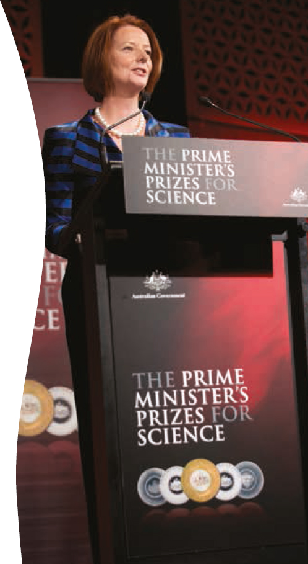

National strategy
The Inspiring Australia Report has provided, for the first time, an Australia-wide framework for engaging people and communities in the sciences. Development of this strategy is ongoing, supporting the building of further partnerships.
Six expert working groups have developed recommendations to strengthen science engagement in relation to Indigenous Australians, tropical regions, marine science, desert regions, mainstream and social media, and to develop an evidence base for science engagement.
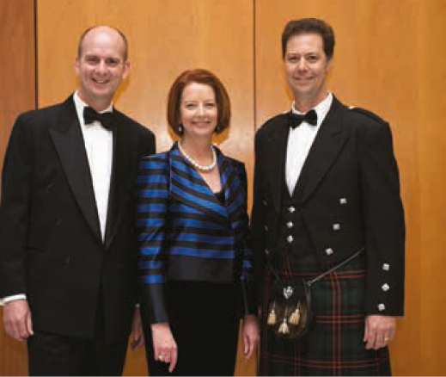
‘The grant has been a massive boost to our project. As a volunteer organisation of people aiming to raise the profile of science … the funding has enabled us to hold community engagement events that we would have otherwise been unable to complete.’
Darren Cooke, Barrick Kanowna Operations, WA and recipient of an Inspiring Australia grant.
These reports provide a coherent, national approach for the science community and partner organisations to respond to the needs and opportunities identified in each of these key areas. Inspiring Australia funding is now supporting national programs which address recommendations of the Science and the media and Developing an evidence base expert working group reports.
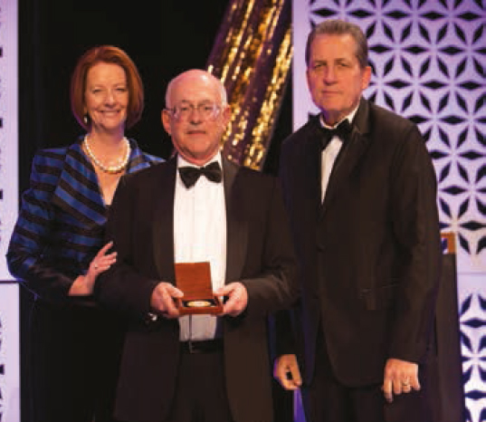

National programs
Through significant national programs, Inspiring Australia has supported hundreds of partnerships and projects that have reached all corners of the nation including traditionally under-served groups.

Unlocking Australia’s Potential
Inspiring Australia is supporting increased year-round opportunities for people and communities to become involved in science-based events and activities. The Unlocking Australia’s Potential grants program is providing a total of $5 million to 63 projects with a strong focus on providing opportunities for participation for all Australians, especially those not normally engaged in science activities including: those living in outer metropolitan, regional and remote areas, Indigenous communities, people for whom English is a second language, and people who are disabled or have limited mobility. Funded projects are being delivered in all states and include talks, events and the use of new media.

National Science Week
Australia’s annual celebration of science attracts more than 1.4 million people of all ages to over 1200 events across the length and breadth of the nation. Highlights of National Science Week in 2012 included:
• The National Science Week ambassador and 2012 Young Australian of the Year, Marita Cheng, spoke at launch events in Perth and Melbourne, participated in media interviews across the country and appeared live on Triple J Radio with Dr Karl to promote National Science Week. Ms Cheng is the founder of Robogals, an international student-run organisation that mentors and engages young women in engineering and technology.
• Approximately 7500 people participated in a national citizen science project Sound Check Australia: the national noise and hearing survey. This project was conducted by ABC Science in collaboration with scientists from the National Acoustic Laboratories who will use survey data to find out about Australian’s hearing health and exposure to loud environments.
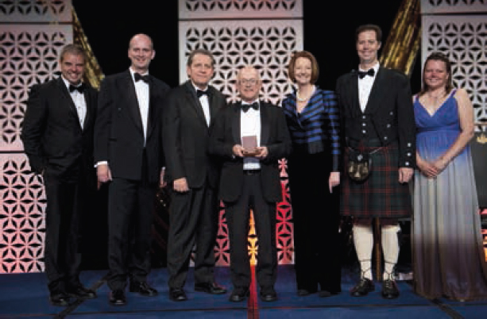

Prime Minister’s Prizes for Science
Australia’s most prestigious awards for excellence in science research and science teaching are a key part of the Inspiring Australia strategy to recognise and tell the story of Australia’s achievements in these areas. The 2012 recipients are:
• Prime Minister’s Prize for Science—Professor Kenneth Freeman, Australian National University. The $300 000 prize recognises Professor Freeman’s work in the discovery of dark matter and galactic archaeology.
• Science Minister’s Prize for Life Scientist of the Year—Dr Mark Shackleton, Peter MacCallum Cancer Centre. Dr Shackleton was recognised for his work in redefining our understanding of melanoma tumours and opening up new pathways for treatment.
• Malcolm McIntosh Prize for Physical Scientist of the Year—Professor Eric May, University of Western Australia. Professor May was recognised for his work in making LNG—the cleanest fossil fuel—even cleaner, through his analytical understanding of gas behaviour.
• Prime Minister’s Prize for Excellence in Science Teaching in Primary Schools—Mr Michael van der Ploeg, Table Cape Primary School. Through providing his students with practical experiences—exploring beaches and fossil cliffs on Tasmania’s northwest coast and interacting with robots—Mr van der Ploeg is inspiring his students to continue to study science at secondary and tertiary levels.
• Prime Minister’s Prize for Excellence in Science Teaching in Secondary Schools—Mrs Anita Trenwith, Salisbury High School. Mrs Trenwith recognises that every student deserves a great science education and has created a unique hands-on program for special education students.
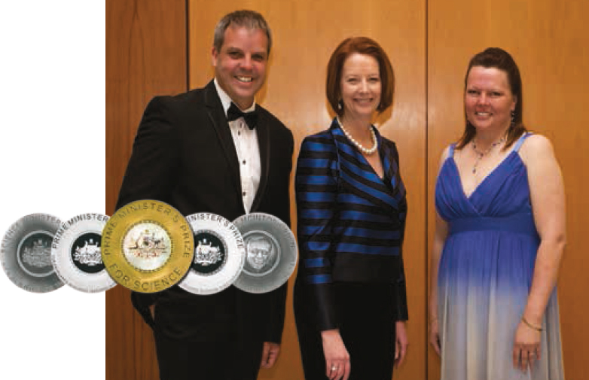

Science and the media
Six projects are underway to support science communication and media training for scientists and assist in furthering Australian science media content. These projects are being delivered by leading universities, science media and science communication organisations in response to key recommendations put forward by the Science and the Media Expert Working Group.
These projects include:
• media skills and new media best practice training for scientists
• a series of topical science forums for media representatives
• training and professional development in science journalism for working generalist journalists and tertiary journalism students
• online resources and tools for working journalists to enable more efficient and accurate reporting of science in the media
• a series of live and online forums where scientists, media experts and school students can discuss current science-related news stories
• media internships for working scientists (pending pilot program outcomes).
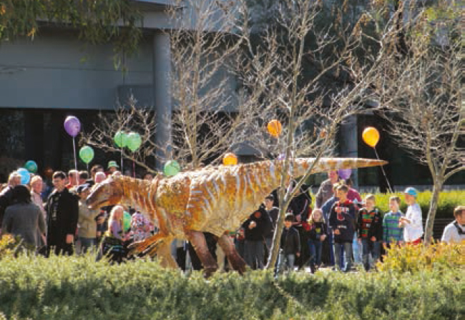

Developing the evidence base
Four projects are underway towards developing an evidence base on the current state and outcomes of science engagement in Australia. The state of Australians’ current attitudes and behaviours towards science and the impact of current science engagement activity will form the evidence base for future policy making and will help inform future investment decisions.
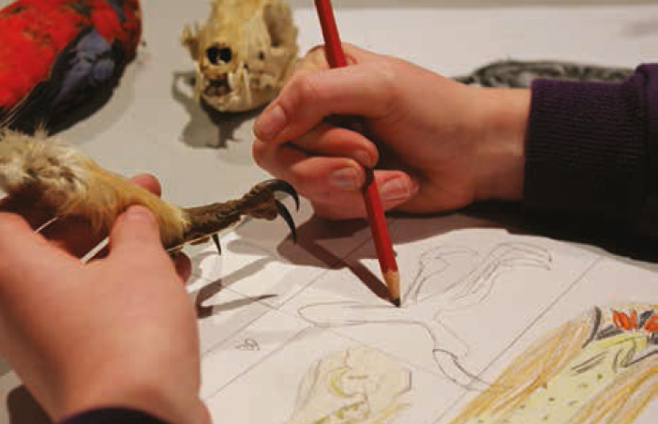
‘For the first time in a long time I could see a bright future for studying science and medicine.’
NSW participant in the Inspiring Australia funded ‘Opening Doors’ project.

‘Thanks for organising this event and bringing your passion, energy and enthusiasm to Stawell! I learned a lot … and gained some very valuable skills and awareness.’
Victorian participant in the ‘Read for Nature’ project funded by Inspiring Australia
These projects will advance recommendations of the Expert Working Group on Developing an Evidence Base for Science Engagement. Projects include:
• a national audit of science engagement activity and development of an online database of activities
• development of national data on engagement activity and best practice in Australia
• development of evaluation tools for measuring the success of science engagement activities.
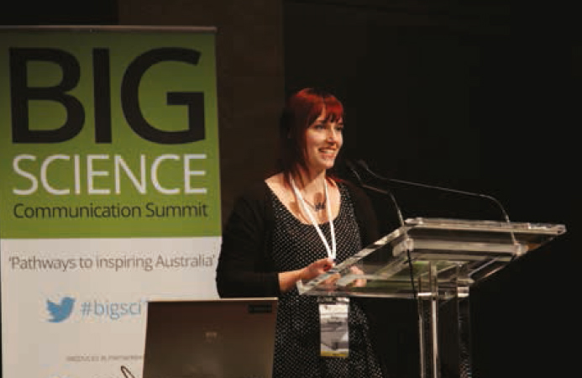

Science and society
The Inspiring Australia strategy recognises the importance of broadening society’s understanding of the value of science and research. Inspiring Australia provides support for initiatives that contribute to achieving this outcome, including Science Meets Parliament (organised by Science & Technology Australia) and the Human Dimension National Forum (organised by the Council for the Humanities, Arts and Social Sciences).

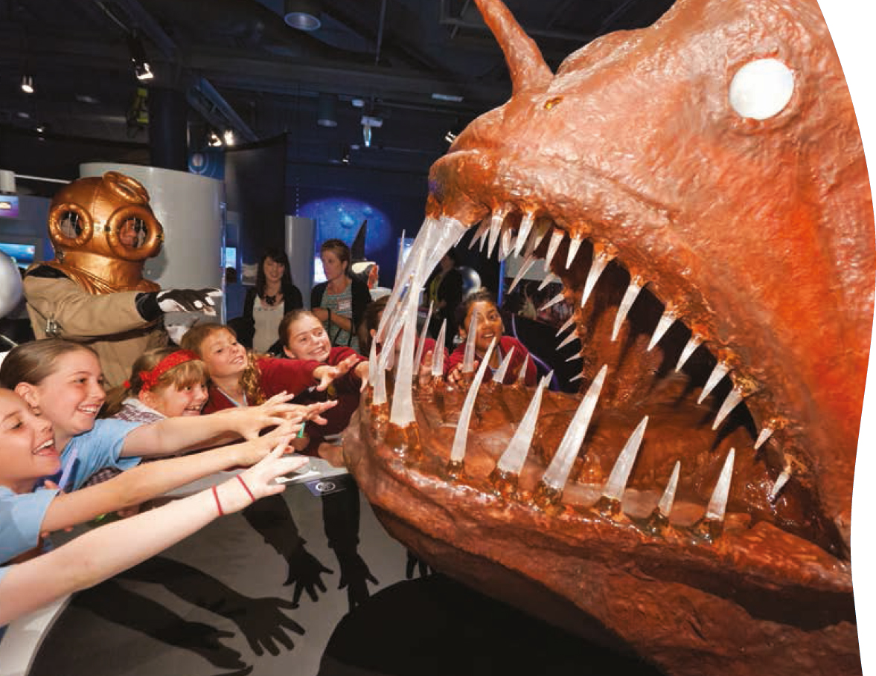
’The most amazing, fantastic, exciting, extraordinary, best ever place ever!’
Visitor feedback, January 2013

Questacon gallery exhibitions
Questacon displays more than 200 exhibits in eight galleries at any one time. The galleries are staffed by Questacon science communicators and volunteers who assist visitors to explore and experience science through interaction with the hands-on exhibits.
Exhibitions on display at Questacon during 2012–13:
• Deep Oceans explores the deep marine environment of Australia and the Pacific region highlighting ecology, biology, oceanography and the technology required to explore the oceans.
• Imagination Factory presents new ways to think about the mechanical world around us.
• Wonderworks highlights the beauty of science phenomena and their power to stimulate the imagination.
• Awesome Earth engages visitors with the forces that shape the earth through cyclones, earthquakes, volcanoes, tsunamis, thunder and lightning.
• Q Lab offers an ever-changing program of activities and exhibits. Visitors can look at the world differently with microscopes and high-definition slow-motion footage. They can also enjoy live scientific demonstrations performed by Questacon’s science communicators and visiting scientists.
• Mini Q—fun for 0–6 year olds encourages younger visitors, along with their parents and carers, to explore science through play.
• Excite@Q is a complete hands-on, minds-on experience, featuring exhibits to get the adrenalin pumping such as the 360 Swing and Freefall.
• H20—Soak up the Science explores how water behaves, how it shapes our world and how we use this precious resource.
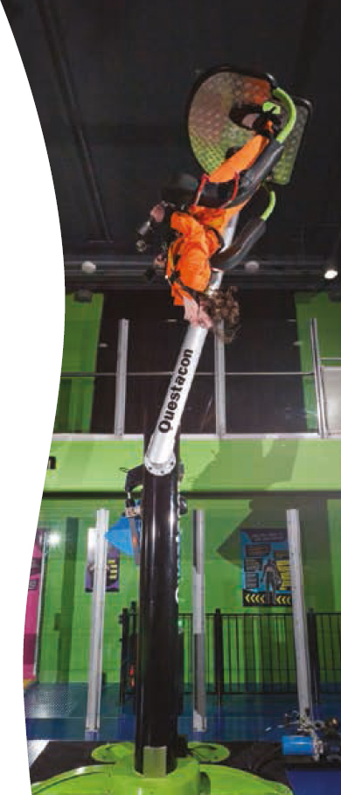

Exhibition highlights
• In November 2012, Questacon’s new Mathamazing travelling exhibition was launched by the Chief Scientist for Australia, Professor Ian Chubb AC and Nobel Laureate Professor Brian Schmidt AC. Mathamazing continues a long tradition of mathematics engagement which started in 1988 with IBM Mathematica, one of Questacon’s first exhibitions.
• Also in November 2012, the Deep Oceans exhibition opened at Questacon. A giant, pink inflatable squid was installed on the roof of Questacon to promote the exhibition, providing a highly visible talking point throughout the Parliamentary Zone.
• The NKRYPT exhibit in the Questacon Science Garden was launched in March 2013 by Senator the Hon Kate Lundy, Senator for the ACT. Within the exhibit’s many codes and ciphers is a code related to the 2013 Centenary of Canberra. With a prize on offer for the first person to solve the code, the NKRYPT exhibit generated significant interest amongst amateur codebreakers in Canberra and beyond, with solutions and ideas being shared online and via social media. The Centenary Code remains unsolved at the time of publication.
• Mathamazing is an interactive travelling exhibition providing mathematically-rich topics such as conics, topology, number theory, probability and statistics, logic and problem solving. The exhibition will expose visitors to the inherent fun to be had by doing maths, and the power of being inspired by maths engagement.
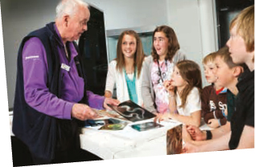

Ramp displays
The walls of the ramp leading to the galleries include a frequently changing display area for science-based art and photographic works. Exhibitions displayed during the year included:
• Focus on Antarctica, a photography exhibition featuring images from the Australian Antarctic Division archives, together with the personal collections of Dr Andrew Dowdy and Questacon Gallery Assistant Geoff Duggan.
• The Dish, a photographic exhibition created in commemoration of the 50th anniversary of the commissioning of the CSIRO Parkes Radio Telescope.
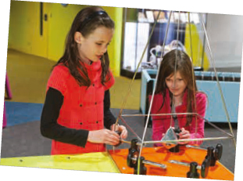

Science Garden outdoor exhibits
The Science Garden offers visitors an outdoor setting in which to explore and discover aspects of science, mathematics, engineering and the environment. The Science Garden exhibits are inspired by the natural elements of sun, wind, water and rock. They include:
• Flickering Leaves, designed and built by world-renowned artist Ned Kahn. This large exhibit’s surface is covered in small stainless steel discs that ripple in the wind, echoing the effect of leaves.
• Möbius, one of the classic forms in both sculpture and mathematics.
• Rock Xylophone—visitors can play a tune on this xylophone constructed of natural stone and appreciate the unique timbre of the stone bars.
• Sound Pillar, a highly polished, flawless column of rock that emits sound when tapped.
• Szilassi Polyhedron—this geometric form was discovered in 1977 by L Szilassi, and is recognised as being the shape with the greatest number of sides (seven) that has every side touching all other sides.
• NKRYPT, a set of sculptural pieces containing many separate codes and ciphers that have been laser cut into eight stainless steel poles. The challenges are all discrete but interlinked and vary in their difficulty. One special code within NKRYPT celebrates the 2013 Centenary of Canberra, and Questacon offered a prize to the first person to solve this code.
• Fundial consists of four sculptural figures representing the different stages of life. As the sun moves across the sky these figures cast shadows indicating the time of day at 2-hour intervals.
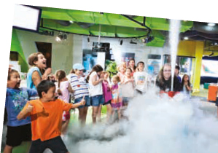
Questacon Technology Learning Centre
The Gallery of Australian Inventiveness at the Questacon Technology Learning Centre (QTLC) features interactive exhibits for visitors to explore the invention cycle and discover the stories of how several Australian inventors have navigated this pathway.
Also on display in the gallery during the year was Henry Hoke: The Lost Tools of Henry Hoke, which features the astonishing creations of a forgotten Australian inventor. This travelling exhibition was developed by the Institute of Backyard Studies and was customised for its installation at the QTLC, including new interpretive panels to include a Canberra chapter to the tale of fictional inventor and entrepreneur Henry Hoke.

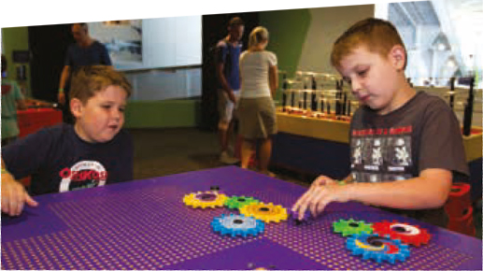
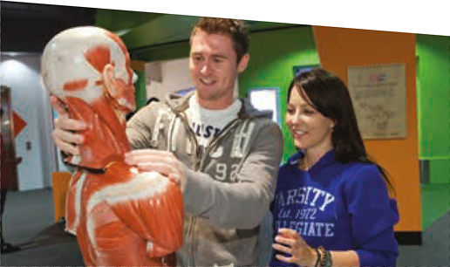
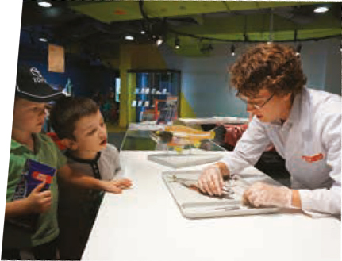
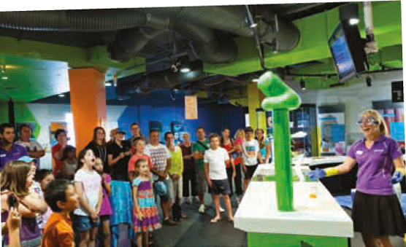
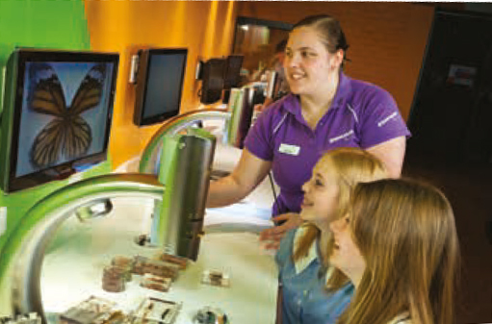

Questacon—the tourism equation
‘A venue on the ‘must visit’ list not only for the hundreds of Australia-wide school groups that travel to the National Capital, but the locals as well.’
Trip Advisor review, April 2013

General Manager perspective
While Questacon is the National Science and Technology Centre and is a major Australian science centre and national institution, it is also a significant tourist attraction. The display cabinet at the Centre is filled with trophies and awards recognising the quality and positive contribution that Questacon makes to the ACT region and Australian tourism industry. Each one is unique, hard earned and highly valued.
While the tourism aspect adds complexity to the goals and decision making in the organisation, it also adds a spirited challenge and exciting edge to what we achieve and how it is delivered. The balance between communicating science, stimulating innovation and attracting visitors is a fine one. We recently opened the Excite@Q exhibition that deliberately included hero exhibits to ensure the ‘wow’ factor was in place for visitors. The 360 Swing and old favourite Free Fall continue to provide the adrenalin rush that appeals to many visitors—both the young and not-so-young. Our science shows, demonstrations, busking and talks are regularly refreshed to enhance visitor experience and ensure repeat visitation. The Centre’s eight galleries, outdoor and foyer experiences are pitched at all generations. It is this ability to engage all ages that sets Questacon apart from many other institutions and tourist attractions.
As one of two dozen tourist attractions in the Canberra and capital region, the sum is greater than the individual parts. Success in tourism rests on the ability to stimulate movement from one postcode to another and, as a member of the National Capital Attractions Association (NCAA), Questacon is able to leverage the menu of offerings across the region. The accessibility of Canberra, the comparative quality of the roads and the unique national institutions located here contribute to a vibrant tourism market. Tourism contributes approximately $1.3 billion to the local economy each year and employs more than 15 000 people, making it an important part of the economic equation. This is recognised and supported through ACT Government initiatives for collaborative marketing activity, along with festivals and events such as Floriade, the Enlighten Festival and those enjoyed during the Centenary of Canberra year.
Each year we welcome to Questacon over 130 000 children from around Australia in school group visits that are co-ordinated through the National Capital Educational Tourism Project (NCETP). These school group visits draw $105 million per annum in real terms into the ACT economy and Questacon is one of the top three drivers for this visitation.
The collaboration we enjoy with the NCETP, NCAA and ACT Tourism means that we are able to actively contribute to regional tourism industry to improve what’s on offer. This year a smart phone application has been launched to assist with tourism information for visitors, a sector-wide client service training program has been developed, advanced professional development activity delivered for education officers, and market and visitor evaluation undertaken to inform future strategies.
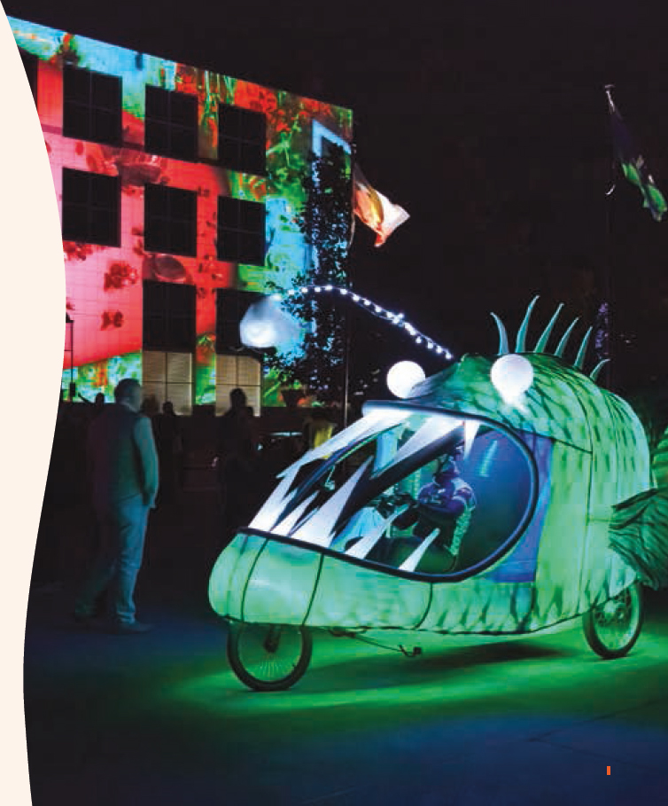
Questacon relies heavily on the ability to generate revenue through admission prices to continue to operate. The highly competitive environment for the tourist dollar means that we need to deliver a consistently high quality visitor experiences to make the cost of entry a forgotten expense. The amenity of an attraction is key to its success and includes parking accessibility, food and beverage, heating, cooling, cleaning, toilet facilities and information availability. All of these components need constant attention to maintain award-winning standards.

The ultimate success of Questacon as a tourist attraction remains with the staff. The difference between a good experience and a great experience can be a smile and assistance when needed. Our people are exceptional and the Centre’s award display is recognition of their work. While the acknowledgment is wonderful, it is also the process of continuous improvement that is so valuable.
It is the requirement for immediate, pro-active and reactive action in the areas of science communication and visitor experience that ensures our focus. The buzz of the crowds and the colour and movement is stimulating and keeps us wanting more—more tourists and more of Questacon.
Lorraine Neish
General Manager – Operations


‘Questacon is guaranteed fun, a wonderful interactive and educational experience.’
Trip Advisor Review, September 2012.

Visitor experience programs and events
Questacon presents a range of in-Centre programs, activities and events 364 days a year. Visitors to Questacon enjoy a range of ways to engage with science, including hands-on exhibits, daily Spectacular Science Shows, school holiday puppet shows, interactive educational presentations and impromptu science busking. Staff and volunteers are on hand in the galleries to assist visitors to get the most from their time at Questacon.
Our youngest visitors and their carers can supplement their visit to the Mini Q exhibition with a Science Time session, designed for children aged between three and six years old. The Science Time program offers learning experiences on a range of science and nature themes that change every three weeks. In-Centre sessions are also complemented by video episodes available on the Questacon website and via Questacon’s YouTube channel.
School and community groups can enjoy an exclusive experience of Questacon after hours with the Q By Night program. Additionally the Q2U program takes a variety of interactive science shows to schools and community groups in the Canberra region.
Questacon also presents special events, science lectures and other activities throughout the year featuring leading Australian and international scientists and experts in a variety of fields. These special events often tie in with Canberra’s public festivals and major exhibitions in our neighbouring cultural institutions.
In 2012–13, Questacon delivered a range of experiences for audiences attending festivals and events in the Canberra region such as the Enlighten Festival, the Floriade flower festival, the Canberra Balloon Festival, National Science Week, The Smith Family Government House Open Day and the Canberra Deep Space Communication Complex Open Day.
Q Lab programs were delivered in partnership with a range of other organisations, communicating current endeavours in science and technology to the public. During the year Q Lab hosted visiting scientists and displayed materials from the Murray–Darling Basin Authority, Geoscience Australia, NICTA, Australian National Botanic Gardens, Royal Australian Chemical Institute, Atlas of Living Australia and many more.
Throughout 2013 Questacon is offering a year-long program of nearly 100 activities as part of Centenary of Canberra celebrations. These activities included 100°C—Stories of 100 Canberra Scientists, a program involving 100 scientists, mathematicians, engineers and technologists with links to Canberra discussing their lives and work. Other Centenary events included themed family fun days and SciNights for adult audiences.
Questacon’s Q Club membership program continued to be a popular option for visitors during the year. Members enjoy unlimited access to Questacon and privileges such as exclusive entry to the Q Club members’ lounge, discounts on merchandise from the Q Shop and member-only discounts at the Mega Bites Café. Members also receive reciprocal entry to science centres and museums throughout Australia and internationally. Q Club members are kept up to date with Questacon’s programs, exhibitions and events through a quarterly electronic newsletter.

Spectacular Science Shows delivered in 2012–13 included:
Tasty Science | Spiders
Balloonatic | Parasites Lost
Boom Crash Boing—The Collision Show | Snakes
Move It—The Engineering Show | Insects
Rocket Science #101 | Shocking Science—The Story of Nikola Tesla
Perception Deception | The Science of Mummification
Testing the Waters | Dino Science
Instrumental as Anything—The Music Show | Rip Slash Go Game Show
Invasion from the Planet FWAH—The BOC Liquid Nitrogen Show | A Drop in the Oceans—Deep Oceans Show
The Natural Disaster Show | Colour & Light
Side Show Science Spectacular | Extreme Environments
Bright Sparks—The Electricity show | Moon Landing
The Science of Flight | Square Kilometre Array Show
Explodaganza | Endurance: The Ernest Shackleton Story
Marie Curie’s Notebook | Mega Predators
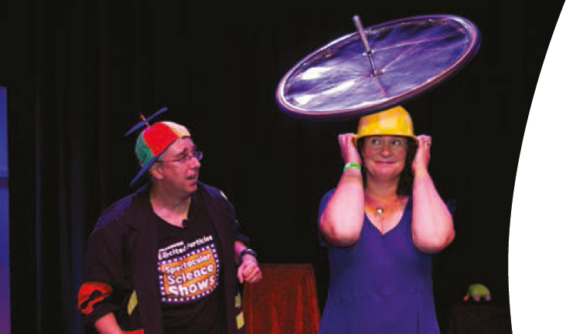

Visitor experience highlights
• The Questacon Excited Particles performed 2609 shows, talks, puppet shows and Q2U visits to 173 504 people. Two theatrical pieces were also developed and performed during the year—Endurance: The Ernest Shackleton Story and Marie Curie’s Notebook. The latter was developed to complement the National Gallery of Australia’s summer exhibition Toulouse Latrec—Paris & the Moulin Rouge. The performance enacted the story of Marie Curie’s pioneering scientific work that took place in the same era as Toulouse Latrec’s artistic work.
• In February, Questacon partnered with the ACT Academy of Sport, the Australian Institute of Sport (AIS) and several local sporting organisations to present the Science Sport Spectacular@Questacon as part of the Centenary of Canberra celebrations. Displays and demonstrations highlighted the connections between sport and science. Utilising high-speed film, high-tech analytics and simple tests, visitors could discover if they are destined for a future in sport. Presentations on sport science were given by representatives of the AIS and University of Canberra.
• Over four magical nights in March 2013, Questacon was presented in a whole new light as part of the Enlighten Festival. The outside of the building was illuminated with scientific-themed projections, and Questacon opened up its foyer and theatre to a hive of activity and Spectacular Science Shows. Local winemaker and Nobel Prize Winner Professor Brian Schmidt led a small group on a tasting journey of his favourite Canberra wines. Performer Bukhchuluun Ganburged delivered a musical performance that brought the ancient and modern worlds together by fusing the centuries-old tradition of Mongolian Throat Singing with high-tech equipment such as a looping pedal and mobile phone applications.
• The Q Club had 5045 memberships, comprising 17 772 individuals, including many interstate residents.
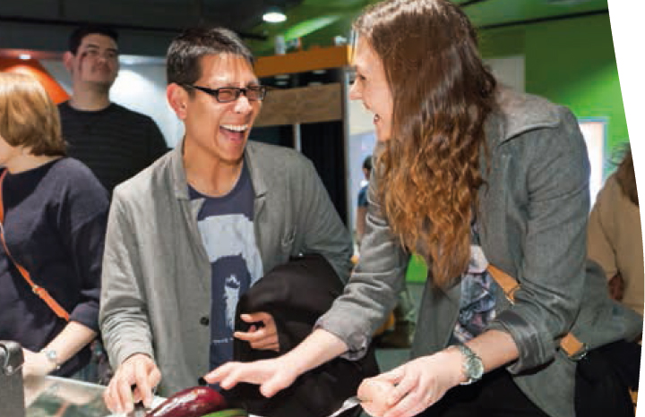

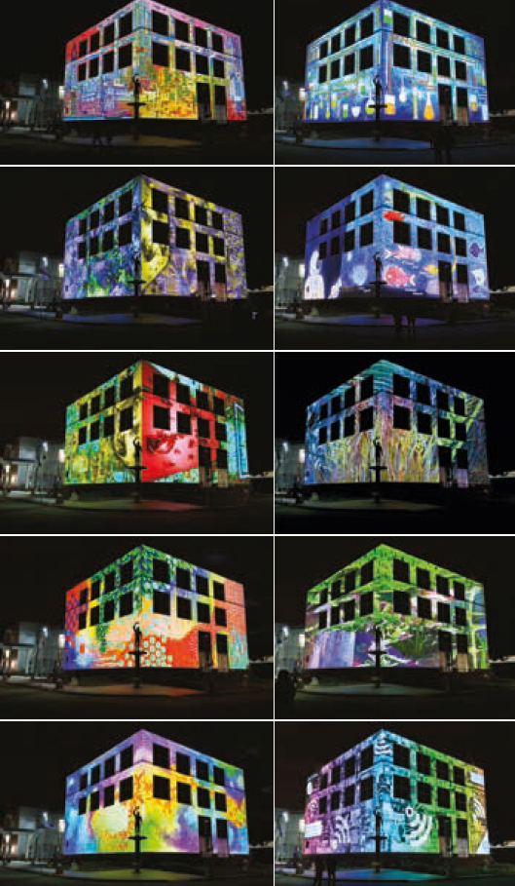

Questacon building
Questacon’s purpose-built science centre—an iconic national institution located within Canberra’s Parliamentary Zone—has been operating for close to 25 years. Over the life of the building visitation has more than doubled, from the projected building capacity of 200 000 per year to approximately 430 000 people annually.
To ensure Questacon’s ability to further extend audience range, communicate emerging science and technology, and maintain visitor amenity, the Questacon building ideally needs more galleries and a new theatre. To this end, Questacon has worked with the original building architect Lawrence Nield, in conjuction with Cox Humphries Moss, on the completion of the building as intended by Lawrence in his initial sketches undertaken in the mid-1980s.
The work undertaken to date has delivered plans for the completion of the National Science and Technology Centre. These plans comprise an extension of the new building towards the National Library of Australia that will provide new galleries and theatres, retail amenities, an expanded foyer and car parking areas, and an expansive ‘science verandah’ with improved connections to the Humanities and Science Campus.
Questacon continues to deliver high levels of building amenity, environmental management and workplace health and safety in this award-winning tourist destination.
Achievements during the 2012–13 financial year include:
• Capital works, including refurbishment of Galleries 1, 6 and 8, upgrades to the foyer ceiling, foyer bathrooms, and roof sheeting; and numerous minor projects which contribute to the life cycle of the building’s services, safety systems and envelope.
• Continual improvements in accordance with Questacon’s Environmental Management System, which is certified to ISO 14001.
• Implementation of recommended actions in response to audits against the recently introduced Work Health and Safety Act 2011. Questacon’s incident numbers and severity continue to be relatively stable even in an environment of expanding activities.
• Very high levels of building amenity continue to be provided and noted in positive visitor comments about the cleaning contractors and building appearance.

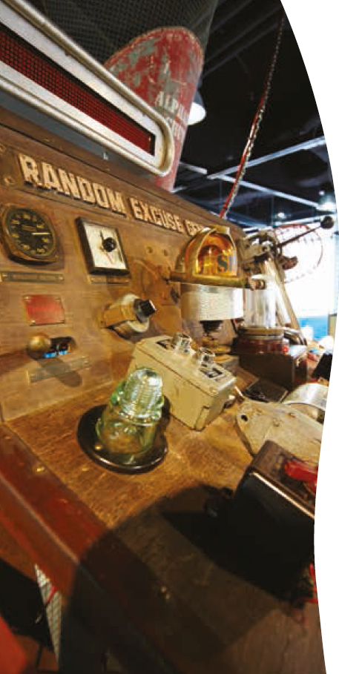

Questacon Technology Learning Centre
Questacon’s newest facility, the Questacon Technology Learning Centre (QTLC) was officially opened on the 27 June 2013 by the Minister for Science and Research, Senator the Hon Don Farrell.
The QTLC is located next to the Royal Australian Mint in Deakin, Canberra. It offers unique educational and public programs with a technology, innovation and design focus, using Questacon’s proven approach of engagement through hands-on interactivity.
Visitors explore the steps of the innovation process through participating in design and engineering challenges. Participants are encouraged to develop creative and inventive solutions to these challenges through problem-solving and inquiry-based learning and utilising both high-tech gadgets and low-tech materials.
The Gallery of Australian Inventiveness features interactive exhibits for visitors to explore the process of innovation and invention and to hear the stories of successful Australian inventors.
The QTLC also houses Questacon’s national programs and exhibition design and fabrication facility—a working example of the innovation and manufacturing process that will be accessible to visitors on public open days.

The Gallery of Australian Inventiveness
This Gallery provides a short duration, walk-through experience that complements the adjacent Royal Australian Mint’s publicly-visible manufacturing process.
Visitors can explore the innovation and manufacturing process through interactive exhibits and associated hands-on activities. The exhibits highlight technology at a broad level along with Australia’s capability and success in innovation, design and manufacturing.
The visitor experience highlights the important stages in the innovation process from conception to production: identifying a problem, prototyping, testing, re-testing and revising the solution, learning from failures and building upon knowledge gained from this process. Case studies from Australian inventors are drawn from different sectors and refreshed regularly.

Henry Hoke: the Lost Tools of Henry Hoke
This visiting exhibition tells the story of an unsung Australian inventive genius. From an isolated workshop in a distant windswept town came a constant stream of dazzling leaps of mechanical imagination, culminating in this exhibition which showcases Hoke’s inventions, including the long weight, the wooden magnet, the glass hammer, dehydrated water pills and many more.
The hitherto forgotten Canberra chapter in the life of Henry Hoke was discovered just in time for the exhibition’s installation at the QTLC. The exhibition reveals that Hoke became the toast of the Canberra’s political community when he invented the Random Excuse Generator - a diplomatic must-have of the time.
This exhibition encourages visitors to second-guess their first impressions and use a little scepticism whilst also demonstrating that innovation for the sake of whimsy follows a similar process to serious product development—and is just as important.
This exhibition was developed by the Institute of Backyard Studies, South Australia, and is on display at the QTLC until March 2014.
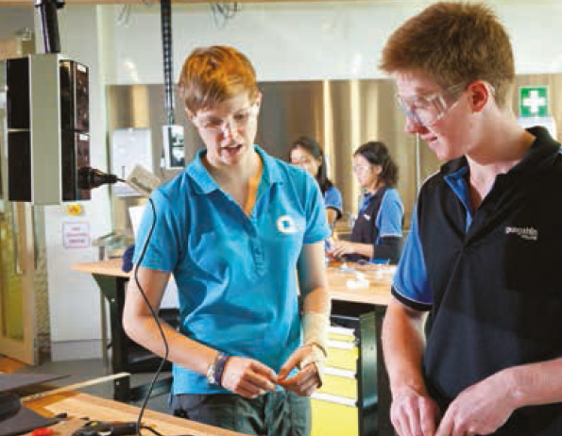

School Workshops and Maker Space
The QTLC offers workshops that immerse secondary school students in ideas, tools and creativity. These two-hour workshops offer a variety of topics and activities, themed under the innovation process steps of think, make, try and refine.
Students use a range of tools and technologies to design and create inventive solutions to specific challenges or problems. Activities range from building robots using salvaged and simple materials, programming them with open-source software through to designing the ultimate paper plane or simple submersible.
Workshops are held in a fully equipped Maker Space and are presented by the Questacon Maker Project team. Workshop sessions are also offered via videoconference for schools outside the Canberra region.
A Neat Kit Room houses a range of high-tech manufacturing tools and equipment, such as 3D printers, routers, plastic formers and laser cutters, which more advanced school and community groups may use for special projects. Other visitors are able to view Questacon staff and volunteers using this equipment to develop exhibits, props and other materials for use in Questacon’s programs and exhibitions.
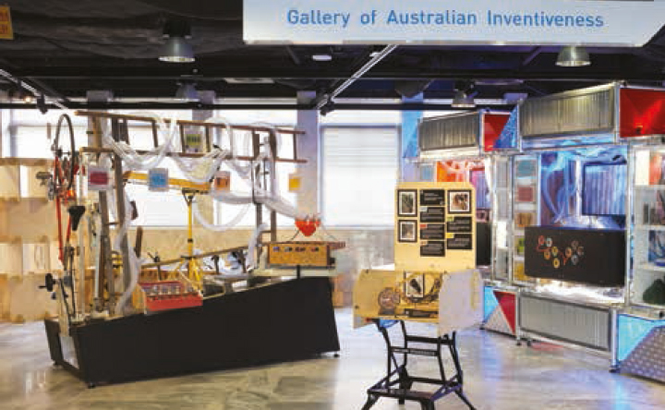
“Great workspace! A lot of thought gone into the whole thing. Excellent facilities. Five star.”
Teacher feedback from the first QTLC student workshop
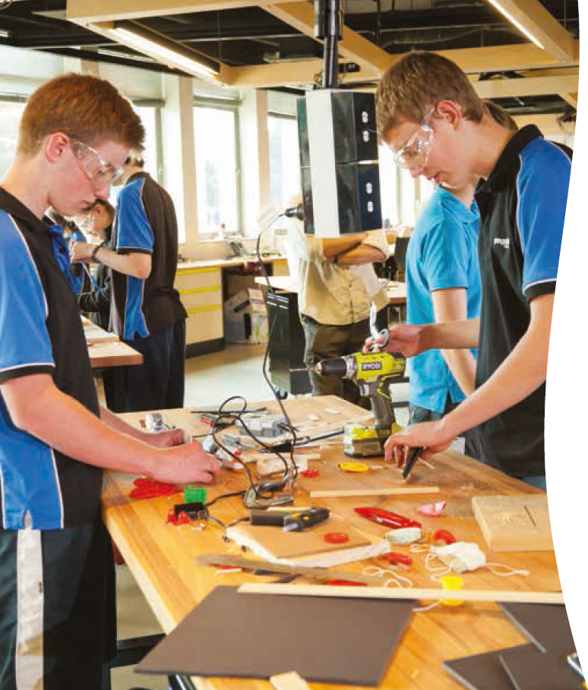

Community activities
The QTLC offers a range of activities and events for the general public and community groups that—with a spirit of curiosity, invention and innovation—will generate an atmosphere of creative exploration through technology and tinkering.

Torque—Revolving ideas
This evening seminar series brings local artists, engineers, designers, scientists and creatives to the QTLC to discuss their work, their hobbies and their construction processes, sharing how they turned their visions into reality. Torque seminar topics vary widely for maximum inspiration and provide an exciting insight into Canberra’s maker culture.
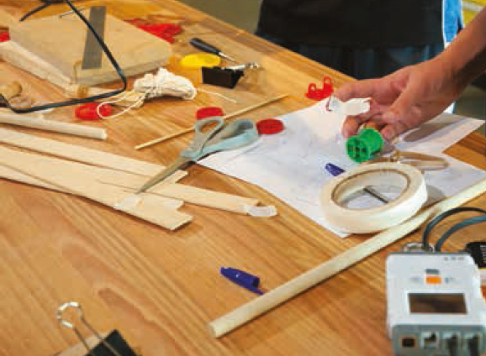

QTLC Highlights
• A major achievement during the year was the completion of the fit-out project. The $6.25 million project was funded by the Australian Government and delivered an innovative workspace and public area fit-out within an iconic heritage building, on time and within budget. Along with providing the public exhibition, program and activity spaces, the fit-out project delivered a new home for the design, development and national program teams who had previously been located in leased premises in Fyshwick, ACT.
• The first student workshop in the new facility was delivered in March 2013 with an ACT home educators group. In this workshop, the students used their building prowess to design and build floating pontoons for working cranes. The workshop received excellent feedback and positive comments on the Maker Space and QTLC facility.
• This year, Questacon offered a QTLC component of the Schools Training Program giving students the chance to gain hands-on experience of technology—from 3D printers to mechanical art. Ten students from schools across the ACT participated in the program, attending weekly sessions that investigate innovation as a process, through creative thinking, making, trying, and refining products and projects. The students also developed their communication skills in order to share knowledge and participate in the maker community in Canberra.
• The first QTLC videoconference was delivered in May 2013 to a school in Victoria. The Foldable Flight session explored the physics of flight by encouraging the students to build and refine their own paper planes. From darts to gliders, the students learnt the importance of aerodynamics and refined their own designs to create the ultimate paper plane.
• A teacher familiarisation event was held at the QTLC in May 2013. This was an opportunity for ACT secondary teachers to experience and sample the range of interactive innovation and technology workshops on offer for their students. Teachers were given guided tours of the facility including the exhibition development workshop, demonstrating Questacon’s own innovation process in developing exhibits.
• Since March, QTLC has hosted monthly Torque seminars which have provided an opportunity for the general public to engage with the local maker community. Over four events, visitors have explored maker culture with Alastair D’Silva, founder of Canberra group Make Hack Void, made science props with science communicator Graham Walker, discussed do-it-yourself energy efficiency with the ABC’s Carbon Cop Lish Fejer and discovered the evolution of face recognition with the National Portrait Gallery’s Sylvia Cockburn.
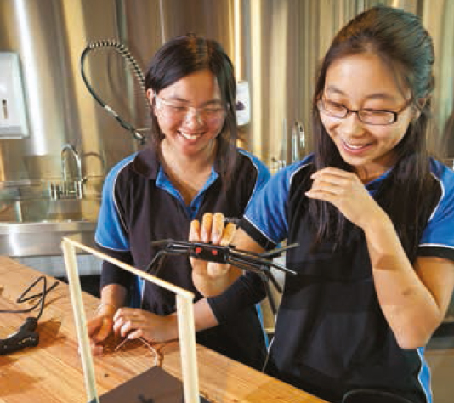

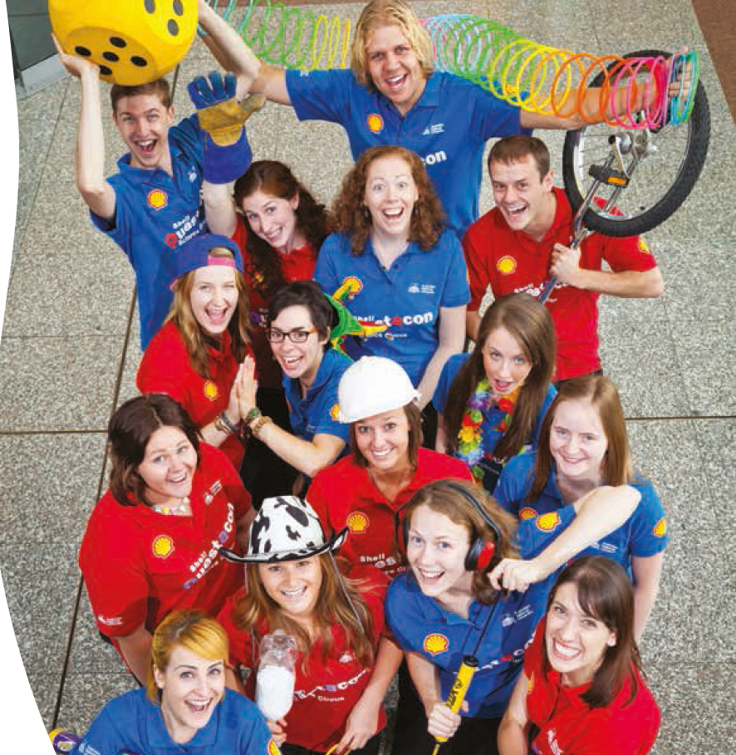
‘Thank you for coming to see us. Science is so valuable and country students haven’t always easy access to places like Questacon. Great idea’
Teacher feedback on the Shell Questacon Science Circus

Questacon national programs
An awareness and understanding of how science and research are critical to our lives is essential for developing and sustaining an innovation culture in Australia. In 2012–13 Questacon offered five national programs designed to make science and technology accessible to communities in regional and remote areas throughout Australia. Each program has a specific target audience and supports national education priorities such as Indigenous education, early childhood and primary science. National programs are supported by partnerships with corporate Australia enabling Questacon to reach communities all over Australia.
Our youngest visitors and their carers can supplement their visit to the Mini Q exhibition with a Science Time session, designed for children aged between three and six years old. The Science Time program offers learning experiences on a range of science and nature themes that change every three weeks. In-Centre sessions are also complemented by video episodes available on the Questacon website and via Questacon’s YouTube channel.
To increase community access to national programs and supplement travelling programs, Questacon also offers a Digital Outreach program to schools using interactive videoconference technology.
During 2012–13, Questacon’s national programs reached an audience of 116 317 people at 867 schools and other venues across Australia. National programs often tour and work closely together to create quality experiences for our audiences. In some instances, programs share the role of host and co-present shows, workshops and events. Program totals in the table above right reflect the number of visitors and venues seen by each program, including co-presented sessions. Questacon Maker Project totals include program trials and delivery within Canberra and nationally.
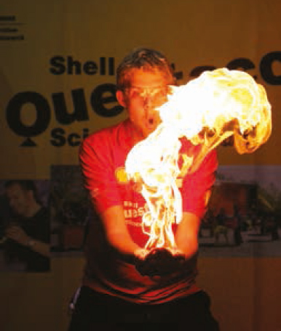
Wonderful staff-relevant, enthusiastic’
Science Circus feedback

Visitors to Questacon national programs in 2012–13
Program | Number of visitors | Number of schools and venues visited
Shell Questacon  Science Circus | 77 304 | 370
Questacon Science  Squad | 20 897 | 129
Questacon Science  Play | 3683 | 142
Questacon  ScienceLines | 2648 | 119
Questacon Digital  Outreach | 1792 | 48
Questacon Maker  Project | 10 552 | 59
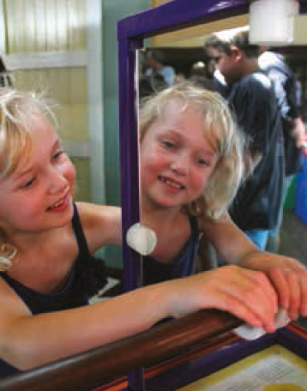

Shell Questacon Science Circus
Each year the Shell Questacon Science Circus carries out travelling tours for up to 16 weeks. The Science Circus, through science shows and a portable exhibition, aims to inspire young people to engage with science and technology. A teacher support program is also a feature of the program.
The program is a major component of an Australian National University Master of Science Communication Outreach for up to 16 science graduates each year.
This year the Beyond School—So, What’s Next? initiative continued to complement the Science Circus program by hosting innovative career expo events in Cairns and Wagga Wagga. These expos showcase local education options, careers and accomplishments in science and technology to senior secondary students in the regions to which the Science Circus tours.
In the past year, the Science Circus expanded its activities to further enhance the program’s impact in each community visited, including workshops for older Australians and primary carers of children, early childhood workshops and videoconferencing events that showcased successful female scientist and engineer role-models to high school students.
Questacon acknowledges and greatly values the ongoing partnership with Shell and The Australian National University in support of the delivery of the Shell Questacon Science Circus program.
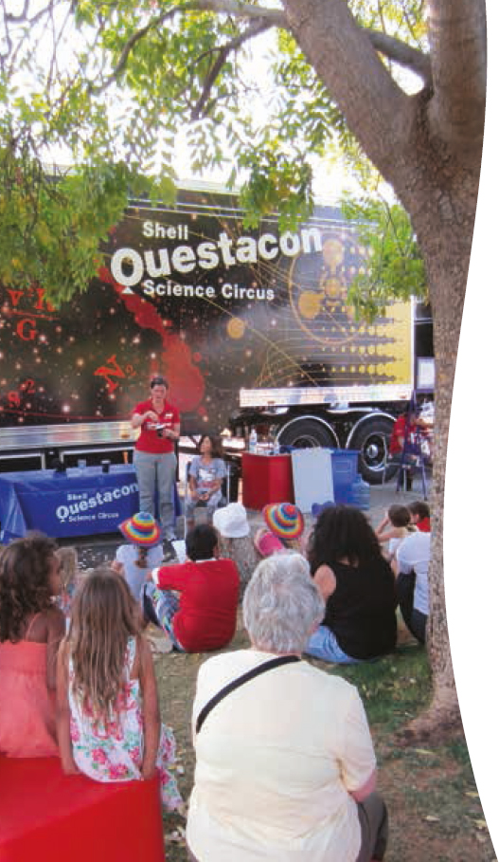

Questacon Digital Outreach
Questacon’s Digital Outreach program delivers a wide range of workshops to school students via videoconference. Students from schools across Australia participate in workshops and share their science learning with each other as part of the experience. During the year several new activities were planned and developed in conjunction with external partners.
The Basin Champion Schools Program is an initiative of the Murray–Darling Basin Authority, facilitated by Questacon. The program encouraged students to think about the connectivity and interdependence of environments across the Murray–Darling Basin by undertaking a real life investigation of their own local aquatic environment. Throughout their projects, students were supported by mentors and shared their findings via interactive videoconference with other students across the Basin. Questacon provided videoconferencing technology and expertise throughout the program, including for a digital launch event in March 2013 followed by a series of classroom videoconferences involving ten schools across the Murray–Darling Basin. The project culminated in a digital finale event in June 2013.
Questacon also delivered the Let’s Get Animated! program to schools across New South Wales in partnership with the National Film and Sound Archive. The two-part workshop incorporated an in-class student project based around creating an animation of a scientific concept. The program encouraged students to learn through exploration, questioning and experimentation with different animation methods and technologies. It encouraged and supported teachers to utilise scientific enquiry across the curriculum by involving a range of classes, from art and design to science.

Questacon ScienceLines
Questacon ScienceLines engages both Indigenous and non-Indigenous communities with science, technology and traditional knowledge to promote the value and relevance of both ways of knowing.
This year the ScienceLines team toured the Murray–Darling Basin, North Queensland and Central Australia, delivering newly developed interactive multimedia-based shows in classrooms. Each show is built around a variety of stories showcasing the achievements of Indigenous people in the sciences. ScienceLines tours also offer dynamic, hands-on workshops that allow students to explore science concepts in more depth and develop their problem-solving skills.
ScienceLines supported the Charles Sturt University and Astronomical Society of Albury-Wodonga’s National Science Week celebrations in Albury in August 2012. The ScienceLines team presented three days of interactive shows for visiting schools, who had travelled to Albury from around the Murray–Darling area to take part in National Science Week.
During November 2012, ScienceLines delivered small group workshops specifically developed for several external partners. These included digital storytelling workshops for Nura Gili Indigenous Programs (Sydney) and Yarkuwa Indigenous Knowledge Centre (Deniliquin).
In 2013, ScienceLines continued to implement the Indigenous Paths in Science project to record the stories of Indigenous people using science in their jobs and everyday life. These stories make science more engaging and relevant to young Indigenous audiences. The people who have been interviewed are inspirational role models, showing students that science and technology are part of almost any study or career path.

Questacon Maker Project
Questacon Maker Project programs offers QTLC programs nationally to interested groups such as inter-school challenges and community events. During the year the Questacon Maker Project conducted QLTC program development trials within Canberra and nationally, presented walk-up workshops and showcased 3D-printer technology at the Fraser Coast Schools Challenge in Queensland and the Bermagui Seaside Fair in New South Wales.
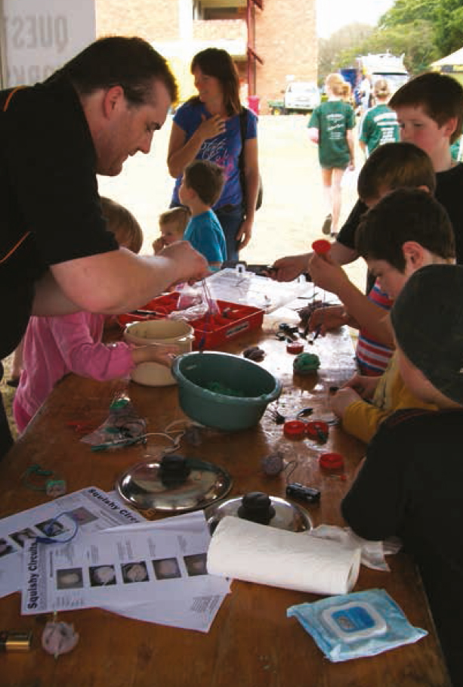
‘This is the best science workshop I have seen in Australia, because it is not just about explosions, it is asking the students to solve problems and use their own knowledge. This was an excellent workshop, engaging and the students enjoyed the hands-on activities’
Teacher feedback from ScienceLines workshop in Alice Springs
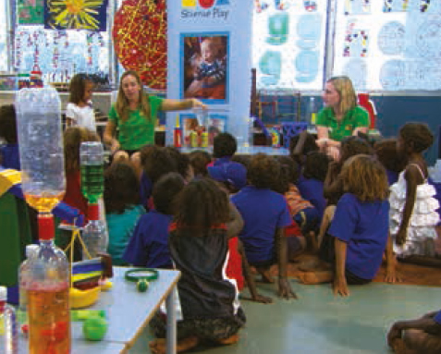

Questacon programs in Sydney
Questacon’s Sydney-based programs, Questacon Science Squad and Questacon Science Play concluded in June 2013. Questacon is proud of the achievements of these long-running programs.
Since their inception, these programs have reached over 330 000 people in the Sydney metropolitan region, greater New South Wales and other regional areas around Australia. These programs have taken science to libraries, early childhood facilities, shopping centres, hospital schools, science festivals, and have even presented science shows to an audience of child actors from a production of Mary Poppins.
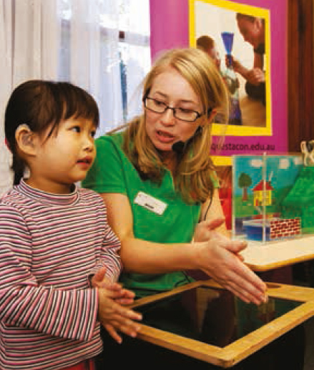

Questacon Science Squad

The Science Squad program has provided students and teachers with positive science experiences since 2001. The Questacon Science Squad delivered shows in primary schools, secondary schools and schools for special purposes across the Sydney metropolitan region.
The program supported classroom science teaching through teacher resources, quarterly newsletters and a large collection of hands-on science activities, videos and information on the Questacon website.
The Science Squad also presented shows and workshops as part of school holiday programs at vacation care centres and libraries, presented large-scale science shows at shopping centres and special events, and worked with museums and other cultural and community groups to deliver science education programs.
The Science Squad began operations in February 2001 with two staff members. At that time, there were no other science awareness programs for schools operating in Sydney. The Science Squad’s approach of delivering curriculum-linked performances that were both educational and entertaining rapidly proved popular with schools.
In the first five years, the program grew considerably, with audiences for the in-school programs increasing by 40 per cent. Program partnerships with organisations such as the Photonics Institute and NRMA were also undertaken.
At its conclusion, the Questacon Science Squad had presented programs to a total of 303 466 students, teachers, parents and members of the general public in the Sydney metropolitan region and greater NSW.
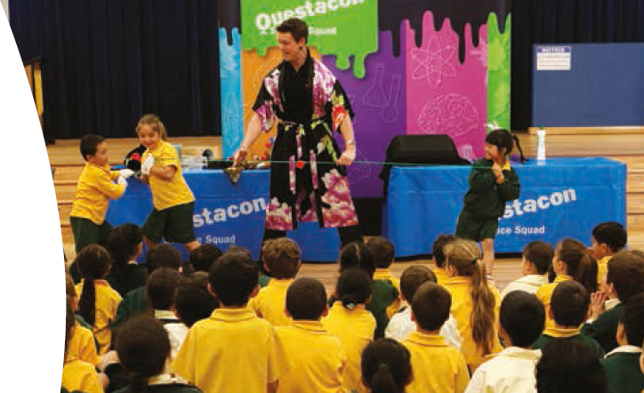

Questacon Science Play
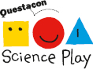
In October 2006, the Australian Government announced funding for Questacon to develop and deliver a nationally travelling early childhood science program—Questacon Science Play. Science Play was the first of its kind in the early childhood space. Delivery of the program began in January 2007 and was based with the Science Squad in Sydney. The program team included an early childhood specialist education officer.
Questacon Science Play delivered play-based science sessions for young children and their parents, educators and carers in regional and metropolitan areas nationally. Science Play tours were supplemented with an activity booklet, a DVD of science episodes and information on the Questacon website.
Science Play sessions were hosted by early childhood facilities, libraries and community groups. The program also delivered professional development in early childhood engagement for educators and from 2011 Science Play sessions were presented in conjunction with the Shell Questacon Science Circus on regional tours.
At the program’s conclusion, Questacon Science Play had delivered programs to 28 301 children, carers, parents and teachers across Australia.

Program highlights
Some key highlights over the years have included:
• Developing two large-scale public shows to be delivered alongside new exhibitions at the Australian Museum in Sydney.
• Presenting at the Fun4Kids children’s festival in Warrnambool, Victoria.
• Working with Channel 7 to develop and deliver content for children’s television shows The Big Arvo, It’s Academic and Saturday Disney.
• Providing material for the Science Teachers Association of NSW conferences, professional development sessions and publications.
• Filming science demonstrations for the NSW Department of Education secondary science syllabus.
• Presenting regular shows for refugee students as part of the St Vincent de Paul Bright Sparks program.
The key to the success of these programs has been the professional and dedicated staff involved with the programs over the years. A total of 25 talented staff members have worked with the programs in a variety of presenting, coordinating, development and managerial roles. The program has also greatly appreciated the assistance of nine short term staff members and hosted four volunteer work experience students.
This brings to an end these programs in their current forms, however it is planned to integrate components into the new QTLC programs and adopt an outreach delivery model where appropriate.

‘I attended the Questacon Science Squad Show yesterday...It was both funny and interesting and my boys loved it. Thanks for making this available particularly in the school holidays when it is always hard to find different things for the kids to do!’
Parent feedback, Questacon Science Squad

Travelling exhibitions
Questacon provides travelling exhibitions that tour to a range of regional and metropolitan venues across Australia and internationally. These interactive exhibitions are developed in-house by Questacon and provide engagement for all ages.
During 2012–13 Questacon toured seven exhibitions to 11 venues reaching 199 696 visitors in Australia, and 163 840 visitors internationally—a total of 363 536 people experiencing at least one of these exhibitions.
The travelling exhibition program included:
• Science on the Move and Fascinating Science—two portable exhibitions that explore simple scientific principles relevant to everyday life. These exhibitions toured to Abu Dhabi in October 2012 and to Vietnam in April 2013.
• Our Water delves into the different ways of using and preserving the precious resource of water. The development and two-year touring program of this exhibition was supported by the National Water Commission and concluded in August 2012. The exhibition was on display at Albury Library in August 2012 and hosted by Tamworth Council for National Water Week in October 2012.
• Perception Deception explores perception and the senses with interactive exhibits, multimedia activities, visual illusions and perception tests. The two parts of this exhibition toured separately during the year; one part to Wanneroo Library and Cultural Centre, Western Australia between November 2012 and March 2013, and the other to the Museum of Tropical Queensland, Townsville from July 2012 to July 2013.
• Eaten Alive—the World of Predators: four exhibits from this exhibition were on display at the Queen Victoria Museum and Gallery in Launceston, Tasmania between February 2011 and April 2013.
• Measure Island examines the concepts of good measurement, measurement systems and techniques, and helps visitors discover the importance of measurement in daily life. This exhibition toured to the Oil and Gas Discovery Centre, Brunei from October 2012 to May 2013.
• Imagination Factory—invent and play captures the spirit of innovation and allows visitors to investigate basic mechanical tools to create ingenious inventions. Imagination Factory toured to the Museum of Transport and Technology in Auckland between December 2012 and June 2013.
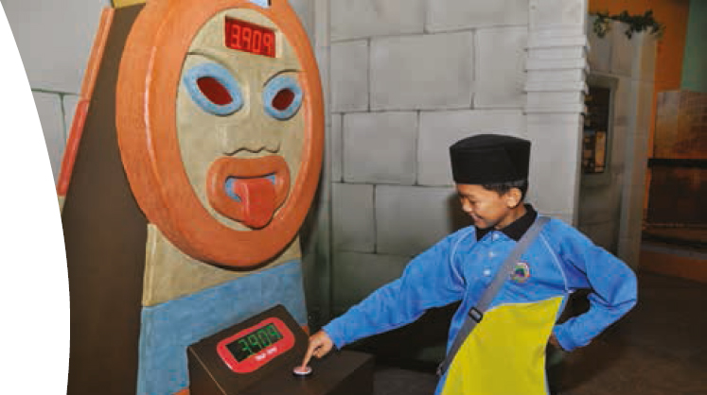

Travelling exhibition highlights
• Questacon’s travelling exhibitions were in high demand internationally this year. The Science on the Move and Fascinating Science exhibitions formed the centrepiece of Questacon programs at the Abu Dhabi Science Festival. They were also the major component of a Questacon tour to Vietnam as part of celebrations marking the 40th Anniversary of Diplomatic Relations between Vietnam and Australia. In addition, Measure Island toured to Brunei and Imagination Factory toured to New Zealand. These international tours highlight Questacon’s expertise in developing travelling exhibitions that are ideal for transportation overseas and that can be customised into different languages as required.
• The National Science Museum in Thailand purchased Questacon’s Earth Quest travelling exhibition for display within the museum, adding 30 interactive exhibits exploring astronomy, geology, geography, environmental science and biology to their existing displays. Questacon has duplicated this exhibition, which is available for hire as a Questacon travelling exhibition.
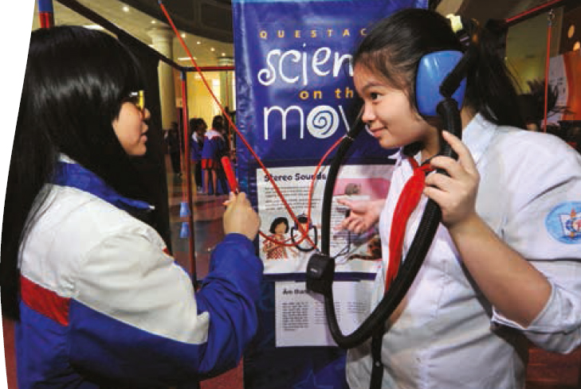

Questacon digital communications
Questacon continues to engage a growing audience with its multi-disciplinary capability in video production and videoconferencing, along with expanding communication via online and social media.

Video production and videoconferencing
Throughout the year, Questacon’s expertise in producing, facilitating and delivering video production projects and videoconferencing events has attracted a variety of government and non-government partners. Key projects during 2012–13 are listed below.
• In collaboration with the National Film and Sound Archive (NFSA), Questacon facilitated a digital music-making videoconference workshop featuring 2013 Grammy Award winner Gotye, Former Minister Simon Crean and NFSA CEO Michael Loebenstein. Gotye talked to students from five schools in Queensland, Victoria and New South Wales about his approaches to composition and performance.
• The NFSA also partnered with Questacon on other regular videoconferencing events for schools across Australia. The NFSA provided program content and Questacon provided videoconference facilities and technical service via the Schmidt Digital Studio.
• A series of videos were produced for use in QTLC programs that featured interviews with prominent Australian innovators along with a detailed look into their inventions. These videos explored the impact of the inventions across various areas—such as increasing environmental awareness and future technology advancement—and how their success has contributed to the international profile of Australian science.
• Questacon produced a short video of the Science Meets Parliament event in September 2012, coordinated by Science & Technology Australia. This event brought together approximately 200 of Australia’s top scientists and put them face-to-face with decision makers in Canberra to discuss their fields in science and the importance of science in Australia. Questacon interviewed scientists throughout the event and produced a short video to showcase the value of bringing scientists and Parliamentarians together.
• Questacon produced a video introduction for the 2012 Prime Minister’s Prizes for Science presentation ceremony in October. This video showcased current research being conducted under the Australian Government’s Cooperative Research Centre initiative.
Questacon’s expertise in slow motion media production has garnered increasing interest from a variety of partners:
• Questacon was engaged by Bearcage Productions to capture slow motion footage for the locally produced TV series The Boffin, the Builder and the Bombardier. This eight-part historical documentary series was based around reconstructing historical devices and machines, and aired on ABC1 during April and May 2013.
• Questacon produced slow motion footage for CSIRO, ANU, ABC TV’s Catalyst program and educational science video producer Veritasium. Slow motion footage of a slinky being dropped from the roof of Questacon attracted over one million views on Veratasium’s YouTube channel.
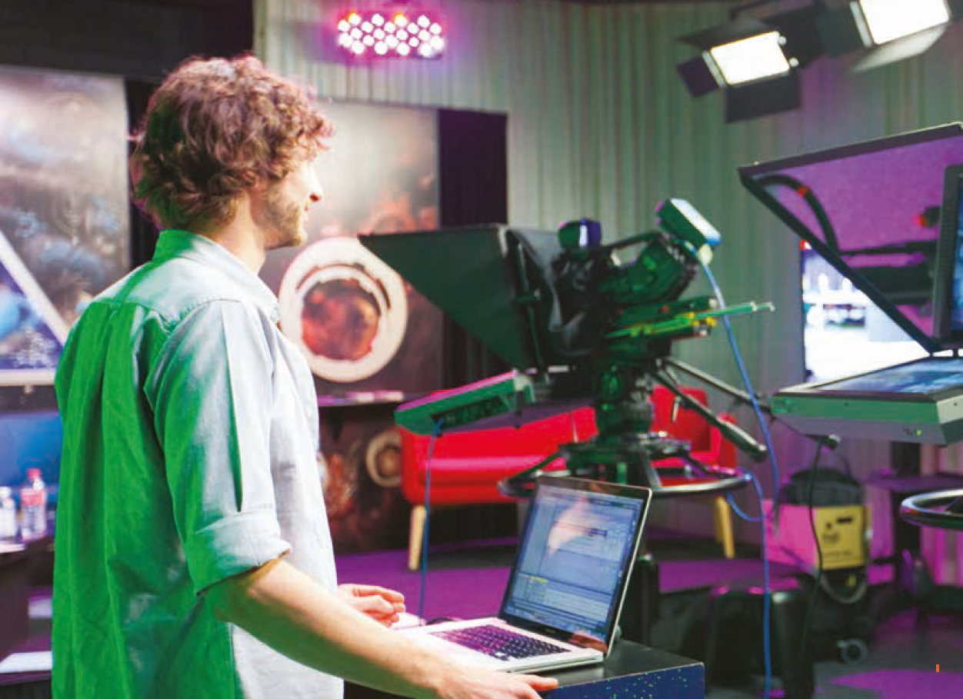

• Questacon continued to produce content for its dedicated YouTube channel. Along with footage produced for partners, a growing library of slow-motion clips were produced and added to the channel, providing a unique science resource for educators and the general public.
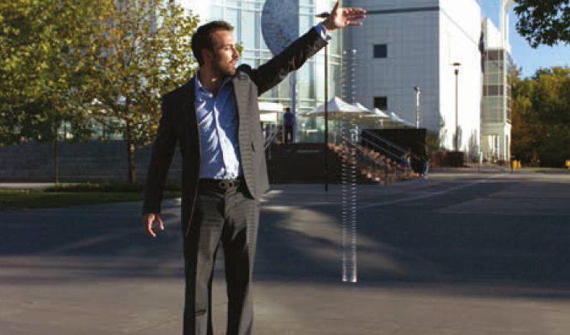

Online and social media
Questacon’s website provides supplementary content and activities linked to exhibitions and programs as well as online-only content, providing access to new and global audiences who may not have the opportunity for an in-person Questacon experience.
A new Questacon website was launched in June 2013. The redeveloped site features a new design, new and refreshed content and improved site architecture that allows users to discover content tailored to their needs and interests. The new website has been built to automatically adjust for mobile and tablet devices through responsive design, accommodating current trends in online viewing.
The website is Website Content Accessibility Guidelines 2.0 (WCAG 2.0) compliant to the ‘AA’ standard, with compliance achieved eight months ahead of the required timeframe for Australian Government websites. These Guidelines define how online content should be made more accessible to people with a wide range of disabilities.
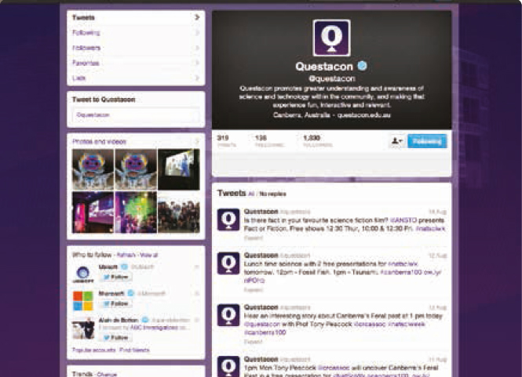
A total of 1 007 210 website visitors from across Australia and around the world engaged with Questacon online in 2012–13.
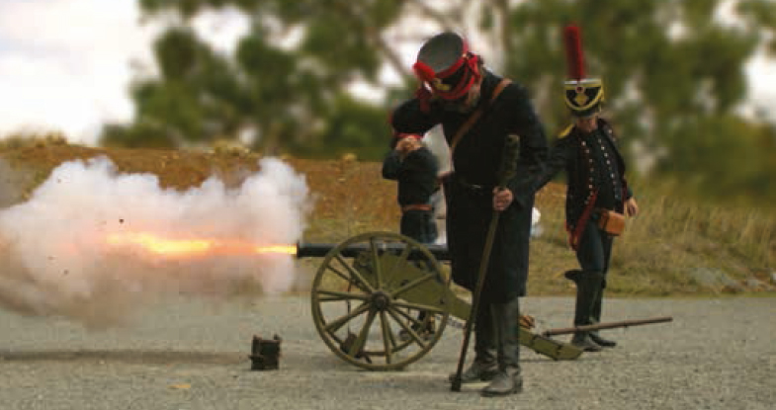
In July 2012 Questacon launched a free Questacon Science Garden Pocket Guide for mobile devices. Like having a Questacon explainer in your pocket, this audio walking tour engages visitors with Questacon’s outdoor exhibits and provides users with a selection of different interpretive content. The Pocket Guide has been accessed more than 7500 times over the year.
During the year, Questacon has increased its presence on social media channels such as Facebook and Twitter as a means of connecting to new and existing audiences. These channels are used to promote Questacon’s exhibitions, programs and events across Australia, as well as to mark key events and happenings in science worldwide. It has also provided a valuable means of receiving immediate feedback from visitors and interacting with stakeholders. Questacon now has over 6700 followers on Facebook and over 2000 followers on Twitter across all programs.
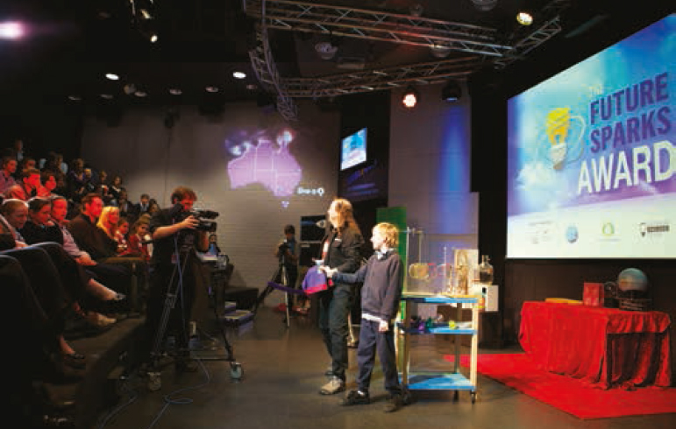
Questacon used a variety of social media channels to engage the ‘Humans’ who participated in the family tourism experience for the Australian Capital Tourism Human Brochure campaign. Social media provided an effective way to communicate with these families before, during and after their visit to Questacon and for them to share their positive experiences at Questacon with their followers.

National reach

Mt Gambier
Naracoorte
Nangwarry
Glencoe
Suttontown
Lucindale
Whyalla
Port Lincoln
Orroroo
Port Augusta
Adelaide
Derby
Broome
Cable Beach
Fitzroy Crossing
Kununurra
Halls Creek
Wyndham
Cairns
Gordonvale
Mossman
Mareeba
Atherton
Malanda
Ravenshoe
Innisfail
Tully
Cardwell
Ingham
Palm Island
Townsville
Ayr
Home Hill
Canberra
Boorowa
Sutton
Binalong
Bowning
Yass
Wagga Wagga
Junee
Coolamon
Narrandera
Temora
Leeton
Cooma
Bombala
Merimbula
Bega
Eden
Narooma
Tathra
Bermagui
Broulee
Batemans Bay
Nowra
Moss Vale
Bowral
Kangaloon
Avoca
Tallong
Goulburn
Mittagong
Buxton
Bundanoon
Burrawong
Perth
Aitkenvale
Annandale
Ayr
Baulkham Hills
Binalong
Bluewater
Boorowa
Braidwood
Broome
Broulee
Callala Bay
Callala Beach
Cambewarra
Cardwell
Casula
Como
Crookwell
Currajong
Derby
Engadine
Falls Creek
Fitzroy Crossing
Goulburn
Green Valley
Gymea Bay
Halls Creek
Heatley
Hurstville
Huskisson
Illawong
Ingham
Innisfail
Kangaroo Valley
Kingsford
Kirwan
Kununurra
Lane Cove
Lilli Pilli
Lithgow
Liverpool
Miranda
Mogo
Moorebank
Moruya
Murrumbateman
Narooma
North Rocks
North Ward
Nowra
O’Connell
Old Guildford
Oyster Bay
Perthville
Picnic Point
Portland
Rowes Bay
Rupertswood
Sanctuary Point
St Marys
Surf Beach
Surfside
Sydney
Thuringowa
Townsville
Tully
Ulladulla
Wallaga Lake
Wallerawang
Wongaling Beach
Wulguru
Wyndham
Yass
Young
Annangrove
Ashfield
Auburn
Austral
Balmain
Bankstown
Bayview
Belrose
Berowa Heights
Blacktown
Bondi
Bonnyrigg
Botany
Bowral
Cabramatta
Campbelltown
Castle Hill
Casula
Chatswood
Chester Hill
Collaroy
Cranebrook
Crows Nest
Currans HIll
Doonside
Eastwood
Edgecliff
Emu Plains
Enfield
Engadine
Epping
Erskineville
Fairfield West
Forestville
Frenchs Forest
Freshwater
Glenbrook
Glossodia
Gordon
Granville
Green Valley
Greenacre
Homebush
Hoxton Park
Ingleburn
Kemps Creek
Kingsford
Kingsgrove
Kogarah
Liverpool
Moorebank
Narellan
Narrabeen
North Rocks
North Sydney
Oatlands
Orchard Hills
Oxley Park
Parramatta
Pendle Hill
Penshurst
Plumpton
Prestons
Punchbowl
Ramsgate
Randwick
Riverwood
Rockdale
Rose Bay
Rosemeadow
Roseville
Rouse Hill
Sans Souci
Seven Hills
St Ives
Stanmore
Sydney
Terrey Hills
Terry Hills
Toongabbie
Waitara
Warriewood
West Ryde
Winston Hills
Woollahra
Albury
Palm Island
Townsville
Innisfail
Yarrabah
Gordonvale
Ingham
Doomadgee
Myola
Pormpuraaw
Alice Springs
Bungendore
Goulburn
Queanbeyan
Sydney
Merewether
Wooli
Lennox Head
Hampton
Richmond North
Unanderra
Chewton
Rutherglen
Rochester
Ardlethan
Wentworth
Nagambie
Eastern Fleurieu
Yanco
Murrumburrah
Tamworth
Ballarat
Wahroonga
Hobart
Brisbane
Barmera
Dubbo
Engadine
Tottenham
Bullarah
Kanwal
Lomond
Penrith
Dharruk
Wodonga
Wooragee
Albury
Tamworth
Wanneroo
Townsville
Launceston
International
Abu Dhabi
Danang
Hanoi
Ho Chi Minh City
Brunei
Auckland
Bermagui
Maryborough
Wagga Wagga
Perth
Goulburn

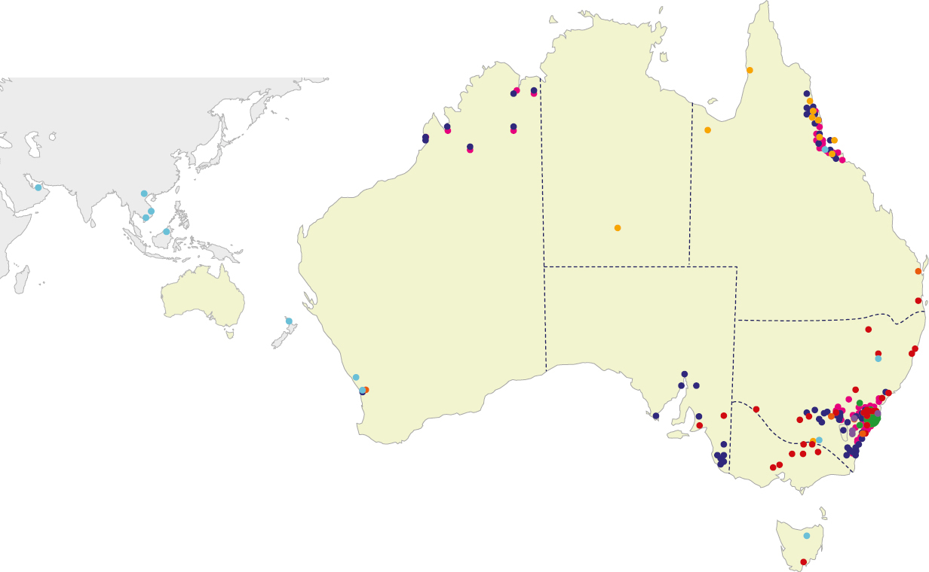
Shell Questacon Science Circus
Questacon Science Play
Questacon Science Squad
Questacon ScienceLines
Questacon Maker Project
Questacon Digital Outreach
Questacon Travelling Exhibitions
Q2U

Questacon international
‘This message is to record my appreciation for all the hard work that went into making the Questacon visit such a success, and to thank everyone involved. I think it has been a new and exciting aspect of promoting Australia in Vietnam. I know the exhibition made a great impression and gave a lot of pleasure in all three locations. The public diplomacy impact, both in Vietnamese media and on Facebook, was excellent…It was [also] great to see new ideas about museum practice and display being shared [during the seminar for museum practitioners delivered by Professor Graham Durant].’
Australian Ambassador to Vietnam, HE Mr Hugh Borrowman
Questacon has continued to advance its international relationships and projects over the past year. The international science centre sector is comprised of approximately 2500 science centres worldwide, which receive over 310 million visitors annually. As a leader in the sector Questacon makes a significant contribution to its global development, with a particular focus on South East Asia. Questacon is increasing participation in science engagement activities around the world, assisting people to explore science concepts in an interactive way and understand how science affects their lives.

Questacon in the Asian Century
In this century the Asian region in which we live is set to become an economic powerhouse. It will be a challenging time with many of the emerging issues needing science-based solutions, which in turn is driving the need for a sufficient supply of science, maths and engineering graduates. Prospering in the Asian century requires strong relationships and a clear purpose in order to make the most of expanding opportunities.
Questacon also has strong relationships with many other Asian countries and has supported the ongoing development of the Asia Pacific Network of Science and Technology Centres (ASPAC) for more than a decade. The variety of Questacon’s current projects with our Asian neighbours indicates the nature and depth of these relationships.

Japan
Questacon has always had a strong relationship with Japan and Japanese science centres and museums. As Questacon approaches its 25th year as Australia’s National Science and Technology Centre, it is timely to acknowledge the gift from the Japanese Government and business sector that led to the Australian Government’s commitment to build the Centre as a Bicentennial project. Planning is progressing for a Science Circus-style tour to the tsunami recovery areas of northern Japan in early 2014, as a gesture of thanks to Japan for its founding contribution.
In June 2013 Questacon Director Graham Durant was involved in a peer review process undertaken at Miraikan, Japan’s National Museum of Emerging Science and Innovation.
In August 2013, Questacon and Miraikan renewed their friendship agreement for a further five years. This is the second renewal of the agreement, originally signed in 2002.

Indonesia
In November 2012, Questacon delivered an intensive, two-week science centre capacity building workshop at Pusat Peragaan IPTEK (PP-IPTEK), the Science and Technology Centre of Indonesia located in Jakarta. The workshop was delivered in collaboration with the ANU Australian National Centre for Public Awareness of Science (CPAS), and was attended by 25 staff from PP-IPTEK and science centres from regional areas of Indonesia. This workshop was the pilot phase of a longer-term trilateral project involving the Exploratorium in San Francisco and PP-IPTEK. Further discussions are underway to progress this partnership.
Questacon also provided seed funding to the Australian Academy of Science for a pilot program in science curriculum development in Indonesia. This funding contributed to the development of a secondary curriculum unit and a training workshop for teachers in Bandung, followed by a three-month trial in ten local high schools.
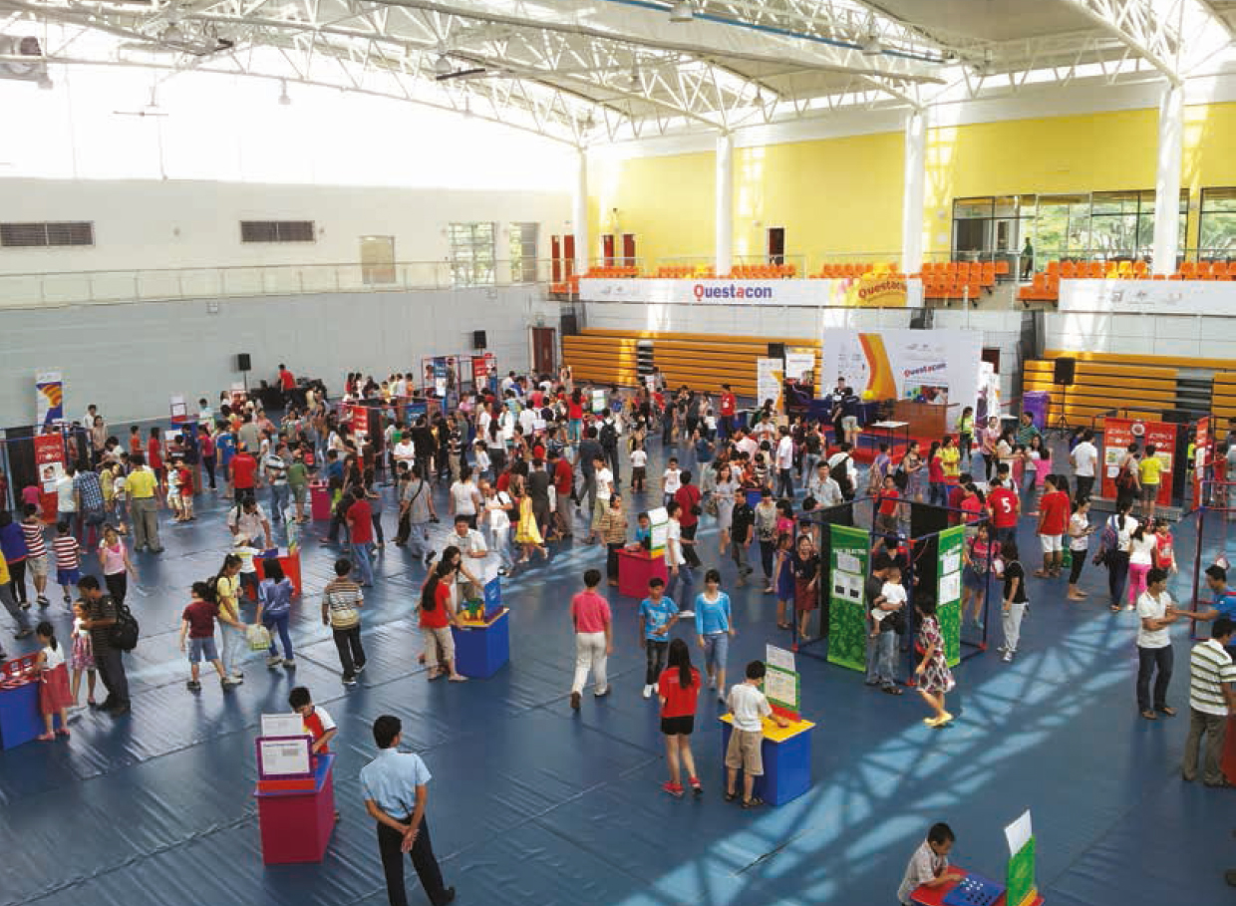
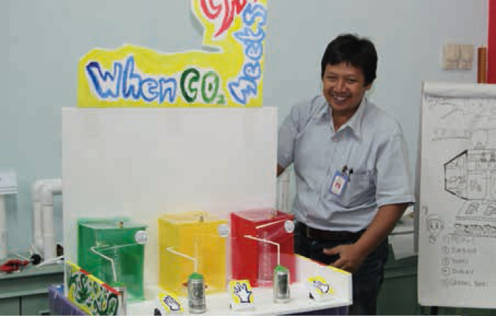

Vietnam
During April 2013, Questacon partnered with the Department of Foreign Affairs and Trade and the Australian Embassy in Vietnam to deliver a three-city tour as part of the Australian Government’s activities to celebrate the 40th Anniversary of Diplomatic Relations between Australia and Vietnam. Three Questacon presenters delivered a packed program to school groups and families in Hanoi, Danang and Ho Chi Minh City. The tour centred around the Fascinating Science on the Move combined interactive exhibition and included daily science shows. Questacon also ran workshops for local science teachers to incorporate simple hands-on activities into their daily lessons. Over 7500 students, teachers and families attended the venues and the tour attracted high levels of interest from the Vietnamese media, reaching significantly greater numbers of people across the country.
Questacon Director Professor Graham Durant joined the tour in Hanoi, meeting with senior government officials to discuss the development of science centres in Vietnam. He also delivered seminars on science communication to staff from local cultural institutions and museums. Discussions with the Vietnamese government have begun to explore how Questacon can support the development of science communication and engagement in Vietnam. It is expected that officials from the Vietnamese Science and Technology and Education and Cultural Ministries will visit Questacon in the near future to continue the exchange of ideas and knowledge.
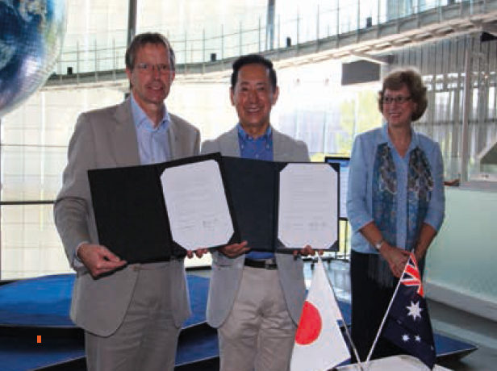

Other activities with Asian Science Centres
During October 2012 Questacon hosted two visitors from the Gwacheon National Museum in South Korea to learn about the development of hands-on exhibitions. In November 2012 three officers from the China Science and Technology Museum in Beijing visited the Centre. These officers also joined the Shell Questacon Science Circus tour in Far North Queensland to gain first-hand experience of how the Science Circus works.
Also in November, Questacon opened the Measure Island travelling exhibition in Brunei and the Earth Quest travelling exhibition was purchased by the National Science Museum in Bangkok.
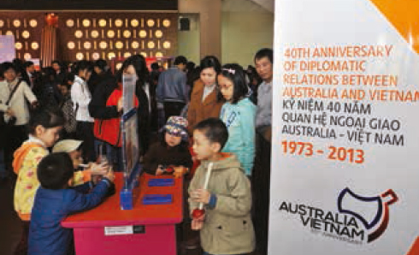

Networks and delegations
Questacon facilitates people-to-people, institution-to-institution and country-to-country interactions through hands-on science exhibits and science shows, as well as teacher and science communicator workshops.
Questacon contributes to science centre networks through executive roles and active participation. These linkages assist to develop best practice within the sector and generate opportunities for collaborative projects.
Questacon Manager—Science and Technology, Dr Stuart Kohlhagen, is President (Australia) for the Australasian Science and Technology Exhibitors Network (ASTEN). Questacon is also an active member of ASPAC and regularly links with ECSITE, the European Network of Science Centres and Museums.
During the year Questacon Director Graham Durant concluded his term on the Board of Directors of the Association of Science Technology Centres (ASTC), the peak body for the science centre sector.
During 2012–13, Questacon welcomed to the Centre over a dozen international delegations from China, Taiwan, Indonesia, Vietnam, Korea, Japan, India, Finland, Chile, Southern Africa and the United States. The wide-ranging groups—ambassadors, teachers, museum association representatives, government officials, science centre staff and university professors—visited Questacon to learn about its programs and operations.
Questacon staff also participated in international conferences, including the Visitors Studies Conference in the USA in July 2012, the ASPAC conference in Korea in May 2013, and the ECSITE conference in Sweden in June 2013. Participation in these conferences provides opportunities for Questacon to showcase our successful models of operation, to exchange ideas, and to keep abreast of trends in the science centre sector.


Other international highlights
The Exploratorium in San Francisco has long been the intellectual leader of the hands-on science movement and was the inspiration for the original founding of Questacon. The Exploratorium is an ongoing partner with whom Questacon has worked on several projects over the years. Most recently, in July 2012 Paul Doherty from the Exploratorium visited Questacon to deliver a very successful series of science communication master classes. Around 20 science communicators attended, representing Questacon, Wollongong Science Centre, Scitech (Perth), CPAS and CSIRO.
In October 2012 Questacon presented a program at the Abu Dhabi Science Festival. The Science on the Move and Fascinating Science exhibitions were on display for the ten days of the festival and were visited by over 12 000 people. Three Questacon presenters also delivered science shows and demonstrations to over 8500 eager Science Festival visitors.
In April 2013, student teachers from the Central Michigan University (CMU) visited Questacon as part of their professional development. CMU is linked with the University of Canberra, an ongoing Questacon partner. The CMU student teachers spent a week at Questacon gaining experience in informal and practical science education. The students worked around the Centre and at the QTLC, participating in busking activities, Q Lab demonstrations and assisting with Spectacular Science Shows. The placements were considered a success by all parties.
Finally, Questacon partnered with 16 other science centres worldwide to undertake a Science Centre Impact study. The study was initiated by Heureka Science Centre, Finland, and is being led by researcher John Falk of Oregon State University. The data collection phase of the study took place from September 2012 to May 2013 and involved wide-scale surveys of children (14–15 years of age) and adults across 12 countries in five continents with active science centre programs. The study outcomes are expected to be available in October 2013.
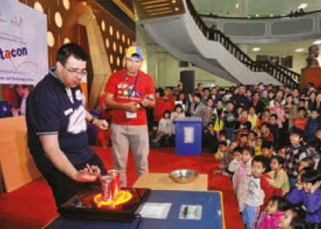

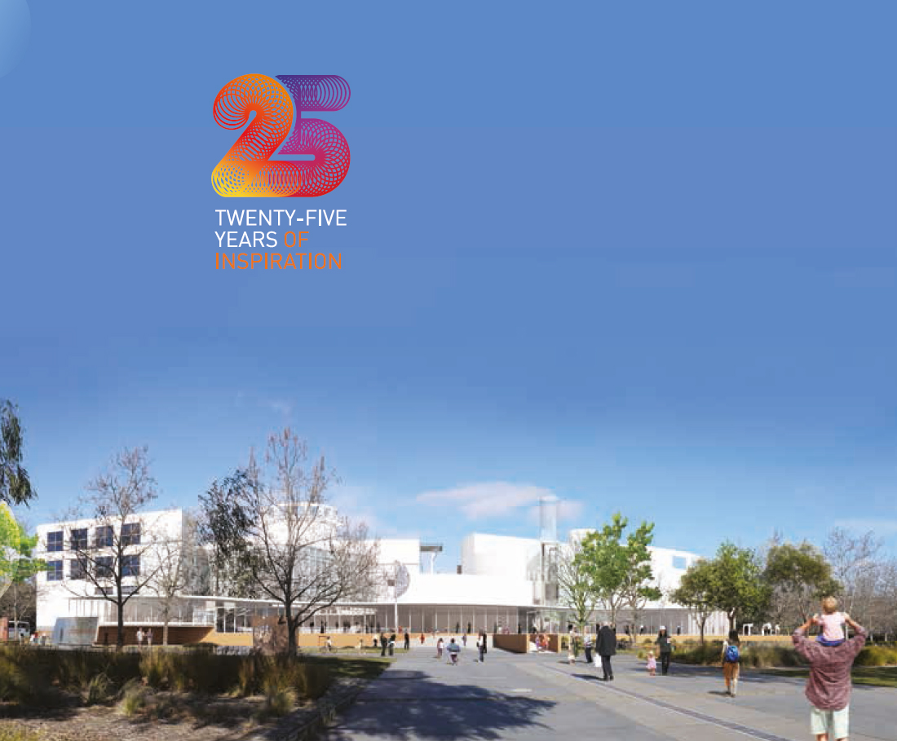

25th Anniversary
As we celebrate Questacon’s 25th Anniversary as Australia’s National Science and Technology Centre, it is time to both celebrate the remarkable successes of the first 25 years and to set up the organisation for the challenges and opportunities of the next 25 years.
Questacon continues to attract visitors to the Centre at more than double the rate of that initially predicted. There is a growing critical need for the completion of the building as originally intended by the Centre’s original architect, Lawrence Nield, in his initial sketches undertaken in the mid-1980s. This original vision was tailored during the initial development period to meet the budget and timeframes of the project.
Recent work undertaken with Lawrence Nield has delivered plans for the completion of the National Science and Technology Centre. These plans have been positively received by the National Capital Authority, and there is strong support for the completion from the Department of Innovation and the science community more generally.
In the next 12 months, Questacon will continue to progress the case for the completion of the National Science and Technology Centre, with a view to securing funding for the building project.

Questacon—the year ahead

Science Circus Japan
A major component of the 25th Anniversary celebrations will be a Questacon tour to Japan in April 2014. The tour will be undertaken in recognition of the Japanese contribution to the establishment of the National Science and Technology Centre and our close continuing collaboration with Japanese science centres.
The tour will visit tsunami-affected areas of the country, as an expression of friendship and gratitude to Japan. The tour will be based on the successful Shell Questacon Science Circus model, featuring portable, interactive science exhibits and science shows. It will be conducted as a collaborative endeavor between Questacon and the National Museum of Emerging Science and Innovation (Miraikan).
This initiative will introduce the Science Circus style of science outreach to Japan and will incorporate training for Japanese science communicators from Miraikan and science organisations from the various tour locations. At the conclusion of the tour the portable exhibits will be gifted to Japan. It is hoped that this tour will further strengthen the cooperative relationship between Australia and Japan as well as have a long-term impact in enhancing Japan’s science outreach capability.

QLTC growth
In the coming year the QTLC will build the core technology programs for secondary students and strengthen ties with the local community, through the Torque seminar program and activities with other interested community groups. It is anticipated that a number of ‘Makers in Residence’ placements will be developed for local makers to work and create unique projects at the QTLC. The Questacon Maker Project team will also deliver activities at technology challenges and festivals in regional areas, further extending the reach of the program.
As the school activity program is fully implemented with local and interstate schools, the content and scope of these activities will be strengthened using feedback from teachers and school students who have participated in the program. The full potential of the new facility is still being discovered—and the future looks exciting!

Inspiring Australia
In the first two years of the Inspiring Australia initiative, Questacon has established a leadership network that provides a ‘national framework—local action’ approach to engaging more Australians in science. The initiative has facilitated countless collaborations and partnerships that are reducing duplication, leveraging support and raising the impact of science engagement. Through the development of tools and resources, as well as through expert working groups, program providers across Australia are being supported and guided to design and target their efforts to increase their impacts. Much has been achieved and there is a need to further consolidate and build upon the early successes. The current review of the program to date will help to identify opportunities to focus the directions of the Inspiring Australia strategy in the year ahead.

Parking
In the Australian Government’s May 2013 Budget it was announced that the National Capital Authority (NCA) will install paid parking in the Parliamentary Zone by 1 July 2014.
Questacon’s preferred parking outcome would be the adequate provision of free parking for visitors, as they are most disadvantaged by the current first-come, first-served parking arrangement. Nonetheless, Questacon’s view is that paid parking is preferential to the impact of the current parking arrangements, which visitor feedback indicates is causing a very high level of visitor frustration, reduced visitation, decreasing revenue and a poorer overall visitor experience.
The current situation also impacts on Questacon’s frontline staff who are responsible for relaying parking information to visitors, and quelling frustrations whenever possible.
Questacon has commenced meetings with the NCA, looking at options to optimise installation and implementation details in favour of Questacon visitors, volunteers and staff. A Working Group will also be established to consider the impact of the paid parking arrangements for staff and volunteers.

Questacon admission
An admission charge is an essential component of Questacon’s budget framework; however, there is an ongoing desire to ensure that price and accessibility are balanced. Work will continue in the following year to aim for all Australians to be able to experience science and technology learning through Questacon.

Questacon partners
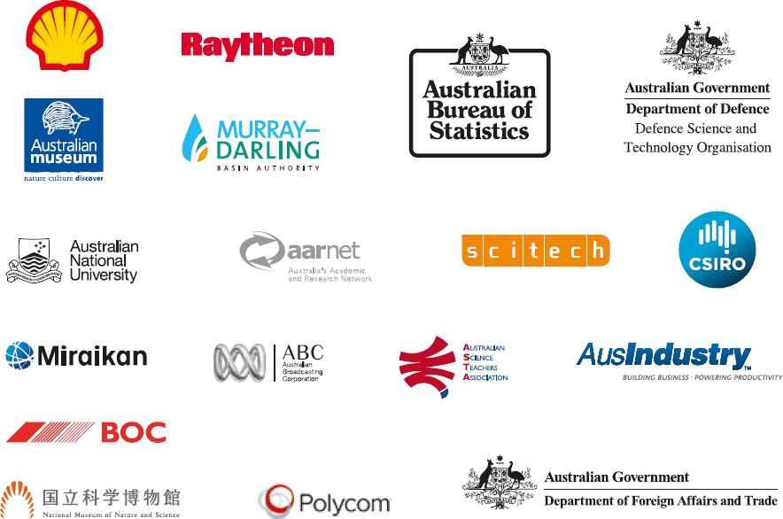

With special thanks
3infun
ACT Government
ACT Heritage
Asia Pacific Network of Science & Technology Centres
Association of Science-Technology Centers Incorporated
Atlas of Living Australia
Australasian Science and Technology Exhibitors
Network
Australian Academy of Science
Australian Academy of Technological Sciences
and Engineering
Australian Capital Tourism
Australian Institute of Marine Science
Australian National Botanic Gardens
Australian National Centre for the Public Awareness
of Science (CPAS)
Australian National Maritime Museum
Australian Nuclear Science & Technology Organisation
(ANSTO)
Australian Science Communicators
Australian Science Media Centre
Australian Tourism Export Council
Balloon Aloft
Canberra Convention Bureau
Canberra Deep Space Communication Complex, NASA
Centenary of Canberra
Charles Darwin University
Council for the Arts, Humanities and Social Sciences
Econnect Communications
Embassy of Japan in Australia
Engineers Australia
Geoscience Australia
Inspiring Australia Expert Working Groups
Inspiring Australia State and Territory Contact Officers
Integrated Ocean Drilling Program
International Museum’s Theatre Alliance
(Asia Pacific Region)
Mt Stromlo High School
Mt Stromlo Observatory
National Capital Attractions Association
National Capital Educational Tourism Project
National Film and Sound Archive
National Library of Australia
National Science Week State and Territory
Coordinating Committees
National Youth Science Forum
National Zoo and Aquarium
New Scientist
NICTA
Northern Territory Department of Business
NSW Department of Trade and Investment, Regional
Infrastructure and Services
Office of the Chief Scientist for Australia
Plant Energy Biology ARC Centre for Excellence
Prime Minister’s Prizes for Science: Committee
for Science Prizes
Prime Minister’s Prizes for Science: Committee
for Science Teaching Prizes
Queensland Department of Science, Information
Technology, Innovation and the Arts
Queensland Museum
Robogals
Royal Australian Chemical Institute
Royal Institution of Australia
Science & Technology Australia
Science Rewired
South Australian Department of Further Education,
Employment, Science and Technology
Tasmanian Department of Economic Development,
Tourism and the Arts
The Embassy of the United States of America
The Exploratorium
The Smith Family
The University of Sydney
University of Canberra
University of Queensland
University of Tasmania
University of Western Australia
Veritasium
Victorian Space Science Education Centre
Volunteering ACT
Western Australian Department of Commerce

