
Questacon Smart Skills Initiative
Questacon Invention Convention
Albury-Wodonga, 9–11 July 2019

Do you like designing, creating and building?
Want to meet some real life inventors, gain new skills and bring your ideas to life? The Questacon Invention Convention is a three-day workshop that lets you explore design, technology and innovation, with other young innovators.
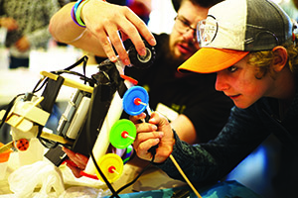



Invention Convention 101: what you need to know!
Free Suitable for 14-18 year olds

Build stuff
Use anything from robotics and electronics to hot glue, hammer, and nails.
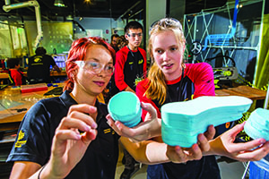

Bring your inventions to life
Prototype your ideas and get them off the page and into your hands.


Meet people
Professional innovators, scientists, designers, communicators, and 19 young people just like you.
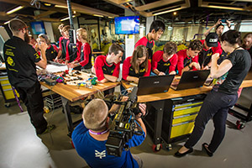
“The best thing was meeting like-minded people, and getting to know them better over the three days.”
Maree, Townsville QLD, 2018 Participant
“Having mentors that knew what they were teaching was amazing.”
Gabriel, Gippsland VIC, 2018 Participant
“I was able to get out of my comfort zone and discover new skills I didn’t know I was capable of and gained new experiences I can use later in the future.”
Wasifa, Townsville QLD, 2016 Participant

How do I get involved?
Fill out the application form attached to this flyer, and scan one for your friends too (you need to be 14–18 years old).

How much does it cost?
Nothing! It’s free!

How long does it go for?
3 days, 9 am – 4 pm

Any other perks?
It’s relaxed, open to anyone (you don’t have to be at the top of the class to come along), you’ll meet lots of cool people… and it’s a heap of fun!
Follow us on Facebook and Instagram for updates about the Invention Convention.

What parents need to know
“Our daughter loved it! She has come home with the project and rebuilt it. She shows enjoyment and excitement when working on it.”
Parent 2018, Armidale NSW
The Invention Convention is a free, three-day workshop run during the school holidays, and is a valuable experience for your child, providing a fun and highly interactive environment for hands-on learning.
Inclusive for all teenagers with different interests and education levels, these catered workshops allow participants to learn new skills, form new friendships, and build new networks with mentors and other like-minded teens.
Supported by mentors and role models, our Invention Convention presenters are professional young innovators using expertise, passion and enthusiasm to create a fun and safe learning environment for the participants.
The three-day experience will see your child gain confidence in new skills, and empower them to make decisions about what passions to pursue in future studies and/or career pathways. The Invention Convention is supported by Principal Partner, The Ian Potter Foundation.
“I found your staff to be truly professional, incredibly warm and friendly and very forthcoming with encouragement for the kids. Amazing!”
Parent 2018, Armidale NSW
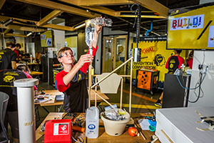
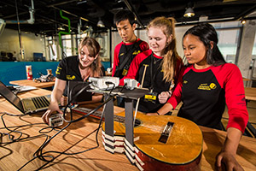

Can’t make this one?
Register now for the National Questacon Invention Convention!
The annual National Questacon Invention Convention is an all expenses paid, five-day workshop in Canberra, held in January 2020. You could be 1 of 25 teenagers from around Australia coming together to work with Australian legends in design, innovation and technology to bring your ideas to life.
Visit the website to express your interest in attending, and we can keep you in the loop on how to apply!
For more information contact:
Questacon Invention Convention
Phone: 1800 889 995
Email: outreach.bookings@questacon.edu.au

www.questacon.edu.au
Registration form

Participant’s details

Given name:
Surname:
Date of birth: Male Female Unspecified
School:

Address details

Apartment/Unit: Street number:
Street name:
Suburb/Town:
State: Postcode:

Parent/Guardian contact details (if under 18 years of age)

Name:
Daytime phone: Mobile:
Email:

General information

- How did you or the participant find out about the Invention Convention?

To be completed by the participant

- Are you currently working on any inventions? If yes, tell us about it.

- What do you hope to gain from attending the Invention Convention?

Accessibility requirements

- Does the participant require any adjustments, or have any allergies (food or other) that we need to be aware of?

Parent/guardian signature (if under 18 years of age)
I am aware that has registered for the Questacon Invention Convention and give them permission to attend.
I have read and agree to the Invention Convention Terms and Conditions, including Questacon’s Privacy Policy.
I am aware that I will be required to notify Questacon staff prior to the event if will be making their own way to/from the Invention Convention.

Name:
Signature:

Participant’s signature
I have read and agree to the Invention Convention Terms and Conditions, including Questacon’s Privacy Policy.

Name:
Signature:

Return your registration form by email, fax or post
Email outreach.bookings@questacon.edu.au
Free fax 1800 641 171
Post Questacon – The National Science and Technology Centre, Loc. 940, PO Box 5322, Kingston ACT 2604

Terms and Conditions

Code of conduct
- Participants must obey all lawful instructions from the workshop Manager and Support Staff such as (but not limited to) all reasonable instructions, directions and procedures relating to work health and safety in operation at our premises.
- Participants must not consume alcohol, use illegal substances, or smoke cigarettes whilst participating in the workshop in any capacity.
- Once registered with the Invention Convention Supervisor, Participants must not depart from the workshop environment without the approval of the Invention Convention Supervisor or the Support Staff.
- Participants are representing their school, family, organisation or business and Questacon. No disrepute should be brought to either of the above. Behaviour befitting a Participant will be required at all times.
- No disrespect to persons involved in the event will be tolerated under any circumstances.
- If Participants have any problems, they are to report them to the workshop Manager as soon as possible.
- There is to be:
  - Respect for the venue and all property;
  - No interference with other people’s property;
  - No use of venue telephones and other services (except at the Participant’s expense).
- The Participant or their parent(s)/guardian will be liable for any damage or loss caused to Questacon’s property and premises resulting from the Participant’s conduct.
- Once signed in, Participants must attend all approved activities unless given permission to do otherwise.
- Participants agree to wear enclosed footwear and any other stipulated uniform compliance.
- Participants agree to demonstrate punctuality as required by the workshop Manager.
- Participants are required to take care of their possessions whilst at the workshop. Questacon will not be held liable for any loss or damage to Participants’ possessions.
Breaches of any Code of Conduct rules may lead to immediate expulsion from the workshop. Should expulsion occur, the Participant or their parent(s)/guardian will be contacted and appropriate travel arrangements will be made. Any and all additional expenses incurred will be the responsibility of the Participant’s parent(s)/guardian.

Consent to apply first aid
In the event of any emergency, injury or illness, you authorise any Questacon Invention Convention official, to obtain on your behalf and at your expense, any medical assistance, treatment and transportation as deemed necessary.

Daily registration and transport
For duty of care purposes, parents/guardians of Participants (or Participants, if 18 years of age or over) will be required to register Participants daily. This is to ensure all Participants are accounted for throughout the day and leave the workshop premises safely. Exceptions to daily registration can be made if agreed in writing, prior to the event.
All transportation to and from the Questacon Invention Convention Venue will need to be arranged by the Participant or their parent/guardian. If the Participant is using public transport please check local timetables. For the avoidance of doubt, it should be understood that Participants are not within the duty of care of Questacon when travelling to and from the event.
Please ensure that the Participant arrives 15 minutes prior to the start of first session to allow for registration. The first session of the day will commence at 9 am. The last session of the day will finish at 4 pm. Please ensure that the Participant arrives on time. More information about the program and sessions will be sent to the Participant once the registration form is received.

Privacy collection statement and consent
Questacon is a division of the Department of Industry, Innovation and Science (the Department) and as such is bound by the Australian Privacy Principles (APPs) outlined in Schedule 1 of the Privacy Act 1988 (Cth) (Privacy Act). These principles regulate how Questacon collects, uses, discloses and stores personal information. As you would be aware your child is applying to participate in a Questacon Invention Convention (Invention Convention). This requires the collection of your and your child’s personal information.
The personal information collected on the attached form includes your contact details, emergency contact details, your child’s name, the name of your child’s school, your child’s age, state or territory location of residence, postal address, any special requirements, dietary requirements. Questacon may use this personal information in printed and digital materials and websites produced for the Department and related Ministers’ offices including reports, brochures, magazines, newspapers, newsletters, posters, fact sheets, websites, social media applications (such as Facebook, Twitter and YouTube), case studies, promotional videos and multimedia presentations. This personal information may also be used by media outlets in the form of media releases including participant’s, name and school to broadcast, advertise and promote the Questacon Invention Convention.
Questacon may use your personal details to notify your local Member of Parliament about your child’s participation in the Invention Convention.
Personal details may also be used to contact the Participant regarding future Questacon events and programs.
The information will only be used for the purposes outlined above, except where authorised or required by law.
For further information, please refer to the Department’s Privacy Policy on the Department of Industry, Innovation and Science website. This policy contains information about how you may access the personal information Questacon holds about you, and how you may correct any inaccuracies in that information. It also includes information as to how you may make a complaint about a breach of the Privacy Act, and how Questacon will respond to such a complaint.
If you have an enquiry or request relating to your personal information, please contact:
Privacy Contact Officer
Legal Services Branch
Corporate Division
Department of Industry, Innovation and Science
GPO Box 9839
CANBERRA ACT 2601
AUSTRALIA
Email: privacy@industry.gov.au
More information about the Privacy Act can be obtained from the Office of the Australian Information Commissioner’s website.
Personal Information obtained will also be stored and held in accordance with Questacon’s obligations under the Archives Act 1983 (Cth).
Questacon understands that you may not want Questacon to use your child’s personal information in printed and digital materials and websites.

