Teacher Resources – Rockets

Welcome to the Questacon Maker Project Catapults workshop. This resource provides information and activities designed to complement your workshop experience. This includes pre- and post-visit activities, questions to keep your class thinking about the project, tips on running this workshop on a smaller scale and general information on the innovation process.

**Innovation**

Contrary to popular belief, Thomas Edison didn't "invent" the light bulb. He is known for this life changing invention because he improved upon a 50-year-old idea and made it accessible for everyone to use. This process of building on ideas to create something new is called innovation.

We all have the tools we need to be innovative; problem solving, creativity, maths, science and technology, but it’s how we use these tools that can make the difference between having an idea and doing something with it.

The process of need, think, make, try, refine is at the heart of any design or engineering feat. These stages don’t follow a set pattern or order, but arise naturally from the exploration of new ideas. It can be useful to think about each of these stages as you work on your own designs.

* + Does your idea address your **need**?
  + Can you **think** of a new or better approach to solve your problem?
  + Can you **make** a prototype?
  + **Try** out your prototype – does it do what it’s supposed to?
  + How can you **refine** your design to make it better?

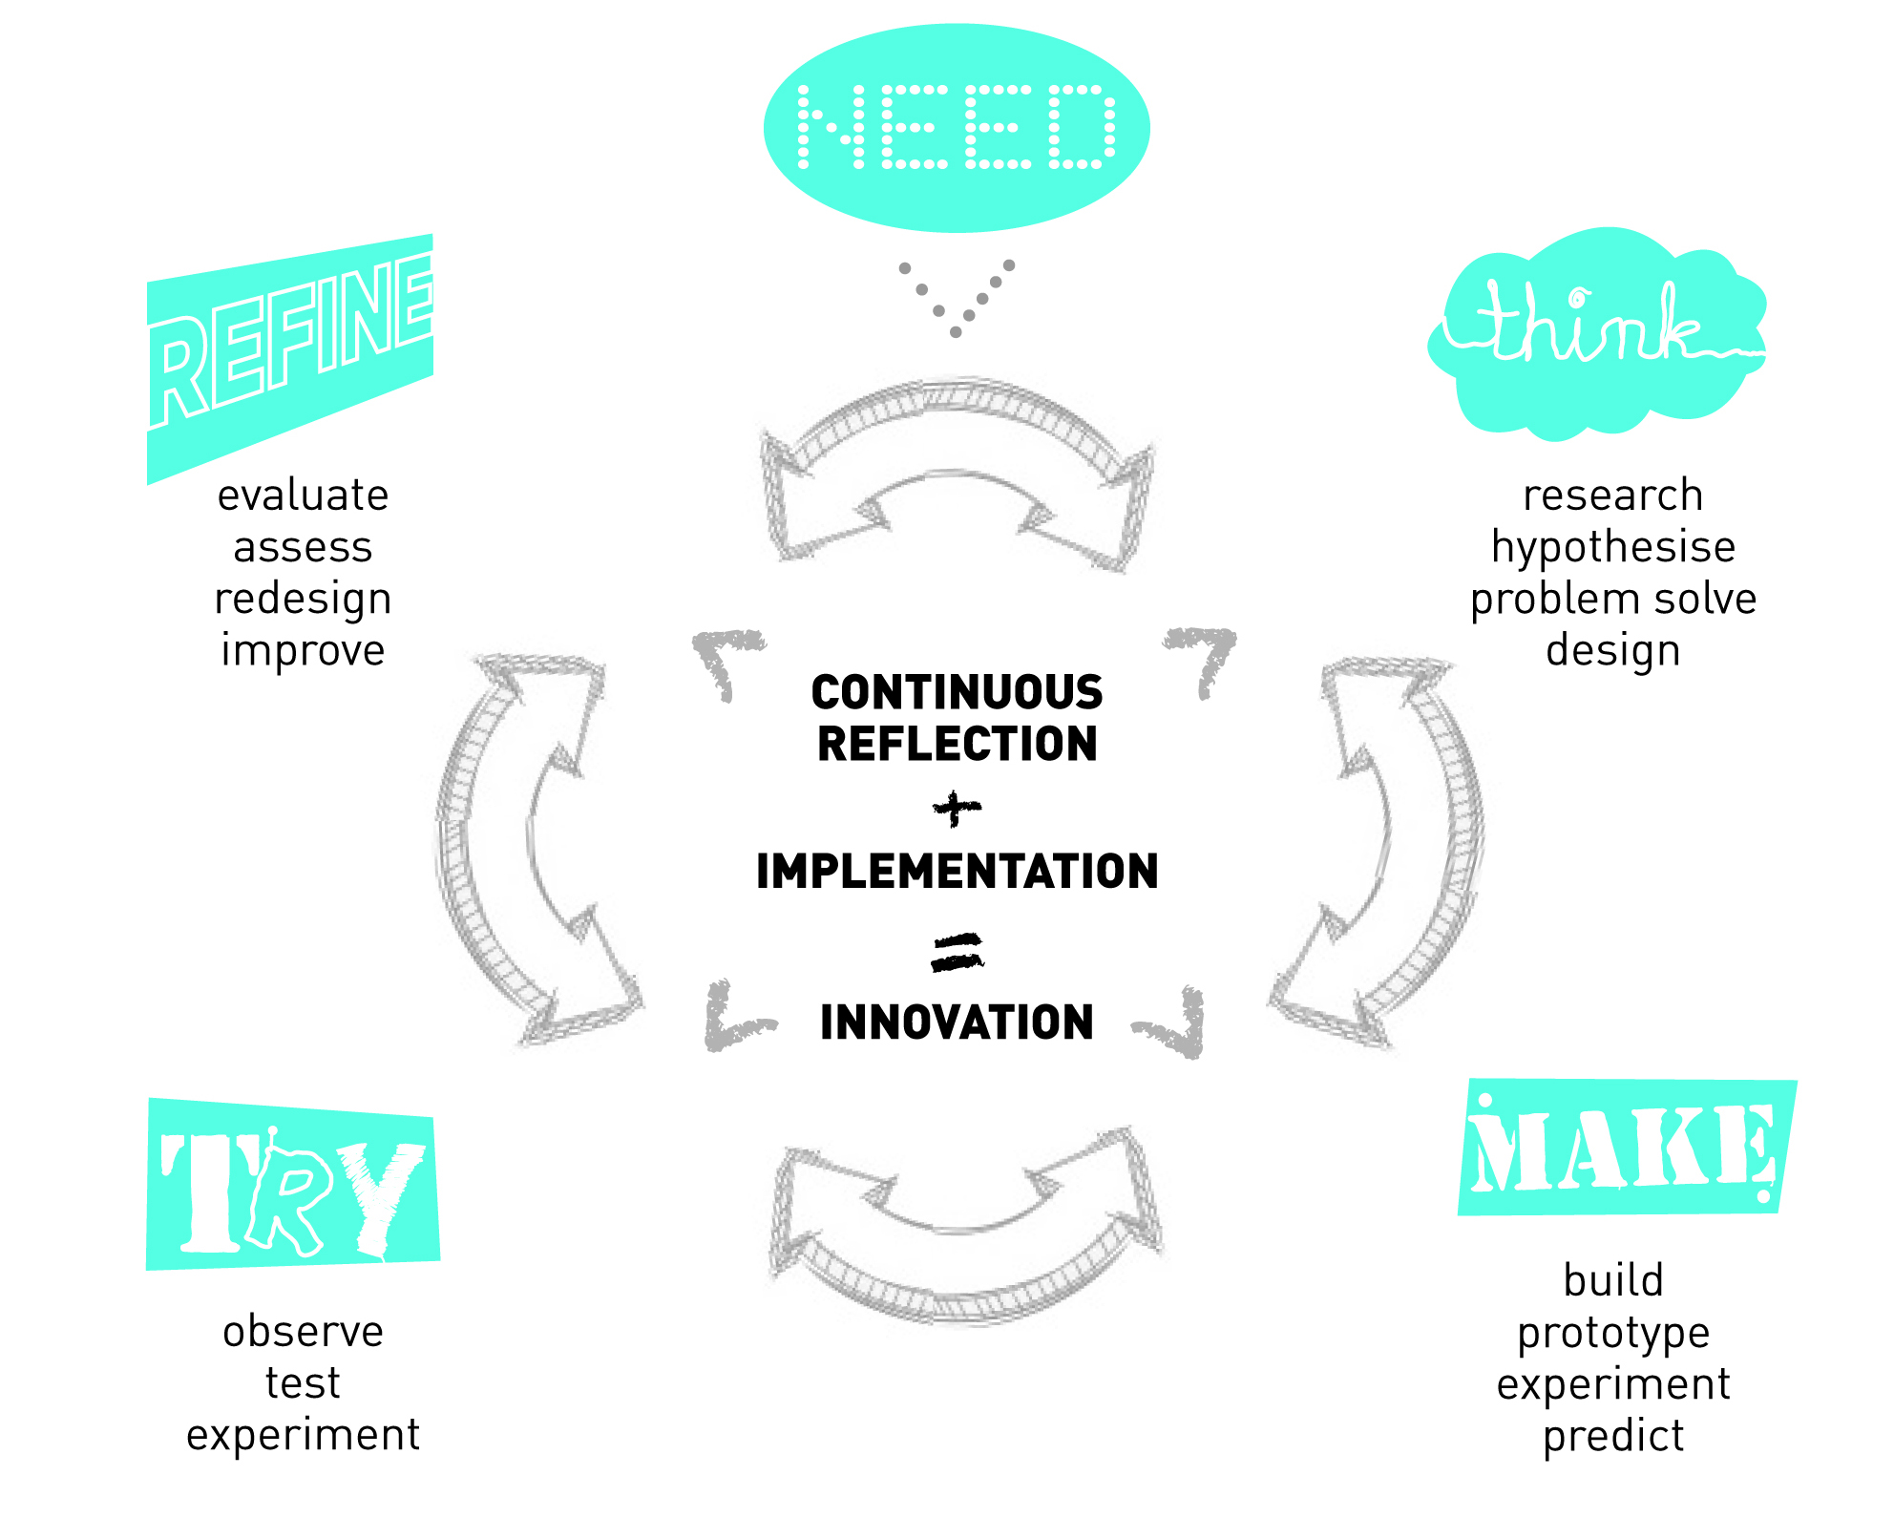

Before your visit

**Pre-visit Activities**

The innovation process is simply about taking an idea and making something new. So an innovator is someone who wants to create change for the better by coming up with new ways of doing things. Sometimes, making this change in society comes from changing your perspective.

**Activity 1**

Obtain two random objects (anything from a plastic spoon, a single serve pack of vegemite to a test tube). For each object ask the class to brainstorm other ways the object could be used.

1. Imagine the object at any scale, made of any material, or in any context. It might be helpful to ask your students what they could use the object for if they were abandoned on a desert island – this can get the creative juices flowing.
2. How would you improve the original object to better address the new purpose? Does this new object perform the function better than existing products?

**Activity 2**

This activity is designed to show your students some real world problems that relate to the Rockets workshop, specifically ideas of experiment design and controlled variables.

**Setting**

Finding the fastest or shortest route to a destination has been an issue for navigators and explorers for centuries. Today, GPS Navigation units can make the job a lot easier by doing a lot of complex calculations for us. Some even take into consideration real-time traffic data. But – does the fastest path necessarily equate to the shortest?

**Problem**

Split the class into small groups. Challenge each group to find the *shortest* path (distance) from your classroom to the library or another building within your school. The students can choose whichever mode of transport between the two points (run, jog, walk, meander, etc.), however, can only measure how *long* it takes (time) to make the journey, using a stopwatch.

**Discussion**

As a class, a discussion can follow as to how different groups may have come up with different answers. Unpack the importance of controlling variables that are not being tested (speed, step length, etc.), and only changing the tested variable (chosen path).

**Things to keep in mind**

* It is probably important to stipulate whether or not students can make shortcuts or have to stick to formal pathways
* The task works best for journeys that have multiple pathways with similar distances, and a mixture of zig-zag paths (difficult to run on) and straight paths (easy to run on).

What to expect at the workshop

In this workshop students will build simple rockets out of paper, card, and tape, to be launched from an air-powered rocket launcher. Follow up discussions will centre on experimental design and the control of variables. Students will then have a facilitated discussion using their critical thinking and problem solving skills to interpret a class data set of launch angles and distances. Students are given freedom of design with their rocket, and design trends will be identified.

All tools and resources will be supplied; a teacher will need to be present at the workshop to act as a supervisor.

Running time: 120 minutes

|  |  |
| --- | --- |
| **Introduction** | Discussion on variables and the experiment design. Outline of tool safety and challenges |
| **Introductory Activity** | Students build and fire a ‘control’ rocket to optimise launch angle/identify result clusters. Results plotted and facilitated discussion of the interpretation of data. |
| **Main Activity** | Students are given freedom to build modifications to rocket design to be launched at controlled launch angle. |
| **Extension activities** | Facilitated as required, dependent on progression of individuals and groups |
| **Wrap-up** | All groups will have a final launch of their designed rocket.   Facilitated questions and discussion on workshop, including:   * Approach to the challenge(s) * Clusters of rocket design features (fins vs wings, size of fin, etc.) * What would you do differently next time? |
| **Resources (provided by Questacon)** | * Air-powered, paper-rocket launchers, tape measure, * Raw materials including; paper, card, tape, etc. * Tools, including; scissors, markers, safety equipment, etc. |

After you visit

**Follow up questions**

During the pre-visit activities, you asked your students to determine the shortest path between two points. Referring back to this question:

* How would each student go about figuring out the shortest distance to another part of the school? This can lead to a discussion focusing on controlling variables.
* Design a class experiment to determine how tall a bean plant will grow with/without light – what variables will need to be controlled?
* How do you deal with variables that you cannot control (e.g. weather, etc.)?
* How do you deal with experiments where variables are not entirely independent - i.e. was the optimised angle of launch the best for all designs of rocket?

**Explore and Expand: Science and Innovation**

Many new inventions that have made our lives easier, or just more enjoyable, wouldn’t have happened without innovative thinking. However, you need tools to innovate, and scientific knowledge is one of those tools. Other tools that you may need (or already have access to) include maths, drawing, design, language and computer science. Science and innovation have a close relationship—they go hand in hand. Many scientific and technological advancements and developments are due to innovative thinking; using something that already exists but applying it to something new—being creative, thinking laterally.

**Australian Innovation**

Did you know? WiFi is an Australian innovation

WiFi was originally developed by Dr. John O’Sullivan while he was trying to solve a radio astronomy problem—finding exploding black holes. After some time, other researchers from CSIRO modified his idea; using mathematics and physics to solve another problem—wireless communication. This didn’t happen overnight, but the various applications of WiFi have made this innovation one of the most crucial technologies in our networked society. Check out the full story at <http://www.abc.net.au/catalyst/stories/2708730.htm>

**Activity 3**

Research and discuss: Ask students to discover some of Australia’s coolest inventions and discuss the process behind their creation!

Questions might include:

1. What are some of Australia’s most creative inventions?
2. Who came up with them? Was it a team effort or an individual effort?
3. How did the creator(s) come up with their invention? What Ideas did they build on? What inspired them?
4. Can you identify the need?
5. Were there any prototypes? What did they look like?

Questions are based around the innovation process to help unpack it and provide real world examples of the process in action.

Curriculum links

To help the classroom, this workshop contains many links to the Australian curriculum.

**Mathematics Content**

This workshop’s activities relate to Mathematics Content skills across all years by exploring:

* Measurement and Geometry
* Statistics and Probability
* Data representation and Interpretation

**Science Inquiry Skills Strand**

This workshop’s activities relate to Science Inquiry Skills across all years by encouraging:

* Questioning and predicting
* Planning and conducting
* Processing and analysing data and information
* Evaluating
* Communicating

**Science as a Human Endeavour Strand**

If this activity is extended to research and discuss the importance of good experimental design and the impact on how different results can influence the development and practices in human activity, it links to the Science as a Human Endeavour Strand.

**Science Understanding Strand**

As well as investigating physical forces including kinetic energy, gravity, air pressure, and projectiles, this activity links directly to physical science subjects in the Science Understanding Strand, specifically:

**Year 7** Physical Science

Change to an object’s motion is caused by unbalanced forces, including Earth’s gravitational attraction, acting on the object (ACSSU117)

**Year 8** Physical Science

Energy appears in different forms including movement (kinetic energy), heat and potential energy and causes changes within systems (ACSSU155)  
**Year 10** Physical Science  
Energy conservation in a system can be explained by describing energy transfers and transformations (ACSSU190)  
The motion of objects can be described and predicted using the laws of physics (ACSSU229)

**Australian National Curriculum Online:** http://www.australiancurriculum.edu.au/